**TY B.Tech. (CSE) – II [ 2022-23 ]**

**5CS372 : Advanced Database System Lab.**

**Assignment No. 1**

29/01/2023

Sanket Shivaji Jadhav

2020BTECS00005.

**Aim :** To revise functionalities of PL/SQL and Demonstrate it.

**Introduction:**

PL/SQL is Oracle Corporation's procedural extension for SQL and the Oracle relational database. PL/SQL is available in Oracle Database, Times Ten in-memory database, and IBM DB 2.

1. **PL / SQL Review :**

* 1. Create a table called test_table with 2 columns RecordNumber (type : Number(3)) and CurrentDate (type : Date)). Write PL/SQL block which will insert 50 records into test_table. Insert the current date value into the table.

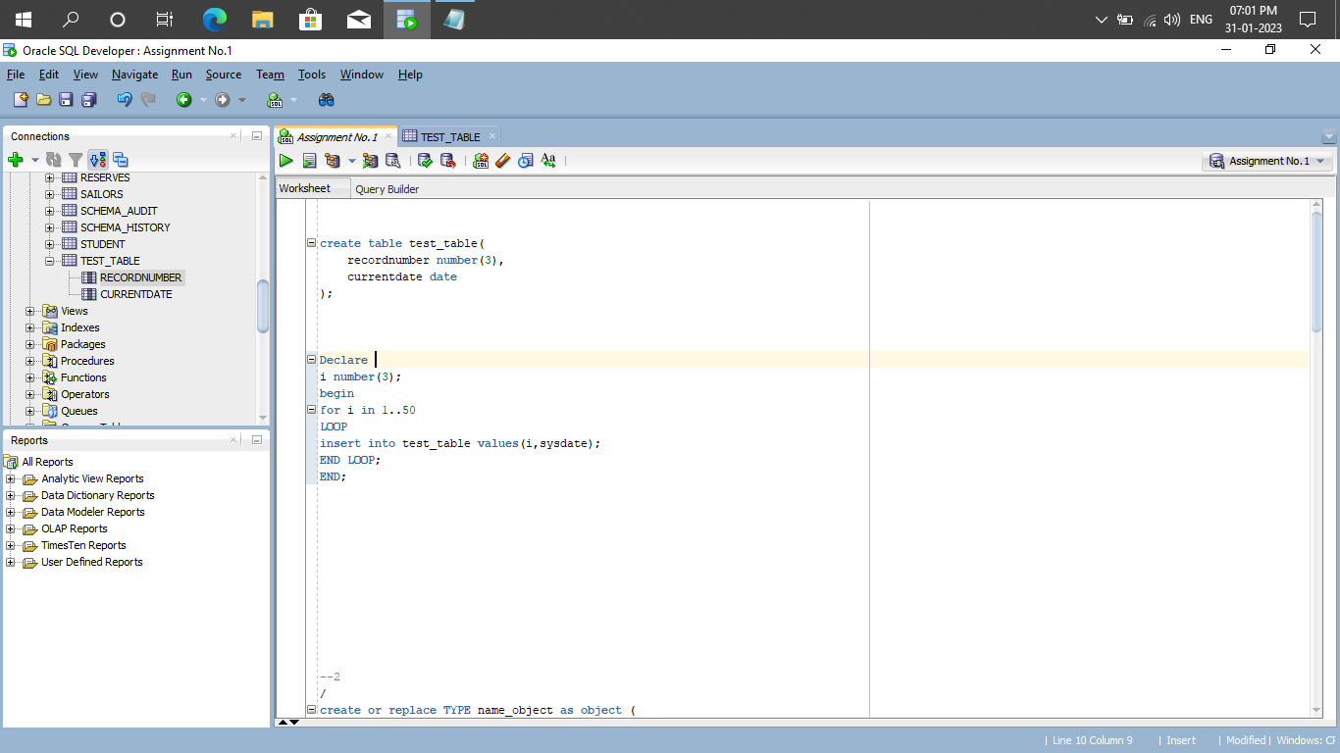

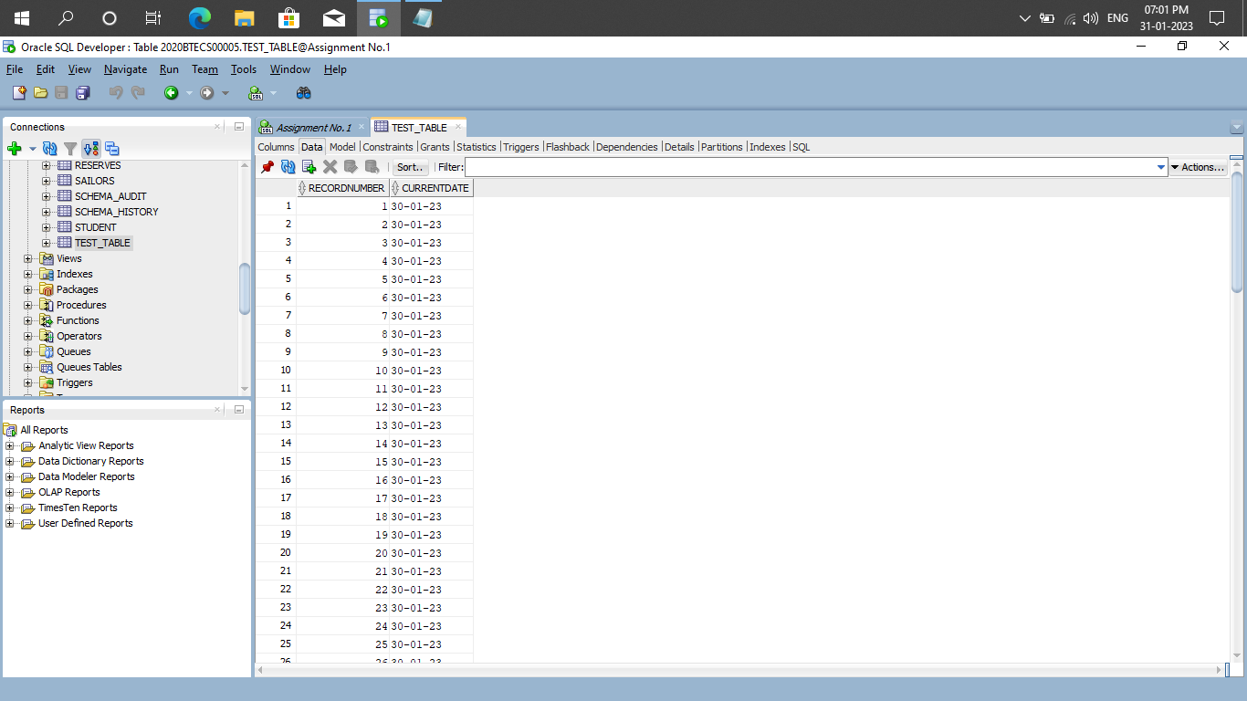

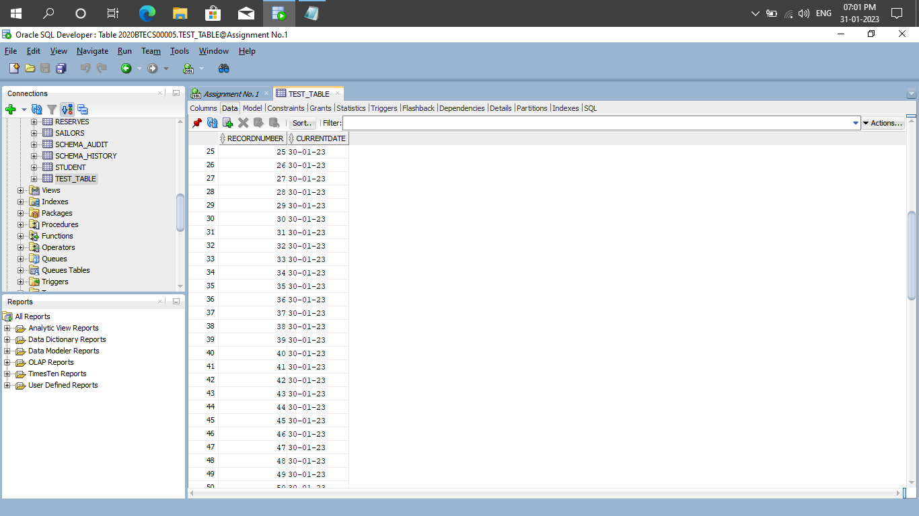

* 1. Create a products table products(ProductID number(4),category char(3),detail varchar2(30),price number(10,2),stock number(5)).

Insert the sample data.

Write PL/SQL procedure with two arguments **X** & **Y** which will increase price by **X**% for all products in category **Y**. X and Y will be given by user.

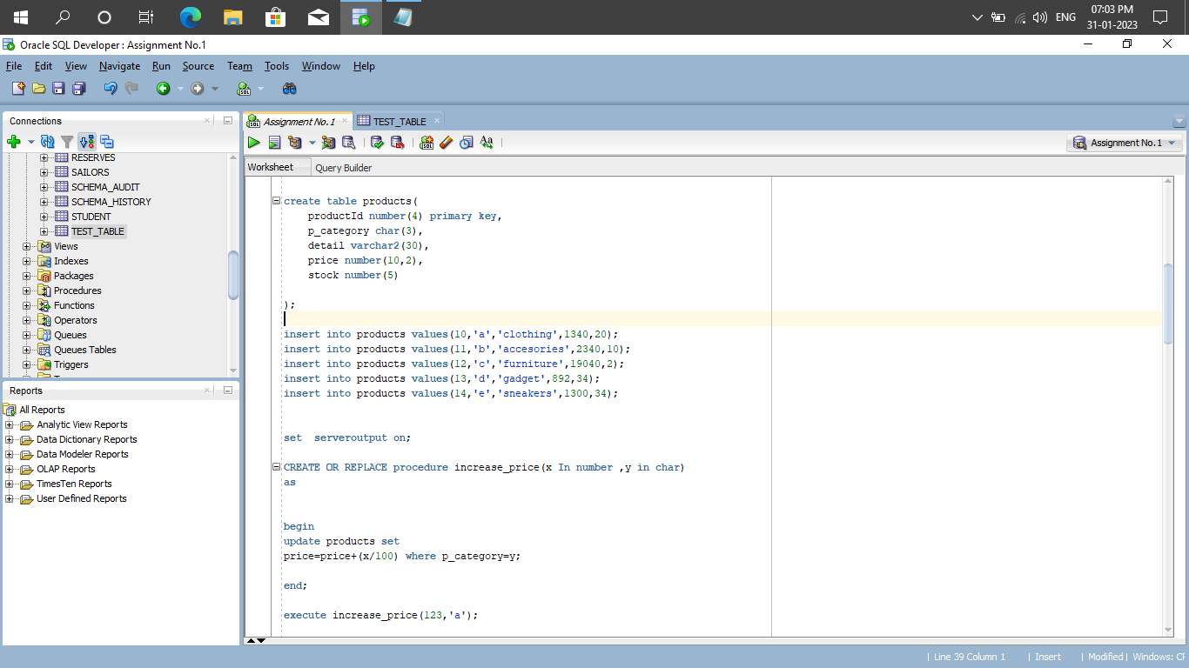

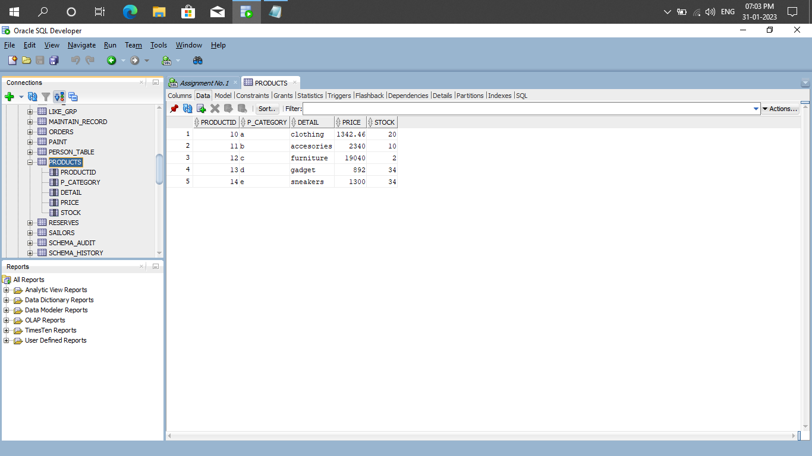

1. **Object Relational Databases:**

* + 1. Create Object Table containing field “name” of size 50 characters and member function “countNoOfWords” which returns the no. of words in “name” field.

Demonstrate the working by entering different data.

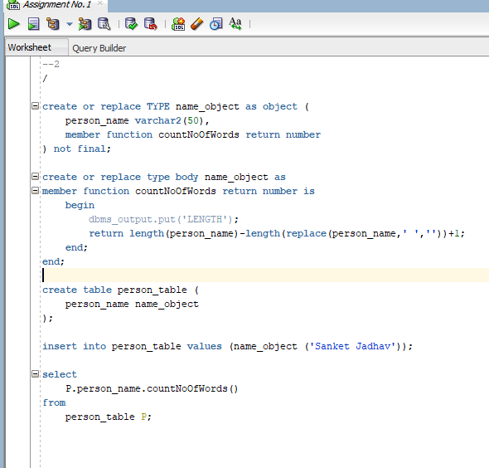

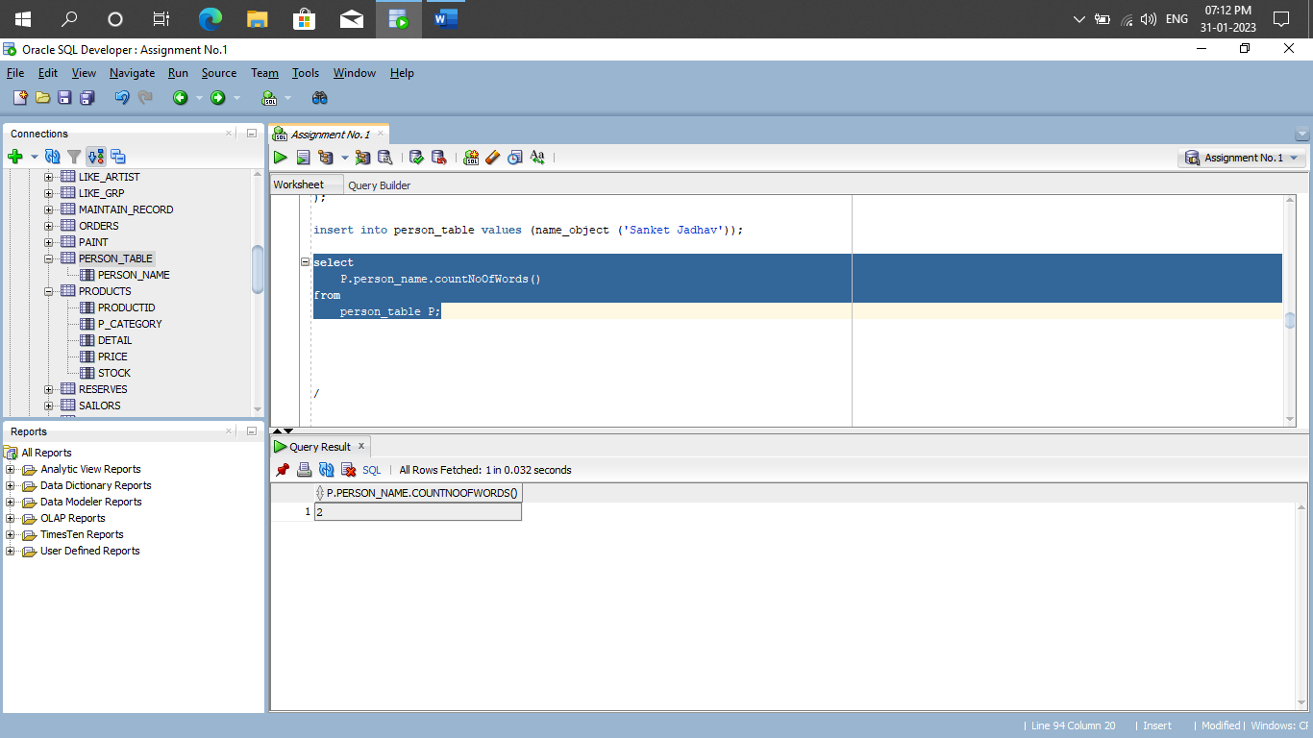

* + 1. Create an address type with the following attributes : address, city, state & pincode. Include the following methods
       1. to extract the addresses based on given keyword.
       2. to return the no. of words in each given field (method should accept the name of attribute/field)

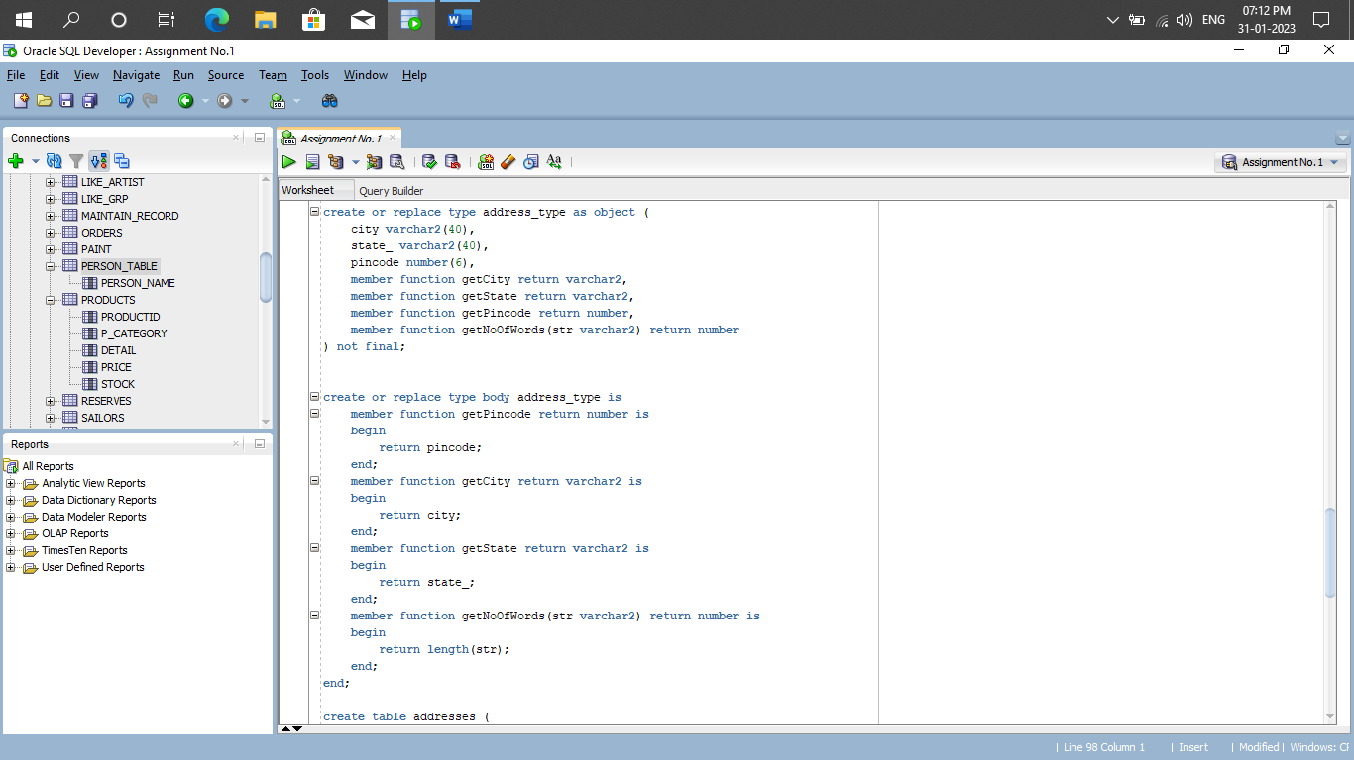

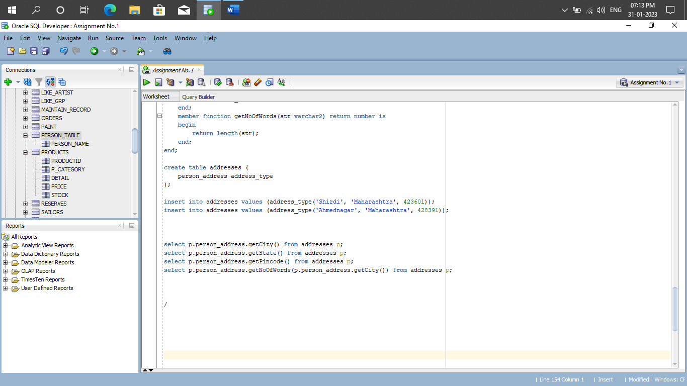

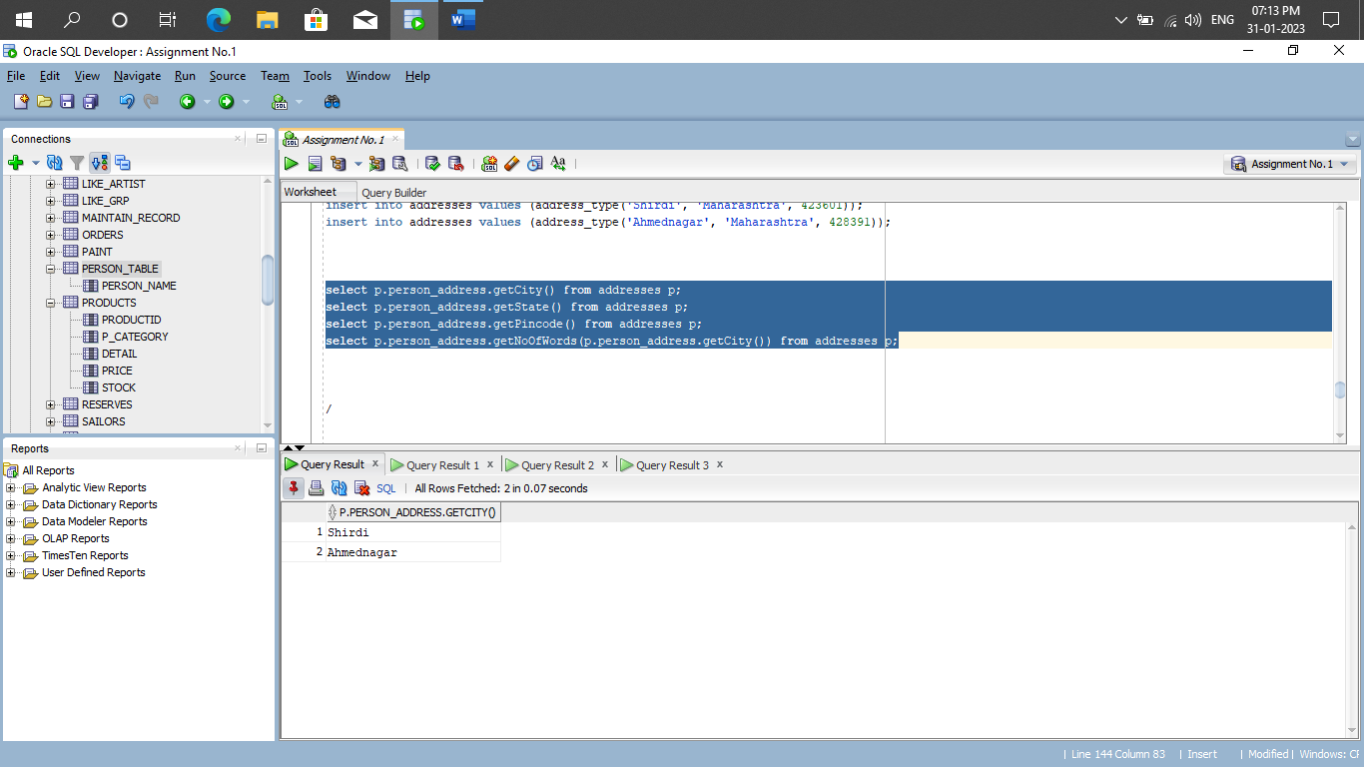

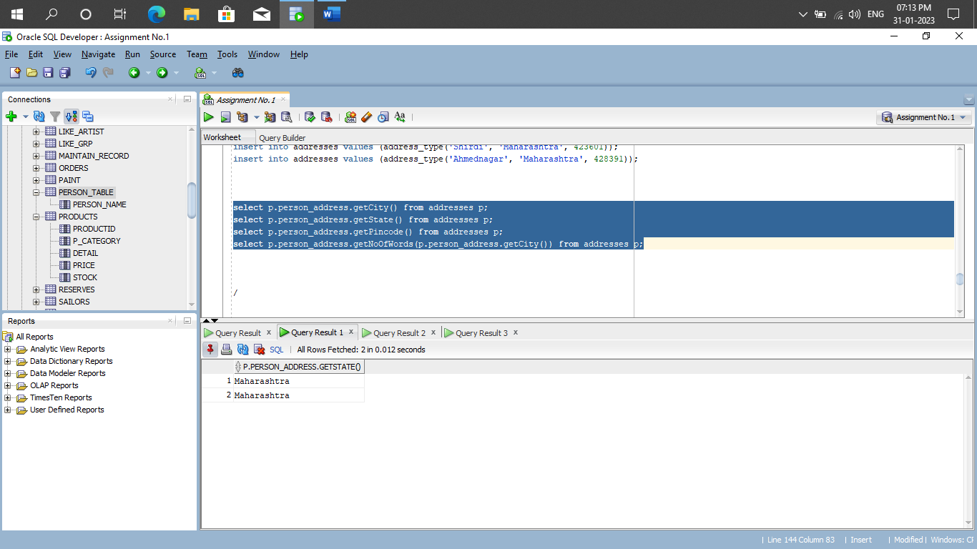

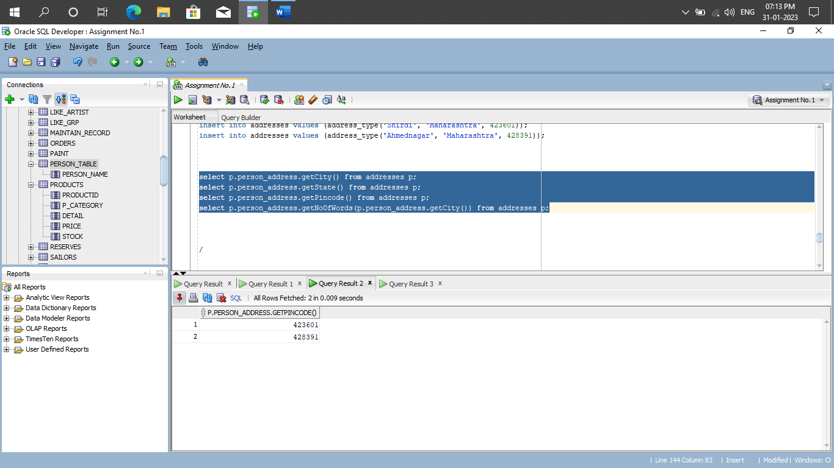

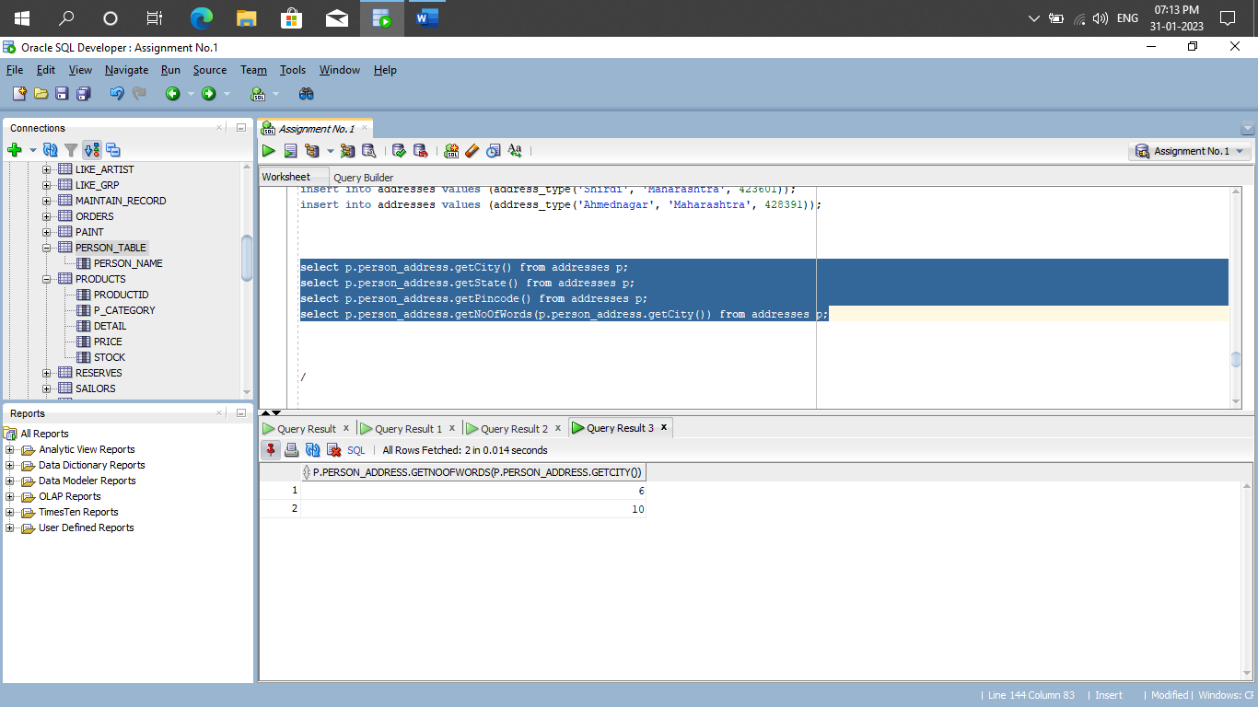

c) Create a user defined data type course_Type with 2 attributes course_id, description :

* + - 1. Create an object table based on the type created.
      2. Insert rows into the table

Demonstrate the working with different data sets

