**ADS Lab.**

**Assignment No. 5**

**Sanket Shivaji Jadhav**

**2020BTECS00005**

**Q 1. Performance Tuning.**

**Title:**  Performance Tunning

**Objective/Aim:** Do the performance tuning for Assignment No.3 & 4.

**Introduction:** When we are developing any application we have to test it under various conditions like how it behaves under very high load conditions, etc. Performance testing in software helps to analyze the performance of the software. Performance testing is important alongside unit testing, system testing, and integration testing. Performance testing is used to analyze the performance, server response time, and throughput under different load conditions.

**Apache JMeter :** This is a java-based application that we can use for performance testing. It generates heavy loads to analyze the performance of applications under different operating conditions.

**Before Tuning:**

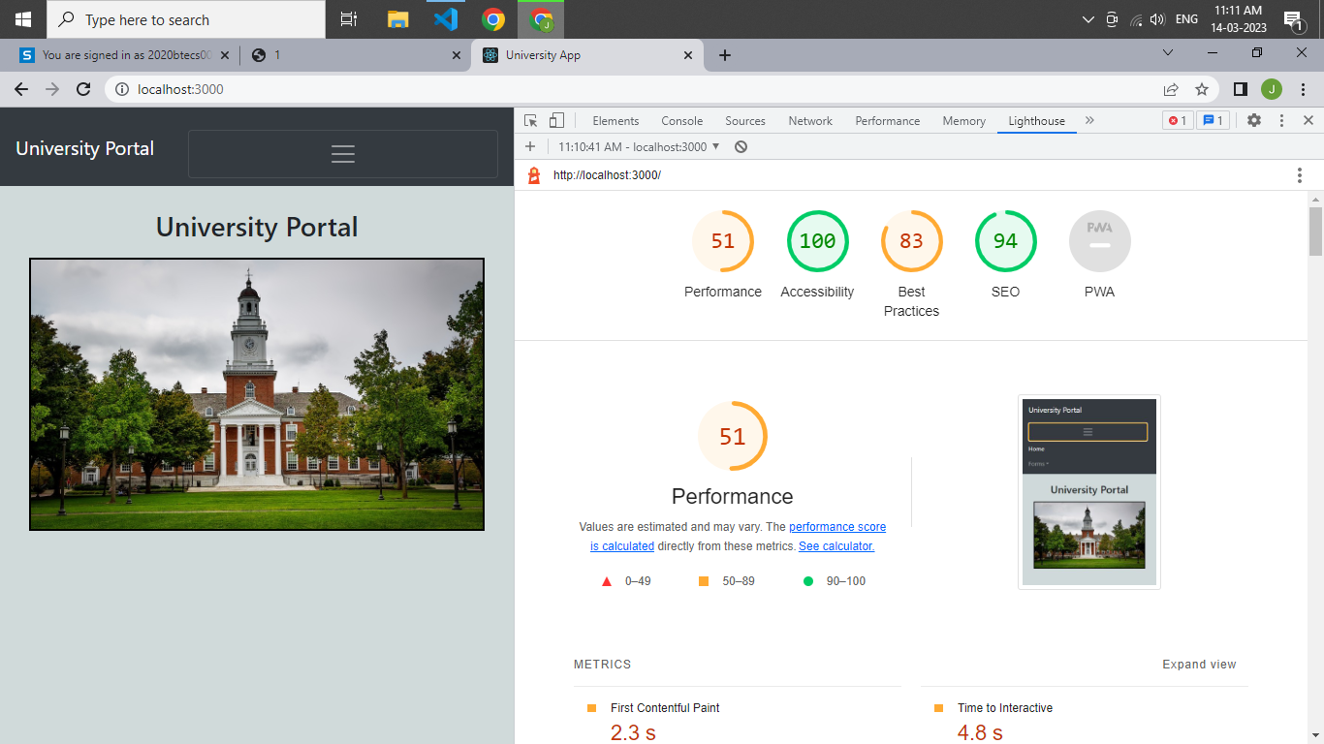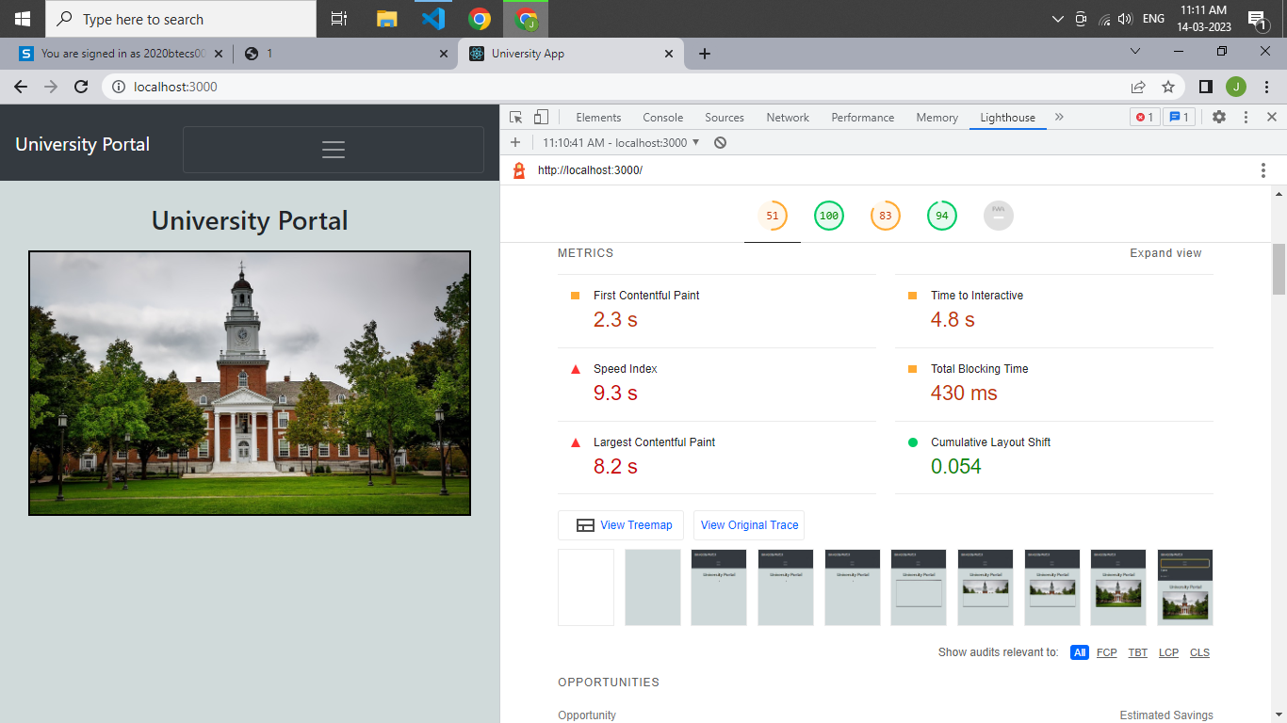

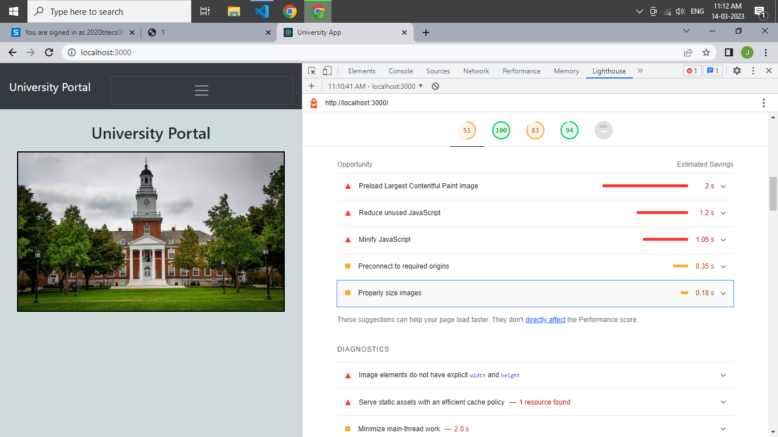

Procedure:

1. Create performance test with the name assignment 5_ADS_test

2. Right-click on the test and add a new thread group specify loop time, no of thread, and other values.

3. Create HTTP requests with specified URL as localhost and port 3001 and then specify the route that we have to fetch and request type I have selected get request.

4. To get the output we have to add listeners I have added view listeners and graph result listeners and just run the test. We can run it multiple times and see the graph and tree result.

