***Advanced Database System Lab***

**Assignment no. 11**

**PRN:** 2020BTECS00005

**Name:** Sanket Shivaji Jadhav

**Neo4j Installation**

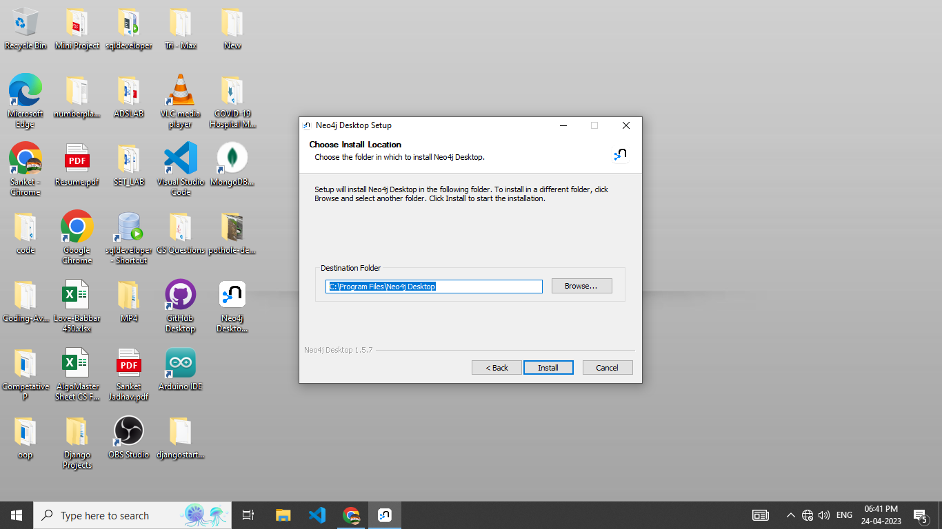

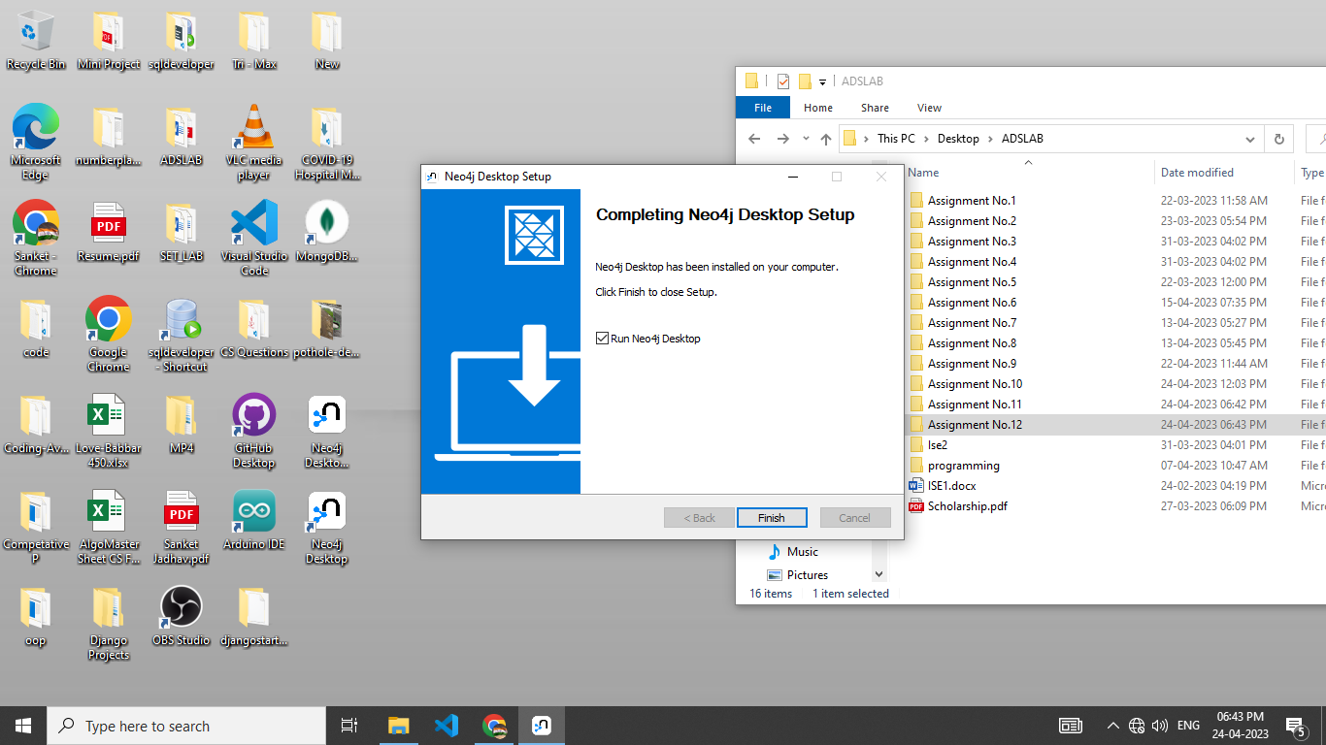

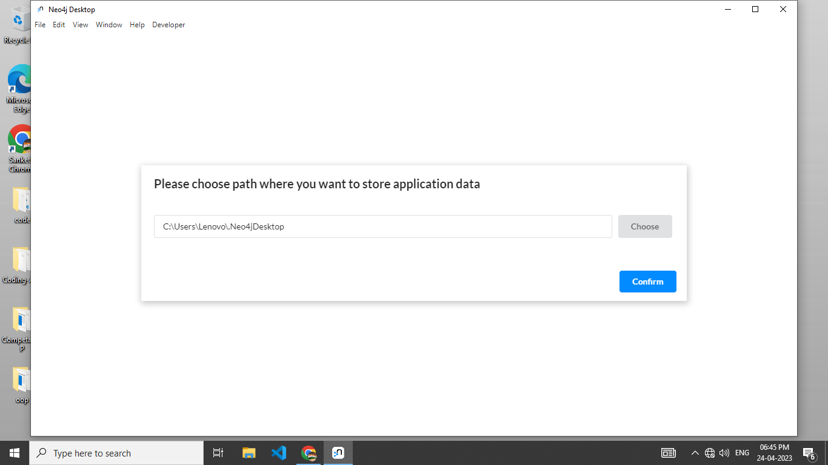

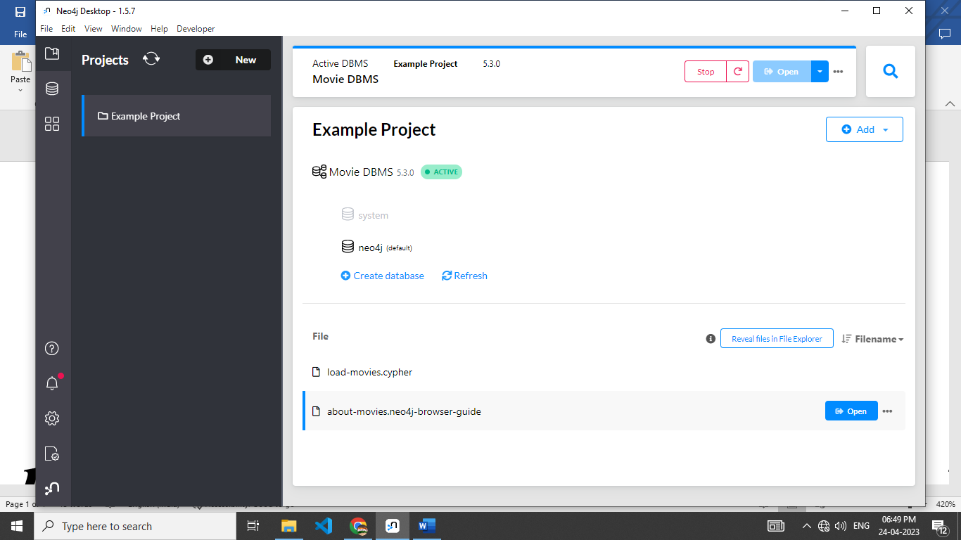

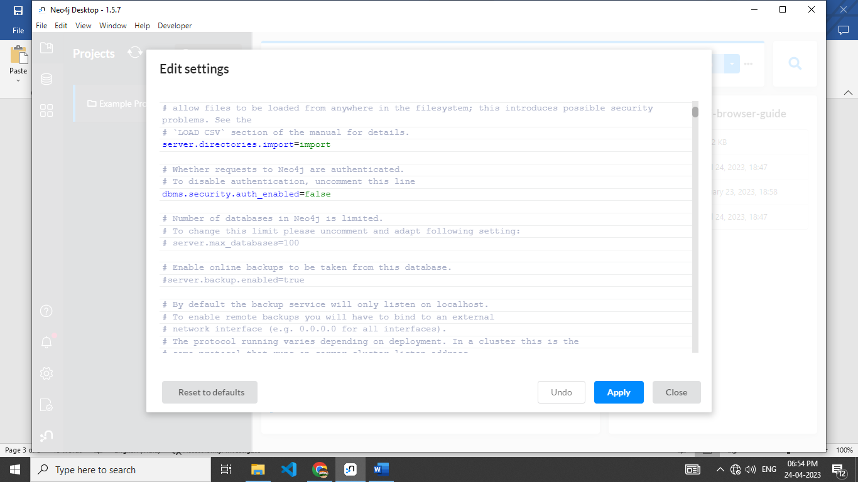

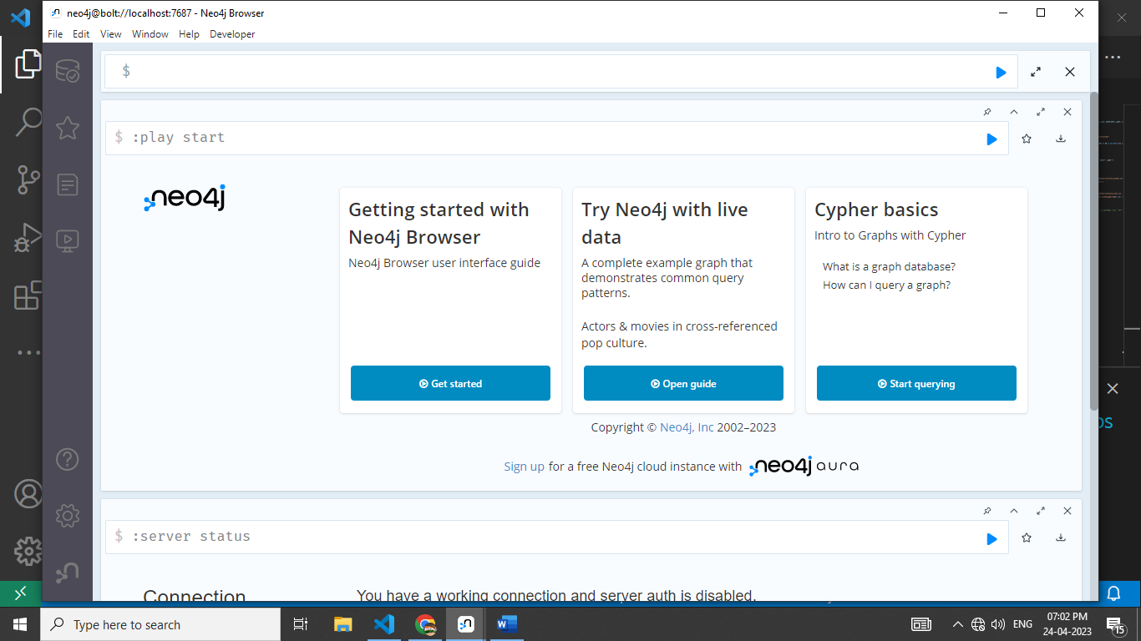

Code :

from neo4j import GraphDatabase

class Neo4jConnection:

    def __init__(self, uri, user, pwd):

        self.__uri = uri

        self.__user = user

        self.__pwd = pwd

        self.__conn = None

        try:

            self.__conn = GraphDatabase.driver(self.__uri, auth=(self.__user, self.__pwd))

        except Exception as e:

            print("Failed to create the conn:", e)

    def close(self):

        if self.__conn is not None:

            self.__conn.close()

    def query(self, query, db=None):

        assert self.__conn is not None, "conn not initialized!"

        session = None

        response = None

        try:

            session = self.__conn.session(database=db) if db is not None else self.__conn.session()

            response = list(session.run(query))

        except Exception as e:

            print("Query failed:", e)

        finally:

            if session is not None:

                session.close()

        return response

conn = Neo4jConnection(uri="bolt://localhost:7687", user="", pwd="")

# res = conn.query("show databases")

# print(res)

# conn.query("CREATE OR REPLACE DATABASE coradb")

query_string = '''

CALL {

LOAD CSV WITH HEADERS FROM

'https://raw.githubusercontent.com/ngshya/datasets/master/cora/cora_content.csv'

AS line FIELDTERMINATOR ','

CREATE (:Paper {id: line.paper_id, class: line.label}) }

'''

conn.query(query_string, db='coradb')

query_string = '''

CALL{

LOAD CSV WITH HEADERS FROM

'https://raw.githubusercontent.com/ngshya/datasets/master/cora/cora_cites.csv'

AS line FIELDTERMINATOR ','

MATCH (citing_paper:Paper {id: line.citing_paper_id}),(cited_paper:Paper {id: line.cited_paper_id})

CREATE (citing_paper)-[:CITES]->(cited_paper)}

'''

conn.query(query_string, db='coradb')

