A Mid-Semester Project Report on
Crowd-Verified Road Hazard Detection and Hazard-Aware Navigation using On-Device Deep Learning
Submitted in partial fulfilment of the requirements for the degree of
Bachelor of Technology in [Branch]
Submitted by
[Member 1 Name] ([MIS No.])
[Member 2 Name] ([MIS No.])
[Member 3 Name] ([MIS No.])
[Member 4 Name] ([MIS No.])
Under the guidance of
[Guide Name]

Department of Computer Science and Engineering
COEP Technological University, Pune
October 2026 · Group ID: [Group ID]

Certificate
This is to certify that the project report titled "Crowd-Verified Road Hazard Detection and Hazard-Aware Navigation using On-Device Deep Learning" submitted by [Member 1 Name], [Member 2 Name], [Member 3 Name] and [Member 4 Name] is a record of bona fide work carried out by them under my supervision, in partial fulfilment of the requirements for the degree of Bachelor of Technology at COEP Technological University, Pune.

[Guide Name] Head of Department
Project Guide Computer Science and Engineering

Acknowledgement
We thank our project guide, [Guide Name], for their direction and feedback throughout this work, and the Department of Computer Science and Engineering, COEP Technological University, for the facilities provided. [Add any further acknowledgements.]

Abstract
Drivers usually learn about a road hazard — an accident, a fallen object, a flooded stretch — only when they reach it. Existing navigation platforms depend on drivers to report hazards by hand and on other drivers to confirm or clear them by hand, while research systems that detect hazards automatically stop at detection and do not tell the cars that are about to meet them. This project presents BAGS, a smartphone system that closes this loop.
A phone mounted as a dashcam runs a YOLO object detector on-device (TensorFlow Lite) at about three frames per second and reports each detection with its GPS position and the car's direction of travel. A FastAPI server merges repeat reports into a single hazard, treats a hazard as confirmed only when two different cars report it or one reports it with high confidence, and pushes it through Firebase Cloud Messaging to cars within 2 km and to navigating cars whose route passes it ahead. The navigation module plans routes that avoid confirmed road-blocking hazards on the driver's side of the road, offers reroutes with a ten-second countdown, and offers a faster route once a hazard clears. Hazards expire after a type-specific lifetime and are removed automatically when two passing cars, with detection running and travelling in a reported direction, fail to see them.
Three detector generations trained by the team — YOLO11m, YOLO26n and YOLO11n — are compared. The nano models are about eight times smaller (9.8–10.6 MB against 80.5 MB) and eight to ten times faster on a laptop CPU (96–116 ms against 963 ms per 640×640 frame) than YOLO11m, and their TFLite conversions match the original ONNX models to within 10⁻⁶. Merging repeat reports cuts alert pushes for a passing reporter from about fifteen to two per nearby car, and 67 automated tests verify the hazard lifecycle, routing and detection pipeline.
Keywords: road hazard detection, on-device deep learning, YOLO, crowdsourcing, hazard verification, hazard-aware routing, Firebase Cloud Messaging.

Contents

(Right-click the table and choose Update Field if page numbers are missing.)

1. Introduction

1.1 Background
India recorded 4,61,312 road accidents in 2022, which claimed 1,68,491 lives [21]. Many of the hazards behind these numbers — a crash ahead, debris in a lane, a flooded underpass — are visible to drivers who reach them first, but that knowledge rarely reaches the drivers behind them in time. Navigation apps such as Waze collect incident reports from drivers; a study of one year of Waze data found that the reports covered 43.2% of officially recorded crashes and congestion and arrived on average 9.8 minutes earlier than probe-based data [13]. These reports, however, depend on a driver tapping the screen while driving, and a hazard stays on the map until other drivers manually say it is gone or a timeout expires.
Smartphones have meanwhile become capable vision computers. One-stage object detectors of the YOLO family [8–11] now run in real time on a phone, and earlier work showed that smartphone cameras can detect and classify road damage reliably [3, 4]. This makes it possible for a phone mounted as a dashcam to detect hazards itself, without driver input, and to share them.

1.2 Motivation
- Earlier warning. A driver heading for a blocked road can be told while there is still a turn-off, not when the queue is already in sight.
- No distraction. Detection is automatic; nobody has to type or tap while driving.
- Trustworthy, current information. Reports from several cars are combined, one false detection cannot reroute everyone, and cleared hazards disappear quickly instead of sending drivers on needless detours.
- Privacy and data cost. Video never leaves the phone; only small JSON events are sent.

1.3 Scope
The project covers an Android application (built with Flutter so that iOS can follow), an alert server, and the detector models. The application detects four classes — accident, non-accident (an undamaged vehicle), fallen object and flood — and handles potholes reported by other sources as warnings. The server runs on a laptop for development; cloud hosting is future work.

1.4 Organisation of the report
Chapter 2 reviews related work and identifies the research gap. Chapter 3 states the problem and objectives. Chapter 4 gives the software requirements. Chapter 5 presents the architecture, and Chapter 6 the methodology and implementation. Chapter 7 compares the detector models, Chapter 8 describes testing, Chapter 9 discusses results, Chapter 10 summarises the novelty, and Chapter 11 concludes.

2. Literature Review
Work related to this project falls into six strands. Each addresses one stage of the problem; Section 2.7 compares them against the capabilities BAGS needs.

2.1 Sensor-based crowdsensing of road conditions
Eriksson et al. built Pothole Patrol [1], which equipped seven taxis in Boston with accelerometers and GPS and used a machine-learning classifier to identify potholes and other severe road anomalies, clustering repeated detections from different passes to suppress false positives. Mohan et al.'s Nericell [2] used the accelerometer, microphone and GPS of ordinary smartphones to detect potholes, bumps, braking and honking in the chaotic traffic of Bangalore, and had to solve problems such as re-orienting an arbitrarily placed phone's accelerometer. Both demonstrate the value of opportunistic sensing from many vehicles, but vibration sensing detects a hazard only after the car has driven over it, cannot see an accident or a fallen object ahead, and was used to build maps rather than to warn approaching drivers.

2.2 Vision-based road damage detection
Maeda et al. [3] collected 9,053 smartphone images containing 15,435 instances of road damage and trained CNN object detectors to classify eight damage types, comparing runtime on GPU servers and on smartphones. The follow-up RDD2022 dataset [4] contains 47,420 images from six countries, including India, and was released for the Crowdsensing-based Road Damage Detection Challenge. These works establish that phone cameras can detect road-surface hazards accurately, but they target offline surveys for road-maintenance agencies; detections are not shared with other road users in real time.

2.3 Accident detection and anticipation from dashcam video
Chan et al. [5] proposed a dynamic-spatial-attention recurrent network to anticipate accidents in dashcam videos. Bao et al. [6] added uncertainty modelling with graph convolution and Bayesian networks and released the Car Crash Dataset (CCD). Yao et al.'s DoTA [7] provides 4,677 driving videos annotated with when, where and what traffic anomaly occurs. These models analyse temporal context and are heavy, typically evaluated on GPUs; more importantly, they protect only the car whose camera sees the event, whereas BAGS aims to warn the cars behind it.

2.4 Efficient object detectors for edge devices
YOLO [8] reframed detection as a single regression from image to boxes, enabling real-time detection. Its successors refined backbone, neck and head design; YOLOv10 [9] introduced consistent dual assignments to train detectors that need no non-maximum suppression (NMS) at inference, removing a post-processing step that hampers end-to-end deployment. Ultralytics' YOLO11 [10] and YOLO26 [11] provide nano variants of about 2.4–2.6 million parameters; YOLO26 is end-to-end (NMS-free) by design. Integer quantisation [12] further reduces size and latency on mobile hardware. These advances are what make continuous on-phone detection practical; Chapter 7 compares three such models for this project.

2.5 Crowdsourced incident reporting and trust
Amin-Naseri et al. [13] evaluated Waze incident reports against Iowa's traffic-management records: reports were timely and reasonably accurate in location, but covered fewer than half of recorded incidents, and their reliability varied. Truth-discovery methods [14] estimate the reliability of noisy sources and combine their claims; the confirmation and clearance rules in BAGS are a simple, explainable instance of this idea for spatial hazard reports. In vehicular networking, the ETSI Decentralized Environmental Notification (DENM) service [17] standardises how equipped vehicles broadcast events such as stationary vehicles or hazardous locations, including their relevance area and traffic direction; it requires dedicated V2X radios and leaves detection to the vehicle.

2.6 Routing on OpenStreetMap
The Open Source Routing Machine (OSRM) [15] computes routes on OpenStreetMap data in milliseconds using contraction hierarchies [16]. It returns alternative routes but cannot be told to avoid an area. OpenRouteService [20] accepts avoid-polygons, which lets a client route around specific points. Douglas–Peucker simplification [18] reduces a route polyline to the points that preserve its shape, which keeps route uploads small.

2.7 Comparison and research gap
Table 1 compares representative systems against the capabilities this project needs. The assessment follows the cited descriptions; '~' marks a capability that is partial or relies on manual input.
Table 1: Capabilities of prior systems (✓ yes, ~ partial or manual, ✗ no)
System | Camera | On-device | Shares | Auto-confirm | Auto-clear | Direction | Reroute
Pothole Patrol [1] | ✗ | ~ | ~ | ✓ | ✗ | ✗ | ✗
Nericell [2] | ✗ | ✓ | ~ | ✗ | ✗ | ✗ | ✗
Maeda et al. [3] | ✓ | ✓ | ✗ | ✗ | ✗ | ✗ | ✗
Accident anticipation [5–7] | ✓ | ✗ | ✗ | ✗ | ✗ | ✗ | ✗
Waze reports [13] | ✗ | ~ | ✓ | ~ | ~ | ✗ | ✓
ETSI DENM (V2X) [17] | ✗ | ✓ | ✓ | ✗ | ~ | ✓ | ✗
BAGS (this work) | ✓ | ✓ | ✓ | ✓ | ✓ | ✓ | ✓

Research gap. Vision research stops at detection; crowdsourcing platforms share hazards but depend on manual confirmation and manual or time-based removal; V2X standards need special hardware. No system combines automatic on-device detection with multi-car confirmation, direction-aware relevance, route-ahead alerting, hazard-aware rerouting and automatic clearance from passing cars that no longer see the hazard.

3. Problem Statement and Objectives

3.1 Problem statement
To design and build a system in which smartphones detect road hazards on-device from a dashcam feed, and in which those hazards are verified by several cars, delivered to the drivers they affect, routed around, and removed automatically once the road is clear — while sending no video off the phone.

3.2 Objectives
- Run a YOLO hazard detector on the phone at about three frames per second, and report each detection with its GPS position and the car's direction of travel.
- Merge repeat reports into hazards on a server, and confirm a hazard only when two different cars report it or one reports it with high confidence.
- Push each hazard to cars within 2 km of it, and to navigating cars whose route passes it ahead.
- Plan routes that avoid confirmed road-blocking hazards; offer reroutes during navigation, and faster routes once a hazard is cleared.
- Expire hazards after a type-specific lifetime, and clear them when passing cars with detection running no longer see them.
- Compare three detector generations for size, speed and accuracy, and keep the app independent of the model's output format.

3.3 Existing methodology and its limitations
- Manual crowd reporting (Waze-style): drivers report and confirm hazards by hand [13]. It distracts the driver and leaves stale reports on the map.
- Sensor crowdsensing [1, 2]: vibration data finds a hazard only after it has been hit, and cannot see accidents or debris ahead.
- Offline vision surveys [3, 4]: accurate detection, but results go to maintenance agencies, not to approaching drivers.
- V2X event messages [17]: real-time and direction-aware, but require dedicated radios in every vehicle and leave detection unsolved.

4. Software Requirements Specification

4.1 SDLC model
The project followed an iterative and incremental prototyping model. Detection, reporting, alerts, navigation, hazard verification and direction handling were built in successive increments. Each increment was integrated on an Android phone, covered by automated tests, and tried on a drive before the next began; requirements such as confirmation and automatic clearance emerged from earlier increments' field behaviour.

4.2 Functional requirements
Table 2: Functional requirements
ID | Requirement
FR-1 | Detect accident, fallen object and flood on-device from the rear camera at about 3 frames per second.
FR-2 | Report each detection (type, confidence, latitude, longitude, timestamp, heading, car id) to the server.
FR-3 | Merge reports of the same type within 50 m of a live hazard into that hazard.
FR-4 | Mark a hazard confirmed when ≥ 2 distinct cars reported it or one report had confidence ≥ 0.8.
FR-5 | Push a hazard to cars within 2 km, and (if confirmed) to navigating cars whose route passes it ahead in the reported direction.
FR-6 | Show alerts as a banner and a map marker; show unconfirmed hazards faded.
FR-7 | Plan routes that avoid confirmed blocking hazards on the route's side of the road.
FR-8 | During navigation, offer a reroute around a newly reported hazard with a 10 s countdown, and a faster route when a blocking hazard is cleared.
FR-9 | Expire hazards after a type-specific lifetime; delete a hazard after 2 'not seen' votes from same-direction cars.

4.3 Non-functional requirements
Table 3: Non-functional requirements
Category | Requirement
Performance | At most one inference per 300 ms; frames that arrive while the model is busy are dropped, never queued.
Privacy | No camera frames leave the phone; only small JSON events are transmitted.
Reliability | Network failures are non-fatal; location pings retry every 20 s and hazard sync every 15 s.
Battery | GPS updates only after 20 m of movement; location pings every 20 s.
Compatibility | Server accepts older app builds that send no car id or heading; app accepts servers that send no confirmation fields.
Maintainability | Detector can be swapped by changing one asset path; the app detects the model's input layout and output format.

4.4 Hardware and software requirements
Table 4: Development and runtime environment
Component | Specification
Phone | Android smartphone with rear camera and GPS (tested on Redmi Note 8)
App | Flutter 3.47.2 / Dart 3.13; packages camera, tflite_flutter, geolocator, flutter_map, firebase_messaging, flutter_riverpod
Server | Python 3.13, FastAPI, Uvicorn, SQLite, firebase-admin
Model tooling | Ultralytics (training), ONNX, onnx2tf, ONNX Runtime, LiteRT
External services | Firebase Cloud Messaging; OSRM or OpenRouteService; OpenStreetMap tiles; Nominatim search

5. System Design

5.1 Architecture
Figure 1 shows the three parts of the system. The vehicle runs the BAGS app: the camera feeds the detector, the detection pipeline tags results with location and heading, the clearance watcher notices hazards passed without being seen, the location pinger reports position (and route, when navigating), and the navigation module plans and follows routes. The alert server keeps one record per hazard, decides when it is confirmed or gone, and decides which cars to tell. External services deliver pushes (Firebase Cloud Messaging) and compute routes and maps.
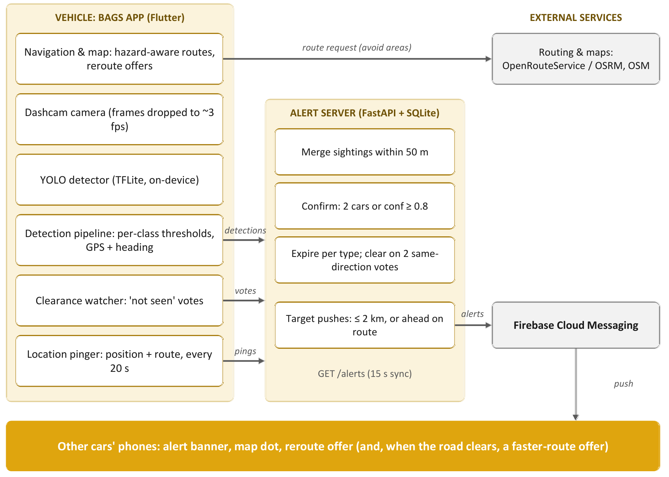
Figure 1: BAGS system architecture

5.2 Data model
The server uses four SQLite tables (Table 5). A hazard is the unit the app sees; detections are the individual sightings that support it.
Table 5: Server data model
Table | Key fields | Purpose
hazards | id, type, lat, lng, first_seen, last_seen | One row per thing on the road; position of first report; times from the server clock
detections | id, type, confidence, lat, lng, timestamp, hazard_id, car_id, heading | Every report, as a sighting of a hazard
not_seen | hazard_id, car_id, timestamp | Cars that passed a hazard without seeing it
cars | car_id, lat, lng, fcm_token, updated_at, route | Last known position, push token and navigated route

5.3 Server interface
Table 6: Server endpoints
Endpoint | Body / parameters | Behaviour
POST /detection | type, confidence, lat, lng, timestamp, car_id?, heading? | Records a sighting; pushes the hazard when new or newly confirmed
POST /location | car_id, lat, lng, fcm_token?, route? | Periodic ping; stores position, token and route
GET /alerts | lat, lng, radius_m | Live hazards nearby with confirmed, reports, headings
POST /hazards/{id}/not-seen | car_id, heading? | Clearance vote: noted, cleared or ignored; 404 if gone
GET /health, POST /reset | – | Status and counts; clear all data for a test run

6. Methodology and Implementation

6.1 On-device detection pipeline
The camera delivers about 30 frames per second. The pipeline passes a frame to the model only if the model is idle and at least 300 ms have passed since the last run; every other frame is dropped. Dropping, rather than queueing, means the model always looks at the newest view of the road, and caps inference at about 3.3 frames per second, which bounds battery use and heat.
Inference runs on a background isolate. The service reads the model's input shape and layout (NCHW or NHWC) and its output tensor, and recognises three output kinds: a classifier, a raw YOLO detection head ([1, 4 + C, anchors], decoded and filtered with NMS in the app), or an end-to-end head ([1, rows, 6], already filtered). Each detection class has its own alert threshold τ from the model's validation (accident 0.469, fallen object 0.477, flood 0.25, non-accident 0.406). The pipeline reports the most confident box that clears its own class's threshold:
reported = argmax { conf(b) : conf(b) ≥ τ(class(b)) }
so that, for example, a 0.30 flood is not hidden behind a 0.40 accident that fails its 0.469 threshold. When a frame yields a reportable detection, the model is freed for the next frame before the GPS lookup starts; detections made during one lookup share it. The car's heading is taken from the GPS fix only when the speed is at least 2 m/s and the bearing accuracy, if reported, is within 45°, since a stationary bearing is noise.

6.2 Hazard lifecycle on the server

Merging
A new report of type t at point p is attached to the nearest live hazard of type t within 50 m of p; otherwise it creates a hazard at p. A report's position is the reporting car's GPS fix, typically some way before the hazard and 10–30 m off, so the radius is wider than GPS error alone. Merging is serialised with a lock so that simultaneous first reports cannot create two hazards.

Confirmation
Let R be the set of distinct cars that reported a hazard and c_max the highest confidence among its sightings. The hazard is confirmed when |R| ≥ 2 or c_max ≥ 0.8. Only confirmed hazards of a road-blocking type (accident, fallen object, flood) cause rerouting; unconfirmed hazards are still pushed to nearby cars as warnings and drawn faded on the map. A hazard is pushed when it is first reported and once more when it becomes confirmed — not on every repeat sighting.

Expiry
A hazard lives for a type-specific lifetime after its latest sighting (Table 7); each new sighting restarts the clock. Expired hazards are excluded from every query immediately and deleted every ten minutes.
Table 7: Hazard lifetimes
Type | Lifetime after last sighting | Routing effect
Accident | 1 hour | Reroute when confirmed
Fallen object | 1 hour | Reroute when confirmed
Flood | 6 hours | Reroute when confirmed
Pothole | 7 days | Warning only
Non-accident (clear road) | 10 minutes | Not a hazard
Unknown / new label | 2 hours | Warning only

Automatic clearance from negative evidence
The app's clearance watcher follows the car's GPS fixes while detection is running. A pass of a hazard starts when the car comes within 150 m of it and ends when it is more than 150 m away again. When a pass ends, the app sends a 'not seen' vote if (i) the car came within 40 m, (ii) the model checked at least ten frames during the pass, (iii) it did not detect that hazard type within 150 m, (iv) the type is one the model can detect, and (v) the car was travelling the same way as someone who reported the hazard. The server deletes a hazard once two different cars have voted after its latest sighting; a new sighting outweighs earlier votes.

6.3 Direction awareness
The camera faces forward, so a hazard seen by cars going one way may be on the far carriageway of a divided road for cars going the other way. Each hazard therefore lists the latest heading of each reporter. Two directions a and b (degrees clockwise from north) are the same way when
Δθ(a, b) = | ((a − b + 180) mod 360) − 180 | ≤ 60°
A route's direction at a hazard is taken from every route segment within ±30 m of the point where the hazard projects onto the route, so a hazard just past a turn still counts for the road leading to it. A hazard reported only from the other direction (i) does not trigger rerouting but remains a warning, because on an undivided road it may still block this lane, (ii) is not pushed to cars far ahead on their route, and (iii) cannot be voted away by them. Hazards with no known heading count for everyone.

6.4 Hazard-aware routing
With an OpenRouteService key, the planner first requests the fastest route, finds confirmed blocking hazards on it reported in its direction, and requests a route avoiding 12-sided 60 m circles around them. Because an avoid area closes the road both ways, only hazards on the route's side are included; if the new route runs into further such hazards, they are added and the request repeated, up to three rounds. Without a key, the planner uses OSRM: it requests alternatives and, if all pass a hazard, forces detours through points 400 m and then 1 km to either side of the first hazard. The plan keeps the route with the fewest blocking hazards, then the shortest duration; hazards closer than 150 m to the start or destination are ignored.

6.5 Alerts and navigation behaviour
- Push targeting. A hazard is pushed to every car (other than its reporters) whose last position is within 2 km; a confirmed hazard is also pushed to navigating cars whose route — sent with each ping, simplified with Douglas–Peucker at 10 m tolerance [18] — passes within 50 m of it, ahead of the car and in the reported direction, if the car pinged within the last two minutes.
- Reroute offer. When a confirmed blocking hazard appears ahead on the route, the app plans a route around it and shows Keep route / New route (10), switching automatically after ten seconds; if no route avoids it, the driver is told so.
- Faster-route offer. When a blocking hazard disappears (expired or cleared), the app plans the fastest route and offers it if it saves at least max(60 s, 5% of the remaining time) without passing more blocking hazards.
- Map synchronisation. Hazards along the trip are re-fetched every 15 s; any the server no longer lists are removed, and each type's lifetime is also applied to pushed alerts.

7. Model Comparison
The ML half of the team trained three detectors on the project's four-class dataset. All three were exported to ONNX and converted to TensorFlow Lite with onnx2tf for the app. Table 8 combines our measurements with the architectures' published COCO benchmarks.

7.1 Models
- v1: YOLO11m (trained 9 Sep 2026): the medium YOLO11 model, raw detection head; NMS runs in the app.
- v2: YOLO26n (25 Sep 2026): nano, end-to-end export with NMS inside the model (output [1, 300, 6]).
- v3: YOLO11n (2 Oct 2026, current): nano, raw head ([1, 8, 8400]); NMS runs in the app.

7.2 Measured and published characteristics
Parameters were counted from each ONNX file. Latency was measured with ONNX Runtime 1.26 on the CPU of an Intel Core i7-1165G7 laptop (640×640 input, batch 1, mean of 20 runs after warm-up). Conversion fidelity is the largest absolute difference between the TFLite and ONNX outputs on the same input.
Table 8: Comparison of the three detectors
Metric | YOLO11m (v1) | YOLO26n (v2) | YOLO11n (v3)
Parameters (counted) | 20.10 M | 2.42 M | 2.62 M
TFLite file size | 80.5 MB | 9.8 MB | 10.6 MB
Output | Raw [1, 8, 8400] | End-to-end [1, 300, 6] | Raw [1, 8, 8400]
NMS | In the app | Inside the model | In the app
CPU latency, measured | 963 ms | 96 ms | 116 ms
COCO mAP50-95, published [10, 11] | 51.5 | 40.9 | 39.5
GFLOPs at 640, published [10, 11] | 68.0 | 5.4 | 6.5
CPU ONNX latency, published | 183.2 ms | 38.9 ms | 56.1 ms
TFLite vs ONNX, max score error | 1.4 × 10⁻⁷ | 4.1 × 10⁻⁷ | 2.5 × 10⁻⁷
Hazard test-set mAP50 / mAP50-95 | [from ML team] | [from ML team] | [from ML team]
On-phone time per frame | [to be measured] | [to be measured] | [to be measured]
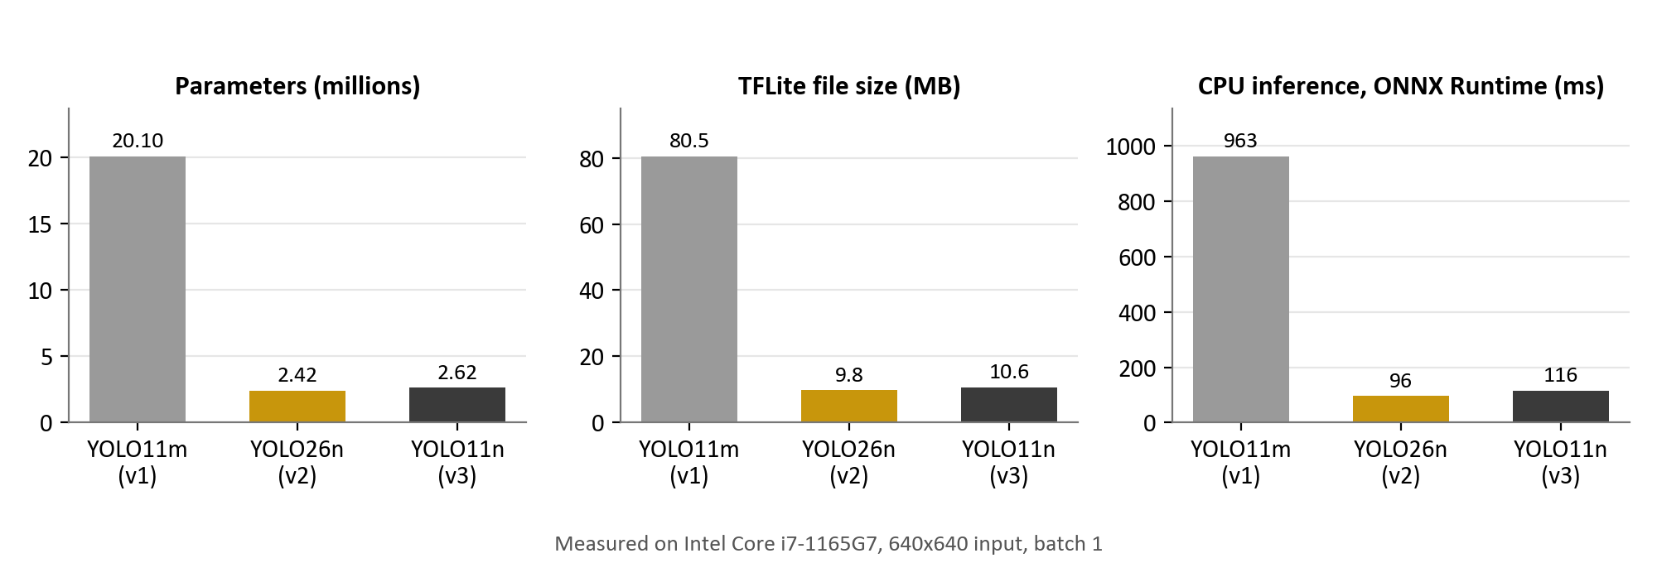
Figure 2: Measured size and CPU latency of the three detectors
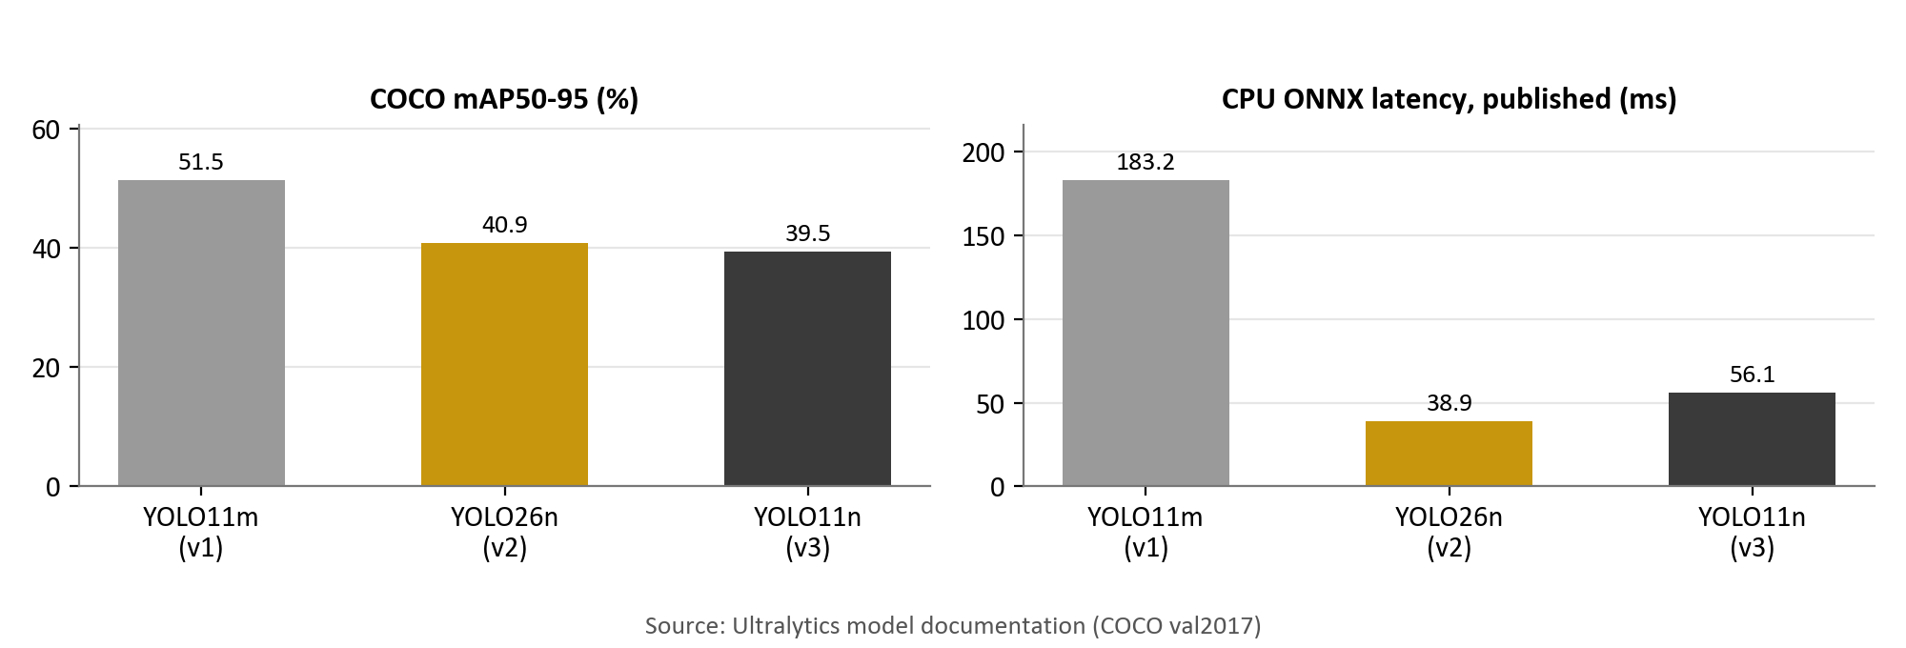
Figure 3: Published COCO accuracy and CPU latency of the architectures [10, 11]

7.3 Discussion
The nano models are about 7.6–8.3 times smaller and 8–10 times faster than YOLO11m on the same CPU, at the cost of roughly 11–12 COCO mAP points for the architectures in general. For a phone that must check about three frames per second while also running GPS, maps and networking, only the nano models are practical; YOLO11m at nearly a second per frame on a laptop CPU would fall far below the target rate on a phone.
Between the two nano models, YOLO26n is slightly smaller and faster and, being end-to-end, removes NMS from the app; YOLO11n requires the app to decode 8,400 candidate boxes and run NMS for each frame. Which of the two to ship should be decided by their accuracy on the project's own hazard test set, which the ML team is to supply (Table 8, last rows), and by on-phone timing, which the app displays per frame. The conversions themselves introduce no measurable error: TFLite and ONNX outputs agree to within 10⁻⁶.
Because the app detects the model's input layout and output kind at load time, and applies per-class thresholds to whichever candidates the model produces, switching between the three models requires changing only the asset path (and the class thresholds, when a model comes with its own).

8. Testing

8.1 Approach
Logic that does not need a device — the hazard lifecycle, routing, route progress, clearance, alert parsing and the detection pipeline with fake camera, model and GPS — is covered by automated tests: 46 Flutter tests for the app and 21 Python tests for the server, run against a throwaway database with a controllable clock and recorded (not sent) pushes. End-to-end checks exercised the real HTTP interface. Device behaviour was checked on an Android phone.

8.2 Functional test cases
Table 9: Functional test cases
ID | Test input | Expected result | Status
TC-01 | One car reports the same accident repeatedly while passing | One hazard; each nearby car pushed once | Pass
TC-02 | A second car reports the same hazard | Hazard confirmed; one further push | Pass
TC-03 | A single report with confidence 0.9 | Confirmed immediately | Pass
TC-04 | Accident and pothole, checked after 1 h 05 min | Accident expired; pothole listed | Pass
TC-05 | Two cars vote 'not seen' after the last sighting | Hazard deleted; later vote returns 404 | Pass
TC-06 | Vote from a car going the opposite way | Vote ignored | Pass
TC-07 | Route ahead passes a hazard reported only by southbound cars | No far-ahead push to a northbound car | Pass
TC-08 | Unconfirmed or oncoming-only accident on route | Warning only; no reroute | Pass
TC-09 | Detour around one hazard meets another (OpenRouteService) | Second avoid request includes both | Pass
TC-10 | Car drives past a hazard, detecting, model sees nothing | One 'not seen' vote with the car's heading | Pass
TC-11 | Same pass, but the model saw the hazard | No vote | Pass
TC-12 | 3 frames arrive while a detection waits for GPS | All 3 checked; one shared GPS lookup | Pass
TC-13 | Alert from FCM with string fields, and from /alerts with JSON types | Both parsed identically | Pass
TC-14 | Database created by an older server version | Old detections migrated into hazards | Pass

8.3 End-to-end verification
Against a running server and a throwaway database: three reports of one accident (two cars with headings 2.5° and 184°, one with no heading) produced a single hazard listing headings [2, 184], confirmed by the second car; a 'not seen' vote at 90° was ignored, one at 10° was noted, and a further vote with no heading cleared the hazard, after which /alerts returned nothing and further votes returned 404. A heading of 400° was rejected with HTTP 422.

9. Results and Discussion
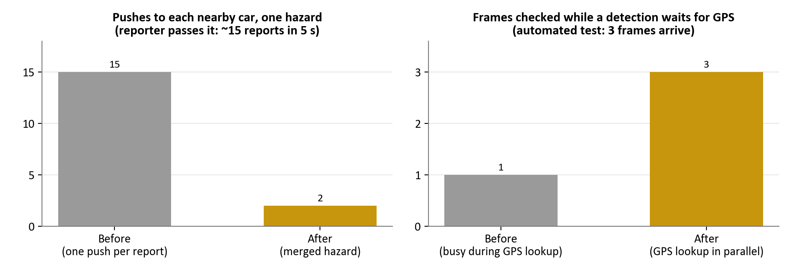
Figure 4: Effect of hazard merging on pushes, and of the parallel GPS lookup on frames checked
- Alert volume. Before merging, every report was a separate alert. A car passing a hazard for five seconds at about three checks per second sends roughly fifteen reports, so each nearby car received about fifteen pushes. With merging, each nearby car receives one push when the hazard appears and at most one more when it is confirmed.
- Frames during GPS lookup. Previously the model stayed busy for up to 2 s while a detection waited for a GPS fix, dropping up to six frames at three per second. In the automated test, three frames arriving during a pending lookup were all checked (previously one).
- Stale hazards. A fixed two-hour lifetime for every type was replaced by per-type lifetimes (one hour for accidents), and hazards are now removed as soon as two passing cars miss them.
- False detections. A single low-confidence report no longer reroutes anyone; it is shown faded until a second car or a very confident report confirms it.
- Divided roads. Hazards seen only from the opposite direction no longer reroute drivers or get voted away by them, while still warning them.
- Model efficiency. The current nano models make on-phone detection practical (Chapter 7).

9.1 Limitations
- Accuracy on the project's hazard test set and on-phone timing are still to be measured (placeholders in Table 8).
- Latency figures are from a laptop CPU; phone timings will differ.
- Thresholds — 50 m merge radius, 0.8 confidence, two votes, 60° — are reasoned defaults that need tuning on real drives.
- A car on a parallel road within 40 m could vote incorrectly; requiring two votes and cancelling votes on any new sighting limits the effect.
- The server runs on a laptop without authentication; it is a development deployment.

10. Novelty and Contributions
- Negative-evidence clearance. Passing cars whose cameras do not see a hazard vote it away, so hazards disappear soon after the road is cleared without any driver action.
- Direction-aware relevance. Rerouting, far-ahead alerts and clearance votes take into account which side of the road a hazard was reported from, while oncoming-only reports still warn.
- Confirmation gate. Rerouting requires two independent cars or one very confident detection; unconfirmed hazards still warn.
- Route-ahead alerting with reroute and faster-route offers. Cars heading for a hazard are told early, offered a detour with a countdown, and offered the faster route back once the hazard clears.
- Model-agnostic on-device pipeline and model comparison. The app adapts to raw or end-to-end detector heads and applies per-class thresholds across all candidates; three detector generations are compared.

11. Conclusion and Future Scope

11.1 Conclusion
BAGS shows that a phone mounted as a dashcam can detect road hazards on-device and that a lightweight server can turn those detections into trustworthy, current, shared information: repeat reports are merged, hazards are confirmed by independent cars, alerts reach the drivers heading for them, routes avoid them on the correct side of the road, and hazards are removed automatically when passing cars stop seeing them. Nano YOLO models make continuous on-phone detection practical.

11.2 Future scope
- Measure accuracy on the hazard test set and on-phone speed for each model; evaluate int8 quantisation [12].
- Use traffic speed in location pings to confirm or clear hazards without a camera.
- Tune the thresholds on real drives; record and analyse false-alert and missed-hazard rates.
- Host the server in the cloud with authentication and rate limiting.
- Spread rerouted traffic across several detours (load-aware rerouting) to avoid creating a second jam.
- Speak alerts and reroute offers aloud.

References
[1] J. Eriksson, L. Girod, B. Hull, R. Newton, S. Madden and H. Balakrishnan, "The Pothole Patrol: Using a mobile sensor network for road surface monitoring," in Proc. 6th ACM Int. Conf. Mobile Systems, Applications, and Services (MobiSys), 2008, pp. 29–39.
[2] P. Mohan, V. N. Padmanabhan and R. Ramjee, "Nericell: Rich monitoring of road and traffic conditions using mobile smartphones," in Proc. 6th ACM Conf. Embedded Networked Sensor Systems (SenSys), 2008, pp. 323–336.
[3] H. Maeda, Y. Sekimoto, T. Seto, T. Kashiyama and H. Omata, "Road damage detection and classification using deep neural networks with smartphone images," Computer-Aided Civil and Infrastructure Engineering, vol. 33, no. 12, pp. 1127–1141, 2018.
[4] D. Arya, H. Maeda, S. K. Ghosh, D. Toshniwal and Y. Sekimoto, "RDD2022: A multi-national image dataset for automatic road damage detection," Geoscience Data Journal, 2024.
[5] F.-H. Chan, Y.-T. Chen, Y. Xiang and M. Sun, "Anticipating accidents in dashcam videos," in Proc. Asian Conf. Computer Vision (ACCV), 2016, pp. 136–153.
[6] W. Bao, Q. Yu and Y. Kong, "Uncertainty-based traffic accident anticipation with spatio-temporal relational learning," in Proc. 28th ACM Int. Conf. Multimedia, 2020.
[7] Y. Yao, X. Wang, M. Xu, Z. Pu, Y. Wang, E. Atkins and D. J. Crandall, "DoTA: Unsupervised detection of traffic anomaly in driving videos," IEEE Trans. Pattern Analysis and Machine Intelligence, vol. 45, no. 1, 2023.
[8] J. Redmon, S. Divvala, R. Girshick and A. Farhadi, "You only look once: Unified, real-time object detection," in Proc. IEEE Conf. Computer Vision and Pattern Recognition (CVPR), 2016, pp. 779–788.
[9] A. Wang, H. Chen, L. Liu, K. Chen, Z. Lin, J. Han and G. Ding, "YOLOv10: Real-time end-to-end object detection," in Advances in Neural Information Processing Systems (NeurIPS), 2024.
[10] G. Jocher and J. Qiu, "Ultralytics YOLO11," 2024. [Online]. Available: https://docs.ultralytics.com/models/yolo11/
[11] Ultralytics, "YOLO26," 2025. [Online]. Available: https://docs.ultralytics.com/compare/yolo11-vs-yolo26/
[12] B. Jacob et al., "Quantization and training of neural networks for efficient integer-arithmetic-only inference," in Proc. IEEE Conf. Computer Vision and Pattern Recognition (CVPR), 2018, pp. 2704–2713.
[13] M. Amin-Naseri, P. Chakraborty, A. Sharma, S. B. Gilbert and M. Hong, "Evaluating the reliability, coverage, and added value of crowdsourced traffic incident reports from Waze," Transportation Research Record, vol. 2672, no. 43, pp. 34–43, 2018.
[14] Y. Li, J. Gao, C. Meng, Q. Li, L. Su, B. Zhao, W. Fan and J. Han, "A survey on truth discovery," ACM SIGKDD Explorations Newsletter, vol. 17, no. 2, pp. 1–16, 2016.
[15] D. Luxen and C. Vetter, "Real-time routing with OpenStreetMap data," in Proc. 19th ACM SIGSPATIAL Int. Conf. Advances in Geographic Information Systems, 2011, pp. 513–516.
[16] R. Geisberger, P. Sanders, D. Schultes and D. Delling, "Contraction hierarchies: Faster and simpler hierarchical routing in road networks," in Proc. 7th Int. Workshop on Experimental Algorithms (WEA), LNCS 5038, 2008, pp. 319–333.
[17] ETSI EN 302 637-3 V1.3.1, "Intelligent Transport Systems (ITS); Vehicular Communications; Basic Set of Applications; Part 3: Specifications of Decentralized Environmental Notification Basic Service," 2019.
[18] D. H. Douglas and T. K. Peucker, "Algorithms for the reduction of the number of points required to represent a digitized line or its caricature," Cartographica, vol. 10, no. 2, pp. 112–122, 1973.
[19] Google, "Firebase Cloud Messaging." [Online]. Available: https://firebase.google.com/docs/cloud-messaging
[20] Heidelberg Institute for Geoinformation Technology, "openrouteservice API." [Online]. Available: https://openrouteservice.org
[21] Ministry of Road Transport and Highways, Government of India, "Road Accidents in India 2022," 2023.

Appendix A: Key Parameters
Table 10: Configuration constants and where they are defined
Parameter | Value | Defined in
Minimum gap between inferences | 300 ms | detection_pipeline.dart
GPS lookup timeout | 2 s | detection_pipeline.dart
Minimum speed for a heading | 2 m/s | detection_pipeline.dart
Merge radius | 50 m | server/hazards.py
Confirmation | 2 cars or confidence ≥ 0.8 | server/hazards.py
Clearance votes | 2 cars | server/hazards.py
Same-way angle | 60° | server/hazards.py, hazards.dart
Push radius | 2 km | server/app.py
Route corridor / freshness | 50 m / 2 min | server/routes.py, app.py
Clearance pass: watch / pass radius / min frames | 150 m / 40 m / 10 | clearance_watcher.dart
Avoid circle radius / rounds | 60 m / 3 | routing_service.dart, hazard_routing.dart
Reroute countdown / faster-route saving | 10 s / max(60 s, 5%) | navigation_screen.dart
Hazard sync / location ping | 15 s / 20 s | navigation_screen.dart, location_pinger.dart

