FROM FRESHWATER TO SEAWATER
A Scenario-Based Techno-Environmental Assessment of Offshore Data Centers as a Cooling Strategy for AI Infrastructure
Independent Research Study
Sanket Kiran Gavali · Amrita Vidyalayam, Class of [2026]

Research focus: sustainable computing • AI infrastructure • data-center cooling • water-energy trade-offs
Research-integrity note: This study is a scenario-based comparative analysis. No full-scale offshore AI-training data center currently provides the empirical dataset needed to validate every modeled parameter. Accordingly, extrapolated values are explicitly labeled as illustrative assumptions rather than measured outcomes. The paper separates observed evidence (especially Project Natick results) from scenario assumptions and decision-model judgments.

Abstract
The analysis gives the offshore scenario the highest baseline composite score (7.85/10), followed by the hybrid scenario (6.25/10) and freshwater baseline (5.15/10). Sensitivity analysis shows that the ranking changes in magnitude, not direction, when decision priorities are altered: offshore remains first under sustainability-, balanced-, and cost/serviceability-oriented weight sets, although its advantage narrows when capital cost and serviceability receive greater weight. The central finding is therefore conditional rather than absolute: offshore cooling has a strong resource-efficiency case where freshwater scarcity and coastal access are binding constraints, but hybrid seawater cooling may offer a more deployable transition because it preserves conventional maintenance access.
Keywords: AI infrastructure; data centers; seawater cooling; offshore computing; water-use effectiveness; power-use effectiveness; sustainability; multi-criteria decision analysis; Project Natick
Research design | Scenario-based comparative analysis
Architectures | Freshwater evaporative; hybrid seawater-assisted; fully offshore submerged
Decision criteria | Water, energy, capital cost, deployment, reliability, ecological/regulatory risk
Empirical anchor | Project Natick reliability evidence; modeled parameters explicitly labeled as assumptions

Study design at a glance

1. Introduction
Artificial intelligence is changing the physical requirements of computing infrastructure. Training and serving large models concentrate high-power accelerators in facilities where most electrical input ultimately becomes heat. As compute demand grows, the cooling system becomes an important part of the infrastructure decision—not only because of electricity use, but because conventional evaporative systems can consume freshwater in regions where water availability is already constrained.
Lawrence Berkeley National Laboratory (LBNL) estimated that U.S. data centers directly consumed approximately 66 billion liters of water in 2023 and projected a substantially higher range by 2028. Its 2025 update also projects rapid growth in U.S. data-center electricity demand through 2030. These are data-center-wide estimates rather than AI-only measurements, so they should not be interpreted as a direct measure of AI water use; they nevertheless establish the scale of the infrastructure trend that motivates this study. [1,2]
At the workload level, recent research shows that water use can vary by orders of magnitude depending on server efficiency, utilization, cooling technology, infrastructure efficiency, climate, electricity-generation mix, and hardware refresh cycles. This finding is important because it implies that there is no universal “best” cooling technology independent of location and operating conditions. [3]
Seawater cooling offers a potentially different boundary condition. Instead of relying on freshwater evaporation, a coastal facility can transfer heat through a seawater heat exchanger, while a submerged facility can reject heat directly through a sealed thermal system to the surrounding ocean. Microsoft’s Project Natick provides the most relevant large-scale experimental precedent: its Northern Isles module contained 864 servers and operated on the seabed off Scotland for more than two years. Microsoft reported a server-failure rate one-eighth that of its land-based control group. [4,5]
Yet technical feasibility is not equivalent to commercial superiority. Microsoft subsequently confirmed in 2024 that it was no longer building subsea data centers, while stating that the project had produced useful operational lessons. [6] This creates the central research problem of this paper: if subsea cooling can reduce freshwater dependence and perform reliably, what trade-offs prevent it from becoming an obvious replacement for land-based facilities?
Research question: Under what site and decision conditions does a shift from freshwater evaporative cooling toward hybrid or fully offshore seawater cooling produce a better overall infrastructure outcome for AI-scale data centers?

1.1 Objectives
• Quantify the relative freshwater implications of the three cooling architectures using a transparent scenario basis.
• Compare the architectures across water impact, energy efficiency, capital cost, deployment speed, reliability, and ecological/regulatory risk.
• Test whether the preferred architecture changes when decision-makers assign different priorities to sustainability, cost, and serviceability.
• Distinguish empirical evidence from engineering assumptions and identify the measurements required for future full-scale validation.

2. Literature and Evidence Base

2.1 Data-center water demand
Water use should be separated into direct and indirect components. Direct consumption occurs at the facility, including water evaporated or otherwise consumed in cooling processes. Indirect consumption is associated with electricity generation and can vary substantially with the local power mix. LBNL’s 2024 report estimated U.S. data-center direct water consumption at about 66 billion liters in 2023 and reported a 2028 direct-consumption range of approximately 60–124 billion liters. [1]
The distinction matters for this study. Replacing evaporative cooling with seawater heat rejection can substantially reduce direct freshwater consumption, but it does not automatically eliminate the water footprint associated with electricity generation. A fair comparison therefore treats cooling-water savings as one dimension of sustainability rather than as the entire environmental footprint.

2.2 Workload-level water efficiency
Lei et al. (2025) show why facility-level WUE should be interpreted cautiously. Their review identifies server efficiency, grid water intensity, utilization, cooling technology, infrastructure efficiency, climate zone, inactive-server share, and refresh cycle as important determinants of workload-level water use. They also caution that WUE-site and WUE-source alone do not capture hardware efficiency or computational output. [3]
Accordingly, this paper uses WUE as an operational indicator rather than as a complete sustainability metric. The scenario framework supplements it with PUE, reliability, capital cost, deployment, and ecological risk.

2.3 Project Natick as empirical precedent
Project Natick is the strongest empirical anchor for the offshore scenario. Microsoft describes the Northern Isles system as a 40-foot module containing 12 racks and 864 servers, deployed off Orkney, Scotland, in 2018. The project page reports that the servers experienced a failure rate one-eighth that of the land-based control group. [4,5]
The evidence should not be overgeneralized. Natick was a prototype rather than an AI-training campus. Its success establishes technical feasibility and provides valuable reliability evidence, but it does not establish commercial lifecycle economics at megawatt or multi-megawatt AI scale.
The project also exposed the central operational trade-off: a sealed subsea module limits routine physical access. Microsoft later confirmed that Project Natick was no longer active, while noting that the team had learned about operations below sea level, vibration, and server impacts. [6] This paper therefore treats serviceability as a first-class criterion rather than assuming that lower cooling demand automatically implies a better infrastructure design.

2.4 Why the hybrid architecture matters
A hybrid coastal system occupies the middle ground. Computing hardware remains on land and can be serviced conventionally, while seawater acts as a heat-transfer medium through heat exchangers. The approach can reduce direct freshwater dependence without requiring the pressure-rated subsea enclosure, marine retrieval operations, and underwater communications infrastructure of a fully offshore system. Its principal environmental challenge is management of intake, discharge, thermal plumes, and marine permitting.

2.1 Literature context
Recent literature supports treating water and energy as coupled data-center design variables rather than isolated metrics. A 2021 optimization study found that deep-seawater cooling can substantially reduce cooling energy in a modeled coastal data center, while also noting higher initial infrastructure costs [12]. More recent work has explored seawater-based cooling systems that co-produce freshwater and reduce power demand, reinforcing the potential of seawater as a resource-efficient cooling medium [13]. Industry frameworks likewise increasingly recommend reporting PUE, WUE, water stress, and broader resource-effectiveness measures together [15–17]. These studies motivate the comparative framework used here, while the present paper differs by comparing three cooling architectures through a transparent multi-criteria decision model rather than optimizing one seawater system alone.

3. Methodology
The study uses scenario-based comparative assessment rather than a site-specific engineering simulation. This choice is deliberate: there is no publicly documented full-scale offshore AI-training facility from which a complete empirical dataset could be constructed. The analysis therefore combines published measurements with clearly labeled assumptions. The framework is designed as a decision-support model, not as a claim that one architecture will perform identically at every site.

3.1 Scenarios
Scenario | Definition
A — Freshwater evaporative | Land-based hyperscale facility using evaporative cooling towers; baseline architecture.
B — Hybrid seawater-assisted | Coastal land facility using seawater heat exchange to offset part of the heat-rejection load while retaining conventional equipment access.
C — Fully offshore submerged | Sealed modular subsea facility rejecting heat to ambient seawater; modeled on the Project Natick architecture.

3.2 Metrics and normalization
Water impact is represented using WUE where evidence permits and a normalized relative burden where direct scenario data do not exist. PUE is used as the primary energy-efficiency indicator. Because PUE and WUE are not directly comparable units, both are translated into a 0–10 decision score rather than mathematically combined as raw quantities.
The multi-criteria score for scenario i is:
Composite Score_i = Σ(w_j × s_ij), where Σw_j = 1, 0 ≤ s_ij ≤ 10.
Here, w_j is the weight assigned to criterion j and s_ij is the scenario score. The baseline weights prioritize water impact because water scarcity is the central research question, while still assigning substantial weight to energy efficiency, cost, reliability, deployment, and ecological risk.
Criterion | Weight | Interpretation
Water resource impact | 0.30 | Freshwater dependence and direct water burden
Energy efficiency (PUE) | 0.20 | Facility overhead associated with cooling and infrastructure
Capital-cost efficiency | 0.15 | Relative upfront cost burden
Deployment speed | 0.10 | Time and logistical complexity to operational deployment
Reliability / uptime | 0.15 | Observed or inferred hardware/operational reliability
Regulatory & ecological risk | 0.10 | Marine disturbance, thermal discharge, permitting uncertainty
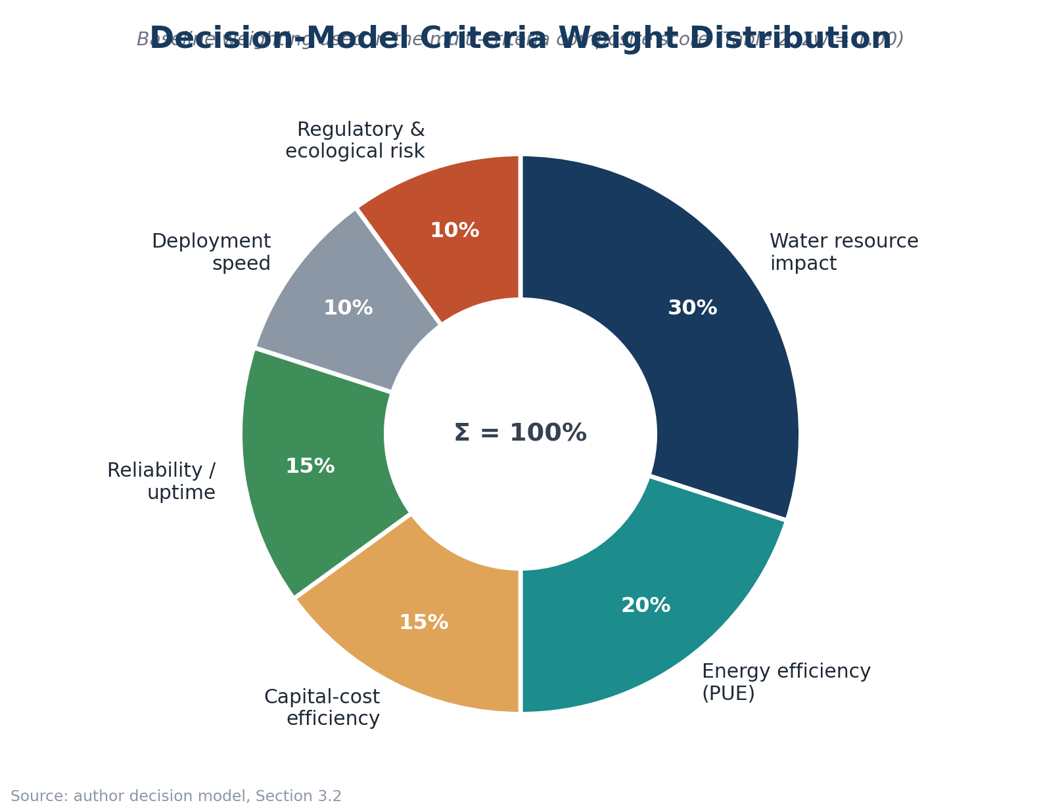
Figure 1. Decision-model criteria weights used in the baseline composite score.

3.3 Evidence hierarchy and research integrity
Evidence was prioritized in the following order: (1) peer-reviewed research and national-laboratory reports; (2) primary project documentation from Microsoft; (3) reputable reporting for developments not documented in primary sources; and (4) clearly labeled analytical assumptions. Media or commercial sources are not used as sole support for the paper’s central quantitative conclusion. Values that cannot be measured directly from public evidence are presented as scenario assumptions rather than facts.

4. Comparative Scenario Analysis
Parameter | A: Freshwater | B: Hybrid | C: Offshore
Primary heat rejection | Evaporative freshwater towers | Seawater heat exchanger + residual freshwater loop | Seawater through sealed thermal system
Illustrative PUE | 1.5–1.6 | 1.2–1.3 | 1.05–1.15
Direct freshwater burden | High | Reduced; site-dependent | Near-zero for cooling loop
Relative capital-cost index | 100 | ~128 | ~150–180
Deployment concept | 18–24 months | 18–30 months | Modular fabrication; rapid field deployment after fabrication
Serviceability | Immediate on-site access | Conventional land access | Marine retrieval required
Primary environmental concern | Freshwater consumption | Thermal discharge / intake effects | Benthic disturbance, thermal effects, biofouling
Table 1. Comparative scenario parameters. Numerical values that are not directly measured in a full-scale offshore AI facility are treated as illustrative assumptions, not observations.
The most important analytical distinction is between observed and assumed quantities. The Project Natick reliability result is empirical. By contrast, the capital-cost index and scenario PUE ranges are modeling inputs used to compare architectures, not measurements from commercial AI-scale offshore facilities. This distinction is retained throughout the analysis.
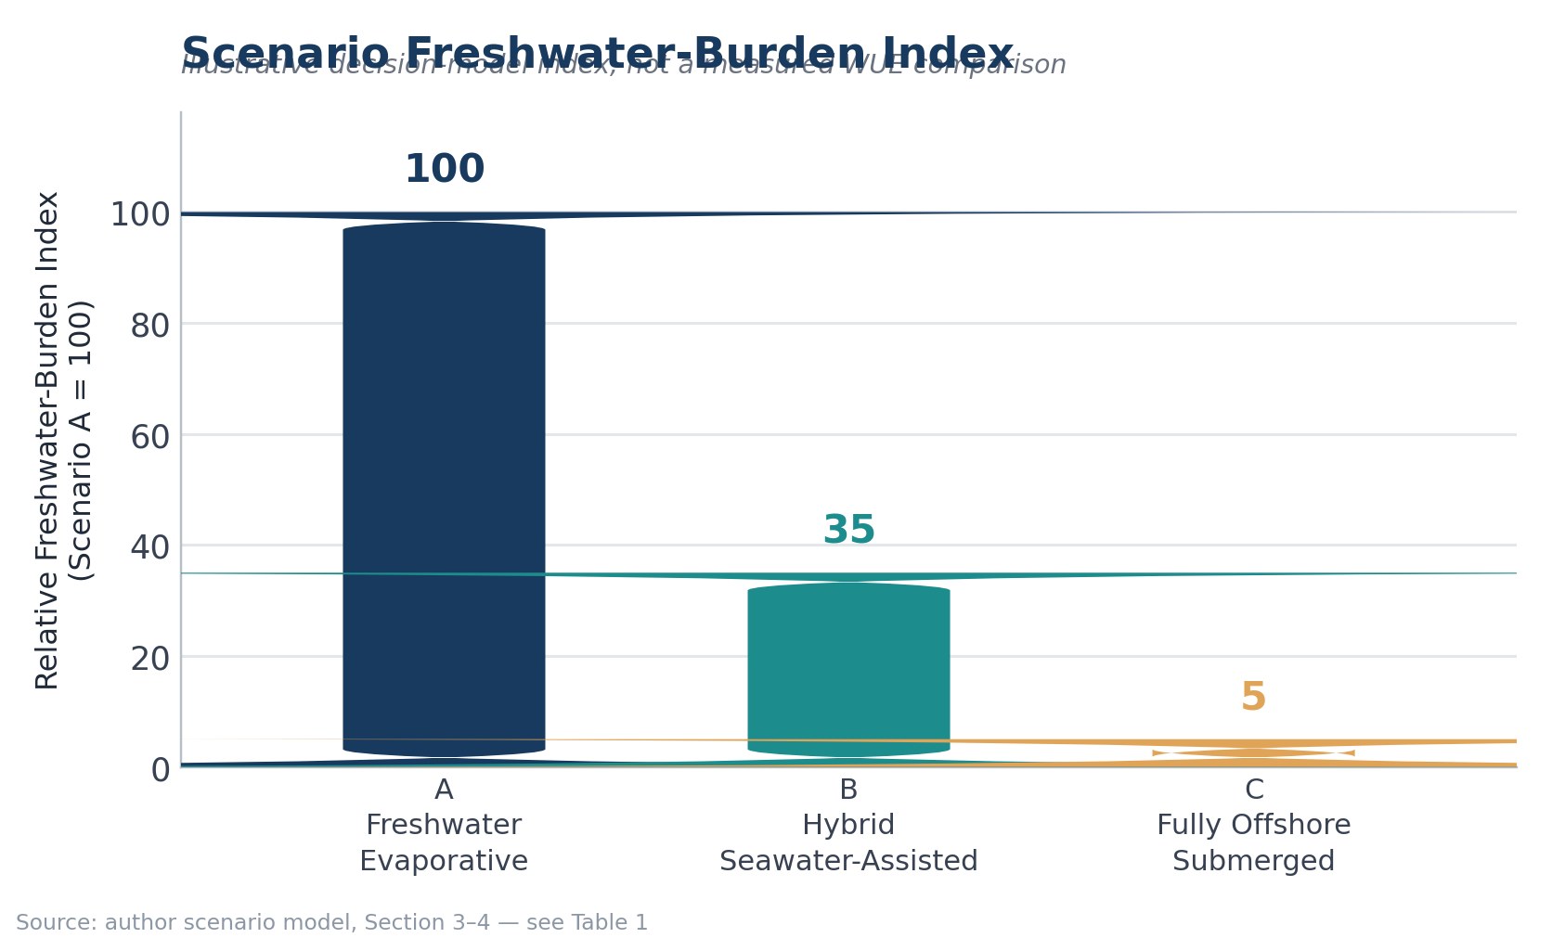
Figure 2. Scenario freshwater-burden index. A = 100 baseline; B and C are analytical assumptions representing partial and near-total displacement of direct freshwater cooling demand. This is not a measured WUE comparison.

4.1 Water impact
Scenario A carries the greatest direct freshwater burden because evaporative heat rejection intentionally consumes water. Scenario B can reduce this burden by transferring part of the heat load to seawater while preserving conventional land-based operations. Scenario C has the strongest direct-water advantage because its cooling loop does not require freshwater evaporation.
However, “near-zero direct freshwater use” should not be interpreted as “zero environmental water footprint.” Electricity generation can carry an indirect water footprint, and offshore infrastructure introduces marine impacts. The 2025 workload-level review reinforces this point: the lowest overall water use depends on the interaction among cooling technology, server efficiency, grid water intensity, utilization, climate, and refresh cycle. [3]

4.2 Energy efficiency and PUE
The modeled PUE advantage for offshore cooling follows from the assumption that seawater provides a stable heat sink and reduces mechanical cooling overhead. The direction of the relationship is physically plausible, but the exact PUE range should be treated as a scenario parameter until full-scale AI-class measurements are available. A strong research paper should therefore avoid presenting the offshore PUE range as an established industry benchmark.
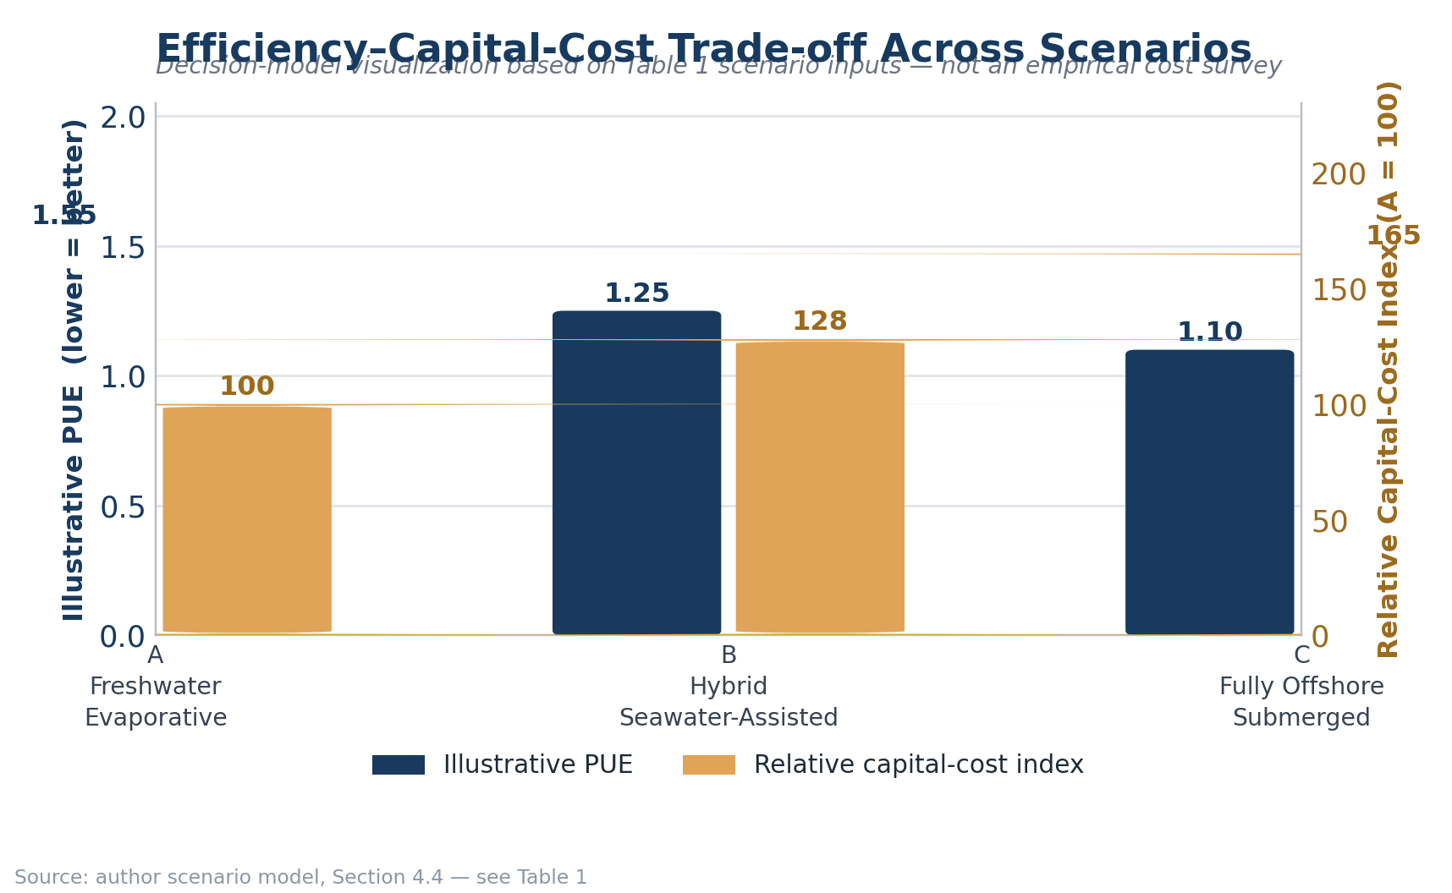
Figure 3. Illustrative efficiency–capital-cost trade-off using the scenario inputs in Table 1. The figure is a decision-model visualization, not an empirical cost survey.

4.3 Reliability
Reliability is where the empirical evidence most clearly favors the offshore concept. Microsoft reported that the Northern Isles servers had a failure rate one-eighth that of the land-based control group. [4] The sealed nitrogen atmosphere and isolation from human contact provide plausible mechanisms for the observed difference, but the result comes from one prototype deployment and should not be extrapolated directly to a large AI cluster.
Key Empirical Result. Unlike the scenario-model figures elsewhere in this paper, the result below is a directly measured outcome from Microsoft’s Project Natick deployment, not an analytical assumption.
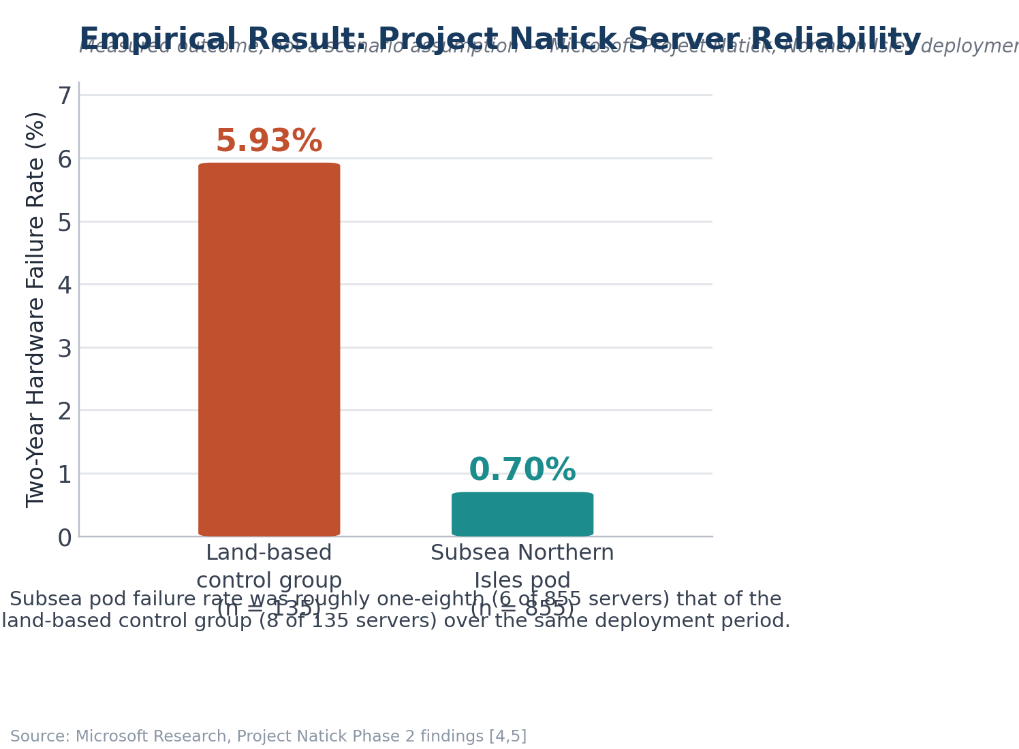
Figure 4. Measured server-failure rate in the Project Natick Northern Isles pod versus the land-based control group, 2018–2020 [4,5].
The operational trade-off is asymmetric. Onshore failures can usually be addressed by technicians within the facility. Offshore failures may be less frequent but more expensive or slower to repair. Thus, the relevant engineering question is not simply “Which system fails less?” but “What is the expected lifecycle cost and downtime of failure under each architecture?”

4.4 Cost and deployment
The original scenario model assigns the offshore architecture a higher relative capital-cost index because it requires marine-grade pressure vessels, corrosion-resistant components, deployment vessels, subsea power and communications, and specialized retrieval operations. The hybrid design retains much of the conventional building and maintenance ecosystem and therefore occupies an intermediate position.
The deployment-speed claim also requires careful interpretation. Microsoft described Project Natick as a concept capable of rapid deployment after fabrication, with the 2018 prototype assembled and tested before marine deployment. [7] This does not mean a commercial AI campus can be permitted, fabricated, connected to the grid, and commissioned in 90 days. Accordingly, the revised analysis treats rapid modular deployment as a potential architectural advantage rather than a universal construction-time claim.

4.5 Baseline weighted decision model
Criterion | Weight | A | B | C
Water resource impact | 0.30 | 2 | 6 | 9
Energy efficiency | 0.20 | 4 | 7 | 9
Capital-cost efficiency | 0.15 | 9 | 6 | 4
Deployment speed | 0.10 | 5 | 5 | 9
Reliability / uptime | 0.15 | 6 | 6 | 8
Regulatory & ecological risk | 0.10 | 6 | 6 | 5
Weighted total | 1.00 | 5.15 | 6.25 | 7.85
Table 2. Baseline multi-criteria scoring. Scores are analytical judgments derived from the evidence and assumptions described in Sections 2–4; they are not measured performance statistics.
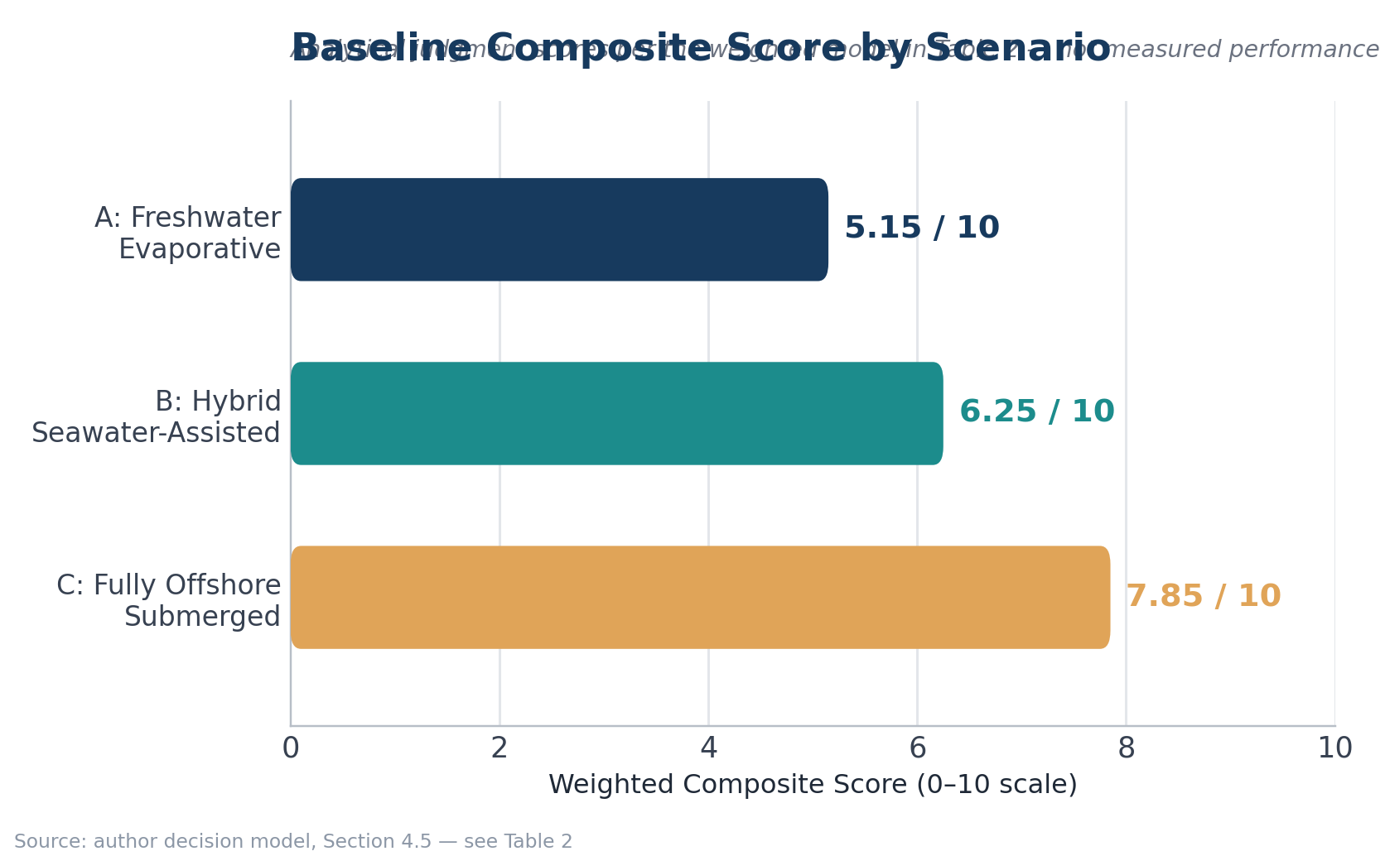
Figure 5. Baseline composite score. Offshore ranks first under the stated baseline weighting.

5. Sensitivity Analysis
A major weakness of many sustainability comparisons is that the final ranking can appear objective even when it depends on subjective priorities. To address this, the paper repeats the decision model under four weight sets: the baseline, a sustainability-focused set, a balanced set, and a cost/serviceability-focused set. The scenario scores themselves are held constant so that only decision-maker priorities change.
Weight set | A | B | C | Rank 1
Sustainability-focused | 4.20 | 6.10 | 8.00 | C
Baseline | 4.75 | 6.10 | 7.70 | C
Balanced | 5.25 | 6.05 | 7.45 | C
Cost/serviceability-focused | 5.70 | 6.00 | 7.15 | C
Table 3. Sensitivity of the composite ranking to decision priorities.
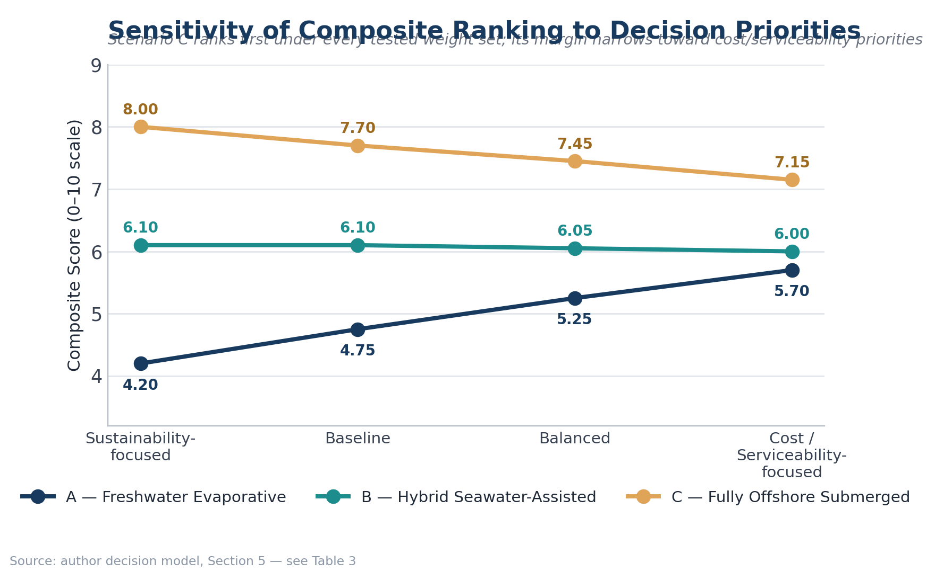
Figure 6. Sensitivity analysis. Offshore remains first across the four tested weight sets, but its margin over hybrid narrows when cost and serviceability receive more weight.
The sensitivity result strengthens the study because the offshore conclusion is not an artifact of a single arbitrary weighting scheme. At the same time, the narrowing margin under cost/serviceability priorities supports the paper’s central practical conclusion: hybrid seawater cooling may be the more deployable transition even when full offshore cooling has the stronger environmental score.

Key findings
1 | Offshore ranks first in the baseline model (7.85/10).
2 | Offshore remains first across all four tested priority sets.
3 | Its advantage narrows when capital cost and serviceability receive greater weight.
4 | The main evidence gap is full-scale, site-specific validation of cost, thermal performance, and marine effects.

6.1 What the model actually demonstrates
The central result should be stated conditionally. The model does not demonstrate that offshore data centers are universally superior to land-based facilities. It demonstrates that, under the paper's stated assumptions and weighting structure, offshore cooling receives the highest composite score and remains the preferred scenario across the tested priority sets. The result is strongest where freshwater use is heavily penalized and where coastal deployment is feasible. It becomes less decisive when capital cost, maintenance access, and serviceability are given substantially greater importance. This conditional framing is important because it identifies a decision boundary rather than presenting the model as a universal engineering proof.

6. Discussion

6.1 The strongest case for offshore cooling
The offshore architecture has three linked advantages. First, it can sharply reduce direct freshwater dependence. Second, a stable seawater heat sink can reduce cooling overhead under suitable site conditions. Third, the Project Natick experiment provides evidence that sealed subsea operation can achieve strong hardware reliability. These advantages are particularly relevant where freshwater scarcity, land constraints, or coastal compute demand are binding infrastructure constraints.

6.2 Why hybrid cooling may win commercially
Hybrid seawater-assisted cooling offers a more conservative engineering pathway. It captures part of the thermal benefit of seawater without moving servers into an environment where routine physical access becomes difficult. This matters for AI infrastructure because accelerator generations change quickly and operators may need to replace, repair, or reconfigure hardware during the life of a facility.
The hybrid model also allows staged adoption. A coastal operator can preserve existing land-based operations while progressively increasing the share of heat rejection handled through seawater exchange. This reduces the technological discontinuity between today’s data centers and a future offshore architecture.

6.3 Ecological risk is not optional
The environmental case for seawater cooling must include marine effects. Seawater intake can interact with organisms and suspended material; discharge can create localized thermal gradients; subsea structures can disturb seabed habitats; and long-duration structures can accumulate biofouling. Microsoft’s own documentation of Project Natick describes marine growth on the retrieved vessel, demonstrating that the ocean is an active operating environment rather than a passive heat sink. [8]
The correct research question is therefore not whether marine impact exists, but whether it can be bounded, monitored, mitigated, and shown to be lower than the freshwater and energy impacts displaced by the cooling architecture. That requires site-specific environmental baselines rather than generic assumptions.

6.4 Siting logic
The results suggest a practical decision rule. Offshore or hybrid seawater cooling becomes more attractive as local freshwater scarcity increases, coastal access improves, cooling energy becomes more expensive, and regulatory pathways become clearer. Conventional land-based systems remain attractive where freshwater is relatively abundant, land and power infrastructure are accessible, and serviceability has high economic value. In other words, cooling architecture should be treated as a siting decision, not as a universally ranked technology.

7. Limitations and Research Gaps
• The offshore scenario is not validated by a full-scale AI-training deployment. Project Natick was a prototype, so its reliability and thermal results cannot be assumed to scale linearly to modern AI clusters.
• The PUE and capital-cost ranges for offshore and hybrid systems are scenario inputs rather than direct observations from comparable commercial facilities.
• The weighted scoring model contains judgment. Sensitivity analysis reduces—but does not eliminate—this limitation.
• The study does not perform a full lifecycle assessment of vessel materials, subsea cables, fabrication, maintenance vessels, hardware replacement, or end-of-life recovery.
• Indirect water use from electricity generation is discussed but is not integrated into the numerical scenario score because it is highly site- and grid-dependent.
• Marine ecological impacts are not modeled quantitatively. A credible next phase would require hydrodynamic modeling, thermal-plume analysis, benthic surveys, intake/outfall assessment, and long-duration monitoring.
• AI workload efficiency is not held constant across architectures. Future research should compare architectures using a common computational-output metric such as workload throughput rather than relying on facility metrics alone.

8. Proposed Next-Phase Research Design
The most valuable extension would convert the scenario model into a site-specific techno-economic simulation. A future study could select three coastal locations with different water-stress and seawater-temperature conditions and evaluate the same AI workload under identical IT assumptions. The model would then calculate annual electricity use, direct water consumption, indirect water consumption, cooling capacity, capital expenditure, operating expenditure, hardware replacement cost, and estimated marine impact.
The study should also test at least three seawater temperatures and multiple heat-exchanger effectiveness values. Rather than assuming a fixed offshore PUE, the next model could derive cooling energy from thermal-load and heat-transfer parameters. This would transform the current decision framework from an evidence-weighted scenario study into a reproducible engineering model.
A particularly useful output would be a break-even map identifying the combinations of freshwater price/scarcity, seawater temperature, electricity price, and hardware refresh interval under which hybrid or offshore cooling becomes economically preferable. Such a model would provide a direct bridge between sustainability research and real infrastructure planning.

9. Conclusion
This study compared three approaches to cooling AI-scale data centers: conventional freshwater evaporative cooling, hybrid seawater-assisted cooling, and fully offshore submerged cooling. The analysis does not support the simplistic conclusion that offshore data centers are universally “better.” Instead, it identifies a conditional advantage that becomes strongest where freshwater scarcity, cooling demand, land constraints, and coastal access intersect.
Under the baseline multi-criteria model, the offshore scenario scores 7.85/10, compared with 6.25/10 for hybrid seawater cooling and 5.15/10 for the freshwater baseline. Sensitivity analysis shows that offshore remains the highest-scoring architecture under multiple reasonable priority structures, although its advantage narrows when capital cost and serviceability are emphasized. The hybrid architecture therefore emerges as the most credible transitional strategy: it captures a substantial part of the water-saving logic of seawater cooling while retaining conventional access to computing hardware.
The most important conclusion is methodological. Sustainable AI infrastructure cannot be evaluated with a single metric. WUE alone can hide grid-water effects; PUE alone can hide freshwater demand; reliability alone can ignore serviceability; and capital cost alone can ignore resource constraints. A credible infrastructure decision must consider these dimensions together and make its assumptions visible. Offshore cooling is promising not because the ocean is automatically a “green” data center, but because, under the right conditions, it changes the physical boundary conditions of heat rejection. The next research step is to determine exactly where that change produces a net environmental and economic benefit.

Analytical scope and interpretation
The composite scores are decision-model outputs, not experimental measurements. They make the study's trade-offs explicit and reproducible. The strongest empirical result used in the analysis is the Project Natick reliability comparison; scenario PUE, cost, deployment, and scoring inputs are interpreted according to the evidence hierarchy described in Section 3.3.

References
[1] Shehabi, A., Smith, S. J., Hubbard, A., Newkirk, A., Lei, N., Siddik, M. A., Holecek, B., Koomey, J. G., Masanet, E. R., & Sartor, D. A. (2024). 2024 United States Data Center Energy Usage Report. Lawrence Berkeley National Laboratory, LBNL-2001637. DOI: 10.71468/P1WC7Q.
[2] Smith, S. J., Hubbard, A., Newkirk, A., Ganeshalingam, M., Holecek, B., Sartor, D. A., Mills, M., & Shehabi, A. (2026). United States Data Center Energy Usage Report: 2025 Update. Lawrence Berkeley National Laboratory.
[3] Lei, N., Lu, J., Shehabi, A., & Masanet, E. (2025). The water use of data center workloads: A review and assessment of key determinants. Resources, Conservation & Recycling, 219, 108310. DOI: 10.1016/j.resconrec.2025.108310.
[4] Microsoft Research. (2020). Project Natick Phase 2: Reliability and environmental findings. Microsoft Project Natick.
[5] Microsoft Research. (2021). Natick: Researching the feasibility of subsea datacenters powered by offshore renewable energy. Microsoft Research.
[6] Moss, S. (2024). Microsoft confirms Project Natick underwater data center is no more. Data Center Dynamics, June 17, 2024.
[7] Microsoft News Center. (2018). Under the sea, Microsoft tests a datacenter that’s quick to deploy, could provide internet connectivity for years.
[8] Microsoft News Center. (2020). Microsoft reveals findings from Project Natick, its experimental undersea datacenter.
[9] Li, P., Yang, J., Islam, M. A., & Ren, S. (2023). Making AI Less “Thirsty”: Uncovering and Addressing the Secret Water Footprint of AI Models. arXiv:2304.03271.
[10] Kurtz, J., Zuberi, J., Wierl, L., & Hammond, S. (2026). Avoiding Waste Heat through AI Infrastructure Thermal Integration. National Academy of Engineering / Lawrence Berkeley National Laboratory.
[11] Herrera, M., Xie, X., Menapace, A., Zanfei, A., Brentan, B. M. (2025). Sustainable AI infrastructure: A scenario-based forecast of water footprint under uncertainty. Journal of Cleaner Production, 526, 146528. DOI: 10.1016/j.jclepro.2025.146528.
[17] The Green Grid Data Center Resource Effectiveness Standing Work Group. (2025). Water Usage Impact (WUI) v1 Metric. White Paper #95.
[16] The Green Grid Data Center Resource Effectiveness Standing Work Group. (2025). Data Center Resource Effectiveness (DCRE) v1 Metric. White Paper #93.
[15] The Green Grid. (2011). Water Usage Effectiveness (WUE): A Green Grid Data Center Sustainability Metric. White Paper #35.
[14] Casale, N. (2021). Data Centers: Where and How Should PUE Be Improved? ASHRAE Journal, 63(6). ASHRAE.
[13] Chen, L., Xie, H., Xie, M., Zhang, L., Ye, K., & Li, S. (2026). A dual-purpose seawater evaporation system for data center cooling and freshwater production: Design and performance analysis. Applied Thermal Engineering, 287, 129458. https://doi.org/10.1016/j.applthermaleng.2025.129458.
[12] Mokhtari, R., & Arabkoohsar, A. (2021). Feasibility study and multi-objective optimization of seawater cooling systems for data centers: A case study of Caspian Sea. Sustainable Energy Technologies and Assessments, 47, 101528. https://doi.org/10.1016/j.seta.2021.101528.

A.1 Reproducibility package
The accompanying repository should contain the manuscript, scenario-input table, scoring matrix, figure-generation files, and a README describing how each result was produced. No measured value should be presented as an experimental observation unless its source is identified. Modeled assumptions should remain labeled as assumptions in both the paper and repository.

Appendix A. Reproducibility Summary
The decision model can be reproduced from Table 2. Each scenario is assigned six criterion scores on a 0–10 scale, multiplied by the corresponding weight, and summed. Sensitivity analysis changes only the weights. This makes the model auditable: a reader can replace any score or weight and immediately observe whether the ranking changes.
The most important future reproducibility improvement is replacing judgment-based scores with measured site data. In particular, future work should collect comparable PUE, WUE-site, WUE-source, workload throughput, cooling energy, maintenance events, capital expenditure, and marine-monitoring data for the same workload and operating period.

Author’s Note: Research Origin and Reflection
I began this project after noticing that public conversation about AI’s environmental footprint focused almost entirely on electricity and carbon, while water consumption — a resource under just as much local strain — rarely came up. That gap is what led me to ask whether shifting data-center cooling from freshwater to seawater could meaningfully change that picture, and to build a framework rigorous enough to test the question honestly rather than simply make the intuitive case for it.
The hardest part of this project was resisting a clean, satisfying answer. My early drafts leaned toward presenting offshore cooling as an obvious win. Building a transparent weighting model, and then stress-testing it with a sensitivity analysis, forced me to see how much of that initial conclusion depended on priorities I had chosen myself rather than on the evidence alone. That shift — from arguing for an answer to building a framework that could be argued with — changed how I approach research questions generally, in and out of the classroom.
I plan to continue developing this model, ideally with feedback from an engineering or environmental science mentor, and to pursue the site-specific techno-economic simulation outlined in Section 8. [Add any competition, journal, class, or mentor context relevant to this project — for example, a science research program, a science fair or symposium submission, or an independent study course — once applicable.]

Acknowledgments
No external support is claimed unless explicitly listed here.

