TECHNICAL SPECIFICATION & USER JOURNEY DOCUMENT  Smart Campus Entry Monitoring & Biometric Access Control System  Real-time, role-based campus gate monitoring with fingerprint-terminal integration  Source code: https://github.com/Sanket1516/Smart-Campus-Monitoring-System | Prepared by: Sanket Mali (Roll No. E265), B.Tech Computer Science  Institution: SVKM’s NMIMS MPSTME, Shirpur  Guide: Dr. Nitin Choubey  Date: 31 October 2026

1 PROJECT OVERVIEW & FUNCTIONAL SPECIFICATION

1.1 Executive summary & problem statement
Smart Campus Entry Monitoring is a MERN web application that replaces the handwritten gate register. It records every student entry and exit automatically and shows it live. A fingerprint terminal (eSSL X990) sends a numeric user ID to the backend. The backend decides whether it is an entry or an exit, applies blocks and warden approvals, flags curfew violations, emails or texts the parents, and pushes the event to the dashboards. Guards can also type a SAP ID when a terminal is unavailable. The repository holds a working version: React frontend, Express API, MongoDB, Docker and a CI/CD pipeline.
Problem (current practice) | Impact | Proposed solution (implemented)
Manual paper gate registers, guard relies on visual recognition | Errors, falsification, unregistered entry | Biometric scan → automated, timestamped EntryLog. Unauthorized IDs logged and alerted
No live view of who is inside, no hosteller exit control | Curfew violations found late | Live dashboard, per-hostel curfew flag, warden-approved time-bound exit windows
Parents not informed, no analytics or audit trail | No data-driven decisions | Async e-mail/SMS to parents, hourly/7-day analytics, AuditLog of admin actions

1.2 Objectives
▪ Automate gate entry/exit recording with a smart toggle (entry → exit → re-entry) from biometric terminals, with SAP-ID fallback.
▪ Apply access rules at the gate: blocked students, unknown terminals or IDs, and warden approval for hostellers.
▪ Show each role only what it needs (admin, security, warden), plus a small public page, and keep an audit trail of changes.
▪ Show live campus status, give analytics, notify parents, and package everything in containers with automated deployment.
1.3 Target users and stakeholders
Role | Access (verified in code) | Primary needs
Admin | All modules: students, enrollment, access control, terminals, settings, staff, audit | Configure and govern the system
Security | Dashboard, Scanner, Logs, alerts, terminal status, block list | Fast gate decisions, visitor entry
Warden | Hostel-scoped dashboard, logs, analytics, hostellers, Warden Portal | Approve/reject exit requests, track late returns
Hosteller (student) | Public /student/exit-request (name + phone check) | Request leave and see status
Public / Parents | /live read-only page, parents receive e-mail/SMS only (no parent login) | Awareness of campus/child movement

1.4 FUNCTIONAL REQUIREMENTS (WHAT THE SYSTEM DOES)

ID | Requirement | Evidence | Status
FR1 | Accept biometric scan events, authenticate terminal by machineNumber + deviceSN, return allow true/false | POST /api/fingerprint/scan | Implemented
FR2 | Manual SAP-ID entry/exit with unauthorized-attempt logging, visitor entry capture | POST /api/scan, /api/visitors | Implemented
FR3 | Auto toggle entry / exit / re-entry from latest EntryLog state | fingerprint & scan controllers | Implemented
FR4 | Block/unblock students with reason, log blocked attempts and raise alerts | /api/access, AccessControlLog | Implemented
FR5 | Student CRUD (soft delete), search/filter, Excel (.xlsx/.xls) bulk upload with row-level errors | /api/students, multer + xlsx | Implemented
FR6 | Hosteller exit request → warden approval → time-limited access window, 5-min expiry job | /api/hosteller, node-cron | Implemented
FR7 | Curfew late-return flag (default 22:00, per-hostel override) and warden late-return alert | configService.isPastCurfew | Implemented
FR8 | Terminal registry, heartbeat, offline detection (2 min), enrollment-station mode | /api/terminals, terminalJobs | Implemented
FR9 | Live events (scan:live, blocked, unauthorized, warden, terminal) over Socket.IO | socket.js, socketService | Implemented
FR10 | Dashboard, hourly distribution, 7-day trend, hosteller status, public live page | /api/dashboard, /api/live | Implemented
FR11 | Parent e-mail (SMTP) and SMS (Fast2SMS) notifications, toggles in settings | notification.js | Implemented*
FR12 | Staff accounts, hostels, system settings, maintenance mode, audit log | /api/auth, /settings, AuditLog | Implemented
FR13 | Dashboard chat: 5 fixed intents (Ollama gemma:2b + keyword fallback) answered from DB | /api/ai-query | Implemented (limited)
FR14 | Parent login portal, multi-gate campus-wide rollout (10,000+ students) | Proposal only | Proposed
*Delivery depends on SMTP / Fast2SMS credentials supplied through environment variables.
1.5 NON-FUNCTIONAL REQUIREMENTS (HOW WELL IT OPERATES)

Category | Requirement / design provision | Status
Security | JWT + bcrypt(12), role guards, helmet, CORS, rate limit, validation (see page 5) | Implemented
Performance / real-time | Terminal reply is a single JSON round trip, events pushed via WebSocket, dashboards poll every 30 s | Implemented, not load-tested
Reliability | Containers set to restart unless-stopped. Mongo health check. Offline monitor. Async notifications never block a scan | Implemented
Usability / compatibility | Responsive Tailwind UI, role-aware navigation, toast + sound feedback. Asia/Kolkata time zone | Implemented
Maintainability / observability | Layered routes→controllers→services→models. Prometheus /metrics, Grafana, /api/health | Implemented
Scalability | Stateless API behind Nginx, single MongoDB node, Socket.IO has no shared adapter | Partial

2 TECHNICAL ARCHITECTURE & TECHNOLOGY SPECIFICATIONS

2.1 System architecture
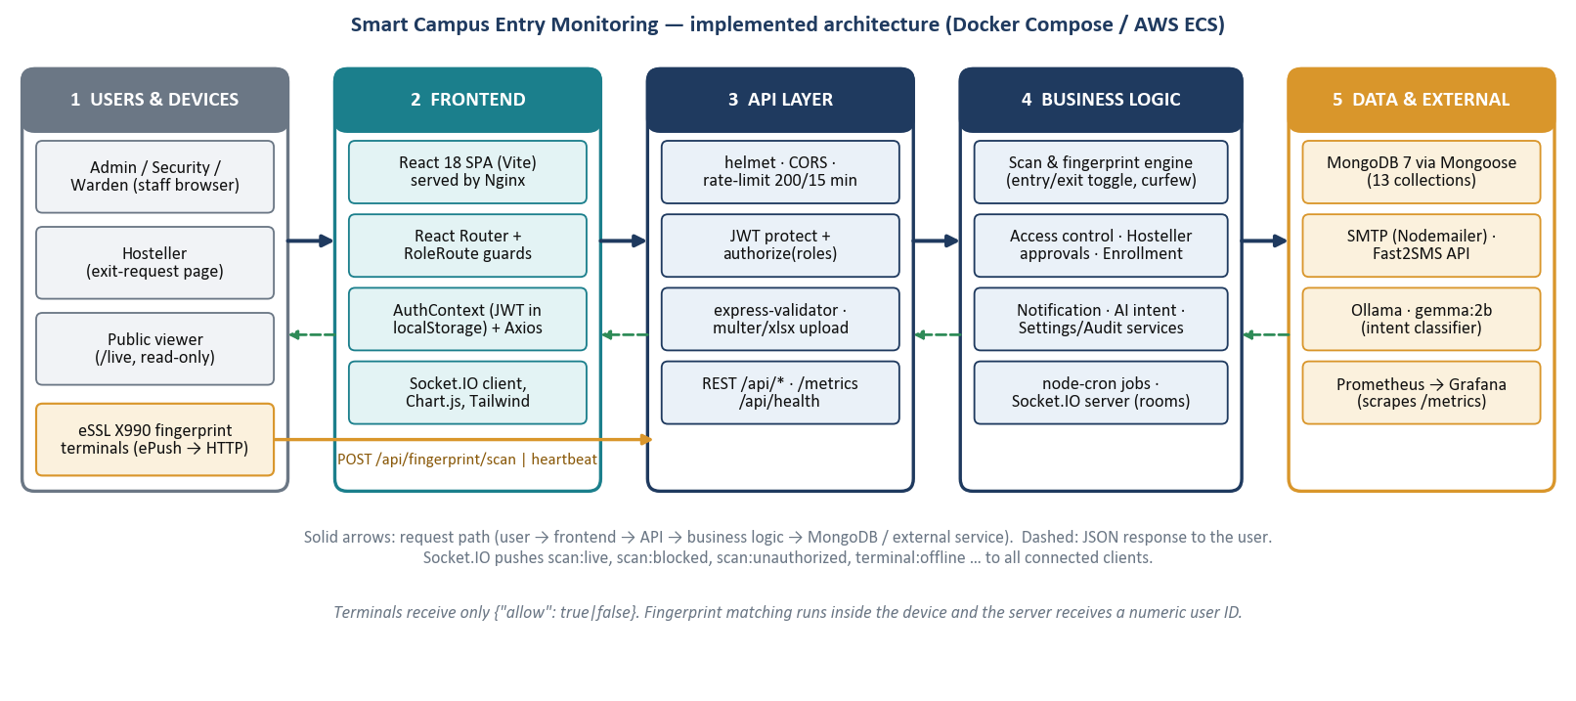
2.2 Component responsibilities
Layer | Architecture (as implemented)
Frontend | React 18 + Vite SPA served by Nginx. React Router with PrivateRoute/RoleRoute guards driven by rolePermissions.js. AuthContext keeps the JWT in localStorage. An Axios interceptor adds the Bearer token and logs out on any 401. SocketContext subscribes to live events. Chart.js renders analytics.
Backend | Node 20 / Express 4 in route → controller → service → model layers. 17 route groups under /api, global error handler (validation, duplicate-key, JWT errors), Prometheus metrics middleware, HTTP + Socket.IO server on port 5000.
Database | MongoDB 7 via Mongoose 8, 13 collections: Admin, Student, Hostel, EntryLog, UnauthorizedLog, VisitorEntry, TerminalConfig, DeviceAllocation, HostellerRequest, AccessControlLog, AlertLog, AuditLog, SystemConfig. Entry records use a YYYY-MM-DD IST date key plus entered/exited status.
AI component | Ollama (gemma:2b) is not used to write answers. It only classifies a question into one of 5 intents (total_inside, late_returns_today, hostellers_outside, unauthorized_today, unknown). Answers are computed from MongoDB. On timeout/error a keyword classifier takes over.
Communication | REST/JSON over HTTP (browser, terminals). WebSocket via Socket.IO for push (warden events go to room warden:<id>). SMTP and HTTPS to Fast2SMS. HTTP to Ollama. Prometheus scrapes /metrics.

2.3 Technology specification
Component | Technology | Purpose | Implementation details
UI framework | React 18.3, Vite 5, Tailwind 3 | Single-page role-based console | Pages: Dashboard, Scanner, Logs, Analytics, Hostellers, Students, Enrollment, Access, Warden Portal, Terminals, Settings, Live, Exit Request
Client libs | Axios, Chart.js 4, socket.io-client, react-hot-toast, html5-qrcode, tesseract.js | HTTP, charts, live updates, feedback, barcode / OCR input | Token interceptor, alert sounds (3 .wav files), BarcodeScanner and OcrScanner components on the Scanner page
API server | Node 20, Express 4.21 | REST API and routing | 17 route files, controllers, services, CORS limited to CLIENT_URL
Auth & security | jsonwebtoken, bcryptjs, helmet, express-rate-limit, express-validator | Identity, access, hardening | JWT 7 d default, bcrypt 12 rounds, 200 req / 15 min on /api, validators on write routes
Database | MongoDB 7, Mongoose 8 | Persistent document store | Schema validation, select:false on password / fingerprintTemplate
Real-time | Socket.IO 4.8 | Push alerts and live ticker | JWT handshake, 11 named events, warden rooms
Biometric link | eSSL X990 (ePush), node-zklib | Scan source and device user sync | Terminal posts {deviceSN, machineNumber, userId}. DeviceAllocation maps terminal-local ID to student
Bulk import | multer 2, xlsx 0.18 | Excel enrollment | Row validation, valid rows inserted, failures returned with reasons
Scheduling | node-cron 4 | Background jobs (IST) | Expire approvals every 5 min, reset scansToday at 00:00, offline monitor every 60 s
Notifications | Nodemailer 6, Fast2SMS REST | Parent / warden alerts | SMTP via env vars, SMS skipped if API key absent
AI intent | Ollama + gemma:2b | Chat intent classification | AI_TIMEOUT_MS bound, deterministic fallback
Ops | Docker Compose, Nginx, Prometheus, Grafana, GitHub Actions, AWS ECR/ECS | Packaging, monitoring, delivery | 6 services in compose, prom-client metrics, see page 5

3 SYSTEM WORKFLOW, MODULES & DATA FLOW

3.1 Module specification
Module | Purpose | Input | Processing | Output | Dependencies
M1 Auth & RBAC | Staff identity, roles | username, password, Bearer JWT | bcrypt compare, JWT sign/verify, active-flag check on every request, authorize(roles) | Token, admin profile, 401/403 | Admin model, auditService
M2 Scan & Biometric | Entry/exit decision | userId + terminal IDs, or SAP ID | Workflow below: terminal, student, block, warden checks. Toggle. Curfew flag | allow flag / JSON result, EntryLog, alerts | M3, M4, M5, M6, M8, configService
M3 Access Control | Block / unblock | SAP ID, reason | Update accessStatus, write AccessControlLog + audit | Block list, log | Student, AuditLog
M4 Student & Enrollment | Student lifecycle, Excel import | Form or .xlsx file | Validate, normalise category/hostel, insertMany, soft delete | Counts + row errors | Student, Hostel, DeviceAllocation
M5 Hosteller Approval | Leave request workflow | Name + phone, reason, return time | Create → approve/reject → accessValidUntil → cron expiry | Request status, alerts | HostellerRequest, M6, M8
M6 Real-time Hub | Live push | Domain events | Socket.IO emit, warden room targeting | scan:*, terminal:*, warden:* events | socket.js
M7 Terminal Mgmt | Device registry & health | Heartbeat, CRUD | Mark online/last-seen, offline job, daily counter reset | Status, offline events | TerminalConfig, cron
M8 Notification | Parent / warden messages | Student, action, time | Build HTML/text, send e-mail and SMS asynchronously | Delivery result (logged) | Nodemailer, Fast2SMS, SystemConfig
M9 Analytics, Live, AI | Statistics and queries | Date, filters, chat text | Aggregate EntryLog, classify intent, hostel-scoped for wardens | Charts, counts, answers | EntryLog, Ollama

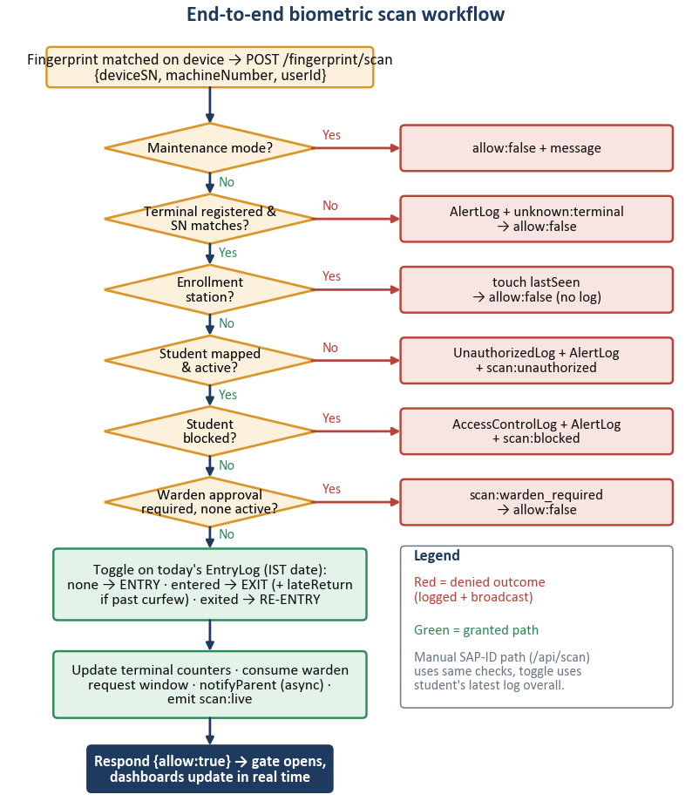 | 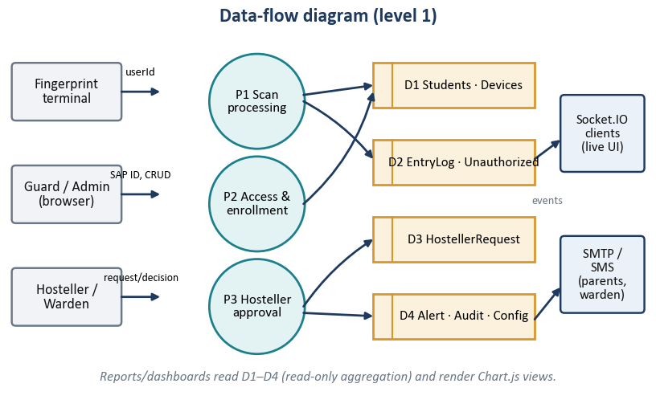  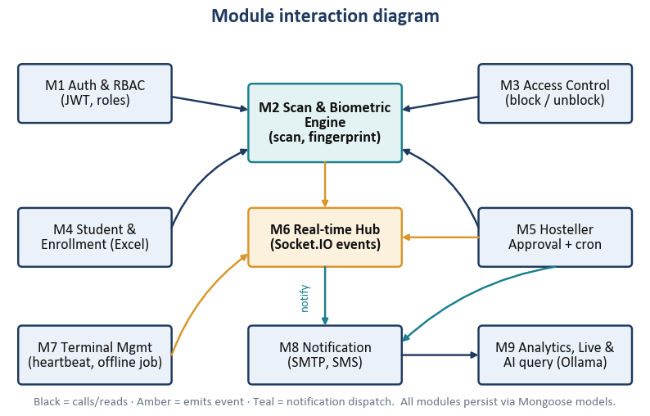

3.2 Cross-cutting mechanisms
Concern | How it works in the implementation
API communication | Axios sends JSON with Authorization: Bearer <JWT>. Terminals call /api/fingerprint/scan and /heartbeat without a JWT (identified by machineNumber + deviceSN) and receive {allow:true|false}.
Database interaction | Controllers use Mongoose queries. EntryLog is looked up by sapId + IST date. populate() joins Student→Hostel→Warden. Scoped queries restrict wardens to their hostel’s SAP IDs.
Auth & authorization | protect() verifies JWT, loads Admin, rejects missing or deactivated accounts. authorize() checks role. React RoleRoute mirrors the same matrix. Hosteller requests use a separate name + phone check (authenticateStudent).
Error handling | Central errorHandler maps Mongoose ValidationError / duplicate key (400) and JWT errors (401). Controllers return 4xx with a message. The terminal endpoint never throws – any failure returns allow:false. Notification and socket failures are caught and logged.
External services | Fire-and-forget calls: notifyParent().catch(log). Ollama call aborted after AI_TIMEOUT_MS then keyword fallback. SMS skipped when no API key. Maintenance mode short-circuits scans with a message.

4 USER JOURNEY & INTERACTION DESIGN

4.1 Journey infographic: user action → system response → backend → database/API → output
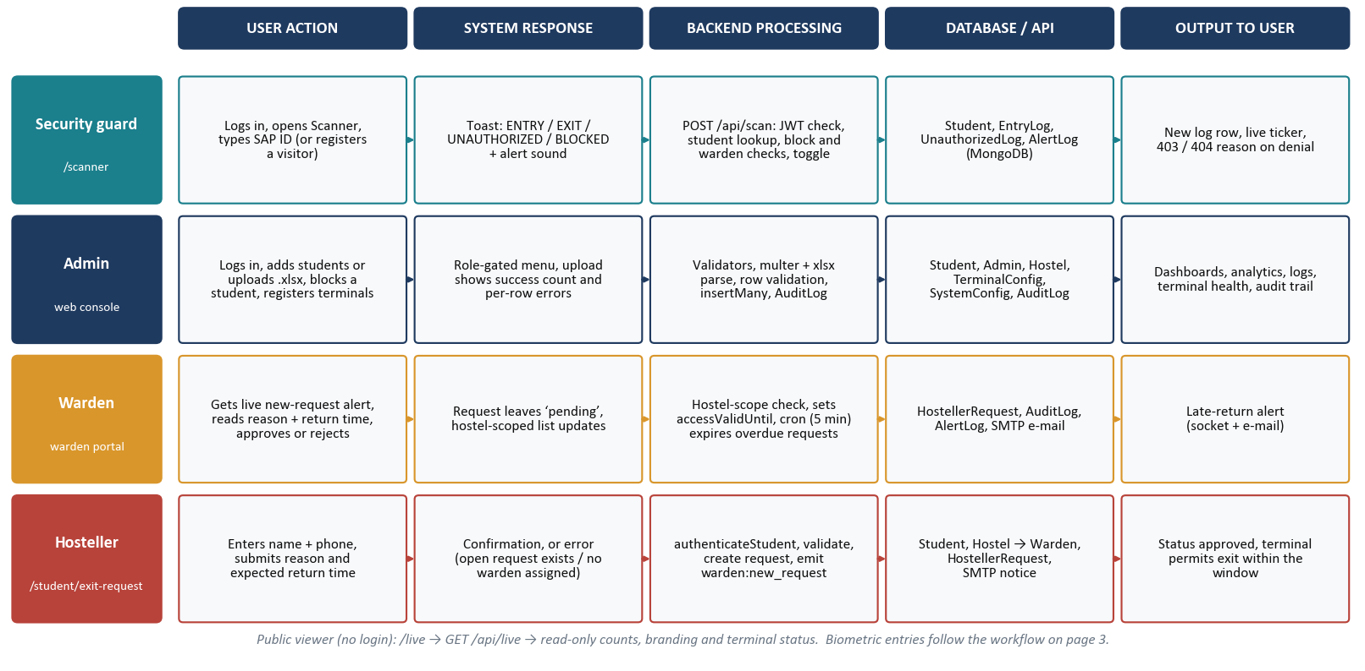
4.2 Role journeys: entry point, outcomes and decisions
Role | Entry & login | Landing | Primary actions | Success | Failure / exception
Security guard | /login (username + password) → JWT | Dashboard: counts, charts, live ticker | Scanner: enter SAP ID, or terminal scans automatically. Register visitor. Review Logs | Entry/exit logged, parent notified, sound cue | Unknown ID → UnauthorizedLog + alert, blocked → 403 + alert, warden approval missing → 403
Admin | /login | Dashboard + admin menu | Add/upload students, block, register terminals, staff and hostels, change settings | Records saved, audit entry | Duplicate SAP ID, bad department/course, invalid row → per-row error list. 403 for other roles
Warden | /login (scoped to own hostel) | Dashboard of hostel only | Warden Portal: approve/reject, Hostellers page: who is outside / late | Student can exit within window | Request outside own hostel → 403, student overdue → expiry + late alert
Hosteller | /student/exit-request (name + phone) | Request form + latest status | Submit reason, return time, check status | Request pending → approved | Wrong credentials 401, open request exists, no warden assigned (400)
Public viewer | /live (no login) | Read-only campus status | View counts, terminal status | Page renders | API down → empty state

4.3 Hosteller exit-request lifecycle (key decision points)
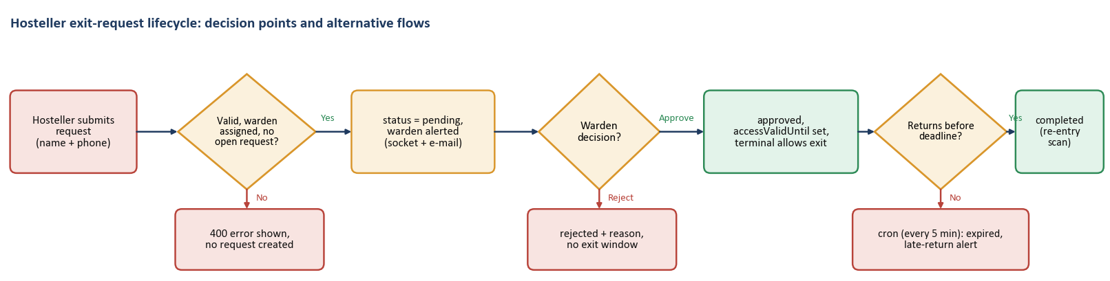
4.4 Alternative flows, error scenarios and UX considerations
▪ Alternative flows: terminal unavailable → guard uses SAP-ID scanner (barcode/OCR helpers exist). Student without warden-approval flag skips the approval gate. Re-entry after exit creates a new EntryLog row.
▪ Exceptions: expired/invalid JWT or deactivated account → 401 and automatic redirect to /login. Unknown terminal → alert + unknown:terminal event. Maintenance mode → scans refused with a message. Terminal silent for 2 min → marked offline and broadcast.
▪ Decision points: terminal known? student mapped? blocked? warden approval active? last status entered or exited? past curfew?
▪ UX considerations: role-filtered navigation, mobile drawer, toast/sound feedback, live status banner, server-side pagination, 30-second auto-refresh, public page needing no sign-in.

5 SECURITY, DEPLOYMENT, TESTING & FUTURE SCOPE

5.A Security specifications
Area | Implemented measure | Observed gap / note
Authentication | JWT (7 d default, JWT_SECRET env). Bcrypt cost 12. Password select:false. Deactivated accounts rejected on every request and socket handshake | No refresh/revocation, token kept in localStorage (XSS exposure)
Authorization | authorize(roles) on routes. Client RoleRoute. Warden queries scoped to assigned hostel. Audit log on staff, student, access, settings changes | POST /api/scan requires login but no role check
Data protection | Soft delete. Fingerprint template field select:false and AES-encrypted with FP_SECRET key. Terminals send only numeric IDs | Key falls back to a default if FP_SECRET unset, confirm no templates are persisted in production
Input validation | express-validator on terminal, auth, student, hostel and request routes. ISO-8601 / Mongo-ID checks. Mongoose schema enums | Student-name regex lookup is not escaped
API security | helmet, CORS to CLIENT_URL, 200 req/15 min limit on /api, centralised error handler | Terminal endpoints have no shared secret/HMAC, limit also applies to terminals
Sensitive data | .env files for secrets, .env.example only with placeholders | studentAuth logs the username and first characters of the password to the console

5.B Deployment architecture
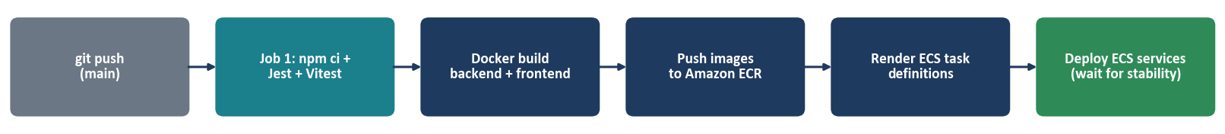
▪ Hosting: Docker Compose runs mongo:7, ollama, backend (node:20-alpine, TZ Asia/Kolkata), frontend (Nginx proxying /api and /socket.io), Prometheus and Grafana. AWS target: images in Amazon ECR, services on ECS cluster smart-campus-cluster (us-east-1).
▪ CI/CD (implemented): .github/workflows/deploy.yml on push to main → test job (Node 20, npm ci, Jest, Vitest) → build/push backend and frontend images → render and deploy ECS task definitions with stability wait. Secrets come from GitHub Actions.
▪ External dependencies: MongoDB, SMTP provider, Fast2SMS, Ollama model, eSSL terminals on the LAN. The Cloudflare-Tunnel pilot and Amazon SES in the proposal are proposed, not present in code.
5.C Testing and validation
Type | Completed (verified by running on 31 Oct 2026) | Recommended (not yet done)
Unit / API | Backend Jest + Supertest: 7 tests passed (login valid / invalid / missing fields, scan authorised and unknown SAP ID, student lookup found / not found) | Fingerprint scan, toggle, curfew and approval-window unit tests
Frontend | Vitest + Testing Library: 2 tests passed (Login render, StatCard) | Role routing, scanner and upload component tests
Integration / system | TESTING_CHECKLIST.md defines manual cases for auth, navigation and modules. Execution results are not recorded | Execute checklist with a real terminal, end-to-end tests
Performance / security | None available, no load figures are claimed | Load test (scan burst), dependency audit, penetration test

5.D Limitations  ▪ API.md documents an older contract (e-mail login, role “guard”). Code uses username and admin/security/warden.  ▪ Manual path uses a UTC date and the latest log overall. Terminal path uses IST date and today’s log: edge cases near midnight may differ.  ▪ Hosteller verification is name + phone, names are not unique keys.  ▪ Single database node, no Socket.IO adapter. 10,000-student scale unverified.  ▪ Chat covers five intents only, notification delivery needs external credentials. | 5.E Future enhancements  ▪ Scalability: MongoDB replica set, Redis adapter for Socket.IO, multi-gate rollout, ECS autoscaling.  ▪ Performance: indexes on date/sapId, cached dashboard aggregates, shared date helper.  ▪ Integrations: parent portal / mobile app, WhatsApp or SES delivery, ERP/SAP sync.  ▪ UX: richer analytics export, multilingual UI, configurable alert rules.  ▪ Security: HMAC-signed terminal calls, httpOnly cookies + refresh tokens, 2FA for admins, automated test suite in CI gates.

5.F Assumptions and missing information
Item | Assumption / gap
Terminal hardware | eSSL X990 behaviour (ePush, local matching) is taken from the proposal. No device was exercised for this document.
Fingerprint templates | The schema holds an encrypted template field. Whether templates are stored server-side in production cannot be verified from the repository.
Cloud environment | AWS task definitions, secrets and live URLs are not in the repository. The deployment is described from the workflow and compose files.
Screenshots / scale | UI described from source code (College Project Images.docx not used as a source). The 10,000+ student target is a proposal figure, not measured.

Technical conclusion. Most of what the proposal describes is already built and runs: biometric scans, role-based access, warden approvals, live events, notifications, analytics, Docker deployment and a CI/CD pipeline. The college gets a searchable, timestamped gate record in place of the paper register. Before wider use, the security gaps listed in 5.A should be fixed and load and end-to-end tests should be run.

