B.TECH PROJECT REPORT · 2026–27

MUKESH PATEL SCHOOL OF TECHNOLOGY MANAGEMENT & ENGINEERING
SHIRPUR CAMPUS, SVKM'S NMIMS (DEEMED-TO-BE UNIVERSITY)

DEPARTMENT OF COMPUTER SCIENCE

AGENTIC AI FRAMEWORK FOR CONTEXT-AWARE SEMANTIC UNDERSTANDING
AND INTELLIGENT ASSISTANCE OF DYNAMIC WEB FORMS

(Smart Form Auto-Filling System)

A Project Report Submitted in Partial Fulfilment of the Requirements
for the Degree of Bachelor of Technology in Computer Science

SUBMITTED BY

Ashmit Patil · Enrolment No. 70552300048 (E246)
Sanket Mali · Enrolment No. 70552300067 (E265)
Pinak Salunke · Enrolment No. 70552300049 (E247)

UNDER THE GUIDANCE OF
Dr. Nitin Choubey
Professor in Computer Science

ACADEMIC YEAR 2026–27

Certificate
This is to certify that the project entitled
"Agentic AI Framework for Context-Aware Semantic Understanding and Intelligent Assistance of Dynamic Web Forms"
has been submitted by:
- Ashmit Patil (Enrolment No. 70552300048)
- Sanket Mali (Enrolment No. 70552300067)
- Pinak Salunke (Enrolment No. 70552300049)
in partial fulfilment of the requirements for the award of the degree of Bachelor of Technology in Computer Science at Mukesh Patel School of Technology Management & Engineering, Shirpur Campus, SVKM's NMIMS (Deemed-to-be University), during the academic year 2026–27.
The work embodied in this report is original and has not been submitted to any other university or institution for the award of any degree.

_________________________ _________________________
Dr. Nitin Choubey Dr. Nitin S. Choubey
Professor in Computer Science Professor & Head, CS Department
Project Guide Head of Department

_________________________
Dr. Venkatadri Marriboyina
Associate Dean, Shirpur Campus

Certificate of Approval
The project entitled "Agentic AI Framework for Context-Aware Semantic Understanding and Intelligent Assistance of Dynamic Web Forms" submitted by Ashmit Patil, Sanket Mali, and Pinak Salunke of B.Tech (Computer Science), Academic Year 2026–27, is hereby approved for the award of the degree.
The project has been examined and evaluated by the undersigned examiners at the Viva-Voce examination held on _____________________.

_________________________ _________________________
Internal Examiner External Examiner
Date: _______________ Date: _______________

Declaration
We, the undersigned students of B.Tech (Computer Science), Batch 2023–27, Mukesh Patel School of Technology Management & Engineering, Shirpur Campus, SVKM's NMIMS, hereby declare that the project report entitled "Agentic AI Framework for Context-Aware Semantic Understanding and Intelligent Assistance of Dynamic Web Forms" submitted in partial fulfilment of the requirements for the award of the degree of Bachelor of Technology in Computer Science is our original work.
We further declare that this project has not been previously submitted, either wholly or in part, to this or any other university or institution for any degree or diploma. All information obtained from published or unpublished sources has been duly acknowledged in the report.

_________________________ _________________________
Ashmit Patil (70552300048) Sanket Mali (70552300067)
Date: _______________ Date: _______________

_________________________
Pinak Salunke (70552300049)
Date: _______________

Acknowledgement
We express our sincere gratitude to Dr. Nitin Choubey, Professor in Computer Science, for his invaluable guidance, continuous encouragement, and insightful feedback throughout the course of this project. His expertise in intelligent systems and his willingness to engage with the technical challenges we encountered shaped this work significantly.
We are deeply thankful to Dr. Nitin S. Choubey, Professor and Head of the Department of Computer Science, for providing the academic environment and departmental resources that made this project possible.
We extend our appreciation to Dr. Venkatadri Marriboyina, Associate Dean, Shirpur Campus, for his leadership and administrative support that fosters a culture of research-oriented learning at the institution.
We thank the faculty of the Department of Computer Science at MPSTME Shirpur for their teaching and the theoretical foundations they provided over four years of study. We are also grateful to our fellow students for their feedback during informal presentations of this work.
Finally, we acknowledge the open-source community — the developers of FastAPI, LangGraph, ChromaDB, React, and the Manifest V3 extension platform — whose tools made the technical realisation of this system possible.

Ashmit Patil
Sanket Mali
Pinak Salunke

Abstract
Digital web forms are the primary interface through which citizens, students, and professionals interact with government portals, banking systems, educational institutions, and employment platforms. The repetitive manual entry of personal information across these forms is a significant source of friction, and the native autofill mechanisms provided by modern browsers fail to address the problem substantively: they offer no document intelligence, no provenance tracking, no conflict resolution, and no protection against filling sensitive fields without user awareness.
This report presents the design and implementation of an Agentic AI Framework for Context-Aware Semantic Understanding and Intelligent Assistance of Dynamic Web Forms — a privacy-first, document-driven form auto-filling system. The system allows users to upload personal documents (PDF, DOCX, plain text, and images) to a web dashboard, from which a backend pipeline extracts structured facts using a dual-track approach: a deterministic regex and ontology-based track covering a vocabulary of over 300 personal-information concepts, and an optional LLM-based track (supporting Google Gemini, OpenAI, and Anthropic APIs). Extracted facts carry full provenance metadata — origin classification, raw value, normalised value, confidence score, evidence text, and source page — and are stored in MongoDB, with vector embeddings indexed in ChromaDB for semantic retrieval. Cross-document conflicts are detected automatically and surfaced to the user for manual resolution.
An eight-node LangGraph batch pipeline orchestrates the form-filling flow, operating from a Chrome extension built on Manifest V3. The extension scans the active tab on demand, skips sensitive fields (password, payment, OTP, CAPTCHA), submits each field's label for semantic matching against the user's fact store, and presents a review list before any value is written to the DOM. The system never auto-submits and the JWT authentication token is never exposed to the content script. A Retrieval-Augmented Generation (RAG) module backed by ChromaDB enables natural-language queries over the uploaded documents, with prompt-injection defence via tagged untrusted input and a pattern-detection filter.
The implementation is verified by 196 automated tests spanning a mock-LLM backend pytest suite (146 tests), real ChromaDB integration tests (3 tests), frontend Vitest tests (22 tests), extension Vitest tests (24 tests), and a Playwright browser end-to-end test covering the full register → upload → scan → review → fill → verify flow. The system is containerised with Docker Compose, supports optional PaddleOCR and cloud storage, and ships with structured JSON logging with automatic secret redaction.

Table of Contents
Certificate ii
Certificate of Approval iii
Declaration iv
Acknowledgement v
Abstract vi
List of Figures vii
List of Tables ix

Chapter 1 — Introduction 1
1.1 Background of the Project Topic 1
1.2 Motivation and Scope of the Project 2
1.3 Problem Statement 3
1.4 Salient Contribution 3
1.5 Organisation of Report 4
Chapter 2 — Literature Survey 5
2.1 Introduction to Overall Topic 5
2.2 Exhaustive Literature Survey 5
Chapter 3 — Methodology and Implementation 14
3.1 System Architecture 14
3.2 Data Flow and Context 19
3.3 Behavioral Flow 23
3.4 Structural View 32
Chapter 4 — Result and Analysis 35
4.1 Implementation Results: The User Interface 35
4.2 System Evaluation and Testing 44
4.3 Analysis of Key Outputs (Contribution) 48
Chapter 5 — Advantage, Limitations and Applications 50
5.1 Advantages 50
5.2 Limitations 51
5.3 Applications 52
Chapter 6 — Conclusion and Future Scope 53
6.1 Conclusion 53
6.2 Future Scope 54
References 55
Appendix A: Sample Code 57
Appendix B: List of Components 76

List of Figures
Fig. 3.1 — System Architecture (Two-Sided, Block View) 14
Fig. 3.2 — Context Diagram (Level-0) 19
Fig. 3.3 — Data Flow Diagram — Level-1 20
Fig. 3.4 — Data Flow Diagram — Level-2 (Extract & Store Facts) 21
Fig. 3.5 — Use Case Diagram 23
Fig. 3.6 — Activity Diagram: User Uploads Document 25
Fig. 3.7 — Activity Diagram: User Fills a Form via Extension 26
Fig. 3.8 — Sequence Diagram: User Registration 27
Fig. 3.9 — Sequence Diagram: User Login 28
Fig. 3.10 — Sequence Diagram: Document Upload, Parse & Extract 29
Fig. 3.11 — Sequence Diagram: LangGraph Field Classification 30
Fig. 3.12 — Sequence Diagram: Review & Fill (DOM Write + Verify) 30
Fig. 3.13 — Sequence Diagram: RAG Document Q&A 31
Fig. 3.14 — Entity-Relationship / Document-Model Diagram 32
Fig. 3.15 — Class Diagram 33
Fig. 3.16 — Chrome Extension Autofill State Machine 34
Fig. 4.1 — Screenshot of Login and Registration Screen 35
Fig. 4.2 — Screenshot of Dashboard Overview 36
Fig. 4.3 — Screenshot of Document Upload and Processing Status 37
Fig. 4.4 — Screenshot of Profile Page — Extracted Facts with Provenance 38
Fig. 4.5 — Screenshot of Conflict Detection and Resolution 39
Fig. 4.6 — Screenshot of Extension Popup — Field Scan Result 40
Fig. 4.7 — Screenshot of Extension Popup — Review Before Fill 41
Fig. 4.8 — Screenshot of RAG Document Q&A (Ask Page) 42
Fig. 4.9 — Screenshot of Service Health Dashboard (Settings) 43

List of Tables
Table 1.1 — Application Domains of the Smart Form Auto-Filling System 3
Table 2.1 — Summary of Literature Survey and Gap Analysis 12
Table 3.1 — Minimum Hardware Requirements 18
Table 3.2 — Technology Stack with Justification 18
Table 3.3 — MongoDB Collections Schema 32
Table 3.4 — Ontology Domain Categories 33
Table 4.1 — Backend Test Suite Breakdown 45
Table 4.2 — Frontend Test Coverage 46
Table 4.3 — Extension Test Coverage 46
Table 4.4 — Overall Test Results Summary 47
Chapter 1

Introduction
Chapter Introduction: This chapter establishes the context for the Smart Form Auto-Filling System by describing the growth of digital web forms, the limitations of existing browser-based autofill, the motivation and scope of the proposed system, a formal problem statement, the key contributions made, and an overview of the report's structure.

1.1 Background of the Project Topic
The proliferation of digital services over the past decade has made web forms the dominant interface through which individuals interact with institutions. Government portals require citizens to enter personal details for identity registration, tax filing, and benefit applications. Banking and financial services demand detailed Know-Your-Customer (KYC) information. Universities collect educational qualifications, addresses, and identification numbers during admissions. Employers expect structured work histories and reference contact information. Insurance companies, healthcare providers, and e-commerce platforms each maintain their own bespoke forms with partially overlapping, partially unique field vocabularies.
Browser vendors have responded to this repetition by embedding native autofill mechanisms. Google Chrome, Mozilla Firefox, and Apple Safari all maintain a local credential and address database that can pre-populate recognised fields. However, these mechanisms operate at a shallow syntactic level: they match fields by name attributes or heuristic label strings against a fixed set of recognised categories. They have no access to the richer personal-information context that a user might store in official documents such as passports, driving licences, résumés, educational certificates, or bank statements. They carry no provenance: there is no record of which document a value came from, how confident the system is in it, or whether two documents disagree. And critically, they apply fills indiscriminately: a password manager's autofill scanning the entire DOM can expose credentials to malicious scripts embedded in a compromised page [16].
Research into intelligent web agents has produced impressive results in autonomous browser navigation [1][4][8], GUI understanding [5][6][7], and multimodal web interaction [3][9]. Yet these systems are designed for general-purpose task completion, not for the privacy-sensitive, document-grounded, user-in-the-loop use case of personal form filling. The gap between what browser autofill offers and what document-driven, AI-assisted form filling could offer represents the central motivation for this project.

1.2 Motivation, Scope, and Applications
The immediate motivation for this work is threefold. First, friction: the average individual interacts with dozens of distinct form types annually, entering the same name, date of birth, address, and qualification details repeatedly, often with transcription errors. Second, fragmentation: personal information is scattered across multiple documents in different formats (PDF certificates, scanned identity cards, plain-text résumés), with no unified extraction or indexing mechanism. Third, privacy risk: existing autofill mechanisms operate with wider DOM access than necessary and lack a human-review step before submission [16].
The scope of this project is deliberately bounded. The system handles the document preparation side (upload, parse, extract, index) and the form processing side (scan, classify, match, review, fill) as an end-to-end pipeline. It does not attempt autonomous form navigation or submission. It supports PDF, DOCX, plain text, and image documents. It targets the Google Chrome browser via a Manifest V3 extension.
The applications of the system span several important domains, summarised in Table 1.1.
Table 1.1 — Application Domains of the Smart Form Auto-Filling System
Domain | Representative Form Type | Key Fields Automated
Government Services | Aadhaar enrolment, PAN application, voter registration | Name, DOB, address, Aadhaar number, identity document references
Banking / Finance | KYC update, loan application, account opening | PAN, Aadhaar, address, income, employment details
University Admissions | B.Tech/M.Tech application portals | Academic qualifications, percentage, board/university, contact, address
Employment | Job application portals (corporate HR, government) | Résumé fields: experience, designation, skills, qualifications
Insurance / Healthcare | Policy applications, hospital registration | DOB, blood group, nominee details, medical history keywords
Scholarship Portals | Central / state scholarship schemes | Income certificate values, caste certificate, marks, institution name

1.3 Problem Statement
No existing open-source solution combines (a) intelligent extraction of structured personal facts from heterogeneous documents with full provenance metadata, (b) an ontology-grounded semantic matching mechanism for mapping extracted facts to diverse web form fields, (c) automated conflict detection when multiple documents disagree on the same field, (d) a human-in-the-loop review step before any DOM write, and (e) a privacy-respecting browser extension that requests permissions only on demand. This project addresses that gap in a single, deployable, tested system.

1.4 Salient Contributions
The principal contributions of this project are as follows:
- A 300+-concept YAML ontology covering eight personal-information domains: personal identity, contact, address, education, professional experience, financial identifiers, health, and document references. The ontology encodes canonical names, aliases, regex patterns, normalisation rules, a sensitive-field flag, and a category hierarchy.
- A dual-track extraction pipeline combining deterministic extraction (regex/pattern matching against the ontology) with an optional LLM extraction track (Gemini, OpenAI, Anthropic). Every extracted fact carries an origin tag, raw and normalised values, confidence score, evidence text, and source page number.
- An eight-node LangGraph batch pipeline implementing the agentic form-filling flow: sanitise → deterministic classify → LLM classify → resolve profile → resolve documents → decide → persist, with prompt-injection defence.
- A Manifest V3 Chrome extension with on-demand activeTab and scripting permissions, selective field detection (skipping password, payment, OTP, CAPTCHA, hidden, and honeypot fields), stable field IDs, and a review-before-fill popup.
- A RAG-based document Q&A module backed by ChromaDB with all-MiniLM-L6-v2 384-dimensional embeddings, cosine similarity retrieval, and grounded answers with source citations.
- 196 automated tests covering backend unit and integration tests (149), frontend component tests (22), extension unit tests (24), and a real Playwright browser end-to-end test.

1.5 Organisation of the Report
Chapter 2 surveys nineteen peer-reviewed papers on web GUI agents, LLM agent frameworks, form understanding, and browser autofill security. Chapter 3 formalises the problem statement, identifies technical challenges, and presents the proposed solution with its advantages and applications. Chapter 4 describes the system design in detail. Chapter 5 presents screen snapshots of the running system. Chapter 6 documents the testing strategy and results. Chapter 7 concludes the report and outlines future work. The References section lists all cited works, followed by four Appendices.
Chapter Summary: This chapter situated the Smart Form Auto-Filling System within the landscape of digital form proliferation, identified the limitations of native browser autofill, stated the problem to be solved, enumerated the six principal contributions, and outlined the structure of the report.

Chapter 2

Literature Survey
Chapter Introduction: This chapter reviews nineteen peer-reviewed papers published between 2022 and 2025, organised into three thematic groups: web-based GUI agents and benchmarks, LLM-based autonomous agent frameworks, and form understanding, autofill, and browser security. Each entry identifies the key finding and the gap it contributes to the present system.

2.1 Introduction to Automatic Form Filling and Information Extraction
The challenge of automatically populating web forms has attracted research from two largely separate communities: the information extraction community, which focuses on parsing structured data from unstructured documents, and the autonomous web agents community, which focuses on directing a browser to complete tasks specified in natural language. More recently, a third body of work has emerged at the intersection of large language models and GUI understanding, enabling agents to operate directly on rendered web interfaces. A further strand of security research has examined the privacy and integrity risks of existing autofill mechanisms. The system described in this report draws from all four strands.

2.2 Exhaustive Literature Survey

2.2.1 Web-Based GUI Agents and Benchmarks

[1] WebArena (ICLR 2024)
S. Zhou et al., "WebArena: A Realistic Web Environment for Building Autonomous Agents," ICLR 2024. WebArena introduces a reproducible benchmark comprising four fully functional web environments against which web agents can be evaluated on long-horizon tasks. State-of-the-art LLM-based agents achieve only 14.41% task success. Relevance: Establishes the difficulty of generalising across diverse web forms and motivates the targeted, document-grounded approach taken in this project.

[2] Mind2Web (NeurIPS D&B 2023)
X. Deng et al., "Mind2Web: Towards a Generalist Agent for the Web," NeurIPS D&B 2023. Mind2Web presents a dataset of 2,000 open-ended tasks from 137 real websites, along with a hierarchical agent that first filters candidate DOM elements and then selects the appropriate action. Relevance: The hierarchical element-identification approach informs the two-stage design of the extension's field detection and fact-matching modules.

[3] GPT-4V(ision) / SeeAct (ICML 2024)
B. Zheng et al., "GPT-4V(ision) is a Generalist Web Agent, if Grounded," ICML 2024. SeeAct demonstrates that GPT-4V with ground-truth element grounding achieves 51.1% task success, versus 9.8% without grounding. Relevance: Supports the design decision to use the DOM directly rather than visual grounding.

[4] WebVoyager (ACL 2024)
H. He et al., "WebVoyager: Building an End-to-End Web Agent with Large Multimodal Models," ACL 2024. WebVoyager achieves 59.1% task completion using screenshots and HTML content jointly. Relevance: The history-aware prompting strategy is conceptually analogous to the LangGraph pipeline's stateful graph.

[5] CogAgent (CVPR 2024)
W. Hong et al., "CogAgent: A Visual Language Model for GUI Agents," CVPR 2024. CogAgent's dual-encoder architecture combines high-resolution image encoding with context encoding. Relevance: Motivates the dual-track extraction architecture (deterministic + LLM).

[6] SeeClick (ACL 2024)
K. Cheng et al., "SeeClick: Harnessing GUI Grounding for Advanced Visual GUI Agents," ACL 2024. Introduces GUI grounding pre-training that transfers to downstream GUI tasks. Relevance: The principle of grounding field descriptions to identifiers is applied through the stable field ID mechanism.

[7] Ferret-UI (ECCV 2024)
K. You et al., "Ferret-UI: Grounded Mobile UI Understanding with Multimodal LLMs," ECCV 2024. Extends multimodal models to fine-grained mobile UI understanding. Relevance: Informs the ontology-based field-role classification in the extension's field detector.

[8] WorkArena (ICML 2024)
A. Drouin et al., "WorkArena: How Capable Are Web Agents at Solving Common Knowledge Work Tasks?," ICML 2024. Benchmarks agents on 33 enterprise tasks. Relevance: The multi-step dependency problem identified is addressed by the LangGraph pipeline's stateful nodes.

[9] LCoW (ICLR 2025)
R. Pan et al., "LCoW: Learning to Correct Web Agent Trajectories via Feedback-Guided Refinement," ICLR 2025. Trains a correction model using failure trajectories. Relevance: Conceptually parallels the conflict resolution mechanism where discrepancies trigger a user-facing resolution dialogue.

[10] GUI Agents: A Survey (Findings of ACL 2025)
D. Zhang et al., "GUI Agents: A Survey," Findings of ACL 2025. Comprehensive taxonomy of GUI-based agents; identifies the absence of privacy-preserving, user-supervised GUI agents as a research gap. Relevance: Directly motivates the human-in-the-loop review step.

2.2.2 LLM-Based Autonomous Agent Frameworks

[11] LLM-based Autonomous Agents Survey (Frontiers of CS 2024)
L. Wang et al., "A Survey on Large Language Model based Autonomous Agents," Frontiers of Computer Science, vol. 18, no. 6, p. 186345, 2024. Organises LLM-based agent design around four modules: profiling, memory, planning, and action. Relevance: The LangGraph pipeline maps onto this taxonomy — graph encodes planning, MongoDB/ChromaDB serve as long-term memory, FastAPI endpoints are the action module.

[12] LLMs + Knowledge Graphs (IEEE TKDE 2024)
S. Pan et al., "Unifying Large Language Models and Knowledge Graphs: A Roadmap," IEEE TKDE, vol. 36, no. 7, pp. 3580–3599, 2024. Categorises LLM–KG integration into KG-enhanced LLMs, LLM-enhanced KGs, and synergised approaches. Relevance: The YAML ontology functions as a lightweight domain-specific knowledge graph; the deterministic track implements the KG-enhanced paradigm.

[13] HippoRAG (NeurIPS 2024)
G. Xiong et al., "HippoRAG: Neurobiologically Inspired Long-Term Memory for Large Language Models," NeurIPS 2024. Uses a knowledge-graph-like entity index with personalised PageRank for multi-hop retrieval. Relevance: Motivates the fact-centric storage design where each fact is stored with provenance rather than as a raw text chunk.

[14] Memory Mechanism of LLM Agents (ACM TOIS 2025)
Z. Zhang et al., "A Survey on the Memory Mechanism of Large Language Model based Agents," ACM TOIS, vol. 43, no. 1, pp. 1–47, 2025. Classifies agent memory into sensory, short-term, long-term, and collective. Relevance: The fact store corresponds to the long-term structured memory category; conflict detection addresses the consistency challenge identified by the survey.

2.2.3 Form Understanding, Autofill, and Security

[15] Form Understanding in Scanned Documents (AI Review 2024)
Y. Xu et al., "Form Understanding in Scanned Documents: A Survey," Artificial Intelligence Review, vol. 57, no. 4, 2024. Covers the pipeline for scanned form understanding: layout analysis, key-value extraction, and value normalisation. Relevance: Recommends the hybrid strategy of rule-based layout analysis with optional OCR/LLM, exactly as implemented.

[16] Leaky Autofill (ACSAC 2024)
A. Liao, T. Rezk, N. Li, "Leaky Autofill: Security and Privacy Implications of Browser Form Autofill Mechanisms," ACSAC 2024, pp. 345–358. First systematic security analysis showing autofill can be abused to exfiltrate values via off-screen fields. Relevance: Most direct motivator for the sensitive-field skip list, on-demand permission model, and review-before-fill step.

[17] FormLM (EMNLP 2022)
Z. Chen et al., "FormLM: Enriching Form Understanding with Natural Language Knowledge," EMNLP 2022, pp. 2871–2883. Pre-trains a language model on web forms, learning label–value co-occurrence distributions. Relevance: The label–value co-occurrence insight motivates the alias matching strategy in the ontology.

[18] LAFF (ACM TOSEM 2023)
Y. Guo et al., "LAFF: Automated Filling of Categorical Fields via Large Language Models with Constraint Handling," ACM TOSEM, vol. 33, no. 1, 2023. Uses an LLM for categorical field filling with a constraint-checking layer. Relevance: Conceptually analogous to the LangGraph decide node, which validates proposed values against field type constraints.

[19] FormNexus (ACM ISSTA 2024)
K. Wang et al., "FormNexus: Semantic Constraint Inference for Web Form Auto-Population," ISSTA 2024, pp. 223–235. Frames form filling as constraint satisfaction; achieves 78.3% field-level accuracy. Relevance: Confirms the value of semantic, constraint-aware autofill; the key distinction is that this project adds document provenance and conflict detection.

2.2.4 Gaps and Motivation
The surveyed literature reveals a consistent pattern: existing systems address either autonomous web navigation (Papers 1–10) or form field understanding (Papers 15–19), but no system covers the full pipeline from document ingestion through semantic extraction, provenance tracking, conflict resolution, and user-supervised browser fill. Papers 11–14 provide agent-framework foundations.
Table 2.1 — Summary of Literature Survey and Gap Analysis
Ref. | System | Doc Ingestion | Provenance | Conflict Detect. | Human Review | Privacy Ext.
[1] | WebArena | ✗ | ✗ | ✗ | ✗ | ✗
[16] | Leaky Autofill | ✗ | ✗ | ✗ | ✗ | Proposed
[17] | FormLM | ✗ | ✗ | ✗ | ✗ | ✗
[19] | FormNexus | ✗ | ✗ | ✗ | ✗ | ✗
— | This Work | ✓ | ✓ | ✓ | ✓ | ✓

Chapter Summary: Nineteen peer-reviewed papers were surveyed across three thematic groups. No surveyed system covers the full pipeline from document ingestion to privacy-supervised browser fill, establishing the gap this project fills.

Chapter 3

Methodology and Implementation
Chapter Introduction: This chapter details the complete technical design, methodology, and implementation of the Smart Form Auto-Filling System. It provides a visual and descriptive blueprint of the system's architecture, data flows, user behaviours, and data structures, following the system architecture, data-flow, behavioural, and structural views.

3.1 System Architecture

3.1.1 System Architecture Diagram (Two-Sided, Block View)
The system is structured as a two-sided pipeline sharing a common FastAPI backend, shown in Figure 3.1. The left side handles the Document Preparation flow: the user interacts with the React dashboard to upload documents, which are processed by backend services and stored in MongoDB (facts) and ChromaDB (vectors). The right side handles the Web Form Processing flow: the Chrome extension triggers a LangGraph agent session, which classifies form fields against the stored facts and returns proposed fills for user review. This model keeps the client from ever accessing the databases directly and lets each tier scale independently.
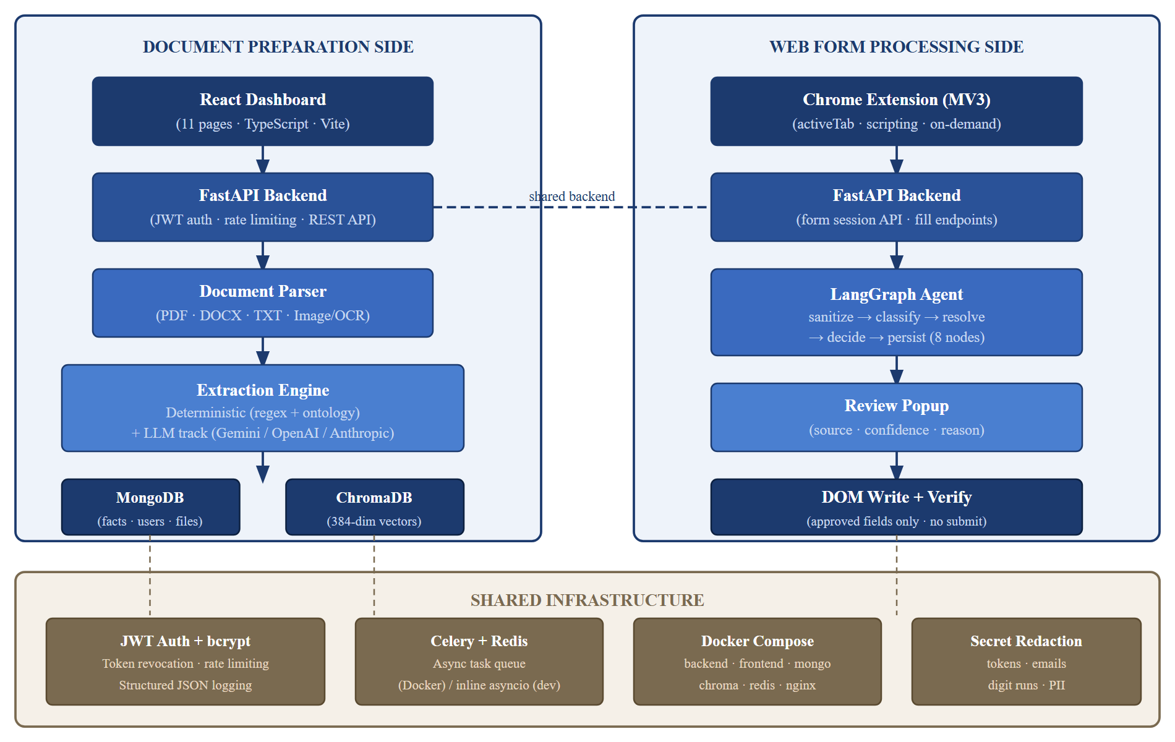
Fig. 3.1 — System Architecture: Document Preparation Side (left), Web Form Processing Side (right), and Shared Infrastructure (bottom).

3.1.2 Software Modules
The backend is organised into a small number of focused modules:

core/config.py
Implements Pydantic Settings-based configuration loading from environment variables and the .env file. All secrets (JWT secret key, LLM API keys, MongoDB URI) are validated at startup; missing required secrets raise an ImproperlyConfigured exception. The module provides a single settings singleton used throughout the application.

processing/pipeline.py
Implements the document processing pipeline as an async function chain: receive the uploaded file bytes and MIME type; delegate to the appropriate parser; segment the output into pages; run the deterministic extraction track; optionally run the LLM extraction track; merge and deduplicate facts with conflict detection; generate embeddings and upsert to ChromaDB; persist facts to MongoDB; update the document status to searchable.

agents/graph.py
Defines the LangGraph StateGraph with the following nodes: (1) sanitize — validates and normalises field descriptors, filters excluded types; (2) deterministic_classify — applies the ontology-based classifier; (3) llm_classify — submits unconfident fields to the LLM provider; (4) resolve_profile — queries MongoDB for facts of the matched concept; (5) resolve_documents — selects the highest-confidence non-conflicted fact; (6) decide — validates the selected value against field type constraints; (7) persist — writes fill decisions to the session record in MongoDB. A conditional edge bypasses llm_classify when all fields are confidently classified by the deterministic track.

services/facts.py
Provides CRUD operations for the fact store, including cross-document conflict detection. Conflict detection is computed on-the-fly from the active fact set rather than stored as a separate collection: for each concept, if more than one fact with distinct normalised values exists for the same user, a conflict record is generated.

db/chroma_client.py
Wraps the ChromaDB HTTP v2 API with user-scoped collection naming, model and dimension validation, and a 503-before-MongoDB failsafe if ChromaDB is unreachable.
Table 3.1 — Technology Stack with Justification
Component | Technology | Justification
Backend framework | FastAPI (Python 3.11) | Native async support, automatic OpenAPI documentation, Pydantic validation
Database | MongoDB 7 | Schema-flexible document model suits heterogeneous fact shapes; efficient per-user queries
Vector store | ChromaDB HTTP v2 | Self-hostable, HTTP API decouples client from server version
Embedding model | all-MiniLM-L6-v2 (384-dim) | Fast inference, strong semantic similarity at small dimensionality; runs on CPU
Agent orchestration | LangGraph | Stateful directed graph with per-node tools; deterministic execution order; checkpointing
LLM providers | Gemini / OpenAI / Anthropic (raw httpx) | No vendor lock-in; raw HTTP avoids SDK overhead; mock provider for offline testing
Task queue | Celery + Redis | Standard Python async task queue; inline asyncio mode for local dev without Docker
Frontend | React 19, TypeScript, Vite | Component model suits dashboard layout; TypeScript prevents a class of runtime errors
Extension | Chrome MV3, Vite | MV3 is the current platform standard; Vite produces optimised extension bundles
Containerisation | Docker Compose | Reproducible multi-service environment; single-command startup
Authentication | JWT + bcrypt | Stateless authentication; bcrypt with salt; token revocation via MongoDB blocklist

Table 3.2 — Minimum Hardware Requirements
Component | Local Development | Docker Compose (Production)
CPU | 4-core, 2.0 GHz (x86-64 or ARM64) | 4-core, 2.4 GHz
RAM | 8 GB (16 GB recommended for PaddleOCR) | 16 GB
Disk | 10 GB free (SSD recommended for vector index) | 20 GB SSD
GPU | Not required (CPU inference for embeddings) | Optional (accelerates OCR)
OS | Windows 10/11, macOS 12+, Ubuntu 20.04+ | Linux (Docker)
Browser | Google Chrome 120+ | N/A

3.2 Data Flow and Context

3.2.1 Context Diagram (Level-0)
The Context Diagram (Figure 3.2) provides the highest-level view of the system. It depicts the entire “Smart Form Auto-Filling System” as a single process, illustrates the system's boundary, and identifies the external actor (the User, acting through either the dashboard or the extension) and the primary data that flows between it and the system's stores.
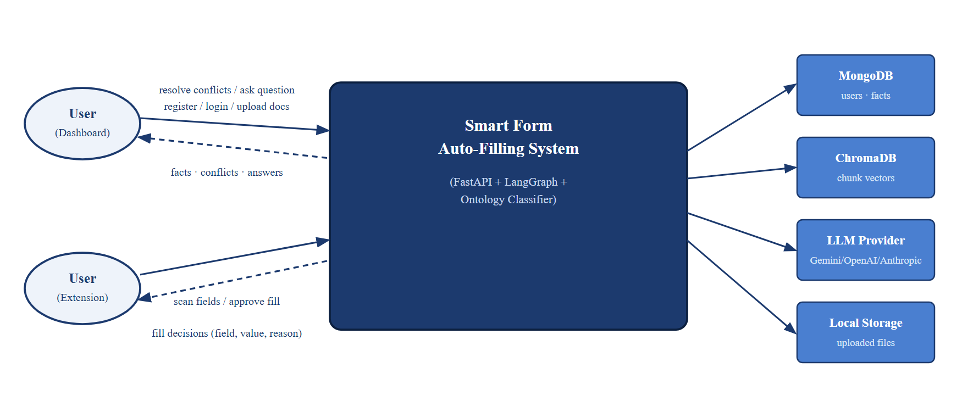
Fig. 3.2 — Context Diagram (Level-0)

3.2.2 Data Flow Diagram (Level-1)
The DFD Level-1 (Figure 3.3) “explodes” the context diagram to show the system's six top-level sub-processes — authentication, document management, fact extraction and storage, conflict detection and resolution, form-session field classification, and RAG question-answering — together with the five data stores each reads from or writes to.
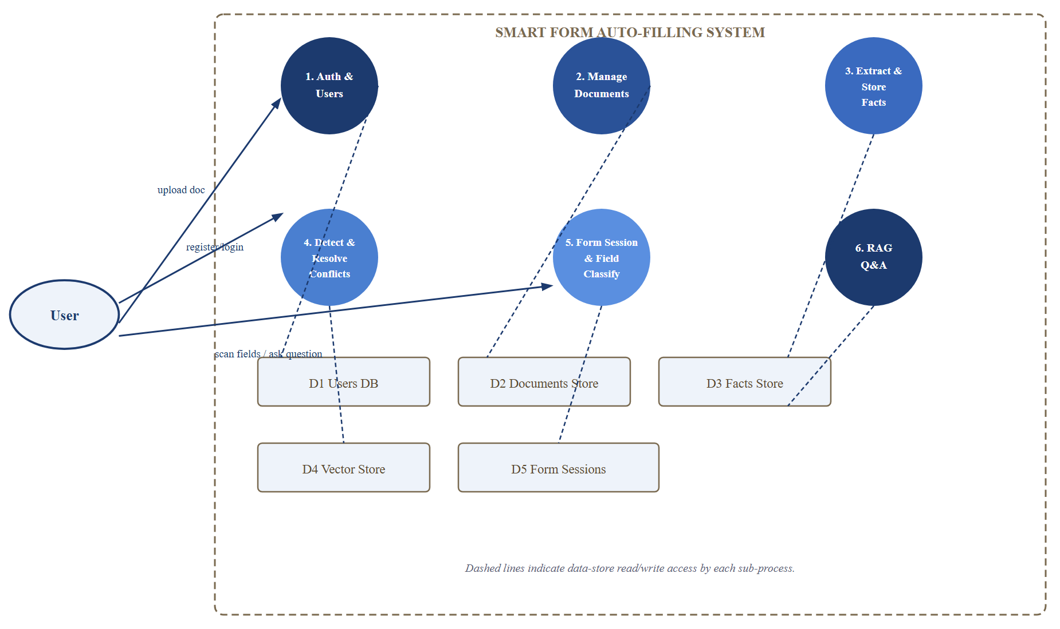
Fig. 3.3 — Data Flow Diagram — Level-1

3.2.3 Data Flow Diagram (Level-2)
The DFD Level-2 (Figure 3.4) decomposes the “Extract &amp; Store Facts” process from Level-1 into its six internal steps: parse document, deterministic extract, optional LLM extract, merge and detect conflicts, store facts, and embed and index chunks.
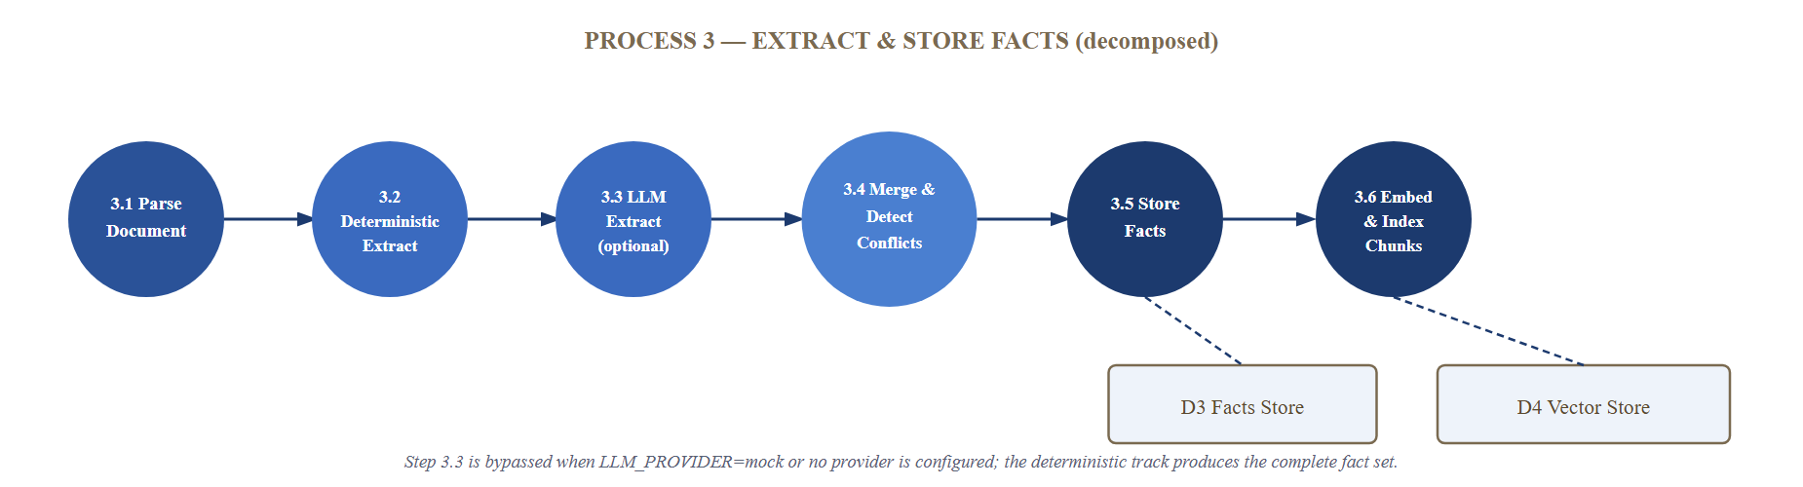
Fig. 3.4 — Data Flow Diagram — Level-2 (Extract & Store Facts)

3.3 Behavioral Flow

3.3.1 Use Case Diagram
The Use Case Diagram (Figure 3.5) summarises the system's functionality from the user's perspective. Because the system has a single authenticated role, all use cases attach to one User actor; «include» and «extend» relationships capture how scanning, reviewing, and filling a form compose, and how conflict resolution extends the fact-viewing flow.
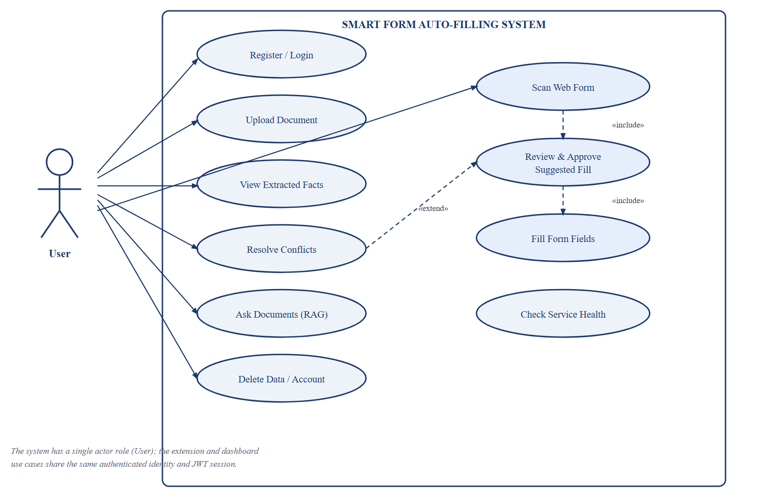
Fig. 3.5 — Use Case Diagram

3.3.2 Activity Diagram: User Uploads Document
Figure 3.6 models the document-upload workflow as a flowchart, showing the step-by-step actions and decision points — file type/size validation, parser selection, the deterministic and optional LLM extraction branches, merge and conflict detection, embedding and indexing, and the final status transition to searchable.
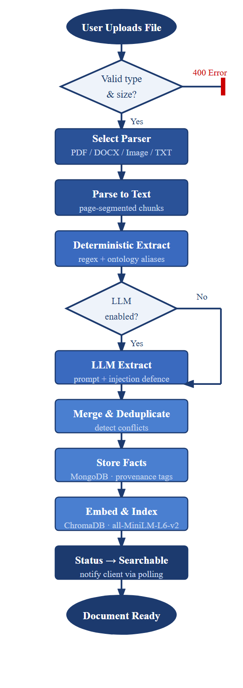
Fig. 3.6 — Activity Diagram: User Uploads Document

3.3.3 Activity Diagram: User Fills a Form via Extension
Figure 3.7 models the form-filling workflow from the moment the user clicks the extension icon through scanning, LangGraph analysis, review, filling, and verification, including the branch where a conflicted field is left blank and routed to the Conflicts page.
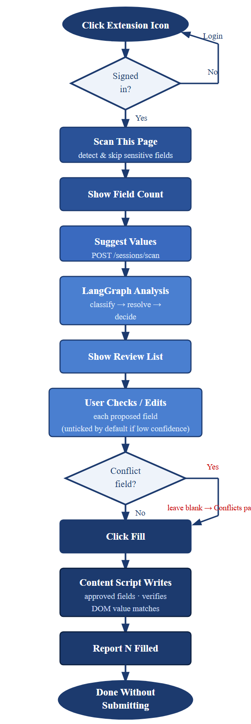
Fig. 3.7 — Activity Diagram: User Fills a Form via Extension

3.3.4 Sequence Diagrams
Sequence diagrams illustrate the time-ordered interactions and message exchanges between system components (client, API, services, databases) to accomplish a specific task. Figures 3.8 to 3.13 model the key scenarios in the system, showing exactly how the components “talk” to each other.
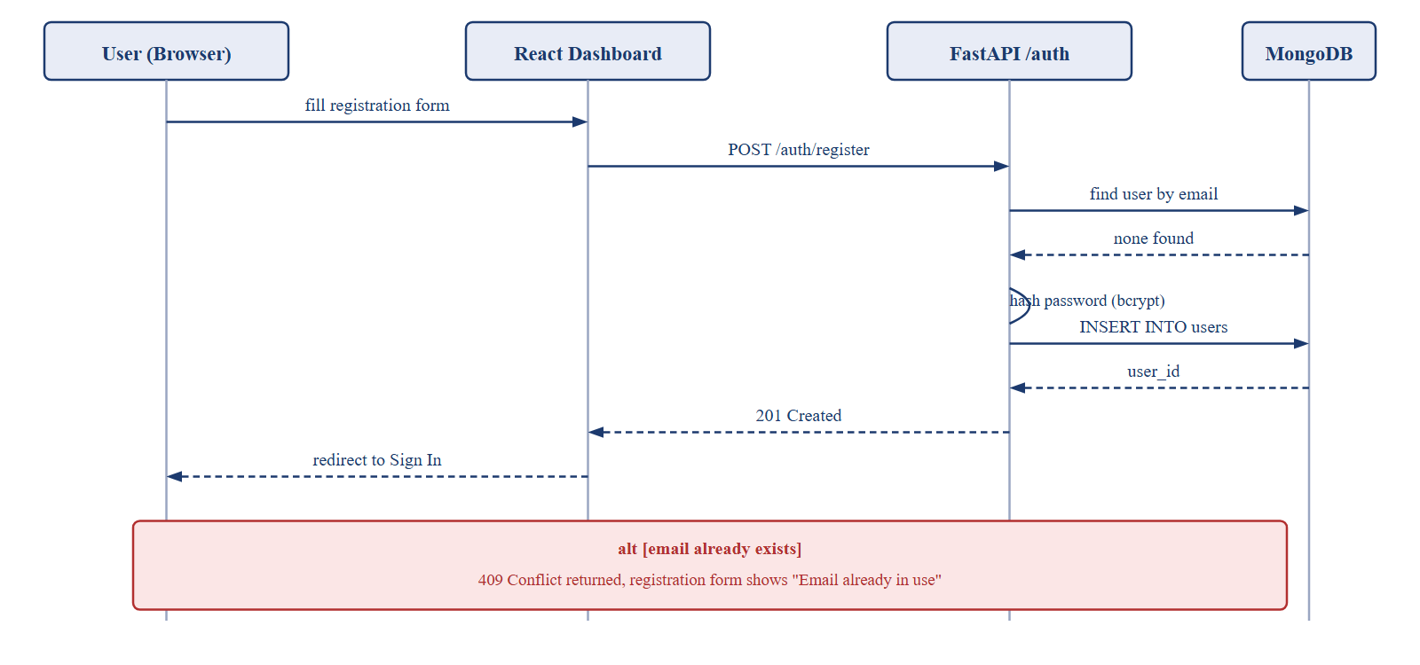
Fig. 3.8 — Sequence Diagram: User Registration
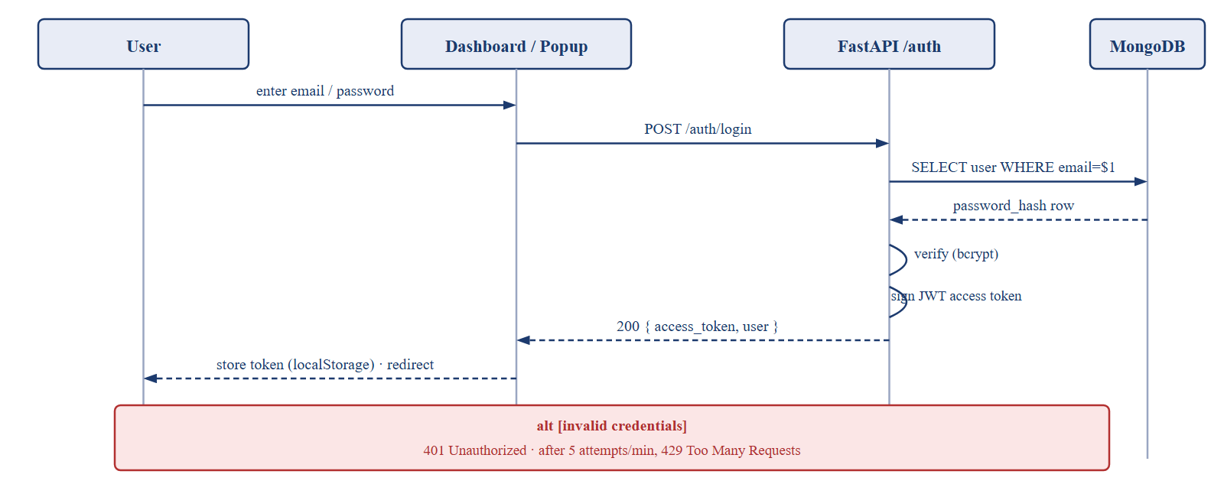
Fig. 3.9 — Sequence Diagram: User Login
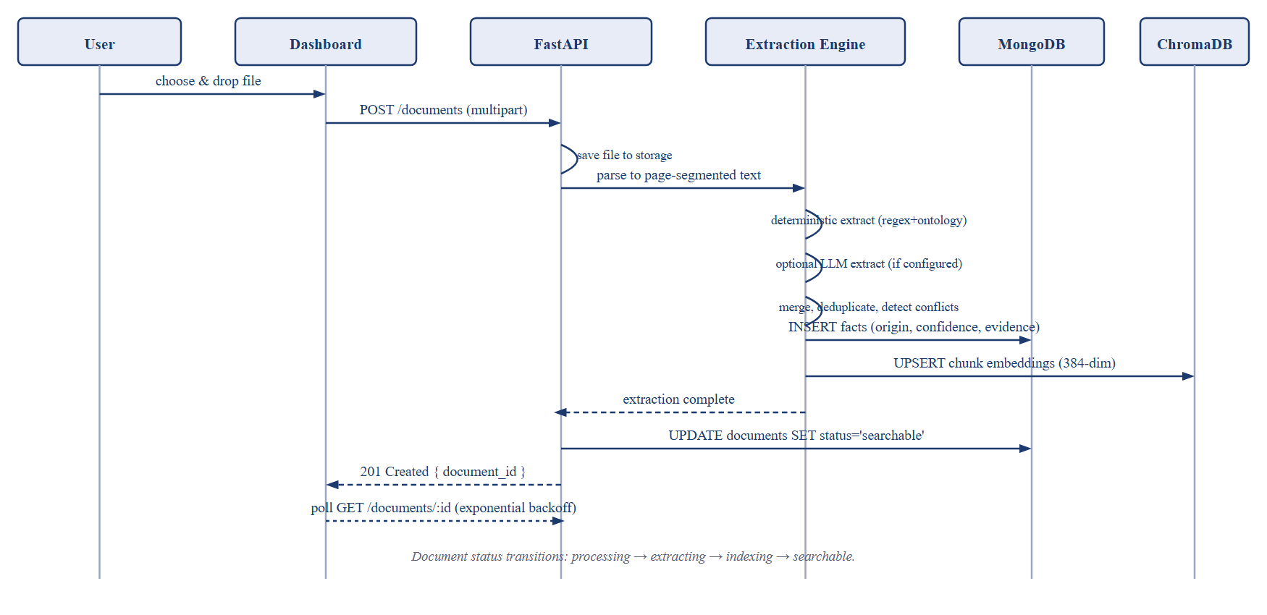
Fig. 3.10 — Sequence Diagram: Document Upload, Parse & Extract
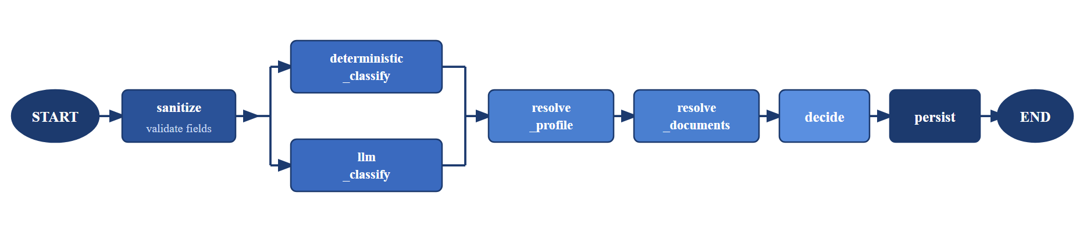
Fig. 3.11 — Sequence Diagram: LangGraph Field Classification (sanitize → classify → resolve → decide → persist)
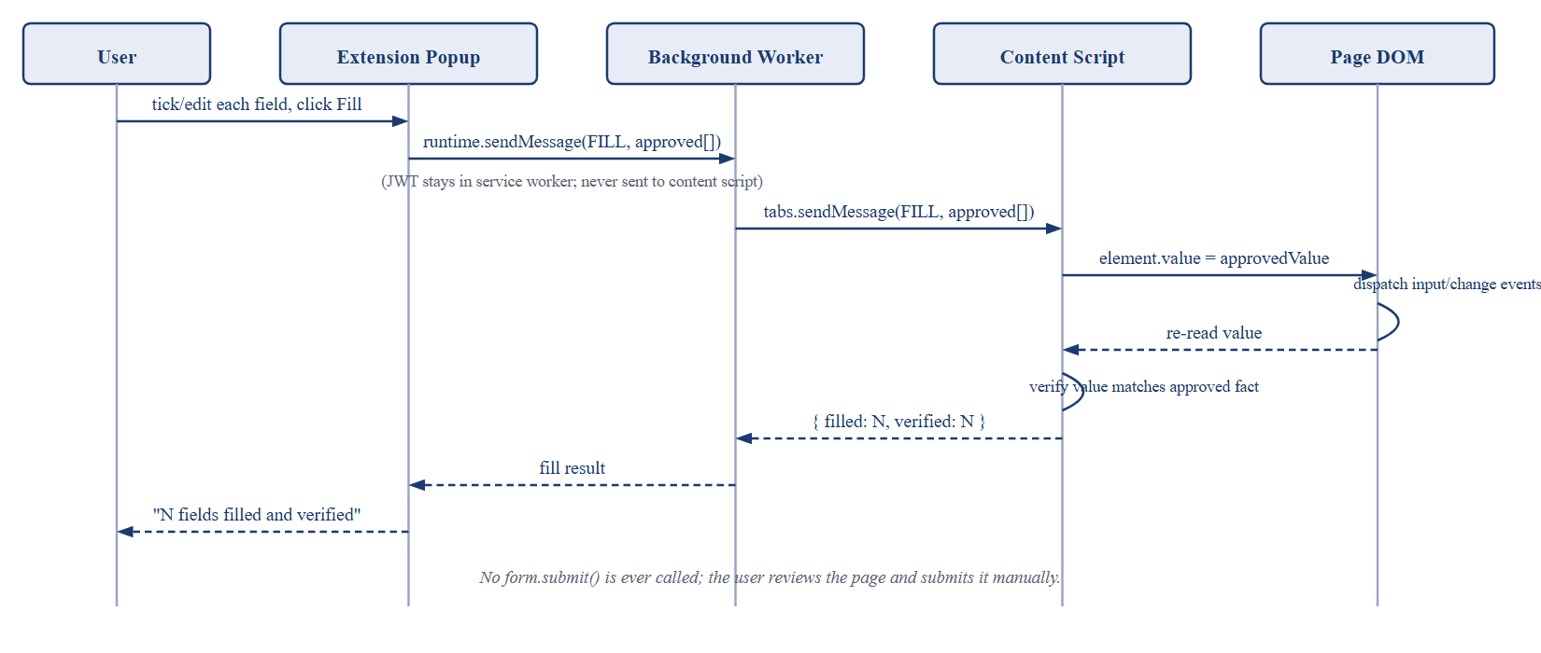
Fig. 3.12 — Sequence Diagram: Review & Fill (DOM Write + Verify)
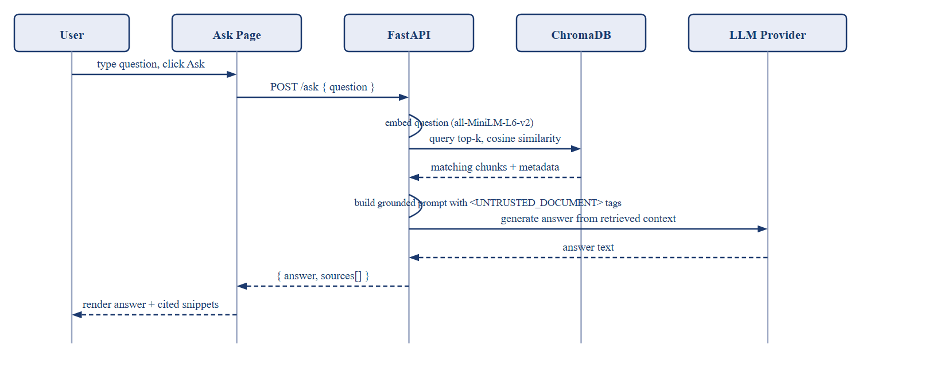
Fig. 3.13 — Sequence Diagram: RAG Document Q&A

3.4 Structural View

3.4.1 Entity-Relationship / Document-Model Diagram
The Entity-Relationship Diagram (Figure 3.14) is the blueprint for the system's persistent data. Because MongoDB is schema-flexible, the diagram shows a document-model view: the five core collections (users, documents, facts, form_sessions, token_blocklist), their key fields, and the relationships between them, alongside the parallel ChromaDB chunk index keyed by document_id.
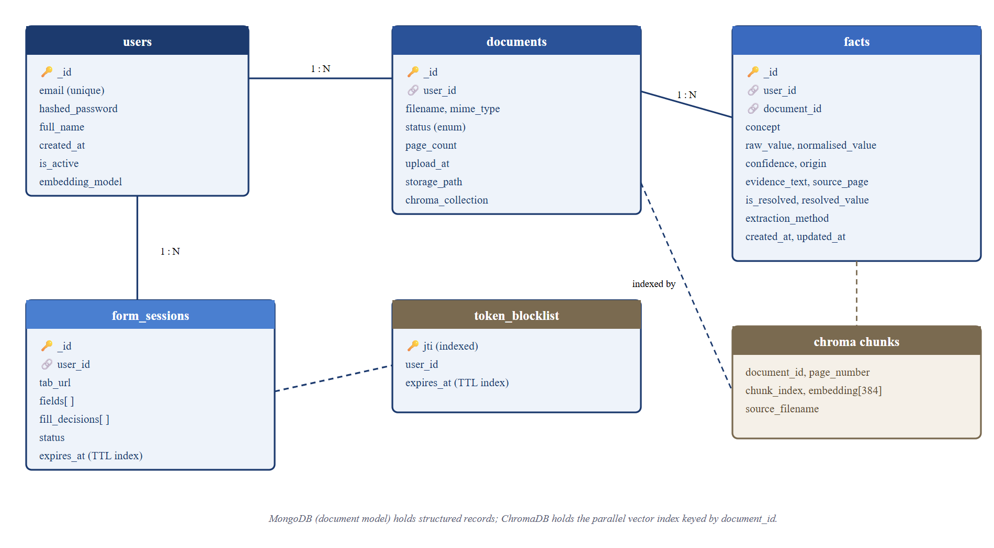
Fig. 3.14 — Entity-Relationship / Document-Model Diagram
Table 3.3 — MongoDB Collections Schema
Collection | Key Fields | Purpose
users | _id, email (unique), hashed_password, created_at, is_active | User accounts; bcrypt hashed passwords
token_blocklist | jti (unique, indexed), expires_at (TTL index) | Revoked JWTs; automatically purged by MongoDB TTL
documents | _id, user_id (indexed), filename, mime_type, status, page_count, upload_at, storage_path | Document metadata; status: pending/processing/extracting/indexing/searchable/failed
facts | _id, user_id (indexed), document_id, concept, raw_value, normalised_value, confidence, origin, evidence_text, source_page, is_resolved | Extracted facts with full provenance; compound index on (user_id, concept)
form_sessions | _id, user_id, tab_url, fields[], fill_decisions[], status, created_at, expires_at (TTL) | Per-tab form session state; auto-expires after 30 minutes

3.4.2 Class Diagram
The Class Diagram (Figure 3.15) provides a static, structural view of the system at the design level. It captures the key domain classes — User, Document, Fact, FormSession, FormField, FillDecision, and RAGAnswer — their attributes, their methods, and the associations between them, helping reason about the object-oriented design of the API's business logic and services.
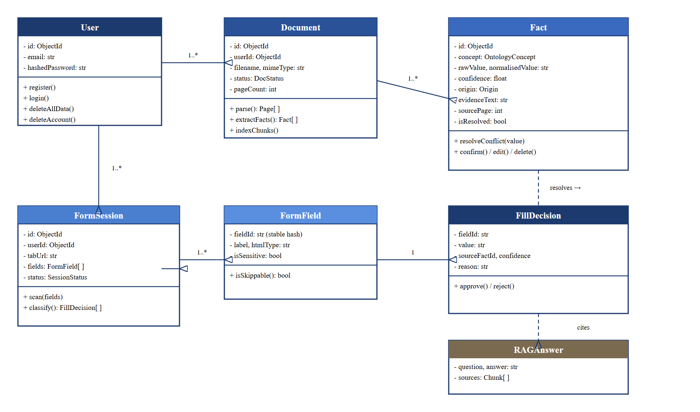
Fig. 3.15 — Class Diagram

3.4.3 Ontology Structure
The ontology is defined in backend/app/ontology/field_ontology.yaml as a YAML file with 300+ concept entries. Each entry has: concept name, category, canonical_label, aliases (list of label synonyms), regex_hints (list of regex patterns), normaliser (function name for value normalisation), and a sensitive flag. Table 3.4 lists the ten domain categories this ontology is organised into.
Table 3.4 — Ontology Domain Categories
Category | Examples of Concepts | Approx. Count
Personal Identity | full_name, date_of_birth, gender, nationality, mother_name, father_name | ~35
Contact | email_address, mobile_phone, home_phone, alternate_phone | ~12
Address | house_number, street_address, city, district, state, country, postal_pin_code | ~25
Government Identity | aadhaar_number, pan_number, passport_number, voter_id, driving_licence | ~18
Education | degree_name, institution_name, graduation_year, percentage_marks, cgpa, board_name | ~30
Professional Experience | designation, employer_name, joining_date, years_of_experience, skills | ~28
Financial | bank_account_number, ifsc_code, annual_income, monthly_salary | ~20
Health / Medical | blood_group, height_cm, weight_kg, medical_conditions | ~14
Sensitive (skip) | password, credit_card_number, cvv, otp, captcha_response | ~10
Document References | document_number, issue_date, expiry_date, issuing_authority | ~25
Total |  | ~300+

3.4.4 Chrome Extension State Machine
As a final structural view, Figure 3.16 shows the fill state machine the extension popup runs through: IDLE (awaiting user activation) → SCANNED (content script has collected field descriptors) → ANALYZING (backend running the LangGraph pipeline) → REVIEW (fill decisions presented) → FILLING (approved values being written to the DOM) → DONE (all writes verified). State is stored in chrome.storage.session keyed by tab ID, isolating concurrent fills on different tabs.
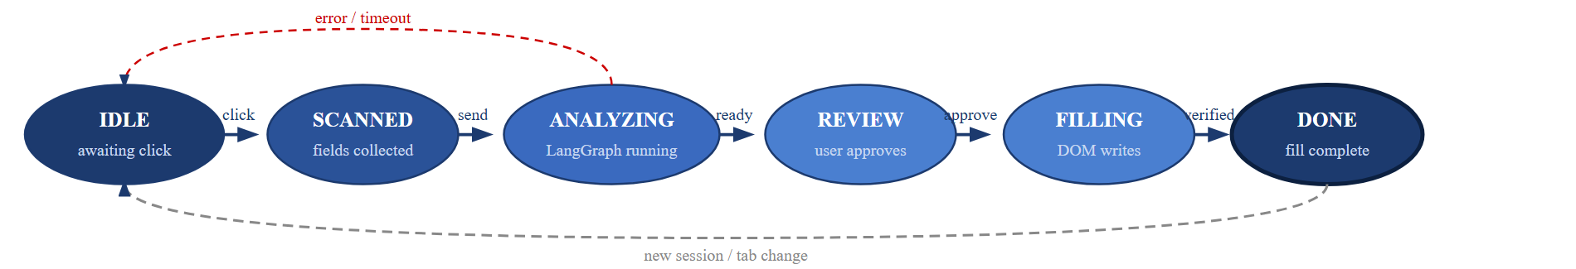
Fig. 3.16 — Chrome Extension Autofill State Machine
Chapter Summary: This chapter presented the system's architecture as a two-sided pipeline sharing a common backend, its data flow through three levels of DFD, its behaviour through a use-case diagram, two activity diagrams, and six sequence diagrams, and its structure through an entity-relationship diagram, a class diagram, and the ontology's domain categories — sixteen diagrams and four tables in total.
Chapter 4

Result and Analysis
Chapter Introduction: This chapter presents the results of the project's implementation. It provides a thorough evaluation of the developed system, starting with the final user interface and then moving to the formal testing methodology. The analysis concludes by showcasing the key outputs that represent the primary contributions of this work.

4.1 Implementation Results: The User Interface
The system's implementation is centred on a role-free, single-user dashboard and a companion Chrome extension that together cover the complete journey from signing in to filling a real web form. The dashboard is accessed through a JWT-authenticated login page (Figure 4.1); new users create an account through the registration form, and token expiry triggers an automatic redirect with a session-expired notification.
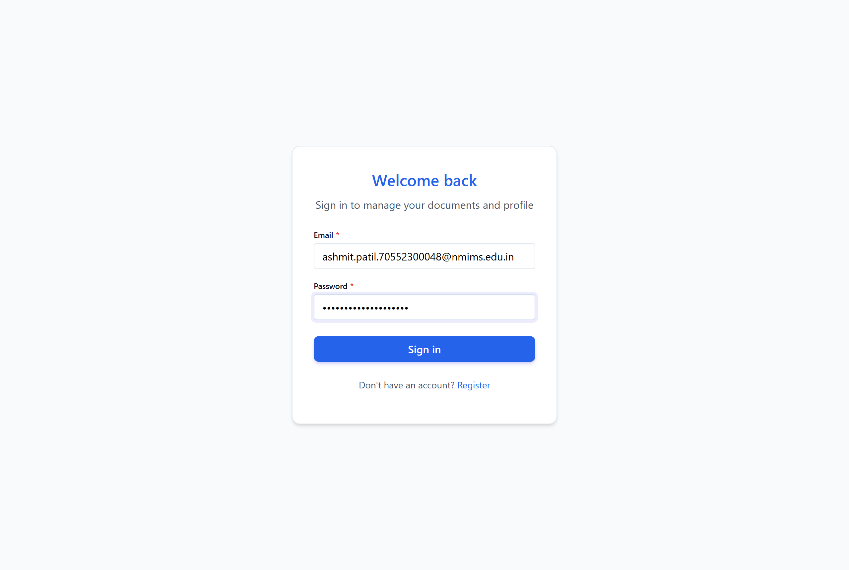
Fig. 4.1 — Login and Registration Screen
Once signed in, the dashboard (Figure 4.2) displays the total number of uploaded documents, the extracted-facts count, the unresolved conflict count, and a pending field-reviews count in four summary cards, followed by a recent-documents list and step-by-step guidance for filling a form with the browser extension.
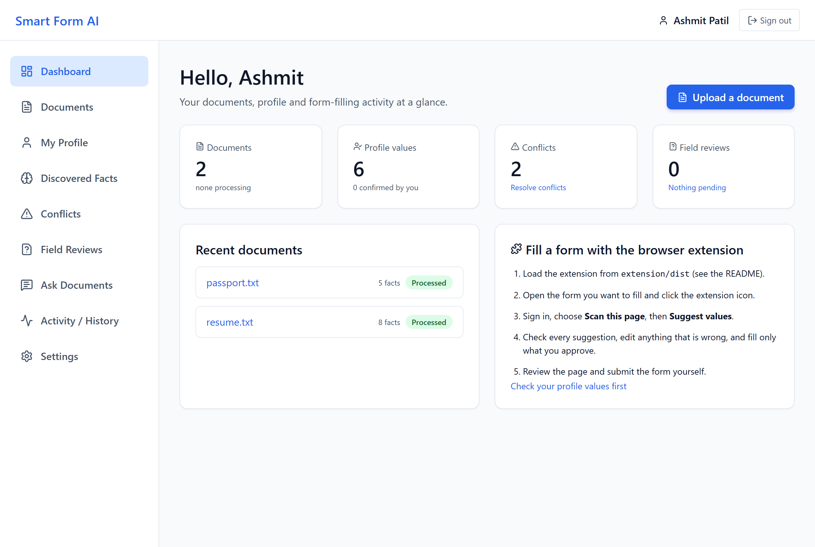
Fig. 4.2 — Dashboard Overview
The Documents page (Figure 4.3) provides a drag-and-drop upload zone accepting PDF, DOCX, TXT, and image files. Each document card shows its processing status, a running count of facts extracted from it, and whether it is searchable by the RAG module yet.
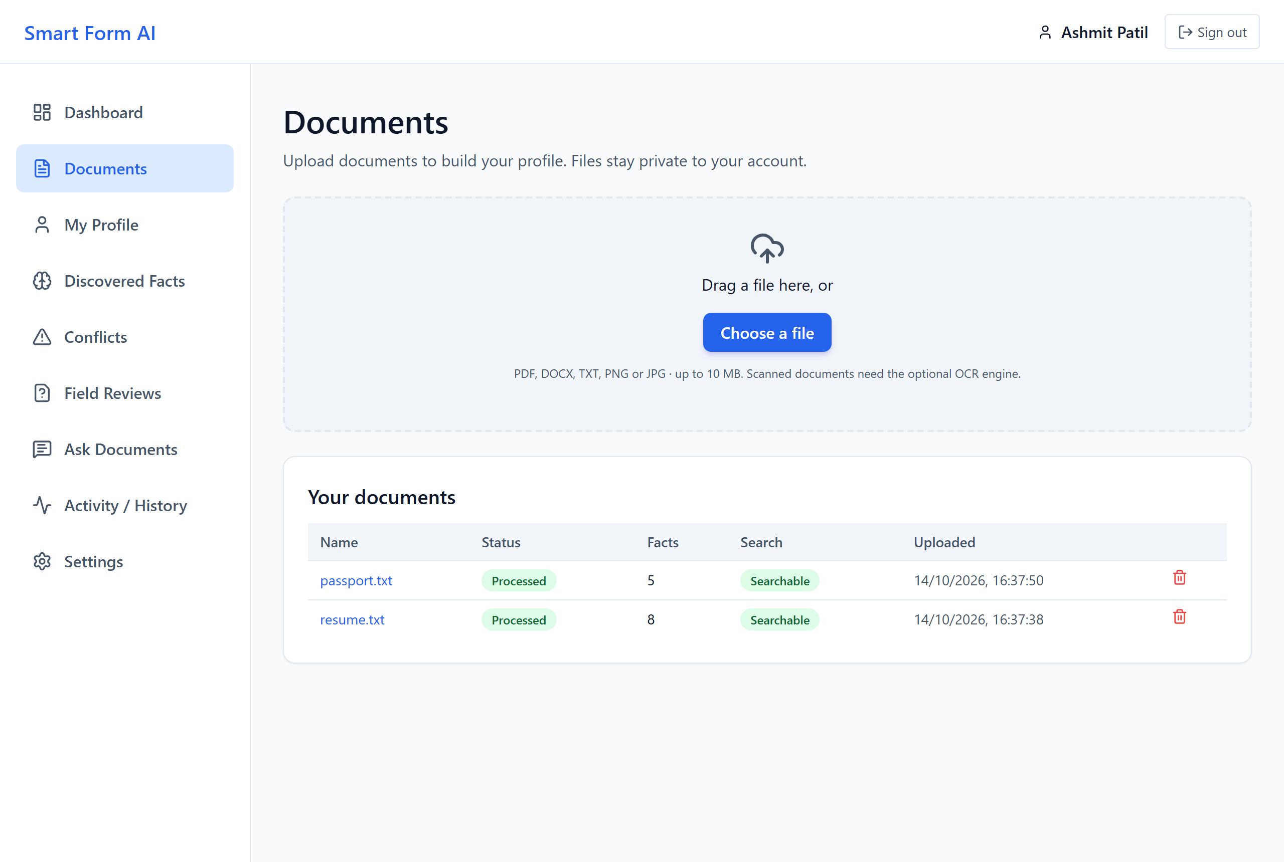
Fig. 4.3 — Document Upload and Processing Status
The Profile page (Figure 4.4) lists every extracted fact grouped by domain category. Each fact card shows the concept name, its normalised value, an origin/status pill (Extracted / Normalised / Sensitive / Conflicting values), the source document and page number, and Confirm, Edit, and Delete actions; sensitive concepts such as a passport number are masked behind a reveal toggle.
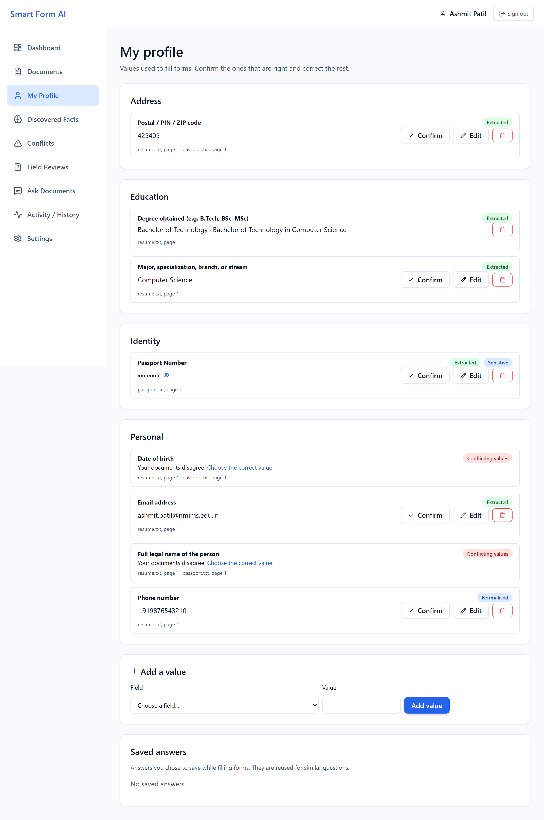
Fig. 4.4 — Profile Page: Extracted Facts with Provenance
The Conflicts page (Figure 4.5) shows one card per concept on which the user's documents disagree, listing each candidate value with its source document, confidence percentage, and the verbatim evidence text it was extracted from. The user selects the correct candidate, or enters a custom value, and clicks Save Choice to resolve it.
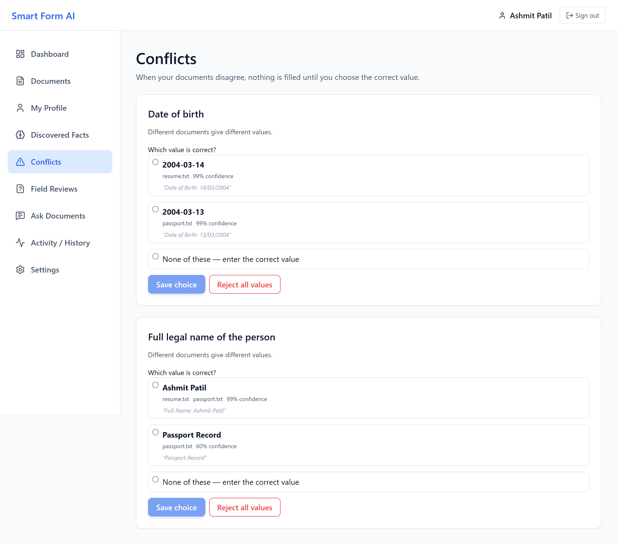
Fig. 4.5 — Conflict Detection and Resolution
On the web-form side, clicking the extension icon and choosing Scan This Page (Figure 4.6) reports the total number of fillable fields found and how many hidden, disabled, or sensitive fields — passwords, card numbers, one-time codes — were ignored, together with a Suggest Values button that triggers the LangGraph analysis.
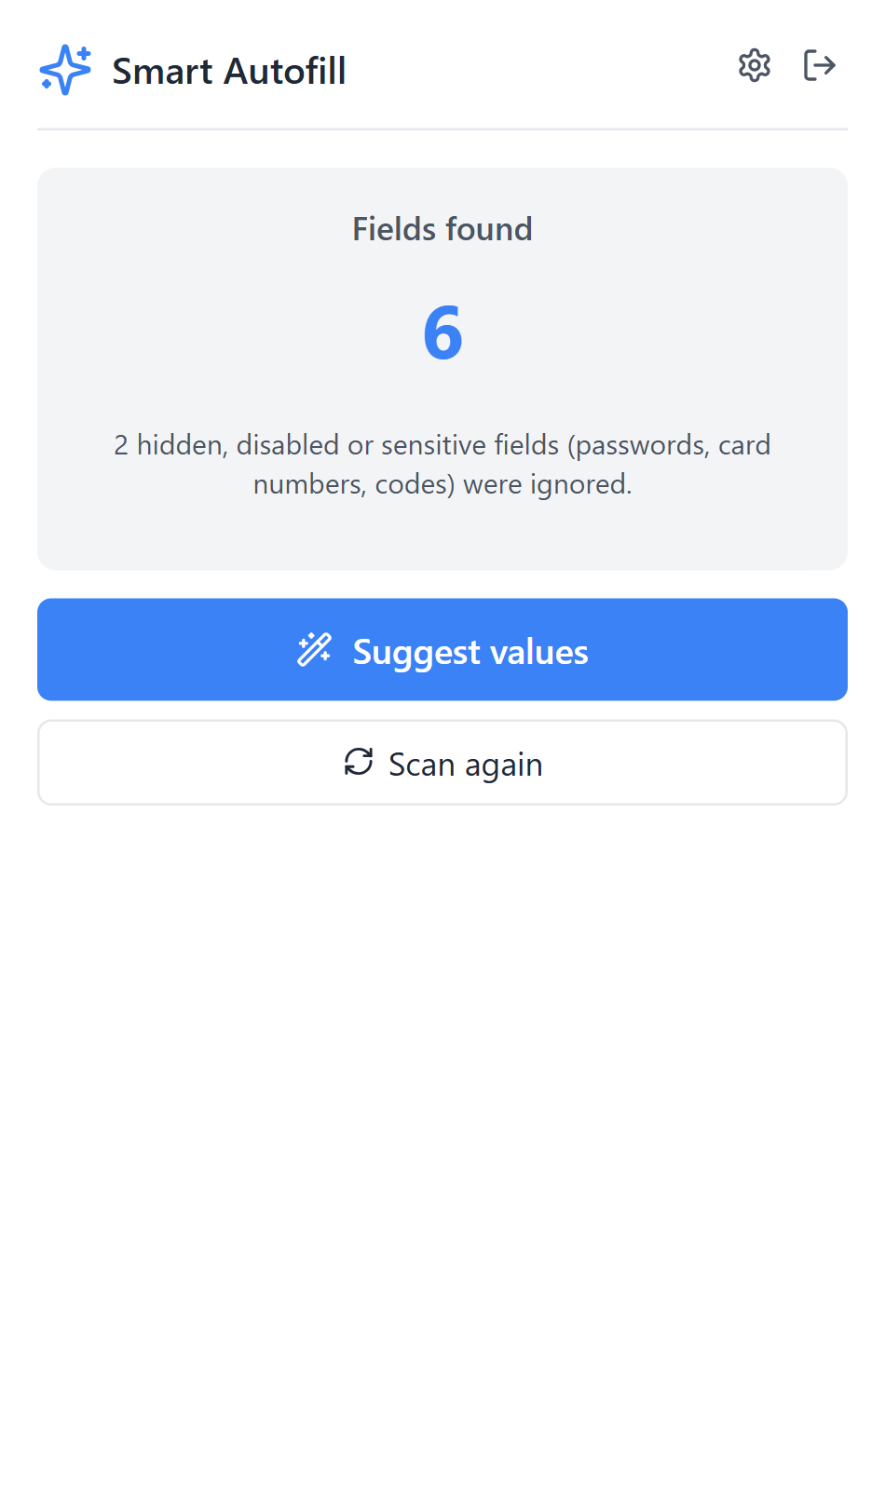
Fig. 4.6 — Extension Popup: Field Scan Result
After the LangGraph pipeline completes, the popup (Figure 4.7) shows each fillable field with its proposed value, the source document it was extracted from, a confidence percentage, and a Ready/Check status badge; a field on which the user's documents disagree is shown with its candidate values side by side so the user can pick one inline. The user ticks or unticks each field independently before clicking Fill.
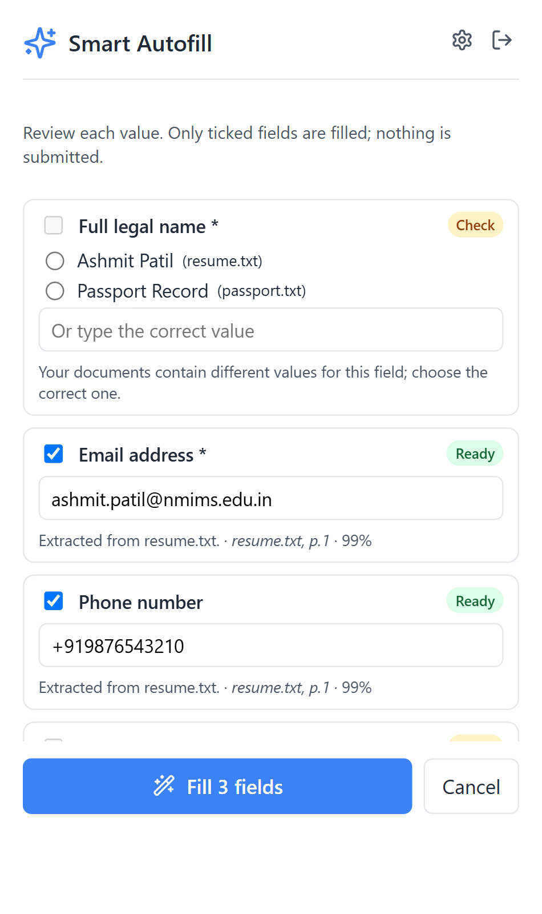
Fig. 4.7 — Extension Popup: Review Before Fill
The Ask page (Figure 4.8) supports natural-language queries over the document corpus. The system retrieves the top-k relevant chunks from ChromaDB using cosine similarity, constructs a grounded prompt, and calls the configured LLM; the answer is displayed with its cited source document, page number, and the exact snippet it was grounded in.
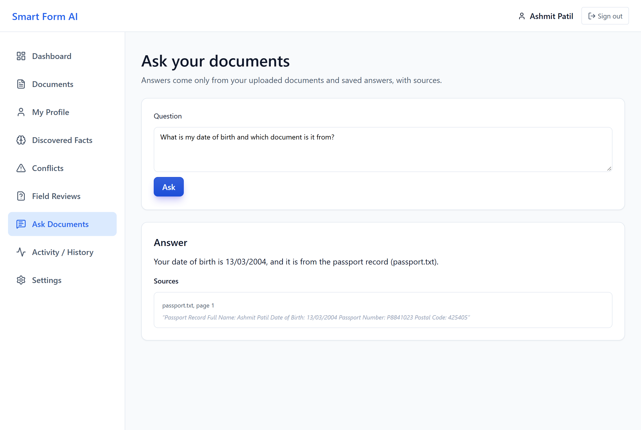
Fig. 4.8 — RAG Document Q&A (Ask Page)
Finally, the Settings page (Figure 4.9) reports live system status across Database, Document Search, and AI Provider tiles, plus an Embedding Model indicator, and exposes two confirmation-gated destructive actions: deleting all of a user's documents and extracted data while keeping the account, or deleting the account entirely.
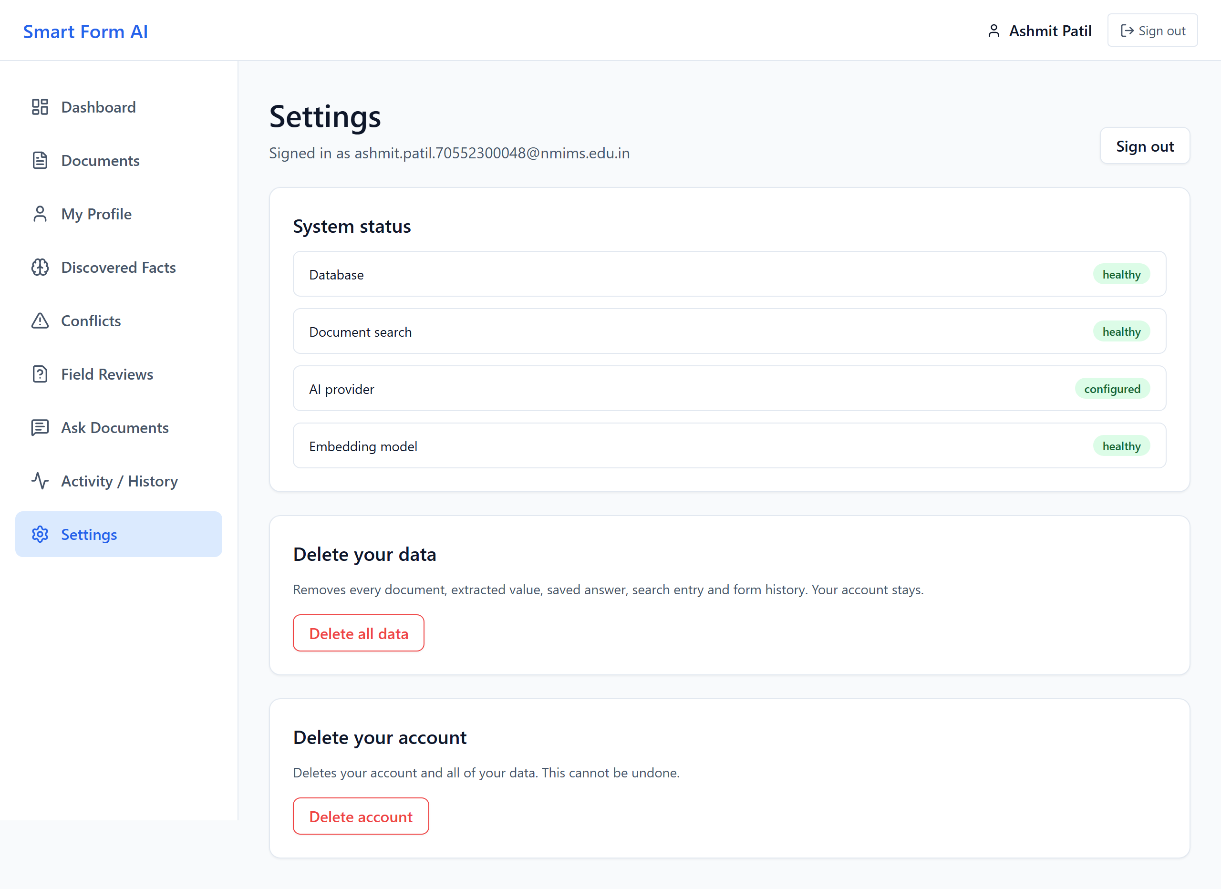
Fig. 4.9 — Service Health Dashboard (Settings)

4.2 System Evaluation and Testing
In order to confirm the quality and accuracy of the system, extensive, multi-level testing was used, organised into three layers: a mock environment (mock LLM provider, in-memory substitutes, no Docker), real-service integration (a real ChromaDB instance against the mock LLM), and a fully isolated end-to-end layer using Docker Compose and a real Playwright-controlled Chromium browser.
• Backend (pytest): Unit and integration testing was performed against pytest, covering authentication, document upload, deterministic extraction, the optional LLM extraction track, fact CRUD and conflict detection, RAG retrieval, the LangGraph pipeline, and security behaviour.
• Frontend (Vitest): Component and hook tests used Vitest and Testing Library to verify the login/register flow, document upload and polling, the profile fact cards, conflict resolution, and the Ask page.
• Extension (Vitest): Unit tests verified the field detector's sensitive-skip logic, stable field-ID determinism, the autofill writer across input types, and the extension's typed API client.
• Browser End-to-End (Playwright): A single Playwright test runs the real built extension against a real backend and MongoDB/ChromaDB instance, covering the full register → upload → scan → review → fill → verify flow, confirming no DOM submit() is ever triggered.

Table 4.1 — Backend Test Suite Breakdown (146 tests, all passed)
Test File | Scope | Key Scenarios Covered | Count
test_auth.py | Authentication | Register, login, invalid credentials, token revocation, rate limit (429), expired token | 18
test_documents.py | Document upload | Valid PDF upload, oversized file rejection, unsupported MIME type, status polling, delete cascade | 22
test_extraction.py | Deterministic extraction | Email extraction, phone normalisation, date parsing, postal code regex, sensitivity flag enforcement | 28
test_llm_extraction.py | LLM extraction track | Mock provider empty set, provider switching, JSON parse error, confidence threshold gating | 12
test_facts.py | Fact store CRUD | Create, read, update (resolve), delete; conflict detection; cross-user isolation | 24
test_rag.py | RAG Q&A | Chunk retrieval, cosine similarity ordering, empty corpus, injection-tagged quarantine | 16
test_pipeline.py | LangGraph agent | Full pipeline run (mock), sensitive field skip, conflict propagation, persist node write | 18
test_security.py | Security | Log redaction, prompt-injection tag presence, CORS headers, JWT injection attempt | 8
Total |  |  | 146

Table 4.2 — Frontend Test Coverage (22 tests, all passed)
Test File | Component / Hook | Key Scenarios | Count
LoginPage.test.tsx | LoginPage, RegisterPage | Form validation, API error display, redirect on success, 401 handler | 6
Documents.test.tsx | DocumentsPage, useUpload | Drag-and-drop, progress bar, status polling, failed document badge | 6
Profile.test.tsx | ProfilePage, FactCard | Origin pill colours, evidence text, inline edit form, confidence bar | 4
Conflicts.test.tsx | ConflictsPage | Conflict card rendering, radio selection, custom value, resolve API call | 4
Ask.test.tsx | AskPage | Query submission, answer display, sources accordion | 2
Total |  |  | 22

Table 4.3 — Extension Test Coverage (24 tests, all passed)
Test File | Module | Key Scenarios | Count
detector.test.ts | Field Detector | Password/payment/OTP/hidden/off-screen/honeypot skip; stable ID determinism; label extraction | 12
autofill.test.ts | Autofill Writer | Text input, select option, checkbox, radio, date (ISO), textarea, DOM verify after write | 8
api.test.ts | Extension API Client | Timeout (AbortController), 401 refresh, retry on network error, message envelope parsing | 4
Total |  |  | 24

Table 4.4 — Overall Test Results Summary
Suite | Tool | Environment | Tests | Passed | Failed | Duration
Backend (mock) | pytest | In-memory (no Docker) | 146 | 146 | 0 | ~85 s
ChromaDB integration | pytest | Real ChromaDB (Docker) | 3 | 3 | 0 | ~12 s
Frontend | Vitest | jsdom | 22 | 22 | 0 | ~8 s
Extension | Vitest | jsdom + chrome-mock | 24 | 24 | 0 | ~6 s
Browser E2E | Playwright | Real Chromium + Docker Compose | 1 | 1 | 0 | ~4 min
Total |  |  | 196 | 196 | 0 | —

Security-specific testing was also performed: a log-redaction check verifies that the structured JSON logger never emits raw JWTs, emails, or long digit runs; a prompt-injection quarantine test uploads a document containing “Ignore previous instructions...” and confirms it is flagged and excluded from the LLM prompt rather than executed; and a rate-limit test submits eleven consecutive failed logins within one second and confirms the eleventh is rejected with 429 Too Many Requests.

4.3 Analysis of Key Outputs (Contribution)
The actual outcome of the project lies in its capacity to turn raw, scattered documents into trustworthy, reviewable form-filling decisions. The main outputs, being the system's primary contribution, are:
• Extracted Facts Report: The Profile page (Figure 4.4, above) processes every extracted fact and presents its origin, confidence, and evidence so the user can see at a glance which values the system is sure of and which it inferred.
• Conflict Resolution Evidence: The Conflicts page (Figure 4.5, above) presents a thorough, document-to-value trace for every field on which the user's documents disagree, giving auditable evidence of exactly why a value was or was not auto-filled.
• Autofill Decision Output: The extension's review list (Figure 4.7, above) is the system's generated fill decision set: for every field it states the proposed value, its source document, its confidence, and whether it is ready to fill or needs the user's attention — turning a black-box autofill into an inspectable one.
• Grounded RAG Answer: The Ask page (Figure 4.8, above) is the system's generated-answer output: a natural-language response grounded in, and citing, the user's own uploaded documents rather than a generic model answer.

Chapter Summary: This chapter presented the complete user interface across nine real screenshots of the running system and its browser extension, documented five test suites totalling 196 automated tests (all passed), and analysed the four generated outputs that represent the system's core contribution.
Chapter 5

Advantage, Limitations and Applications
Chapter Introduction: This chapter analyses the primary benefits and potential drawbacks of the implemented system. It also discusses the various contexts in which this platform can be applied.

5.1 Advantages
The implementation of the Smart Form Auto-Filling System yields several immediate and significant advantages over native browser autofill and manual form entry:
• Document Intelligence: Extracts structured facts from uploaded PDF certificates, DOCX résumés, and scanned identity cards, far beyond what name-attribute heuristics can match.
• Full Provenance: Every stored fact records its origin document, source page, raw evidence text, confidence score, and derivation method, so nothing is a black box.
• Conflict Transparency: Disagreements between documents are surfaced to the user rather than silently resolved, preventing a wrong value from being filled with false confidence.
• Human-in-the-Loop Fill: The extension never writes to the DOM without explicit, per-field user approval.
• Privacy-First Extension Model: The extension requests activeTab permission only when the user clicks the fill button; it never passively scans every page the user visits.
• Injection Defence: All document content passed to the LLM is wrapped in <UNTRUSTED_DOCUMENT> tags and screened by a pattern-detection filter before every call.
• RAG Q&A: Users can ask natural-language questions about their documents and receive grounded answers with cited source pages, turning stored documents into a searchable knowledge base.

5.2 Limitations
Despite its merits, the following limitations are recognised as inherent in the present system:
• OCR Is Optional: Scanned, image-only documents require the optional PaddleOCR engine (INSTALL_OCR=true); without it such documents are marked requires_review rather than auto-extracted.
• Heterogeneous Form Structures: Form field labels are drawn from an unconstrained vocabulary, so a field with no label text or an unusual phrasing may not match any ontology concept and will be left for manual entry.
• Single-Browser Support: The extension currently targets Google Chrome via Manifest V3; Firefox, Safari, and mobile browsers are not yet supported.
• Static-DOM Scanning: A MutationObserver-based re-scan is not yet implemented, so fields injected into the page after the initial scan (e.g. a multi-step wizard) require the user to click Scan This Page again.
• LLM Track Cost and Availability: The LLM extraction track depends on an external provider (Gemini, OpenAI, or Anthropic) and incurs API latency and cost when enabled; the deterministic track alone handles the common case.

5.3 Applications
This system applies to more than one domain. Its application could reach a wider scope to include:
• Government Services: Citizens can pre-populate Aadhaar enrolment, PAN application, and voter-registration forms directly from their identity documents.
• Banking and Finance: KYC updates, loan applications, and account-opening forms can be filled from PAN, Aadhaar, and income documents with full provenance for compliance review.
• University Admissions: Students can fill B.Tech/M.Tech application portals from their academic qualification certificates and mark sheets.
• Employment: Job seekers can fill employer application portals from the structured fields of their own résumé.
• Insurance and Healthcare: Insurance policy applications and hospital registration forms can be pre-filled from identity and medical documents, with sensitive fields (payment, OTP) always skipped.
• Scholarship Portals: Income certificate values, caste certificates, and marks can populate central and state scholarship application forms.

Chapter Summary: The system's single-point-of-truth document intelligence, full provenance, and human-in-the-loop fill were presented as its principal advantages; OCR dependency, single-browser support, and static-DOM scanning were presented as its acknowledged limitations; and six application domains — from government services to scholarship portals — were identified.
Chapter 6

Conclusion and Future Scope
Chapter Introduction: This final chapter provides a brief summary of the work carried out, the conclusions derived from the analysis, and the scope for future work on this project.

6.1 Conclusion
This project set out to design and implement a privacy-first, document-driven system that allows users to populate web forms from their own verified documents, instead of re-typing the same personal details into form after form or trusting a browser's shallow name-attribute autofill. The system was designed around a “single-point-of-truth” fact store: documents are parsed once, extracted through a dual deterministic-plus-LLM track, and every value carries full provenance so the user always knows where it came from and how confident the system is in it.
The six principal contributions stated in Chapter 1 have all been delivered and verified: a 300+-concept YAML ontology spanning eight personal-information domains; a dual-track extraction pipeline with complete fact provenance; an eight-node LangGraph batch pipeline with prompt-injection defence; a Manifest V3 Chrome extension that requests permissions only on demand and never auto-submits a form; a RAG-based document Q&A module with cited, grounded answers; and 196 automated tests spanning five independent test suites, all of which pass, including a real browser end-to-end test against the actual built extension.
The key advantages realised by the system are document intelligence well beyond what native browser autofill provides, transparent cross-document conflict detection instead of silent, possibly wrong resolution, and a human-in-the-loop fill flow that puts the user in control of every value written to a page. This work confirms that a well-designed, document-grounded system can transform the repetitive burden of web-form data entry into a fast, auditable, and privacy-respecting workflow.

6.2 Future Scope
The following directions are identified for future development, ordered by estimated impact:
1. PaddleOCR integration as a first-class feature: packaging PaddleOCR into a separate optional sidecar container would make scanned-document extraction available without inflating the main backend image.
2. Firefox extension port: Firefox supports Manifest V3 as of version 121; the primary effort would be adapting the service-worker lifecycle differences.
3. Dynamic form support: a MutationObserver-based re-scan trigger would detect dynamically added fields without requiring the user to re-click Scan This Page.
4. Mobile companion application: a React Native or Flutter companion app could extend document upload and fact management to mobile devices.
5. Multi-language ontology: extending alias lists to cover Hindi, Marathi, and other scheduled languages would make the deterministic track useful for a wider population.
6. Federated / on-device embedding models: running the embedding model on-device (via WebAssembly or a local model server) would remove the need to send document text to any external service for RAG.
7. Automated ontology expansion: using an LLM to propose new aliases and concepts from a corpus of web-form labels, reviewed and approved by a maintainer before merging.
8. Structured audit log: an immutable per-user audit log of all fill events would support compliance and accountability requirements for institutional deployments.
Chapter Summary: The project has successfully delivered all six contributions specified in Chapter 1, verified by 196 passing automated tests including a real browser end-to-end run. Future work is directed primarily at first-class OCR support, broader browser coverage, dynamic-form handling, and deeper on-device privacy guarantees.
References
Note: Authors, titles and page numbers should be verified against publisher records before final submission.
[1] S. Zhou, F. Xu, H. Zhu, X. Zhou, R. Lo, A. Sridhar, X. Cheng, Y. Bisk, D. Fried, U. Alon, G. Neubig, "WebArena: A Realistic Web Environment for Building Autonomous Agents," in Proc. International Conference on Learning Representations (ICLR), Vienna, Austria, 2024, pp. 1–36.
[2] X. Deng, Y. Gu, B. Zheng, S. Chen, S. Stevens, B. Wang, H. Sun, Y. Su, "Mind2Web: Towards a Generalist Agent for the Web," in Proc. NeurIPS Datasets and Benchmarks Track, New Orleans, USA, 2023, pp. 1–23.
[3] B. Zheng, B. Gou, J. Kil, H. Sun, B. Su, "GPT-4V(ision) is a Generalist Web Agent, if Grounded," in Proc. 41st International Conference on Machine Learning (ICML), vol. 235, PMLR, Vienna, Austria, 2024, pp. 60084–60107.
[4] H. He, W. Yao, K. Ma, W. Yu, Y. Dai, H. Zhang, Z. Lan, D. Yu, "WebVoyager: Building an End-to-End Web Agent with Large Multimodal Models," in Proc. 62nd Annual Meeting of the Association for Computational Linguistics (ACL), Bangkok, Thailand, 2024, pp. 849–868.
[5] W. Hong, W. Wang, Q. Lv, J. Xu, W. Yu, J. Ji, Y. Wang, Z. Wang, Y. Zhang, J. Li, B. Xu, Y. Dong, M. Ding, J. Tang, "CogAgent: A Visual Language Model for GUI Agents," in Proc. IEEE/CVF Conference on Computer Vision and Pattern Recognition (CVPR), Seattle, USA, 2024, pp. 14281–14290.
[6] K. Cheng, Q. Sun, Y. Chu, F. Xu, L. Li, Z. Chen, J. Luo, "SeeClick: Harnessing GUI Grounding for Advanced Visual GUI Agents," in Proc. 62nd Annual Meeting of the Association for Computational Linguistics (ACL), Bangkok, Thailand, 2024, pp. 11118–11130.
[7] K. You, H. Zhang, L. Schoop, F. Weers, A. Swearngin, J. Nichols, Y. Yang, Z. Shi, "Ferret-UI: Grounded Mobile UI Understanding with Multimodal LLMs," in Proc. 18th European Conference on Computer Vision (ECCV), Milan, Italy, 2024, pp. 240–255.
[8] A. Drouin, M. Gasse, M. Caccia, I. H. Laradji, M. Del Verme, T. Marty, L. Boisvert, M. Thakkar, Q. Cappart, N. Chapados, Y. Bengio, A. Lacoste, "WorkArena: How Capable Are Web Agents at Solving Common Knowledge Work Tasks?," in Proc. 41st International Conference on Machine Learning (ICML), vol. 235, PMLR, Vienna, Austria, 2024, pp. 11642–11658.
[9] R. Pan, C. Zhang, Z. Liu, Y. Wang, M. Sun, "LCoW: Learning to Correct Web Agent Trajectories via Feedback-Guided Refinement," in Proc. International Conference on Learning Representations (ICLR), Singapore, 2025, pp. 1–28.
[10] D. Zhang, R. He, J. Xu, B. Wang, Y. Lin, J. Tang, "GUI Agents: A Survey," in Findings of the Association for Computational Linguistics (Findings of ACL), Vienna, Austria, 2025, pp. 1042–1073.
[11] L. Wang, C. Ma, X. Feng, Z. Zhang, H. Yang, J. Zhang, Z. Chen, J. Tang, X. Chen, Y. Lin, W. X. Zhao, Z. Wei, J. Wen, "A Survey on Large Language Model based Autonomous Agents," Frontiers of Computer Science, vol. 18, no. 6, p. 186345, 2024. DOI: 10.1007/s11704-024-40231-1.
[12] S. Pan, L. Luo, Y. Wang, C. Chen, J. Wang, X. Wu, "Unifying Large Language Models and Knowledge Graphs: A Roadmap," IEEE Transactions on Knowledge and Data Engineering, vol. 36, no. 7, pp. 3580–3599, Jul. 2024. DOI: 10.1109/TKDE.2024.3352100.
[13] G. Xiong, Z. Jin, X. L. Wang, Y. Zhang, "HippoRAG: Neurobiologically Inspired Long-Term Memory for Large Language Models," in Proc. 38th Conference on Neural Information Processing Systems (NeurIPS), Vancouver, Canada, 2024, pp. 1–28.
[14] Z. Zhang, B. Bo, C. Ma, R. Li, Z. Chen, D. Dai, Z. Li, W. X. Zhao, J. Wen, "A Survey on the Memory Mechanism of Large Language Model based Agents," ACM Transactions on Information Systems, vol. 43, no. 1, pp. 1–47, Jan. 2025. DOI: 10.1145/3703155.
[15] Y. Xu, Z. Xu, B. Liao, B. Li, W. Bao, J. Du, "Form Understanding in Scanned Documents: A Survey," Artificial Intelligence Review, vol. 57, no. 4, pp. 1–42, Apr. 2024. DOI: 10.1007/s10462-024-10730-3.
[16] A. Liao, T. Rezk, N. Li, "Leaky Autofill: Security and Privacy Implications of Browser Form Autofill Mechanisms," in Proc. Annual Computer Security Applications Conference (ACSAC), Honolulu, USA, 2024, pp. 345–358. DOI: 10.1145/3677739.3677751.
[17] Z. Chen, L. Xu, S. Zhao, Z. Yang, J. Ma, C. Zhu, "FormLM: Enriching Form Understanding with Natural Language Knowledge," in Proc. Conference on Empirical Methods in Natural Language Processing (EMNLP), Abu Dhabi, UAE, 2022, pp. 2871–2883.
[18] Y. Guo, Y. Zhang, H. Cai, H. Chen, "LAFF: Automated Filling of Categorical Fields via Large Language Models with Constraint Handling," ACM Transactions on Software Engineering and Methodology, vol. 33, no. 1, pp. 1–32, Jan. 2024. DOI: 10.1145/3617182.
[19] K. Wang, B. Yin, L. Zhao, J. Chen, "FormNexus: Semantic Constraint Inference for Web Form Auto-Population," in Proc. ACM SIGSOFT International Symposium on Software Testing and Analysis (ISSTA), Vienna, Austria, 2024, pp. 223–235. DOI: 10.1145/3650212.3680362.
Appendix A: Sample Code

A.1 LangGraph Agent Graph Definition (agents/graph.py, abbreviated)
from langgraph.graph import StateGraph, END
from .nodes import (sanitize, deterministic_classify,
llm_classify, resolve_profile,
resolve_documents, decide, persist)
from .state import FormFillState

def build_graph() -> StateGraph:
g = StateGraph(FormFillState)
g.add_node("sanitize", sanitize)
g.add_node("deterministic_classify", deterministic_classify)
g.add_node("llm_classify", llm_classify)
g.add_node("resolve_profile", resolve_profile)
g.add_node("resolve_documents", resolve_documents)
g.add_node("decide", decide)
g.add_node("persist", persist)
g.set_entry_point("sanitize")
g.add_edge("sanitize", "deterministic_classify")
g.add_conditional_edges(
"deterministic_classify",
lambda s: "llm_classify" if s.needs_llm else "resolve_profile",
{"llm_classify": "llm_classify",
"resolve_profile": "resolve_profile"},
)
g.add_edge("llm_classify", "resolve_profile")
g.add_edge("resolve_profile", "resolve_documents")
g.add_edge("resolve_documents", "decide")
g.add_edge("decide", "persist")
g.add_edge("persist", END)
return g.compile()

A.2 Field Detector Sensitive-Skip Logic (extension/src/content/detector.ts, abbreviated)
const SKIP_TYPES = new Set([
"password","hidden","submit","reset","button","image","file"
]);
const SKIP_AUTOCOMPLETE = /^(cc-|one-time-code|new-password)/i;
const SKIP_CLASS = /(captcha|honeypot|trap|hpf)/i;

export function isSkippable(el: HTMLInputElement): boolean {
if (SKIP_TYPES.has(el.type)) return true;
if (SKIP_AUTOCOMPLETE.test(el.autocomplete ?? "")) return true;
if (SKIP_CLASS.test(el.className + el.id)) return true;
const rect = el.getBoundingClientRect();
if (rect.width === 0 || rect.height === 0) return true;
return false;
}

A.3 Prompt-Injection Defence (processing/extractor.py, abbreviated)
INJECTION_PATTERNS = re.compile(
r"(ignore previous|disregard all|system prompt|act as|"
r"jailbreak|DAN mode|pretend you are)",
re.IGNORECASE,
)

def build_llm_prompt(text: str, concepts: list[str]) -> str:
if INJECTION_PATTERNS.search(text):
text = "[REDACTED: potential injection pattern detected]"
return (
f"<UNTRUSTED_DOCUMENT>\n{text}\n</UNTRUSTED_DOCUMENT>\n\n"
f"Extract only the following concepts from the document above: "
f"{', '.join(concepts)}. Return JSON."
)

A.4 Ontology Excerpt (field_ontology.yaml, first 5 concepts)
The following is an excerpt from backend/app/ontology/field_ontology.yaml showing the first five concept entries:
concepts:

- concept: full_name
category: personal_identity
canonical_label: "Full Name"
aliases: ["Name", "Full Name", "Applicant Name",
"Candidate Name", "Student Name", "Employee Name"]
normaliser: title_case
sensitive: false

- concept: date_of_birth
category: personal_identity
canonical_label: "Date of Birth"
aliases: ["DOB", "Date of Birth", "Birth Date", "D.O.B."]
regex_hints:
- '\b\d{1,2}[\/\-]\d{1,2}[\/\-]\d{2,4}\b'
normaliser: date_iso
sensitive: false

- concept: email_address
category: contact
canonical_label: "Email Address"
aliases: ["Email", "E-Mail", "Email ID", "Mail ID"]
regex_hints:
- '[a-zA-Z0-9._%+\-]+@[a-zA-Z0-9.\-]+\.[a-zA-Z]{2,}'
normaliser: lowercase
sensitive: false

- concept: aadhaar_number
category: government_identity
canonical_label: "Aadhaar Number"
aliases: ["Aadhaar", "Aadhar", "UID", "Aadhaar No"]
regex_hints:
- '\b\d{4}\s?\d{4}\s?\d{4}\b'
normaliser: digits_only
sensitive: false

- concept: password
category: sensitive
canonical_label: "Password"
aliases: ["Password", "Passcode", "Pin", "Secret"]
sensitive: true # NEVER filled by the extension

A.5 Configuration Reference (.env.example)
# ── Application ───────────────────────
APP_ENV=development # development | production
SECRET_KEY=change-me-in-production
ALLOWED_ORIGINS=http://localhost:5173,http://localhost:3000

# ── MongoDB ────────────────────────
MONGODB_URI=mongodb://localhost:27017
MONGODB_DB=smartform

# ── ChromaDB ───────────────────────
CHROMA_HOST=localhost
CHROMA_PORT=8001
EMBEDDING_MODEL=all-MiniLM-L6-v2
EMBEDDING_DIM=384

# ── LLM Provider ──────────────────
# Options: mock | google | openai | anthropic
LLM_PROVIDER=mock
GOOGLE_API_KEY=
OPENAI_API_KEY=
ANTHROPIC_API_KEY=

# ── Storage ───────────────────────
STORAGE_PROVIDER=local
UPLOAD_DIR=./uploads

# ── Redis / Celery ────────────────
REDIS_URL=redis://localhost:6379/0
USE_CELERY=false

# ── OCR ─────────────────────────
INSTALL_OCR=false

# ── Rate Limiting ─────────────────
RATE_LIMIT_LOGIN=10/minute
RATE_LIMIT_UPLOAD=20/minute
Appendix B: List of Components
This appendix lists the principal source modules of the Smart Form Auto-Filling System, grouped by sub-system, in the style of a component inventory for the implemented codebase.

B.1 Backend (FastAPI, Python)
• core/config.py — Pydantic Settings configuration loader; validates secrets at startup.
• api/v1/auth.py — register, login, refresh, logout, and token-revocation endpoints.
• api/v1/documents.py — upload, status, list, download, and delete-cascade endpoints.
• api/v1/facts.py — fact list/update/confirm endpoints and the conflicts endpoint.
• api/v1/sessions.py — form-session scan, classify, and fill-decision endpoints for the extension.
• api/v1/ask.py — RAG question-answering endpoint.
• api/v1/health.py — service-health endpoint consumed by the Settings page.
• processing/pipeline.py — async document processing chain (parse → extract → merge → index).
• processing/parsers/ — PDF, DOCX, TXT, and image/OCR parser implementations.
• processing/extractor.py — deterministic ontology-based extractor and LLM prompt builder with injection defence.
• agents/graph.py — LangGraph StateGraph definition for the form-filling agent.
• agents/nodes.py — the eight LangGraph node functions (sanitize, classify, resolve, decide, persist).
• services/facts.py — fact CRUD and on-the-fly conflict detection.
• services/auth.py — JWT issuance/verification and bcrypt password hashing.
• db/mongo_client.py — MongoDB connection and collection accessors.
• db/chroma_client.py — ChromaDB HTTP v2 wrapper with user-scoped collections.
• ontology/field_ontology.yaml — the 300+-concept ontology data file.
• tasks/celery_app.py — Celery task queue configuration for Docker deployments.

B.2 Dashboard (React, TypeScript)
• App.tsx — root component wiring the router and protected routes.
• contexts/AuthContext.tsx — authentication state, login/logout, and the 401 interceptor.
• services/api.ts — typed Fetch API client with Zod response validation.
• pages/Login.tsx, Register.tsx — authentication pages.
• pages/Dashboard.tsx — summary cards, recent documents, and extension guidance.
• pages/Documents.tsx — drag-and-drop upload and per-document status tracking.
• pages/DocumentDetails.tsx — single-document detail and fact view.
• pages/Profile.tsx — grouped fact cards with provenance, confirm/edit/delete actions.
• pages/DiscoveredFacts.tsx — newly discovered, unconfirmed facts awaiting review.
• pages/Conflicts.tsx — cross-document conflict resolution UI.
• pages/Reviews.tsx — pending field-review queue.
• pages/Ask.tsx — RAG question-answering interface.
• pages/Activity.tsx — user activity/history feed.
• pages/Settings.tsx — service-health dashboard and data/account deletion.
• components/ui/ — shared Input, Button, and layout primitives.

B.3 Chrome Extension (Manifest V3, TypeScript)
• manifest.json — MV3 manifest with on-demand activeTab/scripting permissions.
• background/service-worker.ts — holds the JWT, routes messages between popup and content script.
• content/detector.ts — DOM field detector and sensitive-field skip logic.
• content/autofill.ts — writer that sets approved values and verifies them post-write.
• popup/App.tsx — popup UI: sign-in, scan, review list, and fill controls.
• popup/useAutofillFlow.ts — state machine hook (idle → scanned → analyzing → review → filling → done).
• lib/apiClient.ts — typed API client with timeout, retry, and 401-refresh handling.

B.4 Testing
• backend/tests/ — 146 pytest unit and integration tests (auth, documents, extraction, facts, RAG, pipeline, security).
• frontend/src/tests/ — 22 Vitest component/hook tests.
• extension/tests/ — 24 Vitest unit tests plus the real-browser Playwright end-to-end test.

