Name : Sanket Mali

Class : Btech CS A3

Roll No : E265

SAP ID : 70552300067

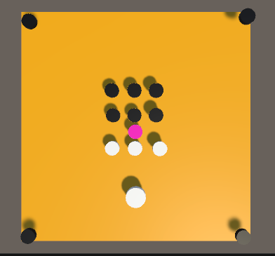

using UnityEngine;

public class striker : MonoBehaviour

{

    // Start is called once before the first execution of Update after the MonoBehaviour is created

    void Start()

    {

    }

    // Update is called once per frame

    void Update()

    {

        transform.Translate(Input.GetAxis("Horizontal")\*Time.deltaTime, 0, 0);

        if (Input.GetKeyDown(KeyCode.Space))

        {

            transform.Translate(0, 0, 500\*Time.deltaTime);

        }

    }

    private void OnCollisionEnter(Collision other)

    {

        if(other.gameObject.CompareTag("pocket"))

        {

            transform.position = new Vector3(0.06708667f, 4186901f , 740009f);

        }

    }

}

using UnityEngine;

public class mens : MonoBehaviour

{

    public AudioSource sound;

    // Start is called once before the first execution of Update after the MonoBehaviour is created

    void Start()

    {

    }

    // Update is called once per frame

    void Update()

    {

    }

    void OnCollisionEnter(Collision other)

    {

        if(other.gameObject.CompareTag("pocket"))

        {

            Destroy(gameObject);

            sound.Play();

        }

        if(other.gameObject.CompareTag("Boundary"))

        {

           transform.position = transform.position;

        }

    }

}