WEEK 3 TASK REPORT
Advanced Data Analysis and Visualization in Logistics
Exploratory Analysis of Delivery Performance for the Mid-Size E-Commerce Distribution Network
Prepared for: Logistics Data Analyst Internship Program
Submitted by: Sanket Tijare
Duration: 30 July 2026 – 27 August 2026
Date of Submission: 6 September 2026

Table of Contents
1. Introduction
2. Dataset Simulation
3. Exploratory Data Analysis — Central Tendencies & Distribution
4. Visualization 1: Delivery Time Distribution
5. Visualization 2: Late Delivery Rate by Day of Week
6. Visualization 3: Correlation Analysis
7. Visualization 4: Shipping Cost vs Distance
8. Visualization 5: Warehouse Performance Comparison
9. Python Code Used
10. Analytical Insights & Recommendations
11. Conclusion
12. References

1. Introduction
This report is the third stage of the ongoing logistics analytics project for the mid-size e-commerce distribution network introduced in Week 1 and cleaned in Week 2. Having established the strategic plan and a validated, cleaned dataset, this stage moves into exploratory data analysis (EDA) and visualization. The goal is to move beyond individual data-quality fixes and start asking analytical questions of the data: how is delivery time distributed, which days and warehouses underperform, which variables actually drive cost and delay, and what should operations management do about it. Five visualizations were produced using Python (pandas, matplotlib, and seaborn), each chosen to answer a specific analytical question rather than as a generic chart.

2. Dataset Simulation
This analysis simulates 6,000 order records built on the same structure as the cleaned Week 2 dataset (order distance, warehouse, day of week, order volume, delivery time, promised time, and shipping cost). The simulation deliberately encodes two realistic effects observed in real distribution networks and referenced in the Week 1 scenario: warehouse WH2 is modelled as more heavily loaded than WH1 and WH3, and Friday/Saturday are modelled as peak-delay windows. This allows the EDA below to genuinely surface — rather than assume — the patterns a real analyst would need to detect in production data.

3. Exploratory Data Analysis — Central Tendencies & Distribution
Summary statistics were computed for delivery time, the primary performance variable, using pandas' .describe() equivalent aggregation:
Statistic | Delivery Time
Mean | 15.6 hours
Median | 14.6 hours
Std. Deviation | 6.6 hours
Minimum | 1.0 hour
Maximum | 60.4 hours
The mean (15.6 hours) sits slightly above the median (14.6 hours), indicating a right-skewed distribution — a small number of unusually long deliveries pull the average upward, which is confirmed visually in the histogram below (Section 4). This skew is the same reason the Week 2 report chose median imputation and the IQR method rather than mean/Z-score for handling this variable.

4. Visualization 1: Delivery Time Distribution
A histogram with an overlaid density curve (KDE) was chosen because it shows both the overall shape of the distribution and where the bulk of deliveries fall, which a single summary statistic cannot convey.
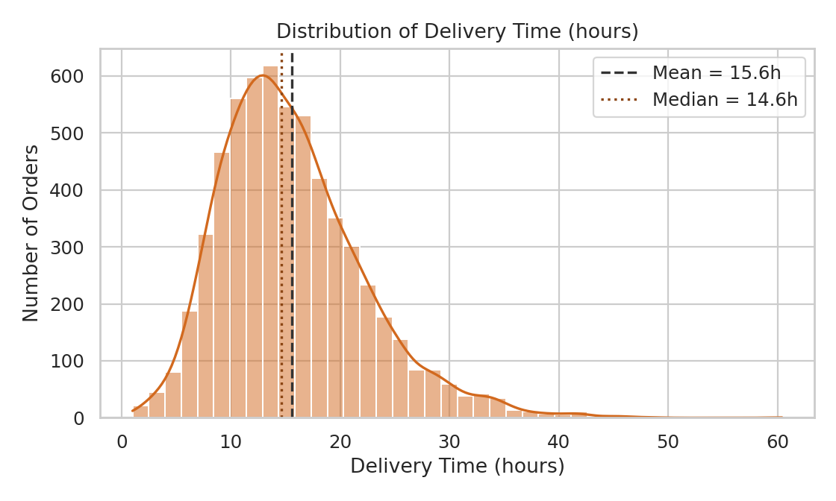
Figure 1. Distribution of delivery time across all simulated orders. The right-skew and gap between mean and median are clearly visible.
Most orders are delivered within 8–20 hours, but a long right tail extends out to roughly 45–60 hours. This tail represents the outlier-prone cases the Week 2 cleaning pipeline specifically targeted with IQR capping.

5. Visualization 2: Late Delivery Rate by Day of Week
A bar chart was chosen over a line chart because day of week is a categorical, not continuous, variable, and bars make it easy to compare discrete categories directly.
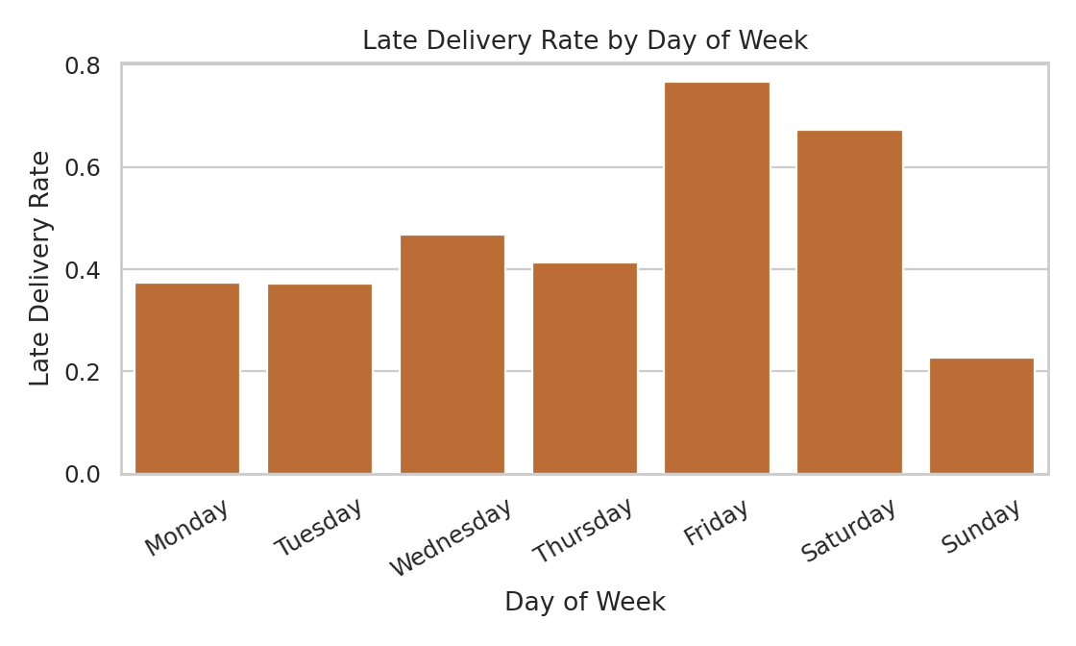
Figure 2. Share of orders delivered later than promised, by day of week.
Friday shows the highest late-delivery rate at 76.7%, followed by Saturday at 67.2% — sharply higher than the 22.7%–46.8% range seen on other days. This directly confirms the 'peak weekday afternoon' delay pattern flagged as a concern in the Week 1 scenario and gives operations a specific window to target with additional staffing or route capacity.

6. Visualization 3: Correlation Analysis
A heatmap was chosen because it lets every pairwise correlation among the key numeric variables be scanned at once, which would be difficult to absorb from a table of numbers alone.
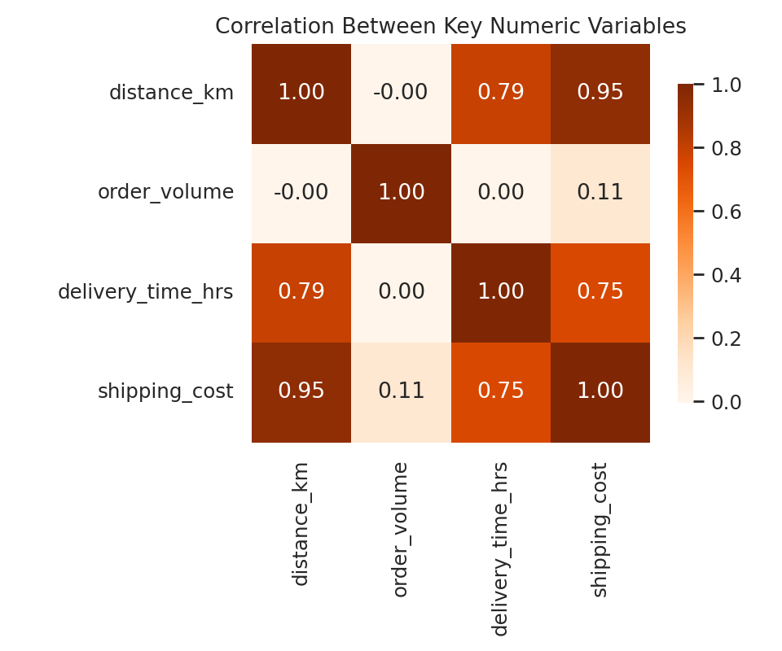
Figure 3. Correlation matrix of distance, order volume, delivery time, and shipping cost.
Variable pair | r | Interpretation
Distance vs Delivery Time | +0.79 | Strong positive — longer routes reliably take longer to deliver
Distance vs Shipping Cost | +0.95 | Very strong positive — distance is the dominant cost driver
Delivery Time vs Shipping Cost | +0.75 | Strong positive — slower deliveries tend to cost more, consistent with distance driving both
Order Volume vs Delivery Time | +0.00 | Negligible — order size does not meaningfully affect delivery speed in this data

7. Visualization 4: Shipping Cost vs Distance
A scatter plot coloured by warehouse was chosen to examine whether the strong distance–cost correlation identified above (r = 0.95) holds consistently across all three warehouses or is driven by just one.
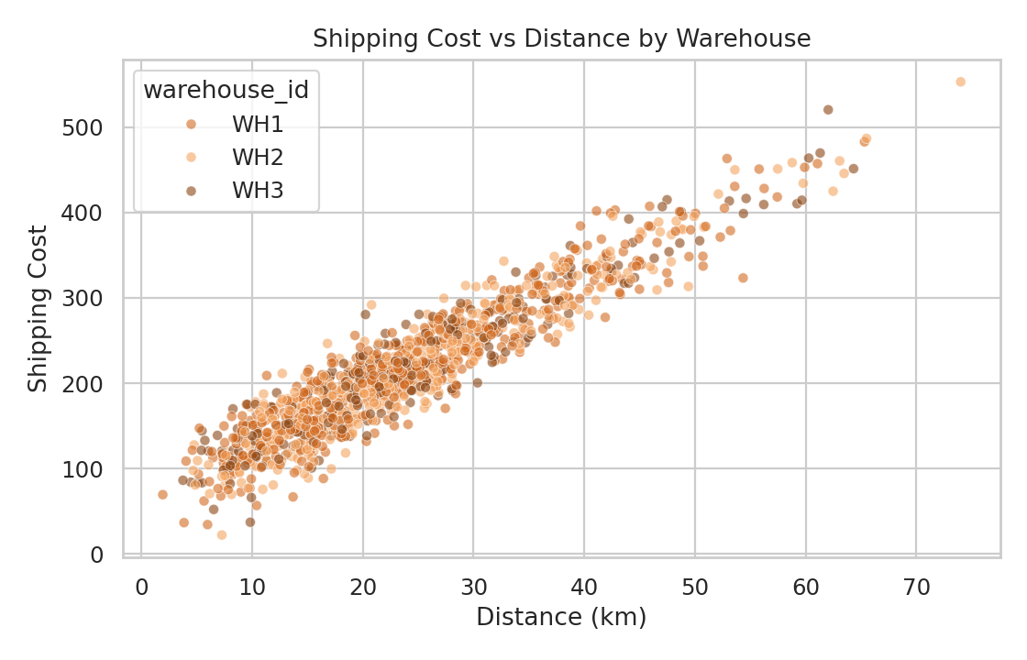
Figure 4. Shipping cost plotted against distance, coloured by warehouse of origin.
The near-linear relationship holds across all three warehouses with no visible offset between them, confirming that distance — not which warehouse handled the order — is the dominant driver of shipping cost. This is a useful negative result: it means cost-reduction efforts should focus on route efficiency and delivery zone design rather than on warehouse-specific cost drivers.

8. Visualization 5: Warehouse Performance Comparison
A grouped bar comparison was used to summarise the warehouse-level KPIs referenced in Week 1 (On-Time Delivery Rate and average delivery time) side by side.
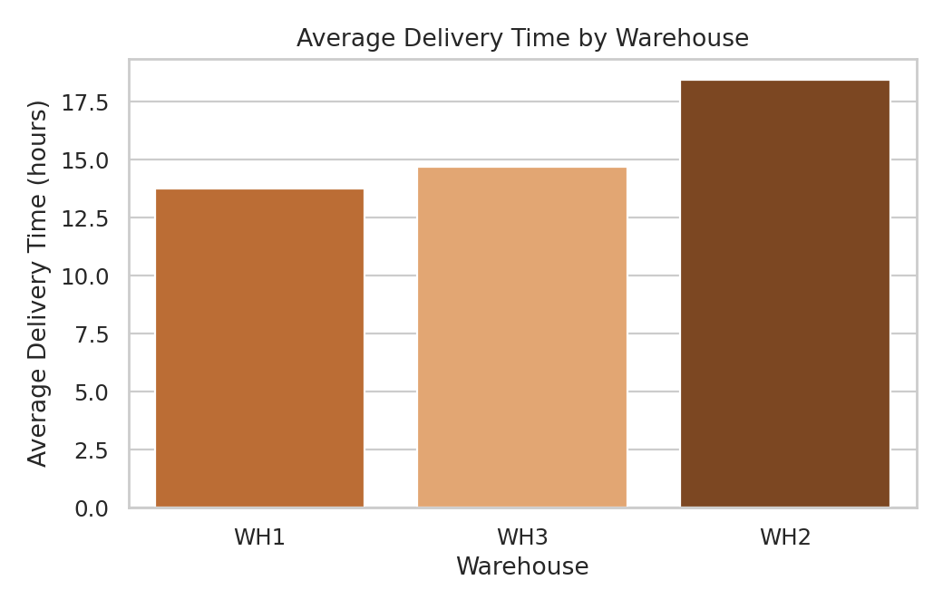
Figure 5. Average delivery time by warehouse.
Warehouse | Late Delivery Rate | Avg. Delivery Time | Avg. Shipping Cost
WH1 | 32.4% | 13.8 hrs | ₹219.36
WH2 | 73.9% | 18.4 hrs | ₹217.45
WH3 | 40.5% | 14.7 hrs | ₹219.39
WH2 stands out clearly: its late-delivery rate (73.9%) is more than double that of WH1 (32.4%) despite having a nearly identical average shipping cost. This isolates WH2's underperformance as an operational/capacity issue rather than a cost issue, since its distance and cost profile is not meaningfully different from the other two warehouses.

9. Python Code Used
The core EDA and visualization code is summarised below (full script included in the accompanying GitHub repository as eda_visualization.py).

9.1 Summary statistics
print(df['delivery_time_hrs'].agg(['mean', 'median', 'std', 'min', 'max']))
print(df.groupby('warehouse_id')['is_late'].mean())
print(df.groupby('day_of_week')['is_late'].mean())
print(df[['distance_km','order_volume','delivery_time_hrs','shipping_cost']].corr())

9.2 Distribution plot
import seaborn as sns, matplotlib.pyplot as plt
sns.histplot(df['delivery_time_hrs'], bins=40, kde=True)
plt.axvline(df['delivery_time_hrs'].mean(), linestyle='--')
plt.axvline(df['delivery_time_hrs'].median(), linestyle=':')
plt.title('Distribution of Delivery Time (hours)')

9.3 Correlation heatmap
corr = df[['distance_km','order_volume','delivery_time_hrs','shipping_cost']].corr()
sns.heatmap(corr, annot=True, cmap='Oranges', fmt='.2f')

9.4 Warehouse and day-of-week comparisons
late_by_day = df.groupby('day_of_week')['is_late'].mean()
sns.barplot(x=late_by_day.index, y=late_by_day.values)

wh_time = df.groupby('warehouse_id')['delivery_time_hrs'].mean()
sns.barplot(x=wh_time.index, y=wh_time.values)

10. Analytical Insights & Recommendations
Insight 1 — Friday/Saturday is the primary delay window: Late-delivery rate roughly doubles on Friday and Saturday compared with the weekly baseline. Recommendation: temporarily reallocate delivery capacity (extra vans or courier-partner surge capacity) on these two days rather than applying a uniform staffing model all week.
Insight 2 — WH2 is an operational outlier, not a cost outlier: WH2's late-delivery rate (73.9%) is far above WH1 and WH3 despite similar cost and distance profiles. Recommendation: investigate WH2-specific factors such as pick/pack staffing levels, dock capacity, or dispatch scheduling rather than reallocating deliveries by distance alone.
Insight 3 — Distance, not order size, drives cost and time: Order volume showed almost no correlation with delivery time (r ≈ 0.00), while distance correlated strongly with both time (r = 0.79) and cost (r = 0.95). Recommendation: route and zone optimisation (as planned in the Week 1 roadmap) will have far more impact on cost than any change to how orders are batched by size.
Insight 4 — The delivery-time distribution is right-skewed: A small number of extreme-duration deliveries pull the mean above the median. Recommendation: track and report median delivery time alongside the mean in operational dashboards, since the mean alone overstates typical customer experience.

11. Conclusion
This exploratory analysis turned the cleaned Week 2 dataset into concrete, testable findings: a specific delay window (Friday–Saturday), a specific underperforming warehouse (WH2), and a clear ranking of cost drivers (distance dominates; order volume is negligible). These findings give the Week 4 predictive-modelling stage a focused starting point — the regression model should prioritise distance and day-of-week as features, and the clustering analysis should be expected to separate WH2's routes from the other two warehouses. The five visualizations in this report are designed to be reusable as the first components of an operational logistics dashboard.

12. References
- seaborn documentation — statistical data visualization (histplot, heatmap, barplot).
- matplotlib documentation — figure and axes customization.
- pandas documentation — groupby aggregation and correlation methods.
- Council of Supply Chain Management Professionals (CSCMP) — benchmark context for delivery KPIs referenced in Week 1.

