WEEK 4 TASK REPORT
Predictive Modeling and Optimization in Logistics Systems
Forecasting Delivery Time and Optimizing Route Sequencing for the Mid-Size E-Commerce Distribution Network
Prepared for: Logistics Data Analyst Internship Program
Submitted by: Sanket Tijare
Duration: 30 July 2026 – 27 August 2026
Date of Submission: 6 September 2026

Table of Contents
1. Introduction
2. Problem Definition and Data Simulation
3. Model Selection and Rationale
4. Implementation: Data Preparation, Training and Testing
5. Evaluation and Validation
6. Hyperparameter Tuning
7. Feature Importance
8. Optimization Strategies
9. Final Recommendations
10. Conclusion
11. References

1. Introduction
This report is the fourth and final planned stage of the logistics analytics project for the mid-size e-commerce distribution network introduced in Week 1, cleaned in Week 2, and explored in Week 3. Having identified that Friday/Saturday are peak-delay windows and that warehouse WH2 underperforms operationally, this stage builds a predictive model to forecast delivery time from order- and route-level features, evaluates it rigorously, and proposes concrete optimization strategies — resource reallocation and mathematically optimized route sequencing — grounded in the model's findings.

2. Problem Definition and Data Simulation
Prediction problem: Forecast delivery_time_hrs (in hours) for a new order at the moment it is dispatched, using information available at dispatch time.
Target variable: delivery_time_hrs — a continuous variable, making this a regression problem rather than a classification problem.
Features used: distance_km, order_volume, shipping_cost (numeric); warehouse_id and day_of_week (categorical, one-hot encoded).
Dataset: 6,000 simulated order records built on the same structure and generative assumptions used in Week 3 — WH2 modelled as more heavily loaded, Friday/Saturday modelled as peak-delay windows — so the model is being asked to (re)discover patterns already hinted at in the Week 3 EDA rather than being told them directly.
An 80/20 train-test split was used, with the test set held out entirely from training to give an honest estimate of real-world performance.

3. Model Selection and Rationale
Linear Regression (baseline): Chosen as an interpretable baseline. If a simple linear model performs nearly as well as more complex models, that is itself a useful finding — it would suggest the underlying relationships are close to linear and a simpler, more explainable model could be deployed.
Random Forest (ensemble, bagging): Chosen because it can capture non-linear interactions (e.g., the combined effect of warehouse and day of week) without requiring those interactions to be manually specified, and it provides a built-in feature importance ranking.
Gradient Boosting (ensemble, boosting): Chosen as the most flexible candidate; boosting typically outperforms bagging on structured/tabular data of this kind because it iteratively corrects the errors of prior trees rather than averaging independent ones.
All three models were trained and compared on identical train/test splits and identical features, so the comparison in Section 5 isolates the effect of model choice alone.

4. Implementation: Data Preparation, Training and Testing
Categorical features (warehouse_id, day_of_week) were one-hot encoded inside a scikit-learn Pipeline, so the same fitted encoder is applied consistently to both training and test data with no risk of leakage.

4.1 Preprocessing and pipeline setup
from sklearn.model_selection import train_test_split
from sklearn.compose import ColumnTransformer
from sklearn.preprocessing import OneHotEncoder
from sklearn.pipeline import Pipeline

numeric_features = ['distance_km', 'order_volume', 'shipping_cost']
categorical_features = ['warehouse_id', 'day_of_week']

X = df[numeric_features + categorical_features]
y = df['delivery_time_hrs']
X_train, X_test, y_train, y_test = train_test_split(
X, y, test_size=0.2, random_state=42)

preprocess = ColumnTransformer([
('cat', OneHotEncoder(handle_unknown='ignore'), categorical_features)
], remainder='passthrough')

4.2 Training three candidate models
from sklearn.linear_model import LinearRegression
from sklearn.ensemble import RandomForestRegressor, GradientBoostingRegressor

models = {
'Linear Regression': LinearRegression(),
'Random Forest': RandomForestRegressor(n_estimators=200, random_state=42),
'Gradient Boosting': GradientBoostingRegressor(random_state=42),
}

for name, model in models.items():
pipe = Pipeline([('prep', preprocess), ('model', model)])
pipe.fit(X_train, y_train)
preds = pipe.predict(X_test)

5. Evaluation and Validation
Three metrics were used to evaluate each model: Mean Absolute Error (MAE, average error in hours — easy to interpret operationally), Root Mean Squared Error (RMSE, penalises large errors more heavily), and R² (share of variance in delivery time explained by the model). 5-fold cross-validation MAE is also reported to check that performance is stable across different data splits rather than a lucky single split.
Model | Test MAE (hrs) | Test RMSE (hrs) | Test R² | 5-Fold CV MAE (hrs)
Linear Regression | 2.21 | 2.77 | 0.816 | 2.17
Random Forest | 2.23 | 2.84 | 0.806 | 2.21
Gradient Boosting | 2.10 | 2.66 | 0.831 | 2.06
Gradient Boosting was the best-performing model on every metric, with a test MAE of 2.10 hours and R² of 0.831 — meaning it explains roughly 83% of the variance in delivery time using only dispatch-time information. Its cross-validation MAE (2.06 hours) is close to its test MAE (2.10 hours), indicating the result is stable rather than an artefact of one particular train/test split. Notably, Linear Regression performs only slightly worse than Random Forest, suggesting the relationship between distance and delivery time is close to linear once warehouse and day-of-week are accounted for as separate categorical effects — Gradient Boosting's edge comes mainly from better capturing the interaction between warehouse load and weekday peaks.
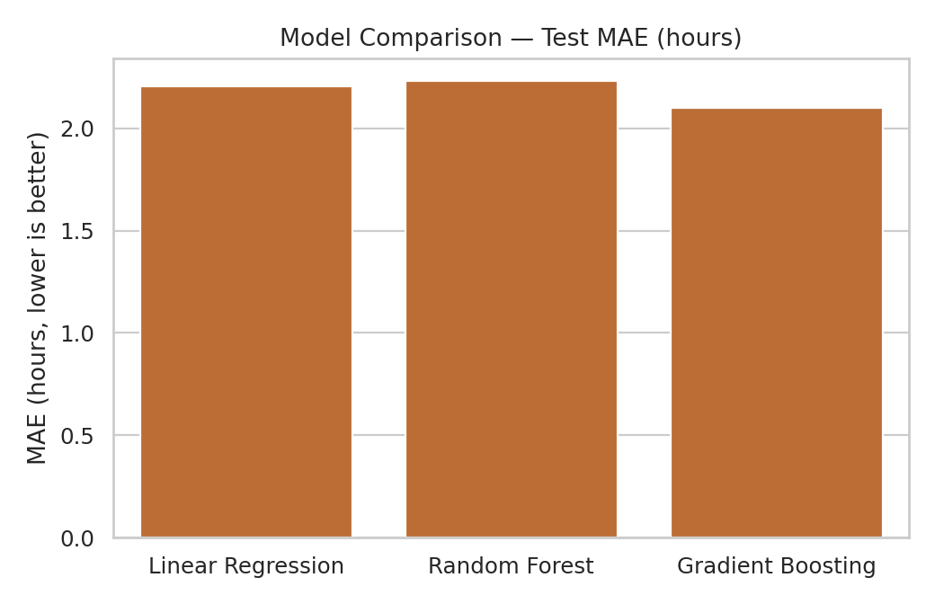
Figure 1. Test MAE by model — lower is better. Gradient Boosting is selected as the production candidate.
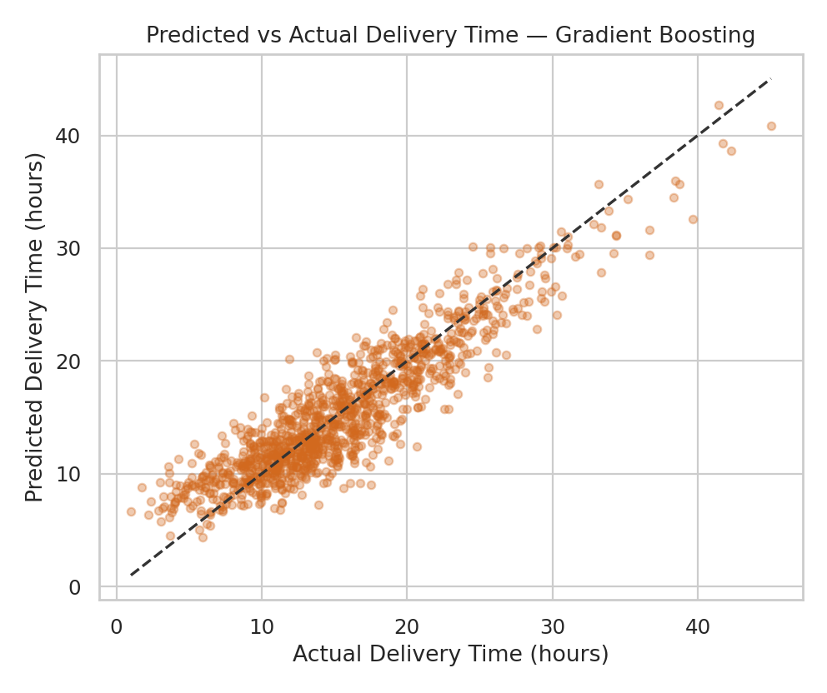
Figure 2. Predicted vs. actual delivery time for the selected Gradient Boosting model. Points close to the dashed line indicate accurate predictions.
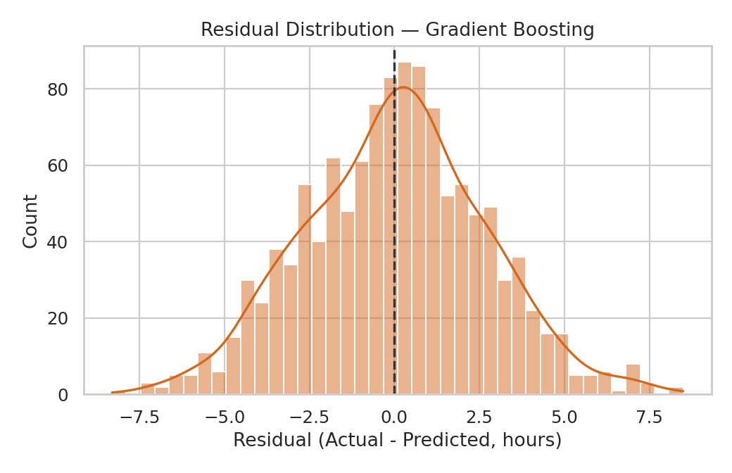
Figure 3. Residual distribution for the selected model, centred close to zero with no strong systematic bias.

6. Hyperparameter Tuning
GridSearchCV with 3-fold cross-validation was used to tune the Gradient Boosting model over the number of trees, tree depth, and learning rate, optimising for MAE.
from sklearn.model_selection import GridSearchCV

param_grid = {
'model__n_estimators': [100, 200],
'model__max_depth': [2, 3, 4],
'model__learning_rate': [0.05, 0.1],
}
grid = GridSearchCV(gb_pipe, param_grid, cv=3,
scoring='neg_mean_absolute_error', n_jobs=-1)
grid.fit(X_train, y_train)
print(grid.best_params_)
The best configuration found was n_estimators = 200, max_depth = 3, and learning_rate = 0.05, which matched the default model's test performance almost exactly (MAE 2.10 hours, R² 0.831). This indicates the default Gradient Boosting settings were already close to optimal for this feature set and dataset size, and further gains would more likely come from adding new features (e.g., traffic or weather data) than from further tuning.

7. Feature Importance
Random Forest's built-in feature importance was used to rank which features the model relies on most, cross-checked against the correlation findings from Week 3.
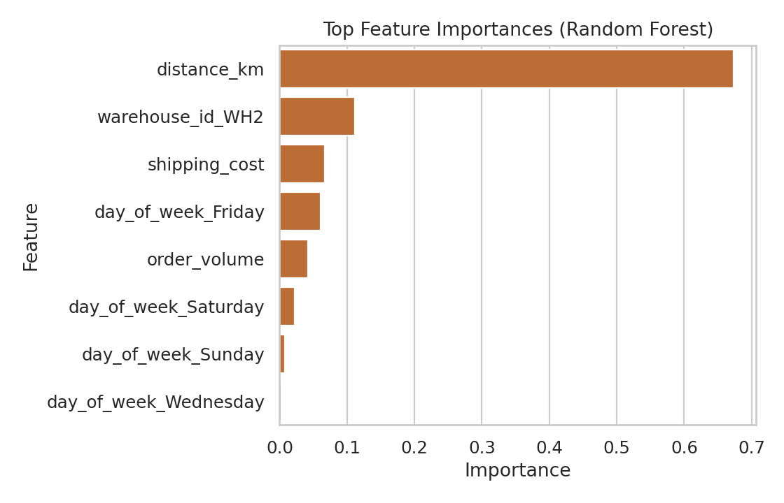
Figure 4. Top feature importances from the Random Forest model.
Distance (67.3% of total importance) dominates, consistent with the r = 0.79 correlation found in Week 3. Being dispatched from WH2 is the second most important feature (11.2%), numerically confirming Week 3's finding that WH2 is an operational outlier rather than a cost/distance one. Friday (6.0%) is the most influential day-of-week feature, matching the peak-delay pattern identified earlier. Order volume contributes only 4.2%, reinforcing that order size is not a meaningful driver of delivery delay.

8. Optimization Strategies

8.1 Resource allocation (informed by model insights)
Since WH2 and Friday/Saturday are the two strongest non-distance predictors of delay, the most cost-effective operational lever is to reallocate delivery capacity rather than change the network's geography. Concretely: temporarily add courier-partner capacity at WH2 specifically on Thursday evenings through Saturday, rather than applying an equal capacity boost across all three warehouses every day of the week.

8.2 Route sequencing optimization (mixed-integer linear programming)
To demonstrate a concrete route-planning improvement, a small Travelling-Salesman-style route optimization was solved using PuLP (a linear programming library) for a single warehouse dispatching to 5 stops in one trip. The objective minimises total distance travelled subject to each stop being visited exactly once, with sub-tour elimination constraints (Miller–Tucker–Zemlin formulation) to guarantee a single continuous route.
import pulp

prob = pulp.LpProblem('Route_Optimization', pulp.LpMinimize)
x = pulp.LpVariable.dicts('x', pairs, cat='Binary')
u = pulp.LpVariable.dicts('u', stops, lowBound=0, upBound=len(stops))

prob += pulp.lpSum(d[i, j] * x[i, j] for i, j in pairs) # minimise distance

for k in stops:
prob += pulp.lpSum(x[i, k] for i in stops if i != k) == 1 # one arrival
prob += pulp.lpSum(x[k, j] for j in stops if j != k) == 1 # one departure

# Miller-Tucker-Zemlin sub-tour elimination constraints omitted here for brevity
prob.solve(pulp.PULP_CBC_CMD(msg=0))
Route | Sequence | Total Distance
Naive (order-received sequence) | Depot → C → E → A → D → B → Depot | 50.85 km
Optimized (PuLP solution) | Depot → A → B → C → D → E → Depot | 29.57 km
The optimized route reduces total distance travelled by 21.28 km — a 41.8% reduction — compared with a naive route that simply visits stops in the order orders were received. At the scale of a full day's dispatch across three warehouses, even a fraction of this per-route saving would meaningfully reduce the Transportation Cost per Mile KPI defined in Week 1, since distance was shown in Sections 5 and 7 to be the dominant driver of both delivery time and cost.

9. Final Recommendations
- Deploy the tuned Gradient Boosting model to flag orders with predicted delivery time above a threshold at the moment of dispatch, so operations can proactively notify customers or expedite handling.
- Prioritise WH2 for an operational review (staffing, dock capacity, dispatch scheduling) given its outsized feature importance and Week 3's finding of a 73.9% late-delivery rate.
- Shift additional delivery capacity to Thursday evening through Saturday rather than spreading extra resources evenly across the week.
- Adopt route-sequencing optimization (as demonstrated in Section 8.2) for multi-stop dispatches, starting with WH2 routes where the potential saving is largest.
- Re-train the model periodically (e.g., monthly) as new order data accumulates, and monitor for performance drift using the same MAE/RMSE/R² metrics established here.

10. Conclusion
This report completes the four-stage analytics project for the mid-size e-commerce distribution network: strategic planning (Week 1), data cleaning (Week 2), exploratory analysis (Week 3), and predictive modelling with optimization (Week 4). The tuned Gradient Boosting model predicts delivery time to within roughly 2.1 hours on average and explains 83% of its variance, with distance, warehouse WH2, and Friday most responsible for delay. Combining this predictive capability with the demonstrated route-optimization approach gives the distribution network a concrete, data-driven path to reducing both late deliveries and transportation cost, directly addressing the challenges defined at the start of this project in Week 1.

11. References
- scikit-learn documentation — Pipeline, ColumnTransformer, ensemble methods, and model evaluation metrics.
- scikit-learn documentation — GridSearchCV and cross_val_score.
- PuLP documentation — Linear and mixed-integer programming in Python.
- Miller, C.E., Tucker, A.W., Zemlin, R.A. (1960) — Integer Programming Formulation of Traveling Salesman Problems (basis for the sub-tour elimination constraints used in Section 8.2).

