Task 1:
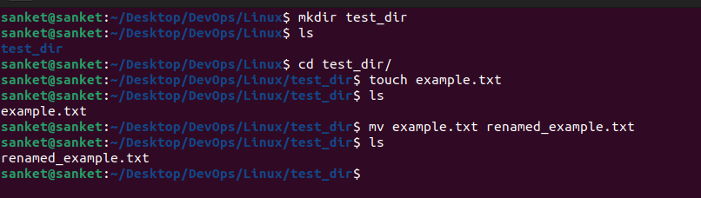
Task 2:

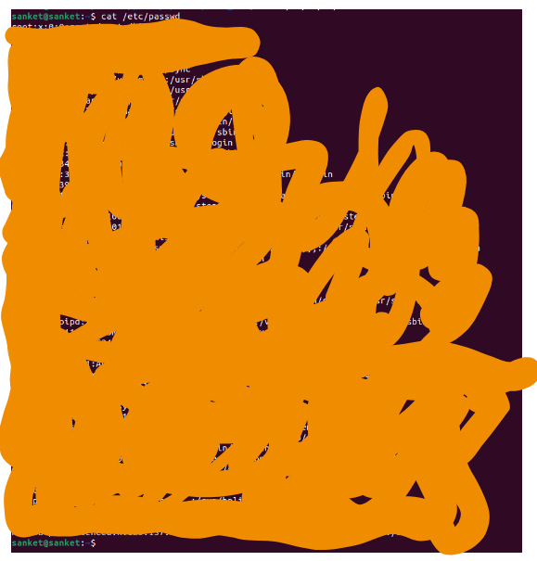

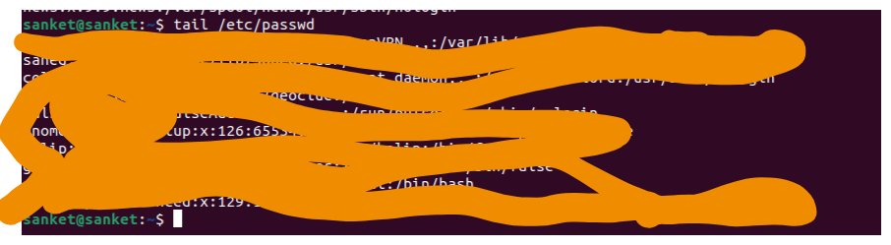

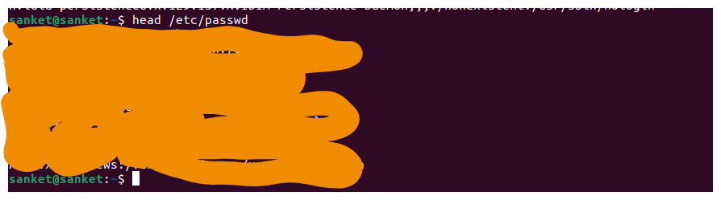
Task3:
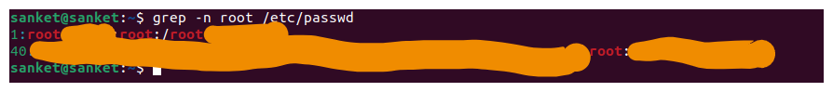

Task4:
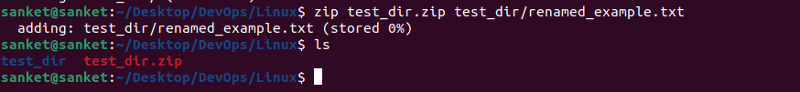
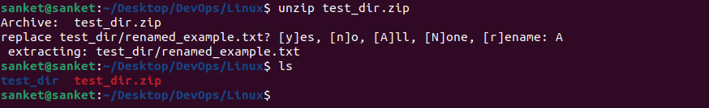

Task5:
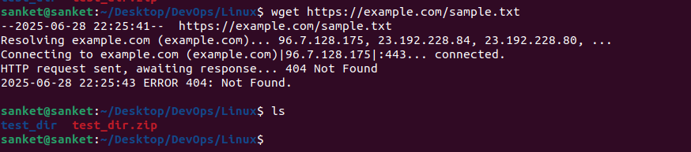
Task6:
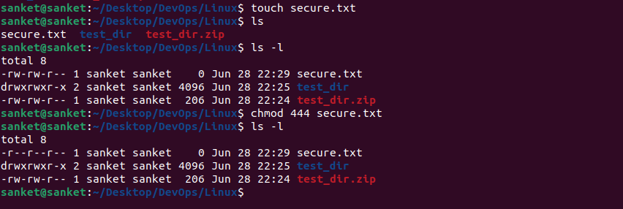

Task7:

