**PROJECT REPORT**

**Project Name :** **Calculator**

Contents

1. [**Certificates**](https://github.com/sumeet2908/M1_Operations_Utility/tree/main/0_Certificates)
2. [**Requirements**](https://github.com/sumeet2908/M1_Operations_Utility/tree/main/1_Requirements)
3. [**Architecture**](https://github.com/sumeet2908/M1_Operations_Utility/tree/main/2_Architecture)
4. [**Implementation**](https://github.com/sumeet2908/M1_Operations_Utility/tree/main/3_Implementation)
5. [**TestPlanAndOutput**](https://github.com/sumeet2908/M1_Operations_Utility/tree/main/4_TestPlanAndOutput)
6. [**Report**](https://github.com/sumeet2908/M1_Operations_Utility/tree/main/5_Report)
7. [**ImageAndVideo**](https://github.com/sumeet2908/M1_Operations_Utility/tree/main/6_ImageAndVideo)
8. [**Other**](https://github.com/sumeet2908/M1_Operations_Utility/tree/main/7_Other)**.**

* **Certificates:**
* **Sololearn**
* **Cisco NDG linux**
* **Screenshot of github learning**
* **Screenshot of hackerearth points**
* **Requirements**
* **Requirements**
* **High Level Requirements**
* **Low Level Requirements**
* **SWOT**
* **4W's and 1H's**
* **Architecture**
* **Design**
* **Structure**
* **Behavioural**
* **flowchart**
* **use case diagram**
* **Implementation**

* **Inc**
* **Src**
* **Test**
* **Unity**
* **Test plan and Output**
* **for every feature,define a test case**
* **how to run that feature**
* **define expected behaviour**
* **capture the actual result**
* **Report**
* **ImageAndVideo**
* **Output image**
* **Other**
* **References**

**Description:**

**Simple Calculator**

## **Introduction:-**

* Simple Calculator helps users to calculate simple calculations with great speed and accessibility. Simple calculator is a project to allow users to calculate basic four operations in mathematics ,they are addition, subtraction, multiplication, division but in this Project which I'm Implementing ,also included three additional operations such as Factorial, Power ,modulas .
* The input includes the command such as we can give numbers based on the operation for example for addition we give 1 as a command and that particular operation works.Moreover, this calculator is smart enough to operate multiplication/division before addition/subtraction/factorial/power, in another word it is implemented with the order of precedence logic.

**Requirements :**

**High Level Requirements:**

|  |  |  |  |
| --- | --- | --- | --- |
| **ID** | **Description** | **Category** | **Status** |
| HR01 | User shall be able to specify their operation choice. | Technical | IMPLEMENTED |
| HR02 | User should able to select the operation. | Technical | IMPLEMENTED |
| HR03 | User shall be able to add the numbers | Technical | IMPLEMENTED |
| HR04 | User shall be able to subtract the numbers | Technical | IMPLEMENTED |
| HR05 | User shall be able to multiply the number | Technical | IMPLEMENTED |
| HR06 | User shall be able to find division | Technical | IMPLEMENTED |
| HR06 | User shall be able square and modulus. | Technical | IMPLEMENTED |

## **Low Level Requirements**

|  |  |  |  |
| --- | --- | --- | --- |
| **ID** | **Description** | **Category** | **status** |
| LR01 | If the calculations is impossible the calculator has to display information helping the user to resolve the erroneous situation. | Technical | IMPLEMENTED |
| LRO2 | On encountering a division by 0 the display should read "Cannot divide by 0" and typing the key “C” should reset the calculator |  |  |
| LR03 | On calculating the square root value of a negative operand the display should read "Wrong operand" | |  | | --- | | Technical | | IMPLEMENTED |

**SWOT**

* STRENGTHS

The ultimate strength Calculators is its innovative, user-friendly and long lasting etc..

* WEAKNESSES

Do not inlude all the operations rather have onlty addition,subtraction multiplication, division ,modulas ,power and factorial.

* OPPORTUNITIES

The tech-based market has a huge opportunities in capturing the youth market. And this calculator comparatively already one step ahead than other

* THREATS

The slower growth in technological innovation will also bring a significant threat in the upcoming dynamic world.

**5W's and 1H's**

**Who**

* Students who want to solve mathematics related problems for their academic work.
* Datascience workers working on machine learning and deep learning applications which majorly involve matrice Software engineer.
* Researchers and mathematicians.

**What**

* Calculate the sum, differemce, product of two matrices and also the determinnt, transpose and inverse of a single matrix.

**When**

* Students facing a difficulty in solving a matrix related problem, can use this program to conform their outputs.
* Researchers can use it for getting a quick calculation output.
* Comes to a great use when calculating for matrices of huge order.

**Where:**

* Students, employees and researchers all over the world.

**How:**

* This program can be executed in a system which has Linux or Windows operating system.

**Architecture**

**Design**

**Structure**

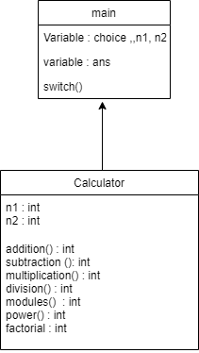

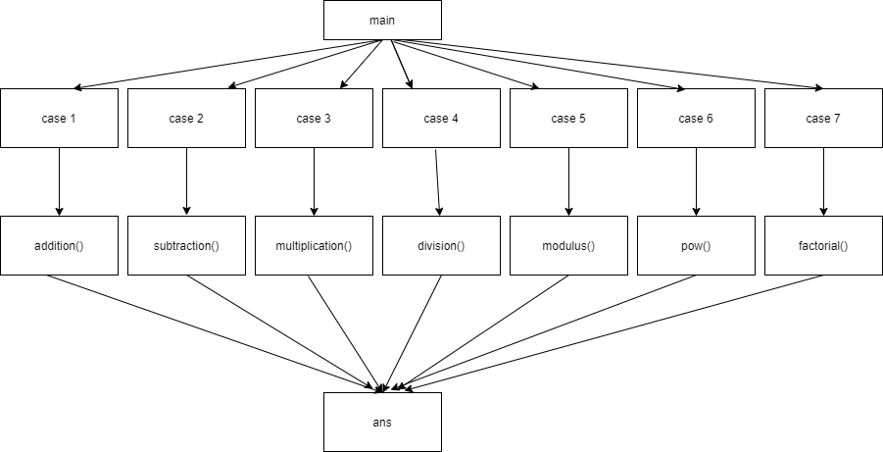

**Behavioural**

* **Flowchart**

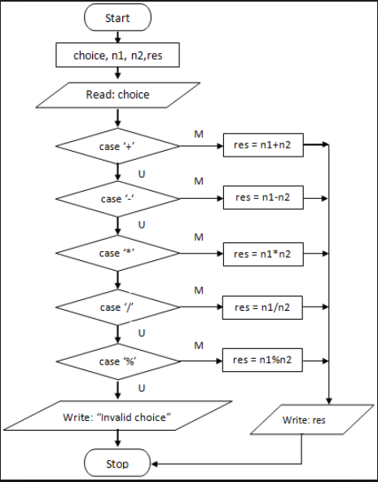

* **Case diagram**

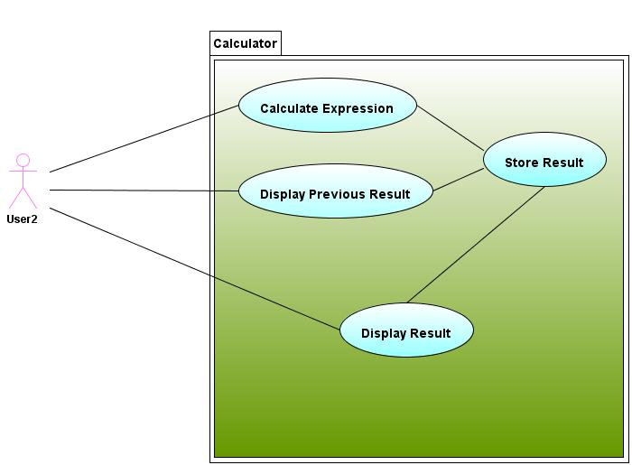

**Test plan & output.**

## **High Level test Plan**

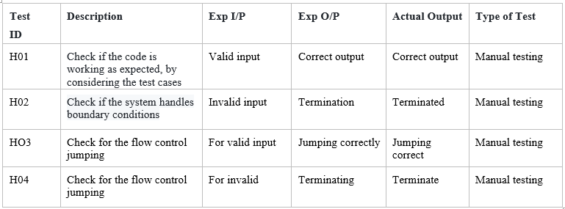

**Low Level test Plan**

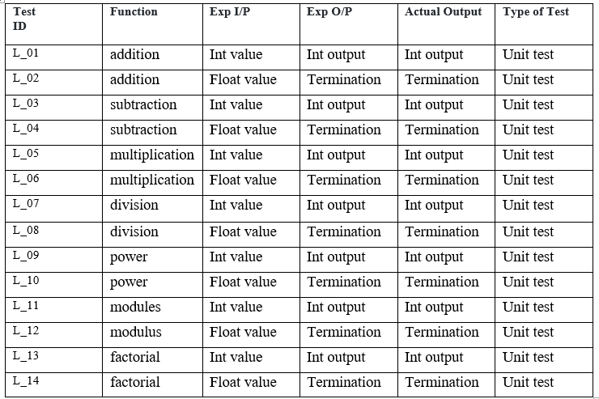

## **Features**

## This calculator can be used to do simple math calculation in very fast and efficient way.

* User Friendly interface.
* Accurate.

## **Future scope of the project**

* Various Mathematical Operations can be added.
* Trignometric calculations can be added.
* Calculation of Binary no. can be possible

**References**

<https://github.com/stepin654321/MiniProject_Template.git>

**Calculator Application by SANKET KAMBLE**