**CPSC-531 Adv. Database Management Systems**

**Topic – Big Data Analytics for Insurance Company**

**Prof. Shen, Tseng-Ching**

**Team Members –**

**Name:** Vaibhav Rastogi (885190280)

**Mail ID - [vaibhav1102@csu.fullerton.edu](mailto:vaibhav1102@csu.fullerton.edu)**

**Name:** Sanket Mungikar (885209239)

**Mail ID –** [**sanketmungikar@csu.fullerton.edu**](mailto:sanketmungikar@csu.fullerton.edu)

**Table of Contents –**

* **Introduction**
* **Objective**
* **Functionality**
* **Architecture Diagram**
* **GitHub location of Code**
* **Steps to run the Application**
* **Test Results**

**Introduction –**

When beginning with our project for CSPC-531, we thought of the problems that Insurance companies are currently facing to make a stand in the market.Due to increased competition insurance company is facing difficulty expanding its revenue and understanding their customer base. Also another problem faced by insurance company is that to meet their annual targets insurance companies are facing difficulties in attracting customers from different regions.

**Objective –**

The main goal or objective of the project was to provide analytics solutions for the insurance company which will help them make appropriate business proposals to enhance their revenue by analyzing different age-group customers buying pattern and find the maximum premium captured by the sourcing channel.

**Functionalities –**

We performed the big data analytics for Insurance Company based on the following use cases which help the company to analyze and help them in increasing their revenue –

1. Which sourcing channel has generated the Max revenue for the company?
2. Which sourcing channel has got best customers with best possible premium policies (application underwriting score vs. sourcing channel).

Our project will perform the analysis based on this use cases and perform the analytics using Apache Spark.

**Architectural Diagram –**

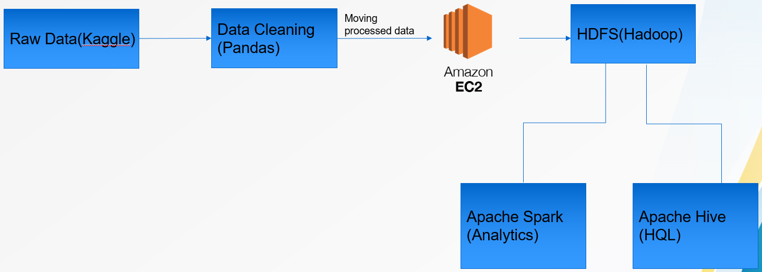

**Architectural flow of project -**

1. **Data Gathering (Raw data) from kaggle**-

Firstly to begin with our analytics process we need to collect raw data (semi-structured form). So to achieve this requirement we collected/ gathered the data from Kaggle.com.

1. **Data cleaning of raw data using pandas**-

Secondly the collected raw data was transformed by performing data cleaning operations by using Pandas library where null and undefined values from data where truncated.

1. **Moving data from local machine to hadoop clusters in AWS EC-2 instances –**

The transformed csv data was then moved from our local machine to determined location in hadoop cluster which was configured in AWS cloud.

1. **Loading data from hdfs AWS EC2 instances into Apache Spark for analytics**-

The data loaded into the hadoop cluster was then used to perform analytics using Apache Spark. To achieve this the transformed data on the hadoop cluster was used and the spark analytics was performed.

**Technologies Used to implement our project** –

1. AWS EC2
2. Pandas for data cleaning
3. Apache hadoop
4. Apache Hive
5. Apache Spark- Analytics
6. Stand-alone configuration using Apache Ambari (Horton Works Sandbox)

**Configuration required for setting up AWS EC-2 instances –**

**Steps to set-up EC-2 instances –**

**IP-Address for every node set-up on AWS -**

**Name Node** ec2-54-189-101-173.us-west-2.compute.amazonaws.com

**SNN** ec2-18-237-128-174.us-west-2.compute.amazonaws.com

**DataNode1** ec2-54-149-20-91.us-west-2.compute.amazonaws.com

**DataNode2** ec2-35-165-118-140.us-west-2.compute.amazonaws.com

**Connecting to every node created using the .pem file(Identity File) -**

1. ssh -i AWSEC2.pem ubuntu@ec2-54-189-101-173.us-west-2.compute.amazonaws.com nn
2. ssh -i AWSEC2.pem ubuntu@ec2-18-237-128-174.us-west-2.compute.amazonaws.com snn
3. ssh -i AWSEC2.pem ubuntu@ec2-54-149-20-91.us-west-2.compute.amazonaws.com d1
4. ssh -i AWSEC2.pem ubuntu@ec2-35-165-118-140.us-west-2.compute.amazonaws.com d2

**Configuring Name Node (NN), Secondary Name Node (SNN), Data Nodes (DN-1, DN-2) –**

**vi ~/.ssh/config**

Host nnode

HostName ec2-54-189-101-173.us-west-2.compute.amazonaws.com

User ubuntu

IdentityFile ~/.ssh/ida_rsa

Host snn

HostName ec2-18-237-128-174.us-west-2.compute.amazonaws.com

User ubunutu

IdentityFile ~/.ssh/ida_rsa

Host datanode1

HostName ec2-54-149-20-91.us-west-2.compute.amazonaws.com

User ubuntu

IdentityFile ~/.ssh/ida_rsa

Host datanode2

HostName ec2-35-165-118-140.us-west-2.compute.amazonaws.com

User ubuntu

IdentityFile ~/.ssh/ida_rsa

**Configuring hadoop - hdfs on AWS EC-2:**

1. install java sudo apt-get -y install openjdk-8-jdk-headless
2. wget link.tar (downloading hadoop tar file)
3. tar xvzf filename (extracting downloaded tar file)
4. mv extracted filename hadoop (moving extracted folder to hadoop)

**Commands to connect data nodes and name node**

1. ssh-keygen
2. copy key generated to other nodes from name node
3. scp -i AWSEC2.pem /home/ubuntu/.ssh/id_rsa.pub ubuntu@ec2-18-237-128-174.us-west-2.compute.amazonaws.com:/home/ubuntu/.ssh/id_rsa.pub (snn,d1,d2 from nn)
4. cat ~/.ssh/id_rsa_pub >> ~/.ssh/authorized_keys (all nodes )
5. vi ~/.ssh/config

**Exporting it to the PATHS:**

**Steps to configure hadoop -**

1. sudo vi ~/.bashrc

* export JAVA_HOME=/usr/lib/jvm/java-8-openjdk-amd64
* export HADOOP_HOME=/home/ubuntu/hadoop
* export HADOOP_CONF=$HADOOP_HOME/conf
* export PATH=$PATH:$JAVA_HOME:$HADOOP_HOME/bin
* source ~/.bashrc

changing user access permission

sudo chown ubuntu:ubuntu /usr/local/hadoop/hdfs/data

**Modify hadoop config files located-**

HADOOP_HOME/etc/hadoop/

**Editing hadoop-env.sh**

vi $HADOOP_HOME/etc/hadoop/hadoop-env.sh (SET JAVA_HOME)

export JAVA_HOME=/usr/lib/jvm/java-8-openjdk-amd64

**Editing core-site.xml**

vi $HADOOP_HOME/etc/hadoop/core-site.xml

<property>

<name>fs.defaultFS</name>

<value>

hdfs://ec2-54-189-101-173.us west2.compute.amazonaws.com:9000

</value>

</property>

**Editing hdfs-site.xml -**

vi $HADOOP_HOME/etc/hadoop/hdfs-site.xml (replication factor )

<property>

<name>dfs.replication</name>

<value>2</value>

</property>

<property>

<name>dfs.namenode.name.dir</name>

<value>file:///usr/local/hadoop/hdfs/data</value>

</property>

**Editing mapred-site.xml**

vi $HADOOP_HOME/etc/hadoop/mapred-site.xml

<property>

<name>mapreduce.framework.name</name>

<value>yarn</value>

</property>

**Editing yarn-site.xml**

vi $HADOOP_HOME/etc/hadoop/yarn-site.xml

<property>

<name>yarn.nodemanager.aux-services</name>

<value>mapred_shuffle</value>

</property>

<property>

<name>yarn.resourcemanager.hostname</name>

<value>ec2-54-189-101-173.us-west-2.compute.amazonaws.com</value>

</property>

**Copy all these files from Name Node to secondary name node, data node-1, data node – 2:**

scp hadoop-env.sh core-site.xml hdfs-site.xml mapred-site.xml yarn-site.xml ubuntu@ec2-18-237-128-174.us-west-2.compute.amazonaws.com:~/hadoop/etc/hadoop

Configuring Master-Slave Nodes:

**Name Node** -

cd ~/hadoop/etc/hadoop

vi masters – IPV4 address of Name Node.

vi slaves IPV4 address of Data Node1,DataNode2

**Secondary Name Node** -

cd ~/hadoop/etc/hadoop

vi masters – IPV4 address of Name Node.

vi slaves IPV4 address of Data Node1,DataNode2

**Data Node 1** -

cd ~/hadoop/etc/hadoop

vi slaves IPV4 address of Data Node1

**Data Node 2** -

cd ~/hadoop/etc/hadoop

vi slaves IPV4 address of Data Node2

After configuring the Name Node, Secondary Name Node and Data Nodes commands to run the services hdfs and yarn:

1. ssh -i AWSEC2.pem ubuntu@ec2-35-88-101-162.us-west-2.compute.amazonaws.com
2. hdfs namenode -format
3. $HADOOP_HOME/sbin/start-dfs.sh
4. $HADOOP_HOME/sbin/start-yarn.sh

**Command to stop all the running resources and services-**

HADOOP_HOME/sbin/stop-all.sh

Command to check the running resources on hadoop cluster – **Jps**

**Steps to Apache Spark on hadoop AWS EC-2 cluster -**

**Installing python** - sudo apt install python3-pip

**Command to install jupyter notebook** - pip3 install jupyter

**Install java** - sudo apt-get install default.jre

**Install scala** - sudo apt-get install scala

**Install py4j** - pip3 install py4j

**Download Spark -**

wget http://archive.apache.org/dist/spark/spark-3.0.0/spark-3.0.0-bin-hadoop3.2.tgz

**Extract downloaded tar file -** sudo tar -zxvf spark-3.0.0-bin-hadoop3.2.tgz

**Install findspark -** pip3 install findspark

**Writing default config to jupyter notebook** --generate-config

**Create directory for certificates** –

1. mkdir certs
2. cd certs
3. writing new private key to mycert.pem

* sudo openssl req -x509 -nodes -days 365 -newkey rsa :1024 -keyout mycert.pem -out mycert.pem

**Config jupyter notebook –**

1. cd ~/.jupyter/
2. setting permission - ls-lrt
3. vi jupyter_notebook_config.py

* c=get_config()
* c.NotebookApp.certfile='u/home/ubuntu/cert/mycert.pem'
* c.NotebookApp.ip='*'
* c.NotebookApp.open_browser=False
* c.NotebookApp.port=8888

1. run notebook - jupyter notebook

**Apache Ambari – Stand-Alone clusters –**

**Steps to set up Apache Ambari –**

1. Download suitable virtual Box compatible with operating system
2. Download Horton 2.6.5 form hortonworks.com/downloads
3. Import it on your installed VM
4. Start Horton sandbox
5. Login to localhost using username as maria_dev and password as maria_dev

**Configuring Spark on Ambari** –

**Ambari UI was used to set-up the Spark** –

<https://docs.cloudera.com/HDPDocuments/HDP2/HDP-2.5.3/bk_spark-component-guide/content/install-spark-over-ambari.html>

**Screenshot for Data Cleaning using Pandas –**

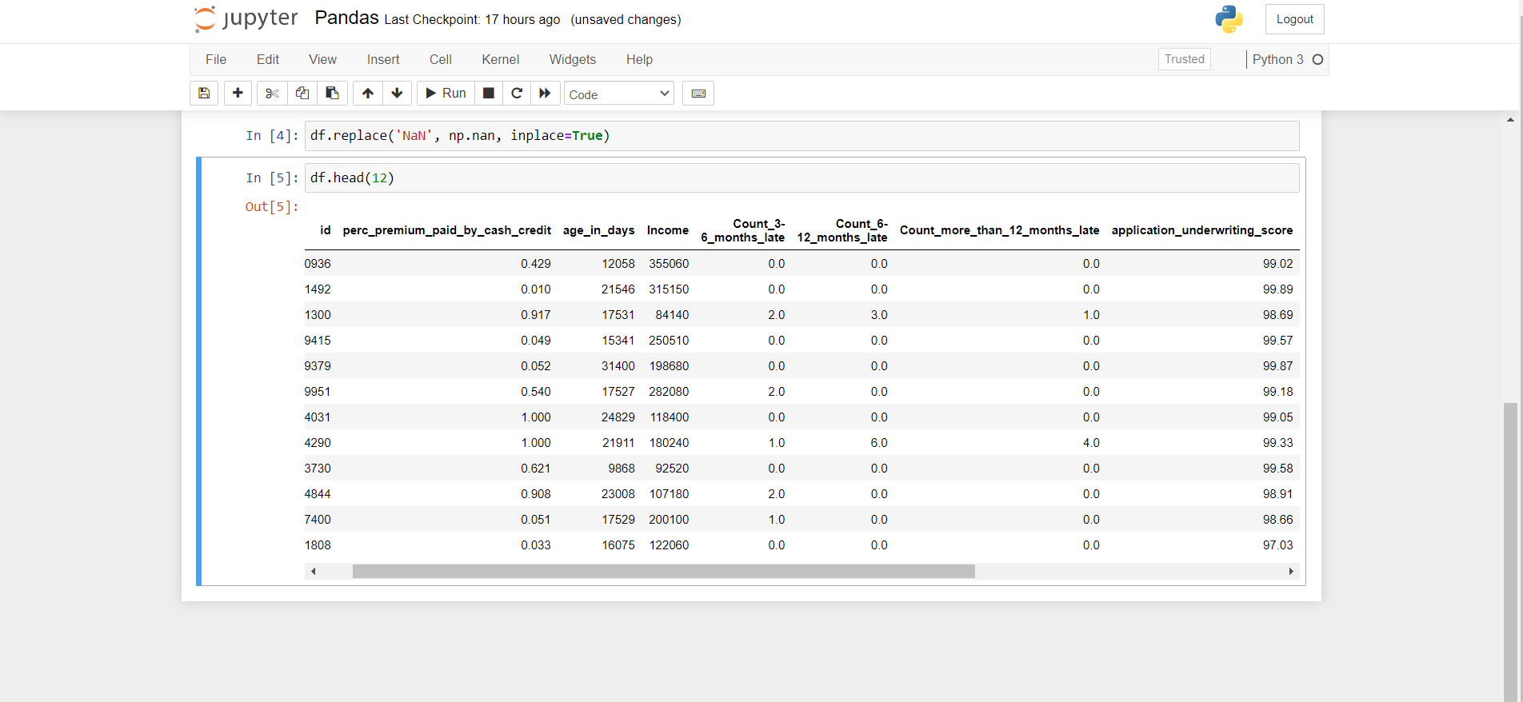

**Screenshots of running instances on AWS EC-2 cluster –**

**Apache Spark –**

Apache Spark is a data processing framework that can quickly perform processing tasks on very large data sets, and can also distribute data processing tasks across multiple computers, either on its own or in tandem with other distributed computing tools.

Advantages of Spark over Hadoop and Hive –

1) Provides memory based solutions – retain as much memory in RAM.

2)11 times faster than Hadoop Map Reduce in memory processing.

3) Use of Directed Acyclic Graph for workflow optimization.

4) Perform analytics on Unstructured Data.

**Use Case-1: Which sourcing channel has generated the Max revenue for the company?**

**Input** –

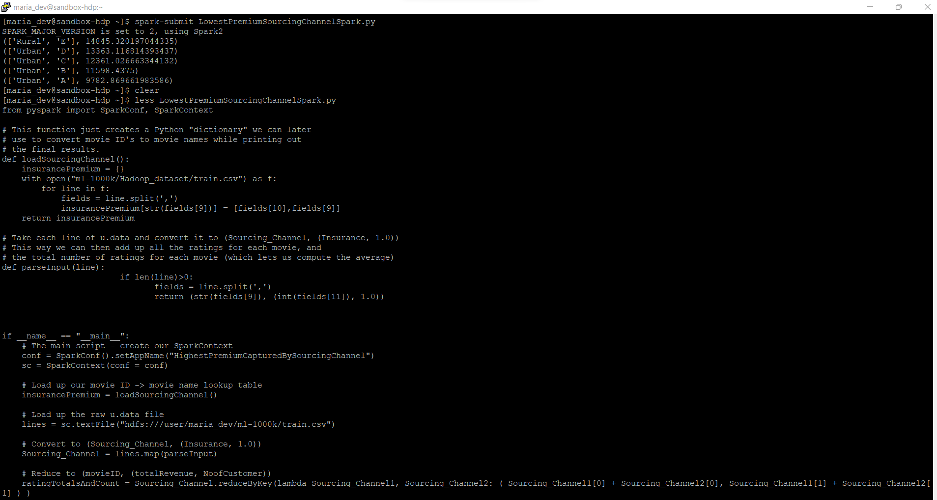

**Use Case-2: Which sourcing channel has got best customers with best possible premium policies (application underwriting score vs. sourcing channel):**

**Input -**

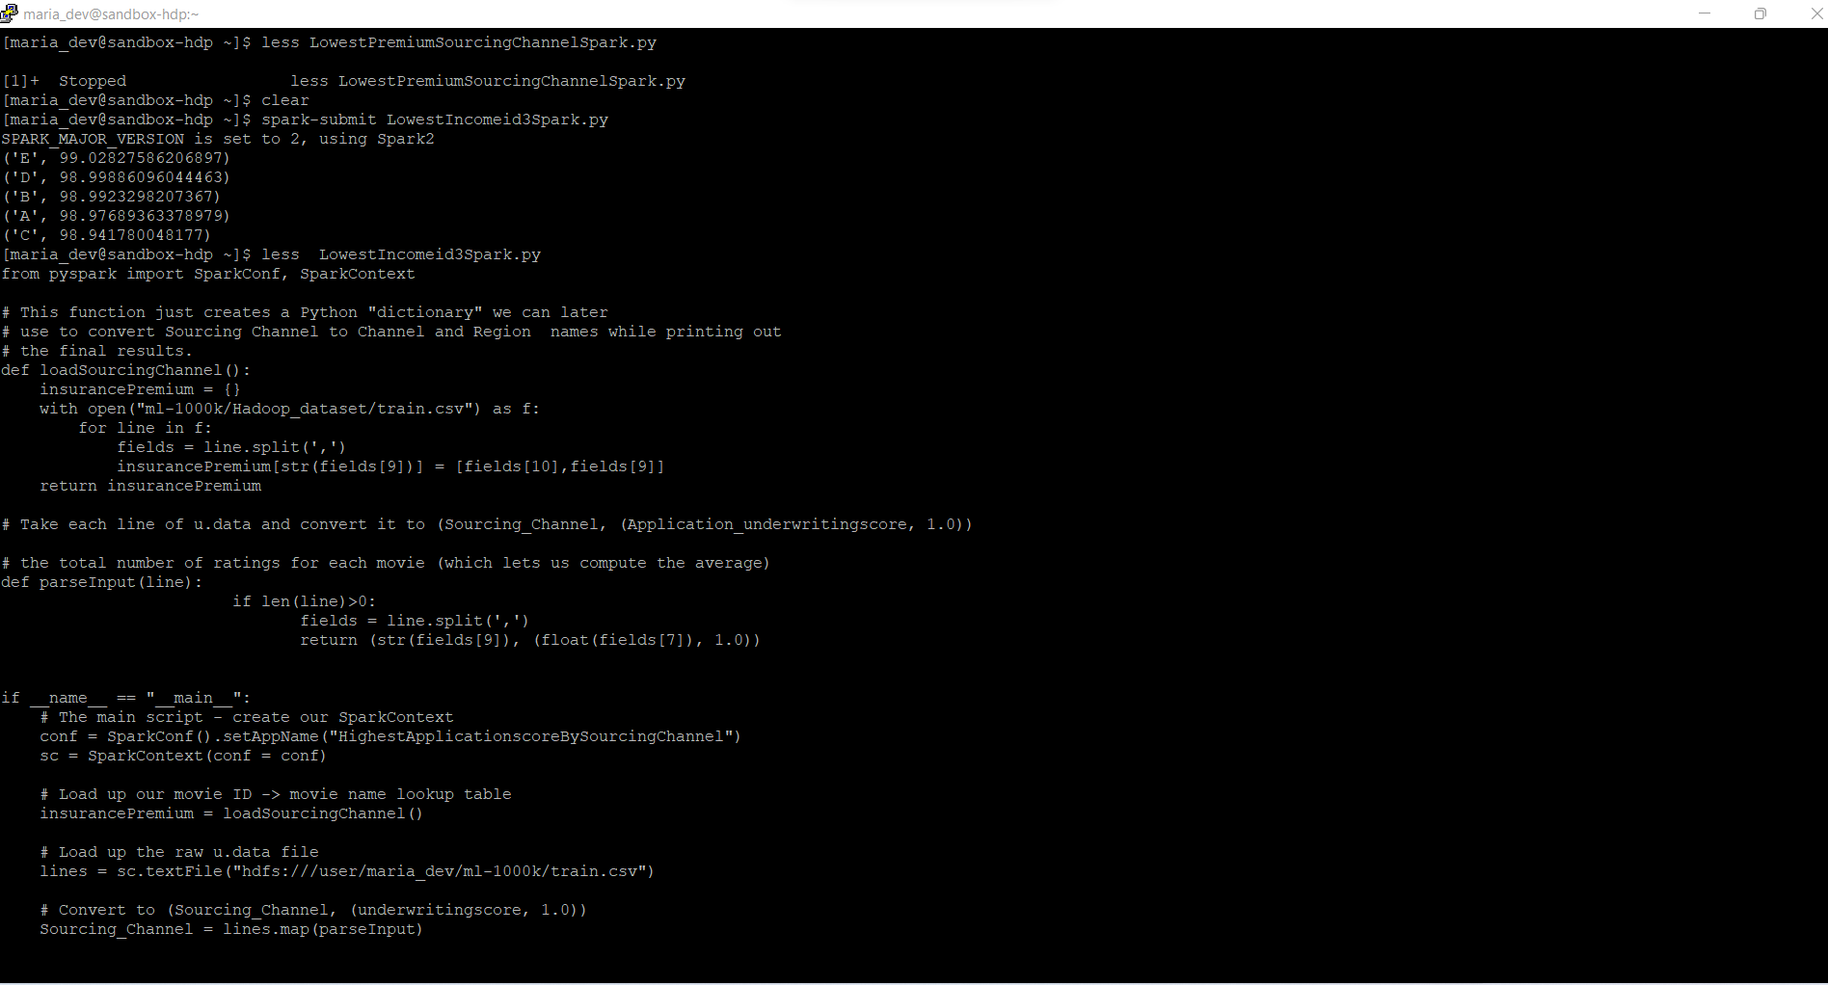

**Use-Case-1** - Which sourcing channel has generated the Max revenue for the company?

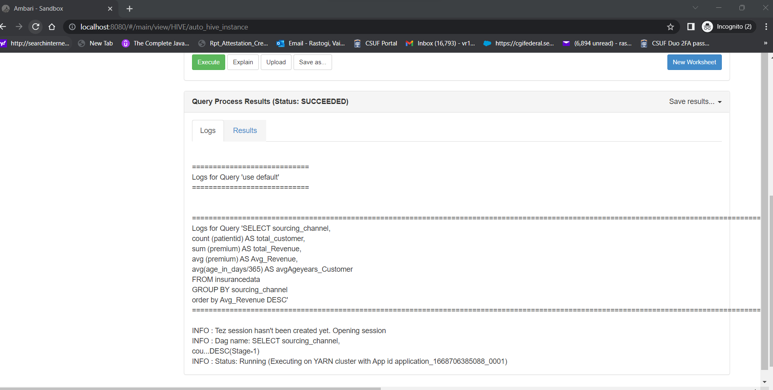

Output –

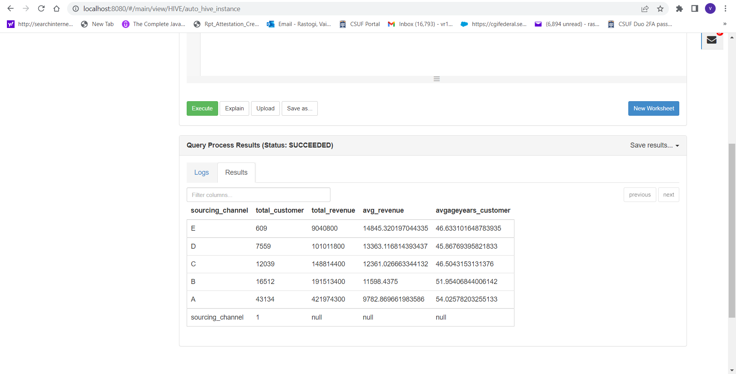

**Use-Case2**: Which sourcing channel has got best customers with best possible premium policies (application underwriting score vs. sourcing channel)

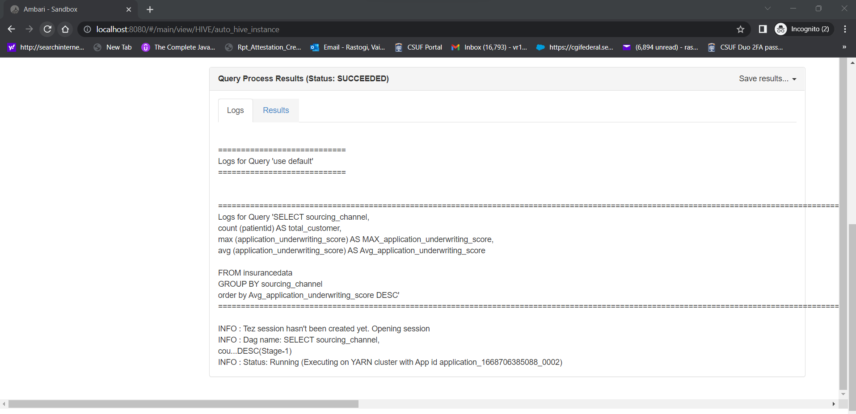

Output –

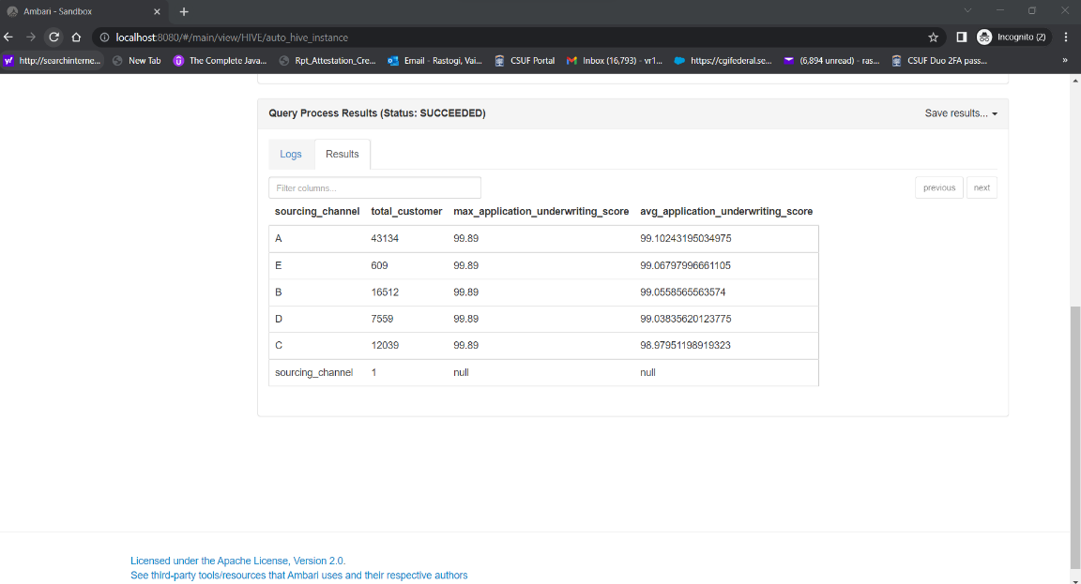

**GitHub Location of Code –**

<https://github.com/Sanket2596/CPSC-531-Final_Project_BigData_Analytics_For_Insurance_Company>

**Steps to run the application –**

1. Connect to the hadoop configured clusters as mentioned in the above steps.
2. Move the data to hadoop clusters.
3. Import code to jupyter notebook and run **spark-submit command** to run the spark analytics**.**
4. For running Hive queries - run zookeeper and then execute the HQL queries using Apache Ambari (Horton Works Sand Box).

**Test Results –**

1. **Test results for Spark Analytics –**

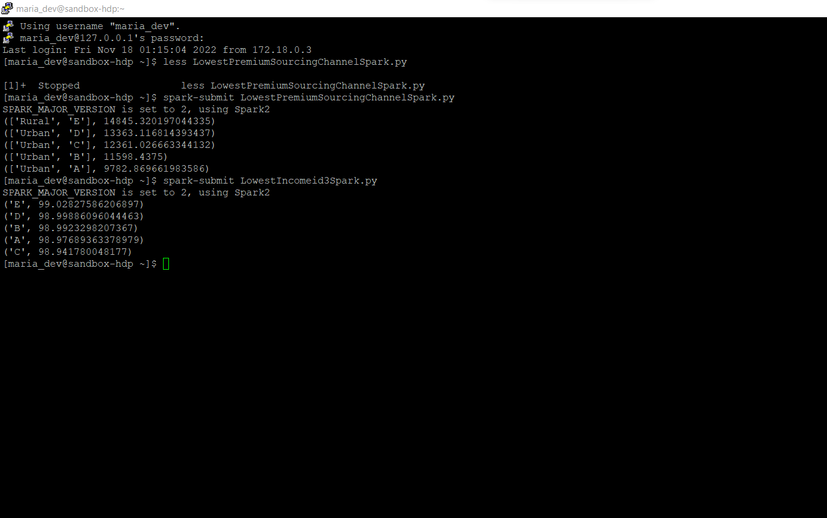

**Test results for Hive Analytics –**

**Result -Use Case -1:** **Which sourcing channel has generated the Max revenue for the company?**



**Result - Use Case-2:** **Which sourcing channel has got best customers with best possible premium policies (application underwriting score vs. sourcing channel).**

