TASK 10
SOME/IP EXPERIMENTS – OBSERVATION REPORT
Introduction to SOME/IP Using Python and someipy
Student: ______________________________ Date: __________________
Project: Virtual Vehicle ECU Provider and Instrument Cluster Consumer

1. Objective
Verify the behaviour of the SOME/IP application under different execution conditions. The experiments change application start/stop order and temporarily change the application event interval. The SOME/IP protocol implementation is not modified.

2. Important observation rule
This report distinguishes direct observations from conclusions. A service is not described as having disappeared or been rediscovered, and a SOME/IP-SD message is not claimed to have been transmitted, unless supported by application output, daemon output, or a Wireshark capture. Application logs, daemon logs and Wireshark packets are separate evidence sources.
A Consumer message saying that a service is unavailable is application-level evidence. A daemon log showing FindServiceRequest is daemon-level evidence. A packet decoded as SOME/IP-SD in Wireshark is network-level evidence.

3. System configuration
Parameter | Configured value
Service | VehicleSpeedService
Service ID | 0x1234
Instance ID | 0x5678
Major version | 1
GetSpeed Method ID | 0x0001
SpeedChanged Event ID | 0x8001
Event Group ID | 0x0001
Consumer endpoint | 127.0.0.1:3002
Provider endpoint | 127.0.0.1:3000
SD multicast | 224.224.224.245:30490
Original interval | 2 seconds

4. Experiment 10.1 – Start Consumer Before Provider

Procedure and observations
The SOME/IP daemon was started first. The Instrument Cluster Consumer was started while the Vehicle ECU Provider was not running. The Consumer connected to the daemon and displayed “Searching for VehicleSpeedService...” followed by repeated “VehicleSpeedService is not yet available” messages.
The daemon logs showed repeated FindServiceRequest messages. The request contained service_id 4660 (0x1234), instance_id 22136 (0x5678), major_version 1 and minor_version 0. The requests appeared at approximately one-second intervals.
After the Provider was started, shared screenshots showed Provider-side GetSpeed request handling and response transmission, Consumer-side successful GetSpeed responses with ReturnCode.E_OK, and SpeedChanged notifications using Event ID 0x8001. Daemon logs also showed internal subscription and method-routing activity, including a subscription for service 0x1234, instance 0x5678 and event group 0x0001.

Explanation and conclusion
Connecting to the SOME/IP daemon is not the same as having the requested service available. Before Provider startup, the Consumer connected to the daemon but repeatedly reported that VehicleSpeedService was not yet available. The daemon received FindServiceRequest messages for the configured service and instance. After Provider startup, successful method responses and event notifications were observed. The supplied evidence does not independently establish the contents of a multicast OfferService packet, so no such packet is claimed here.

5. Experiment 10.2 – Observe Request-Response
The supplied Provider and Consumer screenshots showed a GetSpeed request being handled by the Provider and a successful response being received by the Consumer. Provider output included the current speed, response bytes and a message indicating that the response was sent. Consumer output showed ReturnCode.E_OK and a decoded vehicle speed.

Answers for demonstration
Who initiated communication? The Instrument Cluster Consumer initiated the method call.
Which Method ID was used? 0x0001 (GetSpeed).
What did the request ask for? The current simulated vehicle speed. The request application payload is empty.
What did the Provider return? The current speed as an unsigned 16-bit integer (uint16).
What was in the response payload? A two-byte speed value. For example, 00 1E represents decimal 30 and 00 46 represents decimal 70, using big-endian byte order.
Evidence limitation: terminal evidence of successful request-response was shared. A final Wireshark screenshot proving the matching request/response pair, including matching Session IDs and payload, was not supplied. Packet-level correlation is therefore not marked as independently verified.

6. Experiment 10.3 – Observe Multiple Events
The Consumer screenshot showed SpeedChanged notifications with Event ID 0x8001 and five decoded speed values: 10, 20, 30, 40 and 50 km/h. The displayed payload bytes were 00 0A, 00 14, 00 1E, 00 28 and 00 32.
A later GetSpeed call in the same screenshot reported that the service with service ID 0x1234 and instance ID 0x5678 was not found at that time. This message is recorded as shown; its cause is not inferred.

Explanation and conclusion
The five notifications demonstrate that the Consumer received multiple SpeedChanged updates. A new GetSpeed request is not required before each notification because SpeedChanged is a publish-subscribe event. After subscribing, the Consumer can receive updates published by the Provider. The shared screenshot verifies notifications at application level; a dedicated Wireshark screenshot of five event packets was not supplied.

7. Experiment 10.4 – Stop the Consumer
The Consumer was stopped using Ctrl+C while the daemon and Provider were kept running. The subsequent Provider screenshot showed continued simulated speed generation and SpeedChanged event-send log messages. Values visible included 70, 80, 90, 100, 0, 10 and 20 km/h.

Explanation and conclusion
The Provider continued its local speed simulation after the Consumer was stopped. This supports the separation between application data generation and SOME/IP communication. The Vehicle ECU application generates the simulated speed; SOME/IP is used to communicate data. The Provider's event-send log alone does not prove that a Consumer received events after it had stopped.

8. Experiment 10.5 – Change the Event Period
The application interval was temporarily changed from await asyncio.sleep(2) to await asyncio.sleep(1). The user reported observing the changed notification behaviour. The original two-second setting was then to be restored.
The exact measured notification intervals and a Wireshark timestamp comparison were not provided. This report records the user's observation that notifications became faster, but does not state a measured one-second network interval.

Explanation and conclusion
The sleep interval is application timing logic. Reducing it can increase the frequency of simulated speed updates and associated event publications. Actual packet timing can also be affected by scheduling and processing, so measured timestamps should be used if an exact interval is required.

9. Experiment 10.6 – Stop and Restart the Provider
The user reported performing the stop-and-restart procedure. However, the Consumer output, daemon output and Wireshark observations from the stop and restart stages were not shared. Consequently, this report does not claim that the service disappeared, was rediscovered, or that any particular SOME/IP-SD message was transmitted.
To complete this experiment's evidence record, insert the actual Consumer output after Provider shutdown, daemon messages observed during shutdown, and Consumer/daemon/Wireshark evidence after Provider restart. Record only messages and packets actually seen.

10. Evidence and screenshot register
Experiment | Suggested screenshot filename | Evidence status
10.1 | experiment_10_1_consumer_before_provider.png | Consumer waiting output shared
10.1 | experiment_10_1_provider_consumer_daemon.png | After-startup screenshots shared
10.2 | experiment_10_2_request_response_wireshark.png | Terminal evidence shared; packet correlation still to capture
10.3 | experiment_10_3_consumer.png | Five event notifications screenshot shared
10.3 | experiment_10_3_wireshark.png | Dedicated event packet screenshot not supplied
10.4 | experiment_10_4_provider.png | Provider continues after Consumer stop screenshot shared
10.5 | experiment_10_5_provider_consumer_wireshark.png | User reported observation; measured packet timing not supplied
10.6 | experiment_10_6_consumer_stopped.png | Not supplied
10.6 | experiment_10_6_daemon_stopped.png | Not supplied
10.6 | experiment_10_6_consumer_restarted.png | Not supplied
10.6 | experiment_10_6_provider_restarted.png | Not supplied

11. Final verification before submission
- Restore the original application interval: await asyncio.sleep(2).
- Verify using: grep -n "asyncio.sleep" src/vehicle_speed_service.py.
- Keep terminal screenshots and the Wireshark capture in the project's screenshots/ and captures/ folders.
- For Experiment 10.6, add actual terminal and/or Wireshark evidence before making claims about service stop or rediscovery.
- For packet-level claims in Experiments 10.2 and 10.3, retain Wireshark screenshots showing the relevant SOME/IP message details.

12. Overall conclusion
The demonstrated experiments show Consumer service searching, successful GetSpeed request-response communication, receipt of multiple SpeedChanged notifications, continued local speed generation after the Consumer stops, and a reported change in event timing when the application interval is reduced. The Provider stop/restart experiment was performed, but its detailed observations were not supplied for this report. Final claims about service availability transitions and SOME/IP-SD network messages must be added only after reviewing the corresponding application logs, daemon logs or Wireshark packets.

13. Supplied Screenshot Evidence
The following screenshots are the evidence files supplied for this report. Captions describe only what is visible in each image. The fifth uploaded image was a file-selection view showing the report and screenshot filenames; it is not included as experimental evidence.

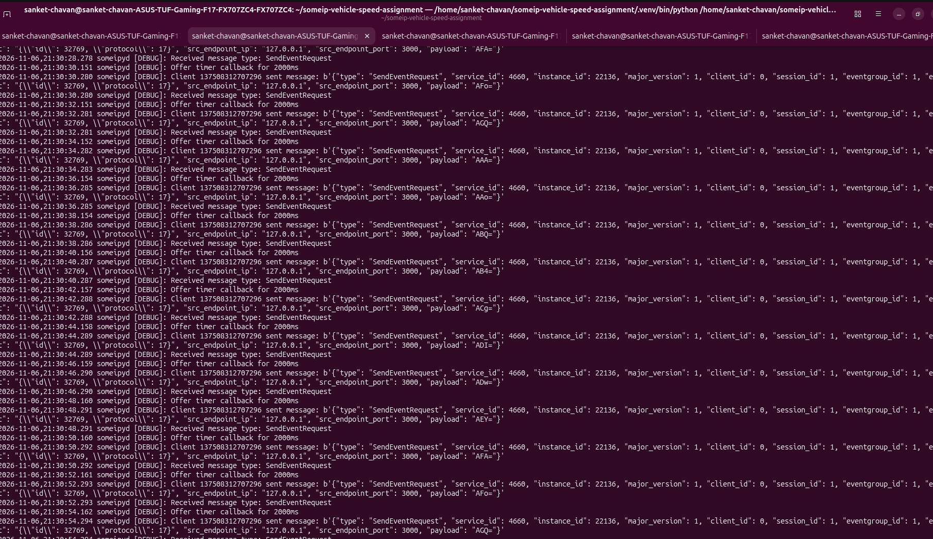
Figure 1. SOME/IP daemon debug output
The visible daemon log contains SendEventRequest messages and an internal subscription log for the configured event group. This supports daemon-side event/subscription activity. It does not show a FindServiceRequest or prove provider disappearance/rediscovery.

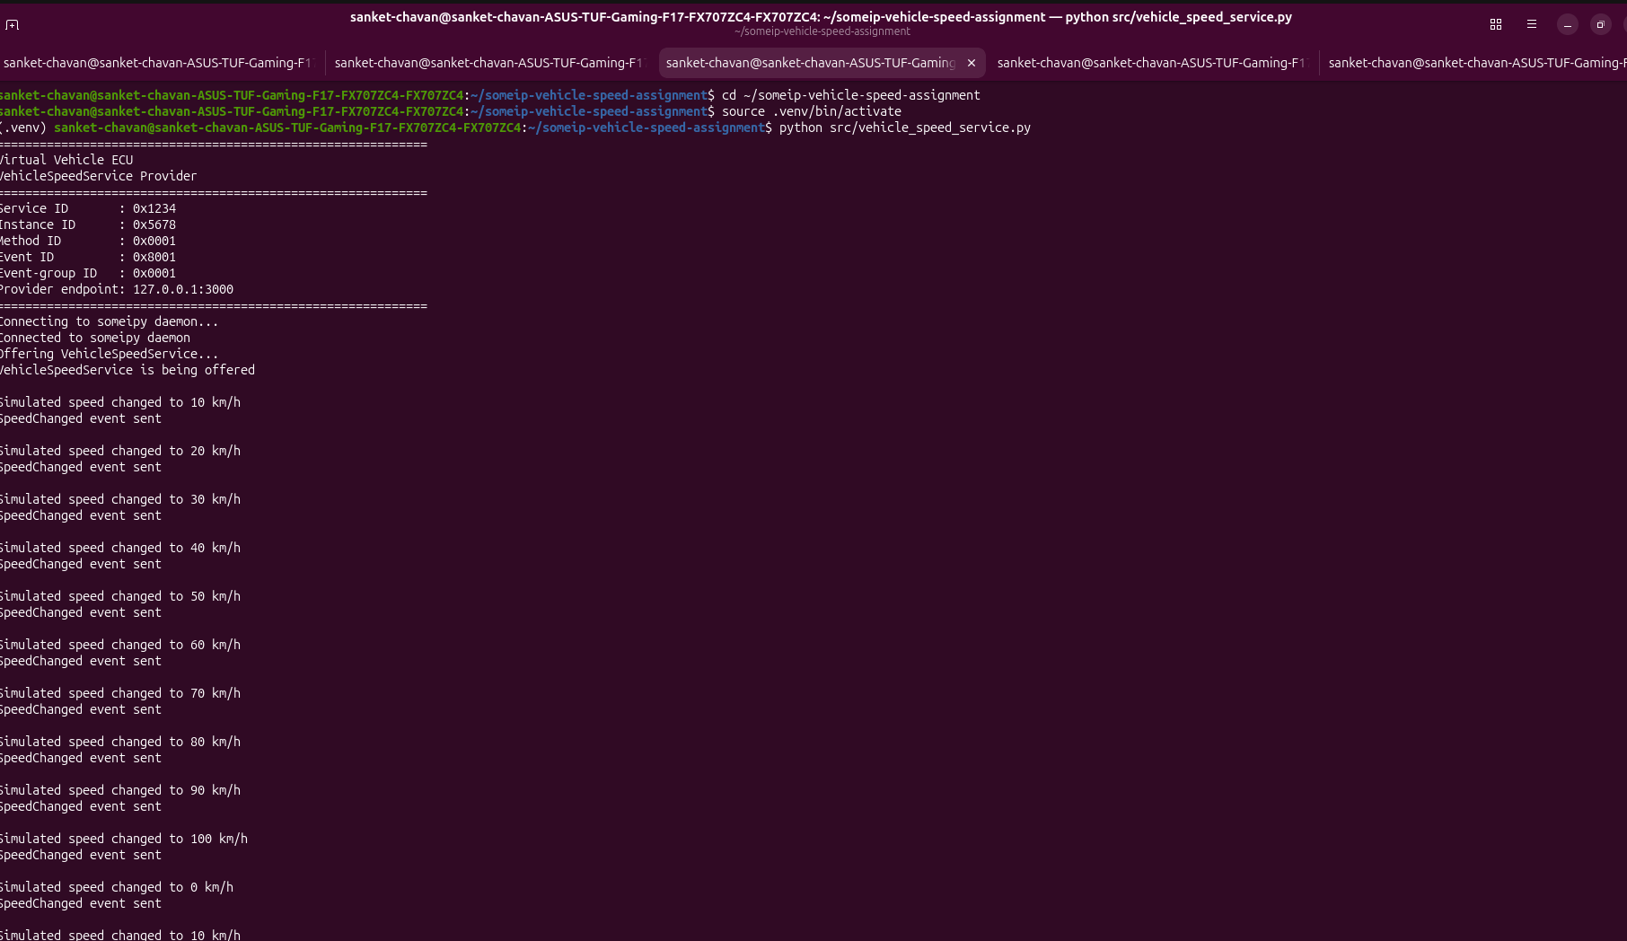
Figure 2. Vehicle ECU Provider terminal
The Provider terminal shows VehicleSpeedService being offered, simulated speed changes, and SpeedChanged event-send messages. It also shows GetSpeed request handling and response transmission in the visible session.

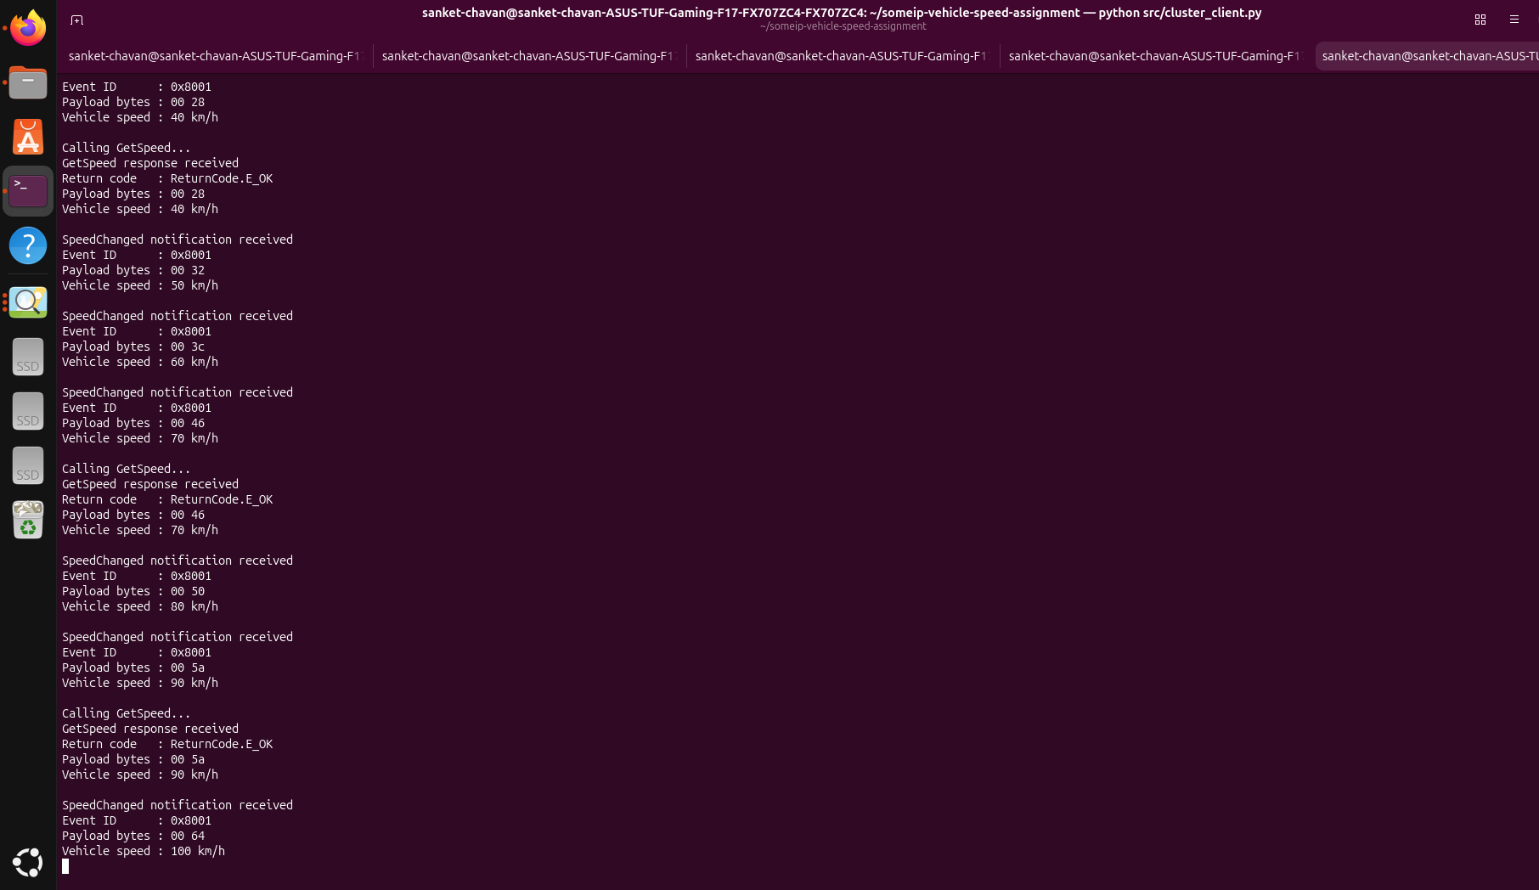
Figure 3. Instrument Cluster Consumer terminal
The Consumer terminal shows SpeedChanged notifications with Event ID 0x8001, decoded speeds from 50 to 100 km/h, and successful GetSpeed responses with ReturnCode.E_OK.

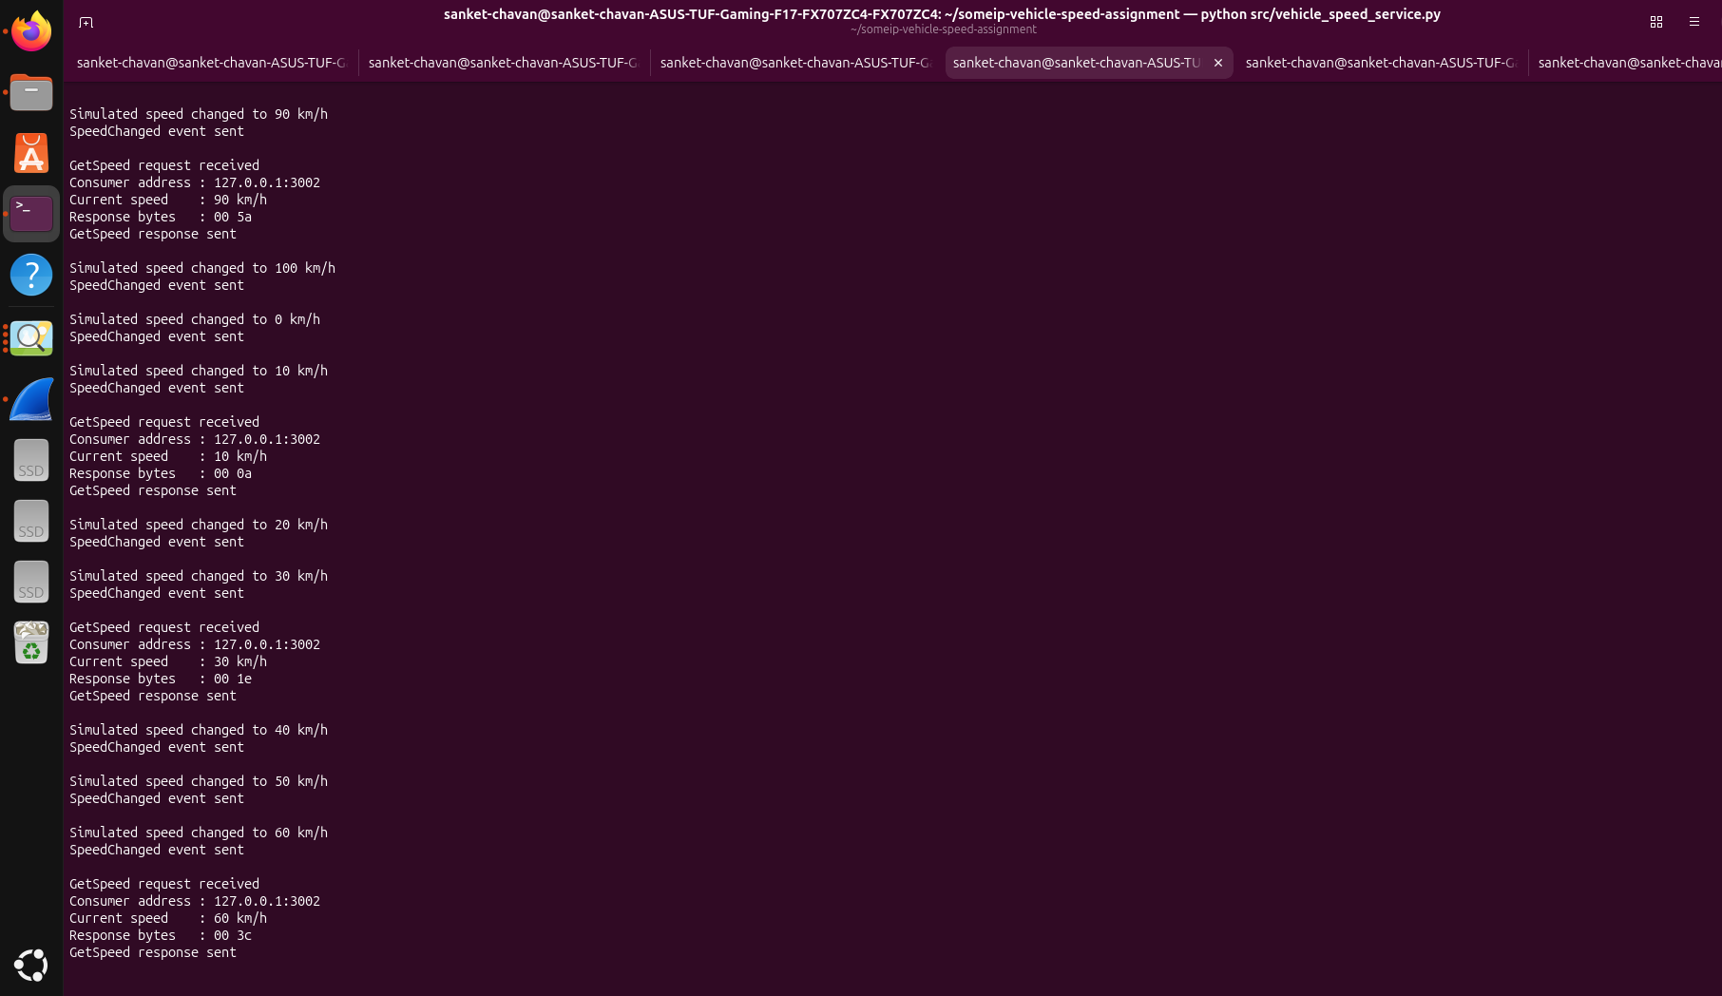
Figure 4. Consumer and Provider output during multiple speed updates
The terminal shown is the Vehicle ECU Provider (as indicated by the window title and output). It displays simulated speed changes and GetSpeed request/response handling. It is supporting application evidence for repeated updates, not a Consumer-side notification screenshot.

14. Evidence-based status of Task 10
10.1 Consumer before Provider: Earlier shared terminal text showed the Consumer waiting and daemon FindServiceRequest logs. The screenshots appended here do not show that waiting stage. The earlier text/log evidence supports the observation; no OfferService packet is claimed.
10.2 GetSpeed request-response: Provider and Consumer screenshots show application-level request/response handling and successful return codes. A Wireshark screenshot correlating the exact request and response is not included in the supplied image set.
10.3 Multiple SpeedChanged events: Consumer screenshot shows multiple event notifications and event ID 0x8001. The additional Provider screenshot shows multiple speed changes and event-send messages. A Wireshark event-packet screenshot is not included.
10.4 Stop Consumer: Provider activity is visible, but the supplied Provider screenshot alone does not prove that the Consumer had already been stopped. Record the stop action as performed only if supported by the separate live observation; do not infer that the Provider's event-send messages were received by a Consumer.
10.5 Change event period: The user reported observing the changed notification behaviour. The supplied screenshots do not show a before/after timestamp measurement, so no exact measured event interval is claimed.
10.6 Stop and restart Provider: No supplied screenshot clearly shows the Consumer waiting after Provider shutdown and then detecting the Provider after restart. Do not claim service disappearance, rediscovery, or specific SOME/IP-SD messages from this screenshot set.

