1. Write a Query to add a column package_stat to the table orders.

Alter table orders add column "package_stat" varchar(10);

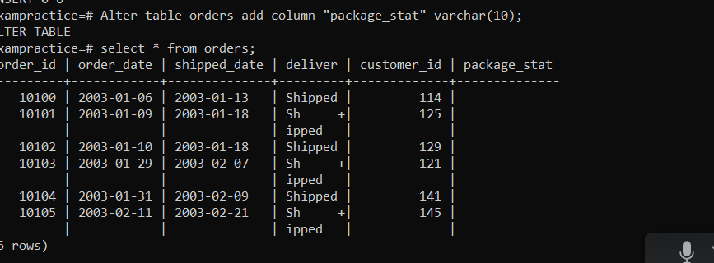

1. Write a Query to change the package_stat column of orders table with 'not available' for all orders

update orders set package_stat='not available';

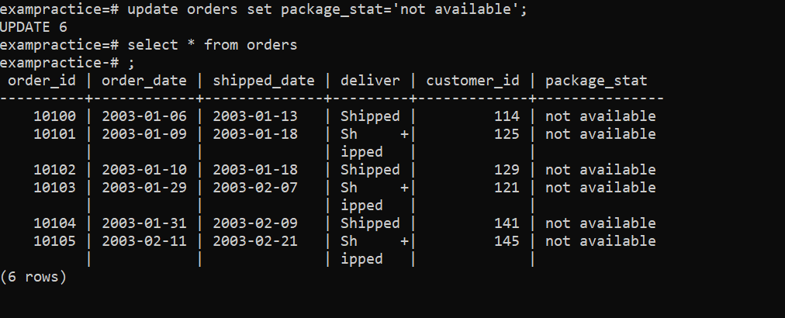

1. Write a Query to delete a row from customers table where credit_limit is 0.00

**Write SELECT statements to achieve the following**:

1. Write a Query to display the first_name with the occurrence of ‘el’ in the customers tables.

select * from customers where first_name like '%el%';

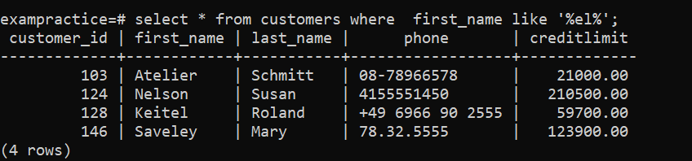

1. Write a Query to prepare a list with customer name ,customer_id ,order_id for the customers whose delivery status is shipped.

Select customers.first_name,customers.last_name,customers.customer_id,orders.order_id ,orders.deliver from customers ,orders where customers.customer_id=orders.customer_id AND orders.deliver='Shipped';

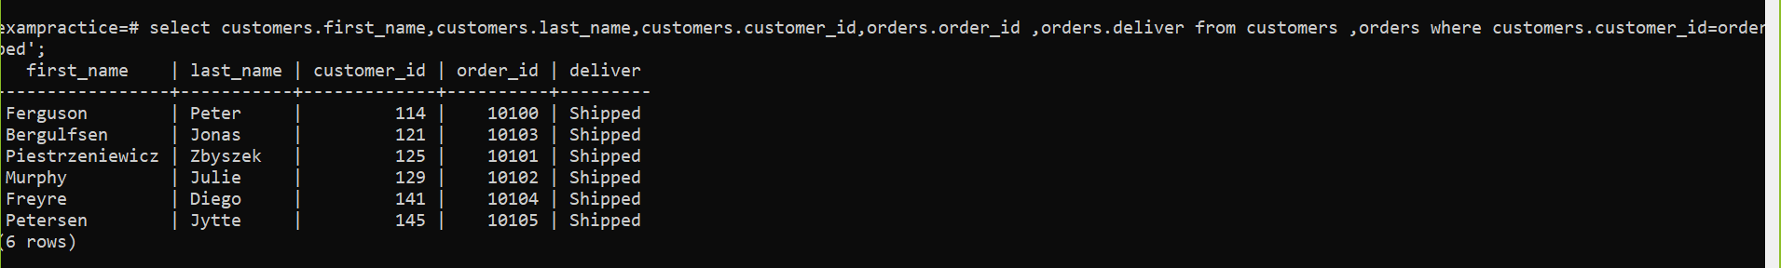

1. Write a Query to get the number of customers with the creditLimit greater than 50000.

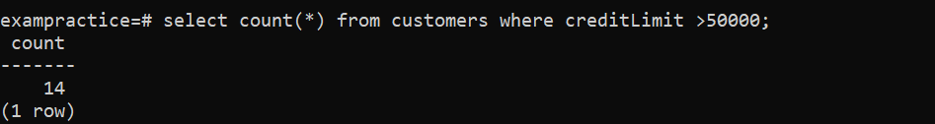

1. 4. Write a Query to display the customer_id, name ( first name and last name ), order_id and deliver for all customers.

select customers.customer_id,customers.first_name,customers.last_name,order_id,deliver from customers full join orders on customers.customer_id=orders.customer_id;

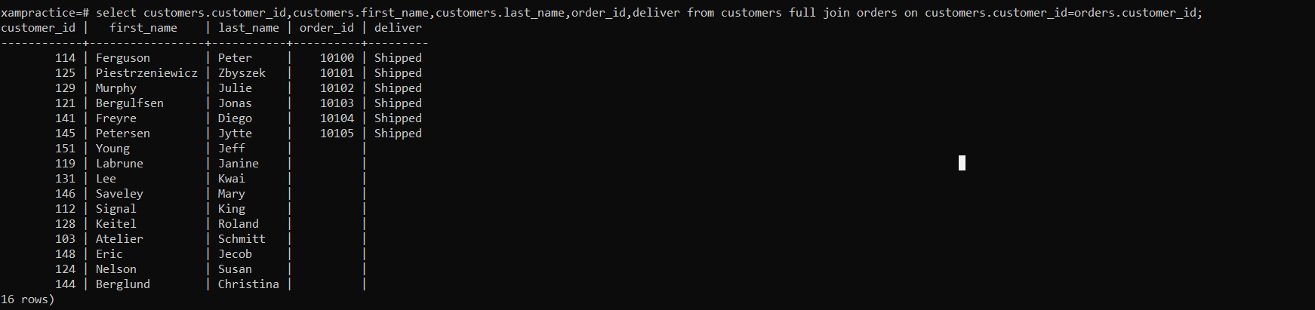

1. Write a Query to customer name in order of creditLimit smallest to highest.

select first_name,last_name,creditlimit from customers order by creditlimit;

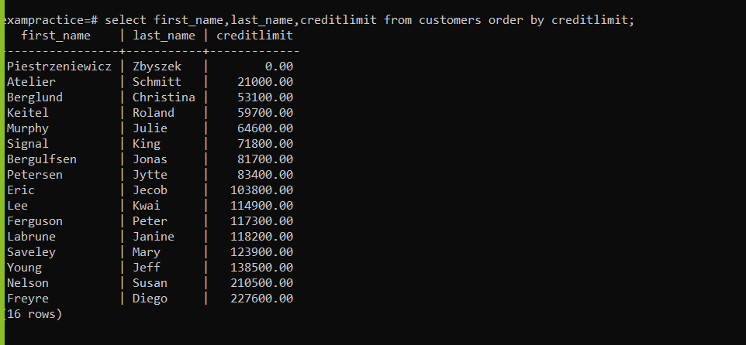

1. Write a stored procedure by name order_day. The procedure should show the customer_id and the day on which he had made the order.
2. Write a stored function by the name of cutomer_search. The stored function should return the maximum creditLimit made by any customer.

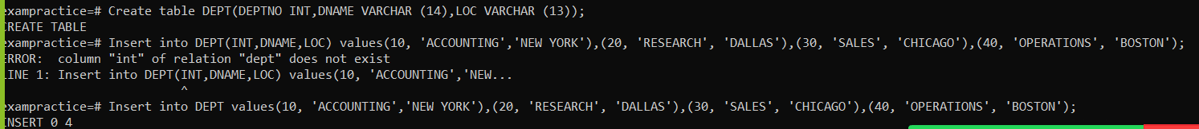

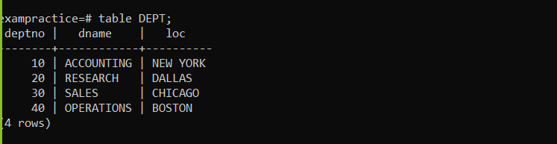

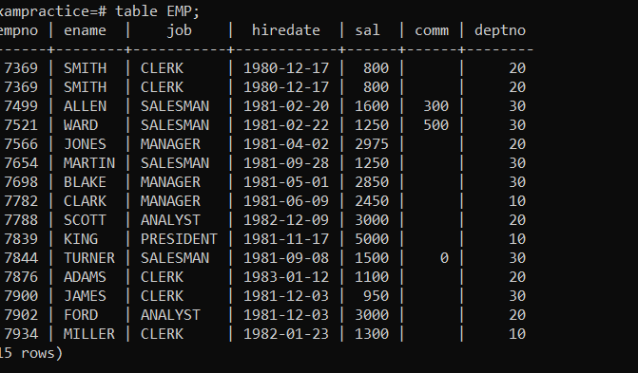

1. Display only the EMPNO and ENAME columns from EMP table.

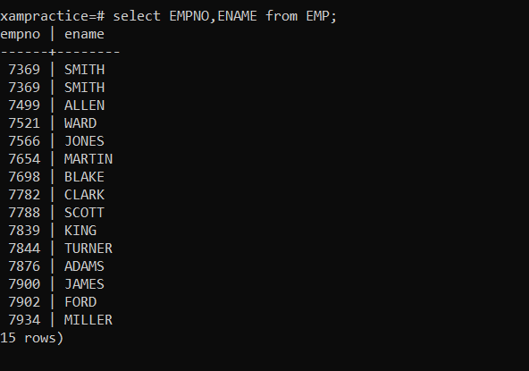

1. Display all employees who are CLERKs and the MANAGERs.

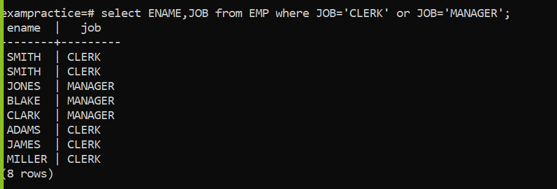

1. Display the ENAME and JOB for all employees who belong to the same DEPTNO as employee ‘KING’.

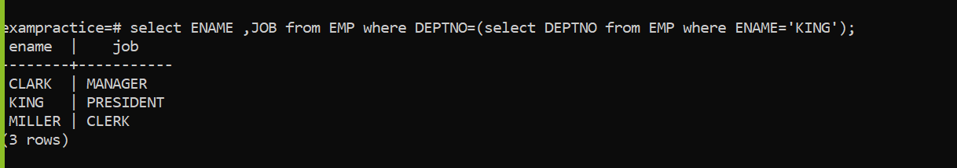

1. Find the names of all employees hired in the month of February (of any year).

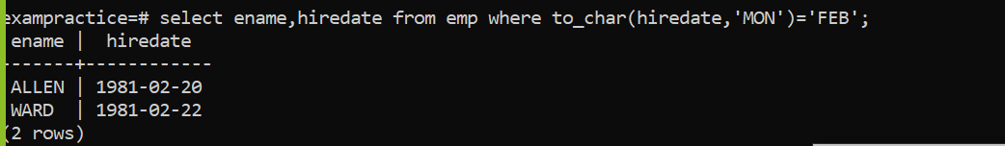

1. Display the employees in descending order of DEPTNO.

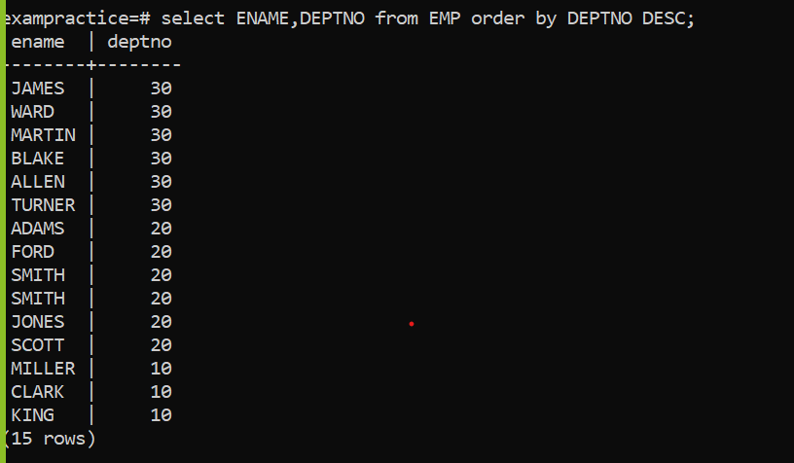

1. Display the employee name and employee number of the employees with the headings as NUMBER and NAME.

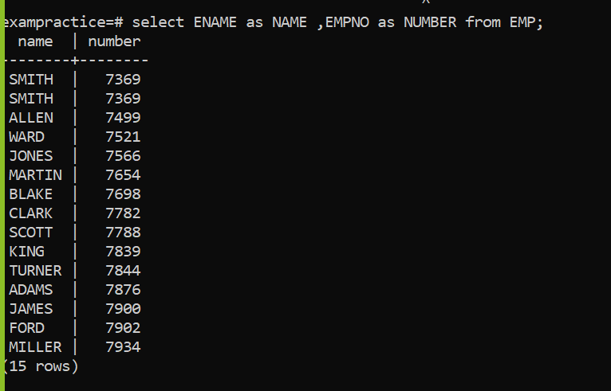

7. Find the names of all employees who were hired on the last day of the month.

8. Find the name of the employee who is receiving the maximum salary.

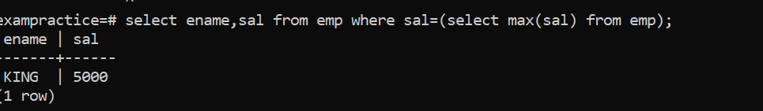

1. Display the sum of SAL for all the employees belonging to DEPTNO 10.

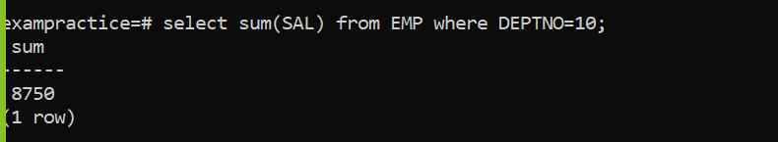

1. Display the rows where JOB column ends with the letter ‘T’.

