***BACKEND:***

***Team:-***

Shruti M. M. Pingle

Swara A. A. Kulkarni

***Tech Stack:-***

MySQL (Database) , Node.js & Express.js

***Entities:-***

1)Admin

2)Tester

3)Developer

4)Project

5)Module

6)Bug Master Table

7)Issue Description

***Tables & Attributes:-***

CREATE DATABASE IF NOT EXISTS bug_tracker_sys_db;

USE bug_tracker_sys_db;

**1)Admin Table:-**

admin_id int PRIMARY_KEY AUTO_INCREMENT;

admin_name varchar(100);

admin_username varchar(100) UNIQUE;

admin_email varchar(255) NOT NULL;

admin_password varchar(20);

**2)Tester Table:-**

tester_id int PRIMARY_KEY AUTO_INCREMENT;

tester_name varchar(100);

tester_username varchar(100) UNIQUE;

tester_email varchar(255) NOT NULL;

tester_password varchar(20);

**3)Developer Table:-**

developer_id int PRIMARY_KEY AUTO_INCREMENT;

developer_name varchar(100);

developer_username varchar(100) UNIQUE;

developer_email varchar(255) NOT NULL;

developer_password varchar(20);

**4)Project Table:-**

project_id int PRIMARY_KEY AUTO_INCREMENT;

project_name varchar(100);

project_status ENUM(“active”, “inactive”) DEFAULT “active”;

created_by int;

FOREIGN KEY (created_by) REFERENCES admin(admin_id);

**5)Module Table:-**

module_id int PRIMARY_KEY AUTO_INCREMENT;

module_name varchar(100);

module_status ENUM(“active”, “inactive”) DEFAULT “active”;

project_id int;

FOREIGN KEY (project_id) REFERENCES project(project_id);

**6)Bug Type Master Table:-**

BugType_id int PRIMARY_KEY AUTO_INCREMENT;

BugType _name varchar(100);

BugType_description text;

BugType _status ENUM(“active”, “inactive”) DEFAULT “active”;

**7)Issue Table:-**

issue_id int PRIMARY_KEY AUTO_INCREMENT;

issue_description TEXT NOT NULL;

steps_to_reproduce TEXT;

source_url VARCHAR(255);

issue_priority ENUM('Low', 'Mid', 'High');

attachment_path VARCHAR(255);

added_on DATETIME DEFAULT CURRENT_TIMESTAMP;

issue_status ENUM('New', 'InProgress', 'Resolved', 'Reopen', 'Closed', 'Not a Bug', 'Hold') DEFAULT 'New';

remark TEXT;

project_id INT;

module_id INT;

bugType_id INT;

added_by INT;

FOREIGN KEY (project_id) REFERENCES Project(project_id);

FOREIGN KEY (module_id) REFERENCES Module(module_id);

FOREIGN KEY (bugType_id) REFERENCES BugTypeMaster(bugType_id);

FOREIGN KEY (added_by) REFERENCES Tester(tester_id)

***RELATIONSHIPS:-***

Admin(Relation):-

●(1) Admin handles-> (Many) Projects.

●(1) Admin handles-> (Many) Modules.

●(1) Admin handles-> (Many) Issues.

●(1) Admin controls-> (Many) Testers.

●(1) Admin controls-> (Many) Developers.

Developer(Relation):-

●(1) Developer handles-> (Many) Issues.

Tester(Relation):-

●(1) Tester add-> (Many) Issues.

●(1) Tester add-> (Many) bugs.

Project(Relation):-

●(1) Project has-> (Many) Modules.

●(Many) Project handled by-> (1)Admin.

●(1) Project has-> (Many) Issues.

Module(Relation):-

●(1) module is in-> (1) Project

●(Many) modules handled by-> (1)Admin.

●(1) module has-> (Many) Issues.

Issue(Relation ):-

●issue (1) have-> (many)projects.

●issue (1) have-> (many)modules.

●issue (1) have-> (Many)BugType.

●(many) Project have-> (many)issues.

●(many) Modules have-> (many)issues.

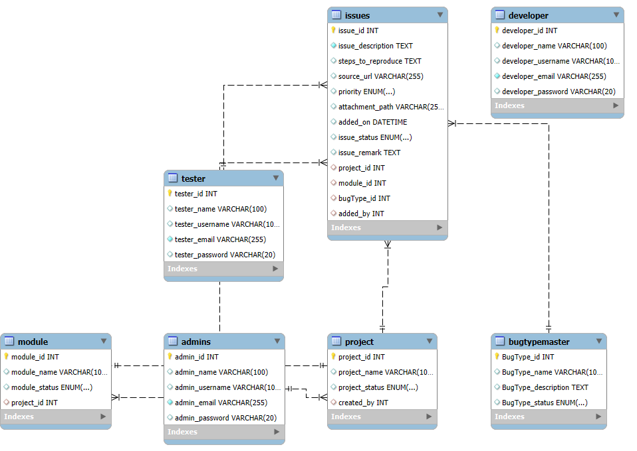

**Diagram: EER (Enhanced Entity-Relationship )**

**Developed by:-MYSQL workbench**