**System WorkFlow Diagram =>**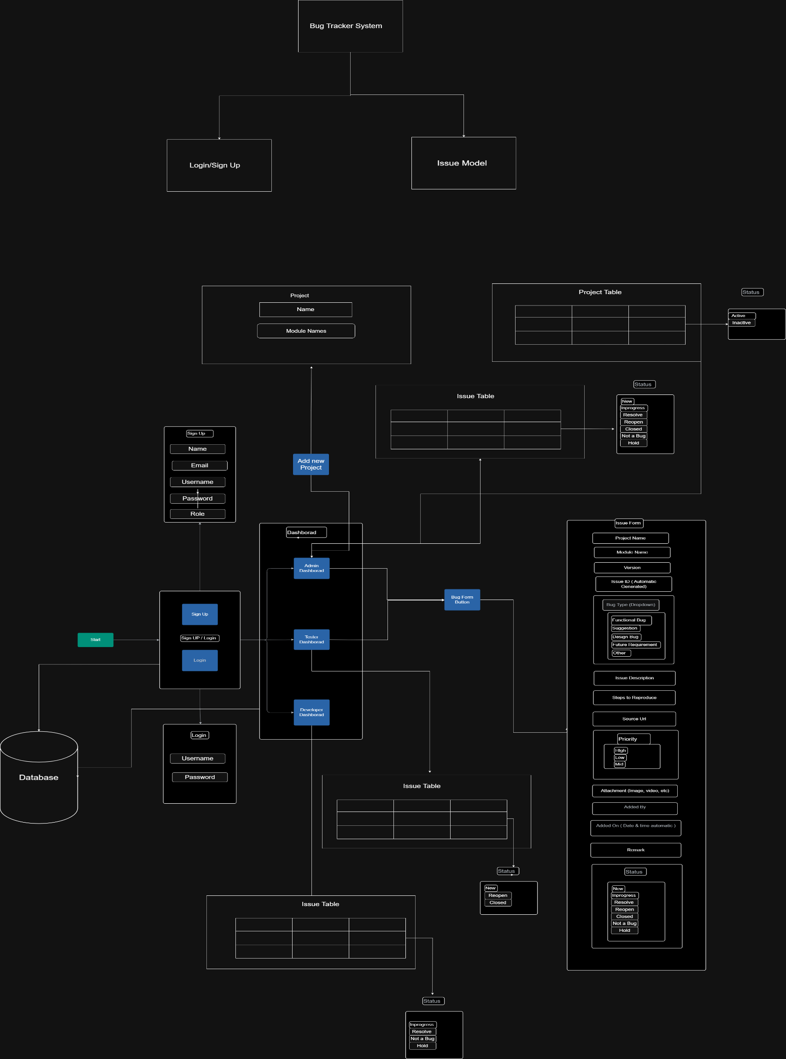

**Description =>**

1) First the User see the dashboard of Bug tracker System there they see the login and sign up button.  
2) If he is new to the system he will click on the sign up button and need to register their details   
  
In sign up they need to give the following details ->

a) Username

b) Password

c) Name

d) Email

e) Role ( Admin / Developer / Tester)

3) Else he need to login through there username & password

4) Then if Login as => **Admin** then he redirect to the admin dashboard where he see the

a) Add Project Button

b) Add Issue Button

c) Existing Issue Table

d) Existing Project Table

a) Add Project Button –

If he click on that the Project form is opened in that they need to add

i) Project Name (only active)

ii) Module Names

b) Add Issue Button –

if he click on that the Issue form is opened in that they need to add

i) Select the Project from the dropdown

ii) Select their Module from the dropdown

iii) Version

iii) Issue Id (Automatically assigned)

iv) Select Bug Type from the dropdown  
 a) function bug

b) suggestion

c) design bug

d) future requirement

e) other ( if user select this new input box will open in that they need to type that bug)

v) Issue Description

vi) Steps to Reproduce

vii) Source URL

viii) Select the Priority

ix) Upload the Attachment file (photo, video etc.)

x) Added by & date (Automatically assigned)

xi) Remark

xii) Select the Status

c) Existing Issue Table –

In that admin should able view the all existing bug & update the status of bug to

a) New b) Inprogress c) Resolve d) Reopen e) Closed f) Not Bug g) Hold  
  
d) Existing Project Table –

In that admin should able view the all existing project & update the status of project to

1) Active

2) Inactive

5) Then if Login as => **Tester** then he redirect to the tester dashboard where he see the

a) Add Issue Button

b) Existing Issue Table

a) Add Issue Button –

he see similar from as described in admin login but for status of bug they only able select following options & very important tester should able to add only active status project bug.

a) New

b) Reopen

c) Closed

b) Exiting Issue Table –

In that tester should able view the all existing bug & update the status of bug to

a) New

b) Reopen

c) Closed

6) Then if Login as => **Developer** then he redirect to the developer dashboard where he see the

a) Existing Issue Table

a) Exiting Issue Table –

In that tester should able view the all existing bug & update the status of bug to

a) Inprogress

b) Resolved

c) Not a Bug

d) Hold