ChurnLDA.R

2019-11-21

##Multivariate Project  
##TELECOM-CHURN-ANALYSIS  
##Author : Sanket Gohel

##Importing Libraries

library(ggplot2)

## Warning: package 'ggplot2' was built under R version 3.5.3

library(dplyr)

## Warning: package 'dplyr' was built under R version 3.5.3

##   
## Attaching package: 'dplyr'

## The following objects are masked from 'package:stats':  
##   
## filter, lag

## The following objects are masked from 'package:base':  
##   
## intersect, setdiff, setequal, union

library (stringr)

## Warning: package 'stringr' was built under R version 3.5.3

library(data.table)

## Warning: package 'data.table' was built under R version 3.5.3

##   
## Attaching package: 'data.table'

## The following objects are masked from 'package:dplyr':  
##   
## between, first, last

library(grid)  
library(gridExtra)

## Warning: package 'gridExtra' was built under R version 3.5.3

##   
## Attaching package: 'gridExtra'

## The following object is masked from 'package:dplyr':  
##   
## combine

library(corrplot)

## Warning: package 'corrplot' was built under R version 3.5.3

## corrplot 0.84 loaded

library(scales)

## Warning: package 'scales' was built under R version 3.5.3

library(qqplotr)

## Warning: package 'qqplotr' was built under R version 3.5.3

##   
## Attaching package: 'qqplotr'

## The following objects are masked from 'package:ggplot2':  
##   
## stat_qq_line, StatQqLine

library(MASS)

##   
## Attaching package: 'MASS'

## The following object is masked from 'package:dplyr':  
##   
## select

library(DMwR)

## Warning: package 'DMwR' was built under R version 3.5.3

## Loading required package: lattice

library(car)

## Warning: package 'car' was built under R version 3.5.3

## Loading required package: carData

## Warning: package 'carData' was built under R version 3.5.2

##   
## Attaching package: 'car'

## The following object is masked from 'package:dplyr':  
##   
## recode

library(e1071)

## Warning: package 'e1071' was built under R version 3.5.3

library(caret)

## Warning: package 'caret' was built under R version 3.5.3

library(caTools)

## Warning: package 'caTools' was built under R version 3.5.3

library(pROC)

## Warning: package 'pROC' was built under R version 3.5.3

## Type 'citation("pROC")' for a citation.

##   
## Attaching package: 'pROC'

## The following objects are masked from 'package:stats':  
##   
## cov, smooth, var

library(tidyverse)

## Warning: package 'tidyverse' was built under R version 3.5.3

## -- Attaching packages ------------------------------------------------------- tidyverse 1.2.1 --

## v tibble 2.1.3 v readr 1.3.1  
## v tidyr 1.0.0 v purrr 0.3.3  
## v tibble 2.1.3 v forcats 0.4.0

## Warning: package 'tibble' was built under R version 3.5.3

## Warning: package 'tidyr' was built under R version 3.5.3

## Warning: package 'readr' was built under R version 3.5.3

## Warning: package 'purrr' was built under R version 3.5.3

## Warning: package 'forcats' was built under R version 3.5.3

## -- Conflicts ---------------------------------------------------------- tidyverse_conflicts() --  
## x data.table::between() masks dplyr::between()  
## x readr::col_factor() masks scales::col_factor()  
## x gridExtra::combine() masks dplyr::combine()  
## x purrr::discard() masks scales::discard()  
## x dplyr::filter() masks stats::filter()  
## x data.table::first() masks dplyr::first()  
## x dplyr::lag() masks stats::lag()  
## x data.table::last() masks dplyr::last()  
## x purrr::lift() masks caret::lift()  
## x car::recode() masks dplyr::recode()  
## x MASS::select() masks dplyr::select()  
## x purrr::some() masks car::some()  
## x qqplotr::stat_qq_line() masks ggplot2::stat_qq_line()  
## x purrr::transpose() masks data.table::transpose()

library(MVA)

## Warning: package 'MVA' was built under R version 3.5.3

## Loading required package: HSAUR2

## Warning: package 'HSAUR2' was built under R version 3.5.3

## Loading required package: tools

library(GGally)

## Warning: package 'GGally' was built under R version 3.5.3

##   
## Attaching package: 'GGally'

## The following object is masked from 'package:dplyr':  
##   
## nasa

library(gvlma)

## Warning: package 'gvlma' was built under R version 3.5.2

library(psych)

## Warning: package 'psych' was built under R version 3.5.3

##   
## Attaching package: 'psych'

## The following object is masked from 'package:car':  
##   
## logit

## The following objects are masked from 'package:scales':  
##   
## alpha, rescale

## The following objects are masked from 'package:ggplot2':  
##   
## %+%, alpha

library(cowplot)

## Warning: package 'cowplot' was built under R version 3.5.3

##   
## ********************************************************

## Note: As of version 1.0.0, cowplot does not change the

## default ggplot2 theme anymore. To recover the previous

## behavior, execute:  
## theme_set(theme_cowplot())

## ********************************************************

library(regclass)

## Warning: package 'regclass' was built under R version 3.5.3

## Loading required package: bestglm

## Warning: package 'bestglm' was built under R version 3.5.3

## Loading required package: leaps

## Warning: package 'leaps' was built under R version 3.5.3

## Loading required package: VGAM

## Warning: package 'VGAM' was built under R version 3.5.3

## Loading required package: stats4

## Loading required package: splines

##   
## Attaching package: 'VGAM'

## The following objects are masked from 'package:psych':  
##   
## fisherz, logistic, logit

## The following object is masked from 'package:tidyr':  
##   
## fill

## The following object is masked from 'package:caret':  
##   
## predictors

## The following object is masked from 'package:car':  
##   
## logit

## Loading required package: rpart

## Loading required package: randomForest

## Warning: package 'randomForest' was built under R version 3.5.3

## randomForest 4.6-14

## Type rfNews() to see new features/changes/bug fixes.

##   
## Attaching package: 'randomForest'

## The following object is masked from 'package:psych':  
##   
## outlier

## The following object is masked from 'package:gridExtra':  
##   
## combine

## The following object is masked from 'package:dplyr':  
##   
## combine

## The following object is masked from 'package:ggplot2':  
##   
## margin

## Important regclass change from 1.3:  
## All functions that had a . in the name now have an _  
## all.correlations -> all_correlations, cor.demo -> cor_demo, etc.

##   
## Attaching package: 'regclass'

## The following object is masked from 'package:lattice':  
##   
## qq

library(stats)  
library(e1071)  
library(pROC)  
library(ROCR)

## Warning: package 'ROCR' was built under R version 3.5.3

## Loading required package: gplots

## Warning: package 'gplots' was built under R version 3.5.3

##   
## Attaching package: 'gplots'

## The following object is masked from 'package:stats':  
##   
## lowess

##Importing Dataset and doing preliminary analysis

#Importing CSV file from drive on my local computer and viewing it   
  
tablechurn<-read.csv("C:/Users/SHIVANSHI/Desktop/Priyanshi/MVA/Telecom Churn Analysis Data.csv")  
tablechurn <- as.data.frame(tablechurn)  
  
  
#Gaining more insight about the kind of data stored in each column  
  
summary(tablechurn)

## CustomerID Gender SeniorCitizen Partner Dependents  
## 0002-ORFBO: 1 Female:3488 Min. :0.0000 No :3641 No :4933   
## 0003-MKNFE: 1 Male :3555 1st Qu.:0.0000 Yes:3402 Yes:2110   
## 0004-TLHLJ: 1 Median :0.0000   
## 0011-IGKFF: 1 Mean :0.1621   
## 0013-EXCHZ: 1 3rd Qu.:0.0000   
## 0013-MHZWF: 1 Max. :1.0000   
## (Other) :7037   
## Tenure PhoneService MultipleLines InternetService  
## Min. : 0.00 No : 682 No :3390 DSL :2421   
## 1st Qu.: 9.00 Yes:6361 No phone service: 682 Fiber optic:3096   
## Median :29.00 Yes :2971 No :1526   
## Mean :32.37   
## 3rd Qu.:55.00   
## Max. :72.00   
##   
## OnlineSecurity OnlineBackup   
## No :3498 No :3088   
## No internet service:1526 No internet service:1526   
## Yes :2019 Yes :2429   
##   
##   
##   
##   
## DeviceProtection TechSupport   
## No :3095 No :3473   
## No internet service:1526 No internet service:1526   
## Yes :2422 Yes :2044   
##   
##   
##   
##   
## StreamingTV StreamingMovies Contract   
## No :2810 No :2785 Month-to-month:3875   
## No internet service:1526 No internet service:1526 One year :1473   
## Yes :2707 Yes :2732 Two year :1695   
##   
##   
##   
##   
## PaperlessBilling PaymentMethod MonthlyCharges   
## No :2872 Bank transfer (automatic):1544 Min. : 18.25   
## Yes:4171 Credit card (automatic) :1522 1st Qu.: 35.50   
## Electronic check :2365 Median : 70.35   
## Mailed check :1612 Mean : 64.76   
## 3rd Qu.: 89.85   
## Max. :118.75   
##   
## TotalCharges Churn   
## Min. : 18.8 No :5174   
## 1st Qu.: 401.4 Yes:1869   
## Median :1397.5   
## Mean :2283.3   
## 3rd Qu.:3794.7   
## Max. :8684.8   
## NA's :11

glimpse(tablechurn)

## Observations: 7,043  
## Variables: 21  
## $ CustomerID <fct> 7590-VHVEG, 5575-GNVDE, 3668-QPYBK, 7795-CFOCW, 92...  
## $ Gender <fct> Female, Male, Male, Male, Female, Female, Male, Fe...  
## $ SeniorCitizen <int> 0, 0, 0, 0, 0, 0, 0, 0, 0, 0, 0, 0, 0, 0, 0, 0, 0,...  
## $ Partner <fct> Yes, No, No, No, No, No, No, No, Yes, No, Yes, No,...  
## $ Dependents <fct> No, No, No, No, No, No, Yes, No, No, Yes, Yes, No,...  
## $ Tenure <int> 1, 34, 2, 45, 2, 8, 22, 10, 28, 62, 13, 16, 58, 49...  
## $ PhoneService <fct> No, Yes, Yes, No, Yes, Yes, Yes, No, Yes, Yes, Yes...  
## $ MultipleLines <fct> No phone service, No, No, No phone service, No, Ye...  
## $ InternetService <fct> DSL, DSL, DSL, DSL, Fiber optic, Fiber optic, Fibe...  
## $ OnlineSecurity <fct> No, Yes, Yes, Yes, No, No, No, Yes, No, Yes, Yes, ...  
## $ OnlineBackup <fct> Yes, No, Yes, No, No, No, Yes, No, No, Yes, No, No...  
## $ DeviceProtection <fct> No, Yes, No, Yes, No, Yes, No, No, Yes, No, No, No...  
## $ TechSupport <fct> No, No, No, Yes, No, No, No, No, Yes, No, No, No i...  
## $ StreamingTV <fct> No, No, No, No, No, Yes, Yes, No, Yes, No, No, No ...  
## $ StreamingMovies <fct> No, No, No, No, No, Yes, No, No, Yes, No, No, No i...  
## $ Contract <fct> Month-to-month, One year, Month-to-month, One year...  
## $ PaperlessBilling <fct> Yes, No, Yes, No, Yes, Yes, Yes, No, Yes, No, Yes,...  
## $ PaymentMethod <fct> Electronic check, Mailed check, Mailed check, Bank...  
## $ MonthlyCharges <dbl> 29.85, 56.95, 53.85, 42.30, 70.70, 99.65, 89.10, 2...  
## $ TotalCharges <dbl> 29.85, 1889.50, 108.15, 1840.75, 151.65, 820.50, 1...  
## $ Churn <fct> No, No, Yes, No, Yes, Yes, No, No, Yes, No, No, No...

#The above results give us an insight that TotalCharges and MonthlyCharges are numerical values  
#SeniorCitizen and Tenure are stored as numerical which need to be converted to categorical variables

## Performing Data Cleaning and Formatting

#Converting SeniorCitizen numerical variable into Categorical Variable   
  
tablechurn$SeniorCitizen<-factor(tablechurn$SeniorCitizen,levels = c(0 ,1),labels = c('no','yes'))  
  
#Converting tenure values into ranges of 12 months  
  
tablechurn <- mutate(tablechurn,Tenure_Range = Tenure)  
cut(tablechurn$Tenure_Range,6,labels = c('0-1 Years','1-2 Years','2-3 Years','4-5 Years','5-6 Years','6-7 Years'))

tablechurn$Tenure_Range <- cut(tablechurn$Tenure_Range,6,labels = c('0-1 Years','1-2 Years','2-3 Years','4-5 Years','5-6 Years','6-7 Years'))  
  
#Checking if there are any NULL values in any of the columns   
table(is.na(tablechurn))

##   
## FALSE TRUE   
## 154935 11

str_detect(tablechurn,'NA')

setDT(tablechurn)  
tablechurn[is.na(TotalCharges),NROW(TotalCharges)]

## [1] 11

#There are 11 rows out of 7043 rows that have null values.Hence removing these rows since they are only 0.15% of total so we can afford to drop them  
  
tablechurn <- tablechurn[complete.cases(tablechurn), ]  
  
#Replacing 'No Internet Service' values in OnlineSecurity,OnlineBackup DeviceProtection,TechSupport,StreamingTV and StreamingMovies columns with 'No'  
  
tablechurn$OnlineSecurity[tablechurn$OnlineSecurity=='No internet service'] <- 'No'  
tablechurn$OnlineBackup[tablechurn$OnlineBackup=='No internet service'] <- 'No'  
tablechurn$DeviceProtection[tablechurn$DeviceProtection=='No internet service'] <- 'No'  
tablechurn$TechSupport[tablechurn$TechSupport=='No internet service'] <- 'No'  
tablechurn$StreamingTV[tablechurn$StreamingTV=='No internet service'] <- 'No'  
tablechurn$StreamingMovies[tablechurn$StreamingMovies=='No internet service'] <- 'No'  
  
#Deleting the unused levels from the factor variables  
  
tablechurn$OnlineSecurity <- factor(tablechurn$OnlineSecurity)  
tablechurn$OnlineBackup <- factor(tablechurn$OnlineBackup)  
tablechurn$DeviceProtection <- factor(tablechurn$DeviceProtection)  
tablechurn$TechSupport <- factor(tablechurn$TechSupport)  
tablechurn$StreamingTV <- factor(tablechurn$StreamingTV)  
tablechurn$StreamingMovies <- factor(tablechurn$StreamingMovies)

##Using same independent variables that we found from logistic regression and performing LDA to see how well we would be able to predict using this model  
  
tablechurn.data <-(tablechurn[,c("SeniorCitizen","Partner","Dependents","Tenure_Range",  
 "PhoneService","InternetService","OnlineBackup","OnlineSecurity",  
 "DeviceProtection","TechSupport","Contract",  
 "PaperlessBilling","PaymentMethod","Churn")])  
  
  
##Splitting data into 75% training and 25% test so that we have some data we can test our model on  
  
smp_size_churn <- floor(0.75 * nrow(tablechurn.data))  
train_ind_churn <- sample(nrow(tablechurn.data), size = smp_size_churn)  
train_churn.df <- as.data.frame(tablechurn.data[train_ind_churn, ])  
test_churn.df <- as.data.frame(tablechurn.data[-train_ind_churn, ])  
  
##Performing LDA on our training data  
  
tablechurn.lda <- lda(Churn~SeniorCitizen+Partner+Dependents+Tenure_Range+  
 PhoneService+InternetService+OnlineBackup+OnlineSecurity+  
 DeviceProtection+TechSupport+Contract+  
 PaperlessBilling+PaymentMethod, data=train_churn.df)  
  
plot(tablechurn.lda)

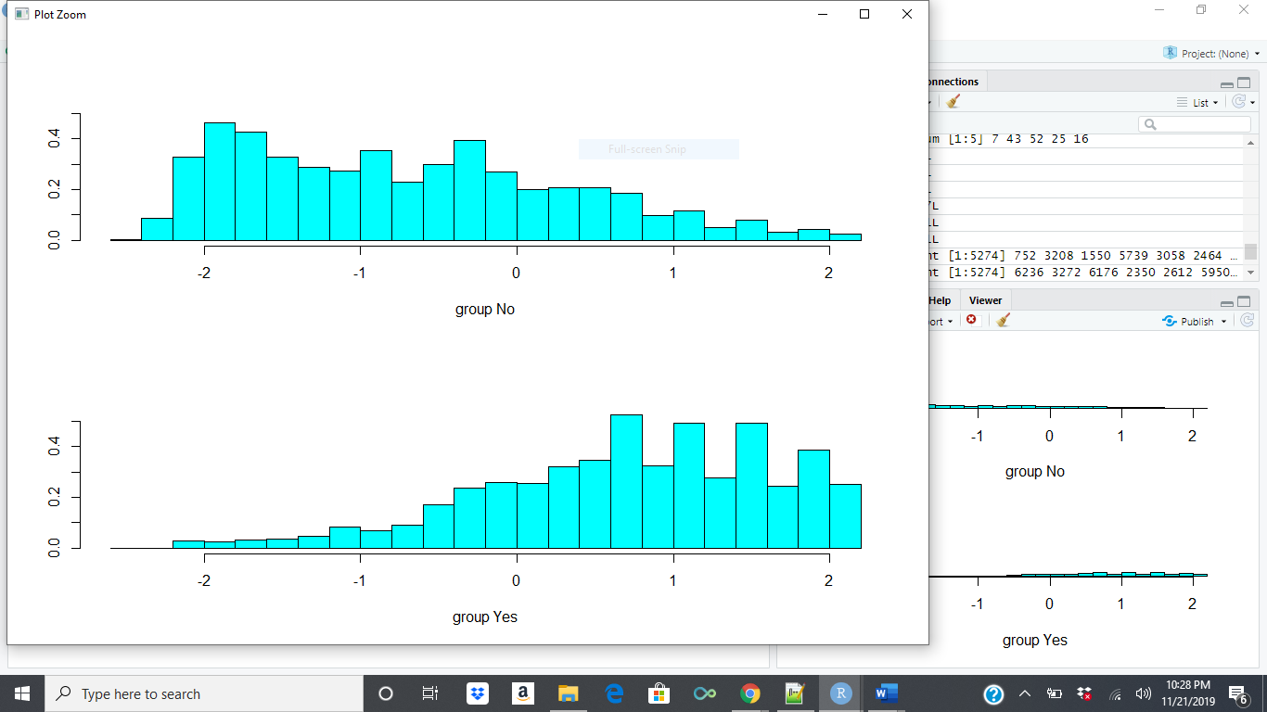

##Making predictions on our testing data   
  
tablechurn.lda.predict <- predict(tablechurn.lda, newdata = test_churn.df)  
  
### CONSTRUCTING ROC AUC PLOT:  
  
# Get the posteriors as a dataframe.  
tablechurn.lda.predict.posteriors <- as.data.frame(tablechurn.lda.predict$posterior)  
head(tablechurn.lda.predict.posteriors)

## No Yes  
## 1 0.4396353 0.56036470  
## 2 0.8991660 0.10083402  
## 3 0.5377297 0.46227028  
## 4 0.9842675 0.01573248  
## 5 0.5976701 0.40232988  
## 6 0.9713542 0.02864578

# Evaluating the model  
  
pred <- prediction(tablechurn.lda.predict.posteriors[,2], test_churn.df$Churn)  
roc.perf = performance(pred, measure = "tpr", x.measure = "fpr")  
auc.train <- performance(pred, measure = "auc")  
auc.train <- auc.train@y.values  
  
#Plotting the graph for better visualization  
  
plot(roc.perf)  
abline(a=0, b= 1)  
text(x = .25, y = .65 ,paste("AUC = ", round(auc.train[[1]],3), sep = ""))

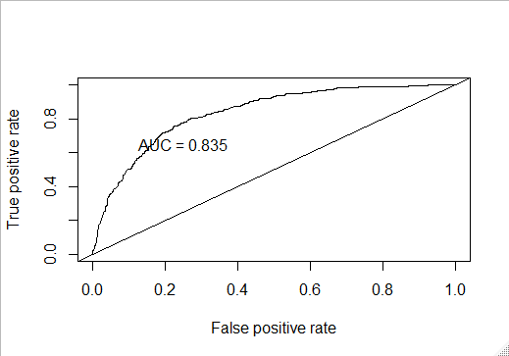

##From the above results we see that we get AUC value as 83.5% using LDA which implies this model is good  
##fit and the predictors used in this model can influence our dependent variable Churn.