Student Name – Sanket Hol
CSE-AIML-A
PRN – 12310611
Roll No. 44
Subject – CN Lab 2

Experiment Number: 02
TITLE: Routing in the Internet
PROBLEM STATEMENT
Write a program to find the shortest path using Dijkstra Equation for Link State Routing Protocol which is used by Open Shortest Path First Protocol (OSPF) in the Internet for the network flow provided by instructor.
Theory:
The Link State Routing Protocol is a type of routing protocol used in computer networks to determine the shortest path from one node to another. It is based on the concept of each router or node in the network maintaining a database of its neighbours and the cost or distance to reach them. Dijkstra's algorithm is commonly employed to compute the shortest path in Link State Routing Protocol.
Overview of Dijkstra's Algorithm:
Dijkstra's algorithm is a graph search algorithm that efficiently finds the shortest path from a source node to all other nodes in a weighted graph. It starts by initializing distances to all nodes as infinity, except for the source node, which is set to zero. Then, it iteratively selects the node with the smallest distance from the source and updates the distances to its neighbouring nodes. The process continues until all nodes have been visited.
Steps to Find the Shortest Path:
• Initialization: Initialize a distance vector for each node, setting the distance to the source node as zero and all other distances as infinity. Also, maintain a set of unvisited nodes.
• Selecting the Nearest Node: At each iteration, select the node with the smallest distance from the source node among the unvisited nodes.
• Updating Distances: For the selected node, update the distances to its neighbouring nodes if the distance through the selected node is shorter than the current distance. This involves comparing the sum of the distance to the selected node and the distance from the selected node to its neighbour with the current distance to the neighbour.
• Marking Visited Nodes: Mark the selected node as visited and remove it from the set of unvisited nodes.
• Repeat: Repeat steps 2 to 4 until all nodes have been visited.
• Shortest Path Tree: Once the algorithm is complete, a shortest path tree is constructed, with the source node as the root and edges representing the shortest paths to each node.
FOR EX.
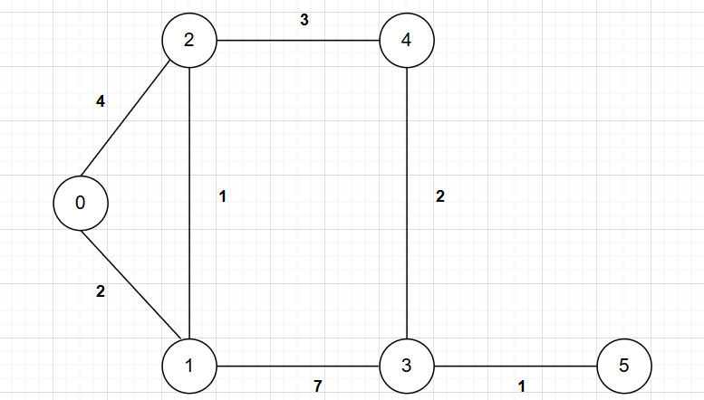
CODE:
#include <iostream>
#include <vector>
#include <limits>
using namespace std;

#define INF 99999

void printPath(vector<int>& parent, int node) {
if (node == -1) return;
printPath(parent, parent[node]);
cout << node << " ";
}

void dijkstra(int graph[6][6], int V, int start, int end) {
vector<int> dist(V, INF);
vector<bool> visited(V, false);
vector<int> parent(V, -1);

dist[start] = 0;

for (int count = 0; count < V - 1; count++) {
int u = -1, minDist = INF;
for (int i = 0; i < V; i++) {
if (!visited[i] && dist[i] < minDist) {
minDist = dist[i];
u = i;
}
}

if (u == -1) break; // All reachable nodes processed
visited[u] = true;

for (int v = 0; v < V; v++) {
if (!visited[v] && graph[u][v] && dist[u] + graph[u][v] < dist[v]) {
dist[v] = dist[u] + graph[u][v];
parent[v] = u;
}
}
}

if (dist[end] == INF) {
cout << "No path from " << start << " to " << end << "\n";
} else {
cout << "Shortest distance from " << start << " to " << end << ": " << dist[end] << "\n";
cout << "Path: ";
printPath(parent, end);
cout << "\n";
}
}

int main() {
int V = 6;
int graph[6][6] = {
{0, 2, 4, 0, 0, 0},
{0, 0, 1, 7, 0, 0},
{0, 0, 0, 0, 3, 0},
{0, 0, 0, 0, 0, 1},
{0, 0, 0, 2, 0, 5},
{0, 0, 0, 0, 0, 0}
};

int start = 0, end = 5;
dijkstra(graph, V, start, end);

return 0;
}

OUTPUT:
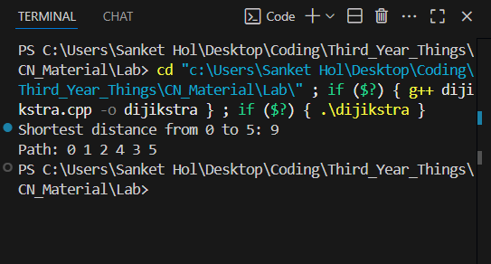

TABLE: Iterative Steps in Dijikstra Algorithm
Iter | List S | D₀₁ | Path | D₀₂ | Path | D₀₃ | Path | D₀₄ | Path | D₀₅ | Path
1 | {0} | 2 | 0→1 | 4 | 0→2 | ∞ | – | ∞ | – | ∞ | –
2 | {0,1} | 2 | 0→1 | 3 | 0→1→2 | 9 | 0→1→3 | ∞ | – | ∞ | –
3 | {0,1,2} | 2 | 0→1 | 3 | 0→1→2 | 9 | 0→1→3 | 6 | 0→1→2→4 | ∞ | –
4 | {0,1,2,4} | 2 | 0→1 | 3 | 0→1→2 | 8 | 0→1→2→4→3 | 6 | 0→1→2→4 | 11 | 0→1→2→4→5
5 | {0,1,2,4,3} | 2 | 0→1 | 3 | 0→1→2 | 8 | 0→1→2→4→3 | 6 | 0→1→2→4 | 9 | 0→1→2→4→3→5
6 | {0,1,2,4,3,5} | 2 | 0→1 | 3 | 0→1→2 | 8 | 0→1→2→4→3 | 6 | 0→1→2→4 | 9 | 0→1→2→4→3→5

Conclusion:
Dijkstra's algorithm plays a crucial role in the Link State Routing Protocol by enabling routers to compute the most efficient paths through the network. By maintaining a complete database of the network topology and applying Dijkstra's algorithm, routers can make intelligent and informed routing decisions, ensuring reliable and optimized communication. In the context of the given directed graph, the algorithm successfully determines the shortest path from node 0 to node 5 with a total minimum cost of 9 units, following the path 0 → 1 → 2 → 4 → 3 → 5. This highlights how Dijkstra's algorithm constructs optimal paths by iteratively expanding from the source node and always selecting the node with the smallest tentative distance, demonstrating its effectiveness in both theoretical graph problems and real-world network routing scenarios.

