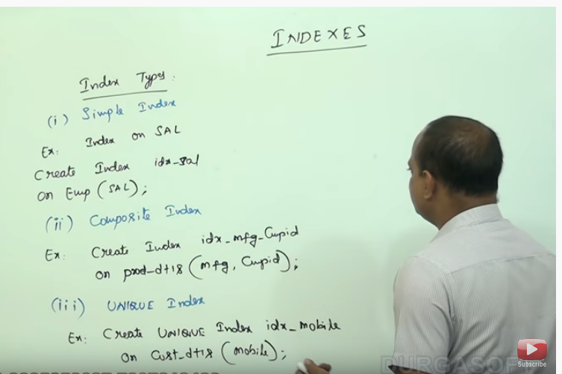

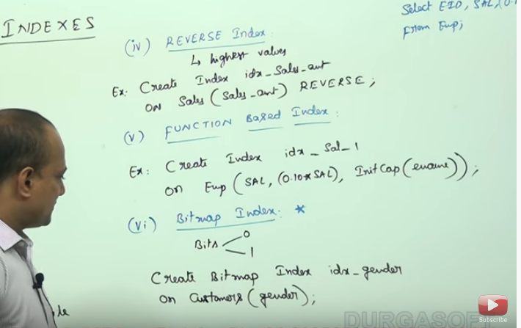

**Index type-**

1. **Simple index**- used to create simple index which will order the element of the table in ascending order by default
2. **Composite index**- If we want to create index on multiple column then we can use composite index.
3. **Unique index**- we can create unique index on column which has only unique data in it.
4. **Functional index**- suppose we have a query like **select name, sal, (sal*0.10) from emp**; then each time we query its need some time to calculate sal*0.10. We can reduce this time by creating the index so this calculation will be done once and it will stored to the index and we can fetch calculated salary from index.
5. **Reverse index**- this index we can use if we have to fetch data from the larger side. It will store data in descending order so while searching we can get data at the initial phase of the search.
6. **Bitmap index**- this index we can use if there is only two type of values in the column like male-female, on-off, active-inactive. So the value from index can be mapped to the table data using only two value.
7. **B-tree index**- in oracle there is no such index. All above indexes are using b-tree search to search the value from the index table. Like how traversing is happening in the tree map in same way searching is happening in this all indexing