WANDERWISE
PROJECT
DOCUMENTATION
AI Travel Recommendation Chatbot
A code-grounded technical project report
Prepared from the project workspace
26 October 2026
Editable Microsoft Word document

Executive Summary
Wanderwise is a Flask-based travel planning web application. Travellers can enter an origin, destination, duration, budget, group size, and travel style; request a day-by-day itinerary; refine it through chat; compare destinations; check current weather; and view a route-oriented map. The browser also provides a packing checklist, optional speech input/read-aloud, and client-side PDF brochure export.
The Python backend exposes JSON endpoints for authentication, chat, itinerary generation, destination comparison, weather, and saved history. The AI service uses the OpenAI Python SDK with a Groq-compatible endpoint when GROQ_API_KEY is configured, with an OpenAI-key fallback in the source. Persistent application records are designed for MySQL: users, conversations, messages, and itineraries. The checked-in SQLite database is a separate users-only file.
Several README claims do not match the current code: storage is MySQL rather than Firestore/local fallback; the weather route calls OpenWeatherMap for current conditions; and the advertised budget chart/allocation logic was not found in the JavaScript. This report records those differences rather than treating them as implemented features.
Evidence note No reference PDF, draft report, or screenshot files were found in the inspected workspace or its immediate parent. This report therefore uses a conventional project-report structure and code-derived diagrams, not a claimed reproduction of the missing PDF.

Document basis
- Inspected app.py, services/*.py, templates/index.html, static/js/script.js, static/css/style.css, README.md, requirements.txt, and .env.example (variable names only).
- No automated test suite was present in the inspected file inventory. Python and JavaScript syntax checks passed; live service behavior was not tested.
- The report describes the workspace snapshot as of 26 October 2026.

Contents
1. Introduction
2. System Study and Requirements
3. Feasibility and Technology Stack
4. System Design
5. Database Design
6. AI and External Integrations
7. Implementation Details
8. User Interface and Evidence
9. Testing and Results
10. Security, Constraints, and Known Gaps
11. Conclusion and Future Scope
12. Bibliography and Project References
Appendix A. API Endpoint Summary
Appendix B. Configuration and Reproduction Notes

CHAPTER 1

Introduction

1.1 Background
Trip planning combines destination ideas, transport options, activities, food, preferences, and practical logistics. Wanderwise brings these tasks into one browser interface and requests AI-generated suggestions from a traveller's prompt and preferences.

1.2 Problem Statement
Travellers may consult several sources and manually assemble a schedule. The project reduces this planning workload by collecting trip details, requesting an AI plan, organizing the response, and offering related utilities such as current weather, destination comparison, packing assistance, and saved history.

1.3 Objectives
- Collect origin, destination, duration, budget, traveller count, and travel style.
- Generate a Markdown itinerary and conversational refinements through a configured AI endpoint.
- Store account and trip records through the MySQL service layer.
- Offer destination comparison, current-weather lookup, route visualization, and packing assistance.
- Provide responsive browser controls, theme switching, speech features, copy, and PDF export where supported.

1.4 Scope
In inspected source | Not established by inspected source
Flask dashboard and JSON API. | Booking, payment, or ticket purchasing.
AI advice, itinerary, and comparisons. | Verified live fares, availability, or guaranteed schedules.
MySQL-oriented user and trip persistence. | Working Firestore/local-fallback path in current storage service.
Current weather and browser map/geocoding. | Three-day forecast, turn-by-turn navigation, verified attractions.
Browser PDF brochure export. | Automated test suite or captured runtime screenshots.

1.5 Intended Users
The interface is intended for individual travellers, couples, families, and groups seeking an AI-assisted starting itinerary. Anonymous sessions receive an owner identifier; account registration and login provide a persistent user identity for history.

CHAPTER 2

System Study and Requirements

2.1 Existing Approach
The README presents Wanderwise as a beginner-friendly travel planner. The application combines a form-driven dashboard with conversation and itinerary endpoints. No comparative evaluation data was supplied, so measured improvement over another system is not claimed.

2.2 Proposed System
The browser submits trip input to Flask. Flask resolves the session owner, constructs a prompt from preferences, calls the AI service, stores request and response through the storage service, and returns JSON. The client renders Markdown and may separately request weather and map data.

2.3 Functional Requirements
ID | Requirement grounded in source
FR-01 | Render the dashboard at GET /.
FR-02 | Register, authenticate, inspect account state, and log out through JSON routes.
FR-03 | Accept a chat message, return an AI reply, and reject invalid/oversized input.
FR-04 | Accept an itinerary request and preferences, generate a plan, and persist it with messages.
FR-05 | Compare two destinations using an AI-generated comparison prompt.
FR-06 | Return current weather when OpenWeatherMap is configured and reachable.
FR-07 | List, retrieve, and delete conversations scoped to the session/account owner.
FR-08 | Render itinerary, map, and packing views; provide browser speech, copy, and PDF actions.

2.4 Non-functional Requirements
- Usability: grouped trip setup, itinerary, map, weather, history, and comparison views; responsive CSS.
- Maintainability: route handling delegates AI, authentication, and storage to service modules.
- Input handling: type and length checks exist for messages, itinerary requests, preferences, IDs, and weather city.
- Availability: AI and weather depend on provider configuration and network access.
- Security controls visible in source include password hashing, HttpOnly/SameSite=Lax cookies, and optional Secure cookies.
- README specifies Python 3.10+ and Windows setup; current services additionally require MySQL.

2.5 Constraints and Assumptions
- AI output is generated text; exact travel details and prices must be verified independently.
- Some features rely on CDNs, browser APIs, OpenStreetMap tiles, and Open-Meteo geocoding.
- The storage code reads MYSQL_HOST, MYSQL_PORT, MYSQL_USER, MYSQL_PASSWORD, and MYSQL_DATABASE; these are absent from .env.example.

CHAPTER 3

Feasibility and Technology Stack

3.1 Technical Feasibility
The application uses Python Flask, service modules, MySQL, and an HTML/CSS/JavaScript client. JSON connects the browser to Flask, while the browser directly requests map tiles and unknown-city geocoding. Full backend operation requires a MySQL server and provider credentials.

3.2 Operational Feasibility
The form-based workflow uses familiar browser controls and can be launched locally as described in README.md. Availability depends on environment variables, a reachable MySQL server, valid AI credentials, and an OpenWeatherMap key for weather.

3.3 Economic Feasibility
No hosting, API usage, subscription, or development cost figures were found. A numerical cost-benefit conclusion is unsupported; service pricing and usage limits should be checked before deployment.

3.4 Software Requirements
Area | Verified or source-indicated requirement
Runtime | Python 3.10 or newer (README).
Packages | Flask >=3,<4; mysql-connector-python >=9; groq >=0.9,<1; openai >=1; httpx >=0.25; python-dotenv >=1,<2.
Database | MySQL with InnoDB and JSON support (db_service.py).
AI | GROQ_API_KEY primary; OPENAI_API_KEY fallback. Model/base URL environment settings are read by code.
Weather | OPENWEATHER_API_KEY for GET /api/weather.
Browser | Modern JavaScript browser; speech depends on browser API support.
Client libraries | Leaflet 1.9.4, marked.js, Chart.js, html2pdf.js 0.10.1, Google Fonts.
Network | Needed for AI, weather, map/geocoding, and CDN assets.

3.5 Hardware Requirements
No minimum CPU, RAM, or disk values are declared. A device capable of running Python/Flask and a supported browser is required. MySQL may run locally or on a separately reachable host; the code defaults MYSQL_HOST to localhost.

CHAPTER 4

System Design

4.1 Architecture Overview
The browser owns the interactive interface. Flask renders the initial template and exposes JSON routes. Authentication, AI, and storage are delegated to Python services. MySQL schema initialization occurs during application creation. Weather is fetched through Flask; map tiles and unknown-city geocoding are requested by browser JavaScript.
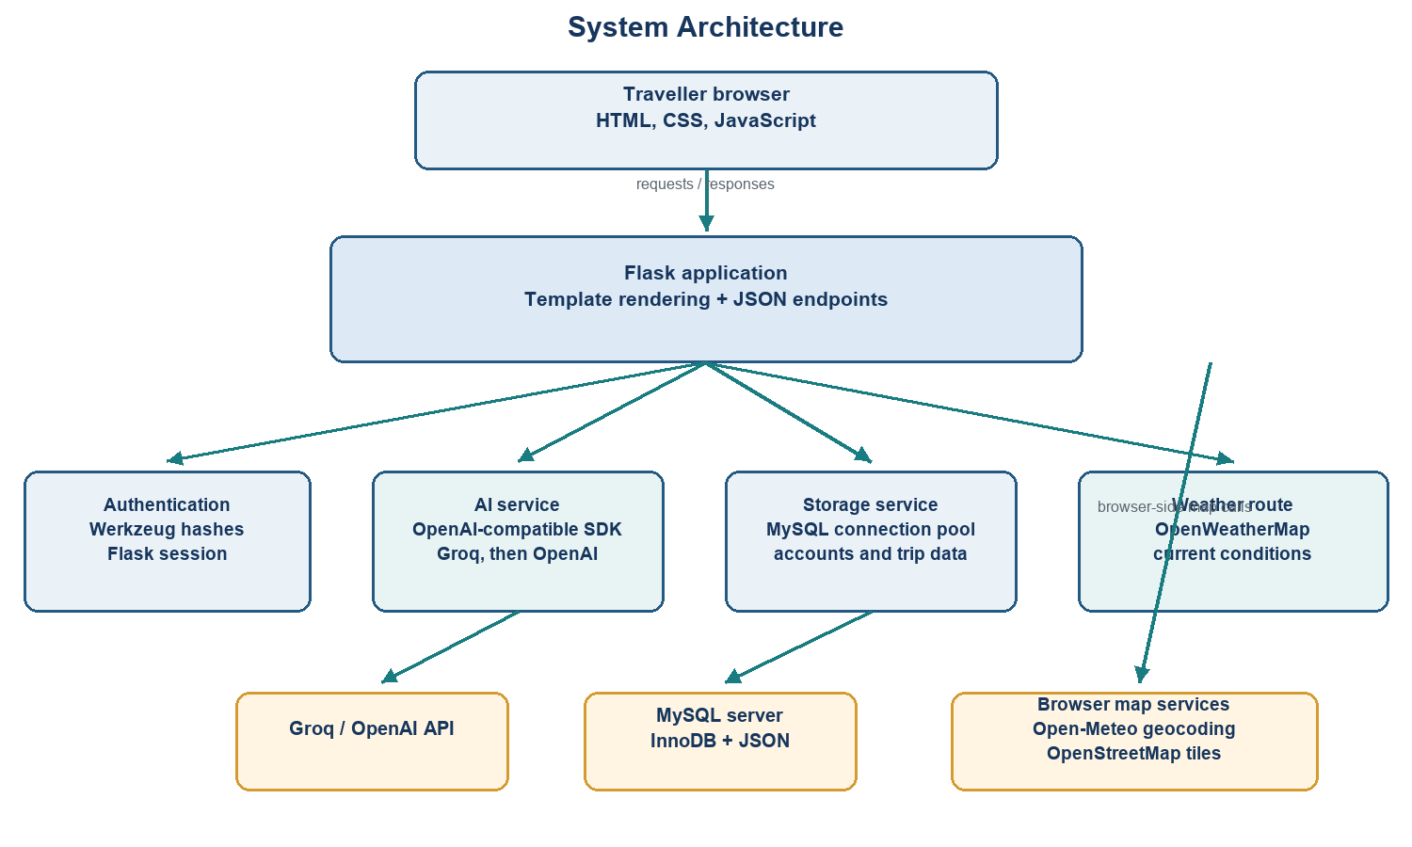
Figure 4.1. Architecture derived from app.py, services, and client code.

4.2 Data Flow Diagram - Level 0
The traveller interacts with one Wanderwise process. It exchanges prompts and completions with the AI service, weather requests with the weather provider, and persistent records with MySQL. The browser separately contacts map and geocoding services.
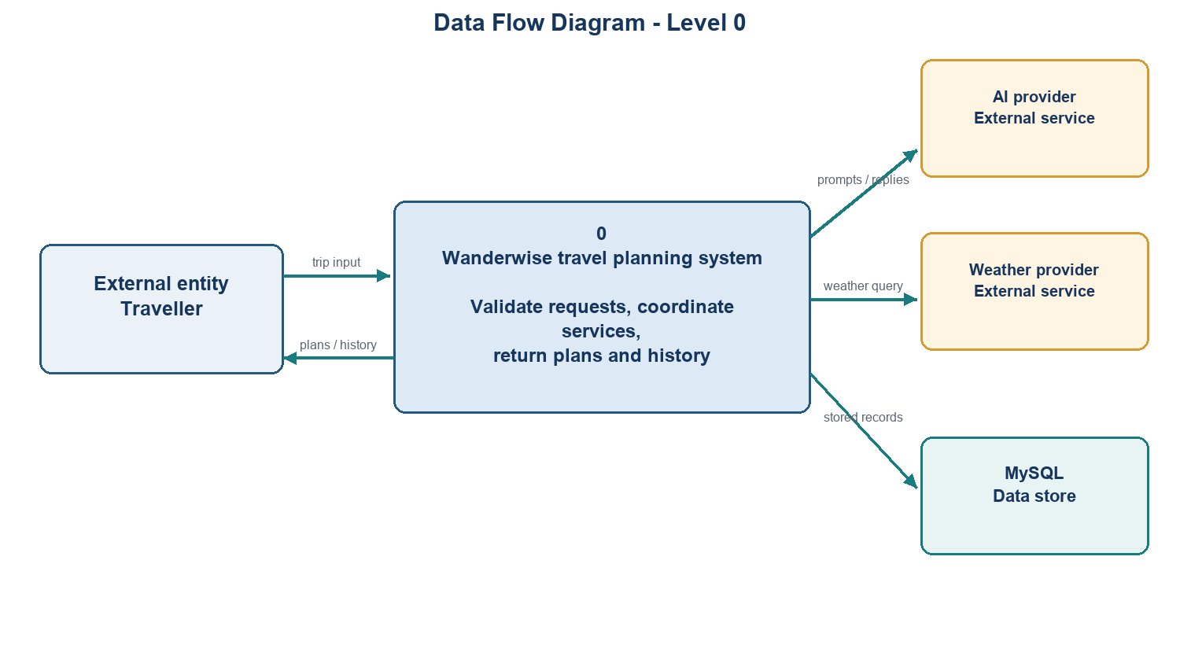
Figure 4.2. Context-level data flow; the map path is browser-side.

4.3 Data Flow Diagram - Level 1
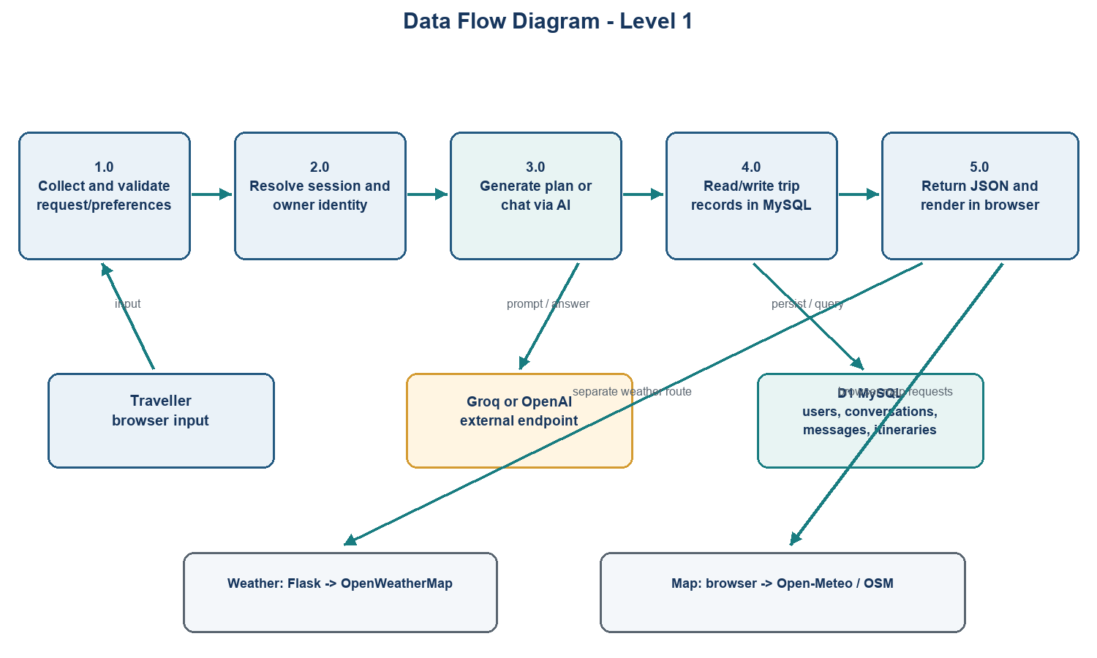
Figure 4.3. Request validation, session resolution, generation, persistence, and presentation.

4.4 Use Case Diagram
The primary actor is the traveller. AI, weather, and map services are external dependencies, not separate user roles.
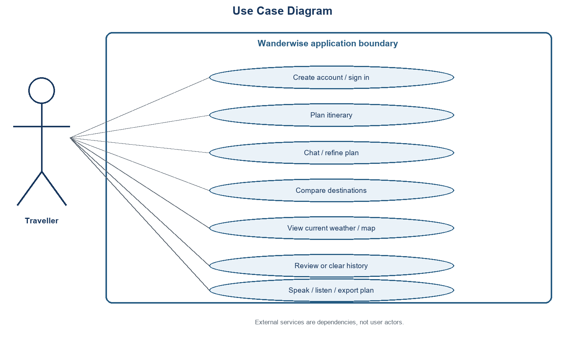
Figure 4.4. Use cases derived from visible controls and routes.

4.5 Itinerary Generation Flow
The browser sends a request to POST /api/itinerary. The server validates the request and preferences, loads any selected conversation context, calls the AI service, stores the itinerary and messages, and returns JSON. Weather and map work follows as separate client requests.
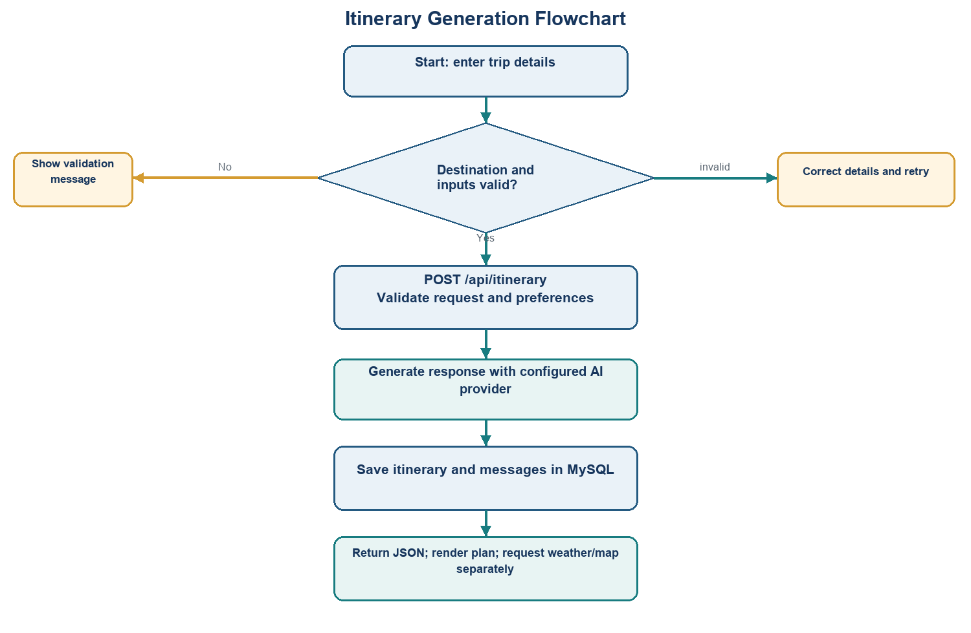
Figure 4.5. Itinerary generation path; weather and map requests are separate.

CHAPTER 5

Database Design

5.1 Database Technology and Evidence
services/db_service.py declares MySQL DDL and initializes four InnoDB tables. The workspace also contains wanderwise.db, an SQLite file with only a users table. That file does not match the MySQL schema declared by current services and should not be described as the active trip store without migration evidence.
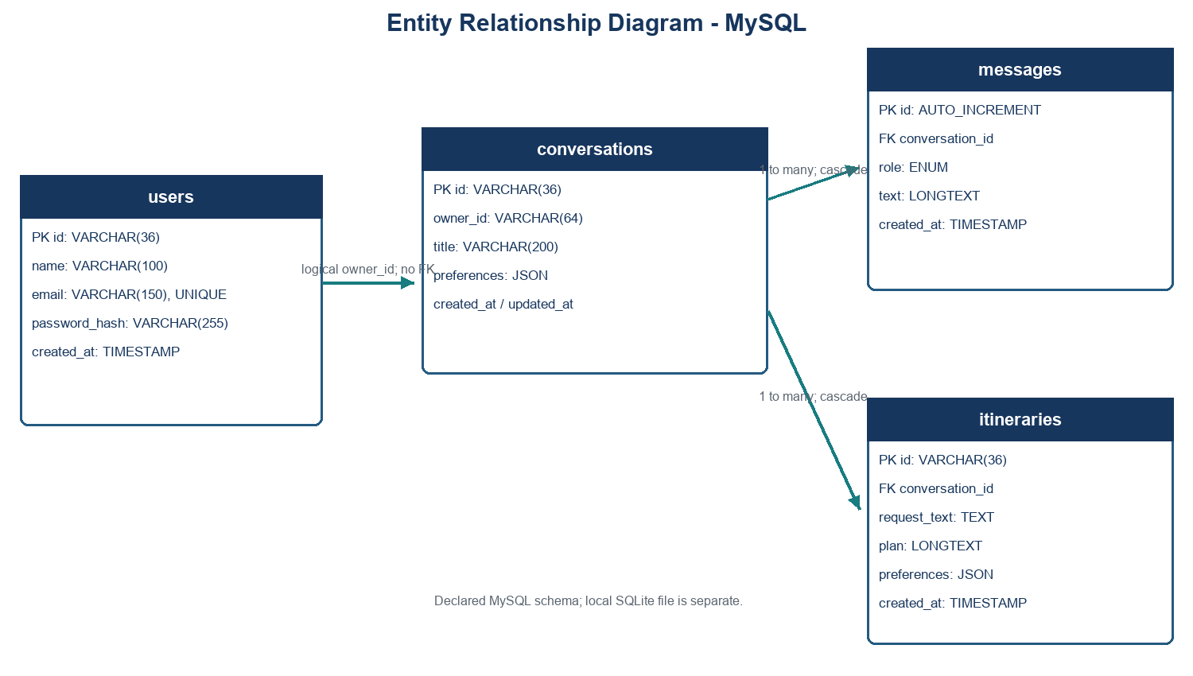
Figure 5.1. Current MySQL DDL relationships; owner_id is not a declared foreign key.

5.2 Entity Descriptions
Entity | Key fields and role
users | id PK; name; unique email; password_hash; created_at.
conversations | id PK; owner_id; title; preferences JSON; created_at; updated_at. owner_id indexed, no FK to users.
messages | id PK; conversation_id FK; role; text; created_at. Parent deletion cascades.
itineraries | id PK; conversation_id FK; request_text; plan; preferences JSON; created_at. Parent deletion cascades.

5.3 Relationships and Integrity
- One conversation has many messages and itinerary records; both child tables declare ON DELETE CASCADE.
- User-to-conversation ownership is represented by owner_id in application queries but is not a database foreign key.
- Preferences use JSON; messages and plan bodies use LONGTEXT.
- History lists at most 30 conversations and loads at most 100 messages per conversation.

5.4 Local Database Observation
Observed file The SQLite database contains only users (id, name, email, password_hash, created_at). Current service code imports mysql.connector and uses MySQL for authentication and trip data.

CHAPTER 6

AI and External Integrations

6.1 AI Request Construction
services/ai_service.py defines general travel and itinerary instructions. It asks for route options, day sections divided into morning/afternoon/evening/night, and packing suggestions. Preferences may include source, destination, duration, budget, travellers, and trip type. Ordinary chat includes at most the last two history entries, truncating each text snippet to 250 characters.

6.2 Provider Selection and Generation
- GROQ_API_KEY selects the OpenAI SDK with Groq-compatible base URL (default https://api.groq.com/openai/v1) and GROQ_MODEL (default openai/gpt-oss-120b).
- If Groq is not configured, OPENAI_API_KEY selects the OpenAI endpoint; OPENAI_MODEL defaults to gpt-4o-mini.
- Itinerary token budget is calculated from requested days and clamped to 1,800-3,200; ordinary chat uses 1,500.
- For selected Groq model names containing openai/gpt-oss, a fallback attempt may use openai/gpt-oss-20b.
- Prompts warn against inventing hotel availability, exact flight rates, or live train schedules and advise official verification.

6.3 External Integrations
Integration | Observed behavior | Limitation
Groq / OpenAI | Server-side text generation through OpenAI Python SDK. | No live request was tested.
OpenWeatherMap | Backend returns current temperature, description, humidity, wind. | No forecast endpoint is present; needs API key.
Open-Meteo | Browser-side geocoding for cities missing from hard-coded coordinates. | Not the weather response provider.
OpenStreetMap | Leaflet loads map tiles in the browser. | Needs external network/tile service.
Leaflet map | Origin/destination markers, straight line, three generic nearby pins. | Pins are static offsets, not extracted from AI plan.
Browser speech | Web Speech recognition and speechSynthesis when available. | Browser-dependent; no server speech service.
html2pdf.js | Client-side itinerary brochure PDF download. | Separate from this editable project report.

6.4 AI and Data Limitations
AI output is advice, not a booking or verified schedule. No fine-tuning, retrieval-augmented generation, destination database, evaluation set, or accuracy measurement was found in the inspected source.

CHAPTER 7

Implementation Details

7.1 Backend Structure
Module | Responsibility from source
app.py | Flask app factory, routes, session configuration, input validation, JSON responses.
services/ai_service.py | Provider selection, prompt construction, history context, token budget, error handling.
services/auth_service.py | Registration, password hashing, login verification, profile lookup through MySQL.
services/db_service.py | MySQL configuration, connection pool, database/table initialization.
services/firebase_service.py | Despite its filename, current implementation uses MySQL for conversations, messages, itineraries, and history.

7.2 API Surface
The application uses Flask routes with JSON bodies for interactions. Appendix A lists paths. Code-level limits include a 16 KB overall request, messages up to 4,000 characters, itinerary requests up to 2,000 characters, and 1-30 trip days.

7.3 Client Interface
- Trip setup collects route, duration, budget, travellers, and trip type; quick-trip chips populate fields.
- Itinerary Markdown is parsed in the browser and split into day-oriented cards.
- Packing options are hard-coded beach, mountain, or default lists; progress is computed in the browser.
- Weather displays current temperature, condition, humidity, and wind.
- Leaflet uses known coordinates or Open-Meteo fallback and draws a direct line between endpoints.
- Comparison and refinements call separate endpoints; copy, read-aloud, speech input, theme, and PDF controls are client-side.

7.4 Authentication and Session Handling
Registration lowercases email, checks required fields and a basic email shape, and requires a six-character password. Werkzeug hashes passwords. Flask sessions store user_id/user_name after login. Anonymous use receives an owner_id to scope history.

7.5 Configuration and Startup
README.md describes creating a virtual environment, installing requirements, copying .env.example, and running python app.py. Current code also requires MySQL settings. The sample environment still includes Firebase entries and omits MYSQL_* values; reconcile it before a clean deployment.

CHAPTER 8

User Interface and Evidence

8.1 Interface Areas
Area | Source-backed purpose
Trip Studio | Collect preferences and render itinerary cards.
Travel archive | List, retrieve, and clear previous conversations.
Live Map | Show endpoints, route line, and generic nearby pin cards.
Weather | Show current conditions returned by the backend.
Compare | Submit two destinations and display AI-generated comparison.
Packing | Show trip-type presets with checkbox progress.
Authentication modal | Present sign-in and registration forms.

8.2 Screenshot Availability
No screenshots included No screenshot files were found. The live app could not be launched in the checked environment because its project virtual environment lacks mysql-connector-python. To avoid presenting a mock-up as a real capture, this report provides source-derived diagrams and interface descriptions only.

For a final presentation, capture the configured running application: initial dashboard, generated itinerary, map, weather, comparison, and saved history. Use genuine application screenshots and redact personal information and API keys.

8.3 Editable Document Note
The deliverable is a .docx with editable text, headings, and tables. Diagrams are embedded PNG figures; their labels and shapes are not individual Word drawing objects.

CHAPTER 9

Testing and Results

9.1 Test Approach
No dedicated automated test suite was found in the inspected inventory. This report separates checks that were executed from integration/UI tests requiring a configured runtime. Syntax checks do not prove that routes, transactions, AI calls, or browser interactions work end to end.

9.2 Checks Executed
Check | Result | Meaning
Python AST parse: app.py and services/*.py | PASS | Source parses; imports and runtime behavior not exercised.
node --check static/js/script.js | PASS | JavaScript parses; browser behavior and CDN libraries not exercised.
DOCX package, XML, contents, diagrams | PASS after generation | OOXML package and expected report structure validated.
Flask startup and route tests | NOT RUN | mysql-connector-python absent from project .venv; database not verified.
AI / weather API calls | NOT RUN | No live calls; credentials and provider responses not tested.
Browser visual test / screenshot | NOT RUN | No capture of a running application was made.

9.3 Functional Test Cases - Pending Execution
ID | Scenario | Expected behavior from source | Status
TC-01 | Open home page | Render index template and controls. | Not run
TC-02 | Submit invalid/oversized chat | Return validation error before AI call. | Not run
TC-03 | Generate valid itinerary | Call AI, persist plan/messages, return JSON. | Not run
TC-04 | Register and log in | Hash password, persist account, establish session. | Not run
TC-05 | Load and clear history | Return owner-scoped records and delete as requested. | Not run
TC-06 | Weather without key | Return configuration error with 503. | Not run
TC-07 | Map known/unknown city | Use fixed coordinates or geocoding fallback. | Not run
TC-08 | Speech and PDF actions | Work only when browser APIs/libraries are available. | Not run

9.4 Results and Interpretation
Executed checks support only syntactic parseability and the structural integrity of this Word file. Functional readiness remains unverified; MySQL, AI, weather, map, and browser workflows need testing in a configured environment.

CHAPTER 10

Security, Constraints, and Known Gaps

10.1 Controls Visible in Source
- Session cookie flags include HttpOnly and SameSite=Lax; Secure is configurable.
- A random secret is generated if FLASK_SECRET_KEY is missing; code warns sessions will not persist across restarts.
- Werkzeug password hashing is used for registration and verification.
- SQL values use parameter placeholders; input sizes and types are checked.
- README says credentials remain server-side; current provider keys are read from environment variables.

10.2 Known Implementation and Documentation Gaps
Topic | README expectation | Current source evidence
Storage | Firestore plus local fallback. | MySQL operations and schema in current services.
Weather | Open-Meteo live weather and three-day forecast. | OpenWeatherMap current-weather endpoint; Open-Meteo is browser geocoding.
Budget | Algorithmic allocations and donut chart. | Budget is prompt input; Chart.js is loaded but no chart/allocation code found.
AI status | Provider status may imply active selection. | AI supports Groq then OpenAI; /api/status reports Groq and checks only its key.
Configuration | Firebase variables listed in sample. | Active database expects MYSQL_* variables absent from .env.example.
Database file | wanderwise.db exists. | SQLite users-only schema, unlike current MySQL service schema.
Map | Interactive route and pins. | Straight polyline and generic fixed-offset pins, not itinerary-derived landmarks.

10.3 Limits of This Report
This is source-based documentation, not a security audit or operational certification. No deployment environment, database server, live API responses, account data, model output, or user-study results were examined.

CHAPTER 11

Conclusion and Future Scope

11.1 Conclusion
Wanderwise is a web-based AI travel planning project with a Flask backend, browser dashboard, AI itinerary and comparison prompts, MySQL-oriented persistence, and client-side map, packing, speech, and export utilities. Its service separation, request validation, password hashing, and session settings are visible in source.
The inspected workspace has material differences between README/configuration and implementation. Most notably, current storage is MySQL rather than Firestore, current weather is OpenWeatherMap conditions rather than an Open-Meteo forecast, and the claimed budget chart is not implemented in the inspected JavaScript. Runtime verification was not possible; these limits are explicit in this report.

11.2 Future Scope - Recommendations, Not Implemented
- Align README, .env.example, database artifacts, and runtime code around one supported storage design; document any required migration.
- Add automated tests for validation, owner-scoped history, persistence, AI errors, and weather responses.
- Implement and test budget allocation/chart behavior if it remains a requirement, or remove the unsupported claim.
- Replace generic map pins and straight-line display with verified landmarks and a clearly sourced route service.
- Implement a multi-day forecast or describe weather as current conditions only.
- Capture authentic screenshots from a configured run, excluding personal data and secrets.
- Add consistent provider status reporting, observability, and resource cleanup.
- Evaluate itinerary completeness and factual reliability with a documented test set.

CHAPTER 12

Bibliography and Project References
References below are project files and service endpoints directly evidenced in the workspace. No unavailable PDF or unverified test report is cited.
[1] app.py - Flask application factory, routes, input validation, and session behavior.
[2] services/ai_service.py - prompt instructions, provider selection, and generation parameters.
[3] services/auth_service.py, services/db_service.py, services/firebase_service.py - authentication and MySQL operations.
[4] templates/index.html, static/js/script.js, static/css/style.css - interface and client integrations.
[5] README.md, requirements.txt, .env.example - setup notes, dependencies, and sample configuration; some descriptions differ from source.
[6] Groq-compatible URL in ai_service.py: https://api.groq.com/openai/v1.
[7] OpenWeatherMap URL in app.py: https://api.openweathermap.org/data/2.5/weather.
[8] Open-Meteo geocoding URL in script.js: https://geocoding-api.open-meteo.com/v1/search.
[9] OpenStreetMap tile template in script.js: https://{s}.tile.openstreetmap.org/{z}/{x}/{y}.png.
[10] Client URLs in index.html: Leaflet 1.9.4, html2pdf.js 0.10.1; marked.js and Chart.js are unpinned.
Reference PDF Not present in the inspected workspace or immediate parent; matching its exact chapter structure could not be verified.

APPENDIX A

API Endpoint Summary
Method and path | Observed purpose
GET / | Render the main HTML page.
GET /api/auth/me | Return current authentication state.
POST /api/auth/register | Register account and establish session.
POST /api/auth/login | Authenticate and establish session.
POST /api/auth/logout | Remove user identity from session.
GET /api/status | Report AI/storage status fields.
GET /api/weather?city=... | Return current conditions or configuration/provider error.
GET /api/history[?conversation_id=...] | List conversations or retrieve one owner-scoped conversation/messages.
POST /api/chat | Generate and persist a conversational response.
POST /api/itinerary | Generate and persist itinerary and messages.
POST /api/compare | Generate a text comparison for two destinations.
DELETE /api/history[?conversation_id=...] | Delete one conversation or all records for the owner.

This table is descriptive; routes were not exercised during documentation.

APPENDIX B

Configuration and Reproduction Notes

B.1 Environment Variables Read by Current Source
Variable | Use
GROQ_API_KEY | Primary AI key; /api/status checks only this key.
GROQ_MODEL / GROQ_BASE_URL | Groq model and compatible URL; source defaults are openai/gpt-oss-120b and https://api.groq.com/openai/v1.
OPENAI_API_KEY / OPENAI_MODEL | Fallback AI provider settings.
MYSQL_HOST / PORT / USER / PASSWORD / DATABASE | MySQL connection settings; defaults are in db_service.py.
OPENWEATHER_API_KEY | Current-weather endpoint key.
FLASK_SECRET_KEY | Persistent Flask session-signing key.
FLASK_HOST / FLASK_PORT / FLASK_DEBUG / SESSION_COOKIE_SECURE / LOG_LEVEL | Optional bind, debug, cookie, and logging configuration.

B.2 Reproduction Caveat
README setup commands are a starting point, but .env.example does not document MYSQL_* values required by current source. Configure MySQL and provider secrets outside source control. Do not include credentials in screenshots or this report.
The project .venv was checked for dependency availability; mysql-connector-python was absent. No package was installed, no source code was changed, and no live database/provider test was performed.

