Sales & Inventory Data Warehouse
Microsoft Fabric Functional & High-Level Design
Fabric flow: SQL Server / Flat Files → Data Factory Pipelines → OneLake Lakehouse → Fabric Warehouse → Power BI

1. Purpose
Objective: Build the same Sales & Inventory analytical solution described in the reference specification, but using Microsoft Fabric as the primary analytics platform. The solution centralizes sales, inventory and return data, applies validation and business rules, preserves history where required, and provides reporting through Power BI.

2. Fabric Architecture
Reference / Azure Component | Microsoft Fabric Component | Purpose
SQL Server | SQL Server source + Fabric Data Factory connection | Source sales/inventory data
Flat files (CSV/TXT/Excel) | Fabric Data Factory / OneLake landing | Source lookup and reference files
Azure Data Factory | Data Factory pipelines in Fabric | Ingestion, orchestration, scheduling and monitoring
ADLS Gen2 RAW | OneLake + Lakehouse Files / raw zone | Store source data in open formats
Databricks / PySpark | Fabric Notebooks / Spark | Validation, cleansing and transformations
Azure SQL Ingestion | Lakehouse tables / staging | Structured landing and validation-ready data
Azure SQL Integration | Lakehouse curated tables | Dimensions, lookups and transformation layer
Azure Synapse / Azure SQL DB | Fabric Warehouse | SQL analytics, fact/dimension model and BI serving
Power BI | Power BI in Fabric | Dashboards, reports and business insights
Key Vault / Azure AD | Fabric security, workspace roles, connections and credentials | Access control and secure connectivity

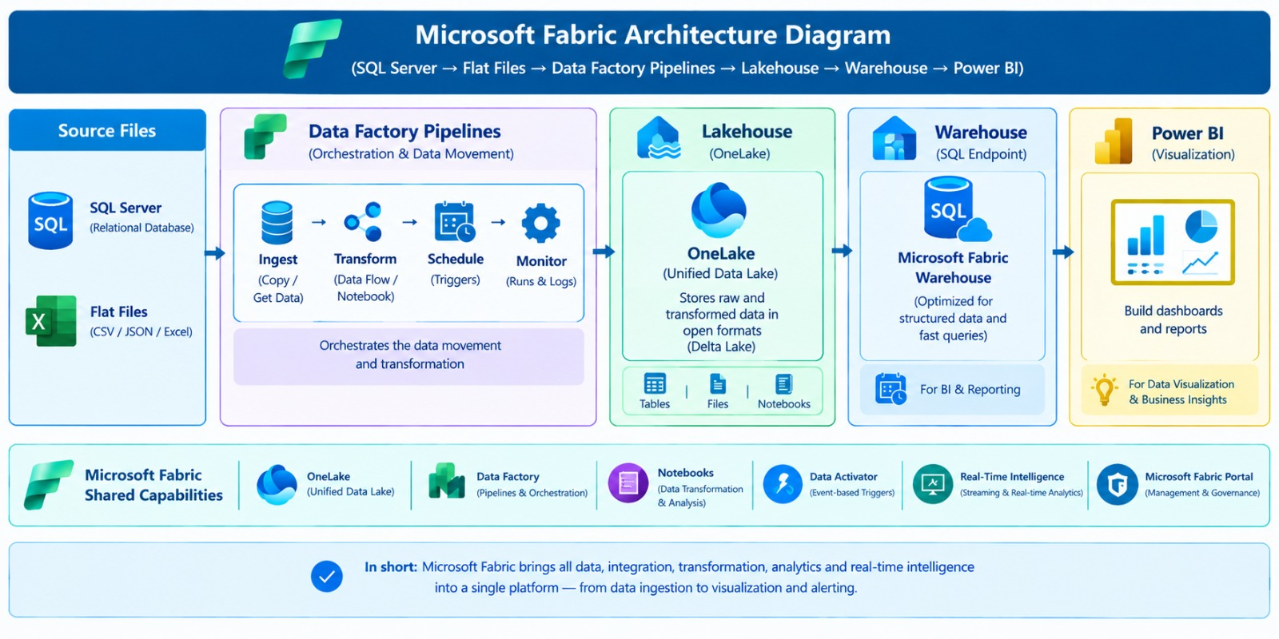
Figure 1. Microsoft Fabric target architecture — SQL Server / Flat Files → Data Factory → OneLake Lakehouse → Fabric Warehouse → Power BI

3. End-to-End Data Flow
- 1. Source: SQL Server tables and flat files provide sales, inventory, product, branch and lookup data.
- 2. Ingest: Fabric Data Factory copies data into OneLake/Lakehouse raw storage.
- 3. Validate: Fabric Notebook/Spark validates keys, nulls, duplicates and basic data-quality rules.
- 4. Transform: Notebook/Dataflow logic cleanses and standardizes data; business rules are applied.
- 5. Curate: Lakehouse tables hold curated dimensions, lookups and data prepared for analytics.
- 6. Warehouse: Fabric Warehouse stores the analytical star schema: dimensions and transactional facts.
- 7. BI: Power BI connects to the Warehouse for dashboards and reporting.

4. Recommended Fabric Layers
Layer | Fabric Location | What it contains
Raw / Bronze | OneLake → Lakehouse Files | Original SQL extracts and source flat files; timestamped and retained for recovery/audit.
Staging / Silver | Lakehouse Tables | Validated, standardized and cleansed source data.
Curated / Integration | Lakehouse Tables | Business transformations, lookup tables, SCD dimensions and prepared analytical data.
Gold / Serving | Fabric Warehouse | Final dimension and fact tables used by Power BI.

5. Source Data
SQL Server tables: ORDER_HEADER, PRODUCT, ORDER_DETAILS, RETURN_ITEM, INVENTORY_LEVELS, BRANCH.
Flat files: ORDER_METHOD.csv, RETURN_REASON.csv, COUNTRY.txt, WAREHOUSE.txt, Retailer.csv, PRODUCT_NAME_LOOKUP.csv.

6. Ingestion & Incremental Processing
Initial load: Perform a full extraction from SQL Server to the Fabric raw layer. Flat files are treated as the latest/delta delivery as described in the reference.
Incremental load: For ORDER_HEADER and ORDER_DETAILS, use the source update-date column and a watermark/control table. Store the last successfully processed value and use it on the next run.
Failure rule: Do not advance the watermark when a pipeline fails. Advance it only after successful completion and reconciliation.
Fabric implementation: Use Data Factory pipeline parameters/variables plus a Warehouse or Lakehouse control table for watermark management.

7. Data Quality & Rejection Handling
- Reject records with duplicate primary keys.
- Reject records with null primary keys.
- Store rejected records separately for investigation and reprocessing.
- Keep source/target record counts for reconciliation.
- Use Fabric Notebook/Spark for validation and transformation.

8. Dimension & Fact Model
Object | Type | Fabric target / rule
DIM_ORDER | SCD Type 2 | Warehouse dimension; preserve history using effective dates/version.
DIM_PRODUCT | SCD Type 1 | Warehouse dimension; overwrite current attribute values.
DIM_ORDER_METHOD_LKP | SCD Type 1 | Lookup/reference dimension.
DIM_RETURN_REASON_LKP | SCD Type 1 | Lookup/reference dimension.
DIM_COUNTRY_LKP | SCD Type 1 | Lookup/reference dimension.
DIM_WAREHOUSE_LKP | SCD Type 1 | Lookup/reference dimension.
DIM_RETAILER_LKP | SCD Type 1 | Lookup/reference dimension.
DIM_PRODUCT_NAME_LKP | SCD Type 1 | Lookup/reference dimension.
DIM_DATE_TIME | Role-playing | Date/time dimension for reporting and multiple date relationships.
FACT_SALES | Transactional fact | Insert-based sales/return measures with dimension keys.
FACT_INVENTORY | Transactional fact | Inventory measures by product/warehouse/time.

9. SCD Type 2 Rule
For historical dimensions such as DIM_ORDER: new business key → insert version 1; changed existing business key → expire the current version and insert a new version. Maintain BEGIN_EFFECTIVE_DATE, END_EFFECTIVE_DATE, VERSION_NUM and CHANGE_INFO. The current record uses 31-DEC-2099 as the open-ended end date, consistent with the reference.

10. Fact Tables
FACT_SALES: ORDER_DATE_KEY, RETAILER_KEY, PRODUCT_KEY, COUNTRY_KEY, ORDER_METHOD_KEY, SALES_ORDER_KEY, SHIP_DATE_KEY, RETURN_REASON_KEY, CLOSE_DAY_KEY, RETURNED_QUANTITY, QUANTITY, UNIT_COST, UNIT_PRICE, UNIT_SALE_PRICE, SALE_TOTAL, SOURCE_ID, DATA_DATE, UPDATE_DATE.
FACT_INVENTORY: INVENTORY_YEAR_KEY, PRODUCT_KEY, WAREHOUSE_KEY, OPENING_INVENTORY, QUANTITY_SALE_SHIP, INV_ADDITIONS, UNIT_COST, CLOSING_INVENTORY, SOURCE_ID, DATA_DATE, UPDATE_DATE.
Load rule: Fact tables are insert-oriented; join source/staging data to the curated dimensions to resolve surrogate keys.

11. Fabric Data Factory Orchestration
Pipeline | Main activities | Schedule / behavior
SQL child pipeline | Copy SQL → Raw; validate; transform; load curated/Warehouse | Called by master pipeline
Flat-file child pipeline | Detect/copy file → Raw; validate; transform; load curated/Warehouse | Ad-hoc/on demand
SQL master pipeline | Execute child pipelines + notebooks + reconciliation | Daily, target 9:00 AM IST
Monitoring | Status, duration, row counts, error capture and alerts | Every execution
Retry | Retry failed activity/pipeline | Up to 3 attempts with 1-minute wait, per reference requirement

12. Standard Naming Convention
Recommended standard: <ObjectType>_<Project>_<Purpose/Layer>_<Environment>. Use short, consistent prefixes and always make the environment visible (DEV/QA/PROD).
Fabric Object | Prefix | Recommended Pattern | Example
Workspace | WS | WS_<Project>_<Environment> | WS_SalesInventory_DEV
Lakehouse | LH | LH_<Project>_<Layer>_<Environment> | LH_SalesInventory_BRONZE_DEV
Warehouse | WH | WH_<Project>_<Environment> | WH_SalesInventory_DEV
Data Pipeline | PL | PL_<Source>_<Target>_<Purpose>_<Environment> | PL_SQL_RAW_ORDER_HEADER_DEV
Master Pipeline | PL | PL_MASTER_<Project>_<Environment> | PL_MASTER_SalesInventory_DEV
Notebook | NB | NB_<Layer>_<Purpose>_<Table>_<Environment> | NB_SILVER_SCD2_ORDER_DEV
Dataflow Gen2 | DF | DF_<Source>_<Target>_<Purpose>_<Environment> | DF_RAW_SILVER_PRODUCT_DEV
Connection | CON | CON_<SourceType>_<SourceName>_<Environment> | CON_SQLServer_Sales_DEV
Shortcut | SC | SC_<Source>_<Object>_<Environment> | SC_SQLServer_Product_DEV
Semantic Model | SM | SM_<Project>_<Subject>_<Environment> | SM_SalesInventory_BI_DEV
Power BI Report | RPT | RPT_<Project>_<Subject>_<Environment> | RPT_SalesInventory_Executive_DEV
Parameter | PAR | PAR_<Purpose> | PAR_WatermarkDate
Control Table | CTL | CTL_<Purpose> | CTL_WATERMARK
Audit Table | AUD | AUD_<Purpose> | AUD_PIPELINE_EXECUTION
Error Table | ERR | ERR_<Purpose> | ERR_PIPELINE_EXECUTION
Recommended workspace structure
WS_SalesInventory_DEV
├── LH_SalesInventory_DEV
├── WH_SalesInventory_DEV
├── PL_MASTER_SalesInventory_DEV
├── PL_SQL_RAW_ORDER_HEADER_DEV
├── PL_SQL_RAW_ORDER_DETAILS_DEV
├── NB_SILVER_VALIDATE_ORDER_DEV
├── NB_SILVER_SCD2_ORDER_DEV
├── PL_SILVER_WH_DIM_ORDER_DEV
├── PL_SILVER_WH_FACT_SALES_DEV
├── SM_SalesInventory_BI_DEV
└── RPT_SalesInventory_Executive_DEV
Environment pattern: Use the same object name across DEV, QA and PROD, changing only the environment suffix. Example: WH_SalesInventory_DEV → WH_SalesInventory_QA → WH_SalesInventory_PROD
Naming principle: Avoid names such as Connection1, Pipeline_New, Test_Lakehouse or Final_Final. Names should identify the object, purpose and environment at a glance.

13. Monitoring, Audit & Security
- Maintain pipeline start/end time, status and source/target row counts.
- Maintain error details for troubleshooting and reruns.
- Track watermark values and pipeline execution history.
- Apply workspace/item permissions and least-privilege access.
- Protect sensitive cost/price fields with appropriate Fabric/Power BI security controls.
- Use row-level security in the semantic model where warehouse/branch access must be restricted.

14. Power BI Layer
Power BI semantic model: Build relationships between fact and dimension tables, expose business-friendly measures, and use the Fabric Warehouse as the primary serving layer.
Typical reporting: sales trends, quantity and revenue, returns, inventory availability, product performance, warehouse/branch performance and retailer analysis.

15. Simple Implementation Plan
- Create Fabric workspace and Lakehouse/Warehouse.
- Configure SQL Server and file connections.
- Build raw ingestion pipelines in Fabric Data Factory.
- Create validation and transformation notebooks.
- Create control/watermark tables.
- Build curated dimensions and implement SCD rules.
- Build FACT_SALES and FACT_INVENTORY in the Warehouse.
- Add orchestration, retries, logging and reconciliation.
- Build Power BI semantic model, measures and dashboards.
- Test initial load, incremental load, failure/retry and historical-change scenarios.

16. Key Assumptions
- The source SQL Server and flat files remain available in the required format.
- Update-date columns are available for incremental SQL processing; if not, they must be introduced at the source.
- Business rules and data-quality expectations remain the same as the reference project unless separately changed.
- Fabric workspace capacity and required permissions/connectivity are available.
- The architecture image supplied for this document represents the desired high-level flow: Data Factory → Lakehouse → Warehouse → Power BI.

17. Final Architecture Checklist
- Source connections configured for SQL Server and flat files.
- Raw data lands in OneLake/Lakehouse with clear archive and reject handling.
- Data Factory pipelines manage ingestion, orchestration, scheduling and retries.
- Fabric Notebooks perform validation, cleansing, business rules and SCD processing.
- Warehouse contains the final dimensional model and transactional facts.
- Watermark, audit, error and reconciliation controls are implemented.
- Power BI semantic model and reports consume the curated Warehouse layer.
- Naming convention is applied consistently across all Fabric items and environments.

Reference Basis
This Fabric version is based on the supplied Sales & Inventory Functional Requirement/Functional Specification, including its scope, source tables/files, incremental watermark approach, SCD2 rules, fact definitions, orchestration, monitoring and security requirements. The reference specifies Azure services such as ADF, ADLS Gen2, Databricks, Azure SQL DB and Synapse; the document above maps those responsibilities to Fabric-native components where appropriate.

