**#1.EV Adoption Over Time: Analyze the growth of the EV population by model year.**

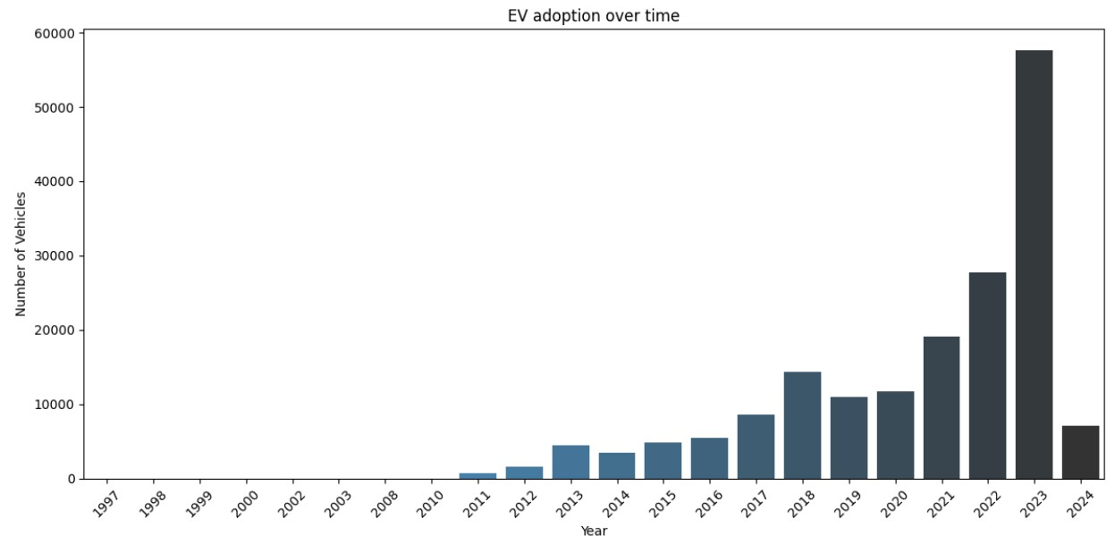

* From the above bar chart, it’s clear that EV adoption has been increasing over time, especially noting a significant upward trend starting around 2016.
* The number of vehicles registered grows modestly up until that point and then begins to rise more rapidly from 2017 onwards.
* The year 2023 shows a particularly sharp increase in the number of registered EVs, with the bar for 2023 being the highest on the graph, indicating a peak in EV adoption.

**#2.Geographical Distribution: Understand where EVs are most commonly registered (e.g., by county or city).**

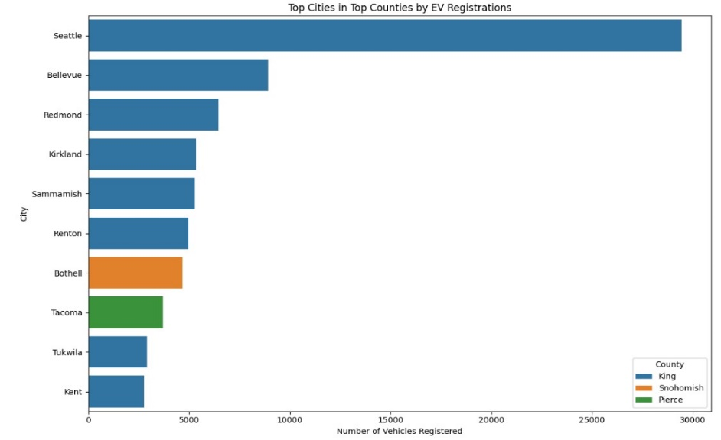

* Selecting the top 3 counties based on EV registrations and then analyze the distribution of EVs within the cities of those counties:
* The above graph compares the number of electric vehicles registered in various cities within three counties: King, Snohomish, and Pierce.
* The graph indicates that EV adoption is not uniform across the cities and is more concentrated in certain areas, particularly in King County.

**#3.EV Types: Breakdown of the dataset by electric vehicle type (BEV, etc.).**

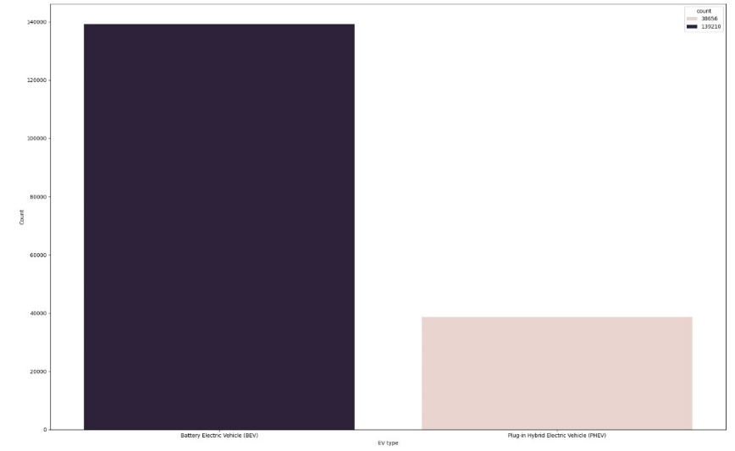

* The above graph shows that BEVs are more popular or preferred over PHEVs among the electric vehicles.

**#4.Make and Model Popularity: Identify the most popular makes and models among the registered EVs.**

This analysis will help us identify which manufacturers and specific models dominate the EV market, potentially **indicating consumer preferences, brand loyalty, and the success of various manufacturers’ strategies** in promoting electric mobility.

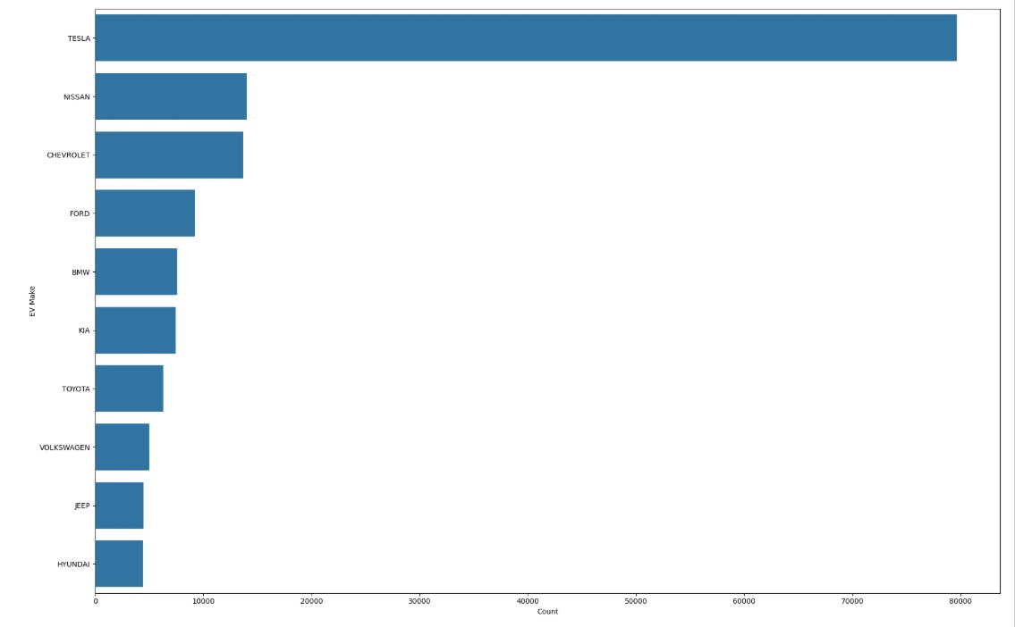

* TESLA leads by a substantial margin with the highest number of vehicles registered.
* NISSAN is the second most popular manufacturer, followed by CHEVROLET, though both have significantly fewer registrations than TESLA.

Let’s drill down into the most popular models within these top manufacturers to get a more detailed understanding of consumer preferences at the model level:

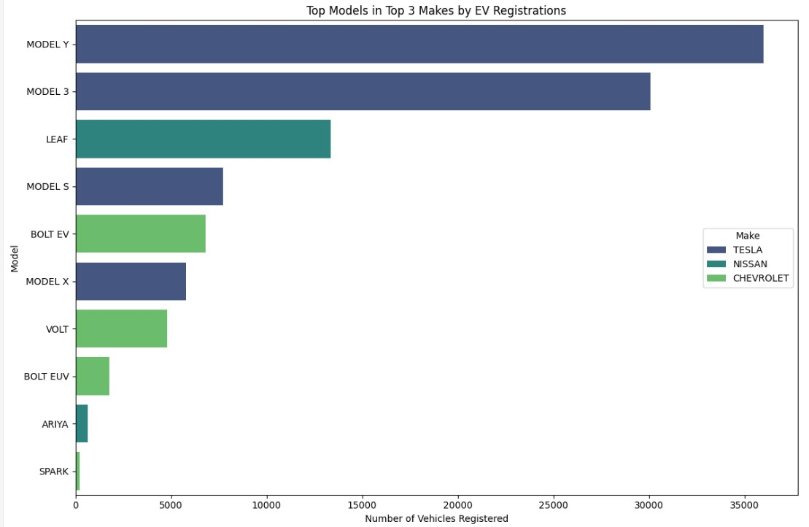

* TESLA’s MODEL Y and MODEL 3 are the most registered vehicles, with MODEL Y having the highest number of registrations.
* NISSAN’s LEAF is the third most registered model and the most registered non-TESLA vehicle.
* TESLA’s MODEL S and MODEL X also have a significant number of registrations.
* CHEVROLET’s BOLT EV and VOLT are the next in the ranking with considerable registrations, followed by BOLT EUV.

**#5.Electric Range Analysis: Analyze the electric range of vehicles to see how EV technology is progressing.**

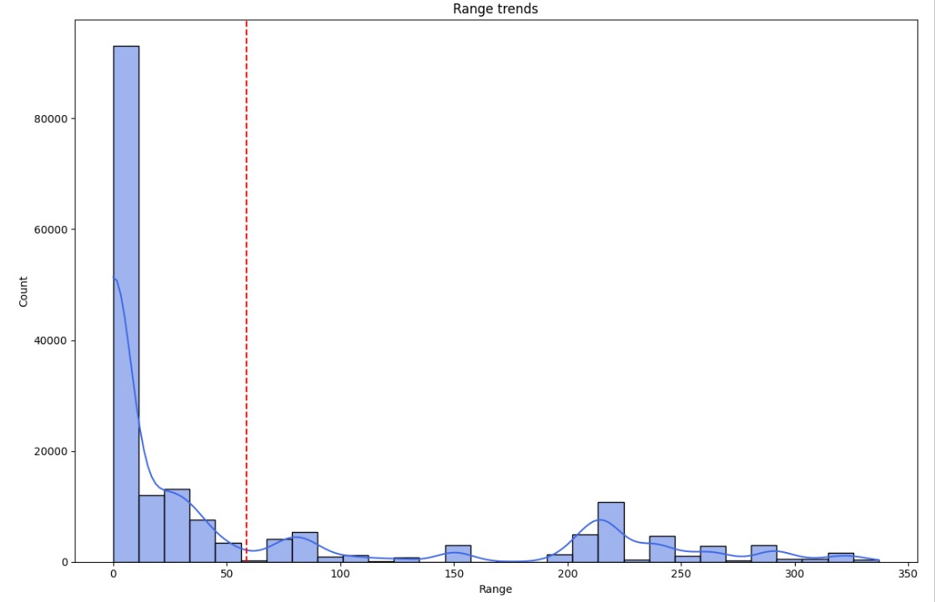

* There is a high frequency of vehicles with a low electric range, with a significant peak occurring just before 50 miles.
* The distribution is skewed to the right, with a long tail extending towards higher ranges, although the number of vehicles with higher ranges is much less frequent.
* The mean electric range for this set of vehicles is marked at approximately 58.84 miles, which is relatively low compared to the highest ranges shown in the graph.
* Despite the presence of electric vehicles with ranges that extend up to around 350 miles, the majority of the vehicles have a range below the mean.

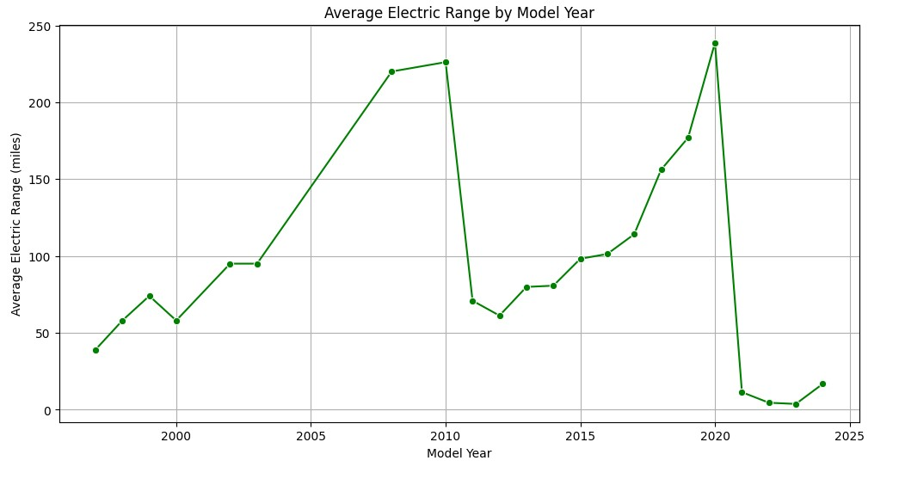

**The above graph shows the progression of the average electric range of vehicles from around the year 2000 to 2024. Key findings from the graph:**

* There is a general upward trend in the average electric range of EVs over the years, indicating improvements in technology and battery efficiency.
* There is a noticeable peak around the year 2020 when the average range reaches its highest point.
* Following 2020, there’s a significant drop in the average range, which could indicate that data for the following years might be incomplete or reflect the introduction of several lower-range models.
* After the sharp decline, there is a slight recovery in the average range in the most recent year shown on the graph.

**#6.Estimated Growth in Market Size: Analyze and find the estimated growth in the market size of electric vehicles.**

The dataset provides the number of electric vehicles registered each year from 1997 through 2024. However, the data for 2024 is incomplete as it only contains the data till March. Here’s a summary of EV registrations for recent years:

* In 2021, there were 19,063 EVs registered.
* In 2022, the number increased to 27708 EVs.
* In 2023, a significant jump to 57,519 EVs was observed.
* For 2024, currently, 7,072 EVs are registered, which suggests partial data.

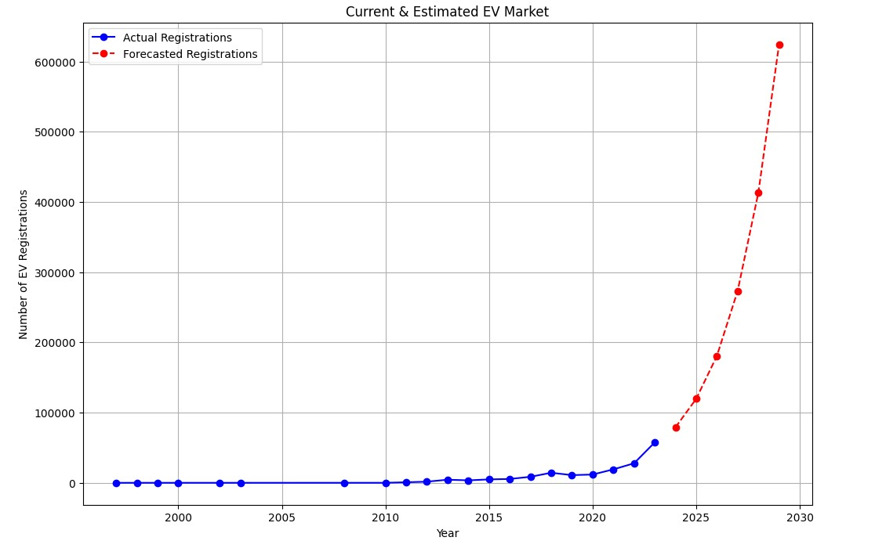

From the above graph, we can see:

* The number of actual EV registrations remained relatively low and stable until around 2010, after which there was a consistent and steep upward trend, suggesting a significant increase in EV adoption.
* The forecasted EV registrations predict an even more dramatic increase in the near future, with the number of registrations expected to rise sharply in the coming years.

Given the growing trend in actual EV registrations and the projected acceleration as per the forecast data, we can conclude that the EV market size is expected to expand considerably. The steep increase in forecasted registrations suggests that consumer adoption of EVs is on the rise, and this trend is likely to continue.