SQL:

SQL stands for **Structured Query Language**. It is a standardized programming language used to **manage**and manipulate relational databases. It enables users to perform a variety of tasks such as querying data, creating and modifying database structures, and managing access permissions. SQL is widely used across various relational database management systems such as **MySQL**, **PostgreSQL**, Oracle, and SQL Server.

When data needs to be retrieved from a database, SQL is used to construct and send the request. The Database Management System (DBMS) processes the **SQL query**, retrieves the requested data, and returns it to the user or application. Instead of specifying step-by-step procedures, SQL statements describe what data should be retrieved, **organized**, or modified, allowing the DBMS to handle how the operations are executed efficiently.

**Purpose of SQL in Web Development**

In web development, SQL plays a crucial role in the **backend** of web applications. It is used to:

* **Store user data** (e.g., login credentials, profiles)
* **Retrieve content** to display on websites (e.g., blog posts, products)
* **Update database records** when users take actions (e.g., editing a profile)
* **Ensure data integrity and relationships** between different types of data (e.g., linking users to their orders)

Created a Database:

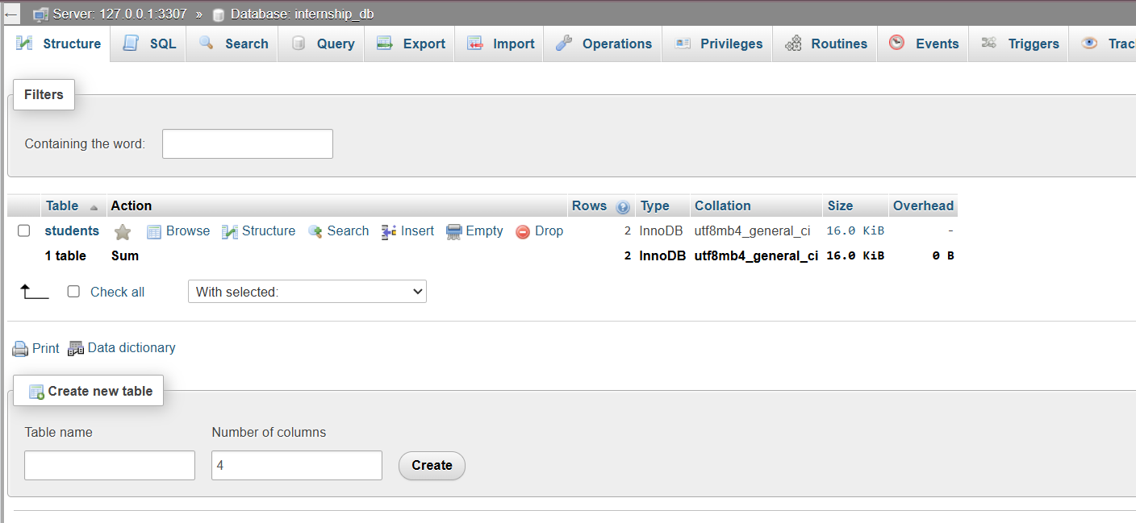  
  
Added new Table:



Inserting new row:

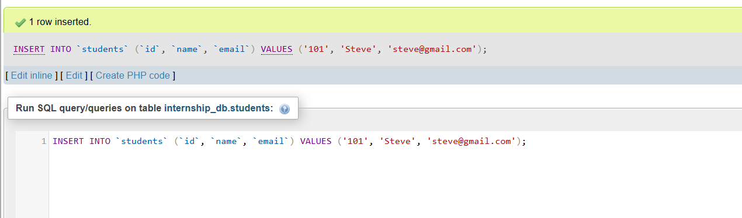

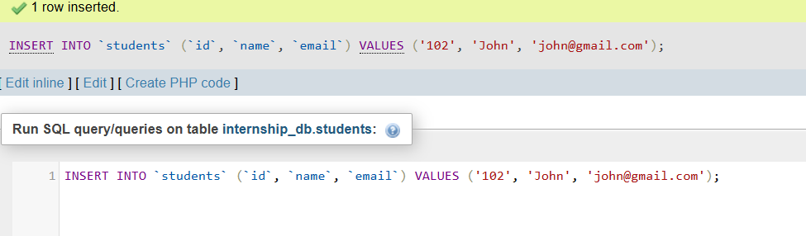

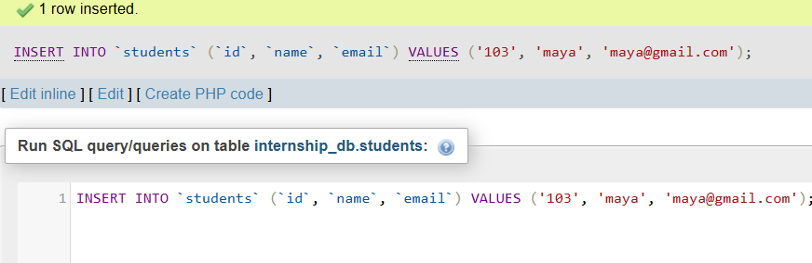

Selecting all inputs:

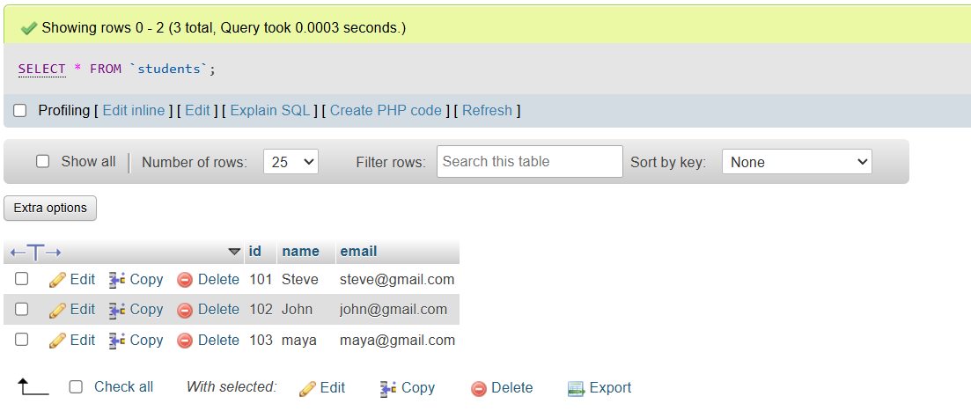

Updated the email entry of 1 student:  
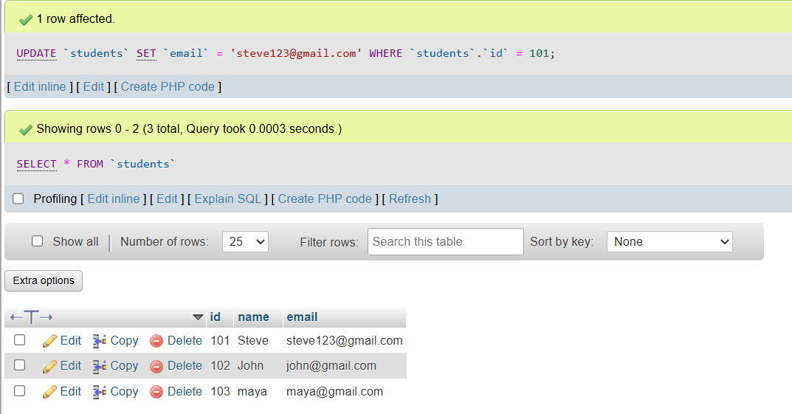

Deleted the last student entry:  
