Practical - 1

Create a calculator application in Android

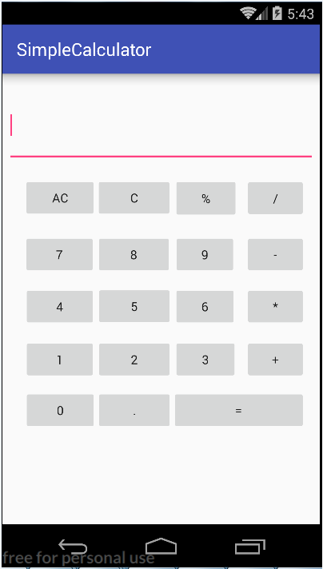

**Fig 1:** Calculator interface

Practical - 2

Create a Login interface in Android

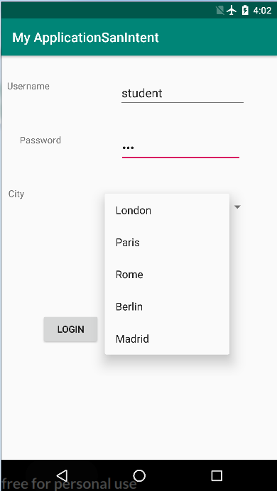

**Fig 1:** Login interface

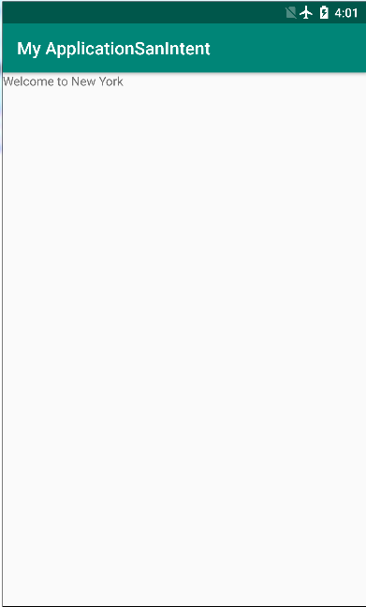

**Fig 2:** Navigating to home page using Intents

Practical - 4

Demonstrate AsyncTask in Android

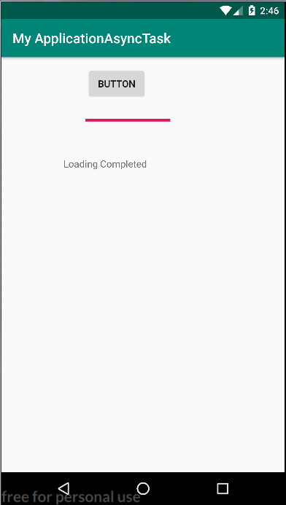

**Fig 1:** AsynTask

Practical - 5

Demonstrate Menus (Options and Context) in Android

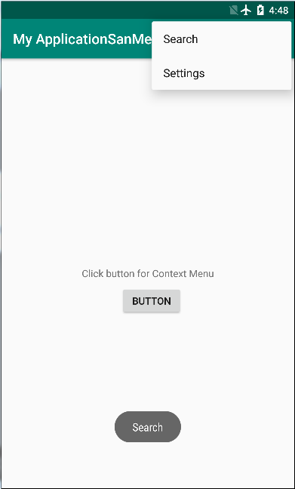

**Fig 1:** Options Menu

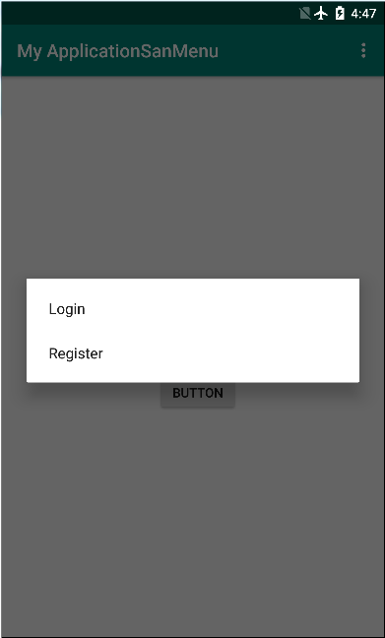

**Fig 2:** Context Menu

Practical - 6

Demonstrate Broadcast Receiver in Android

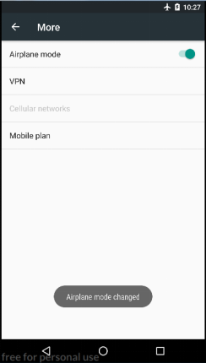

**Fig 1:** Broadcast receiver for Airplane mode

Practical - 7

Demonstrate AlarmManager in Android

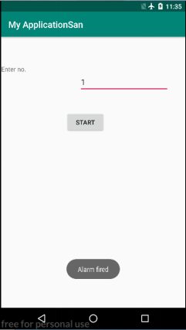

**Fig 1:** AlarmManager demo