**SAARTHI: CHATBOT FOR MENTAL HEALTH**

**A PROJECT REPORT**

**for**

**Mini Project-I (K24MCA18P)**

**Session (2024-25)**

**Submitted by**

**TANISHA**

**202410116100216**

**TANISHKA SINGH**

**202410116100219**

**SHRUTI SAGAR**

**202410116100203**

**Submitted in partial fulfilment of the**

**Requirements for the Degree of**

**MASTER OF COMPUTER APPLICATION**

**Under the Supervision of**

**Ms. Divya Singhal**

### Assistant Professor



**Submitted to**

**Department Of Computer Applications**

**KIET Group of Institutions, Ghaziabad**

**Uttar Pradesh-201206**

**(december- 2024)**

### CERTIFICATE

Certified that Tanisha **202410116100,** Tanishka Singh **202410116100219** and Shruti Sagar **202410116100203** have carried out the project work having “**SAARTHI:** **Chatbot for mental health**” (**Mini Project-I, K24MCA18P**) for **Master of Computer Application** from Dr. A.P.J. Abdul Kalam Technical University (AKTU**)** (formerly UPTU), Lucknow under my supervision. The project report embodies original work, and studies are carried out by the students herself and the contents of the project report do not form the basis for the award of any other degree to the candidate or to anybody else from this or any other University/Institution.

**Ms. Divya Singhal Dr. Arun Kr. Tripathi**

**Assistant Professor Dean**

**Department of Computer Applications Department of Computer Applications**

**KIET Group of Institutions, Ghaziabad KIET Group of Institutions, Ghaziabad**

**SAARTHI : Chatbot for Mental Health**

**Tanishka Singh, Tanisha, Shruti Sagar**

**ABSTRACT**

This project report explores the development of a **mental health chatbot**, conceptualized as a mini-project aimed at delivering accessible and scalable mental health support. In an era where mental health issues are increasingly recognized as critical yet remain underserved due to stigma, limited resources, and high costs, the chatbot seeks to bridge this gap by providing assistance to individuals who may not have access to professional therapy or counselling.

The chatbot leverages the power of **artificial intelligence (AI)** and **natural language processing (NLP)** to engage users in meaningful conversations and provide them with personalized emotional guidance. It incorporates features such as self-help exercises, mood tracking, and curated resource recommendations tailored to individual needs. The chatbot is designed to operate within a user-friendly, web-based interface, ensuring ease of access for a diverse audience, including underserved communities.

This report provides a detailed analysis of the project's feasibility, encompassing technical, financial, and social perspectives. The implementation plan outlines the use of **Python** as the development tools, focusing on creating an intuitive, interactive, and empathetic conversational flow. Additionally, the report evaluates the integration of **real-time data collection**, enabling the chatbot to offer more dynamic and personalized support by adapting to users' emotional states and feedback over time.

Beyond the technical scope, this project emphasizes its potential impact, particularly in promoting mental health awareness and offering scalable solutions for mental health challenges. By providing a confidential and supportive space for users, the chatbot aims to complement traditional mental health services, ultimately contributing to the broader goal of improving global mental well-being.

### ACKNOWLEDGEMENTS

Success in life is never attained single-handedly. My deepest gratitude goes to my project supervisor, **Ms. Divya Singhal** for her guidance, help, and encouragement throughout my project work. Their enlightening ideas, comments, and suggestions.

Words are not enough to express my gratitude to Dr. Arun Kumar Tripathi, Professor and Dean, Department of Computer Applications, for his insightful comments and administrative help on various occasions.

Fortunately, I have many understanding friends, who have helped me a lot on many critical conditions.

Finally, my sincere thanks go to my family members and all those who have directly and indirectly provided me with moral support and other kind of help. Without their support, completion of this work would not have been possible in time. They keep my life filled with enjoyment and happiness.

**Tanisha**

**Tanishka Singh**

**Shruti Sagar**

### TABLE OF CONTENTS

|  |  |  |  |
| --- | --- | --- | --- |
|  | Certificate | | ii |
|  | Abstract | | iii |
|  | Acknowledgements | | iv |
|  | Table of Contents | | v |
| 1 | Introduction | | 1-4 |
|  | 1.1 | Overview | 1 |
|  | 1.2 | Objective | 2 |
|  | 1.3 | Project Scope | 3 |
|  | 1.4 | Project Description | 4 |
|  | 1.5 | Purpose | 4 |
| 2 | Feasibility Study | | 5-7 |
|  | 2.1 | Market Analysis | 5 |
|  | 2.2 | Technical Feasibility | 5 |
|  | 2.3 | Operational Feasibility | 6 |
|  | 2.4 | Financial Feasibility | 6 |
|  | 2.5 | Legal and Ethical Consideration | 7 |
|  | 2.6 Recommendation | | 7 |
| 3 | Project Objective | | 8-9 |
| 4 | Hardware and Software Requirements | | 10-11 |
| 5 | Project Flow | | 12-25 |
| 6 | Project Outcome | | 26-32 |
| 7 | Reference | | 33-36 |
|  |  | |  |
|  |  | |  |
|  |  | |  |
|  |  | |  |

### CHAPTER 1

### INTRODUCTION

**1.1 Overview**

Mental health issues are increasingly recognized as a critical aspect of public health. Anxiety, depression, and stress are common mental health concerns that affect individuals across various demographics. However, access to professional mental health services remains limited due to factors such as stigma, high costs, and lack of resources.

Recent advancements in digital health technologies have created opportunities to address these gaps. Chatbots, powered by artificial intelligence, provide a scalable, low-cost, and user-friendly approach to mental health support. These tools can complement existing mental health services by offering immediate assistance and psychoeducation.

**1.2 Objectives**

* **Introduction to the Mental Health Chatbot Concept:** To provide an overview of what a mental health chatbot is, its significance in addressing mental health issues such as stress and anxiety, and how technology is transforming mental health care.
* **Assessment of the Need for a Mental Health Chatbot:** To explore the growing demand for mental health support tools, particularly for managing stress and anxiety. To discuss the limitations of traditional mental health resources and the advantages of having a chatbot for immediate, scalable support.
* **Identifying Key Features and Functionalities:** To outline the main features and functionalities of the chatbot, such as stress/anxiety assessments, personalized exercises, video resources, and progress tracking.
* **Exploration of Technology and Tools Used:** To explain the underlying technologies (e.g., NLP, AI, video integration) and platforms used to build and deploy the chatbot. To discuss privacy and data security concerns in developing mental health tools.
* **Benefits and Limitations of Using a Chatbot for Mental Health:** To evaluate the potential benefits of using a chatbot, such as accessibility, privacy, and scalability. To discuss the limitations, including the lack of human empathy, the inability to handle complex mental health conditions, and reliance on accurate data input.
* **Effectiveness of Mental Health Chatbots**: To examine existing research and case studies on the effectiveness of chatbots in alleviating stress and anxiety.To discuss any user feedback, clinical results, or studies on the success rate of chatbot interventions.
* **Personalization and User Experience:** To highlight the importance of personalization in delivering tailored mental health support through AI. To discuss the user experience design that ensures accessibility, ease of use, and a compassionate tone.
* **Ethical Considerations:** To address ethical concerns around data privacy, user consent, and the limitations of AI-based mental health interventions. To consider the role of chatbots in complementing, rather than replacing, human therapists and mental health professionals.
* **Challenges in Implementing the Chatbot**: To discuss potential challenges in deploying the chatbot, including technical issues, user engagement, and the need for continuous improvement based on feedback and outcomes.
* **Future Directions and Enhancements:** To propose future improvements for the chatbot, such as incorporating more advanced AI features, integrating with existing mental health platforms, or adding more personalized options for different demographics.

**1.3 Project Scope: Mental Health Chatbot for Stress and Anxiety**

**Core Features**

a) Stress and Anxiety Assessment: Basic questionnaires or mood checks to assess the user's current state. Personalized assessments to detect the severity of anxiety or stress.

b) Stress Reduction Exercises:

Guided breathing exercises (e.g., deep breathing, box breathing).

Progressive muscle relaxation techniques.

Mindfulness exercises (e.g., body scans, meditation).

Cognitive-behavioural techniques (e.g., thought reframing).

c) Video References:

Integration of video content (e.g., YouTube or custom library) with guided sessions for stress relief.

Content could include yoga, meditation, or relaxation practices.

d) Personalized Recommendations:

Based on user responses, the chatbot will suggest exercises or videos tailored to the level of stress or anxiety.

Option to track progress over time (e.g., mood improvement or stress reduction).

**1.3.2 Technology Stack**

a) Natural Language Processing (NLP): To understand user input and provide meaningful responses. Use of pretrained models (like GPT or other NLP models) to handle conversations.

b) Machine Learning (Optional):To analyze patterns in user behaviour and provide more personalized recommendations over time.

c) Video Integration: YouTube or other platforms for embedding stress-relief videos. Option to upload custom video content.

d) Privacy & Data Security: Ensure compliance with relevant privacy laws (e.g., GDPR, HIPAA). Avoid storing sensitive data without clear user consent.

**1.3.3 User Experience (UX) and Interface**

a) Conversational Interface:

Simple, empathetic, and non-judgmental tone for user engagement.

Easy-to-navigate interface with clear instructions for exercises.

b) Multi-Platform Accessibility:

Access via web, mobile apps, or messaging platforms (e.g., WhatsApp, Facebook Messenger).

c) Customizable User Settings:

Users can set reminders for daily exercises, notifications for check-ins, etc.

**1.3.4 Optional Advanced Features**

a) Emergency Protocols:

In case a user is in severe distress, the chatbot can offer immediate emergency contacts or help lines.

b) In-App Tracking and Analytics:

Collect non-sensitive data to understand user progress (e.g., frequency of exercises, improvements in mood).

c) Integration with Mental Health Professionals:

Option for users to be referred to licensed therapists or counsellors.

**1.4 Project Description**

"SAARTHI: Chatbot for Mental Health" is a web-based application that offers users an empathetic and interactive platform to manage stress and anxiety. The chatbot integrates AI, NLP, and user-centered design to create a safe and accessible environment for emotional support.

**Functionalities**

1. **Personalized Interactions**:
   * Tailors responses and recommendations to user input and mood levels.
2. **Educational Resources**:
   * Provides articles, videos, and exercises to enhance users’ understanding of mental health.
3. **Secure Communication**:
   * Ensures user confidentiality through encrypted conversations and anonymized data handling.
4. **24/7 Availability**:
   * Offers round-the-clock support, making mental health resources accessible at any time.

**1.5 Purpose**

The primary purpose of this project is to bridge the gap in mental health resources, making support available to those who may face barriers to accessing traditional therapy. It aims to:

1. **Promote Emotional Well-being**:
   * Provide users with tools and resources to manage stress and anxiety effectively.
2. **Enhance Accessibility**:
   * Offer a digital-first solution that reaches underserved communities and individuals unable to afford therapy.
3. **Encourage Proactive Care**:
   * Empower users to take charge of their mental health through personalized guidance and self-help exercises.
4. **Support Mental Health Awareness**:
   * Reduce stigma and foster a culture of openness around mental health discussions.

### CHAPTER-2

### FEASIBILITY STUDY

**Introduction**

Mental health issues continue to rise globally, but many individuals lack access to affordable and timely mental health resources. This mini-project chatbot seeks to bridge this gap by offering basic mental health guidance, self-help tools, and resource recommendations, accessible through a simple AI-driven interface.

**2.1 Market Analysis**

* Target Audience:
  + Students, young professionals, and underserved communities with limited access to mental health services.
* Market Demand:
  + Rising awareness and destigmatization of mental health discussions.
  + Growing reliance on mobile apps and chatbots for basic health services.
  + Opportunity to provide localized, low-cost solutions.
* Competitor Analysis:
  + Existing tools such as Woebot and Wysa provide insights into features users find valuable.
  + Differentiation in the mini-project includes simplified design, language localization, and integration with existing academic or workplace support systems.

**2.2 Technical Feasibility**

* **Technology Stack:**
  + **Frontend**: Simple web app or chatbot integration with platforms like WhatsApp or Telegram.
  + **Backend**: Cloud-based NLP APIs (e.g., Google Dialogflow or OpenAI GPT-based APIs).
  + **Database**: Lightweight storage solutions (e.g., Firebase) to store non-sensitive user preferences.
* **Core Features:**
  + Basic emotional support and active listening.
  + Delivery of mental health tips, guided exercises, and psychoeducation.
  + Resource links to professional help or emergency services.
* **Challenges:**
  + Maintaining conversational relevance with limited training data.
  + Ensuring scalability for a growing user base while staying within budget.

**2.3 Operational Feasibility**

* **Human Resource Requirements:**
  + 1-2 developers for chatbot configuration and integration.
  + A psychologist or counselor to validate content.
  + Minimal support staff for quality assurance during the pilot phase.
* **Workflow:**
  + Phase 1: Development and testing of core functionalities.
  + Phase 2: Pilot deployment in a targeted environment (e.g., university or small organization).
  + Phase 3: Feedback-driven improvements and scaling.
* **Risks and Mitigation:**
  + Risk: Limited user engagement.
    - Mitigation: Easy-to-use interface and gamified interactions.
  + Risk: Over-reliance on chatbot for serious mental health issues.
    - Mitigation: Clear disclaimers and escalation mechanisms.

**2.4 Financial Feasibility**

* **Cost Estimation:**
  + Development: $5,000 - $10,000 (initial setup using pre-built chatbot frameworks).
  + Hosting and API usage: $500 - $1,000/year.
  + Content validation and updates: $2,000/year.
* **Revenue Model:**
  + Free usage with optional premium features (e.g., expanded content or personalized insights).
  + Partnerships with academic institutions or NGOs to fund operations.
* **Break-even Analysis:**
  + Break-even achievable within 1-2 years through low operational costs and targeted outreach.

**2.5 Legal and Ethical Considerations**

* **Data Privacy:**
  + Minimal data collection (anonymous user interactions).
  + Use of secure API services for chatbot functionality.
* **Liability and Disclaimer:**
  + Clear terms stating the chatbot offers general guidance and is not a substitute for professional care.
* **Bias and Inclusivity:**
  + Incorporate diverse datasets and user feedback to ensure inclusivity in chatbot responses.

**2.6 Recommendations**

* Begin with a prototype leveraging existing chatbot platforms like Dialogflow or Microsoft Bot Framework.
* Conduct a pilot program in a controlled setting (e.g., university counseling services).
* Focus on user feedback to refine features and address gaps.
* Partner with local mental health organizations for content validation and outreach.

### CHAPTER 3

### PROJECT OBJECTIVE

1. **Key Objectives**
2. **Enhancing Accessibility to Mental Health Support**
   * Provide a digital-first solution that ensures round-the-clock access to stress and anxiety management tools.
   * Address the barriers of cost, stigma, and limited availability associated with traditional therapy.
3. **Promoting Mental Health Awareness and Education**
   * Educate users about stress, anxiety, and effective coping mechanisms.
   * Encourage open discussions and reduce stigma surrounding mental health issues.
4. **Delivering Personalized and Scalable Support**
   * Leverage AI and NLP to provide tailored responses based on individual user needs and emotional states.
   * Enable scalability to reach a larger audience, including underserved communities.
5. **Ensuring User Privacy and Security**
   * Adhere to global privacy standards like GDPR and HIPAA.
   * Provide a secure platform where users can share their concerns confidentially.
6. **Project Objectives**
7. **Development of the Chatbot Platform**
   * Design and implement an AI-powered chatbot that engages users in meaningful conversations to manage stress and anxiety.
   * Integrate features such as mood tracking, guided exercises, and video resources for comprehensive mental health support.
8. **User-Centric Design and Experience**
   * Create an intuitive, empathetic interface that ensures ease of use across web and mobile platforms.
   * Include customizable settings, such as reminders for exercises and progress tracking, to enhance user engagement.
9. **Integration of Advanced Technologies**
   * Utilize natural language processing (NLP) and sentiment analysis to understand user inputs effectively.
   * Implement AI models like DialoGPT for dynamic and context-aware responses.
10. **Scalability and Multi-Platform Deployment**
    * Deploy the chatbot on web, mobile applications, and messaging platforms to maximize its reach.
    * Ensure the architecture supports concurrent users without performance degradation.
11. **Future-Proofing and Continuous Improvement**
    * Design the chatbot with a modular architecture to allow future enhancements, such as multilingual support and integration with professional therapists.
    * Collect anonymized user feedback to refine features and improve user satisfaction over time.

### CHAPTER 4

### HARDWARE AND SOFTWARE REQUIREMENTS

1. **Hardware Requirements**
2. **Development Environment**
   * Processor: i5/i7 for smoother execution.
   * RAM: At least 8 GB
   * Storage : 20-50 GB free space for installing libraries , frameworks, and storing logs or datasets.
   * Graphics : A basic GPU can accelerate response generation using PyTorch.
3. **Internet Connection:**
   * A stable and fast internet connection for downloading the pre-trained model, libraries, and deployment dependencies.
4. **Optional Devices:**
   * Microphone and speakers for voice interaction (if extended later).
   * External storage for backups.
5. **Software Requirements**

**1. Operating System**

* Windows 10/11.
* Linux is preferred for better compatibility with PyTorch and NLP libraries.

**2. Programming Language and Environment**

* Python 3.8 or higher (Required for using the DialoGPT model, Flask, and NLP libraries).
* Text Editor : VS Code for coding and debugging.

**3. Frameworks and Libraries**

* Flask :
* For creating the web application.
* PyTorch:
* Required for loading and running the pre-trained DialoGPT model.
* Install using pip install torch.
* Transformers :
* Used for the DialoGPT model and tokenizer.
* Install using pip install transformers.
* Bootstrap:
* For frontend styling and responsive design.
* Included through CDN links in your HTML.
* jQuery:
* For handling dynamic frontend interactions
* Font Awesome:
* For icons used in your chatbot interface.
* HTML/CSS:
* Used for structuring and styling the frontend.

**4. Browser Compatibility**

* Modern browsers like Google Chrome and Edge for testing and running the chatbot interface.

**5. Database**

* MySQL for structured data.

**6. Pre-trained Model**

* DialoGPT (Medium):
* A conversational model used for generating chatbot responses.
* Downloaded automatically using transformers from Hugging Face.

**7. Hosting and Deployment**

* Local Development:
* Flask's built-in server for running the app locally.
* Cloud Deployment:
* AWS or Google Cloud Platform (GCP) for hosting the chatbot online.

**8. Version Control**

* Git:
* For tracking code changes.
* GitHub:
* To store and share the project repository.

### CHAPTER-5

### PROJECT FLOW

1. **Project Planning & Research**

* **Objective:** Set the groundwork for the chatbot project, ensuring clear goals, understanding of needs, and feasibility.
* **Tasks:**
  + **Market Research:** Investigate existing mental health chatbots, apps, or platforms. Understand their strengths, weaknesses, and areas for innovation. **Outcome**: A detailed comparison matrix highlighting strengths, weaknesses, and opportunities for your chatbot to offer innovative features and provide better user experiences.
  + **Target Audience Analysis**: Identify who the chatbot will serve—adults, teenagers, or people with specific stress and anxiety disorders. Consider demographics, technological access, and mental health needs. **Outcome**: A well-defined user persona that outlines the target audience’s needs, behaviours, pain points, and expectations. This will guide the chatbot’s development to ensure relevance and usability.
  + **Needs Assessment:** Define the specific goals for the chatbot (e.g., stress relief, anxiety management). Conduct surveys or interviews with potential users or mental health professionals to identify key areas of support. **Outcome**: A clearly outlined list of chatbot objectives and features, ensuring it directly addresses user needs while remaining practical to develop.
  + **Scope Definition:** Determine the core features the chatbot will provide (e.g., exercises, assessments, resources), as well as any limitations (e.g., not offering professional therapy).

**Outcome**: A detailed scope document outlining what the chatbot will and will not do. This ensures clarity for developers, stakeholders, and users.

* + **Compliance & Regulations:** Research privacy regulations (e.g., GDPR, HIPAA) to ensure user data is protected, and the chatbot complies with applicable laws.

**Outcome**: A compliance checklist ensuring the chatbot adheres to privacy regulations, ethical standards, and user safety guidelines. This builds user trust and ensures legal compliance.

1. **Requirements Gathering**

* **Objective:** Detail the specific features and functional requirements for the chatbot.
* **Tasks:**
  + **Create User Personas:** Develop personas to represent the chatbot’s target users. These should include demographic details, specific stress or anxiety triggers, and preferences regarding mental health support.

**Outcome**: A set of personas that represent diverse user groups, guiding chatbot features, design, and tone.

* + **Define Core Features:**
    - **Stress/Anxiety Assessments:** Define the types of assessments (e.g., mood check-ins, anxiety scales like GAD-7) the chatbot will use to determine user needs.
    - **Exercise Suggestions**: List types of stress-relief exercises (e.g., breathing exercises, mindfulness activities, guided meditations).
    - **Video Resources:** Identify platforms for embedding videos (e.g., YouTube, internal resources). Curate content related to stress relief.
    - **User Tracking**: Determine how the chatbot will track user progress (e.g., frequency of use, changes in stress levels) and any optional personal information (e.g., user name, preferences).

**Outcome**: A feature list document that outlines the chatbot's core capabilities and specific user interactions.

* + **Platform Selection:** Decide if the chatbot will be available on web platforms, mobile apps, or integrated with messaging services like WhatsApp or Facebook Messenger.

**Outcome**: A platform strategy document that finalizes whether the chatbot will launch as a web app, mobile app, or integrate with messaging platforms.

* + **Security & Privacy:** Clarify the types of data the chatbot will collect (e.g., user interactions, mood data) and ensure there is no collection of sensitive health information unless necessary. Define user consent protocols.

**Outcome**: A security and privacy policy document that ensures all chatbot features adhere to ethical and legal standards.

1. **Design Phase**

* **Objective:** Lay out the chatbot’s user interface (UI), conversation flow, and integration points.
* **Tasks:**
  + **User Experience Design:**
    - Design an intuitive interface that facilitates smooth interactions, ensuring easy navigation for users.
    - Decide on the platform design (web, mobile, or messaging apps) and develop a clean, accessible UI that’s visually appealing.
    - **Outcome**: Wireframes and mockups that serve as the blueprint for the chatbot interface.
  + **Conversation Flow:**
    - Map out user dialogues with the chatbot. Define the different stages, such as:
      * Greeting the user with an empathetic tone.
      * Conducting an initial assessment (e.g., "How are you feeling today?").
      * Suggesting personalized exercises (e.g., "Would you like to try a deep breathing exercise now?").
      * Offering video resources when appropriate.
      * Handling user follow-up or feedback.
      * **Outcome**: A complete conversational flowchart with decision branches for different user interactions.
  + **Video Integration:**
    - Integrate a video player (e.g., embedded YouTube videos or custom video content). Ensure the videos are easily accessible and relevant to the user’s needs.
    - **Outcome**: A functional plan for integrating video content seamlessly into the chatbot.
  + **Chatbot Persona Design:**
    - Decide on the chatbot’s personality (e.g., warm, friendly, non-judgmental). This will help in tone-setting during interactions.
    - **Outcome**: A persona guide that defines the chatbot’s tone, style, and behavior.
  + **Feedback Mechanisms:**
    - Include mechanisms for users to give feedback about their experience, whether they felt better after exercises or if they found the video helpful.
    - **Outcome**: A feedback system integrated into the chatbot.

1. **Development Phase**

* Objective: Build the chatbot according to the designs and specifications.
* Tasks:
  + NLP Model Development:
    - Use natural language processing (NLP) algorithms to understand and process user inputs. Ensure the chatbot can handle variations in how users express stress or anxiety (e.g., “I’m feeling anxious” vs. “I’m stressed out”).
    - Integrate sentiment analysis to detect emotional tone and provide more empathetic or appropriate responses.
  + **AI/Personalization Features:**
    - Use machine learning or predefined rules to tailor responses to the user based on their interactions. For example, if a user frequently mentions anxiety, the chatbot might suggest calming exercises or videos related to anxiety relief.
  + **Video Content Integration:**
    - Develop code to embed videos from external platforms or upload custom content directly. The chatbot should recommend videos based on user responses.
  + **Backend System Development:**
    - Set up databases to store non-sensitive data (e.g., user preferences, interaction history) for personalized experiences. Ensure all data is securely encrypted.
  + **Multi-Platform Deployment:**
    - Build the chatbot for the required platforms (e.g., web interface, mobile app, or messaging apps). Ensure consistency across platforms in both functionality and design.
  + **Testing for Privacy Compliance:**
    - Double-check that data handling complies with legal and privacy requirements. Ensure that user data is anonymized or kept to a minimum if needed.

1. **Testing Phase**

* **Objective:** Ensure the chatbot functions as intended, is user-friendly, and meets privacy standards.
* **Tasks:**
  + **Functional Testing:**
    - Test all chatbot features—assessments, exercises, video integration, and responses to varied user inputs.
    - Ensure that the chatbot handles edge cases (e.g., unclear or conflicting user inputs) gracefully.
  + **Usability Testing:**
    - Conduct user testing with real participants to evaluate ease of use. Gather feedback on how intuitive the interface is, how clear the chatbot’s responses are, and how helpful the exercises and videos are.
  + **Security & Privacy Testing:**
    - Test the system’s compliance with security protocols, making sure no sensitive user data is exposed. Perform encryption checks for user data storage.
  + **Performance & Load Testing:**
    - Test the chatbot’s performance under load, especially if you expect high traffic. Ensure that the chatbot can handle multiple users without significant delays.

1. **Launch Phase**

* **Objective:** Deploy the chatbot to users and begin monitoring its performance.
* **Tasks:**
  + **Soft Launch:**
    - Consider a beta release to a limited user group to gather initial feedback and make final adjustments.
  + **Public Launch:**
    - Officially release the chatbot on the chosen platform(s). Promote it via social media, email campaigns, or other channels to reach the target audience.
  + **User Onboarding:**
    - Provide introductory materials (e.g., a tutorial or FAQ section) to guide new users on how to interact with the chatbot and benefit from its features.
  + **Monitor System Health:**
    - Use monitoring tools to track the chatbot’s uptime, performance, and any bugs or issues that arise during early usage.

1. **Maintenance & Updates**

* Objective: Continuously improve the chatbot based on user feedback and usage data.
* Tasks:
  + Bug Fixes:
    - Address any technical issues or bugs reported by users promptly to ensure a smooth experience.
  + Feature Updates:
    - Continuously improve the chatbot by adding new features, refining exercises, updating videos, or enhancing personalization algorithms.
  + User Feedback Loop:
    - Collect feedback from users through surveys or follow-up messages to identify areas for improvement.
  + Regular Content Updates:
    - Add new videos, exercises, or stress-relief techniques periodically to keep the content fresh and relevant.

1. **Reporting & Evaluation**

* **Objective:** Measure the success of the chatbot in terms of user engagement and effectiveness.
* **Tasks:**
  + **Engagement Metrics:**
    - Track metrics like user interaction frequency, session duration, completion rates of exercises, and video views to assess chatbot engagement.
  + **Effectiveness Evaluation:**
    - Use user surveys or feedback to evaluate if the chatbot is achieving its goals (e.g., reducing stress or anxiety).
  + **Analyze Data:**
    - Review trends in user interactions, such as common requests or frequent exercises, and adjust chatbot responses or content accordingly.
  + **Impact Report:**
    - Prepare a detailed report summarizing the chatbot’s performance, user satisfaction, and areas for future improvements or additions.

### Entities and Their Attributes

* **User:**

This entity represents the users of the mental health chatbot, typically people interacting with the system for stress and anxiety relief.

* **Attributes:**

**UserID :** Primary Key, a unique identifier for each user.

**Name** : User’s full name.

**Email** : User’s email address for contact/registration purposes.

**Age** : User’s age to better tailor recommendations.

**Gender** : Optional field to identify gender.

**RegistrationDate :** The date when the user registered with the chatbot.

**ChatSession :** This entity logs each individual session of the user interacting with the chatbot. Each user can have multiple chat sessions.

* **Attributes:**

**SessionID :** Primary Key, a unique identifier for the chat session.

**UserID :** Foreign Key, references the User entity.

**StartTime** : Timestamp when the chat session started.

**EndTime :** Timestamp when the chat session ended.

**Message :** This entity stores messages exchanged during the chat session. It could include messages from the user or chatbot responses.

* **Attributes:**

**MessageID** : Primary Key, a unique identifier for the message.

**SessionID :** Foreign Key, references the ChatSession entity.

**Sender** : Indicates whether the sender is the User or the Chatbot.

**Timestamp** : The time the message was sent.

**Content** : The actual text or content of the message.

**FeedbackEntry:** After a chat session, users can provide feedback about their experience. This helps improve the chatbot.

* **Attributes:**

**FeedbackID :** Primary Key, a unique identifier for each feedback entry.

**UserID :** Foreign Key, references the User entity.

**SessionID :** Foreign Key, references the ChatSession entity.

**Rating :** A numeric score (e.g., 1-5) provided by the user for the session.

**Comments :** Optional textual feedback.

**SubmissionDate :** The date when the feedback was submitted.

**KnowledgeBase :** This entity stores pre-defined responses, recommendations, and exercise details used by the chatbot to respond to the user.

* **Attributes:**

**EntryID** : Primary Key, a unique identifier for each entry.

**Topic :** The subject or category of the entry (e.g., breathing exercises, stress tips).

**Content:** Detailed content or description of the topic.

Relationships Between Entities

User ↔ ChatSession

Relationship: A User can have one or more ChatSessions.

Type: One-to-Many (1:N)

Example: User "John Doe" may initiate 3 separate chat sessions with the chatbot.

ChatSession ↔ Message

Relationship: Each ChatSession can contain multiple Messages exchanged between the user and the chatbot.

Type: One-to-Many (1:N)

Example: During one session, 10 messages (5 from the user, 5 from the chatbot) are exchanged.

User ↔ FeedbackEntry

Relationship: A User can submit one or more FeedbackEntries after completing chat sessions.

Type: One-to-Many (1:N)

Example: A user provides feedback for 2 separate chat sessions.

ChatSession ↔ FeedbackEntry

Relationship: A ChatSession can have one corresponding FeedbackEntry.

Type: One-to-One (1:1)

Example: SessionID 1234 receives a rating of 4 stars with comments "Very helpful."

Message ↔ KnowledgeBase

Relationship: A Message can reference an entry from the KnowledgeBase.

Type: Many-to-One (N:1)

Example: If a user asks about stress-relief techniques, the chatbot references a"Stress Management" entry from the KnowledgeBase

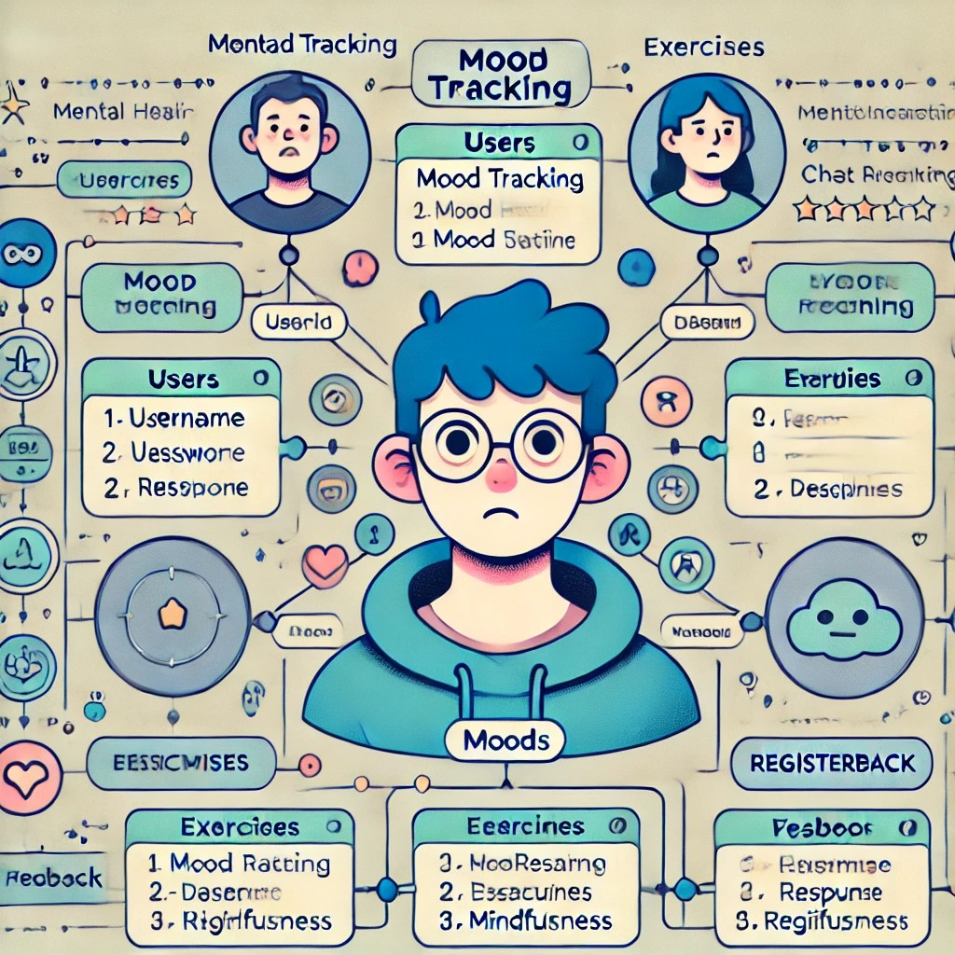

Fig -E-R Diagram

1. **DFD Level 0 (Context Diagram)**

The context diagram represents the system as a single process with external entities interacting with it.

**Components**

External Entities :

User: Provides inputs and receives responses.

System: Mental Health Chatbot.

**Data Flow:**

User sends inputs/messages → System processes the message → User receives chatbot responses.

**DFD Level 1**

Level 1 breaks the system into sub-processes and illustrates the key functionalities.

**Processes:**

Start Chat Session: User initiates a chat session.

Process User Input: Chatbot processes messages received from the user.

Generate Recommendations: Based on inputs, the chatbot fetches responses or exercises from the Knowledge Base.

Store Chat Data: Messages, timestamps, and session data are saved.

Collect Feedback: User provides feedback at the end of the session.

**Data Stores:**

User Data: Stores user details (e.g., name, age, email).

Chat Session Data: Stores session information like messages and timestamps.

Knowledge Base: Contains pre-defined advice, exercises, and chatbot responses.

Feedback Data: Stores user feedback (rating and comments).

**External Entities:**

User: Inputs messages, receives responses, and submits feedback.

**DFD Level 2**

Level 2 breaks down individual processes in greater detail.

**Start Chat Session:**

Validate User → Create New Session Record → Confirm Start to User.

**Process User Input:**

Receive Input → Analyze Content → Identify Relevant Knowledge Base Entries.

**Generate Recommendations:**

Retrieve Relevant Exercises/Advice → Format Response → Send Response to User.

**Store Chat Data:**

Save Message, Session ID, Timestamp → Store in Chat Session Data.

**Collect Feedback:**

Receive Feedback → Validate Input → Save Feedback to Feedback Data.

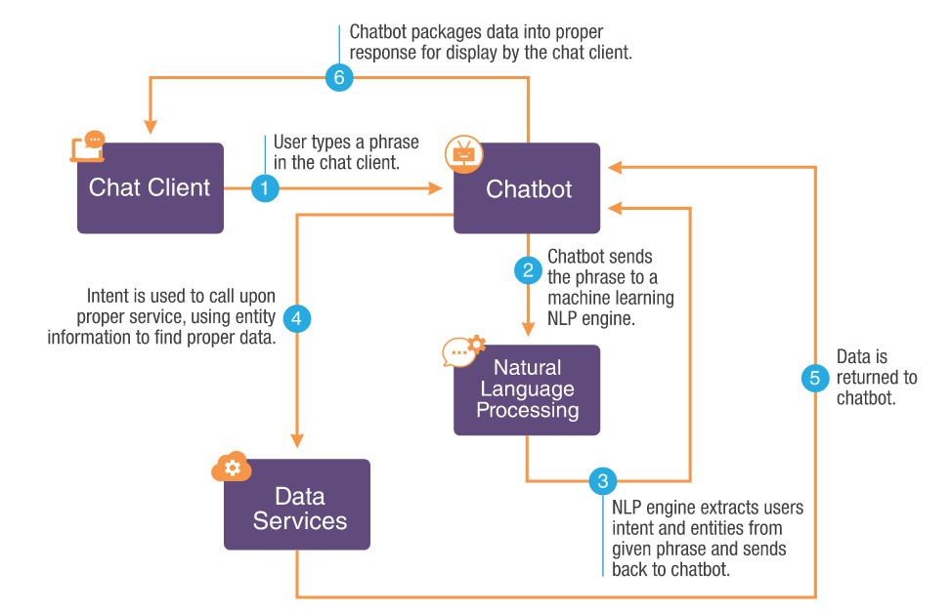

Fig 4.2 DFD

### CHAPTER-6

### PROJECT OUTCOME

### Improved Mental Health Support Accessibility

* **Description:** The chatbot provides immediate, 24/7 support to users, offering a first line of defense for managing stress and anxiety. Users have access to guided exercises, mood tracking, and video resources whenever they need them, reducing the barriers to mental health care.
* **Outcome:** Increased access to mental health resources, especially for individuals who may not have the time, means, or willingness to seek traditional therapy. The chatbot incorporates a secure user authentication system to ensure privacy and personalized interactions. By implementing a login page, only authenticated users can access the chatbot, which adds a layer of security to protect sensitive mental health information. User sessions are managed securely, allowing for seamless communication between the user and chatbot. The login page serves as a gateway to provide a personalized experience where user preferences, such as previous conversations and mood ratings, can be stored and recalled for continuity. Additionally, the login system ensures that users feel confident in sharing their emotional struggles, knowing their data is protected. Implementing such features not only builds trust but also enables features like user history tracking, mood-based support, and personalized feedback.

1. **Personalized Stress and Anxiety Management**

* **Description**: The chatbot adapts its responses and suggestions based on individual user needs. Whether it’s offering deep breathing exercises for immediate relief or recommending longer-term stress management practices, the chatbot personalizes its advice based on user input.
* **Outcome:** Higher engagement from users as the chatbot becomes a personalized, tailored solution for their mental health journey. Users are more likely to continue using the tool regularly due to the customized experience. The chatbot focuses on delivering an empathetic and engaging experience tailored to user needs. By prompting the user to rate their mood on a scale of 1-10 at the beginning of the interaction, the chatbot can adjust its tone and suggestions based on the user's emotional state. If a user reports low mood levels, the chatbot responds with empathetic, supportive messages and recommends stress-relief strategies like mindfulness exercises or relaxation techniques. The chatbot further adapts its responses dynamically during conversations, ensuring an ongoing personalized experience. This approach encourages users to open up about their feelings while providing practical tools for immediate stress management. Such tailored responses improve user satisfaction, creating a supportive digital environment for mental well-being.

1. **Enhanced Mental Health Awareness and Education**

* **Description:** The chatbot not only provides exercises but also educates users about stress, anxiety, and mental health. Through interactive dialogues, users learn effective coping mechanisms and gain a better understanding of their emotional states.
* **Outcome:** Users become more aware of their mental health, which can lead to greater self-management and a reduction in stigma surrounding mental health issues. The chatbot encourages users to reflect on their emotional well-being through simple yet powerful tools like mood rating and self-assessment questions. By asking users to rate their current mood or share their mental state, the chatbot not only tracks progress but also helps users recognize patterns in their emotional health. Regular check-ins allow users to monitor changes over time, enabling better self-awareness about triggers or improvements. Additionally, the chatbot offers educational content to help users understand mental health concepts, such as stress, anxiety, and coping mechanisms. Interactive dialogues make this information accessible and digestible, reducing stigma and encouraging individuals to prioritize their mental well-being. Over time, users gain insights into their emotional health, leading to improved self-management and proactive care.

1. **Increased User Engagement and Satisfaction**

* **Description:** With engaging, easy-to-use features (e.g., guided exercises, video resources, personalized feedback), users are motivated to return to the chatbot frequently. The empathetic tone and supportive interactions enhance user satisfaction and retention.
* **Outcome:** High levels of user engagement, reflected in frequent use of the chatbot and positive feedback, leading to a sense of trust in the tool as a reliable mental health aid. The chatbot operates as an accessible 24/7 digital mental health companion, eliminating barriers like time, cost, and stigma associated with seeking traditional therapy. Users can access personalized support and educational resources on stress, anxiety, and mental health management at their convenience. By integrating responses from trusted APIs or mental health sources (like articles or strategies from verified websites), the chatbot delivers evidence-based guidance to users instantly. Additionally, the chatbot can recommend helpful links, mental health helplines, or professional support resources based on user input. Such accessibility empowers individuals to seek help or learn strategies for improving their emotional health whenever they need it, especially in underserved regions or communities with limited access to mental health professionals.

1. **Data-Driven Insights for Continuous Improvement**

* **Description:** Through user interactions, data is collected (in a secure, anonymized manner) that helps track progress and understand which features or content are most effective. This data informs future updates and improvements to the chatbot.
* **Outcome:** Continuous refinement of the chatbot’s features based on real-world user data, leading to a better user experience and more effective mental health interventions over time. The chatbot collects and analyzes anonymized user data, including frequently mentioned keywords, user feedback, and mood trends. This data is used to understand the chatbot's effectiveness, identify popular features, and highlight areas requiring improvement. By analyzing conversational patterns, developers can fine-tune the chatbot's responses, ensuring greater empathy, relevance, and helpfulness. Continuous updates informed by real-world data enhance the chatbot’s ability to support users effectively. For example, if users frequently mention "stress" or "burnout," the chatbot can prioritize offering stress-relief techniques or recommending professional resources. With ongoing refinements, the chatbot evolves into a more efficient and empathetic tool for supporting mental health, leading to higher user satisfaction and engagement.

1. **Scalability and Reach**

* **Description:** The chatbot, once developed and launched, can easily be scaled to reach a larger audience. It can be deployed across multiple platforms (web, mobile, messaging apps) to reach users in different demographics and locations.
* **Outcome:** The ability to support a wide user base, including people in remote or underserved areas where access to mental health professionals might be limited. The chatbot tailors its suggestions based on the user’s specific needs and emotional state. By integrating natural language processing (NLP) with predefined mental health logic, the chatbot identifies concerns like anxiety, stress, or depression from user input. For example, if a user mentions feeling overwhelmed or anxious, the chatbot may recommend deep breathing exercises, guided mindfulness, or stress management techniques. Additionally, it can fetch relevant resources from external APIs, ensuring its advice is backed by expert knowledge. This personalized approach ensures that users receive targeted recommendations instead of generic responses, increasing the likelihood of meaningful impact on their mental health. Regular interaction with the chatbot can help users adopt better coping strategies, leading to improved emotional well-being.

1. **Positive Impact on Mental Health Management**

* **Description:** The ultimate goal of the chatbot is to help users manage stress and anxiety more effectively. This can lead to tangible improvements in their emotional well-being and quality of life, especially if used as a supplementary tool alongside other forms of support.
* **Outcome:** Users report lower levels of stress and anxiety after using the chatbot regularly, citing improvements in their coping skills, mood, and overall mental health. Recognizing the sensitive nature of mental health data, the chatbot strictly adheres to privacy and security guidelines like **GDPR** or **HIPAA**. Implementing secure login authentication ensures that user sessions are protected and unauthorized access is prevented. Sensitive information, such as conversations, mood ratings, and emotional states, is handled responsibly, without storing unnecessary user data. Additionally, anonymized data collection ensures privacy while allowing for system improvement. By following ethical data-handling practices, the chatbot earns user trust, creating a safe space for individuals to share their thoughts and feelings. Compliance with recognized legal frameworks reassures users that their confidentiality is protected, allowing them to engage in open and honest conversations.

1. **Ethical and Privacy Standards Maintained**

* **Description:** Throughout the development and deployment of the chatbot, strict adherence to privacy and security regulations (e.g., GDPR, HIPAA) ensures that user data is protected, and ethical guidelines are followed.
* **Outcome:** Users trust the chatbot with their personal information because it adheres to the highest standards of data privacy and security, ensuring compliance with legal frameworks. The chatbot is designed to be highly scalable, capable of reaching a diverse audience across platforms like web, mobile, and messaging applications. Once deployed, it can support an increasing number of users simultaneously without significant performance loss. Scalability ensures that individuals in underserved areas, who might lack access to professional therapists or mental health resources, can benefit from the chatbot. Moreover, the modular design of the chatbot allows developers to easily integrate new features, such as multilingual support or specialized modules for specific mental health issues. By expanding its reach and functionality, the chatbot has the potential to become a widely accessible tool for mental health management on a global scale.

1. **Knowledge and Insights for Future Development**

* **Description:** After the chatbot is live and in use, the development process provides valuable lessons regarding user behavior, effective stress-relief techniques, and potential improvements in AI algorithms.
* **Outcome:** Insights gained from user feedback and analytics drive future versions of the chatbot, making it more efficient, empathetic, and effective in meeting user needs. The chatbot is designed to keep users engaged through a combination of empathetic responses, personalized feedback, and interactive tools like mood tracking. By dynamically responding to user inputs and offering mental health support tailored to their emotional state, the chatbot builds a strong sense of trust and reliability. Additionally, its easy-to-use interface and timely suggestions encourage users to interact with the chatbot regularly. Features like stress-relief exercises, educational resources, and mood-based adjustments ensure a satisfying experience that resonates with users. Higher engagement leads to greater impact, as users feel supported and empowered to manage their mental health through a trusted digital companion.

1. **Recognition as a Viable Mental Health Tool**

* **Description:** As the chatbot proves its effectiveness, it gains recognition as a legitimate tool for supporting mental health. It may be recommended by mental health professionals or even integrated with larger health systems as a supplemental resource.
* **Outcome:** The chatbot is acknowledged as a valuable mental health tool that complements traditional care, further contributing to the mental well-being of its users. The chatbot aims to gain recognition as a valuable mental health support tool that complements traditional therapy. By delivering consistent, empathetic, and personalized mental health advice, the chatbot can build credibility among users and mental health professionals. With continued improvement and validation, it may even be integrated into health systems or recommended as a supplementary tool for managing stress and anxiety. Partnering with mental health organizations or professionals can further enhance its credibility. As the chatbot proves its effectiveness in improving user well-being, it has the potential to be recognized as a trusted, scalable solution for addressing mental health challenges globally.

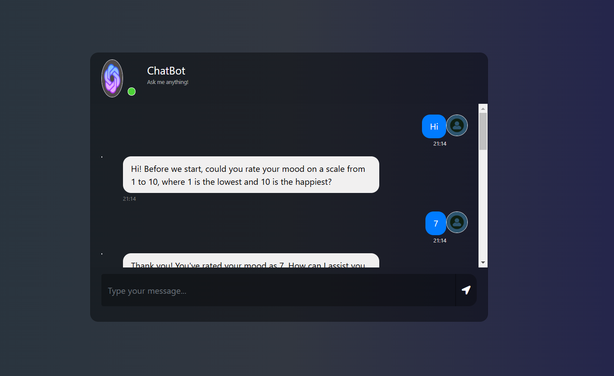

Fig 5.1

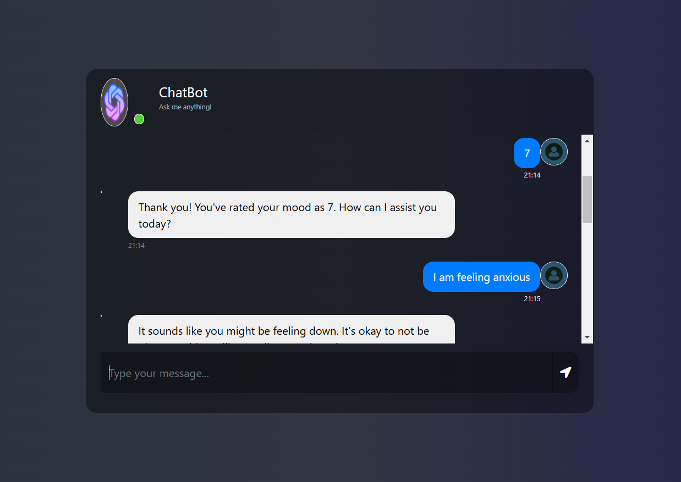

Fig 5.2

### REFERENCES

**Books**

1. **“Designing Bots: Creating Conversational Experiences” by Amir Shevat**
   * This book provides a comprehensive guide on designing chatbots, including conversational UI, user engagement, and best practices for developing successful bots.
2. **“Artificial Intelligence in Behavioral and Mental Health Care” edited by David D. Luxton**
   * A detailed exploration of AI in mental health, this book addresses the integration of AI tools, including chatbots, in mental health care and therapy.
3. **“Mental Health and Well-Being in the Digital Age” edited by John R. Weitz and Stuart S. Brown**
   * This book offers insights into how digital technologies, including chatbots, can be used to improve mental health and well-being, along with the ethical considerations involved.

**Research Papers and Articles**

1. **Fitzpatrick, K. K., Darcy, A., & Vierhile, M. (2017). “Delivering Cognitive Behavioral Therapy to Young Adults with Depression and Anxiety Using a Smartphone App: A Randomized Controlled Trial.” Journal of Medical Internet Research.**
   * This study evaluates the effectiveness of mental health apps (including chatbots) for delivering cognitive behavioral therapy (CBT) to users with depression and anxiety. It highlights the potential benefits of such tools in managing mental health.
2. **Gajos, K. Z., & Lee, B. L. (2018). “Designing Conversational Agents for Mental Health: Opportunities and Challenges.” ACM SIGCHI Conference on Human Factors in Computing Systems.**
   * This paper explores the challenges and opportunities in designing conversational agents for mental health, with a focus on engagement, user experience, and therapeutic outcomes.
3. **Torous, J., & Roberts, L. W. (2017). “The Role of Mental Health Apps in Psychological Well-being: A Review of Current Research.” Psychiatric Clinics of North America.**
   * This article reviews the current research on mental health apps, including chatbots, focusing on their effectiveness in improving mental health outcomes.
4. **Kisely, S., Campbell, L. A., & Clayton, R. (2016). “Telemedicine and e-mental health interventions for mental health and addiction: A systematic review of the effectiveness of different approaches.” *Psychiatric Clinics of North America*.**
   * This systematic review evaluates the effectiveness of telemedicine and e-mental health tools, including chatbots, for mental health and addiction treatment.

**Online Articles & Reports**

1. **“Chatbots for Mental Health: How They Can Improve Your Well-being” (2019), *Psychology Today*.**
   * This article outlines the potential for chatbots in mental health care, discussing their use in stress management, therapy, and emotional support.
2. **“AI for Mental Health: Current Trends and Future Prospects,” *World Health Organization* (WHO), 2022.**
   * This report by the WHO explores the integration of AI, including chatbots, in mental health systems worldwide, addressing challenges and opportunities for scaling mental health services.
3. **“The Impact of Digital Mental Health Interventions: A Meta-Analysis of Randomized Controlled Trials,” *JAMA Psychiatry*, 2020.**
   * This meta-analysis examines the effectiveness of digital interventions, including chatbots, in treating mental health disorders such as anxiety and depression.

**Websites and Online Resources**

1. **World Health Organization (WHO) - Mental Health**
   * The WHO provides reports, guidelines, and resources on mental health and digital health interventions, which can inform the development and ethical considerations for your chatbot.
   * <https://www.who.int/mental_health>
2. **Mental Health Foundation - Stress and Anxiety**
   * This resource provides evidence-based information on stress and anxiety management, which can guide the content and exercises for your chatbot.
   * <https://www.mentalhealth.org.uk/>
3. **Chatbots.org**
   * A platform that offers a range of resources on chatbot development, including examples, guidelines, and research on chatbot implementation in different industries, including mental health.
   * <https://www.chatbots.org/>

**Guidelines for Developing Mental Health Chatbots**

1. **“Ethical Guidelines for Digital Mental Health Tools” (2022), *The Digital Mental Health Network*.**
   * This document provides ethical considerations for developing mental health tools, including chatbots, ensuring privacy, safety, and inclusivity.
2. **“Designing Ethical Chatbots: A Framework for Addressing Privacy and Transparency in Mental Health Apps” (2021), *Journal of Medical Internet Research*.**
   * This paper offers guidance on designing ethical chatbot interactions for mental health care, focusing on transparency, privacy, and user autonomy.

**Technical Tools for Chatbot Development**

1. **Dialogflow (Google Cloud)**
   * Dialogflow is an NLP platform for building conversational interfaces. It’s useful for developing chatbots, especially in mental health, for understanding and processing user inputs.
   * https://cloud.google.com/dialogflow
2. **Rasa**
   * An open-source conversational AI platform for developing sophisticated chatbots with natural language understanding (NLU) and deep learning features.
   * <https://rasa.com/>
3. **TensorFlow (by Google)**
   * TensorFlow is an open-source machine learning framework that can be used to develop AI models for chatbot NLP capabilities.
   * <https://www.tensorflow.org/>