**OrangeHRM :- BUG REPORT**

**Date:- 04-10-2024**

**Name:- Sanket Sarode**

|  |  |
| --- | --- |
| **Platform** | **Browser** |
| **Windows 11** | Chrome, Edge, Electron |

|  |  |  |
| --- | --- | --- |
| **Who Detected** | **How Detected** | **Status** |
| **Sanket** | **Testing** | **Open** |

Bug_001

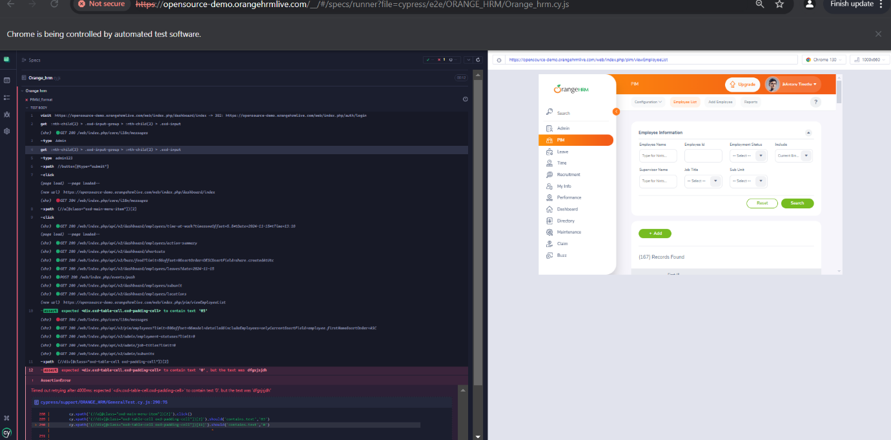

Bug_002

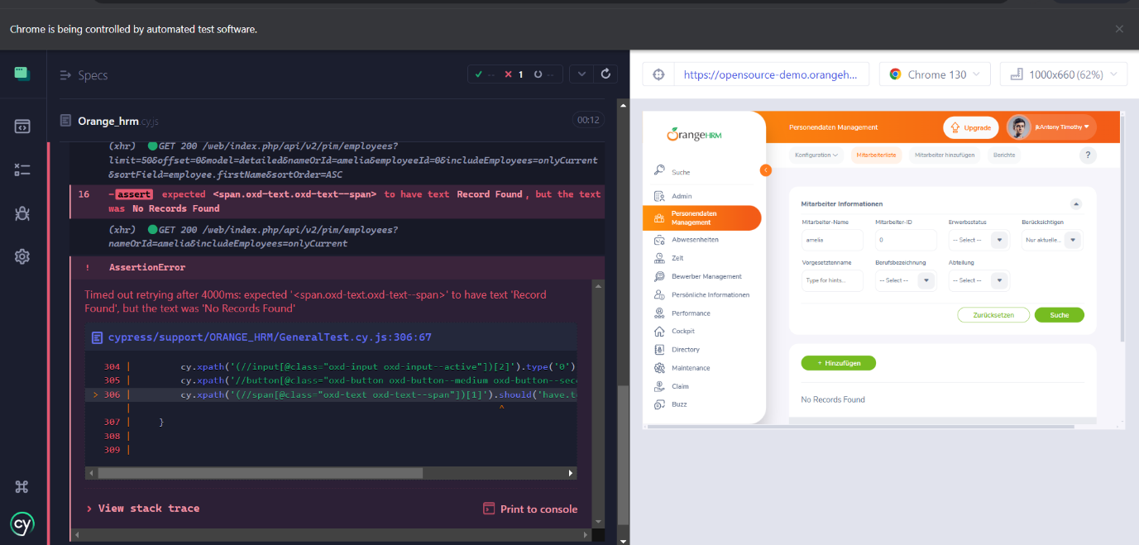

Bug_003



Bug_004

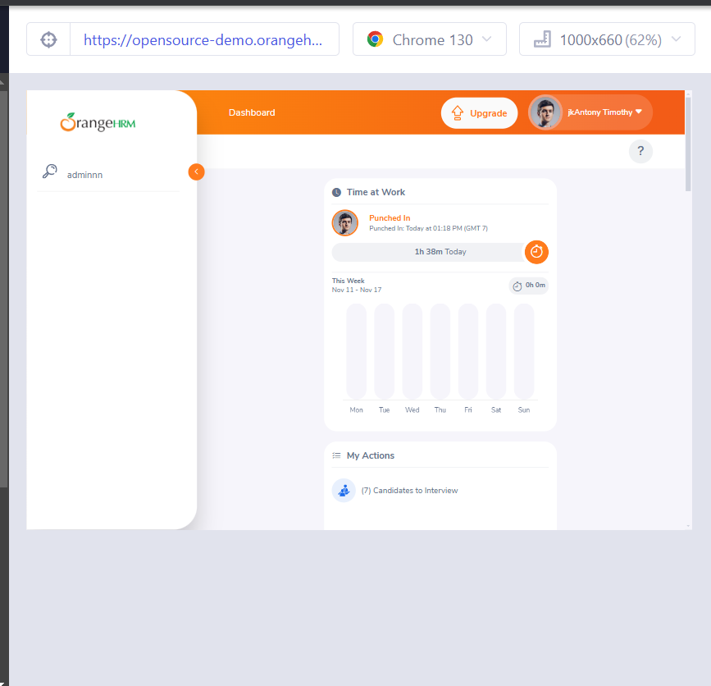

Bug_005

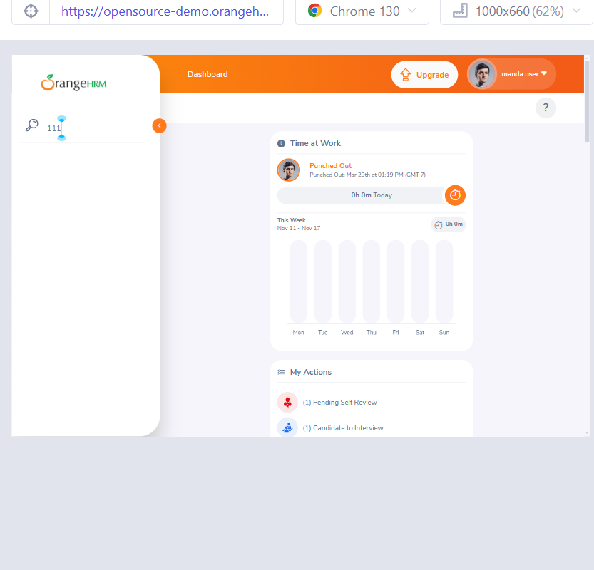

Bug_006

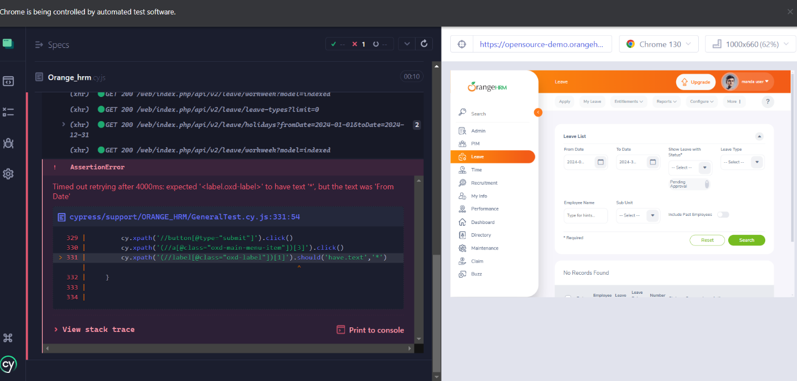

Bug_007

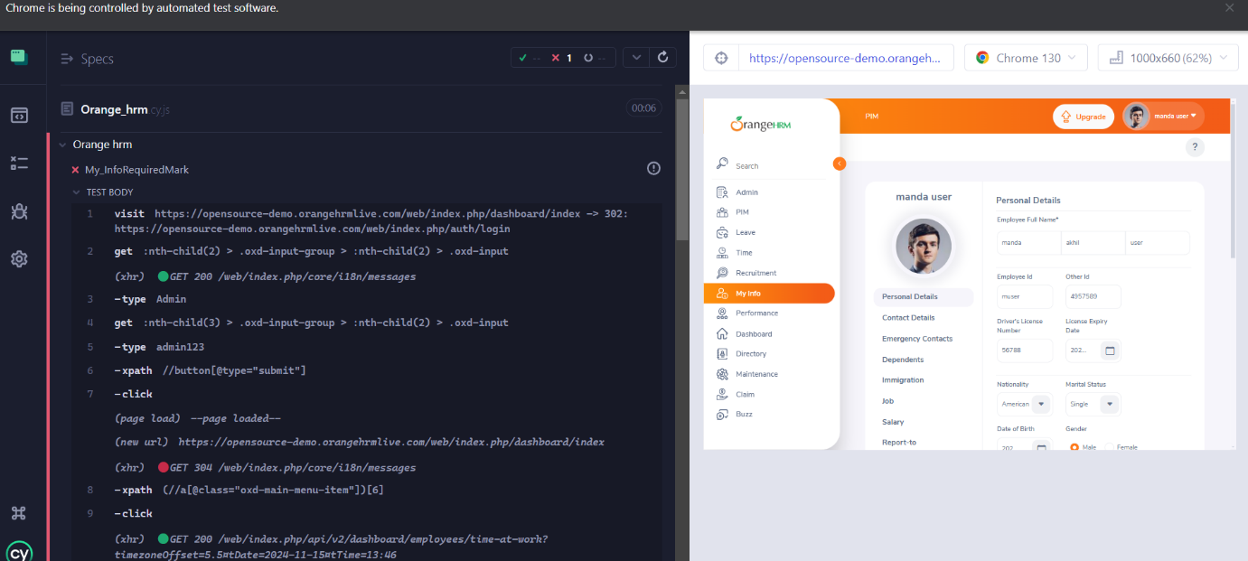

Bug_008

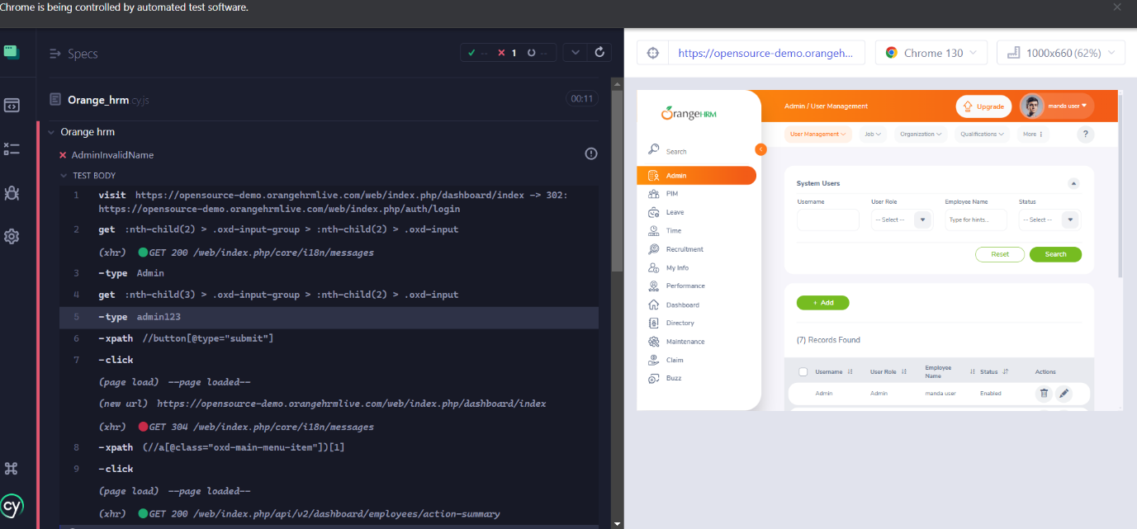

Bug_009

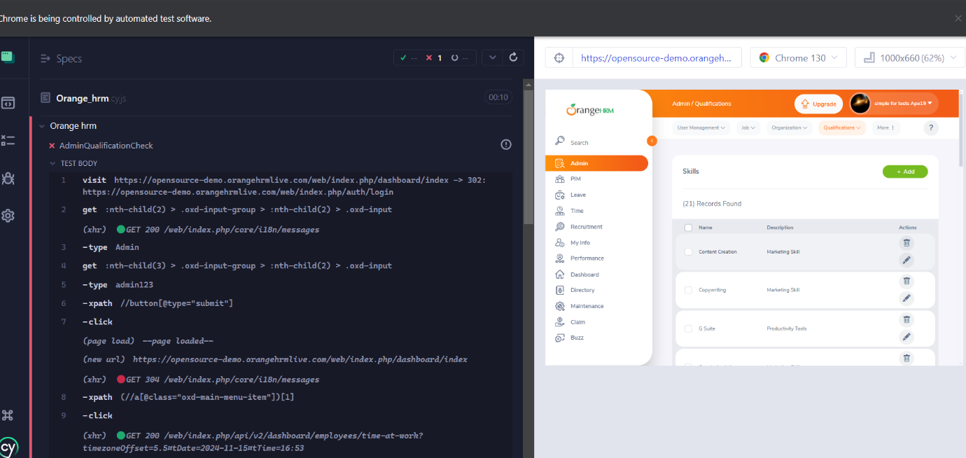

Bug_010

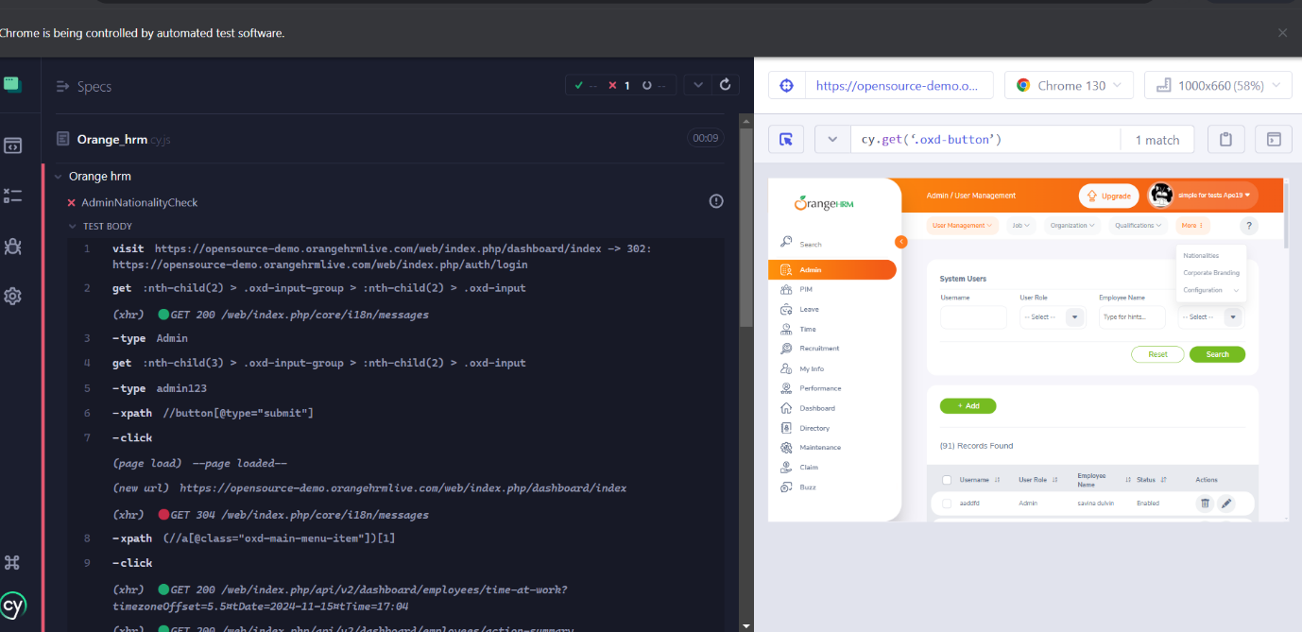

Bug_011

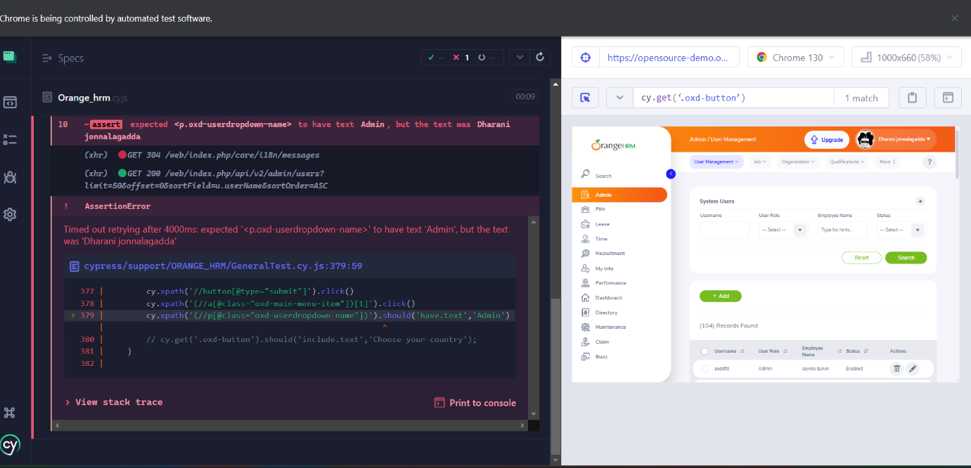

Bug_012

