NEWS HUNT

**PROJECT REPORT**

***Submitted by***

***SANKET SHIROYA (20270107110)***

***NIKHIL RAMOLIYA (20270107089)***

***KRISH HIRPARA (20270107029)***

***In fulfillment for the award of the degree of***

# DIPLOMA ENGINEERING

***In***

**INFORMATIONTECHNOLOGY**

**DEPARTMENT**

# Bhagwan Mahavir Polytechnic for Diploma,

# Jun 2023

# Bhagwan Mahavir Polytechnic for Diploma,

# Information Technology Department

# Jun 2023

**CERTIFICATE**

# Date:

**This is to certify that the dissertation entitled “PROJECT TITLE” has been carried out by SANKET SHIROYA (20270107110), NIKHIL RAMOLIYA (20270107089), KRISH HIRPARA (20270107029) under my guidance in fulfillment of the degree of Diploma in Engineering in INFORMATIONTECHNOLOGY 6th Semester of Bhagwan Mahavir University, Surat during the academic year 2023.**

**Internal Guide External Faculty**

**Head of Department**

**ACKNOWLEDGEMENT**

# This project consumed huge amount of work , research and dedication .Still , implementation would not have been possible if we did not have a support of many individuals and organization. Therefore we would like to extend our sincere gratitude to all of them.

# First of all we are thankful to KHYATI KOTAHTI for their logistical support and for providing necessary guidance concerning projects implementation.

# We would like to express our sincere thanks volunteer researcher who devoted their name and knowledge in the implementation of this project .

# Nevertheless, we express our gratitude toward our families and colleagues for their kind co-operation and encouragement which help us in completation of this project.

**Yours Thankfully,**

**CHAHAT PATEL (20270107063)**

**JEEL BHADANI (20270107008)**

**MANAV PATEL (20270107073)**

* **ABSTRACT**
* Purpose of this to learn about Web Development.
* Using Scripting Language like HTML, CSS , JavaScript , Bootstrap , PHP and MySQL .
* I have created different small projects/tasks with the help of sub line text.
* The users can add the NEWS and BLOGS and that can be confirmed by the admin in their Backend, I have created website which involves Frontend and Backend .
* For News and Blogs I created website which can be handled by the user from the admin panel.
* **INDEX**

|  |  |  |
| --- | --- | --- |
| **Ch.No.** | **Content** | **Page**  **No.** |
| **1.** | **Introduction of Project** |  |
|  | **1.1 Project Summary** |  |
|  | * 1. **Introduction to Project**      1. **Detail Description**      2. **Description of Each module**      3. **Tools and Technology** |  |
| **2.** | **Description of the Product and Problem Analysis** |  |
|  | **2.1 Project Planning** |  |
|  | **2.2 Hardware Requirement** |  |
|  | **2.3 Software Requirement** |  |
| **3.** | **Flow Chart** |  |
| **4.** | **Test Strategies & Cases** |  |
| **5.** | **Snapshots** |  |
| **6.** | **Advantages & Disadvantages** |  |
| **7.** | **Conclusion** |  |
|  | **Bibliography** |  |

# Project Summary

* **Project Name: *NEWS HUNT***
* **Type of Application:** WEB
* **Developers:** CHAHAT PATEL (20270107063)

JEEL BHADANI (20270107008)

MANAV PATEL (20270107073)

* **University:** Bhagwan Mahavir University
* **Internal Guide:** Khyati khotari
* **Front End:** BOOTSTRAP TEMPLET
* **Back End :** PHP

# Introduction to Project

**1.2.1 Detailed Description**

“News Hunt “ is an website of News and Blogs telling information happing over the world.

I have used technologies such as HTML , CSS and JavaScript .

User Who have an phone & active internet connection can contact and start searching for a news easily through this website .

The purpose of this website is to help people to know about daily and local happning .

* + 1. **Description of Each module**

1. **NEWS AND BLOGS EDITING**

This website has many activity to but the main activity is to edit.

The ending the any news is third website can easily done from database itself,in very easy and in short time .

1. **DELETATION OF THE NEWS AND BLOGS**

News and Blogs has many crucial news in world.

Sometimes it is necessary to detect the blog and news in it .Due to hard times in daily times ,It can easily be detected from the database.

1. **ADMIN LOGIN**

In this website we also have the admin login in database were only author can login into it can have their record over there no other can see it withour login into Admin Panel .

* + 1. **Tools and Technology :**

**1.PHP & MySQL**

PHP is the most popular scripting language for web development. It is free, open source and server-side (the code is executed on the server). MySQL is a Relational Database Management System (RDBMS) that uses Structured Query Language (SQL). It is also free and open source.

**Advantages of PHP & MySQL**

PHP and MySQL are open-source server-side programming languages used to create dynamic websites. They provide flexibility, as they can be used and manipulated on any operating system. PHP and MySQL work together to provide fast web page response times even with slow internet and data speed.

# 2.1ProjectPlanning

* 1. **Project Development Approach**

# Waterfall Model

The classical waterfall model is the basic **software development life cycle** model. It is very simple but idealistic. Earlier this model was very popular but nowadays it is not used. But it is very important because all the other software development life cycle models are based on the classical waterfall model .

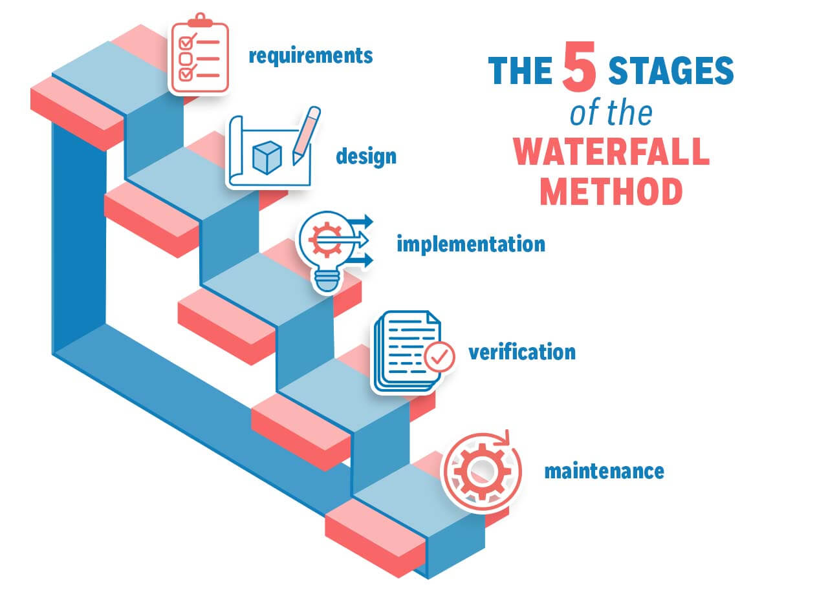

Let us now learn about each of these phases in brief detail:

1. **Feasibility Study**: The main goal of this phase is to determine whether it would be financially and technically feasible to develop the software.
2. **Requirements analysis and specification**: The aim of the requirement analysis and specification phase is to understand the exact requirements of the customer and document them properly. This phase consists of two different activities.
3. **Requirement specification:** These analyzed requirements are documented in a software requirement specification (SRS) document. SRS document serves as a contract between the development team and customers.
4. **Design**: The goal of this phase is to convert the requirements acquired in the SRS into a format that can be coded in a programming language. It includes high-level and detailed design as well as the overall software architecture.
5. **Maintenance:** Maintenance is the most important phase of a software life cycle. The effort spent on maintenance is 60% of the total effort spent to develop full software.

**Advantages of Classical Waterfall Model**

The classical waterfall model is an idealistic model for software development. It is very simple, so it can be considered the basis for other software development life cycle models. Below are some of the major advantages of this SDLC model:

* This model is very simple and is easy to understand.
* Phases in this model are processed one at a time.
* Each stage in the model is clearly defined.
* This model has very clear and well-understood milestones.

## **Disadvantages of waterfall model**

* Once an application is in the **testing** stage, it is very difficult to go back and change something that was not well-thought out in the concept stage.
* No working software is produced until late during the life cycle.
* High amounts of risk and uncertainty.
* Not a good model for complex and object-oriented projects.
* Poor model for long and ongoing projects.

# Hardware Requirement

## **Minimum Hardware Requirement:**

* Processor : Core I3
* Hard disk : 320 GB
* Ram : 1 GB

# Software Requirement

## **The Tools &Technology used in preparing this system are:**

* + Front-end : BOOTSTRAP TEMPLATE
  + Back-end : PHP
  + Environment : Visual Studio Coed
  + Documentation : Microsoft Office Word 2016 and Above
  + Presentation : Microsoft Office PowerPoint2016 and Above
  + E- Draw : Different types of Diagram

## **Software Requirement:**

* Microsoft Office Word 2016 and Above
* Windows XP/Vista /Windows 7/Operating system

# Data Flow Diagram (DFD)

# Entity Relationship Diagram (ERD)

# Data Dictionary (System Database)

1. **ADMIN LOGIN 4) CATEGORY**

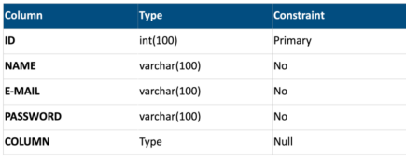 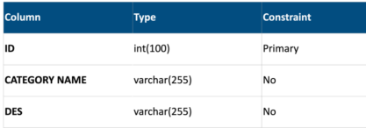

**2)ADVERTISMENT 5) NEWS**

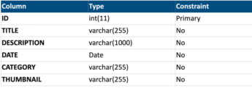

**3) BREAKING NEWS 6) SIGN UP**

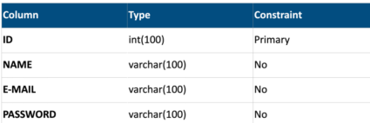 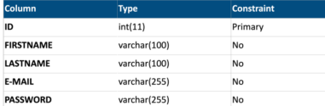

# Testing

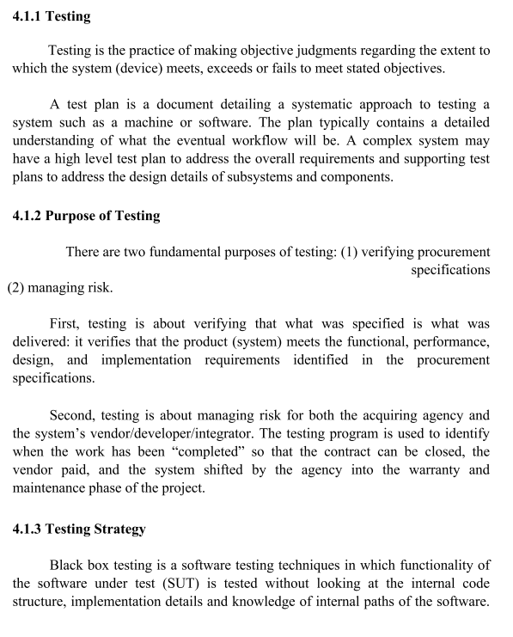

# 5-Snapshots

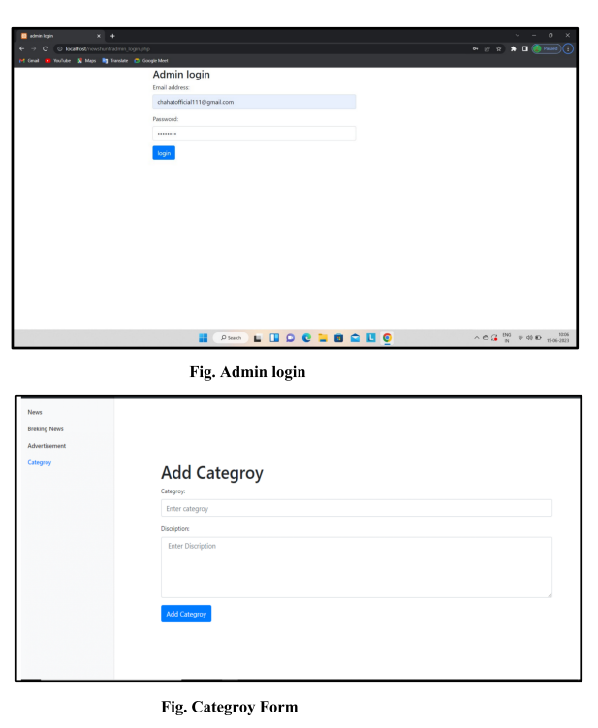

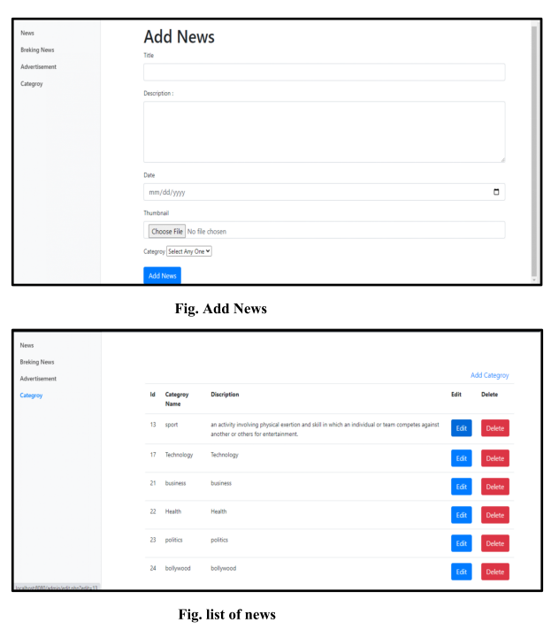

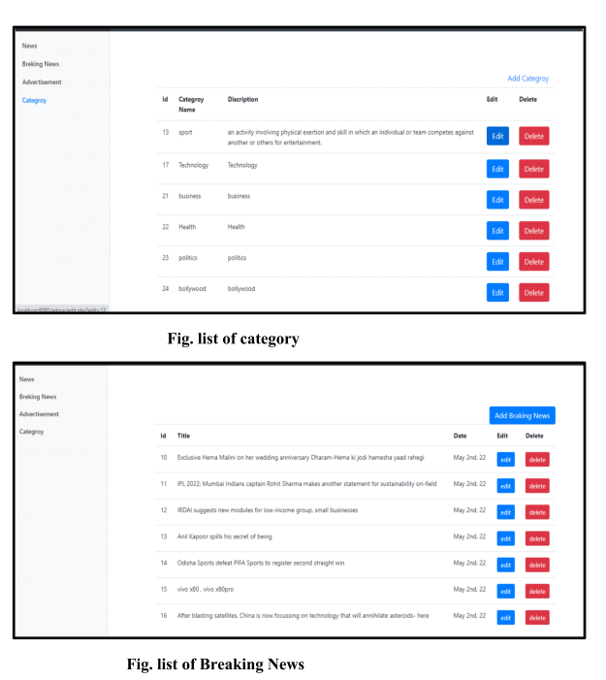

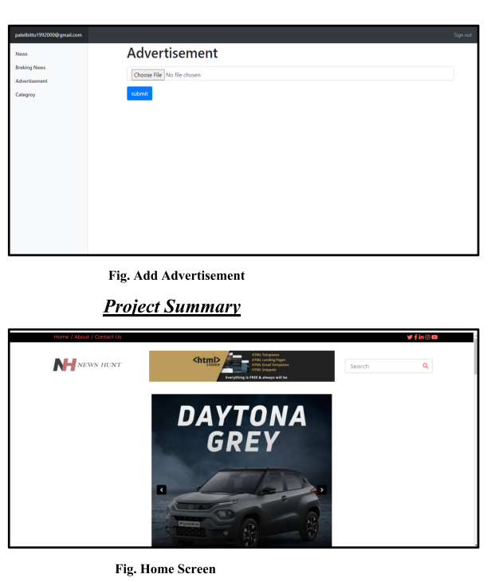

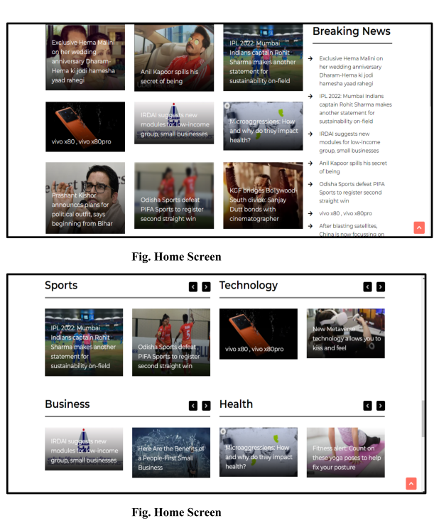

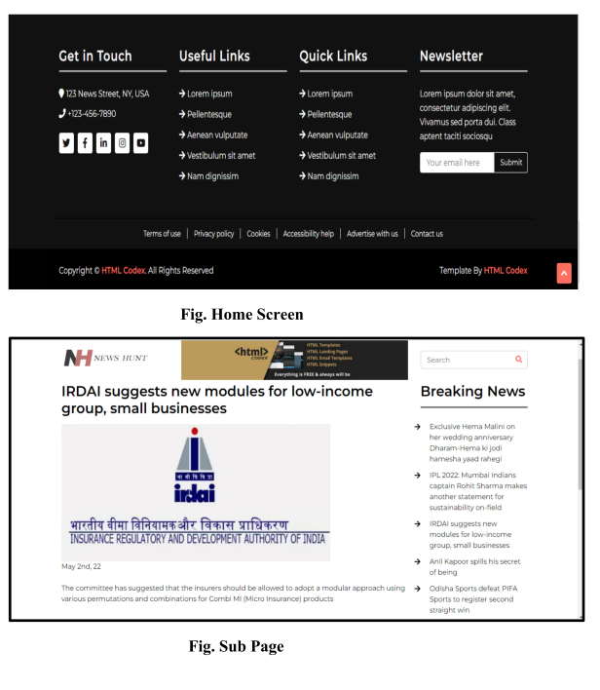

**6.1 Advantages**

1. Easy to use on web browser .
2. Easy to find & read your favorite category news.
3. In admin side easy to add news.
4. News hunt admin panel is easy to use and understand

**6.2 Limitations**

1. This website only work on web browser.
2. In this website not use API so news updates are late.
3. This website show only neutral news .

**7.1 Future Enhancement**

1. Implementing API in news hunt web sire.
2. In future creating a desktop app and mobile app.
3. Add many more features in news hunt web app.

Bibliography : *https://www.tutorialspoint.com/tutorial*

Books :

Websites : [*https://stackoverflow.com*](https://stackoverflow.com)

*https://github.com/*