**On Page SEO for TOPS Technologies Pvt. Ltd – Rajkot**

**Current Position on SERP**

**1). Keyword Target for Python and iOS – Rajkot**

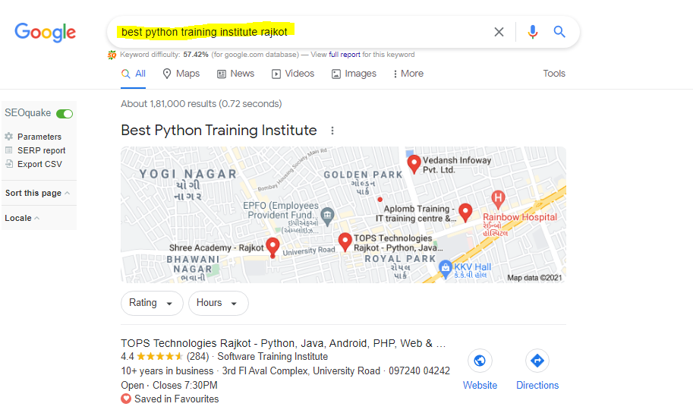

* **Best Training Institute Rajkot - Result at 1st Position.**

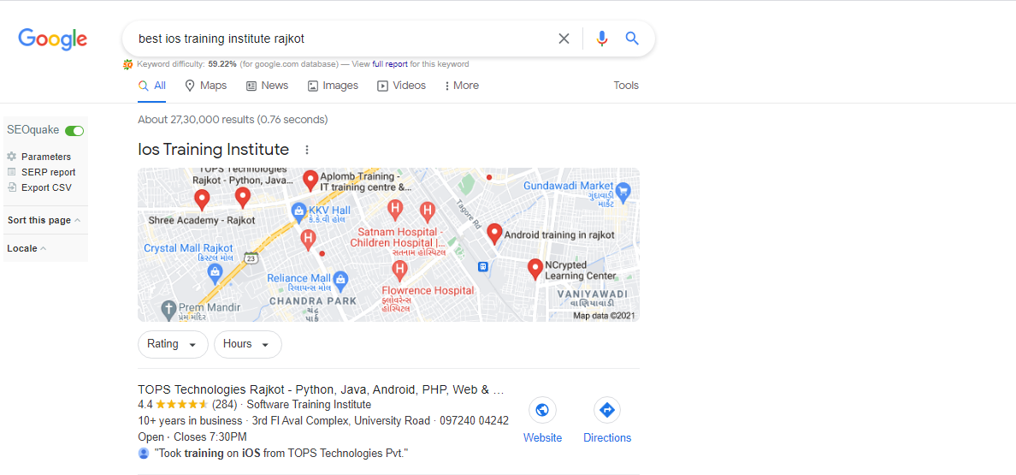

* **Learn Python in Rajkot - Result at 1st Position.**

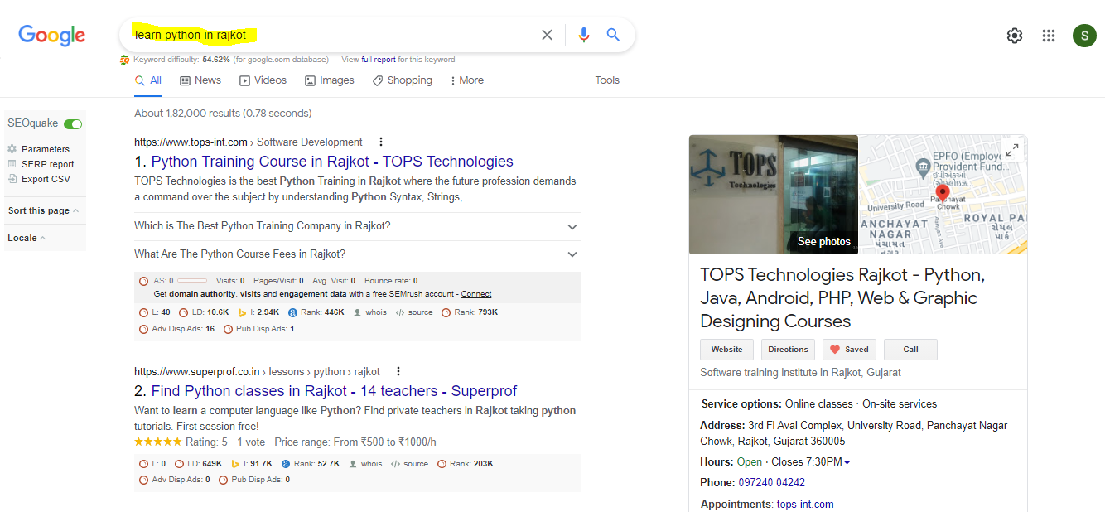

* **Learn iOS in Rajkot - Result at 1st Position.**

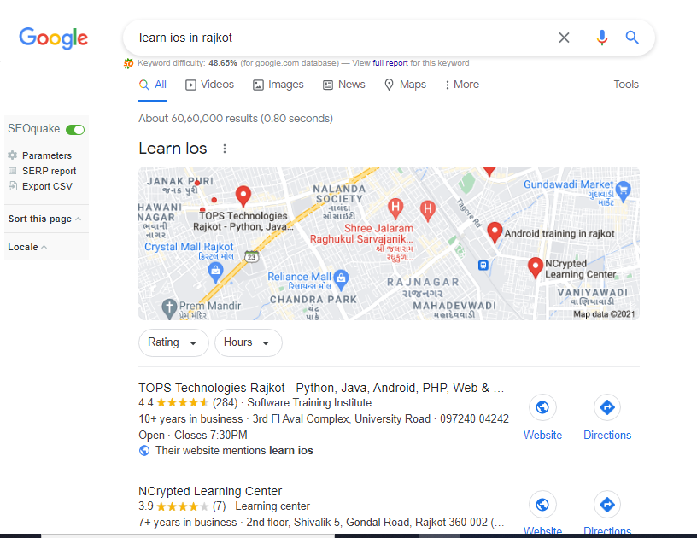

* **iOS Training in Rajkot - Result at 2nd Position.**

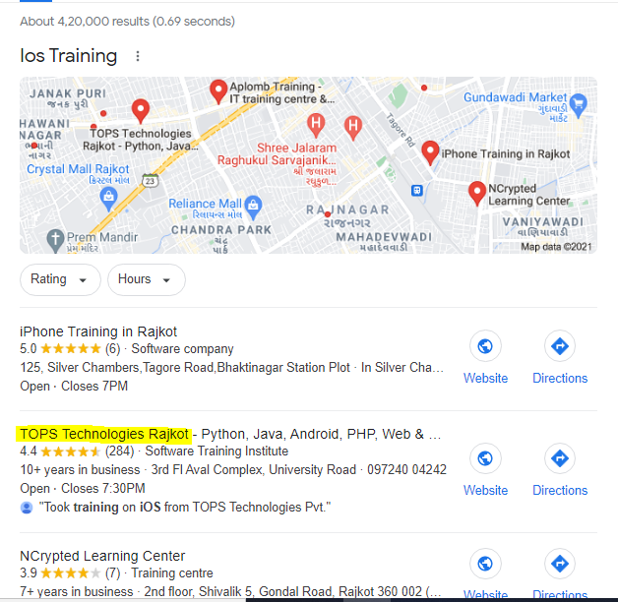

* **Python Training in Rajkot - Result at 1st Position.**

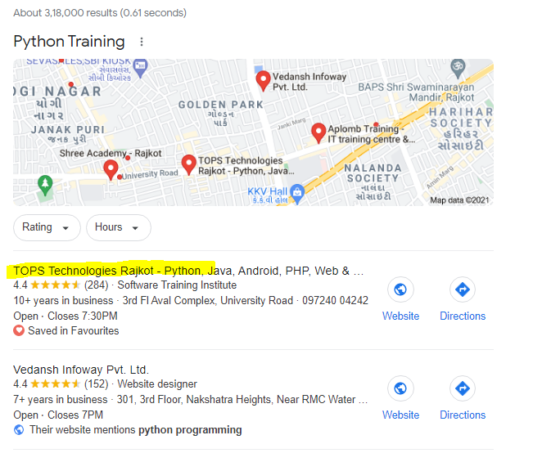

**2). Content Optimization**

* **Unused space in -** [**https://www.tops-int.com/python-training-course/**](https://www.tops-int.com/python-training-course/)

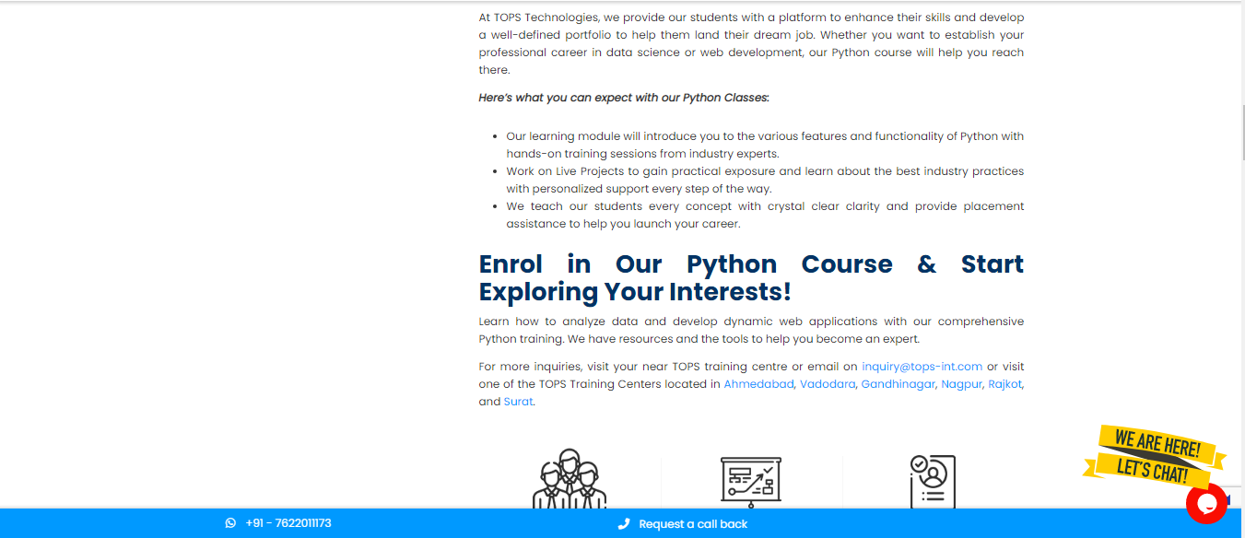

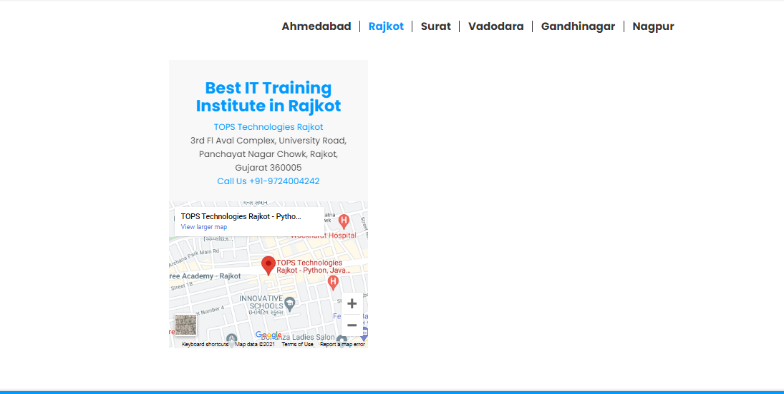

Unused Space

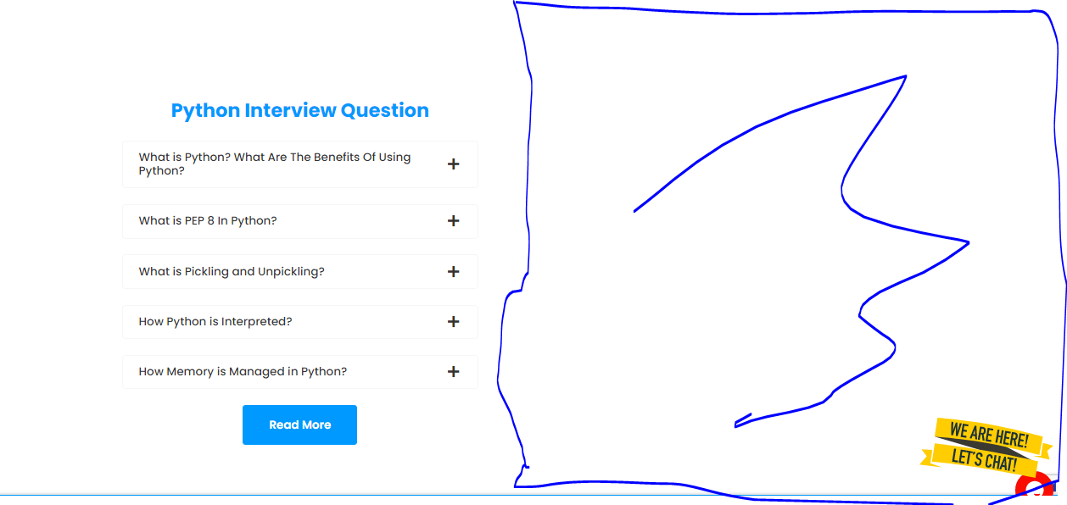

**3). Mobile Friendliness**

* **Test by: https://search.google.com/**

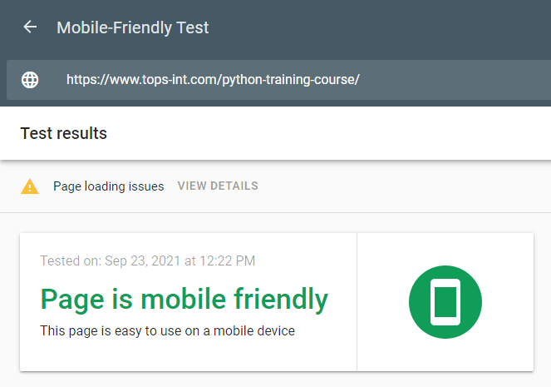

* **Mobile Friendly Test by Page Speed Insights – Mobile**

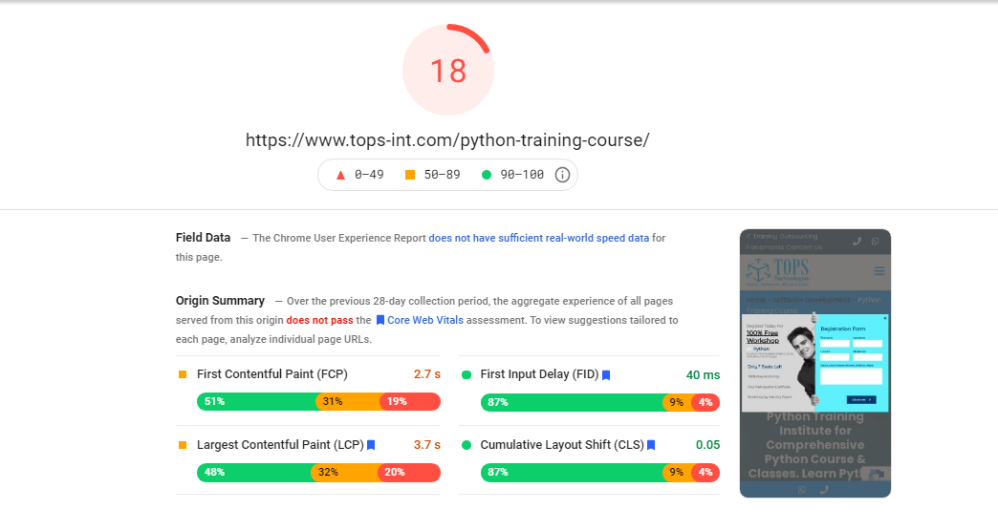

* **Mobile Friendly Test by Page Speed Insights – Desktop**

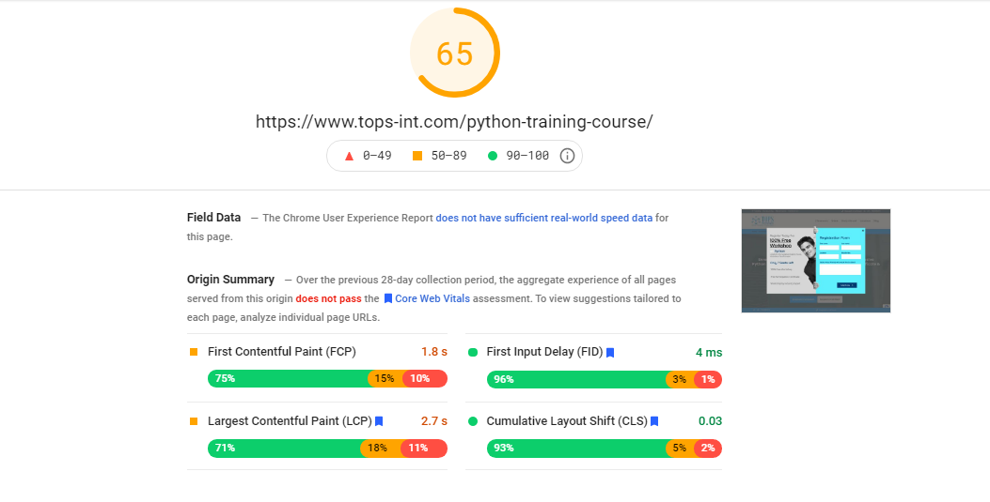

* **Page Speed Insights – Issues Found**

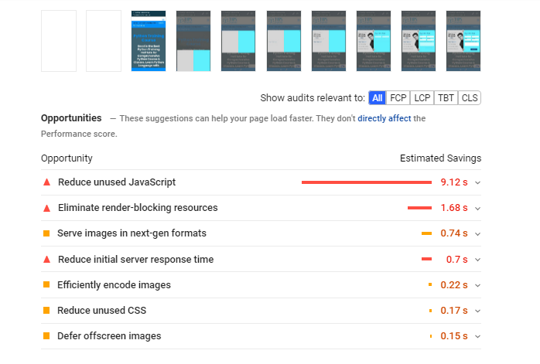

* **Treemap -** [**https://www.tops-int.com/python-training-course/**](https://www.tops-int.com/python-training-course/)

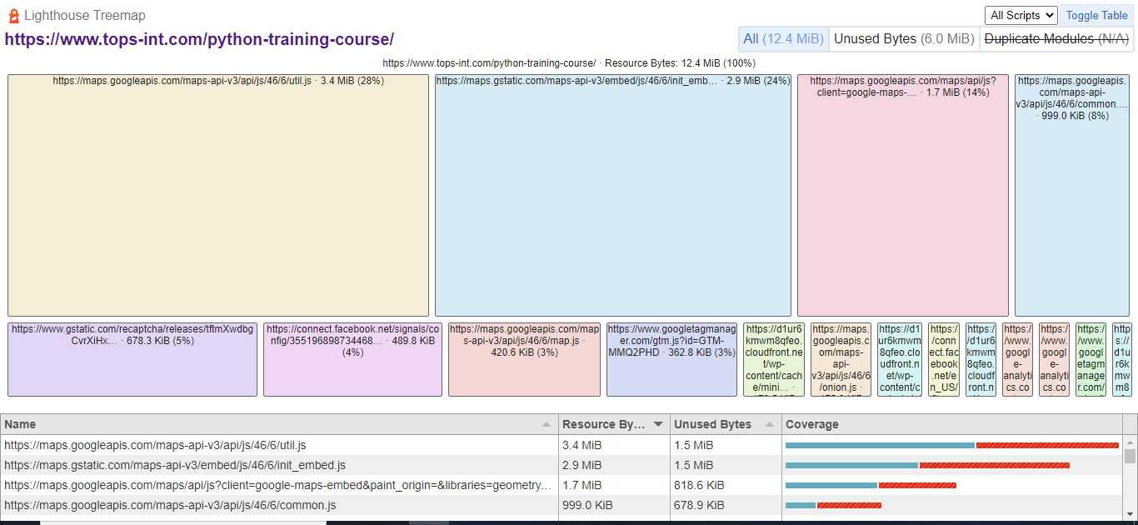

**4). Keyword Target**

**Some of the important keyword for this website**

1. python training
2. python training in rajkot
3. best python training institute
4. learn python in rajkot
5. learn web development using python
6. python course
7. python course in rajkot
8. best institute for python
9. best institute for python in rajkot
10. python with django
11. python with django course
12. learn django in rajkot