INTERNSHIP PROJECT REPORT
EduPredict AI
Student Performance Analytics & Final Grade Prediction
AICTE | IBM SkillsBuild Data Analytics with AI Internship 2026 | BharatCares
Student | Sanket Shantaram Tarle
Course | BCS / B.Sc. Computer Science — Third Year
College | K. K. Wagh Arts, Commerce, Science and Computer Science College, Chandori
University | Savitribai Phule Pune University, Pune
Project Type | Data Analytics + Artificial Intelligence / Machine Learning

1. Executive Summary
EduPredict AI is an internship-oriented data analytics and machine-learning project designed to demonstrate an end-to-end workflow: dataset preparation, exploratory data analysis, preprocessing, predictive modeling, evaluation, and deployment through a lightweight Flask dashboard. The system accepts a student profile and estimates the final grade (G3) on a 0–20 scale.
The project is packaged for easy local testing and includes a bundled dataset, trained Random Forest model, Jupyter Notebook, web interface, requirements file, README and this report.

2. Problem Statement
Student-performance data contains multiple factors such as study time, previous failures, absence count, support, lifestyle indicators and earlier assessment scores. Examining these variables together provides a useful demonstration of how data analytics and machine learning can identify patterns and estimate a final grade.

3. Objectives
- Prepare and inspect a structured student-performance dataset.
- Perform exploratory data analysis using Python and Matplotlib.
- Process mixed numerical and categorical features with a Scikit-learn pipeline.
- Train a Random Forest regression model to estimate final grade.
- Evaluate the model using MAE, RMSE and R².
- Deploy the trained model in a Flask web application.
- Provide a reproducible project package that can be tested locally.

4. Dataset & Data Preparation
The bundled CSV contains 649 synthetic demonstration records. Its feature structure follows the general variable style of the public UCI Student Performance dataset. The UCI reference is included in the README so the project can later be adapted to the real public dataset.
Reproducibility note: the included CSV is synthetic and was generated specifically for offline demonstration. Therefore, the model metrics reported here apply only to the included demonstration data.

5. Exploratory Data Analysis
The analysis includes final-grade distribution, the relationship between second-period and final grades, average grade by study-time level, and model feature importance. These visualizations are also displayed in the web dashboard.
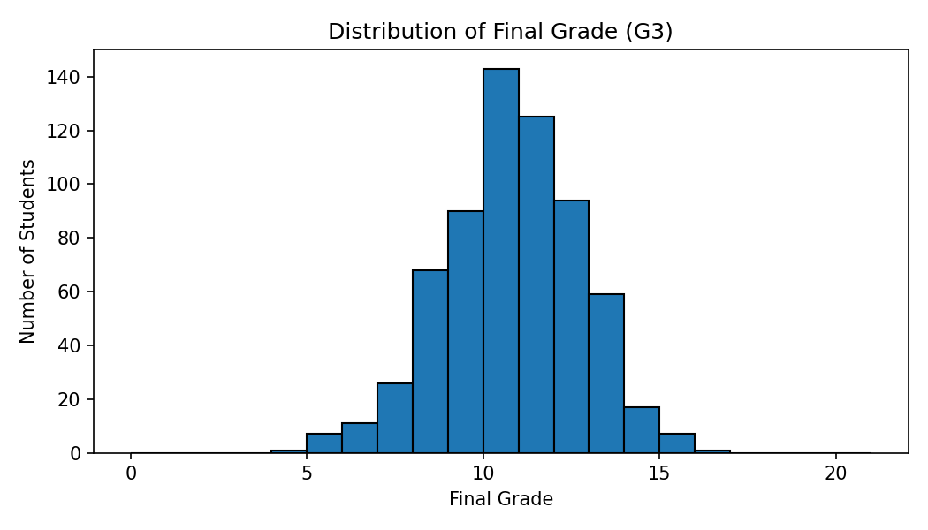
Figure 1. Final grade distribution
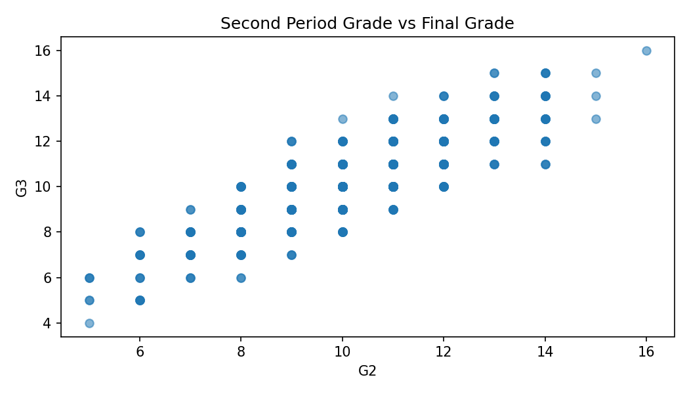
Figure 2. Second-period grade versus final grade
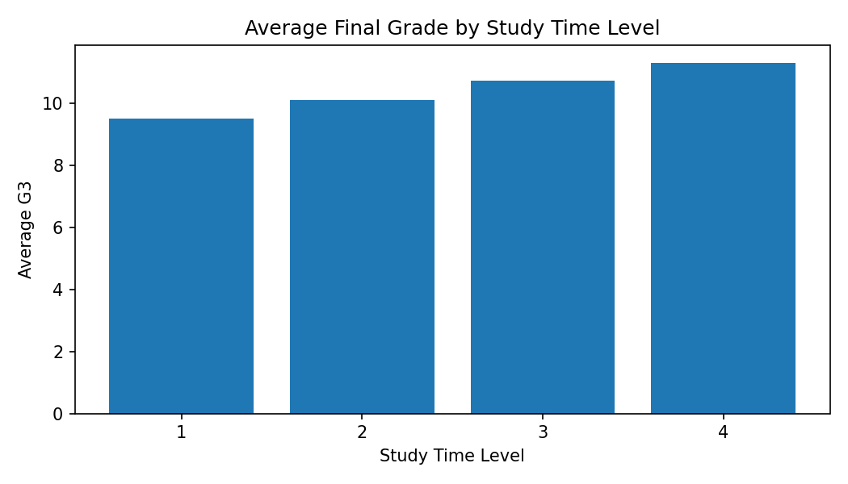
Figure 3. Average final grade by study-time level

6. Machine Learning Methodology
- Target variable: G3 (final grade).
- Train-test split: 80% training and 20% testing with random_state=42.
- Numerical features are standardized with StandardScaler.
- Categorical features are transformed with OneHotEncoder.
- A Random Forest Regressor with 300 trees is used for prediction.
- The preprocessing and model are combined into one Scikit-learn Pipeline.

7. Model Evaluation
Metric | Result
MAE | 0.72
RMSE | 0.91
R² | 0.759
On the bundled demonstration dataset, the model achieved an MAE of approximately 0.72 grade points, RMSE of approximately 0.91 and R² of approximately 0.759. These are demonstration results and should not be interpreted as validated performance on a real student population.
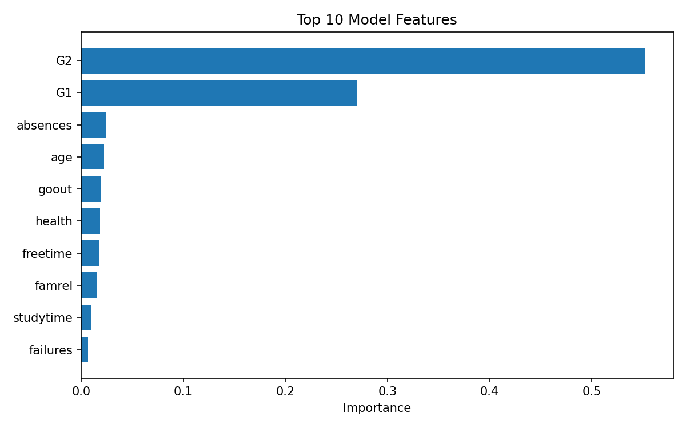
Figure 4. Top model features by Random Forest importance

8. Application Workflow
- User opens the Flask dashboard.
- The dashboard loads summary statistics from the bundled CSV.
- The user enters a student profile in the prediction form.
- The saved preprocessing and Random Forest pipeline transforms the input.
- The model estimates G3.
- The dashboard displays the estimated grade and a simple risk indicator.
- Analytics charts provide dataset-level context.

9. Technology Stack
- Python
- Pandas and NumPy
- Scikit-learn
- Flask
- Matplotlib
- Jupyter Notebook
- HTML/CSS/JavaScript
- Joblib

10. Project Structure
Sanket_Tarle_Student_Performance_AI/
├── app.py
├── requirements.txt
├── README.md
├── data/
│ └── student_performance.csv
├── models/
│ └── student_performance_model.joblib
├── notebooks/
│ └── Sanket_Student_Performance_Analysis.ipynb
├── templates/
│ └── index.html
└── static/
├── style.css
├── script.js
└── charts/

11. How to Run
- cd Sanket_Tarle_Student_Performance_AI
- python -m venv venv
- venv\Scripts\activate
- pip install -r requirements.txt
- python app.py
- Open http://127.0.0.1:5000 in a browser.

12. Limitations
- The bundled dataset is synthetic and intended for reproducible offline testing.
- The prediction is an estimate and not a guaranteed academic result.
- The current application is a local prototype rather than a production student information system.
- Real deployment would require permissioned, representative data and appropriate privacy/security controls.

13. Future Scope
- Use a real institutional dataset with appropriate consent and privacy controls.
- Add SQL-based storage and user authentication.
- Compare Random Forest with Gradient Boosting and other regressors.
- Add explainable AI with SHAP.
- Add Power BI/Tableau reporting.
- Add model monitoring and periodic retraining.

14. Conclusion
EduPredict AI demonstrates a complete beginner-to-intermediate data analytics and AI workflow. The project connects data exploration with a practical prediction interface and is structured so the notebook, model, dataset, web application, requirements and documentation can be tested together.

15. References
UCI Machine Learning Repository — Student Performance dataset:
https://archive.ics.uci.edu/dataset/320/student%2Bperformance
K. K. Wagh Arts, Commerce, Science and Computer Science College, Chandori:
https://ascc.kkwagh.edu.in/
AICTE National Internship Portal:
https://internship.aicte-india.org/

