Resources

2.1 Global Corporate Systems and Services (GCSS)

Responsible for project delivery,

application support and

release management.

2.2 Global Sales Operations (GSO)

Global resources who have overall accountability of

the Global Salesforce application from a business perspective

and is also responsible for prioritization of cases,

communications to users, etc.

2.3 Global CRM Support [For *Sales* and *Live Agent Services*]

Regional CRM Support resources who are responsible for

the first tier of support for all Salesforce CRM

and Callidus CPQ users.

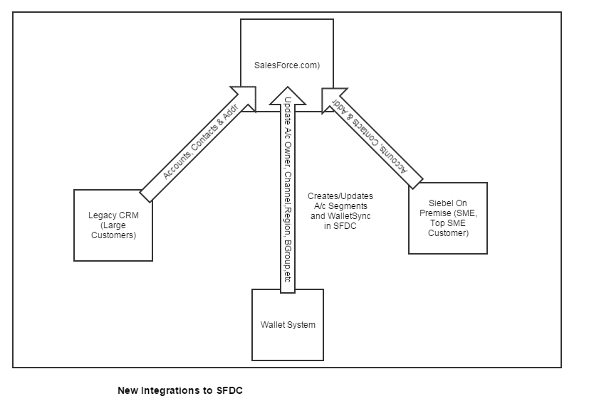

Salesforce will replace the existing implementation of CRMOD **for sales users only**.

Incidents:

An incident is a problem or issue that has caused a disruption in service. Resolution of incidents is top priority.

Change Requests

A change request is an enhancement request for new functionality or a change to the existing application.

Example of Change requests:

* When you change a close date on opportunity, its contract start and end date should change based on user’s credentials(CPQ), and it should change start and end dates of all the products.

Experian offers

* Marketing Solutions to increase sales amongst current customers.
* Credit solutions to cross-sell and up-sell.
* Debt collecting solutions to eradicate debt
* Customer management
* Credit monitoring

Case Study:

Water Delivery Company – Aqua Inc.

5000 customers

* How to increase sales
* Which other areas in the region can you target your marketing campaign to gain more customers?
* How can you retain existing customers?

Had 500 bad addresses in the database.

* That’s 10% of the total addresses.
* That caused 10% waste in marketing campaign.  
    
  Experian offers services that corrects bad addresses.

Offers Live Agent service that can be incorporated in client’s existing website.

**Integration work:**

* Seal – Contract Discovery and Analytics
* Aria Billing System
* WalletSync
* Legacy CRM Brazil Serasa

Oracle EIA

**Seal**

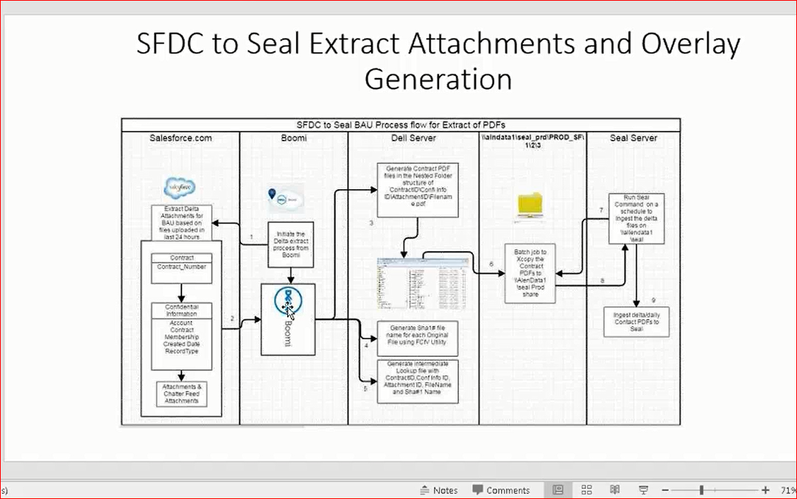

Seal Contract Discovery and Analytics quickly locates and identifies contractual documents from a variety of locations, extracting key contractual metadata such as contracting parties, contract dates, termination clauses, jurisdiction, right of assignment, pricing and discounting, penalty clauses, automatic renewal, beneficial terms, and much more. Seal Contract Discovery and Analytics not only extracts this business critical data, but also intelligently leads the user through a structured review process to address omissions, errors, and ambiguities.

Contract metadata, once extracted and reviewed, can then easily be uploaded to key operational systems such as Enterprise Resource Planning, Customer Relationship Management, Contract Lifecycle Management, and Supplier Relationship Management to provide the complete relationship picture.

For many organizations, their legal, procurement, and commercial teams spend a significant amount of time and resource negotiating the terms and conditions of a contract. In most cases, the contract is scanned in as an image file and stored electronically or filed away in a filing cabinet in paper format. Once the contract is signed, it may never be viewed again unless an event trigger requires someone to locate and review the contract. An average procurement or commercial contract will contain a mixture of critical dates and obligations or commitments. These need to be tracked and managed effectively in order to maximize the value from the business relationship.

<https://www.seal-software.com/sites/default/files/resource/Seal-Datasheet-Salesforce.pdf>

Contracts stored as an image file format are converted to searchable PDF files and are fully text searchable from within Salesforce®. This way text, clause, and clause combinations not contained in the extracted metadata can be searched. Additionally, contract documents can reside outside of Salesforce® with all the extracted information still available within the Salesforce interface.

**CSDA (Credit Services and Data Analytics)**

Subscriber code generated in Mainframe that represents if a customer is subscribed to Experian service or products.

Contract Attachment – they create contract attachments in Salesforce, process syncs up, uploads in Confidential information.

Account Merge history – when account is merged, it needs to go to mainframe systems.

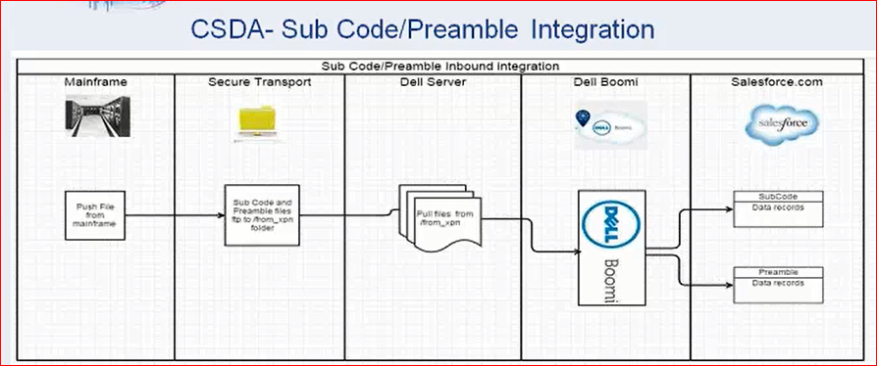

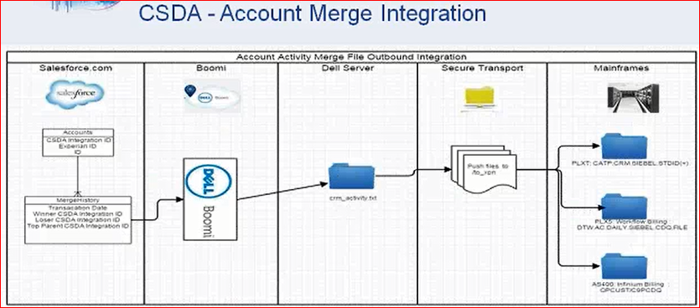

* APEX Batch : The start, execute, and finish methods can implement up to 100 callouts each.

<https://developer.salesforce.com/docs/atlas.en-us.apexcode.meta/apexcode/apex_batch_interface.htm>

You can chain a batch job by calling Database.executeBatch or System.scheduleBatch from the finish method of the current batch class. The new batch job will start after the current batch job finishes.

**Integration with ServiceNow**

**EDQ – license key for data products**

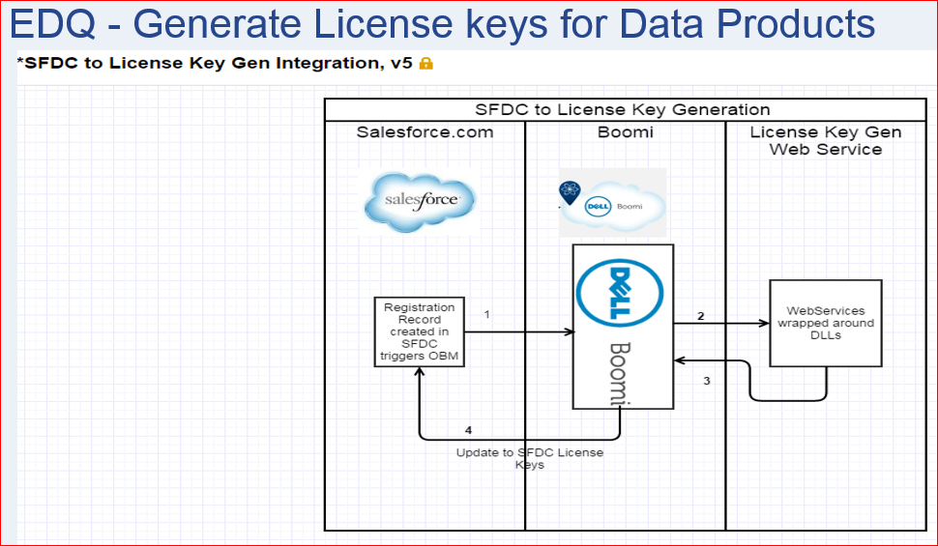

* **What does this interface do ?**
  + **Generate Serial Number for Data Products so clients can use it to install software**
* **Trigger point : When Registration record is created for an Asset with Data Product in Salesforce.com using OBM**
* **Summary: Send relevant information for generating the License Key based on Account Reference, Product, Data Set and Expiry Date. Consumes Web service via Boomi and updates License Key to SFDC registration record**

**Middleware : Dell Boomi**

**Callidus CPQ Integration Overview**

* From SFDC to Callidus CPQ
  + When a user is created in SFDC, with CPQ User Flag and any CPQ User Type, a Web service is invoked to create the user in Callidus CPQ. This only runs the update one user at a time.
  + When a Product Master record is created in SFDC, it creates a corresponding Product Master record in Callidus CPQ.
  + When the New Quote button or Edit button on the Opty is clicked, it pulls in Billing & Shipping Contact addresses details into Callidus CPQ.
  + When an Opty is Closed Won/Lost in SFDC, the Quote status is updated back to Callidus CPQ.
  + When pressing the Simple Renewal button, Salesforce will send the asset information related to the current Follow-On opportunity line items into CPQ to build new items that are going to be used for quoting the new deal. These assets were created when executing the previous opportunity.
* From Callidus to SFDC
  + When a Quote is added with Products, when the Save button is clicked, CPQ pushes to the Opty Line Item & Royalties on the Opty.
  + Once a Quote document is generated in CPQ, it is attached as a PDF to a Confidential Information record under the Opty.

**Legacy CRM to Salesforce.com**

This integration currently interfaces the Accounts and Contacts for Top Customers and SME Customers using AIA middleware to Salesforce.com. For Serasa Customer Care project, this integration needs to be revised to support Consumer Accounts.

**Siebel On Premises to Salesforce – Inbound Real-time**

This integration currently interfaces the Accounts and Contacts for Top SME and SME Customers using AIA middleware to Salesforce.com. For Serasa Customer Care project, this integration needs to be revised to support Consumer Accounts.

**Receita Federal to Salesforce.com (CNPJ/CPF Govt. db) – Inbound Real-time**

This integration was developed for Sales to help create Accounts and Contacts within Salesforce using data from a copy of the government database held within the Mainframe. For Serasa Customer Care project, this will require changes to return Consumer Contacts and store additional information on these records. Also introduce ability to update this information on demand, instead of just on creation.

## Contract Retention

### Retention / Upsell – Inbound (Real-time) & Outbound – Batch (Daily)

Customer agents (Retention/Contracts Team) are able to view the existing Contracts when a customer calls in. These contracts are either in Legacy CRM or CRMOP. If the customer wishes to Cancel, the Agent will create a case of type ‘ContractCancelRequest’ in Salesforce.com and using the Case Reason/Sub-Reason on the case, they can offer either an immediate (end of day) cancellation, or 30 day (in terms of service) cancellation. The agent must select an existing set of live contract(s) for this call (at least one) for them to close the case. This information needs to be extracted via a real-time integration to SFDC. Once selected, this information is stored in Salesforce.com in a new custom object ‘ContractCancelRequest’. This is processed overnight (via a batch) to then set the contracts to cancel within the source CRM systems. It is possible to cancel (void) the cancellation after a case is completed should a customer change their mind (or agent selected incorrect contract). Should the customer not cancel, the Case request must still be recorded but with a different type/Case Reason/Sub Reason and contract(s) selected, due to commission for the agents. There is only limited information returned from the contract source system (number/description) so this can be expanded to include more information.

## Account Updating

## Company Value Sync – Inbound Batch (Monthly, Nice to have)

A field on Accounts (Value [High/Medium/Low]) needs to be regularly updated to show how valued this account is for Serasa. This process has to deal with a large number of Accounts to determine the Delta changes to the Company Value. There are some complex calculations that happen to arrive at the Company Value for each Account. Only those Accounts whose value has changed since the last run will be sent over to Salesforce.com.

#### Integration Approach

Use AIA middleware to Upsert Account or Account Segment from .NET Application to SFDC based on Account CNPJ. If Account doesn’t exist in SFDC, need to log errors.

Impact: New field to be created on Account or Account Segment to hold this value.

## Post Office File (Returned Mail) – Inbound Batch ( Weekly?, Nice to have)

Files are received from the Post Office with information regarding undelivered mail (e.g. posted invoices). This contains CNPJ number of the Account. The Account needs to be updated about the address being undeliverable via a flag.

#### Integration Approach

Use AIA middleware to Upsert Account or Account Segment from .NET Application to SFDC based on Account CNPJ. If Account doesn’t exist in SFDC, need to log errors.

Impact: New field to be created on Account ‘Undelivered Address’.

### Legacy CRM to Salesforce.com Flow

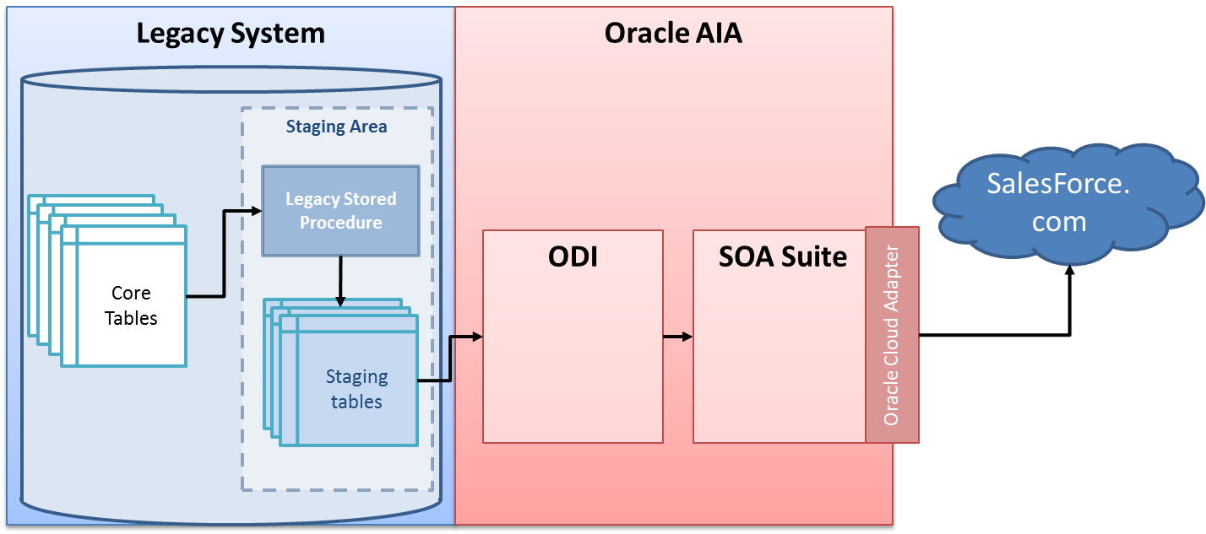

**Service Cloud**

Features