Constructor
_______________________________________________________________
Q. What is constructor?
___________________________________________________________________________
Constructor is a function same name as class name but without return type called as constructor
Syntax of constructor
_________________________________________________________________________
class classname
{ classname() //constructor
{
}
}
Example:
class ABC{
ABC(){
}
}
Q. Why use constructor or what is benefit of constructor?
_________________________________________________________________________________
1. Initialize the class member at the time of object creation or object initialization purpose
______________________________________________________________________________

2. To call function at the time of object creation.
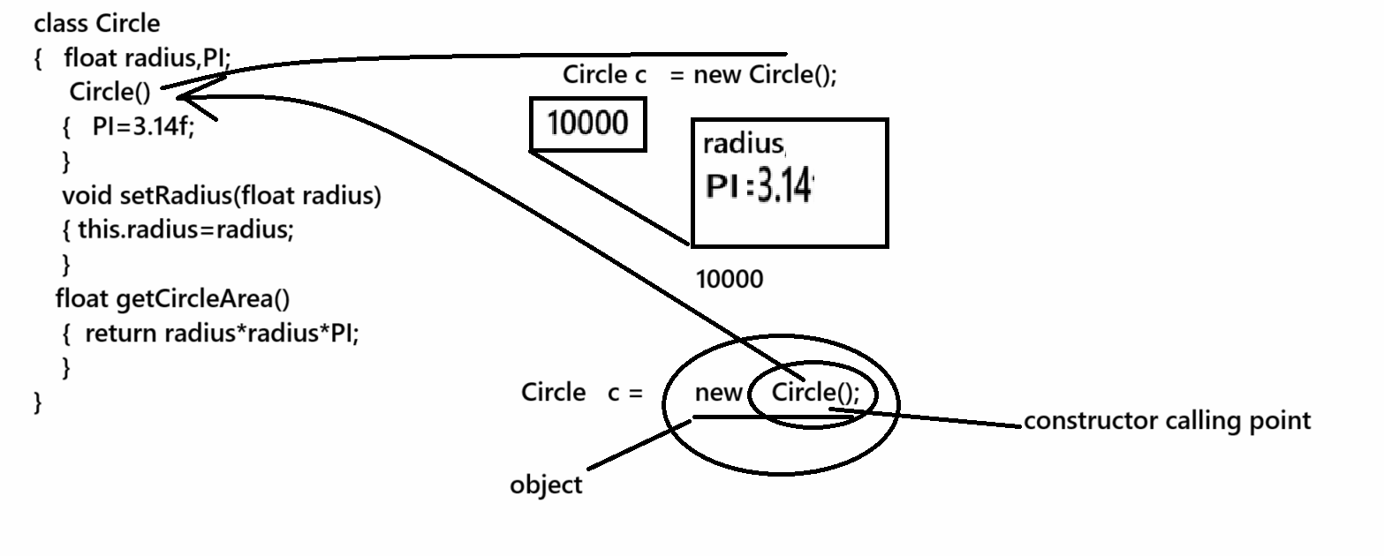
Note: if we declare not constructor within class then every class has one default constructor known as implicit constructor.
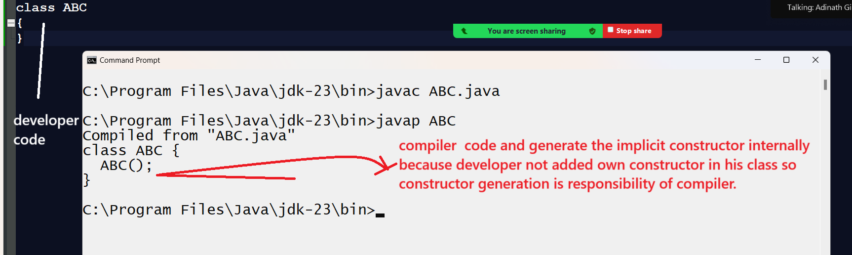
If we want to work with constructor we have some types of constructor
1. Default constructor: default constructor means user defined no argumented constructor called as
default constructor
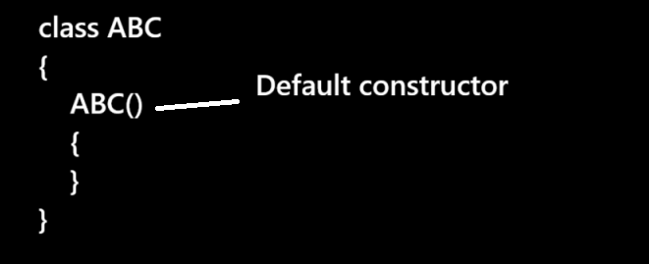
Note: Normally default constructor is choice of developer as per coding to initialize fix values at the time of object creation in instance variable or static variable
class Circle
{ float radius,PI;
Circle()
{
PI=3.14f;
}
void setRadius(float radius)
{ this.radius=radius;
}
float getArea(){
return radius*radius*PI;
}
}
public class CircleApp
{
public static void main(String x[])
{
Circle c = new Circle();
c.setRadius(3.0f);
float result=c.getArea();
System.out.printf("Area of circle is %f\n",result);
}
}
or
import java.util.*;
class Fibo
{
int f1,f2,fib;
Fibo(){
f1=0;
f2=1;
}
void printSeries(int limit){
System.out.printf("%d\n%d\n",f1,f2);
for(int i=1;i<=limit;i++)
{ fib=f1+f2;
f1=f2;
f2=fib;
System.out.printf("%d\n",fib);
}
}
}
public class FiboApp
{ public static void main(String x[])
{
Fibo f1 = new Fibo();
Scanner xyz = new Scanner(System.in);
System.out.println("Enter number");
int no=xyz.nextInt();
f1.printSeries(no);
}
}
2. parameterized constructor or argumented constructor
________________________________________________________________________________
When we pass parameter to constructor called as parameterized constructor.
Normally Parametarized constructor recommended by developer we want to initialize value to instance variable or class variable at the time of object creation but value vary every time or not fixed
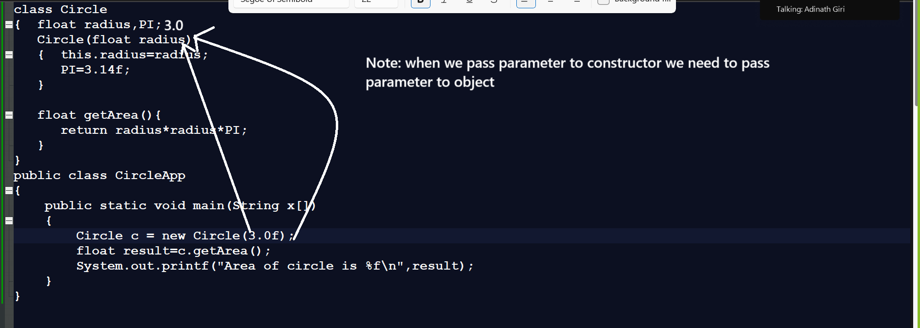

3. Overloaded constructor
_________________________________________________________________________________
Constructor overloading is part of compile time polymorphism means we define multiple constructors with different parameter list or with a different parameter type or different parameter sequence then we can use constructor overloading.

Note: if we think about constructor overloading which constructor should execute is dependent on number of parameter pass in it , its sequence and its data type.
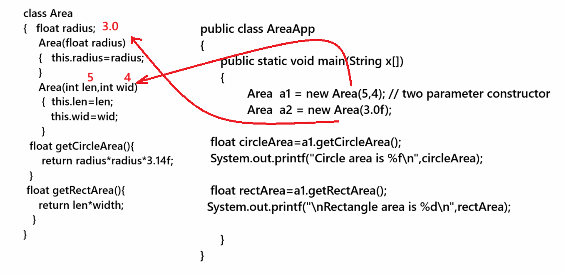
Source code with example
class Area
{ float radius,PI=3.14f;
int len,wid;
Area(float radius)
{ this.radius=radius;
}
Area(int len,int wid)
{ this.len=len;
this.wid=wid;
}
float getCircleArea()
{ return radius*radius*PI;
}
int getRectArea()
{ return len*wid;
}
}
public class AreaApplication
{ public static void main(String x[])
{
Area a1 = new Area(5,4);
int rectArea=a1.getRectArea();
System.out.printf("\nRectangle area is %d\n",rectArea);
Area a2 = new Area(3.0f);
float cirArea=a2.getCircleArea();
System.out.printf("\nCircle area is %f\n",cirArea);
}
}

Example: Suppose consider we have class name as Sort with two constructors
Sort(int a[]): this constructor accept integer array as parameter
Sort(char ch[]): this constructor accept character array as parameter.
int[] getIntSortedArray(): this function can return the integer sorted array
char [] getCharSortedArray(): this function can return character sorted array

import java.util.*;
class Sort
{
int a[];
char ch[];
Sort(int a[])
{ this.a=a;
}
Sort(char ch[])
{ this.ch=ch;
}
int [] getIntSortedArray(){
for(int i=0; i<a.length; i++)
{
for(int j=(i+1); j<a.length; j++)
{
if(a[i]>a[j])
{
int temp=a[i];
a[i]=a[j];
a[j]=temp;
}
}
}
return a;
}
char [] getCharSortedArray()
{ for(int i=0; i<ch.length; i++)
{
for(int j=(i+1); j<ch.length; j++)
{
if(ch[i]>ch[j])
{
char temp=ch[i];
ch[i]=ch[j];
ch[j]=temp;
}
}
}
return ch;
}
}
public class SortingApplication
{
public static void main(String x[])
{ Scanner xyz = new Scanner(System.in);
int a[]=new int[5];
char ch[]=new char[5];
System.out.println("Enter data in integer array");
for(int i=0;i<a.length;i++)
{ a[i]=xyz.nextInt();
}
Sort s = new Sort(a); //call integer array constructor
System.out.println("Enter data in character array");
xyz.nextLine();
for(int i=0; i<ch.length;i++)
{
ch[i]=xyz.nextLine().charAt(0);
}

Sort s1 = new Sort(ch);//call character array constructor

int result[]=s.getIntSortedArray();
char res []=s1.getCharSortedArray();
System.out.println("Display integer sorted array");
for(int i=0;i<result.length;i++)
{ System.out.printf("%d\t",result[i]);
}
System.out.println("\nDisplay character sorted array");
for(int i=0;i<res.length;i++)
{ System.out.printf("%c\t",res[i]);
}
}
}

Example: Suppose consider we are working for Hiring Agency and they hire the fresher as well as experience people so you can manage it by overloading like as

class Experience
{ private String name;
private String email;
private String contact;
private String prevComp;
private int expSal;
private int prevSal;

public void setName(String name)
{ this.name=name;
}
public String getName(){
return name;
}
public void setEmail(String email)
{ this.email=email;
}
public String getEmail(){
return email;
}
public void setContact(String contact)
{ this.contact=contact;
}
public String getContact(){
return contact;
}
public void setPrevComp(String prevComp)
{ this.prevComp=prevComp;
}
public String getPrevComp(){
return prevComp;
}
public void setPrevSal(int prevSal)
{ this.prevSal=prevSal;
}
public int getPrevSal(){
return prevSal;
}
public void setExpSal(int expSal)
{ this.expSal=expSal;
}
public int getExpSal(){
return expSal;
}
}
class Fresher
{ private String name;
private String email;
private String contact;
private String degreeCert;
private int expSal;

public void setName(String name)
{ this.name=name;
}
public String getName(){
return name;
}
public void setEmail(String email)
{ this.email=email;
}
public String getEmail(){
return email;
}
public void setContact(String contact)
{ this.contact=contact;
}
public String getContact(){
return contact;
}
public void setDegreeCert(String degreeCert)
{ this.degreeCert=degreeCert;
}
public String getDegreeCert(){
return degreeCert;
}
public void setExpSal(int expSal)
{ this.expSal=expSal;
}
public int getExpSal(){
return expSal;
}
}
class Recruiter
{ private Experience e;
private Fresher f;
Recruiter(Experience e)
{ this.e=e;
}
Recruiter(Fresher f)
{this.f=f;
}
void showExperience()
{
String name=e.getName();
String email=e.getEmail();
String contact=e.getContact();
String prevComp=e.getPrevComp();
int prevSal=e.getPrevSal();
int expSal=e.getExpSal();
System.out.println("Experience Details\n");
System.out.println("===========================================");
System.out.println("Name is "+name);
System.out.println("Email is "+email);
System.out.println("Contact is "+contact);
System.out.println("Previous Company "+prevComp);
System.out.println("Previous Salary is "+prevSal);
System.out.println("Expected Salary is "+expSal);
}
void showFresher()
{ String name=f.getName();
String email=f.getEmail();
String contact=f.getContact();
String degreeCert=f.getDegreeCert();
int expSal=f.getExpSal();
System.out.println("===========================================");
System.out.println("Frehser Details Details\n");
System.out.println("============================================");
System.out.println("Name is "+name);
System.out.println("Email is "+email);
System.out.println("Contact is "+contact);
System.out.println("Degree Certificate "+degreeCert);
System.out.println("Expected Salary is "+expSal);
}

}
public class RecruiterApp
{
public static void main(String x[])
{
Experience e = new Experience();
e.setName("RAM");
e.setEmail("ram@gmail.com");
e.setContact("1234567891");
e.setPrevComp("TCS");
e.setPrevSal(100000);
e.setExpSal(150000);

Fresher f=new Fresher();
f.setName("Shyam");
f.setEmail("shyam@gmail.com");
f.setContact("2233445566");
f.setDegreeCert("BTECH");
f.setExpSal(30000);

Recruiter r1 = new Recruiter(e);
Recruiter r2 = new Recruiter(f);
r1.showExperience();
r2.showFresher();

}
}
or
Example with source code
class Experience
{ private String name;
private String email;
private String contact;
private String prevComp;
private int expSal;
private int prevSal;

public Experience(String name,String email,String contact,String prevComp,int prevSal,int expSal){
this.name=name;
this.email=email;
this.contact=contact;
this.prevComp=prevComp;
this.expSal=expSal;
this.prevSal=prevSal;
}

public void setName(String name)
{ this.name=name;
}
public String getName(){
return name;
}
public void setEmail(String email)
{ this.email=email;
}
public String getEmail(){
return email;
}
public void setContact(String contact)
{ this.contact=contact;
}
public String getContact(){
return contact;
}
public void setPrevComp(String prevComp)
{ this.prevComp=prevComp;
}
public String getPrevComp(){
return prevComp;
}
public void setPrevSal(int prevSal)
{ this.prevSal=prevSal;
}
public int getPrevSal(){
return prevSal;
}
public void setExpSal(int expSal)
{ this.expSal=expSal;
}
public int getExpSal(){
return expSal;
}
}
class Fresher
{ private String name;
private String email;
private String contact;
private String degreeCert;
private int expSal;

Fresher(){
}

Fresher(String name,String email,String contact,String degreeCert,int expSal)
{ this.name=name;
this.email=email;
this.contact=contact;
this.degreeCert=degreeCert;
this.expSal=expSal;
}
public void setName(String name)
{ this.name=name;
}
public String getName(){
return name;
}
public void setEmail(String email)
{ this.email=email;
}
public String getEmail(){
return email;
}
public void setContact(String contact)
{ this.contact=contact;
}
public String getContact(){
return contact;
}
public void setDegreeCert(String degreeCert)
{ this.degreeCert=degreeCert;
}
public String getDegreeCert(){
return degreeCert;
}
public void setExpSal(int expSal)
{ this.expSal=expSal;
}
public int getExpSal(){
return expSal;
}
}
class Recruiter
{ private Experience e;
private Fresher f;
Recruiter(Experience e)
{ this.e=e;
}
Recruiter(Fresher f)
{this.f=f;
}
void showExperience()
{
String name=e.getName();
String email=e.getEmail();
String contact=e.getContact();
String prevComp=e.getPrevComp();
int prevSal=e.getPrevSal();
int expSal=e.getExpSal();
System.out.println("Experience Details\n");
System.out.println("===========================================");
System.out.println("Name is "+name);
System.out.println("Email is "+email);
System.out.println("Contact is "+contact);
System.out.println("Previous Company "+prevComp);
System.out.println("Previous Salary is "+prevSal);
System.out.println("Expected Salary is "+expSal);
}
void showFresher()
{ String name=f.getName();
String email=f.getEmail();
String contact=f.getContact();
String degreeCert=f.getDegreeCert();
int expSal=f.getExpSal();
System.out.println("===========================================");
System.out.println("Frehser Details Details\n");
System.out.println("============================================");
System.out.println("Name is "+name);
System.out.println("Email is "+email);
System.out.println("Contact is "+contact);
System.out.println("Degree Certificate "+degreeCert);
System.out.println("Expected Salary is "+expSal);
}

}
public class RecruiterApp
{
public static void main(String x[])
{
Experience e = new Experience("RAM","ram@gmail.com","1234567891","TCS",100000,150000);

Fresher f=new Fresher("Shyam","shyam@gmail.com","2233445566","BTECH",30000);

Recruiter r1 = new Recruiter(e);
Recruiter r2 = new Recruiter(f);
r1.showExperience();
r2.showFresher();

}
}
or
Example with source code
class Experience
{ private String name;
private String email;
private String contact;
private String prevComp;
private int expSal;
private int prevSal;

public Experience(String name,String email,String contact,String prevComp,int prevSal,int expSal){
this.name=name;
this.email=email;
this.contact=contact;
this.prevComp=prevComp;
this.expSal=expSal;
this.prevSal=prevSal;
}

public void setName(String name)
{ this.name=name;
}
public String getName(){
return name;
}
public void setEmail(String email)
{ this.email=email;
}
public String getEmail(){
return email;
}
public void setContact(String contact)
{ this.contact=contact;
}
public String getContact(){
return contact;
}
public void setPrevComp(String prevComp)
{ this.prevComp=prevComp;
}
public String getPrevComp(){
return prevComp;
}
public void setPrevSal(int prevSal)
{ this.prevSal=prevSal;
}
public int getPrevSal(){
return prevSal;
}
public void setExpSal(int expSal)
{ this.expSal=expSal;
}
public int getExpSal(){
return expSal;
}
}
class Fresher
{ private String name;
private String email;
private String contact;
private String degreeCert;
private int expSal;

Fresher(){
}

Fresher(String name,String email,String contact,String degreeCert,int expSal)
{ this.name=name;
this.email=email;
this.contact=contact;
this.degreeCert=degreeCert;
this.expSal=expSal;
}
public void setName(String name)
{ this.name=name;
}
public String getName(){
return name;
}
public void setEmail(String email)
{ this.email=email;
}
public String getEmail(){
return email;
}
public void setContact(String contact)
{ this.contact=contact;
}
public String getContact(){
return contact;
}
public void setDegreeCert(String degreeCert)
{ this.degreeCert=degreeCert;
}
public String getDegreeCert(){
return degreeCert;
}
public void setExpSal(int expSal)
{ this.expSal=expSal;
}
public int getExpSal(){
return expSal;
}
}
class Recruiter
{ private Experience e;
private Fresher f;
Recruiter(Experience e)
{ this.e=e;
}
Recruiter(Fresher f)
{this.f=f;
}
void showExperience()
{
String name=e.getName();
String email=e.getEmail();
String contact=e.getContact();
String prevComp=e.getPrevComp();
int prevSal=e.getPrevSal();
int expSal=e.getExpSal();
System.out.println("Experience Details\n");
System.out.println("===========================================");
System.out.println("Name is "+name);
System.out.println("Email is "+email);
System.out.println("Contact is "+contact);
System.out.println("Previous Company "+prevComp);
System.out.println("Previous Salary is "+prevSal);
System.out.println("Expected Salary is "+expSal);
}
void showFresher()
{ String name=f.getName();
String email=f.getEmail();
String contact=f.getContact();
String degreeCert=f.getDegreeCert();
int expSal=f.getExpSal();
System.out.println("===========================================");
System.out.println("Frehser Details Details\n");
System.out.println("============================================");
System.out.println("Name is "+name);
System.out.println("Email is "+email);
System.out.println("Contact is "+contact);
System.out.println("Degree Certificate "+degreeCert);
System.out.println("Expected Salary is "+expSal);
}

}
public class RecruiterApp
{
public static void main(String x[])
{

Recruiter r1 = new Recruiter(new Experience("RAM","ram@gmail.com","1234567891","TCS",100000,150000));
Recruiter r2 = new Recruiter(new Fresher("Shyam","shyam@gmail.com","2233445566","BTECH",30000));
r1.showExperience();
r2.showFresher();

}
}
or
class Experience
{ private String name;
private String email;
private String contact;
private String prevComp;
private int expSal;
private int prevSal;

public Experience(String name,String email,String contact,String prevComp,int prevSal,int expSal){
this.name=name;
this.email=email;
this.contact=contact;
this.prevComp=prevComp;
this.expSal=expSal;
this.prevSal=prevSal;
}

public void setName(String name)
{ this.name=name;
}
public String getName(){
return name;
}
public void setEmail(String email)
{ this.email=email;
}
public String getEmail(){
return email;
}
public void setContact(String contact)
{ this.contact=contact;
}
public String getContact(){
return contact;
}
public void setPrevComp(String prevComp)
{ this.prevComp=prevComp;
}
public String getPrevComp(){
return prevComp;
}
public void setPrevSal(int prevSal)
{ this.prevSal=prevSal;
}
public int getPrevSal(){
return prevSal;
}
public void setExpSal(int expSal)
{ this.expSal=expSal;
}
public int getExpSal(){
return expSal;
}
}
class Fresher
{ private String name;
private String email;
private String contact;
private String degreeCert;
private int expSal;

Fresher(){
}

Fresher(String name,String email,String contact,String degreeCert,int expSal)
{ this.name=name;
this.email=email;
this.contact=contact;
this.degreeCert=degreeCert;
this.expSal=expSal;
}
public void setName(String name)
{ this.name=name;
}
public String getName(){
return name;
}
public void setEmail(String email)
{ this.email=email;
}
public String getEmail(){
return email;
}
public void setContact(String contact)
{ this.contact=contact;
}
public String getContact(){
return contact;
}
public void setDegreeCert(String degreeCert)
{ this.degreeCert=degreeCert;
}
public String getDegreeCert(){
return degreeCert;
}
public void setExpSal(int expSal)
{ this.expSal=expSal;
}
public int getExpSal(){
return expSal;
}
}
class Recruiter
{ private Experience e;
private Fresher f;
Recruiter(Experience e)
{ this.e=e;
}
Recruiter(Fresher f)
{this.f=f;
}
void showExperience()
{
String name=e.getName();
String email=e.getEmail();
String contact=e.getContact();
String prevComp=e.getPrevComp();
int prevSal=e.getPrevSal();
int expSal=e.getExpSal();
System.out.println("Experience Details\n");
System.out.println("===========================================");
System.out.println("Name is "+name);
System.out.println("Email is "+email);
System.out.println("Contact is "+contact);
System.out.println("Previous Company "+prevComp);
System.out.println("Previous Salary is "+prevSal);
System.out.println("Expected Salary is "+expSal);
}
void showFresher()
{ String name=f.getName();
String email=f.getEmail();
String contact=f.getContact();
String degreeCert=f.getDegreeCert();
int expSal=f.getExpSal();
System.out.println("===========================================");
System.out.println("Frehser Details Details\n");
System.out.println("============================================");
System.out.println("Name is "+name);
System.out.println("Email is "+email);
System.out.println("Contact is "+contact);
System.out.println("Degree Certificate "+degreeCert);
System.out.println("Expected Salary is "+expSal);
}

}
public class RecruiterApp
{
public static void main(String x[])
{
new Recruiter(new Experience("RAM","ram@gmail.com","1234567891","TCS",100000,150000)).showExperience();
new Recruiter(new Fresher("Shyam","shyam@gmail.com","2233445566","BTECH",30000)).showFresher();

}
}

4. this() constructor
__________________________________________________________________________________
this() constructor is used for perform constructor chaining

Q. What is constructor chaining in JAVA?
Constructor chaining is a concept where one constructor can call from another constructor without creating object by using new keyword.
If we want to perform constructor chaining in java we have two ways.
1. Using same class: if we want to perform constructor within a same class then we can use constructor overloading concept with this () constructor
2. Using inheritance: if we want to perform constructor chaining by using inheritance we can use super() constructor
Note: super () constructor we will discuss in next chapter i.e in inheritance.

Now we want to perform constructor chaining using this() constructor
_____________________________________________________________________
If we want to perform constructor chaining using this () constructor we need to use the constructor overloading concept.
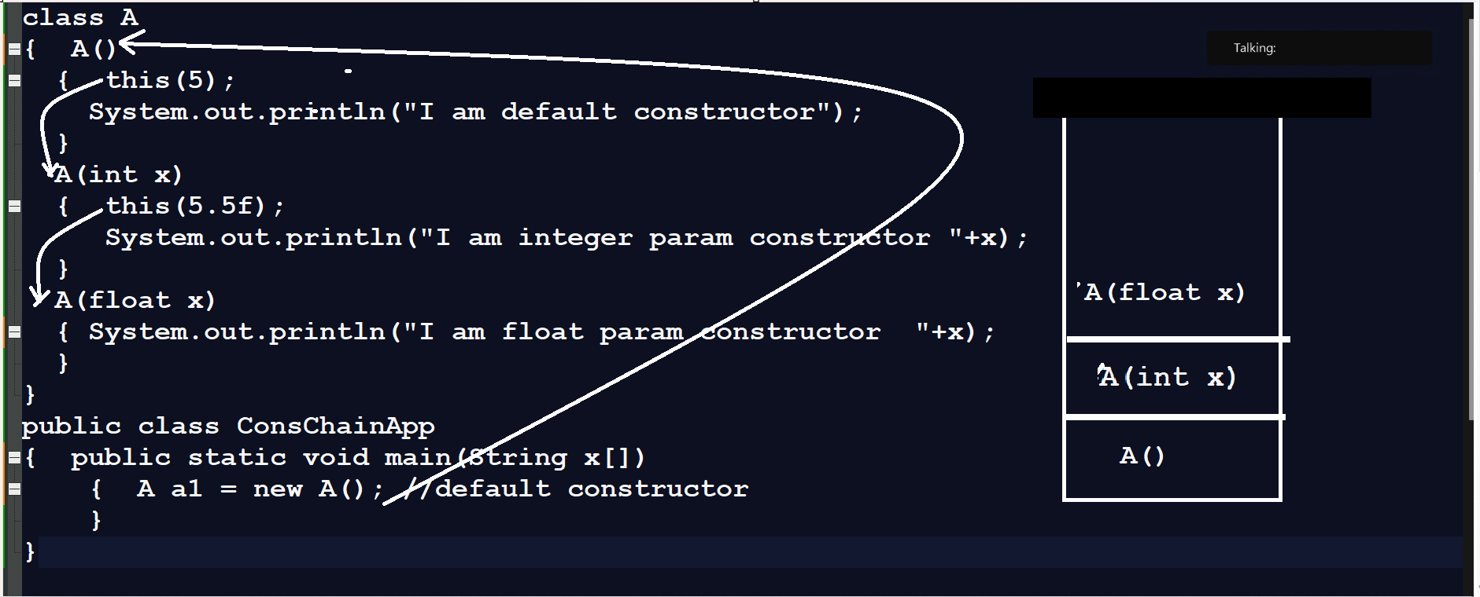
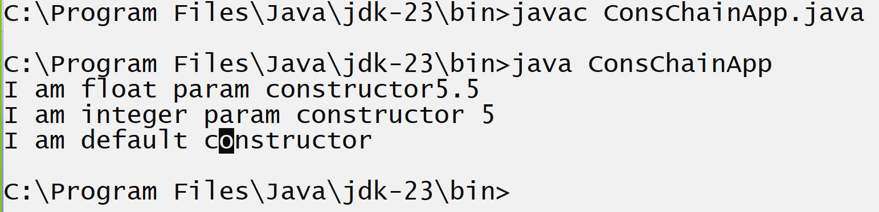
Note: if we think about this() constructor then this() construct must be first line of code in child class constructor.

If we want to work with constructor we need to know the some important points related with constructor
__________________________________________________________________________
1. Constructor cannot have return type
______________________________________________________________________
If you give return type to constructor then constructor consider as method in java means we can say in java function name and class name may be same.
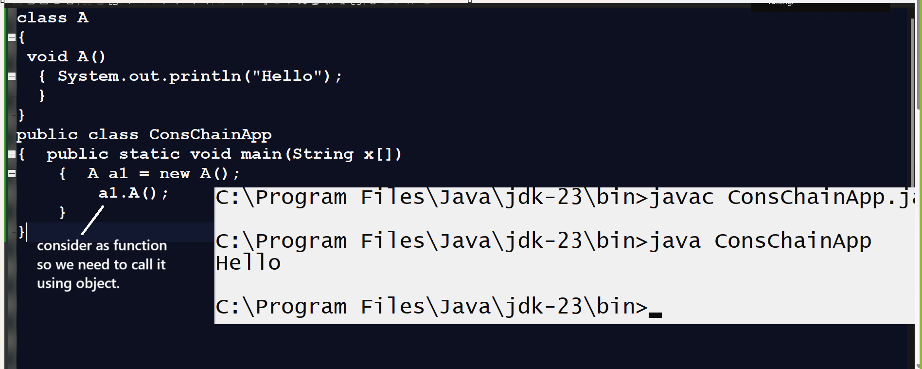
2) Cannot declare constructor as static
If we declare the constructor as static then we get compile time error because constructor call when we create object of class and static member allocate memory before object means we can say constructor calling and static keyword working principle opposite of each other so we cannot declare constructor as static and if we declare it as static then we get compile time error.
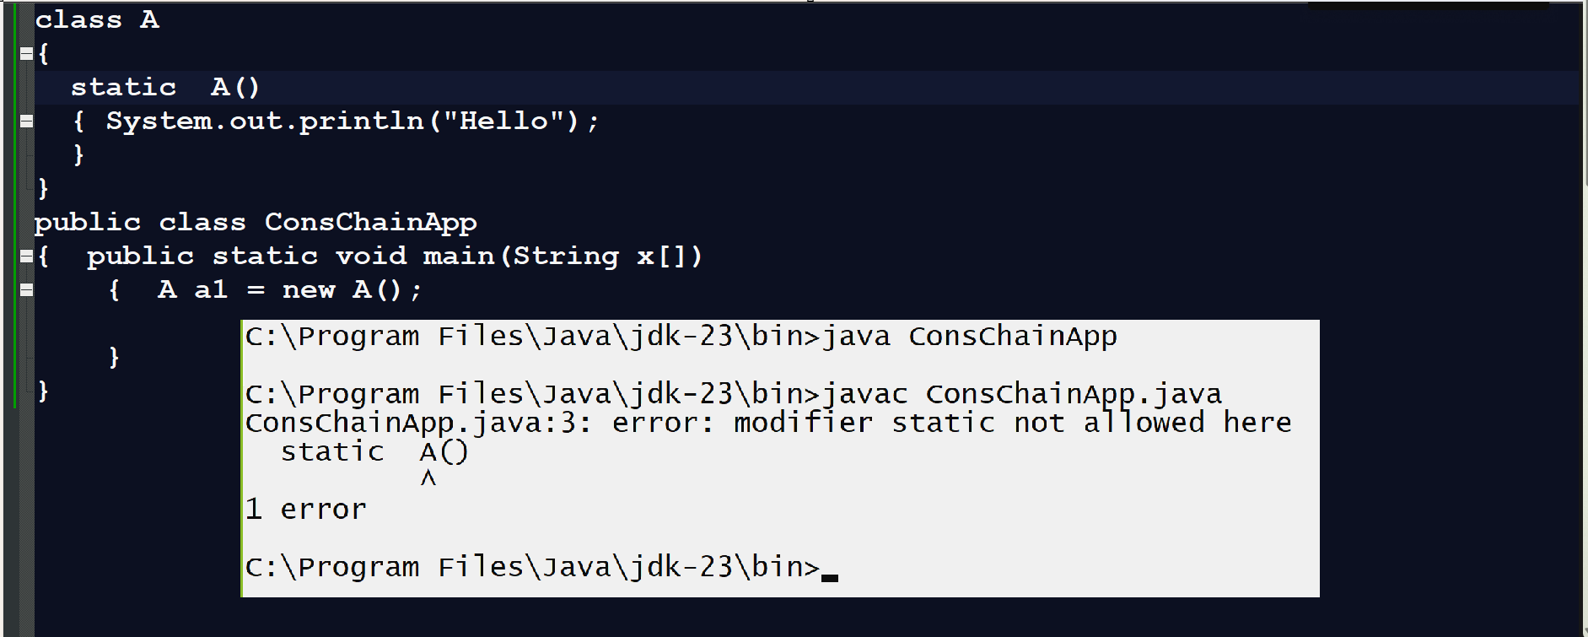

3) Try to avoid declare constructor as private.
When we declare the constructor as private then we cannot create class object outside of his class definition
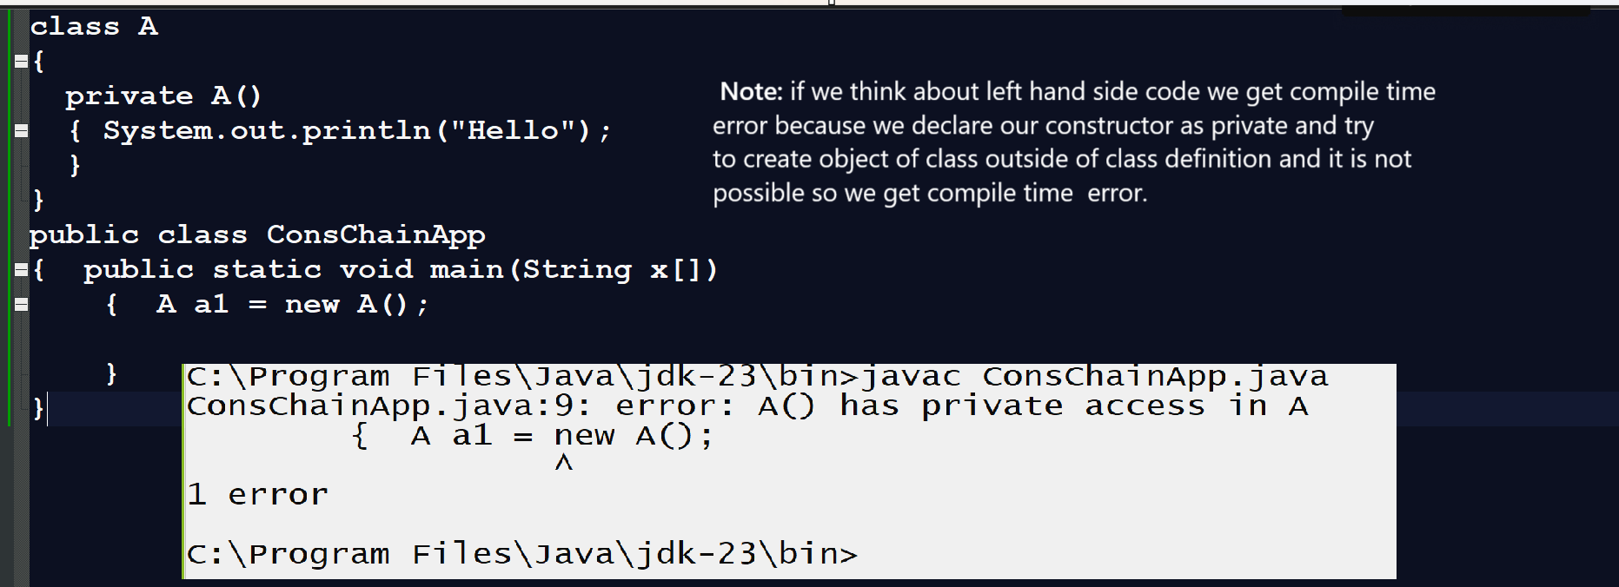
Note: if we want to create single tone class or utility class in java then class constructor must be private.

Q. What is utility class?
___________________________________________________________________________
Utility class means class which contain private constructor and static methods called as utility class means we can say we cannot create object of utility class and we can use its static method without object by using class name

Example of utility class?
______________________________________________________________________________
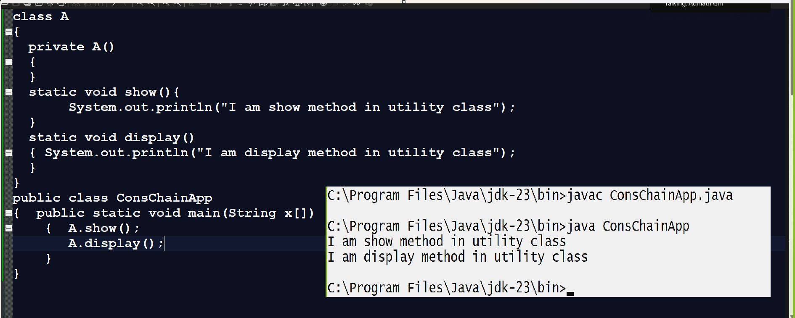

Q. What is singleton class?
__________________________________________________________________________
Singleton class is a design pattern and if we use the singleton design pattern then we can create only one object of class in whole application.

Q. What is design pattern?
____________________________________________________________________________
Design pattern are the some standard principle in software development which help us to develop the better code and manage the some limitation of OOP.

How to implement singleton design pattern practically
_____________________________________________________________________
Steps to work with Singleton design pattern
_____________________________________________________________________
1. Declare class with private constructor
class Test
{
private Test()
{
System.out.println("I am singleton class");
}
}
2. Declare the same class reference in it with private static
class Test
{ private static Test t=null;
private Test()
{
System.out.println("I am singleton class");
}
}

3. Define static method which returns reference of same class with following logics
________________________________________________________________________
class Test
{ private static Test t=null;
private Test()
{ System.out.println("I am singleton class");
}
public static Test getTest()
{
if(t==null)
{
t = new Test();
}
return t;
}
}
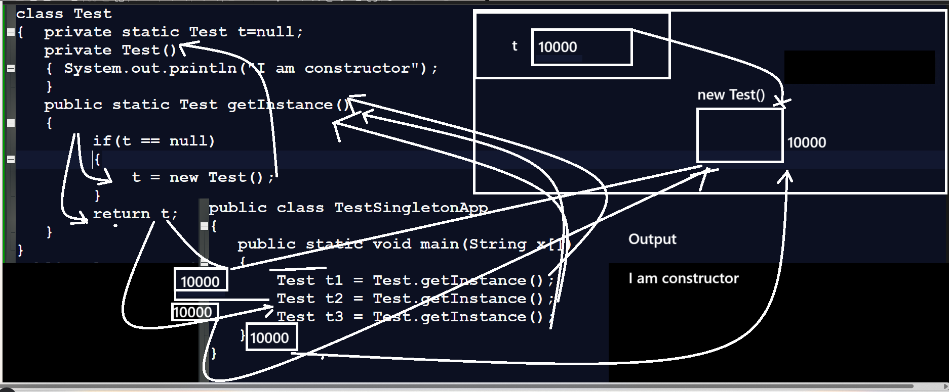

Q. Can we declare constructor as final?
No
Note: we will discuss reason in inheritance chapter.
Q. Can we declare constructor as abstract?
No
Note: we will discuss reason in inheritance chapter
Q. What is difference between function and constructor?
___________________________________________________________________________________

Function | Constructor
Function can have return type | Constructor cannot have return type
Function need to call for execute its logic using object.functionname or reference.functionname | Constructor not need to call manually it is call automatically at the time of object creation
There is no implicit function in class | But there is implicit constructor in class means when user not provide constructor to class then class define own constructor known as implicit constructor
Function support to recursion | Constructor not support to recursion
Function can declare as static | Constructor cannot declare as static
Function can declare as final | Constructor cannot declare as final
Function can declare as abstract | Constructor cannot declare as abstract
According to coding standard function is used for write the logics | According coding standard constructor is used for initialize class variable at the time of object creation
Function can implement dynamic polymorphism with the help of overriding | Constructor cannot implement dynamic polymorphism with the help of overriding.

