Looping
__________________________________________________________________________
If we want to perform some task repeat again and again called as loop.
The major purpose of loop is to optimize the code

There are two types of loop
_______________________________________________________________
1. Entry control loop: Entry control loop means first we check condition and after that decide loop will be execute or not called as entry control loop.
There are two types of entry control loop
1. while loop
2. for loop

2. Exit control loop: exit control loop means first we execute the loop and after that check condition called as exit control loop.
1. do while loop

If we want to work with any loop we should have to know three important points.
1. Initialization: initialization means decide the starting point of loop
2. Condition: condition means check how many times loops will be execute or how many times loop will be iterate called as condition.
3. Increment or decrement: gap between every iterations.

While loop
___________________________________________________________________
initialization;
while(condition)
{ write here your logics
increment or decrement
}
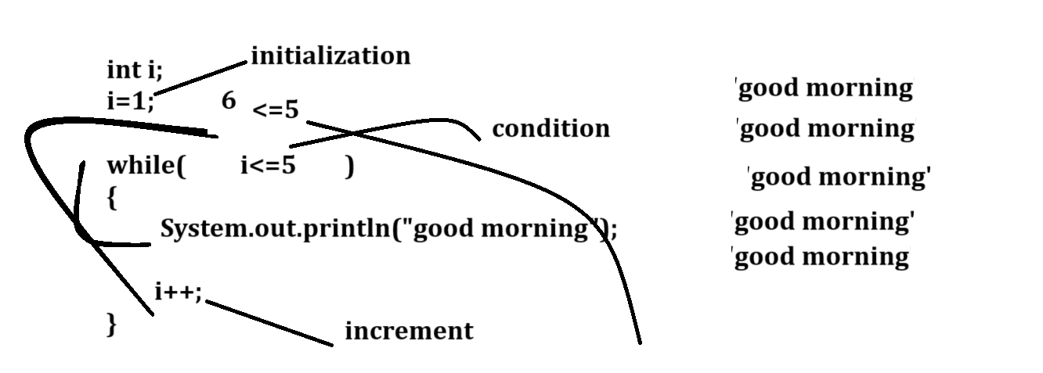

Example: WAP input number from keyboard and print its table
2
2 4 6 8 10 12 14 16 18 20
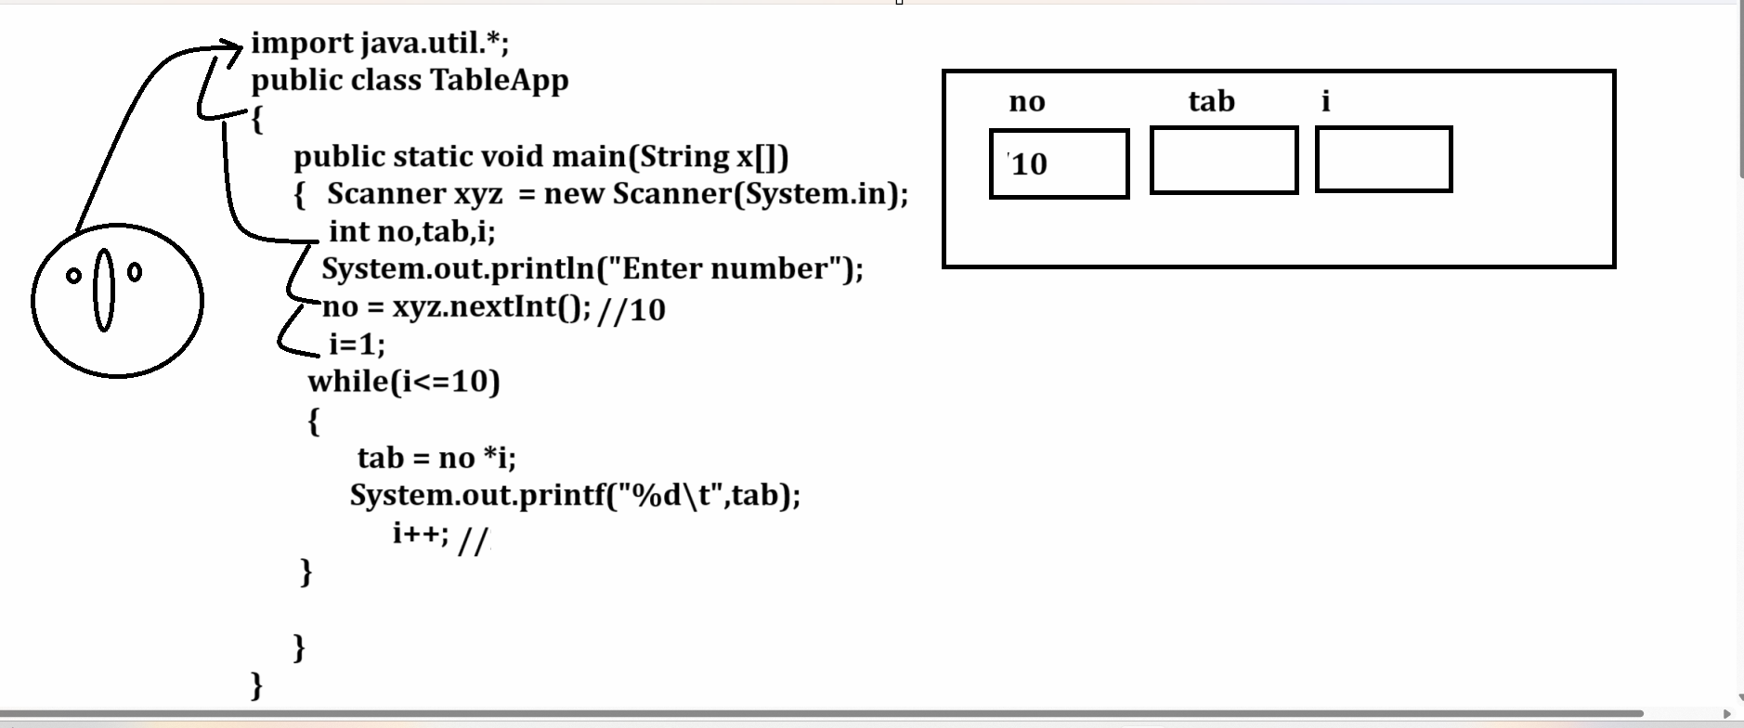

Example: WAP to input number and print its factorial using while loop
5
Output: 120
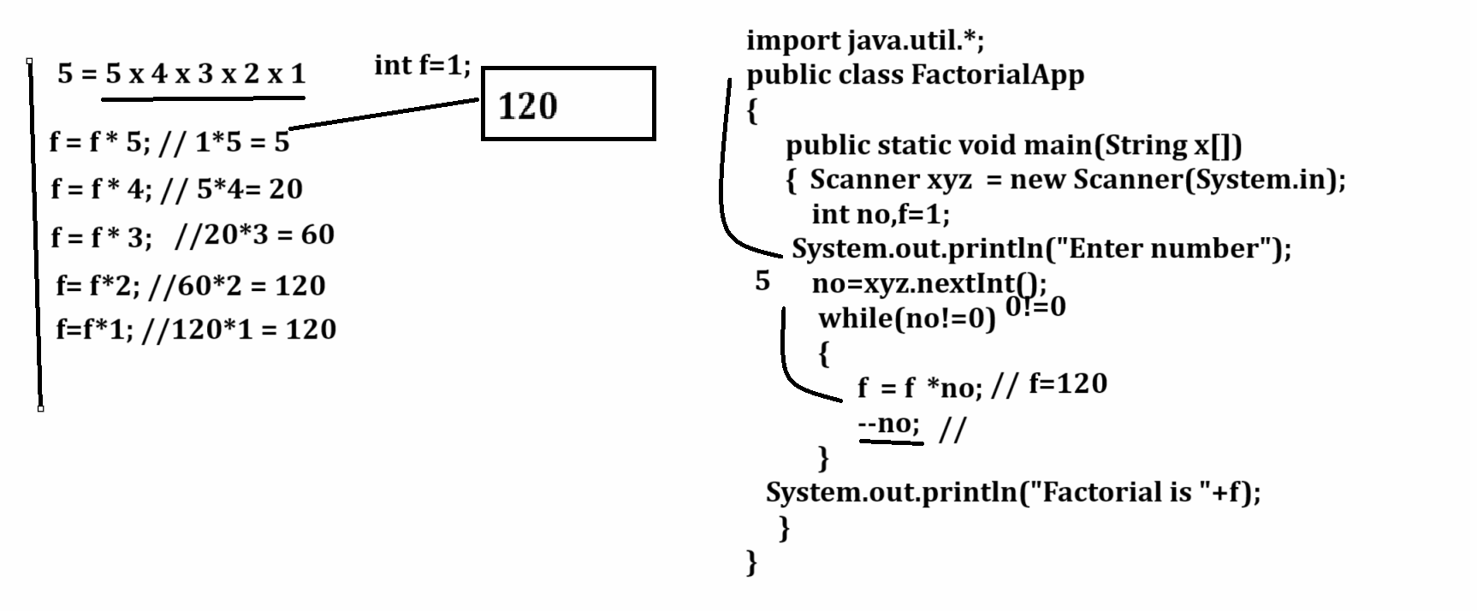
Example: WAP to input the two values consider first as base and second as index and calculate its power.

5
4

Output 4
5 = 5 x 5 x 5 x 5 = 625

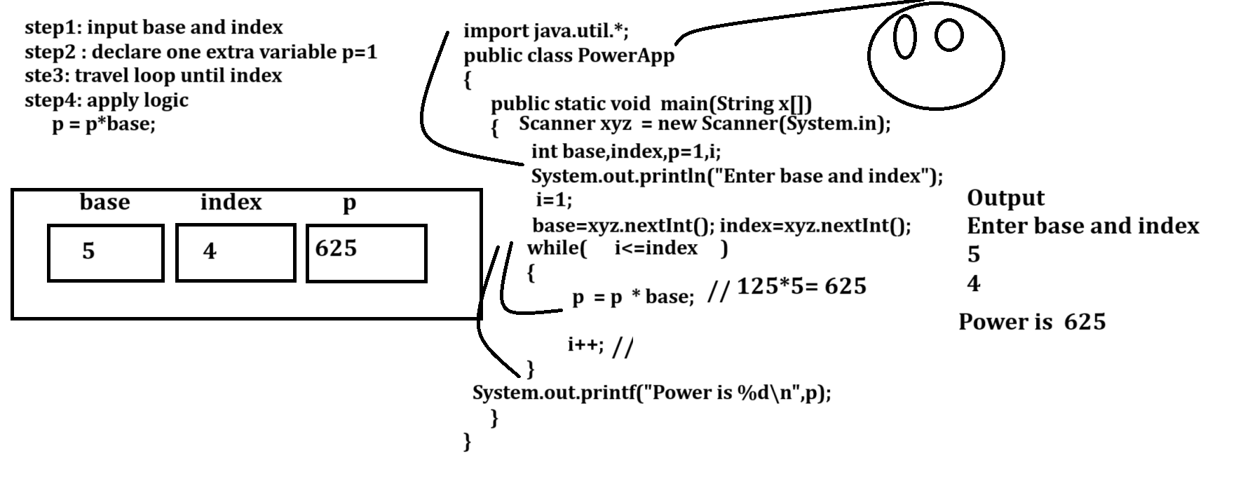
Example with source code
import java.util.*;
public class PowerApp
{
public static void main(String x[])
{
Scanner xyz = new Scanner(System.in);
int base,index,p=1;
System.out.println("enter base and index");
base=xyz.nextInt();
index=xyz.nextInt();
int i=1;
while(i<=index)
{ p =p * base;
i++;
}
System.out.printf("Power is %d\n",p);
}
}
Output
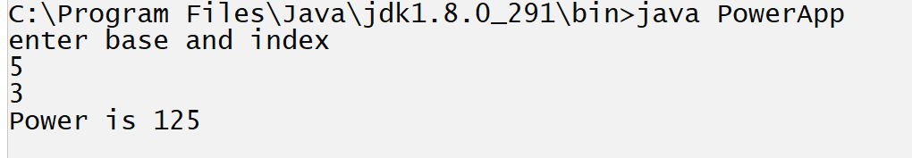

Example: WAP to input the number and check number is duck or not
Input: 1024
Output: it is duck number
Input: 1234
Output: it is not duck.

Example with source code
import java.util.*;
public class DuckApp
{
public static void main(String x[])
{ int no,rem;
Scanner xyz = new Scanner(System.in);
System.out.println("enter number");
no=xyz.nextInt();
while(no!=0)
{
rem = no % 10;
no = no / 10;
if(rem ==0)
{ System.out.println("Number is duck");
}
else
{ System.out.println("Number is not duck");
}
}
}
}
Output
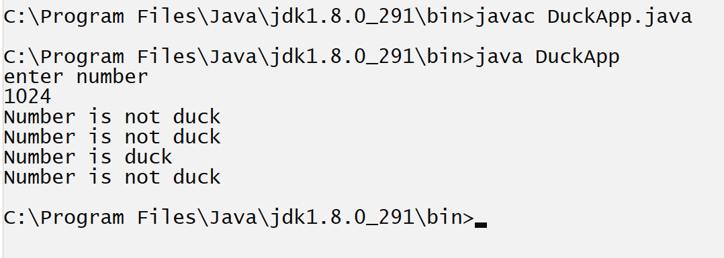
Note: if we think about above code we get output number is not duck three times and number is duck single time.
If we think about above output then above code not generate property output to us
Means we expect program should generate only one time number is duck or number is not duck but we use if else in loop so every time either if or else get executed so this is major reason we not get proper output so if we want to solve this problem we have to use flag concept.

Q. What is flag in programming?
flag is boolean variable which either represent true or false

Q. Why use flag variable in code?
________________________________________________________________________

If we think about loop and if we if else in loop then we get true and false output every time but if we required either true or false only once in code then we can use single if in code and use boolean variable and if update the boolean variable as per the condition in loop and if we break the loop after meeting condition and use if else outside loop and execute if or else according boolean variable value

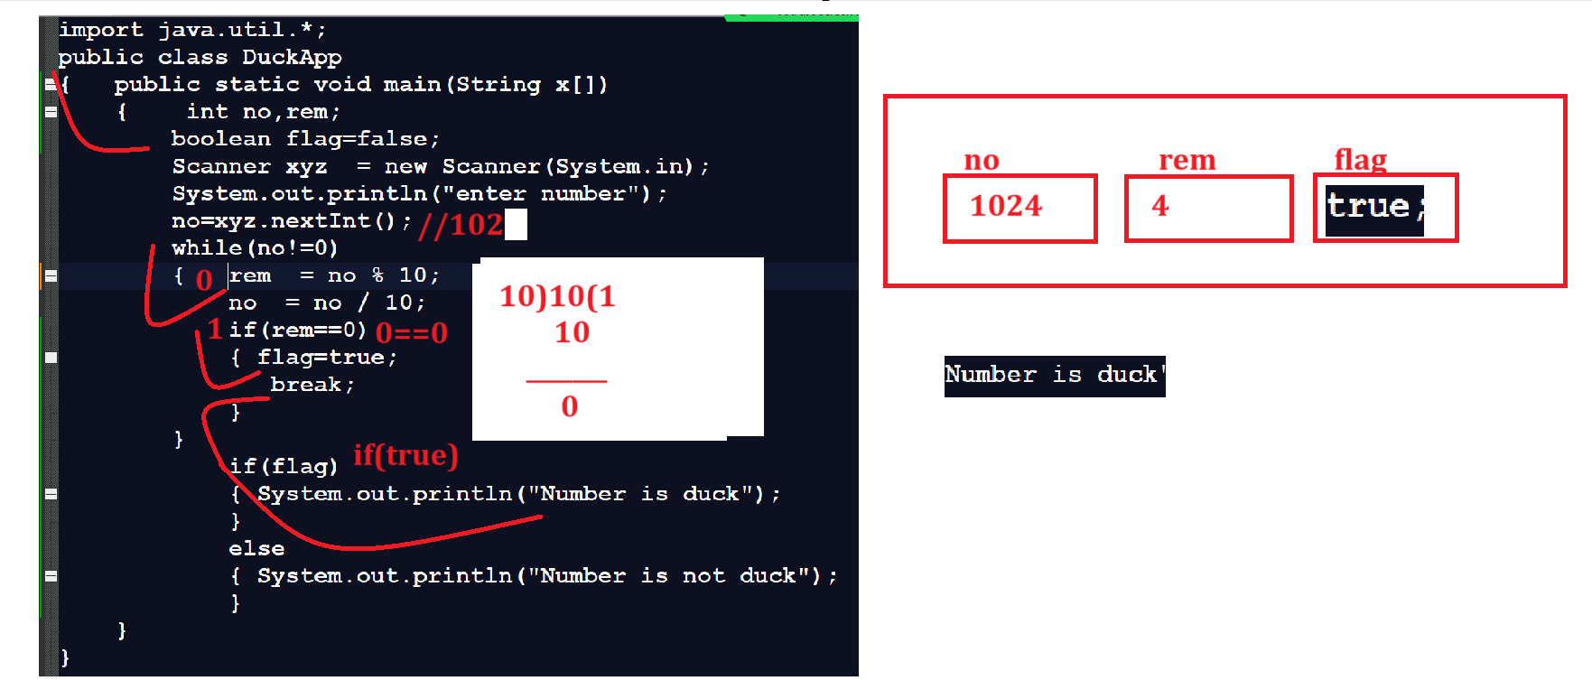

Example: WAP to input the number from keyboard and input the search digit from keyboard and check digit present in number or not.
Example: input number: 12345
Input digit for search 3
Output: digit found
Example: input number: 12345
Input digit for search 6
Output: digit not found.

Example with source code
import java.util.*;
public class SearchDigitApp
{ public static void main(String x[ ])
{ Scanner xyz = new Scanner(System.in);
int no,rem,skey;
boolean flag=false;
System.out.println("Enter number from keyboard");
no=xyz.nextInt();
System.out.println("Enter search key from keyboard");
skey=xyz.nextInt();
while( no!=0 )
{
rem = no % 10;
no = no /10;
if(rem==skey)
{ flag=true;
break;
}
}
if(flag)
{ System.out.println("Search key found");
}
else{
System.out.println("Search key not found");
}
}
}
Example:
WAP to print the fibonacii series like as
0 1 1 2 3 5 8 13 21 34 etc
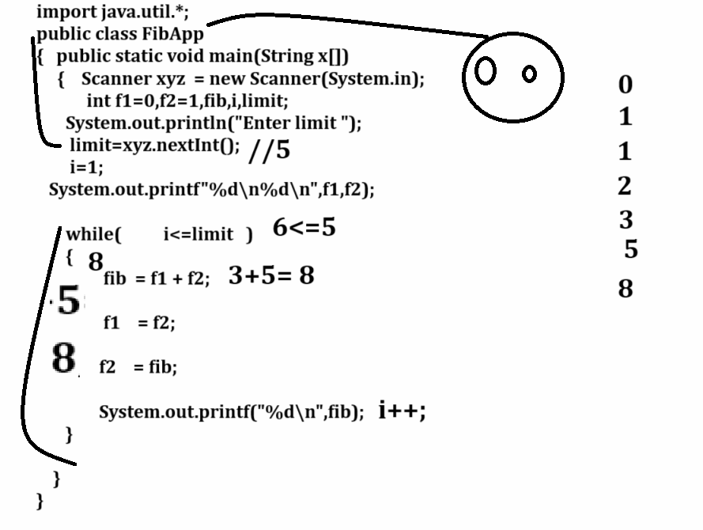
Example with source code
import java.util.*;
public class FibApp
{ public static void main(String x[ ])
{ Scanner xyz = new Scanner(System.in);
int f1=0,f2=1,fib,i,limit;
System.out.println("Enter number of iterations");
limit=xyz.nextInt();
System.out.printf("%d\n%d\n",f1,f2);
i=1;
while( i<=limit)
{
fib=f1+f2;
f1=f2;
f2=fib;
System.out.printf("%d\n",fib);
i++;
}

}
}

Example: WAP input the number and check number present in Fibonacci series or not
import java.util.*;
public class FibApp
{ public static void main(String x[ ])
{ Scanner xyz = new Scanner(System.in);
int f1=0,f2=1,fib,i,limit,skey;
boolean b=false;
System.out.println("Enter number of iterations");
limit=xyz.nextInt();
i=1;
System.out.println("Enter search key");
skey=xyz.nextInt();
System.out.printf("%d\n%d\n",f1,f2);

while( i<=limit)
{
fib=f1+f2;
if(fib==skey)
{ b=true;

}
f1=f2;
f2=fib;
System.out.printf("%d\n",fib);
i++;
}
if(b)
{ System.out.println("Number present in fibonacii series");
}
else
{ System.out.println("Number not present in fibonacii series");
}

}
}

Example: WAP to input the number and find the occurrence of every digit in number
1231245

Output: 1 --- 2
2 --- 2
3 – 1
4 – 1
5 - 1

For loop
__________________________________________________________________________________
for loop is same like as while loop with some major differences

Syntax
________________________________________________________________________
for(initialization; condition; increment or decrement)
{ write here your logics
}
Example: WAP to print the good morning 5 times.
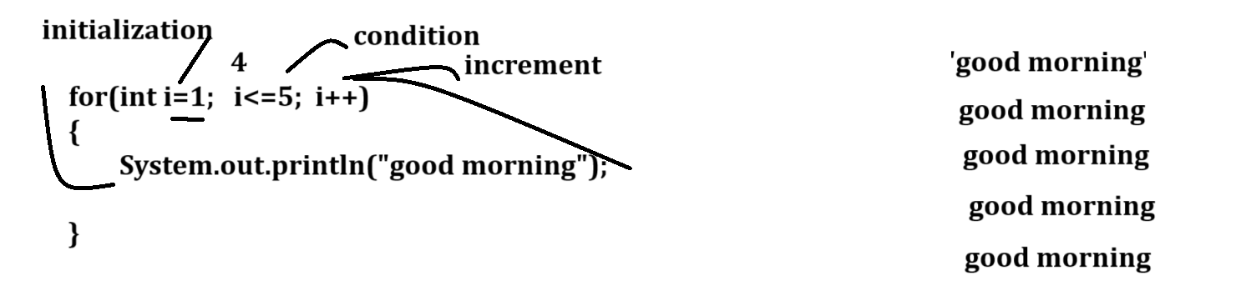
Example with source code
public class ForApp
{
public static void main(String x[])
{ for(int i=1; i<=5; i++)
{
System.out.println("good morning");
}
}
}
You can use for loop in following fashion.
public class ForApp
{
public static void main(String x[])
{ int i=1;
for(; i<=5; i++)
{
System.out.println("good morning");
}
}
}
or
public class ForApp
{
public static void main(String x[])
{ int i=1;
for(; i<=5; )
{
System.out.println("good morning");
i++;
}
}
}

Example: WAP to input the two values consider first as base and second index and calculate its power.
import java.util.*;
public class PowerApp
{ public static void main(String x[])
{ Scanner xyz = new Scanner(System.in);
int base,index,p=1;
System.out.println("Enter base and index");
base=xyz.nextInt();
index=xyz.nextInt();
for(int i=1; i<=index;i++)
{ p = p *base;
}
System.out.printf("\nPower is %d\n",p);
}
}

Nested for loop or Nested loop
__________________________________________________________________
Nested loop means loop within loop called as nested loop
There are two types of loop in nested loop.
Syntax of nested loop
___________________________________________________________________
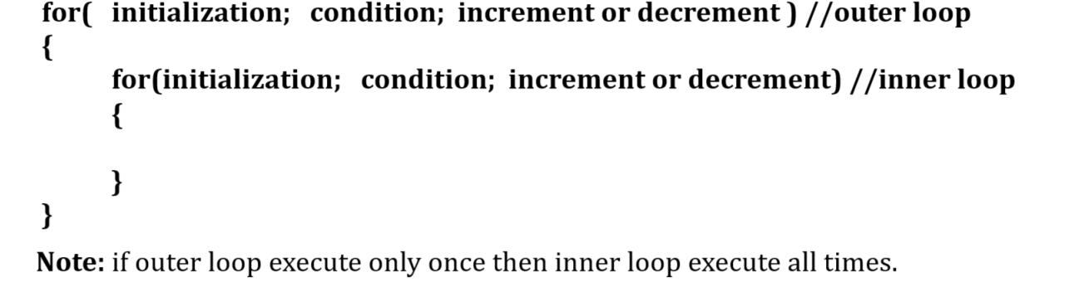

Example of nested loop
________________________________________________________________________
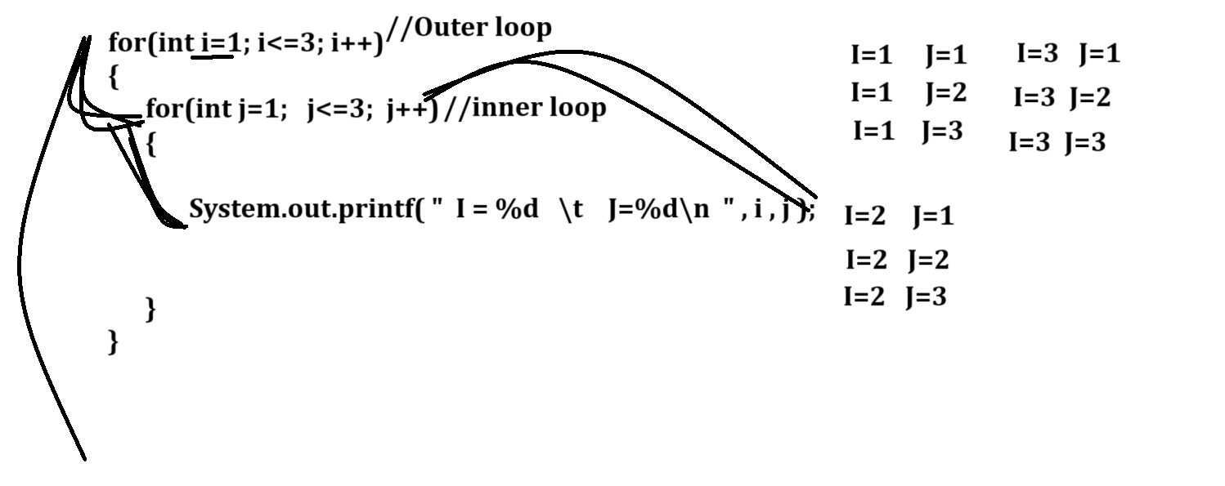

Example with source code
public class NestedLoopApp
{
public static void main(String x[])
{
for(int i=1; i<=3;i++)
{
for(int j=1; j<=3; j++)
{
System.out.printf("I=%d\tJ=%d\n",i,j);
}
System.out.printf("\n");
}
}
}
Output
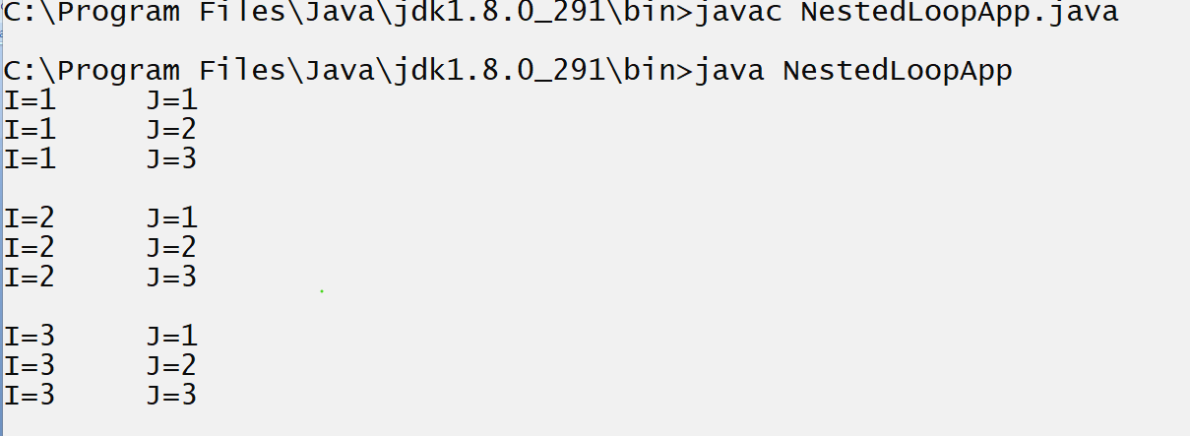
Q. What is benefit of nested loop?
____________________________________________________________________
Nested loop help us to work with matrix means here outer loop work as row and inner loop work as column.
Example with source code
public class NestedLoopApp
{ public static void main(String x[])throws Exception
{ for(int i=1; i<=10;i++)
{
for(int j=2; j<=10; j++)
{
System.out.printf("%d\t",i*j);
Thread.sleep(100);
}
System.out.printf("\n");
}
}
}
Output
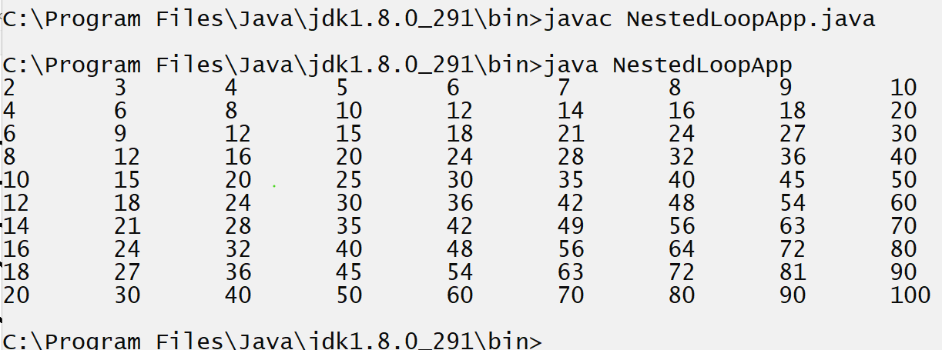

Now we want to work with pattern programming or start patterns , number patterns , combination of number and start, alphabetical pattern etc

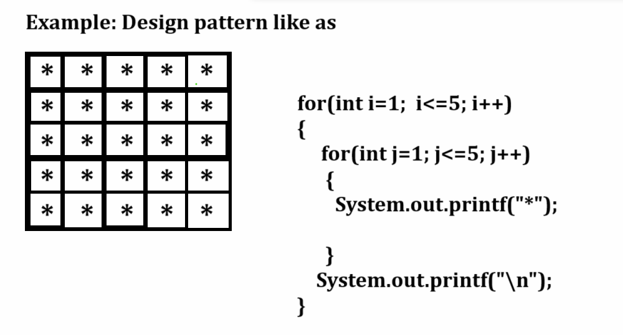

Example with source code
public class NestedLoopApp
{
public static void main(String x[])
{
for(int i=1; i<=5;i++)
{
for(int j=1; j<=5; j++)
{
System.out.printf("*");
}
System.out.printf("\n");
}
}
}
Output
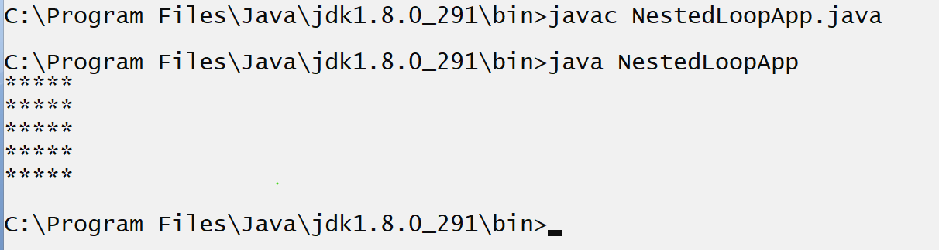

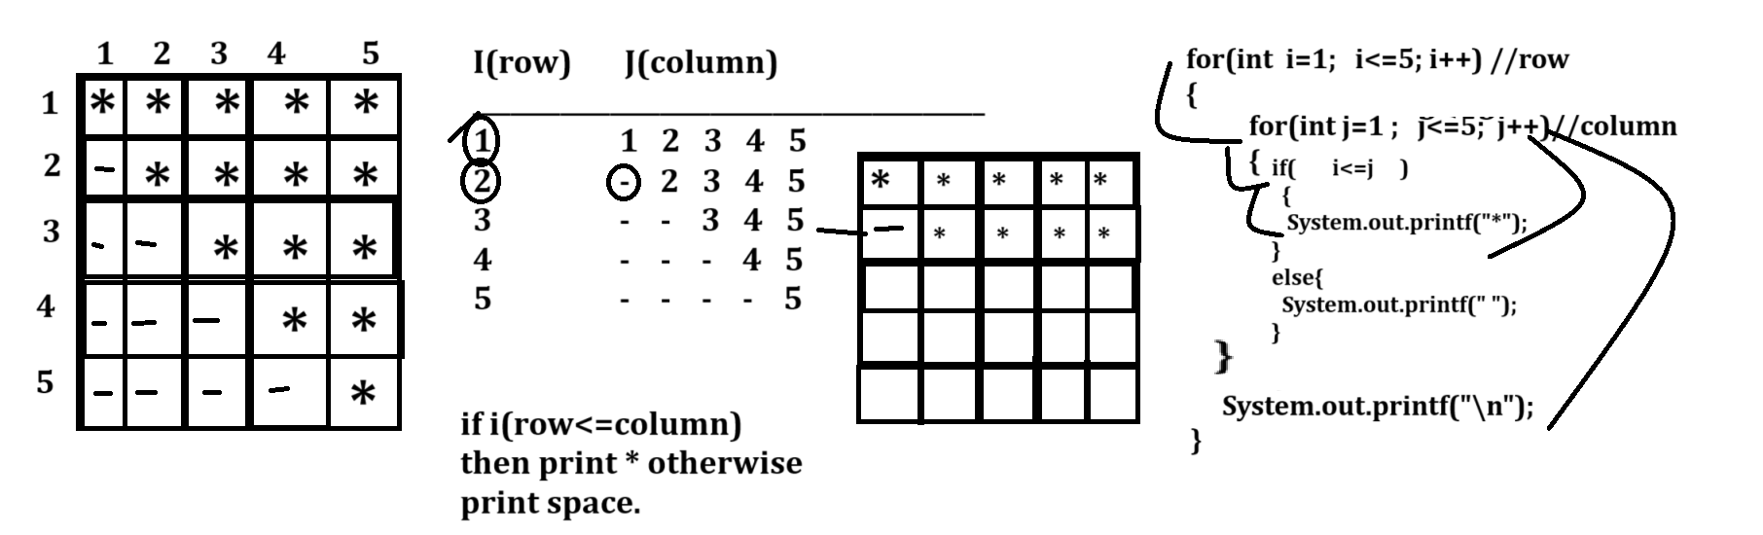

Example with source code
public class P1
{
public static void main(String x[])
{
int i,j;
for(i=1; i<=5; i++)
{
for(j=1; j<=5; j++)
{
if(i<=j)
{ System.out.printf("*");
}
else{
System.out.printf(" ");
}
}
System.out.printf("\n");
}
}
}
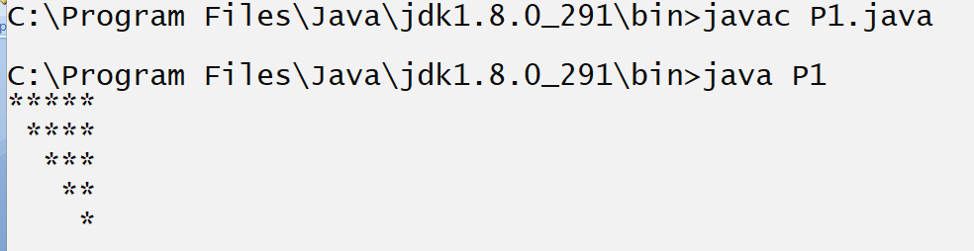

Example with source code
public class P1
{ public static void main(String x[])
{ int i,j;
for(i=1; i<=5; i++)
{
for(j=1; j<=5; j++)
{
if(j==1 || i==5 || j==6-i)
{ System.out.printf("*");
}
else{
System.out.printf(" ");
}
}
System.out.printf("\n");
}
}
}
Output
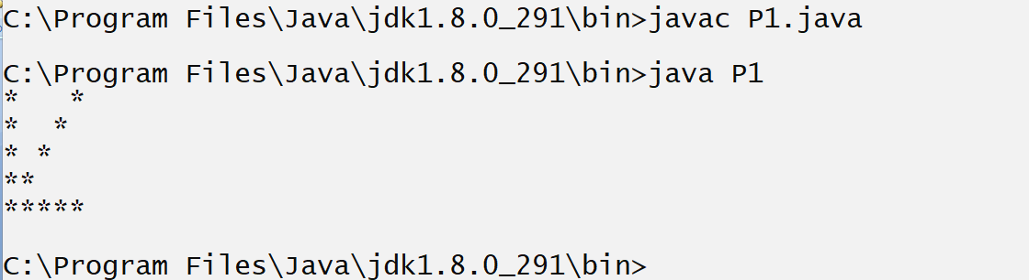

Example: WAP to print the following patterns?
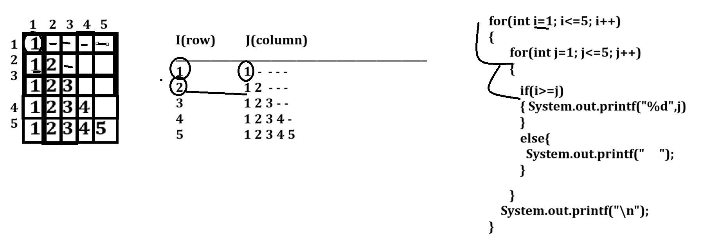

Example with source code

public class P1
{
public static void main(String x[])
{
int i,j;
for(i=1; i<=5; i++)
{
for(j=1; j<=5; j++)
{
if(i>=j)
{ System.out.printf("%d",j);
}
else{
System.out.printf(" ");
}
}
System.out.printf("\n");
}
}
}

Example : WAP to print the following pattern?
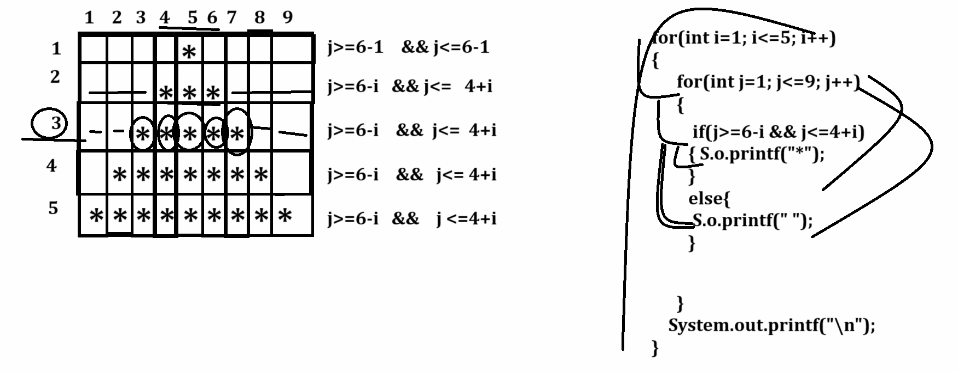
Example with source code
public class TestP2
{
public static void main(String x[])
{
int i,j;
for(i=1; i<=5; i++)
{
for(j=1; j<=9;j++)
{
if(j>=6-i && j<=4+i)
{ System.out.printf("*");
}
else{
System.out.printf(" ");
}
}
System.out.printf("\n");
}
}
}
Output
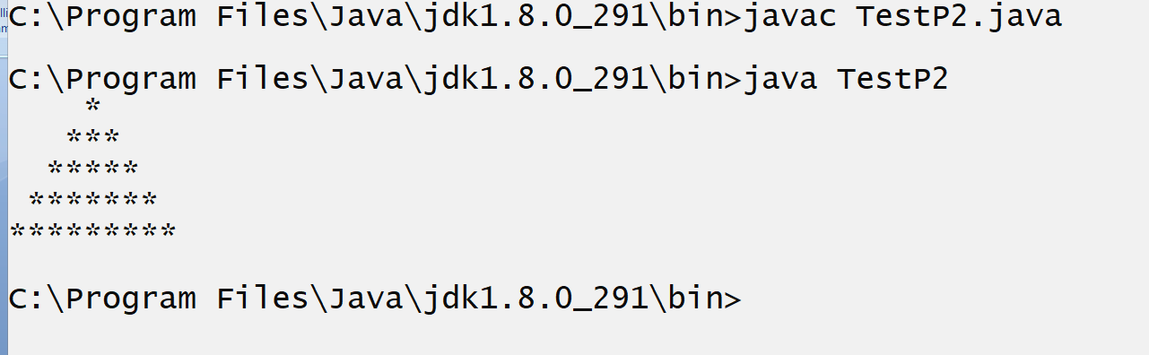
Example: WAP to print the following pattern?
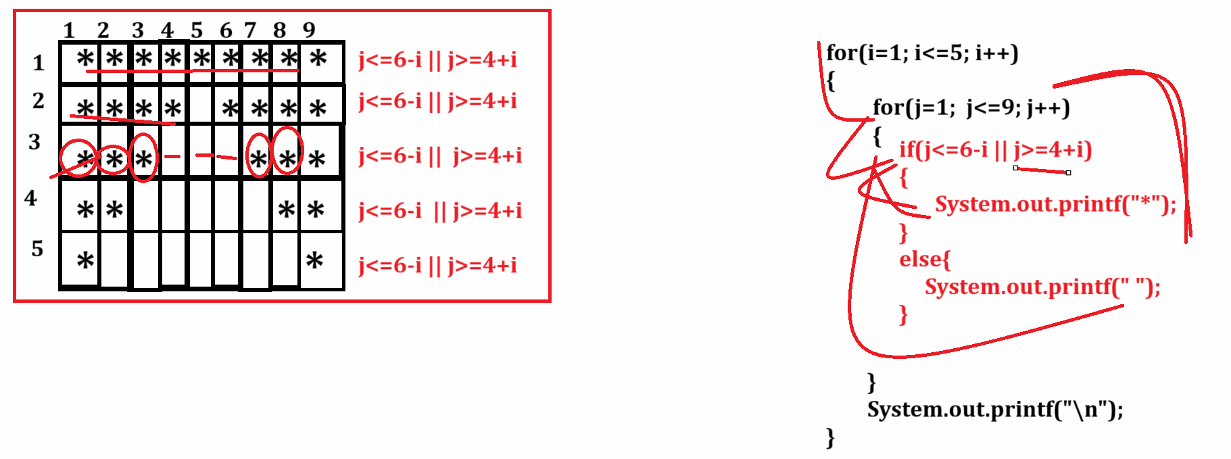

Example with source code
__________________________________________________________
public class TestP2
{
public static void main(String x[])
{
int i,j;
for(i=1; i<=5; i++)
{
for(j=1; j<=9;j++)
{
if(j<=6-i || j>=4+i)
{ System.out.printf("*");
}
else{
System.out.printf(" ");
}
}
System.out.printf("\n");
}
}
}
Output
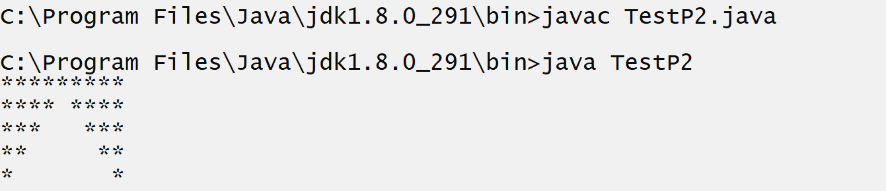

Example with source code
public class TestP2
{ public static void main(String x[])
{ int i,j;
for(i=1; i<=9; i++)
{ for(j=1; j<=5;j++)
{ String s=((i>=j && i<=5)||(j<=10-i && i>=6))?"*":" ";
System.out.print(s);
}
System.out.printf("\n");
}
}
}

Output
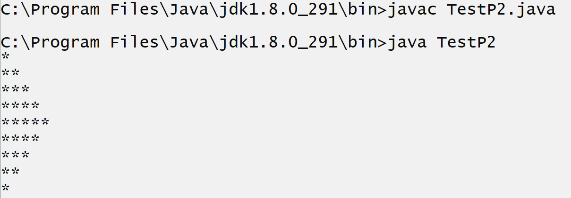

Example with source code
public class TestP2
{
public static void main(String x[])
{ int i,j;
for(i=1; i<=9; i++)
{
for(j=1; j<=9;j++)
{
if((j>=6-i && j<=4+i && i<=5) ||(j>=i-4&&j<=14-i&&i>=6))
{ System.out.printf("*");
}
else{
System.out.printf(" ");
}

}
System.out.printf("\n");
}
}
}
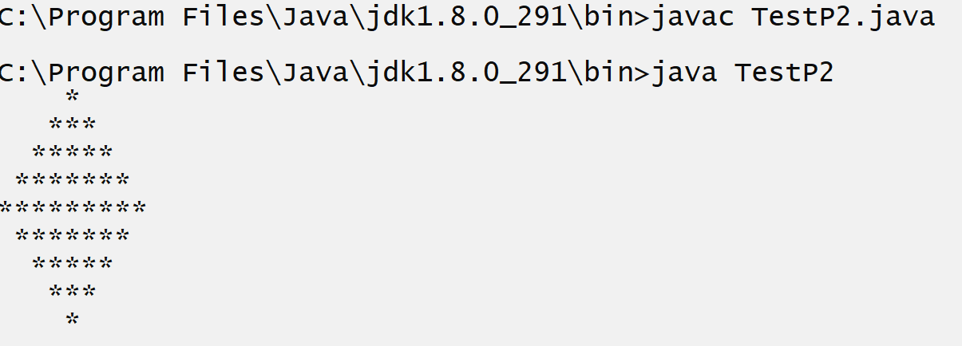

Example: WAP to print the following pattern?
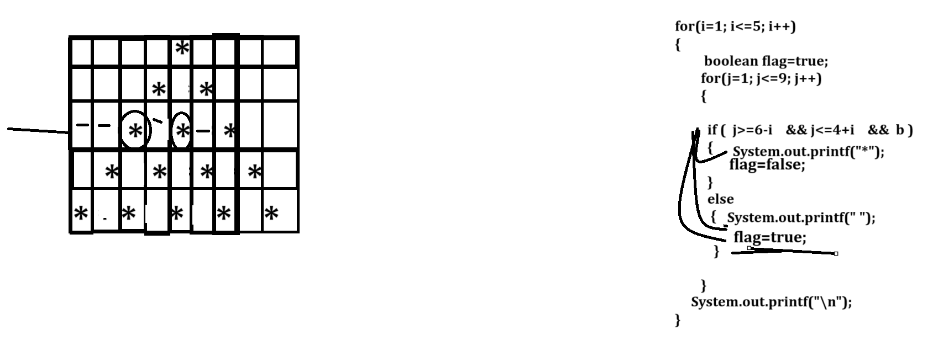

Example: with source code

public class PatternApp
{
public static void main(String x[])
{
int i,j;
for(i=1;i<=5;i++)
{boolean b=true;
for(j=1; j<=9;j++)
{
if(j>=6-i&&j<=4+i&&b)
{ System.out.printf("*");
b=false;
}
else{
System.out.printf(" ");
b=true;
}
}
System.out.printf("\n");
}
}
}

Example: WAP to print the following pattern?
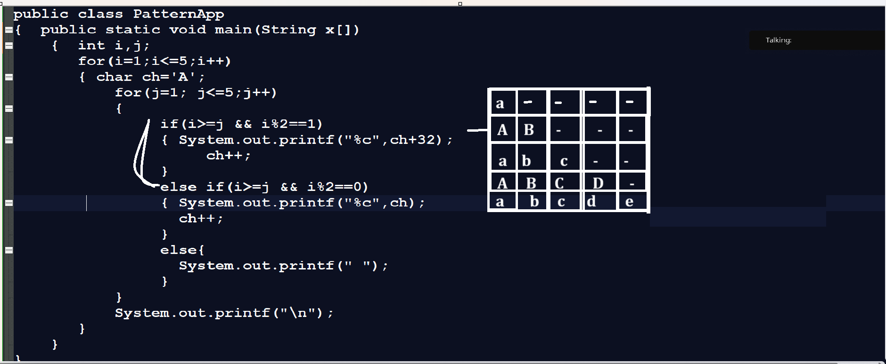

Continue keyword
____________________________________________________________________________
Continue keyword is used for skip the some execution steps of loop called as continue keyword.
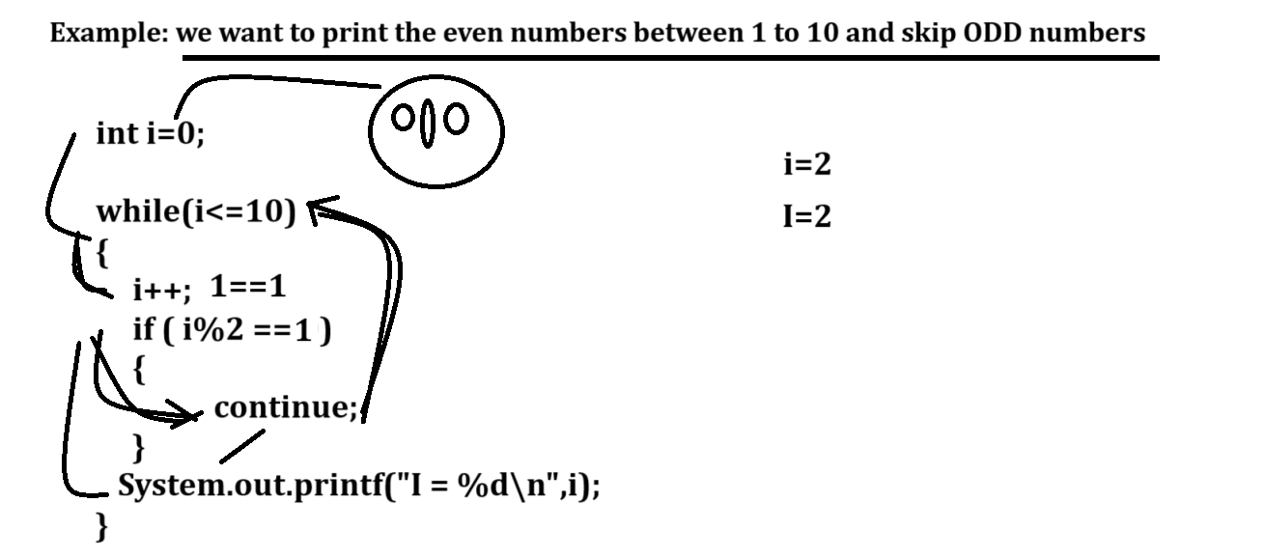

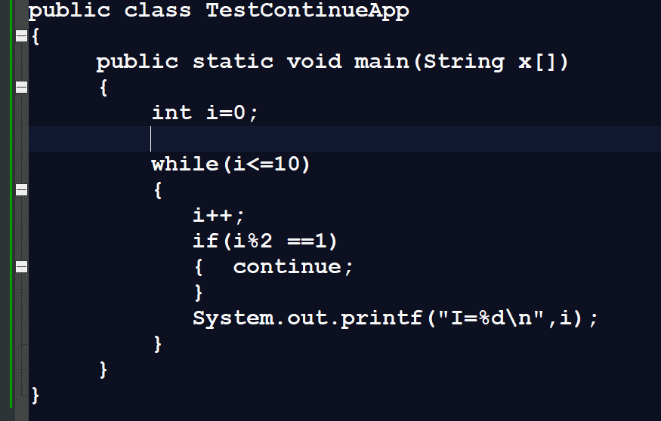

Q. What will be output of given code?
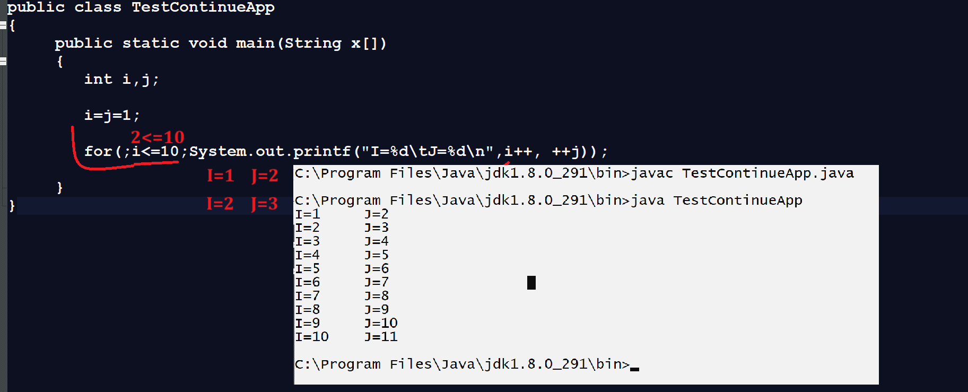
Q. What will be output of given code?
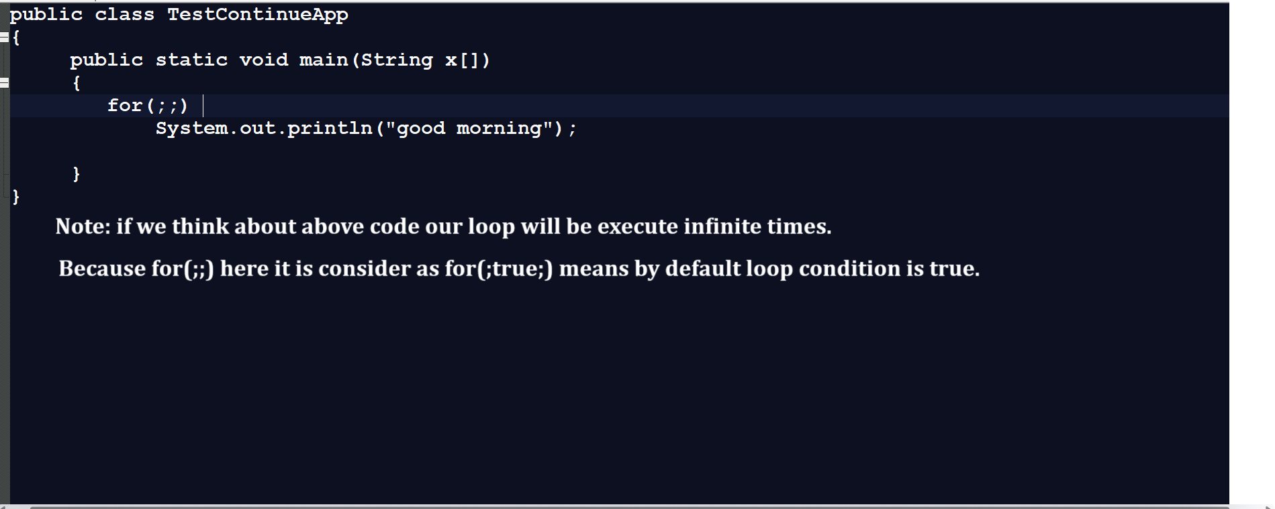
Q. What will be output of given code?
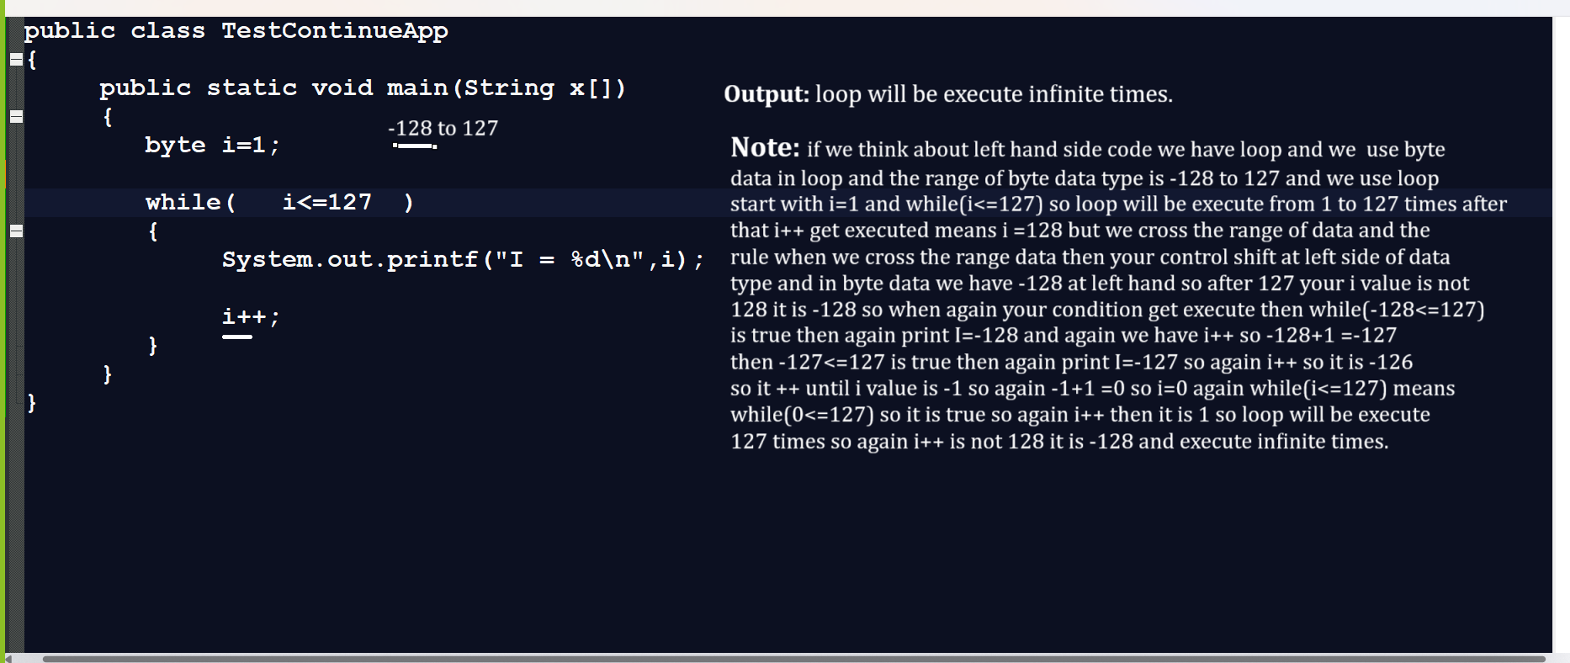

Q. what will be output of given code?
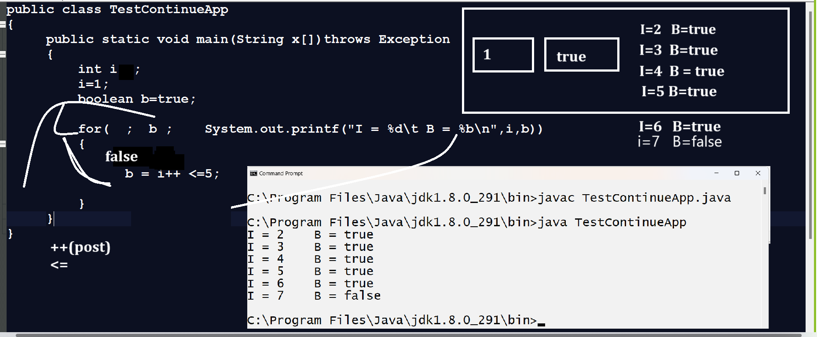

Q. what will be output of given code?
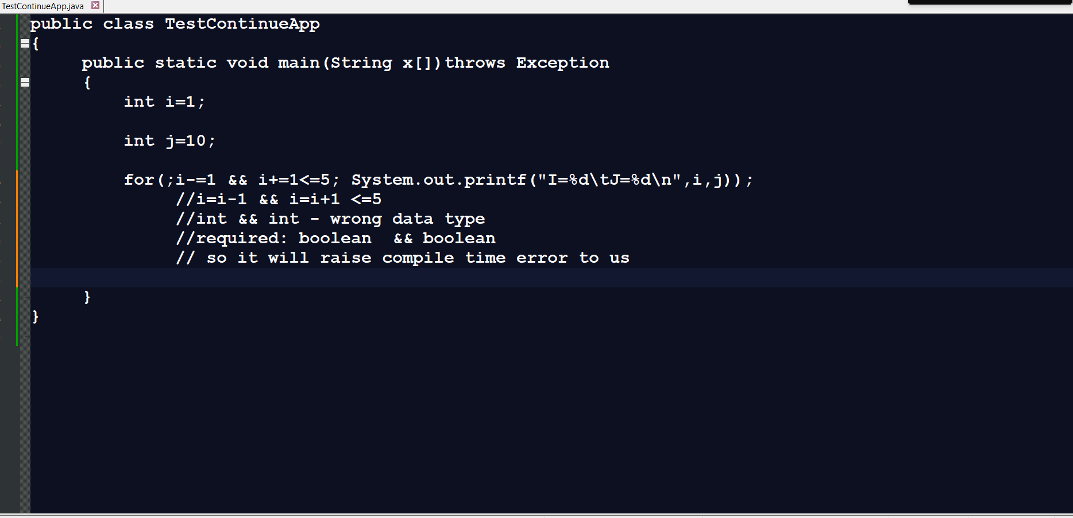
Q. what will be output of given code?
