**Client Server Programming**

**\*\*Message Passing From Client To server**

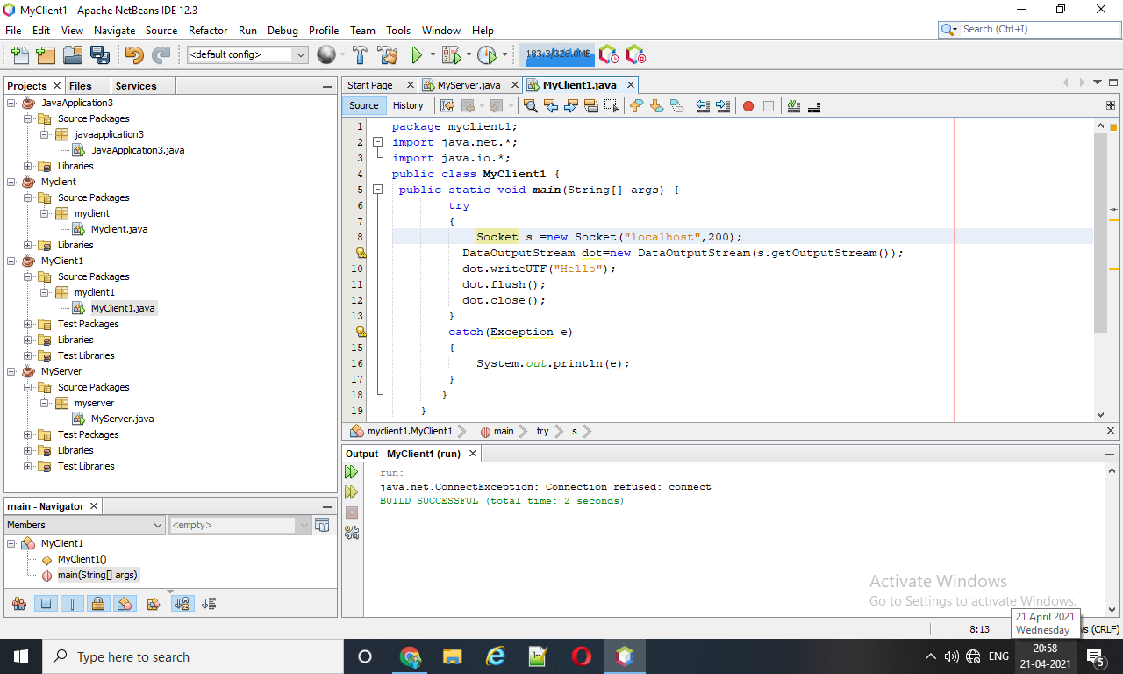

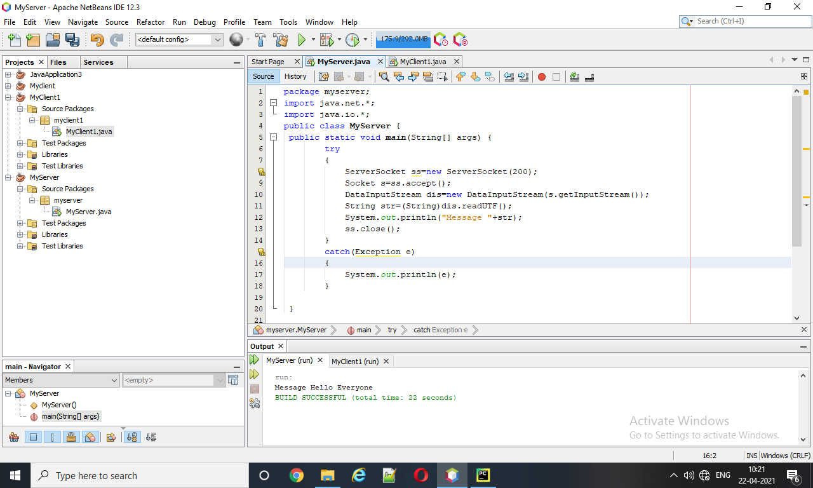

**\*\*Message Passing From Server To Client.**

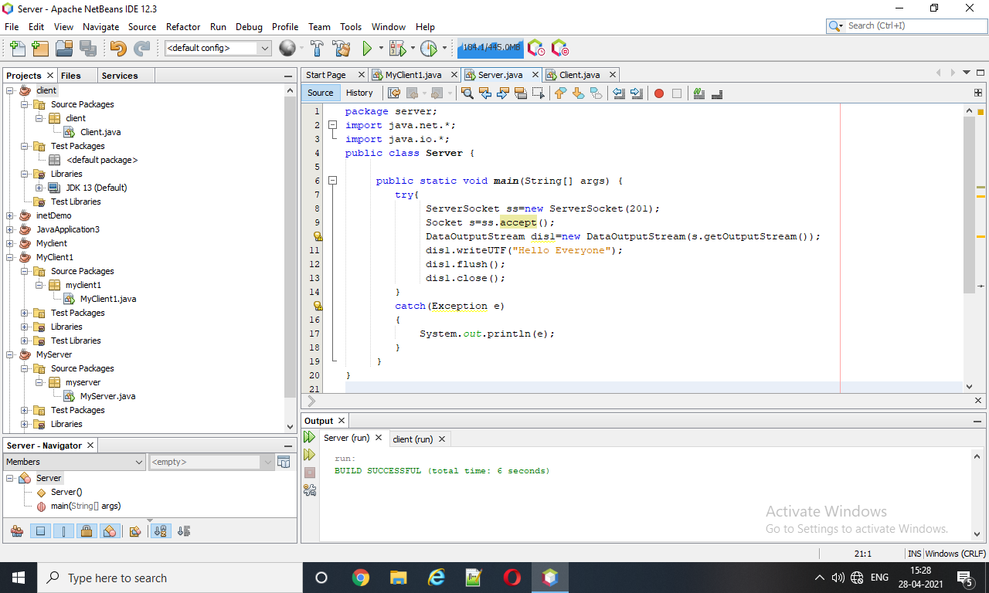

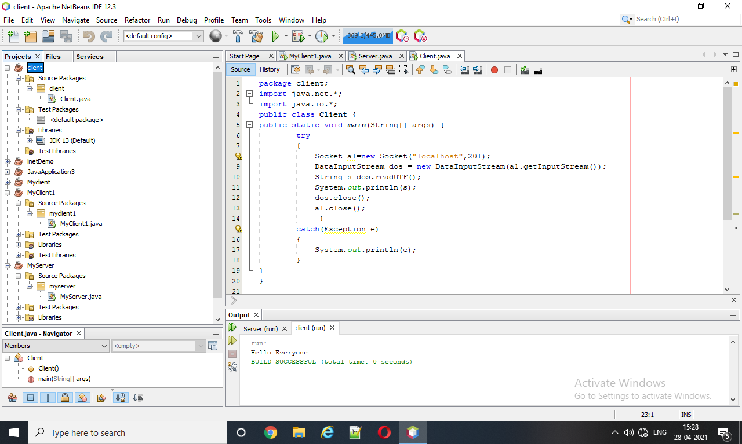

**\*\*Mesagge Passing from Both The Sides**

package serveexample;

import java.net.*;

import java.io.*;

public class ServeExample {

public static void main(String[] args)throws Exception{

ServerSocket ss=new ServerSocket(3333);

Socket s=ss.accept();

DataInputStream din=new DataInputStream(s.getInputStream());

DataOutputStream dout = new DataOutputStream(s.getOutputStream());

BufferedReader br=new BufferedReader (new InputStreamReader(System.in));

String str="",str2="";

while(!str.equals("stop"))

{

str=din.readUTF();

System.out.println("Client says : "+str);

str2=br.readLine();

dout.writeUTF(str2);

dout.flush();

}

din.close();

s.close();

ss.close();

}

}

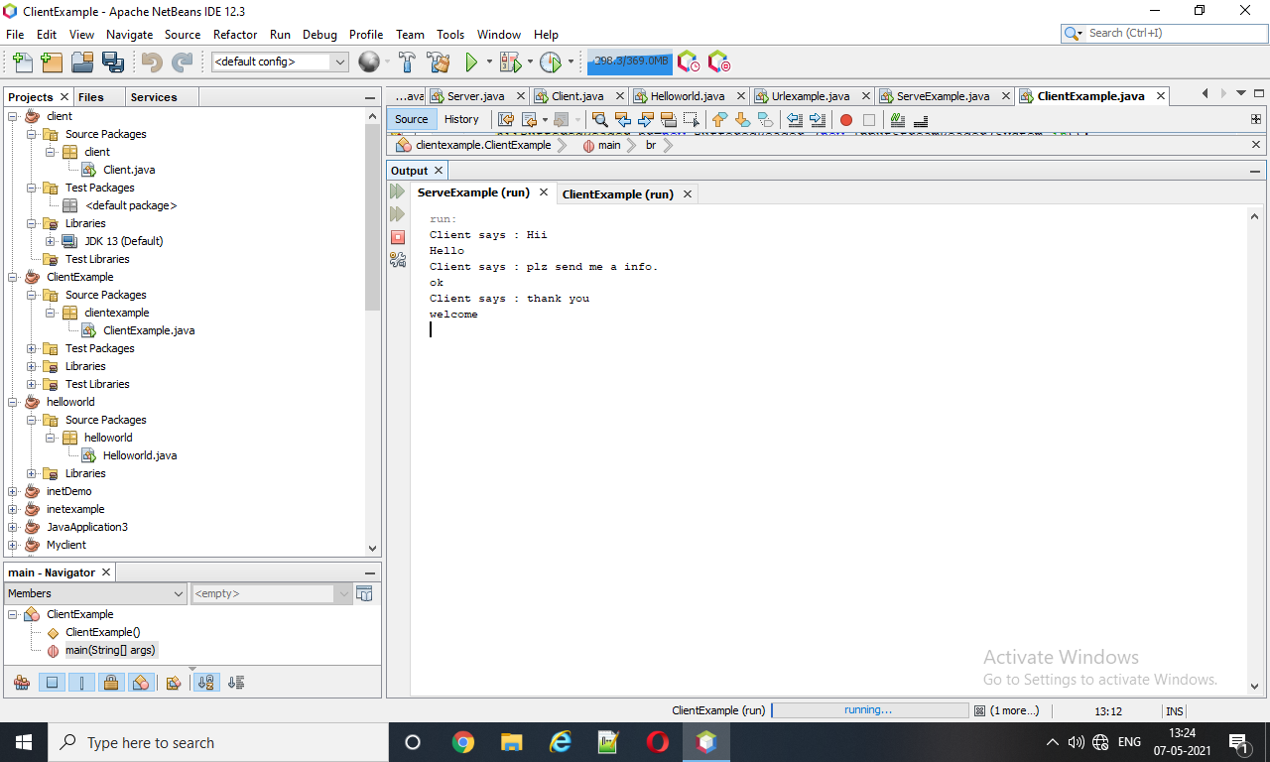

package clientexample;

import java.net.*;

import java.io.*;

public class ClientExample {

public static void main(String[] args)throws Exception{

Socket s= new Socket("localhost",3333);

DataInputStream din=new DataInputStream(s.getInputStream());

DataOutputStream dout = new DataOutputStream(s.getOutputStream());

BufferedReader br=new BufferedReader (new InputStreamReader(System.in));

String str="",str2="";

while(!str.equals("stop"))

{

str=br.readLine();

dout.writeUTF(str);

dout.flush();

str2=din.readUTF();

System.out.println("Server says:"+str2);

}

dout.close();

s.close();

}

}

