**AI/ML PROJECT ON CREDIT CARD FRAUD DETECTION**

**Objective of the task:**

Develop a machine learning model to detect fraudulent transactions using a Kaggle dataset, with a focus on data handling, model training, evaluation, and explain ability. Implementing an unsupervised model will be given higher preference to showcase skills in handling un-labelled data and anomaly detection.

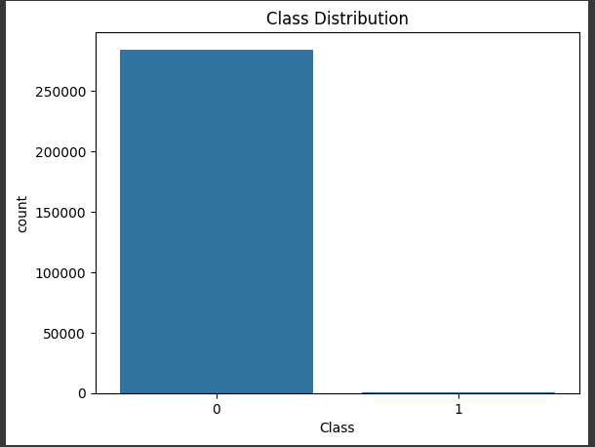

|  |
| --- |
| **Logistic Regression Results:** |
| Accuracy: 0.948542989290048 |
| Precision: 0.9741353718272228 |
| Recall: 0.9217345505617978 |
| F1 Score: 0.9472107959875875 |
| Confusion Matrix: |
| [[83058 2091] |
| [ 6687 78753]] |

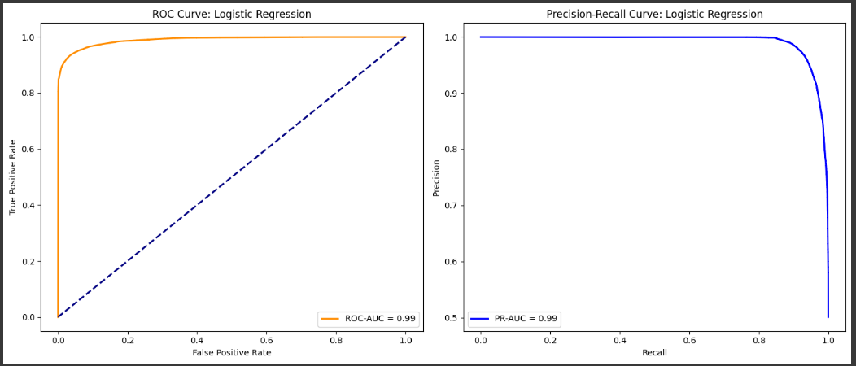

|  |
| --- |
| **XGBoost Results:** |
| Accuracy: 0.9996951737802555 |
| Precision: 0.9993917559537735 |
| Recall: 1.0 |
| F1 Score: 0.9996957854585449 |
| Confusion Matrix: |
| [[85097 52] |
| [ 0 85440]] |

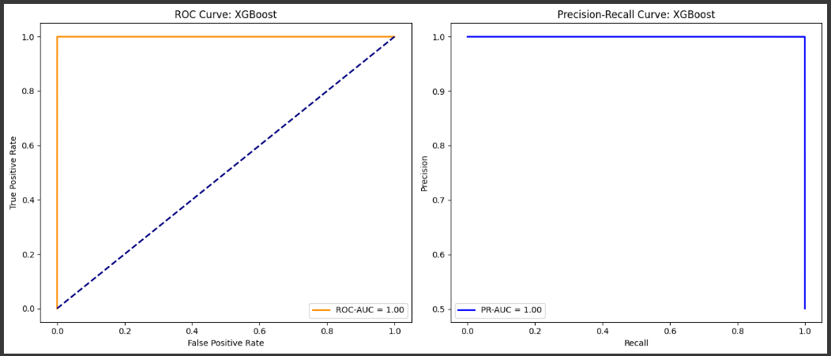

|  |
| --- |
| **MLP Results:** |
| Accuracy: 0.9998358628047529 |
| Precision: 0.9996723920063649 |
| Recall: 1.0 |
| F1 Score: 0.9998361691670372 |
| Confusion Matrix: |
| [[85121 28] |
| [ 0 85440]] |
|  |

**Isolation Forest Results:**

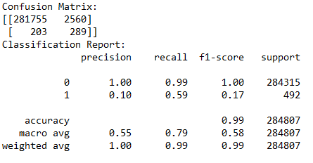

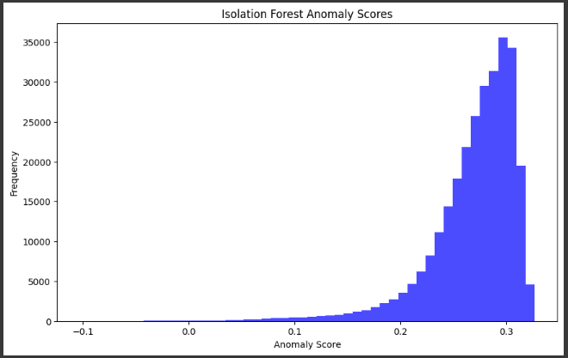

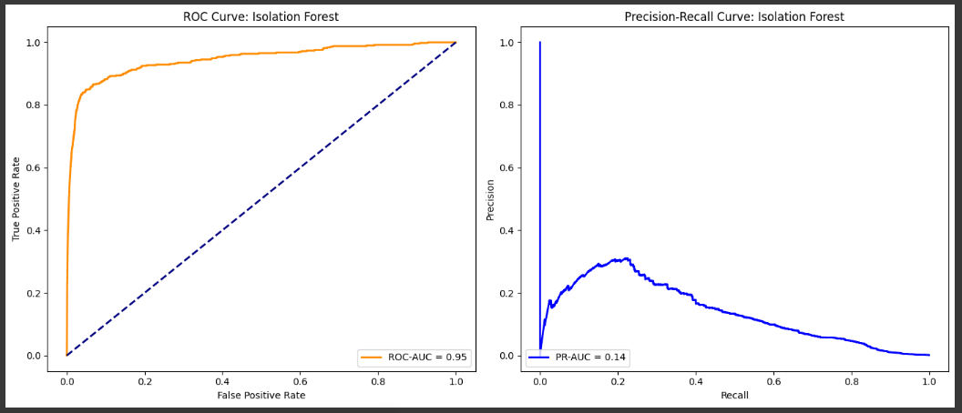

**Autoencoder Results:**

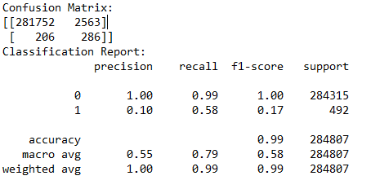

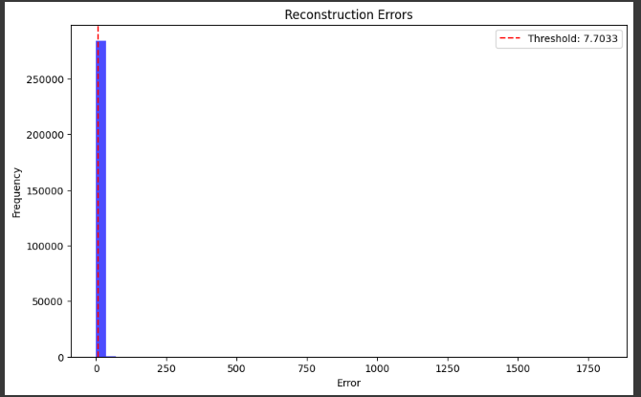

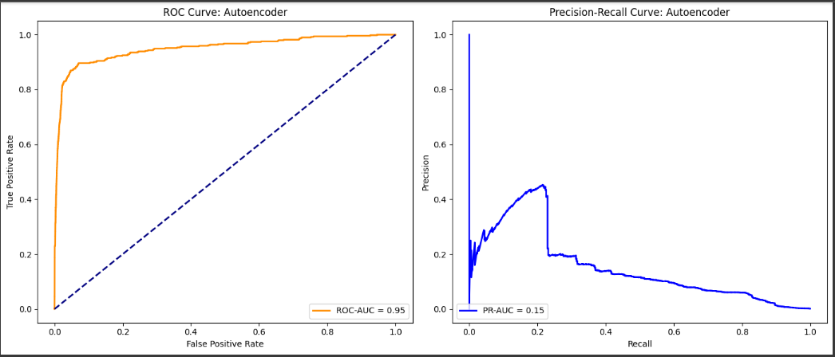

**SHAP (SHapley Additive exPlanations)** to interpret predictions made by the XGBoost model. SHAP provides insight into how each feature contributes to a particular prediction.

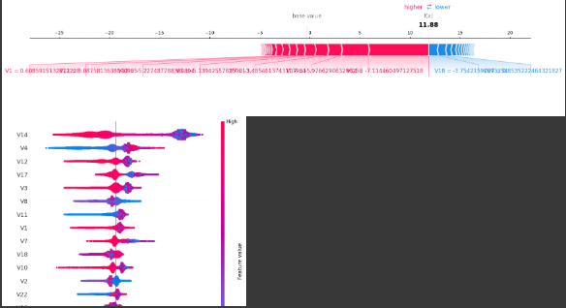

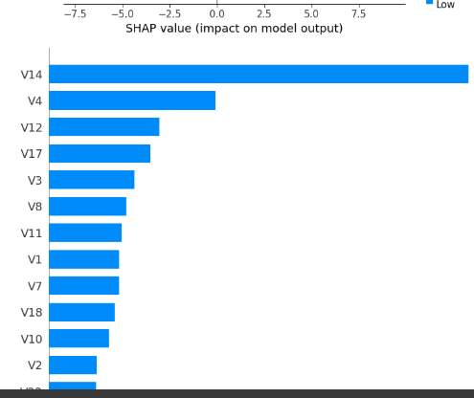

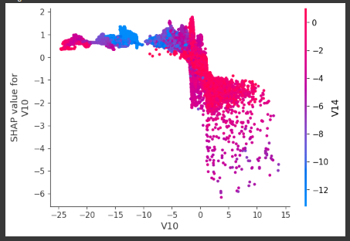

**Significance of Unsupervised model:**

**Objective: Effectively uses anomaly detection techniques to identify fraudulent transactions.**

**Models:**

**A) Isolation Forest:** Detects anomalies based on the decision function**.**

**B) Autoencoder**: Learns a compressed representation and flags transactions with high reconstruction errors.

**Significance:**

Effectively identifies anomalies without labeled data.

Detecting even a small percentage of fraud can significantly reduce financial losses.

Anomaly detection methods like Isolation Forest and Autoencoders can provide insights into atypical transaction patterns for further investigation.

**Future Enhancements**

Experiment with advanced anomaly detection methods like Variational Autoencoders or One-Class SVM.

Incorporate domain knowledge to fine-tune models for real-world applications.

Apply transfer learning techniques to leverage pre-trained models for fraud detection tasks.