**PROJECT-NAME :- *mi.com***

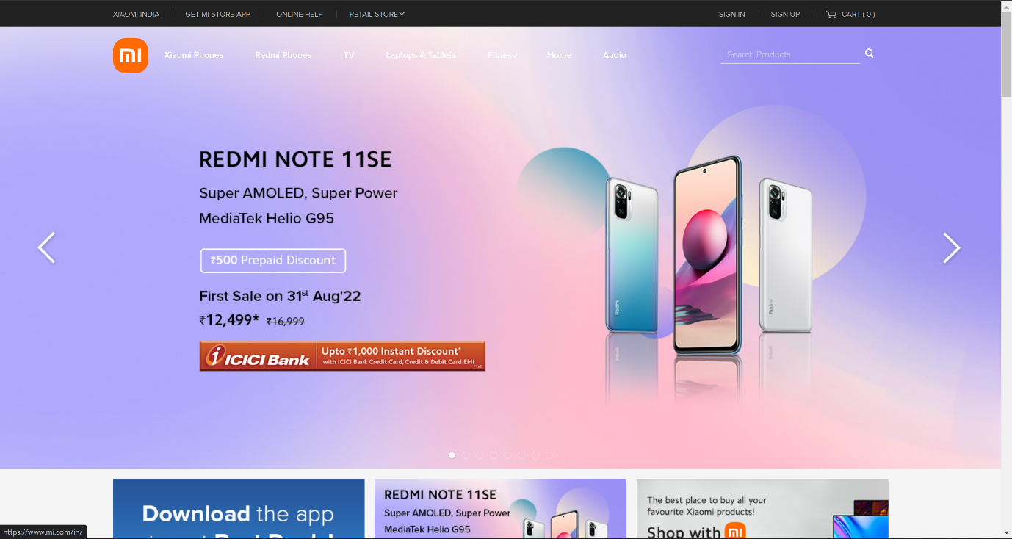

**OVERVIEW**

Xiaomi is a consumer electronics and smart manufacturing company with smartphones and smart hardwares connected by an IoT platfom at its core.

**HOME PAGE**

> Header – Company name, Login/SignUp, Cart

> Sliders With Arrows - (Images)

> SEARCH BAR

> Star Products

> Hot Accessories

> Footer – ( Contact Us , Helplines , Brief Description

About The Company , Social-Media Handle

Icons , Link To Mobile App )

**MAIN PAGE**

> Images Of The Chosen Product With Details Like -

[ Product Name , Price , Discount% ( If Any ) ]

> On Clicking The Image - (Multiple Images Of The

Product Will Appear From Different Angles ,

Zoom In , Zoom Out

>Product Description - Product Name Price , Discount% (If Any) , Delivery Options , Product Details , Specifications , Ratings , Customer Reviews With Images (If Any )

>Lower Half Of The Page - Related Products

**PAYMENT PAGE**

> Address Selection

> Payment Method – Phonepe, Google Pay, Paytm, Bhim UPI, COD, Credit/Debit Card, Net Banking, EMI.