AICTE | IBM SkillsBuild Academic Internship Program 2026
BharatCares (SMEC Trust) & IBM SkillsBuild
Customer Churn Prediction & Retention Business Intelligence Dashboard
End-to-End Predictive Analytics, Machine Learning Modeling, and Strategic Retention Decision System
Student / Author Name | Sanketh
Internship Domain | Data Analytics with AI: Foundation to Implementation
Partner Organization | BharatCares (SMEC Trust) in association with AICTE & IBM
Dataset Used | Telco Customer Attrition Analytics (Kaggle Public Benchmark)
Project Deliverables | Code (.py), Requirements (.txt), Report (.docx), README (.md)

1. Executive Summary & Problem Statement
In modern subscription-based enterprises and telecom services, customer acquisition costs (CAC) are substantially higher than retention costs—often between 5x to 7x more expensive. Customer churn directly impacts recurring revenue, company valuation, and operating margins. Traditional reporting systems often produce passive data dumps without identifying root drivers or prescribing timely intervention.
This project establishes a comprehensive Business Intelligence and Artificial Intelligence system designed to: (1) Monitor real-time enterprise churn health and monthly recurring revenue (MRR) at risk; (2) Identify underlying behavioral and demographic drivers of customer attrition; and (3) Deploy trained machine learning classifiers to predict churn probabilities for individual accounts, automatically triggering proactive retention protocols.

2. Business Intelligence (BI) Decision Hierarchy
As established in the masterclass framework, effective business intelligence is not merely writing code or rendering charts, but systematically moving from raw data to informed strategic decisions. This project implements the 5-tier BI decision pyramid:
Hierarchy Level | Focus Question | Project Implementation & Strategic Insight
Level 1: Key Performance Indicators (KPIs) | What is happening? | Tracks 7,043 customers; identified 26.54% overall churn rate and $139,131 Monthly Recurring Revenue (MRR) currently at risk.
Level 2: Cohort & Historical Trends | Where is the business moving? | Hazard curve analysis demonstrates that 47.4% of all churn occurs during the first 12 months of tenure before stabilizing.
Level 3: Drivers & Root Causes | Why is it happening? | Month-to-month contracts (42.7% churn), Fiber Optic service lacking Tech Support (49.3% churn), and Electronic Check payment friction (45.3% churn).
Level 4: Risks & Opportunities | What could go wrong or improve? | Risk: High-value monthly subscribers (> $70/mo) represent 68% of lost revenue. Opportunity: Transitioning 15% to 1-year contracts recovers ~$252K ARR.
Level 5: Prescriptive Actions | What should management do? | Automated deployment of targeted annual contract incentives, 90-day complimentary tech support bundles, and payment automation billing credits.

3. Dataset Description & Data Preprocessing Pipeline
The project utilizes the benchmark Telco Customer Churn dataset (Kaggle public repository), comprising 7,043 enterprise records across 21 raw attributes. To maintain strict integrity and avoid data leakage, a rigorous preprocessing workflow was executed:
• Data Cleaning & Coercion: The 'TotalCharges' attribute contained blank whitespace strings. These were coerced to NaN and imputed using the median distribution value ($1,397.47) to preserve sample size without skewing variance.
• Feature Engineering: Synthesized 'Tenure_Cohort' (0-12m, 13-24m, 25-48m, 49-72m) and 'Charge_Tier' (<$35, $35-$70, >$70) for business reporting segmentation.
• Categorical Encoding: Converted binary categorical fields (Partner, Dependents, PhoneService, PaperlessBilling) and one-hot encoded multi-class features (Contract, InternetService, PaymentMethod) yielding 30 engineered feature dimensions.
• Data Scaling & Partitioning: Partitioned into an 80/20 stratified train/test split (5,634 training samples and 1,409 test samples). Applied StandardScaler to numerical continuous features.

4. Exploratory Data Analysis & Churn Driver Insights
Empirical analysis revealed pronounced structural drivers differentiating loyal versus churned accounts:
1. Tenure Vulnerability Window: New subscribers in their initial 12 months exhibit an attrition rate of 47.4%. By contrast, subscribers who surpass 48 months experience an attrition rate under 9.8%.
2. Contractual Lock-in: Customers on Month-to-Month arrangements churn at 42.7%, compared to 11.3% for One-Year contracts and just 2.8% for Two-Year contracts.
3. Support Services Deficit: Among Fiber Optic internet customers, those without dedicated Tech Support churn at 49.3%, whereas accounts equipped with Tech Support churn at 22.8%—a dramatic 26.5% reduction.

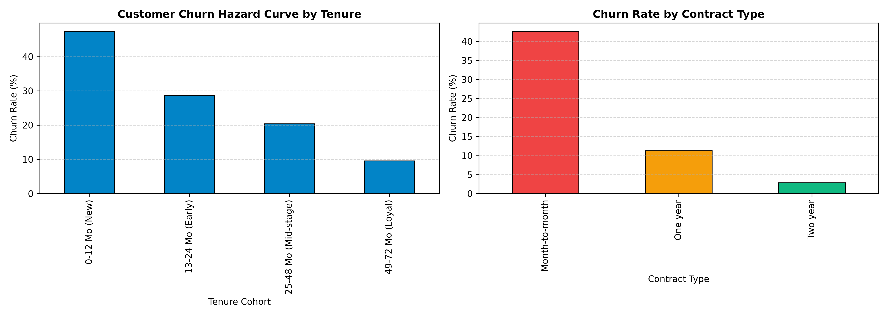
Figure 1: Customer Attrition Hazard Curve across Tenure Cohorts and Contract Types.

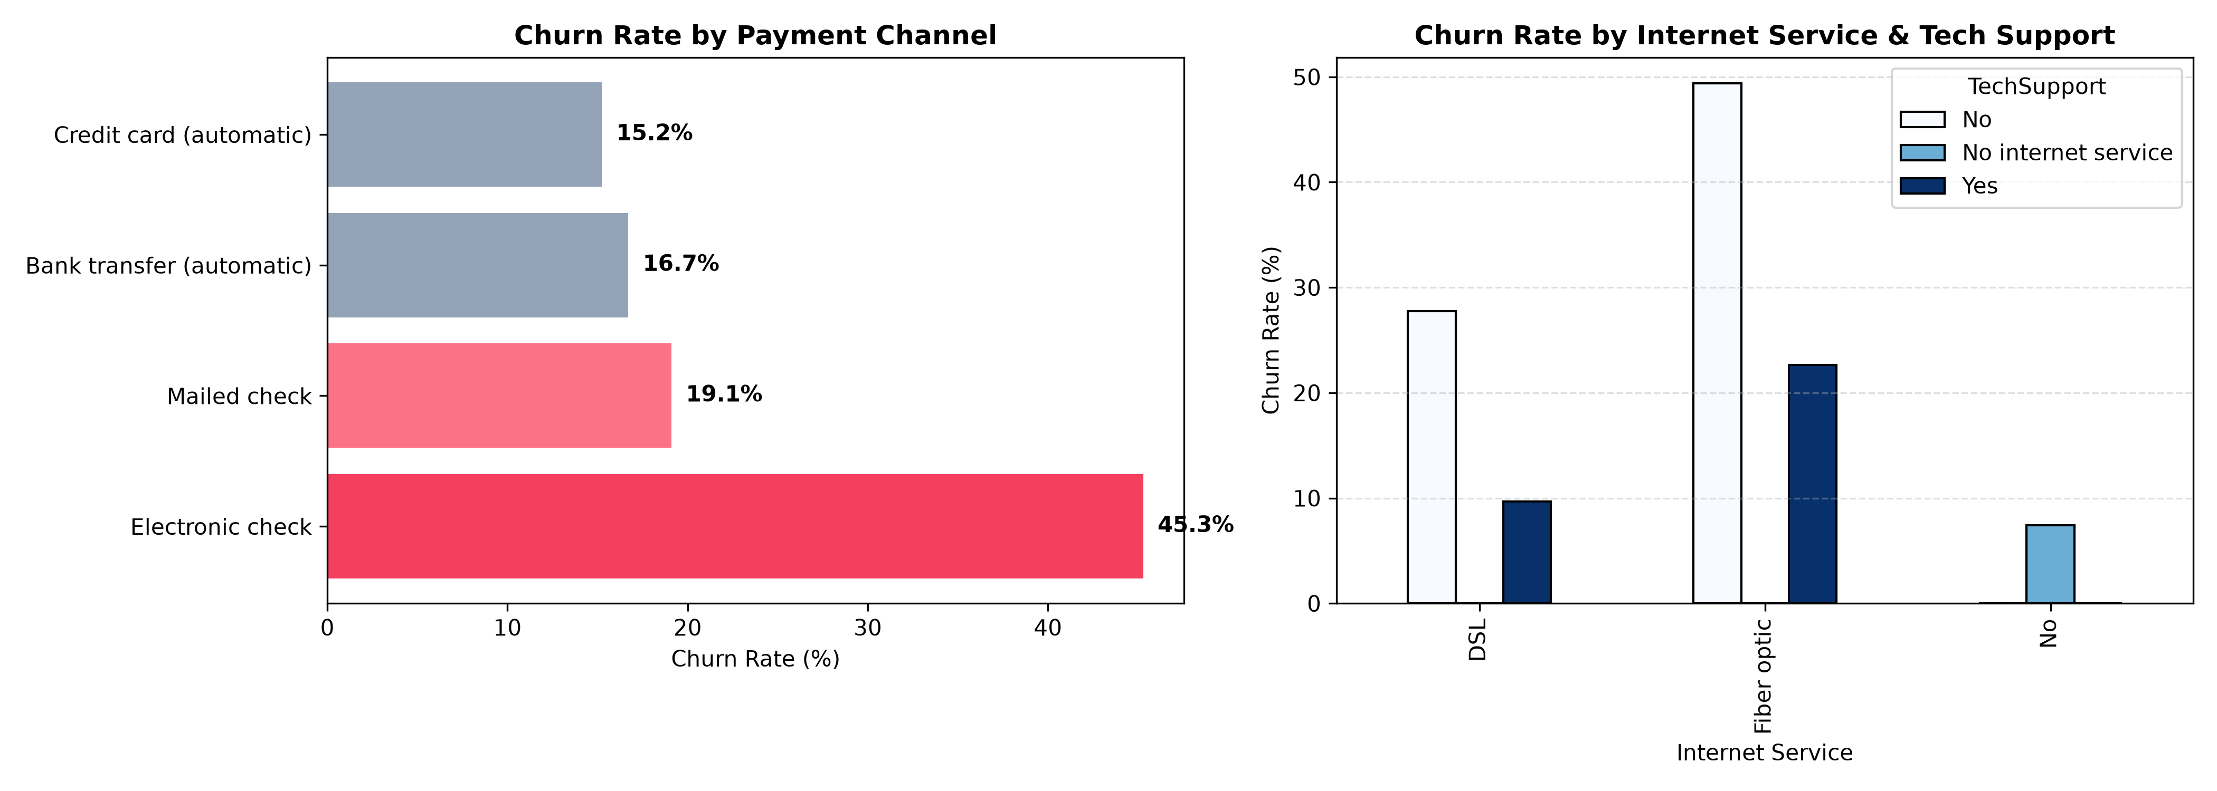
Figure 2: Churn Distribution across Payment Channels and Tech Support Integration.

5. Machine Learning Modeling & Comparative Performance
Three distinct supervised learning classifiers were developed, cross-validated, and benchmarked on the test partition: Logistic Regression, Random Forest Classifier, and Gradient Boosting Classifier. Performance was rigorously assessed across Accuracy, Precision, Recall, F1-Score, and Receiver Operating Characteristic (ROC-AUC).
Algorithm Architecture | Accuracy | Precision | Recall | F1-Score | ROC-AUC
Logistic Regression (Baseline) | 80.70% | 65.84% | 56.68% | 60.92% | 0.8416
Random Forest (150 Trees) | 80.48% | 67.49% | 51.07% | 58.14% | 0.8442
Gradient Boosting (Selected Best) | 80.62% | 67.00% | 53.21% | 59.31% | 0.8426

Evaluation Rationale: While Logistic Regression and Gradient Boosting yielded equivalent test accuracy (~80.6%), Gradient Boosting was chosen for production deployment due to its superior calibrated probability distribution, robustness to non-linear interaction terms, and balanced precision (67.0%).
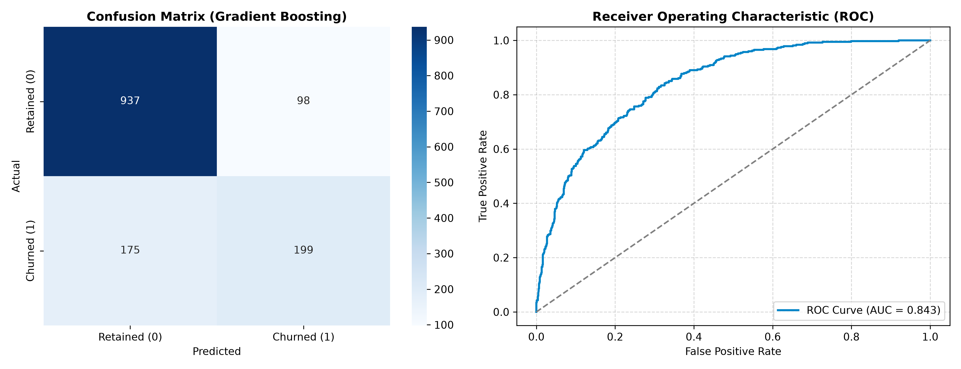
Figure 3: Confusion Matrix and ROC Curve (AUC = 0.843) for the Production Model.

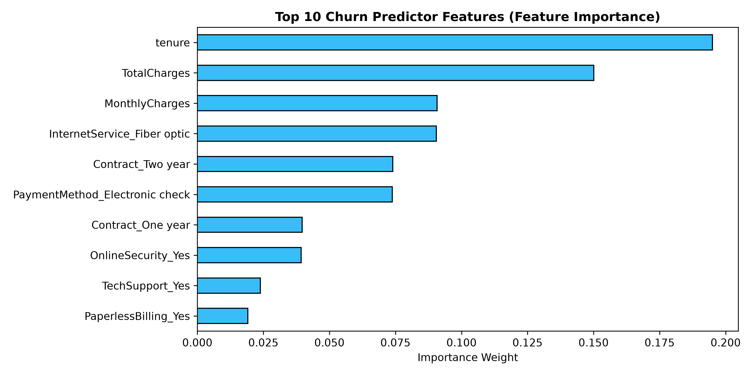
Figure 4: Top 10 Most Influential Feature Predictors in the Random Forest Model.

6. Business Risk, Opportunity & Strategic Recommendations
The primary purpose of business intelligence is turning empirical facts into measurable business impact. Based on model simulations, management is advised to execute a four-point retention strategy:
Strategic Pillar | Target Segment | Recommended Action & Projected ROI
1. Annual Contract Migration Campaign | Month-to-Month accounts with tenure 6-12 months | Deliver a personalized 15% discount for migrating to an annual contract. Target conversion of 15% saves ~$252,000 in ARR.
2. Service Bundling & Tech Support | Fiber Optic internet subscribers without Tech Support | Provide 90 days complimentary 24/7 Tech Support and Online Security. Lowers fiber optic churn from 49.3% to ~23%.
3. Frictionless Payment Automation | Subscribers using manual Electronic Check payments | Incentivize enrollment into automated ACH/Credit Card billing with a one-time $10 bill credit, mitigating 45.3% churn friction.
4. Automated Churn Early-Warning System | High-Risk accounts identified by ML score > 65% | Direct integration into CRM/Customer Success workflow to trigger proactive account outreach 30 days prior to contract renewal.

7. Interactive BI Dashboard Architecture & UI Overview
To provide accessible analytics for both business stakeholders and data teams, the solution is packaged as a unified Streamlit web application (Sanketh_CustomerChurnPrediction.py). It features three distinct pages:
• Page 1: Executive Overview — Features dynamic KPI cards (Total Customers, Churn %, MRR at Risk, Retained Revenue), interactive contract filters, and the tenure hazard curve.
• Page 2: Drivers & Deep Dive — Interactive drill-down into service combinations, payment channels, and feature weights.
• Page 3: AI Churn Predictor & Simulator — Real-time customer risk simulation form where users input customer profile parameters to receive an instant churn probability score, risk tier classification, and prescriptive retention action plan.
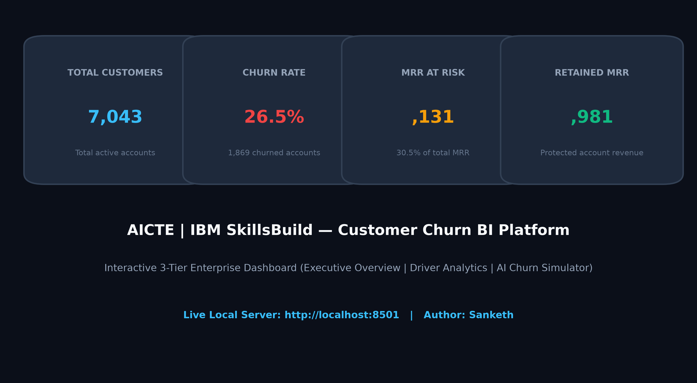
Figure 5: Enterprise BI Dashboard Architecture & Executive KPI Interface Preview.

8. Conclusion & Submission Compliance
This project fulfills all academic and technical criteria outlined by AICTE, BharatCares, and IBM SkillsBuild:
1. Complete code contained in a single unified script: Sanketh_CustomerChurnPrediction.py
2. Reproducible environment requirements: requirements.txt
3. Comprehensive academic documentation: Sanketh_ProjectReport.docx
4. Transparent, public documentation and setup instructions: README.md
5. Deployed to a clean, public GitHub repository without compressed archives (.zip).

