**Problem Statement**

**Key Performance Indicators (KPIs) Requirements:**

**Total Loan Applications: We need to calculate the total number of loan applications received during a specified period. Additionally, it is essential to monitor the Month-to-Date (MTD) Loan Applications and track changes Month-over-Month (MoM).**

1. **Total Loan Applications:**

SELECT count (id) as Total_Loan_Application FROM Bank_loan_Data



1. **MTD Loan Application:**

SELECT count (id) as MTD_Total_Application FROM Bank_loan_Data

WHERE MONTH(issue_date ) = 12 AND YEAR(issue_date)=2021



1. **PMTD Loan Application:**

SELECT count (id) as PMTD_Total_Application FROM Bank_loan_Data

WHERE MONTH(issue_date ) = 11 AND YEAR(issue_date)=2021



**Total Funded Amount: Understanding the total amount of funds disbursed as loans is crucial. We also want to keep an eye on the MTD Total Funded Amount and analyse the Month-over-Month (MoM) changes in this metric.**

1. **Total Funded Amount:**

SELECT SUM(loan_amount) Total_Funded_Amount FROM Bank_loan_Data



1. **MTD Total Funded Amount:**

SELECT SUM(loan_amount) MTD_Total_Funded_Amount FROM Bank_loan_Data WHERE MONTH(issue_date ) = 12 AND YEAR(issue_date)=2021



1. **Previous MTD Funded Amount:**

SELECT SUM(loan_amount) PMTD_Total_Funded_Amount FROM Bank_loan_Data WHERE MONTH(issue_date ) = 11 AND YEAR(issue_date)=2021



**Total Amount Received: Tracking the total amount received from borrowers is essential for assessing the bank's cash flow and loan repayment. We should analyse the Month-to-Date (MTD) Total Amount Received and observe the Month-over-Month (MoM) changes.**

1. **Total Amount Received:**

SELECT SUM(total_payment) AS Total_Amount_Received from Bank_loan_Data



1. **MTD Total Received Amount:**

SELECT SUM(total_payment) AS MTD_Amount_Received from Bank_loan_Data

WHERE MONTH(issue_date)=12 AND YEAR(issue_date)=2021



1. **PMTD Total Received Amount**:

SELECT SUM(total_payment) AS PMTD_Amount_Received from Bank_loan_Data

WHERE MONTH(issue_date)=11 AND YEAR(issue_date)=2021



**Average Interest Rate: Calculating the average interest rate across all loans, MTD, and monitoring the Month-over-Month (MoM) variations in interest rates will provide insights into our lending portfolio's overall cost.**

**1.Average Interest Rate:**

SELECT ROUND(AVG(int_rate),4)*100 AS Avg_Interst_Rate from Bank_loan_Data



1. **MTD Average Interest Rate:**

SELECT ROUND(AVG(int_rate),4)*100 AS MTD_Avg_Interst_Rate from Bank_loan_Data

WHERE MONTH(issue_date)=12 AND YEAR(issue_date)=2021



1. **PMTD Average Interest Rate:**

SELECT ROUND(AVG(int_rate),4)*100 AS MTD_Avg_Interst_Rate from Bank_loan_Data

WHERE MONTH(issue_date)=11 AND YEAR(issue_date)=2021



**Average Debt-to-Income Ratio (DTI): Evaluating the average DTI for our borrowers helps us gauge their financial health. We need to compute the average DTI for all loans, MTD, and track Month-over-Month (MoM) fluctuations.**

1. **Average Debt-to-Income Ratio (DTI):**

SELECT ROUND(AVG(dti),4)*100 AS Avg_DTI_Ratio from Bank_loan_Data



1. **MTD Average Interest Rate:**

SELECT ROUND(AVG(dti),4)*100 AS MTD_Avg_DTI_Ratio from Bank_loan_Data

WHERE MONTH(issue_date)=12 AND YEAR(issue_date)=2021



**3.PMTD Average Interest Rate:**

SELECT ROUND(AVG(dti),4)*100 AS PMTD_Avg_DTI_Ratio from Bank_loan_Data

WHERE MONTH(issue_date)=11 AND YEAR(issue_date)=2021



**KPI: Good Loan VS Bad Loan**

**Good Loan:**

1. **Good Loan Application Percentage.**

SELECT

COUNT(CASE WHEN LOAN_STATUS >= 'FULLY PAID' OR LOAN_STATUS='CURRENT' THEN ID END)*100 /

COUNT(ID) AS Good_Loan_Percentage

FROM Bank_loan_Data



1. **Good Loan Applications.**

SELECT COUNT(ID) AS Good_Loan_Applications FROM Bank_loan_Data

WHERE LOAN_STATUS='FULLY PAID' OR LOAN_STATUS= 'CURRENT'



**3.Good Loan Funded Amount**

SELECT SUM(Loan_amount) as Good_Loan_Funded_Amount from Bank_loan_Data

WHERE LOAN_STATUS='FULLY PAID' OR LOAN_STATUS= 'CURRENT'



**4.Good Loan Total Received Amount**

SELECT SUM(total_payment) as Good_Loan_Total_Received_Amount from Bank_loan_Data WHERE LOAN_STATUS='FULLY PAID' OR LOAN_STATUS= 'CURRENT'



**Bad Loan:**

**1.Bad Loan Application Percentage**

SELECT

(COUNT(CASE WHEN LOAN_STATUS = 'CHARGED OFF' THEN ID END)*100.0) /

COUNT(ID) AS Bad_Loan_Percentage

FROM Bank_loan_Data



**2.Bad Loan Applications**

SELECT COUNT(ID) AS Total_Bad_Loan_Application FROM Bank_loan_Data

WHERE LOAN_STATUS = 'CHARGED OFF'



**3.Bad Loan Funded Amount**

SELECT sum(loan_amount) AS Bad_Loan_Funded_Amount FROM Bank_loan_Data

WHERE LOAN_STATUS = 'CHARGED OFF'



**4.Bad Loan Total Received Amount**

SELECT sum(total_payment) AS Bad_Loan_Total_Received_Amount FROM Bank_loan_Data

WHERE LOAN_STATUS = 'CHARGED OFF'



**Loan Status Grid View:**

SELECT LOAN_STATUS,

COUNT(ID) as Loan_Account,

SUM(loan_amount) as Total_Funded_Amount,

SUM(TOTAL_PAYMENT) as Total_Payment_Received,

AVG(int_rate*100),

AVG(dti)

FROM Bank_loan_Data

group by

LOAN_STATUS

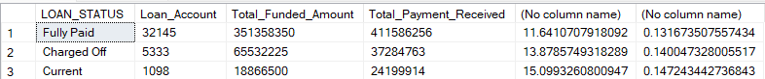

**Month-to-Date (MTD) Funded Amount,' 'MTD Amount Received,'**

SELECT loan_status,

SUM(loan_amount) as MTD_Funded_Amount,

SUM(total_payment) as MTD_Amount_Received

FROM Bank_loan_Data

WHERE MONTH(issue_date)=12

group by

loan_status

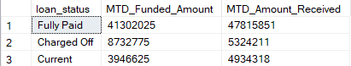

**Overview:**

1. **Monthly Trends by Issue Date for 'Total Loan Applications,' 'Total Funded Amount,' and 'Total Amount Received:**

SELECT

MONTH(ISSUE_DATE) as Month_Number,

DATENAME(MONTH, issue_date) AS Month_Name,

count(id) as Total_Application,

sum(loan_amount) as Funded_Amount,

SUM(TOTAL_PAYMENT) as Total_Received_Payment

FROM Bank_loan_Data

group by MONTH(ISSUE_DATE), DATENAME(MONTH, issue_date)

ORDER BY MONTH(ISSUE_DATE)

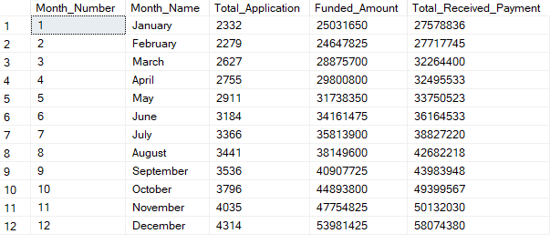

1. **Regional Analysis by State for 'Total Loan Applications,' 'Total Funded Amount,' and 'Total Amount Received'**

SELECT

TOP 10 address_state,

count(id) as Total_Application,

sum(loan_amount) as Funded_Amount,

SUM(TOTAL_PAYMENT) as Total_Received_Payment

FROM Bank_loan_Data

group by address_state

ORDER BY address_state

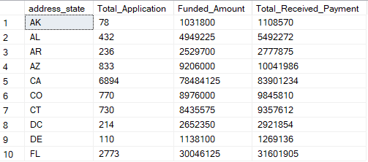

1. **Loan Term Analysis for 'Total Loan Applications,' 'Total Funded Amount,' and 'Total Amount Received'**

SELECT

term,

count(id) as Total_Application,

sum(loan_amount) as Funded_Amount,

SUM(TOTAL_PAYMENT) as Total_Received_Payment

FROM Bank_loan_Data

group by term

ORDER BY term

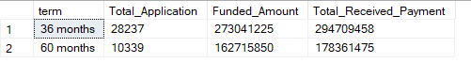

1. **Employee Length Analysis 'Total Loan Applications,' 'Total Funded Amount,' and 'Total Amount Received'**

SELECT

emp_length,

count(id) as Total_Application,

sum(loan_amount) as Funded_Amount,

SUM(TOTAL_PAYMENT) as Total_Received_Payment

FROM Bank_loan_Data

group by emp_length

ORDER BY emp_length

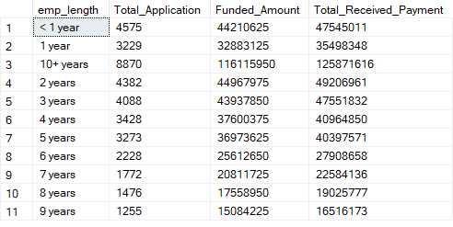

1. **Loan Purpose Breakdown 'Total Loan Applications,' 'Total Funded Amount,' and 'Total Amount Received'**

SELECT

purpose,

count(id) as Total_Application,

sum(loan_amount) as Funded_Amount,

SUM(TOTAL_PAYMENT) as Total_Received_Payment

FROM Bank_loan_Data

group by purpose

ORDER BY purpose

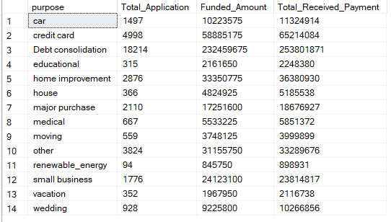

1. **Home Ownership Analysis 'Total Loan Applications,' 'Total Funded Amount,' and 'Total Amount Received'**

SELECT

home_ownership,

count(id) as Total_Application,

sum(loan_amount) as Funded_Amount,

SUM(TOTAL_PAYMENT) as Total_Received_Payment

FROM Bank_loan_Data

group by home_ownership

ORDER BY home_ownership

