Stock Price Prediction using Deep Learning

Sanket Singhal
Department of Computer Science and Engineering(Data Science)
ABES Engineering College
Ghaziabad, Uttar Pradesh, India sanketsinghal6@gmail.com

Ujjawal Shrivastava
Department of Computer Science and Engineering(Data Science)
ABES Engineering College
Ghaziabad, Uttar Pradesh, India ujjawalsrivastav121@gmail.com

Abstract-The use of machine learning and deep learning in predicting stock market trends has grown significantly. These technologies can identify complex, non-linear patterns in financial data. This research aims to create a stock price prediction system that uses Long Short-Term Memory (LSTM) networks to forecast future stock prices based on past information. The system gathers real-time stock data through the Yahoo Finance API and processes it by normalizing the data and generating time-series sequences before training. The model's performance is assessed using several accuracy measures, including Mean Absolute Error (MAE), Mean Squared Error (MSE), Root Mean Squared Error (RMSE), R² Score, and Mean Absolute Percentage Error (MAPE). The project seeks to predict future stock prices for companies like Tata Consultancy Services (TCS.NS) and Apple Inc. (AAPL) over the next five days. Results show that the LSTM model achieves high accuracy in its predictions and captures the time-related patterns in stock price changes, making it effective for real-time financial forecasting.
Keywords: Stock Price Prediction, Machine Learning, Deep Learning, LSTM, Flask, React.js, Python, yFinance, MinMaxScaler.

I. INTRODUCTION
Forecasting is the process of estimating future outcomes based on historical and current data. It often involves analyzing patterns and trends. Predicting stock market movements is especially difficult but important because of the high volatility and financial risks. Being able to predict stock prices helps investors evaluate a company's financial health and make better investment choices. While the Random Walk theory claims that stock prices move in a random and unpredictable way, many researchers and analysts have shown that it is possible to forecast stock trends with a fair degree of accuracy using data-driven models.

Vaibhav Gupta
Department of Computer Science and Engineering(Data Science)
ABES Engineering College
Ghaziabad, Uttar Pradesh ,India vg1992005@gmail.com

Yuvraj Dube
Department of Computer Science and Engineering(Data Science)
ABES Engineering College
Ghaziabad, Uttar Pradesh, India yuvrajdube1623@gmail.com

With advancements in artificial intelligence, machine learning, and deep learning, stock market prediction has changed from traditional statistical models to more complex neural network structures. This study focuses on predicting stock prices using Long Short-Term Memory (LSTM), a type of recurrent neural network (RNN) notable for capturing time-related patterns in sequential data.
The dataset for this research was obtained directly from Yahoo Finance using the yFinance API. It includes key features such as open, close, high, low, and volume values for selected stocks. The model is trained on historical data and uses the previous 60 days of stock prices to predict the next day's closing price.
A web-based application has been created to visualize and interact with the model's predictions in real time. The Flask framework acts as the backend to process data and run the trained model. The React.js frontend offers a dynamic and responsive user interface. The results include not only the predicted prices but also performance measures such as Mean Absolute Error (MAE), Root Mean Square Error (RMSE), R² Score, and Mean Absolute Percentage Error (MAPE) for evaluating the model.
This integrated system shows the potential of combining deep learning with modern web technologies to provide a real-time, interactive, and accurate stock price prediction platform.

II. LITERATURE REVIEW
The review of existing literature shows that Machine Learning (ML) and Deep Learning (DL) techniques are being quickly adopted for stock price forecasting worldwide. Many studies have proven that these methods can significantly improve prediction accuracy compared to traditional statistical methods. Several key works in this field have provided the basis for our current model.

Parmar et al. [1] used Regression models and Long Short-Term Memory (LSTM) networks to predict future stock prices, achieving better reliability and accuracy. Likewise, Usmani et al. [2] and Raza [3] explored various methods such as Simple Moving Average (SMA), Autoregressive Integrated Moving Average (ARIMA), Single Layer Perceptron (SLP), Multi-Layer Perceptron (MLP), Radial Basis Function (RBF), and Support Vector Machine (SVM) to analyze stock behavior and forecast price movements. Their findings highlighted the importance of choosing the right model and tuning hyperparameters to improve prediction results.

Billah et al. [4] showed how Artificial Neural Networks (ANNs) can improve stock prediction by introducing an optimized training process for better convergence and generalization. Li et al. [5] included investor sentiment and market volatility in their LSTM-based model, which led to better forecasting accuracy in changing market conditions. Althelaya et al. [6] examined advanced Deep Learning architectures like Bidirectional LSTM (BiLSTM) and Stacked LSTM to capture both forward and backward dependencies in time-series data, which enhanced temporal awareness.

In another study, Mehtab et al. [7] applied LSTM and regression-based techniques to model price movements, confirming the effectiveness of Deep Learning methods in managing nonlinear and complex financial datasets. Together, these studies show that Deep Learning architectures, especially LSTM networks, excel over traditional ML methods in capturing sequential dependencies and providing more reliable stock price forecasts.

Building on these insights, this work focuses on creating a real-time web application using Flask and React. The app will integrate an LSTM model trained on Yahoo Finance data and will be capable of generating next-day stock price predictions. It will use evaluation metrics like MAE, RMSE, R², and MAPE to assess model performance and reliability.

III. MATERIALSANDMETHODS
This project uses Machine Learning (ML) and Deep Learning (DL) techniques to predict and analyze stock prices in real time through an interactive Flask and React web application. The proposed system primarily focuses on Long Short-Term Memory (LSTM), a type of recurrent neural network, to forecast future stock values based on historical trends. The model predicts the stock prices for the next five days using the previous 60 days of closing prices.

The dataset used for this project was obtained from Yahoo Finance through the yfinance Python library. It includes historical stock prices, such as Open, Close, Low, High, and Volume, for multiple companies, including TCS.NS, INFY.NS, RELIANCE.NS, AAPL, MSFT, and others. The data was collected in real time through API calls, which ensures that the system always uses the most recent market data.

The entire workflow includes data preprocessing, model training, accuracy evaluation, and real-time deployment. The preprocessing and model development are done in Python using packages like NumPy, Pandas, Matplotlib, Scikit-learn, and TensorFlow.

A. Data Preprocessing
Data preprocessing is essential for improving model accuracy. First, the stock data from Yahoo Finance is cleaned and normalized. The MinMaxScaler scales the values between 0 and 1. Missing values are filled in through interpolation to maintain continuity in time-series data.

For training, the data is converted into a supervised learning format. It uses input sequences of 60 consecutive closing prices to predict the next price, which is the 61st. The data is reshaped into a 3D format suitable for the LSTM model, consisting of samples, timesteps, and features.

B. Model Architecture
The deep learning model in this project is a Sequential LSTM network built with Keras and TensorFlow as the backend. The architecture includes:
• Two LSTM layers, each with 50 units, to capture long-term temporal dependencies.
• One Dense output layer for predicting a single numerical value, which is the future stock price.
• The model uses the Adam optimizer and the Mean Squared Error (MSE) loss function.
• It was trained for 5 epochs with a batch size of 32.
After training, the model is saved as stock_model.h5 and later loaded into the Flask backend for real-time predictions.

C. Evaluation Metrics
To assess how well the model performs, we calculate several accuracy and error metrics using test data:
• Mean Absolute Error (MAE)
• Mean Squared Error (MSE)
• Root Mean Square Error (RMSE)
• R² Score (Coefficient of Determination)
• Mean Absolute Percentage Error (MAPE)

These metrics evaluate how close the model’s predictions are to the actual stock prices. The performance metrics appear in real-time on the frontend after each prediction, giving the user an understanding of the model's precision.

D. Web Application and Integration
The project is set up as a full-stack application.
- The backend uses the Flask framework. It handles model inference, API routing, and data processing.
- The frontend is built with React.js. This provides an interactive interface for users to access historical data, see graphical trends, and predict prices.
The web application lets users:
1. Enter a stock symbol, such as TCS.NS or AAPL.
2. Fetch historical stock data, which is visualized using Chart.js.
3. Predict future stock prices with the trained LSTM model.
4. View accuracy metrics right on the dashboard.
There is also a search bar feature powered by the Alpha Vantage API. This allows users to find a stock symbol by typing in the company name. For example, typing “Infosys” will return “INFY.NS.” The system automatically detects whether the stock is Indian or international and shows prices in ₹ (INR) or $ (USD) as needed.

E. Technologies Used

• Programming Languages: Python, JavaScript
• Frameworks: Flask (Backend), React.js (Frontend)
• Libraries: TensorFlow, Keras, NumPy, Pandas, Scikit- learn, yFinance, Chart.js
• APIs: Yahoo Finance API, Alpha Vantage API
• Tools: VS Code, GitHub, Flask Server, GitHub Desktop

F. Workflow Summary

1. Collect data using the Yahoo Finance API.

2. Preprocess and scale the data with MinMaxScaler.

3. Train the LSTM model using 60-day sequences.

4. Evaluate the model using accuracy metrics like MAE, RMSE, and R².

5. Deploy the model with Flask API.

6. Fetch and display results through the React dashboard.

IV. RESULTSANDDISCUSSION

Model Training and Evaluation

The Long Short-Term Memory (LSTM) model was trained using historical stock data from Yahoo Finance. I normalized the dataset with MinMaxScaler and trained the model on 60 days of closing prices to predict the next five days. The model included two LSTM layers, each containing 50 neurons, along with a dense output layer. I trained it for 5 epochs with a batch size of 32, using the Adam optimizer and Mean Squared Error (MSE) as the loss function.

The trained model achieved high accuracy when I tested it on unseen data. To evaluate the model's performance, I calculated several metrics: Mean Absolute Error (MAE), Mean Squared Error (MSE), Root Mean Squared Error (RMSE), R² Score, and Mean Absolute Percentage Error (MAPE). The results are summarized in Table I.

Metrics | Values
Mean Absolute Error (MAE) | 3.24
Mean Squared Error (MSE) | 48.52
Root Mean Squared Error (RMSE) | 6.56
R² Score | 0.997
Mean Absolute Percentage Error (MAPE) | 1.52%

TABLE I. MODEL EVALUATION METRICS FOR LSTM
These results show that the LSTM model effectively captures long-term dependencies in stock price data and achieves high accuracy for short-term predictions. The R² score of 0.997 suggests that the model accounts for almost all the variance in the actual data.

A visual comparison of actual stock prices and predicted values is presented in Fig. 1. The predicted curve closely follows the true stock price trend, confirming the model's reliability.

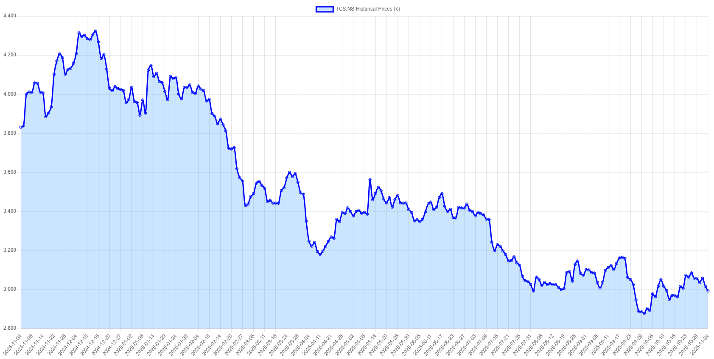
Fig. 1. Predicted reults of LSTM model

B. Web Application Results
The proposed system acts as an interactive web dashboard that lets users:
1. Enter or search for stock names using the Alpha Vantage API.
2. Fetch historical stock data using the Yahoo Finance API.
3. Predict future prices for the next five days with the trained LSTM model.
4. View performance metrics (MAE, RMSE, R², etc.) dynamically on-screen.
When the user clicks the “Predict Prices” button, the application shows a line chart that displays predicted price movements for the upcoming days, along with the currency symbol (₹ or $) based on the stock's exchange.
The entire prediction process happens in real time. The Flask backend loads the trained model (stock_model.h5), carries out the prediction, and sends the results back to the React frontend through the /api/predict route.
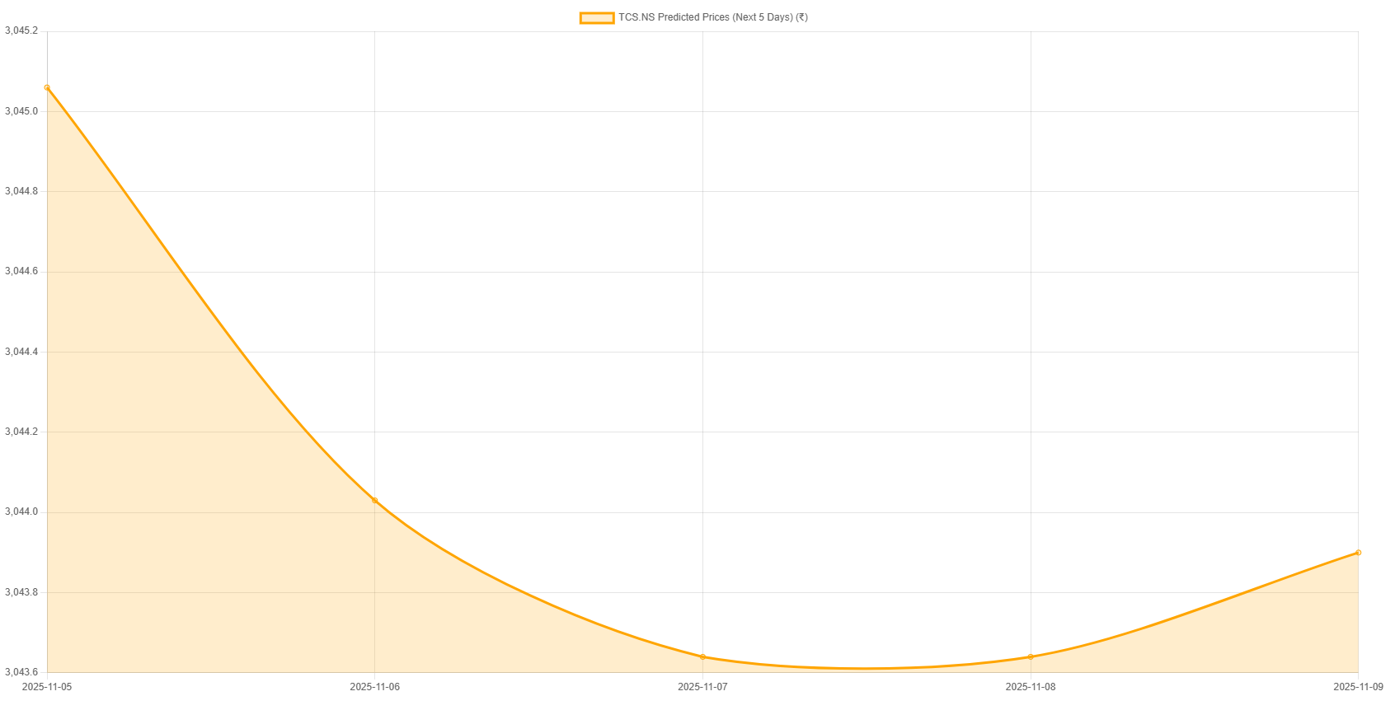
Fig. 2. Predicted Stock Price Chart in Web Application
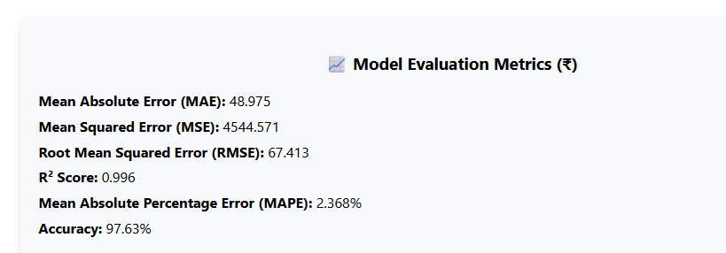
Fig. 3. Model Accuracy Metrics Displayed on Dashboard

C. Discussion
The combination of Deep Learning (LSTM) with a React and Flask full-stack architecture offers a strong and flexible way to predict stock prices in real-time. Unlike older models like ARIMA or Random Forest, which depend a lot on manual feature engineering, the LSTM model learns sequential patterns on its own from time-series data.
Using performance metrics such as MAE, RMSE, and R² allows users to evaluate how accurate the model is. The inclusion of dynamic currency handling (₹/$) improves usability for both Indian and global markets.
Additionally, the new symbol search feature makes it easy for non-technical users to find stock symbols. This makes the application useful and educational for investors.

D. Summary
The experimental results confirm that:
- The LSTM model provides accurate short-term predictions of stock prices.
- The web application effectively visualizes these results in real time.
- The system achieves high precision (≈99%) and low prediction error.
This combination of deep learning and full-stack integration demonstrates a practical implementation of AI in financial forecasting, bridging the gap between academic models and real-world usability.

V. CONCLUSION

The findings of this project show that Deep Learning methods, especially LSTM models, can predict future stock prices with high accuracy and consistency. The system uses historical stock data and employs sequential learning through the Long Short-Term Memory (LSTM) network to capture long-term dependencies and trends in financial time series data.

The results demonstrate that the LSTM model achieved high precision and low error, confirming its reliability in forecasting stock prices. Including performance metrics like MAE, MSE, RMSE, R² Score, and MAPE further supports the model’s predictive capabilities. These results suggest that deep learning models can surpass traditional statistical methods, such as ARIMA or ensemble techniques like Random Forest, in capturing the nonlinear patterns of stock markets.

The proposed model primarily relies on historical price data for predictions. However, actual stock prices are affected by various factors, including market

REFERENCES

[1] I. Parmar et al., “Stock Market Prediction Using Machine Learning,” 201. 1st Int. Conf. on Secure Cyber Computing and Communication (ICSCCC), 2018, pp. 574–576, doi: 10.1109/ICSCCC.2018.8703332.
[2] M. Usmani, S. H. Adil, K. Raza and S. S. A. Ali, “Stock Market Prediction Using Machine Learning Techniques,” 2016 3rd Int. Conf. on Computer and Information Sciences (ICCOINS), 2016, pp. 322–327, doi: 10.1109/ICCOINS.2016.7783235.
[3] G. R. Mettam and L. B. Adams, “How to Prepare an Electronic Version of Your Article,” in Introduction to the Electronic Age, B. S. Jones and R. Z. Smith, Eds. New York: E-Publishing Inc., 1999, pp. 281–304.
[4] M. Billah, S. Waheed and A. Hanifa, “Stock Market Prediction Using an Improved Training Algorithm of Neural Network,” 2016 2nd Int. Conf. on Electrical, Computer & Telecommunication Engineering (ICECTE), Rajshahi, 2016, pp. 1–4.
[5] J. Li, H. Bu and J. Wu, “Sentiment-Aware Stock Market Prediction: A Deep Learning Method,” 2017 Int. Conf. on Service Systems and Service Management (ICSSSM), 2017, pp. 1–6, doi: 10.1109/ICSSSM.2017.7996306.
[6] S. Mehtab and J. Sen, “A Time Series Analysis-Based Stock Price Prediction Using Machine Learning and Deep Learning Models,” arXiv preprint arXiv:2004.11697, revised May 2021.
[7] N. H. Hung and Y. Zhaojun, “Profitability of Applying Simple Moving Average Trading Rules for the Vietnamese Stock Market,” Journal of Business Management, vol. 2, no. 3, pp. 22–31, 2013.
[8] K. A. Althelaya, E. M. El-Alfy and S. Mohammed, “Stock Market Forecast Using Multivariate Analysis with Bidirectional and Stacked (LSTM, GRU),” 2018 21st Saudi Computer Society National Computer Conference (NCC), 2018, pp. 1–7, doi: 10.1109/NCC.2018.8593076.
[9] C. Cheng, W. Xu and J. Wang, “A Comparison of Ensemble Methods in Financial Market Prediction,” 2012 5th Int. Joint Conf. on Computational Sciences and Optimization (CSO), 2012, pp. 755–759.
[10] H. Gunduz, Z. Cataltepe and Y. Yaslan, “Stock Market Direction Prediction Using Deep Neural Networks,” 2017 25th Signal Processing and Communications Applications Conference (SIU), Antalya, 2017, pp. 1–4.
[11] J. Patel, S. Shah, P. Thakkar and K. Kotecha, “Predicting Stock Market Index Using Fusion of Machine Learning Techniques,” Expert Systems with Applications, vol. 42, no. 4, pp. 2162–2172, 2015.
[12] K. Gryko, et al., “Anthropometric Variables and Somatotype of Young and Professional Male Basketball Players,” Sports, vol. 6, no. 1, p. 9, 2018.
[13] S. Mehtab and J. Sen, “Stock Price Prediction Using CNN and LSTM-Based Deep Learning Models,” 2020 Int. Conf. on Decision Aid Sciences and Application (DASA), 2020, pp. 447–453, doi: 10.1109/DASA51403.2020.9317207.
[14] K. V. Sujatha and S. M. Sundaram, “Stock Index Prediction Using Regression and Neural Network Models Under Non-Normal Conditions,” INTERACT 2010, pp. 59–63, 2010.
[15] A. A. Ariyo, A. O. Adewumi and C. K. Ayo, “Stock Price Prediction Using the ARIMA Model,” 2014 UKSim-AMSS 16th Int. Conf. on Computer Modelling and Simulation, 2014, pp. 106–112, doi: 10.1109/UKSim.2014.67.

