Name:- Sankalp Kitey BTECH EN

SQL PROJECT- MUSIC STORE DATA ANALYSIS

Question Set 1 - Easy

1. Who is the senior most employee based on job title?

Ans:-

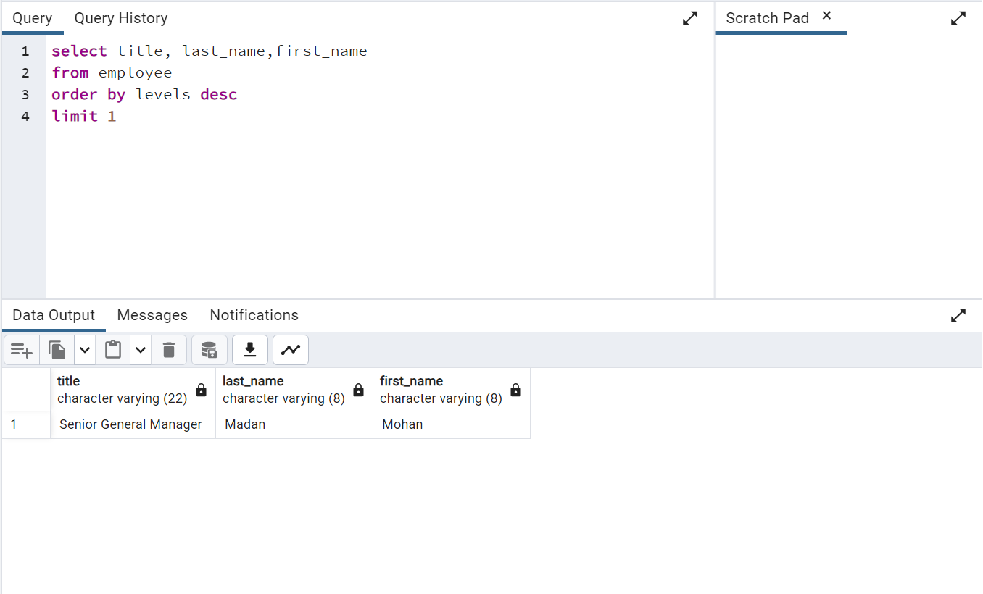

1. Which countries have the most Invoices?

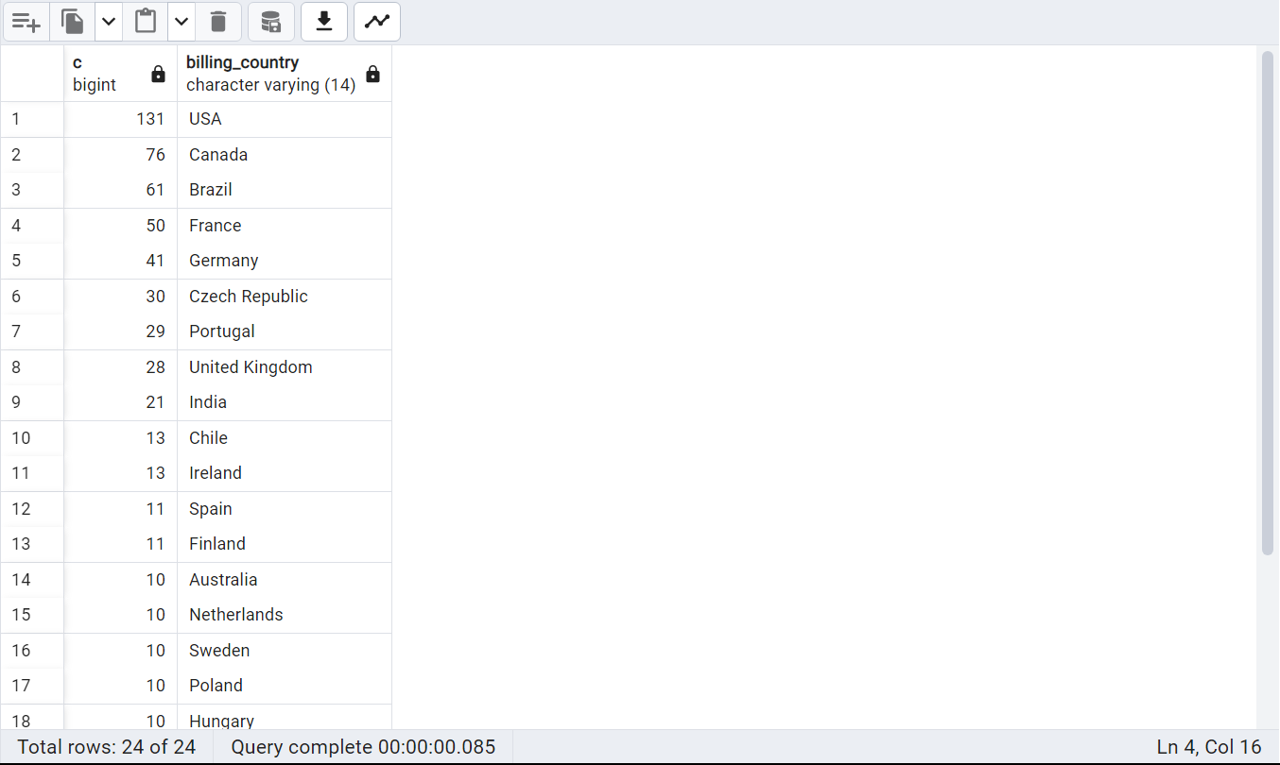

1. What are top 3 values of total invoice?

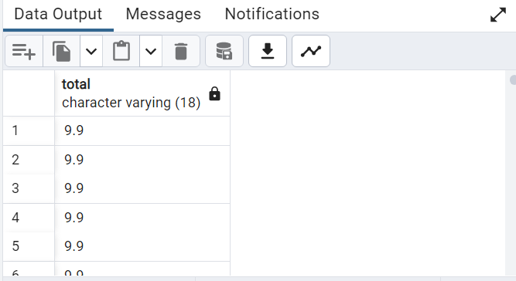

1. Which city has the best customers? We would like to throw a promotional Music

Festival in the city we made the most money. Write a query that returns one city that

has the highest sum of invoice totals. Return both the city name & sum of all invoice

totals

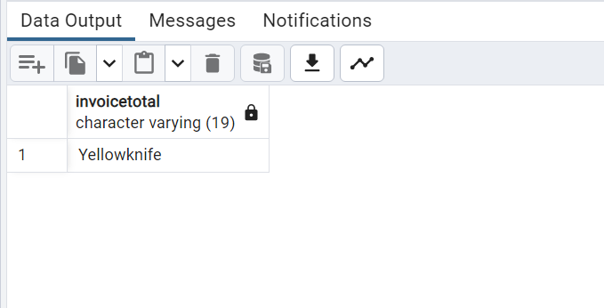

5. Who is the best customer? The customer who has spent the most money will be

declared the best customer. Write a query that returns the person who has spent the

most money

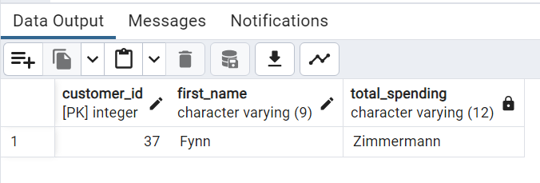

Question Set 2 – Moderate

1. Write query to return the email, first name, last name, & Genre of all Rock Music

listeners. Return your list ordered alphabetically by email starting with A

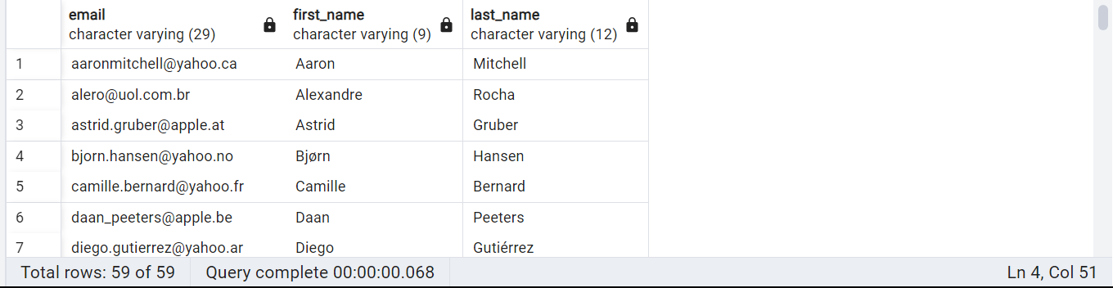

2. Let's invite the artists who have written the most rock music in our dataset. Write a

query that returns the Artist name and total track count of the top 10 rock bands

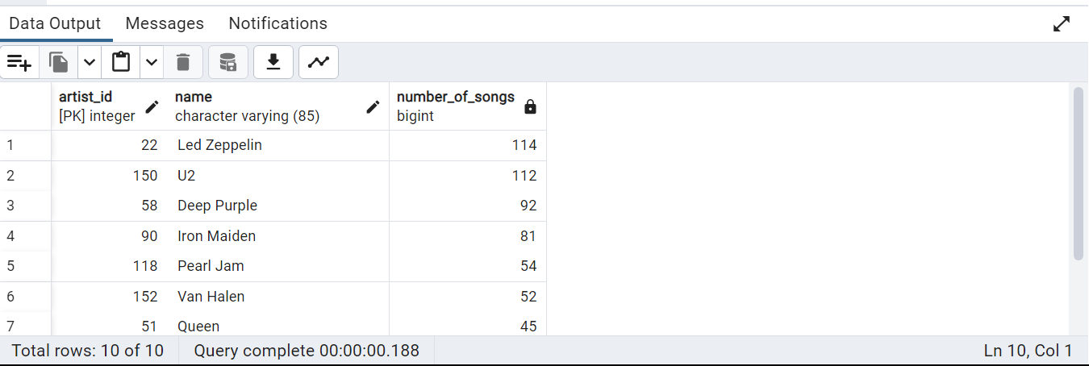

3. Return all the track names that have a song length longer than the average song length.

Return the Name and Milliseconds for each track. Order by the song length with the

longest songs listed first

