TECHNICAL DOCUMENTATION
Source-Agnostic RAG Knowledge Assistant
Complete Code Reference — Every Folder, File, Class & Function
With process-flow diagrams at every stage · written for technical and non-technical readers

Field | Detail
Document type | End-to-End Technical Reference (deep / code-level)
Companion to | Solution Design & Delivery Plan v2.0
Prepared by | Sankha Suvra Ghosal
Version | 2.0
Date | 18 August 2026

Contents
1. How to Read This Document
2. Key Concepts & Terminology
3. Concept Explainers (jargon, defined)
4. Two Models: Embedding vs LLM (important)
5. System Overview & Master Flow
6. Repository Map — Every Folder & File
7. Core Layer (app/core)
8. Sources Layer (app/sources)
9. Ingestion Layer (app/ingestion)
10. Processing Layer (app/processing)
11. Embeddings Layer (app/embeddings)
12. Retrieval Layer (app/retrieval)
13. LLM Layer (app/llm)
14. Pipeline Layer (app/pipeline)
15. Evaluation Layer (app/evaluation)
16. Application (streamlit_app.py & main.py)
17. Scripts
18. Data & Storage Layout
19. Configuration & Environment Reference
20. Metrics Defined
21. End-to-End Worked Example
22. Module & Function Index

1. How to Read This Document
This is the complete technical reference for the system: every folder, file, class and function is documented. It is written so that both technical and non-technical readers can use it.

1.1 The pattern used for every function
Each function is documented the same way, so you can read at whatever depth you need:
function_name(parameters) -> return_type
In plain terms: a single sentence explaining what it does, in everyday language.
Parameters: each input, its type, and meaning.
Returns: the output type and meaning.
Notes: key behaviour, why it exists, and any gotchas.
Non-technical readers can read just the “In plain terms” line and the diagrams and still follow the whole system. Developers get the exact signatures, parameters and returns.

1.2 A note on names
Code identifiers appear in monospace. Folders end with a slash (e.g. app/core/). “Chunk”, “embedding”, “collection” and other terms are defined in Section 2.

2. Key Concepts & Terminology
These terms recur throughout. Plain-English meaning first, technical meaning second.
Term | Plain-English | In this system
RAG | Answer by looking things up in your documents, then writing an answer from what was found. | The whole pipeline: retrieve chunks, then generate a grounded answer.
Collection | One named, separate knowledge base. | A source (a Confluence space or a wiki) with its own folder, index and golden set.
Chunk | A small passage of a page. | The unit that is embedded, retrieved and cited.
Embedding | A list of numbers capturing meaning. | A 384-number vector per chunk, from a small local model.
Vector index (FAISS) | A structure to find the closest vectors fast. | Holds a collection's chunk vectors for search.
BM25 | Classic keyword matching. | The keyword half of hybrid retrieval; strong on exact terms.
Hybrid retrieval | Combine meaning-based and word-based search. | Dense (embeddings) + BM25, fused.
Re-ranking | Re-order the shortlist using extra clues. | Boosts title/section/exact-match; lifts the right chunk up.
Grounding | Answer only from the supplied passages. | The anti-hallucination rule given to the LLM.
Citation | A pointer to the exact source. | Page, section, link and score shown with each answer.
Golden set | A labelled test set of questions. | Per collection; used to score retrieval quality.
Registry | A list of the knowledge bases. | registry.json — each collection's source configuration.

3. Concept Explainers
Short, self-contained explanations of the key ideas the code relies on. Read these once and the rest of the document reads easily.

Chunking
What: splitting each page into small, self-contained passages (“chunks”) instead of treating a whole page as one block. Why: models and search work best on focused pieces of text, and retrieving a small passage lets a citation point to the exact spot rather than a whole page. The system chunks on section headings so each chunk is a coherent unit.

Overlap
What: letting consecutive chunks share a little text at their boundary. Why: a fact that sits on the border between two chunks could be cut in half and lost by both; a small overlap guarantees the answer-bearing sentence appears whole in at least one chunk.

Embedding
What: converting a piece of text into a list of numbers (a “vector”, here 384 numbers) that captures its meaning. Why: computers can’t compare meaning directly, but they can compare numbers. Texts with similar meaning get similar vectors, so “how do I undo a deploy” lands near a chunk about “rollback” even though the words differ. Produced by a small local model — not the LLM.

Vector index (FAISS)
What: a specialised store that holds all the chunk vectors and can find the closest ones to a query vector very quickly. Why: comparing a question against thousands of chunks one by one would be slow; the index (FAISS — Facebook AI Similarity Search) makes it near-instant. Here it stores each collection’s vectors separately.

Cosine similarity
What: a score from 0 to 1 for how closely two vectors point in the same direction — higher means more similar in meaning. Why: it’s the measure used to rank chunks against the question. Because the vectors are normalised, the index’s inner-product search gives exact cosine similarity.

Dense vs sparse retrieval
What: “dense” retrieval matches by meaning using embeddings; “sparse” retrieval matches by exact words. Why: each has a blind spot — dense can miss exact tokens (error codes, product names), sparse can miss paraphrases. The system uses both.

BM25
What: a long-established keyword-relevance formula that scores how well a chunk’s words match the query’s words (rewarding rare, distinctive terms). Why: it’s excellent at exact matches — an API name, an error code, a specific number — which embeddings can blur. It is the “sparse” half of hybrid retrieval and needs no model or key.

Hybrid retrieval
What: combining the meaning-based (dense/embedding) results and the keyword-based (BM25) results into one ranked list. Why: it captures the strengths of both, so the system answers conceptual questions and exact-term questions well. The two score sets are rescaled to a common range and blended with a weight (α) that favours one side or the other.

Re-ranking
What: taking the shortlist of candidate chunks and re-ordering it using extra clues beyond raw similarity — does the chunk’s title or section match the question, does it contain the exact phrase, does its metadata line up. Why: raw similarity is good but “blind” to structure; a chunk whose heading exactly matches the question deserves to rise. Re-ranking adds these cheap, high-precision signals without retraining anything.

Grounding
What: instructing the LLM to answer strictly from the retrieved passages and nothing else. Why: this is the main defence against “hallucination” (confident but made-up answers). If the model may only use what was retrieved, it can’t invent facts — and every statement can be traced to a citation.

Citation & confidence
What: each answer shows the exact source passages it used (page, section, link, score), and a confidence label derived from the top similarity. Why: citations let a reader verify the answer; confidence flags when the supporting evidence was weak and the answer should be treated with caution.

Collection
What: one named, isolated knowledge base — a single source (a Confluence space or a wiki) with its own folder, index and golden set. Why: it lets many sources coexist without mixing; each is added, queried, evaluated and removed independently.

Golden set
What: a labelled test set: a list of questions each paired with the page(s) that correctly answer it. Why: it’s the answer key used to score retrieval. At evaluation time the system sees only the question and must find the right page; grading against the labels gives an honest quality measure.

4. Two Models: Embedding vs LLM
A common point of confusion is where the large language model (LLM) is used. The system uses TWO different kinds of model, and only one of them is an LLM.
 | Embedding model | LLM
Example | all-MiniLM-L6-v2 | OpenAI GPT
Size / location | Small, runs locally | Large, called via API
What it produces | Numbers (a 384-d vector) | Text (the written answer)
Used in | Retrieval (embedding the question & chunks) | Generation (writing the answer)
Needs a key? | No | Yes
Where each is used, precisely:
- Ask page — retrieval part: embedding model + FAISS + BM25 + re-ranker. No LLM.
- Ask page — generation part: the LLM writes the final grounded answer. LLM used here.
- Evaluation page: retrieval only (embedding + search). No LLM — which is why it runs without a key.
- Golden set — auto method: no model for questions (uses titles/sections). No LLM.
- Golden set — LLM method: the LLM drafts candidate questions. LLM used, optionally, for test-set authoring only.
So: RAG as a whole uses an LLM (for the answer). Retrieval does not — it uses the embedding model, which turns text into vectors but never writes text.

5. System Overview & Master Flow
The system runs in three modes that share one pipeline and one retriever: Indexing (offline, builds a collection's index), Query (online, answers a question), and Evaluation (offline, scores retrieval).
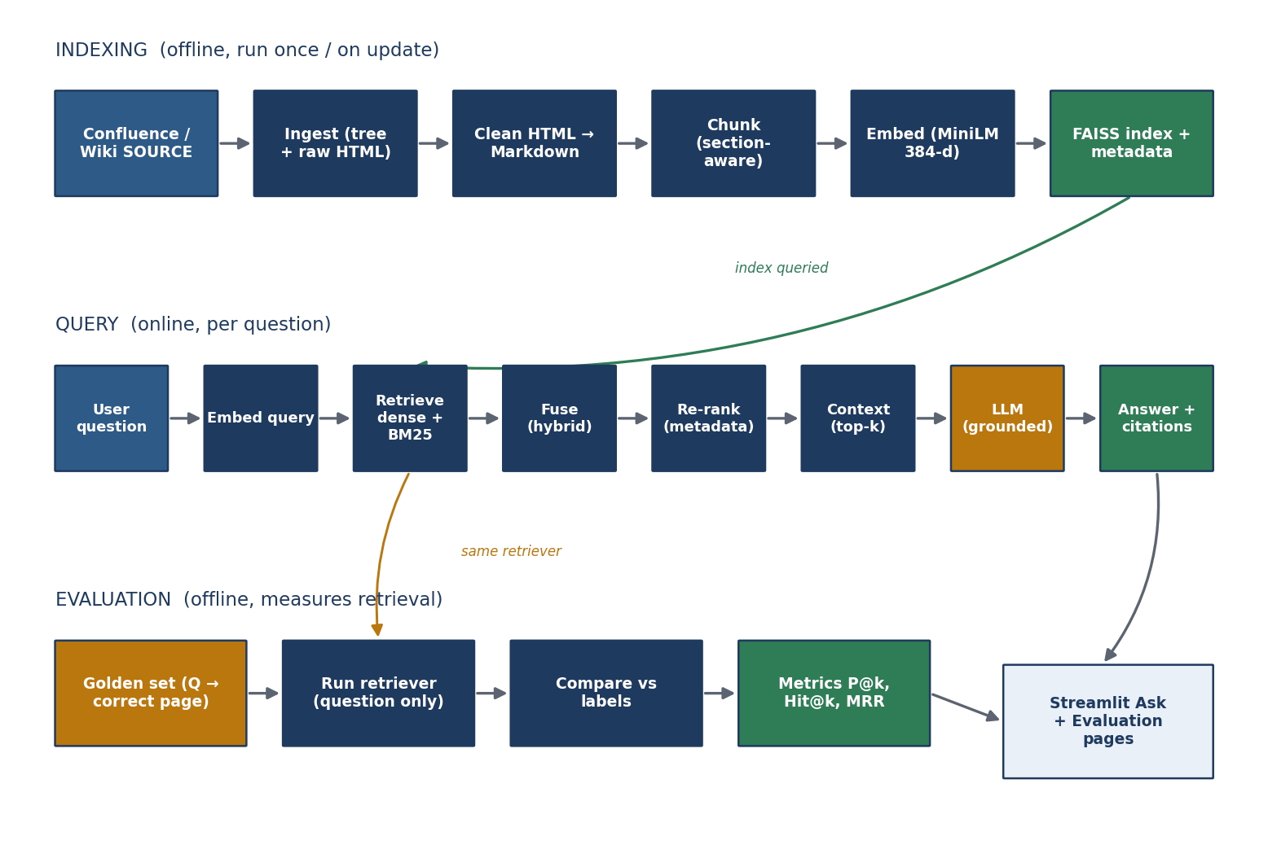
Figure 1 — Master flow: indexing (top), query (middle), evaluation (bottom) share one index and retriever.
- Indexing: source → ingest → clean → chunk → embed → index, into the collection's folder.
- Query: question → embed → retrieve (dense + BM25) → fuse → re-rank → context → LLM → answer + citations.
- Evaluation: the collection's golden questions run through the same retriever and are scored against known-correct pages.

6. Repository Map — Every Folder & File
The project is organised by responsibility. Everything after the source-adapter layer is source-independent.

5.1 Top level
Path | What it is
main.py | Ingestion & indexing CLI (the pipeline's front door).
streamlit_app.py | The interactive application (Ask, Evaluation, Corpus, Architecture, Add-source).
app/ | All library code, organised into layers (below).
scripts/ | Runnable utilities: evaluation, benchmark, golden bootstrap, plus older dev scripts.
tests/ | Automated test suite.
data/ | Default collection data + data/collections/<name>/ for each added source.
documents/ | Generated design & technical documents.
requirements.txt / -dev.txt | Runtime and development dependencies.
Dockerfile / Makefile | Containerisation and common commands.
pyproject.toml | .Project metadata and tool configuration.

5.2 The app/ layers
Folder | Responsibility
app/core/ | Settings, collection paths, registry, logging, errors, HTTP, ingest runner.
app/sources/ | Source adapters: the KnowledgeSource interface, Confluence, MediaWiki.
app/ingestion/ | Confluence-specific fetching: client, hierarchy, downloader, models.
app/processing/ | Clean HTML, extract metadata, chunk into passages.
app/embeddings/ | Embedding model, embedding generator, FAISS vector store.
app/retrieval/ | BM25, hybrid fusion, re-ranker, retriever, citation builder.
app/llm/ | Prompt builder, LLM generator, response parser.
app/pipeline/ | RAGPipeline — the end-to-end query orchestrator.
app/evaluation/ | Metrics, evaluator, dense-vs-hybrid comparison, golden bootstrap.

6. Core Layer (app/core)
Foundational services used by every other layer: configuration, collection paths, the registry, logging, typed errors, resilient HTTP, and the ingest runner.

6.1 config.py — settings & collection paths
Defines where each collection's data lives and loads all settings from the environment.

class CollectionPaths
In plain terms: the set of folders for one knowledge base; 'default' maps to the original data/ layout, any other name lives under data/collections/<name>/.
__init__(self, name='default') -> None
Parameters: name — the collection name; 'default' uses data/, otherwise data/collections/<name>/.
Notes: Computes .raw, .cleaned, .chunks, .metadata, .vectorstore, .evaluation and .golden paths for that collection.
mkdirs(self) -> CollectionPaths
In plain terms: creates the collection's folders on disk if they don't exist, and returns itself.
Returns: the same CollectionPaths object (so calls can be chained).
collection_paths(name='default') -> CollectionPaths
In plain terms: a shortcut to get the folder set for a named collection.
Parameters: name — collection name.
Returns: a CollectionPaths for that collection.

class Settings
In plain terms: all configuration for the app — which source, Confluence/wiki details, model names, keys — loaded from the environment (.env).
from_env(cls) -> Settings
In plain terms: reads environment variables and builds the Settings object.
Returns: a populated Settings instance.
Notes: Includes helpers _int and _float for safe numeric parsing. Wiki fields include wiki_api_url, wiki_category, wiki_titles and wiki_page_limit.
require_confluence(self) / require_wiki(self) / require_source(self) / require_openai(self) -> None
In plain terms: guard checks — each raises a clear error if the settings needed for that action are missing.
Notes: Called at the point of use, so the app still starts even if only some settings are present (e.g. retrieval works without an OpenAI key).

6.2 collections.py — the registry
Manages the list of collections and their source configuration. Secrets are never stored here — tokens are referenced by environment-variable name.
list_collections() -> list[dict]
In plain terms: returns every registered collection, always including 'default' first, each marked with whether it has an index and a golden set.
Returns: a list of dicts with name, source, title, has_index, has_golden.
get_collection(name) -> dict
In plain terms: looks up one collection by name.
Parameters: name — collection name.
Returns: that collection's registry entry.
Notes: Raises ConfigError if the name isn't registered.
register_collection(name, source, title=None, description='', **source_cfg) -> dict
In plain terms: adds (or updates) a collection and its source settings in the registry.
Parameters: name — unique slug; source — 'confluence' or 'mediawiki'; title/description — display text; source_cfg — source-specific keys (base URL, parent page, or wiki API/category/titles; token_env for the token's env-var name).
Returns: the stored registry entry.
Notes: 'default' is reserved; a bad source raises ConfigError. Creates the collection's folders.
remove_collection(name) -> None
In plain terms: removes a collection from the registry (its folder is deleted separately).
apply_source_config(entry, settings) -> None
In plain terms: copies a collection's stored source settings onto the live Settings object just before ingestion, so the pipeline pulls THAT collection's source. Reads the token from the named environment variable.
Parameters: entry — a registry entry; settings — the live Settings to update.
Notes: Handles both Confluence and MediaWiki, including wiki_titles (single/multi-page mode).

6.3 logger.py, exceptions.py, http.py, constants.py, ingest_runner.py
get_logger(name) -> Logger
In plain terms: returns a ready-to-use logger so every stage can report progress and errors consistently.
exceptions.py — a typed error hierarchy: RagError (base), and ConfigError, SourceError, IngestionError, VectorStoreError, RetrievalError, GenerationError. Why: failures are explicit and catchable, not silent.

class HttpClient
In plain terms: a web-request helper that automatically retries on transient network errors.
__init__(self, retries, backoff, timeout, auth=None, headers=None) -> None
Parameters: retries — attempts; backoff — wait multiplier; timeout — seconds; auth — credentials; headers — default headers.
get(self, url, params=None) -> Any / post(self, url, ...) -> Any
In plain terms: make GET/POST calls that survive brief network hiccups.
constants.py — shared constants such as STOP_WORDS used by keyword handling and re-ranking.

ingest_runner.py — the wizard's engine
stream_ingest(collection, steps=None) -> Iterator[str]
In plain terms: runs the ingestion for a collection as a separate process and yields its log lines one by one, so the app can show live progress.
Parameters: collection — which collection to build; steps — optional subset of stages.
Returns: a stream of log-line strings; raises RuntimeError on non-zero exit.
Notes: Runs 'python main.py --collection <name>' as a child process; the token stays in that process's environment (from .env) and never touches the browser.
run_ingest_collect(collection, steps=None) -> list[str]
In plain terms: a blocking version that runs the ingest and returns all log lines at once.

8. Sources Layer (app/sources)
The only place source-specific logic lives. Every source is reduced to the same contract, which is what makes everything downstream reusable.

7.1 base.py — the KnowledgeSource contract

class RawDocument
In plain terms: a single fetched page in a common shape — id, title, HTML, and metadata — regardless of which source it came from.
sidecar(self) -> dict
In plain terms: produces the small metadata file saved next to each page's raw HTML.

class KnowledgeSource (interface)
The four operations every source must provide:
test_connection(self) -> dict
In plain terms: checks the source is reachable and credentials work; returns basic info.
build_tree(self) -> node
In plain terms: discovers the pages to ingest and returns them as a tree (or list).
download_all(self, root) -> None
In plain terms: saves every page's raw HTML and metadata sidecar to the collection's folder.
metadata_extractor(self) -> MetadataExtractor
In plain terms: returns the right metadata extractor for this source.

7.2 __init__.py — the factory
get_source() -> KnowledgeSource
In plain terms: picks and returns the correct adapter (Confluence or MediaWiki) based on the current settings.
Returns: a ready source adapter.
Notes: This is how the pipeline stays source-agnostic — it asks the factory rather than naming a source.

7.3 confluence.py — Confluence adapter
Implements the four operations for Confluence, reusing the ingestion layer (Section 9).
test_connection / build_tree / download_all / metadata_extractor
In plain terms: connect to Confluence; walk the page tree from the parent page; download each page; and use the Confluence metadata extractor.

7.4 mediawiki.py — MediaWiki adapter
Implements the same four operations for any MediaWiki site (e.g. Wikipedia), supporting both category and specific-title ingestion.
__init__(self) -> None
In plain terms: prepares the adapter (HTTP client, API URL from settings).
_query(self, params) -> dict
In plain terms: makes one call to the wiki's action API and returns the JSON.
Parameters: params — API query parameters.
Returns: the parsed response.
_resolve_titles(self, titles) -> list[dict]
In plain terms: turns a list of exact page titles into page records, skipping any that don't exist.
Parameters: titles — exact article titles (underscores are normalised to spaces).
Returns: a list of {pageid, title}; missing titles are logged and skipped.
Notes: Handles both API response shapes (a dict of pages, or a list under formatversion=2).
_list_pages(self) -> list[dict]
In plain terms: decides which pages to ingest: specific titles if given, otherwise a category, otherwise a general listing.
Returns: the list of pages to fetch.
Notes: Title mode takes precedence over category mode. Category names are normalised (underscores → spaces).
build_tree(self) / _fetch_html / download_all / metadata_extractor / _page_url / test_connection
In plain terms: discover pages, fetch each page's HTML, save them with sidecars, and provide the wiki metadata extractor and page URLs.

9. Ingestion Layer (app/ingestion)
Confluence-specific fetching, used by the Confluence adapter.
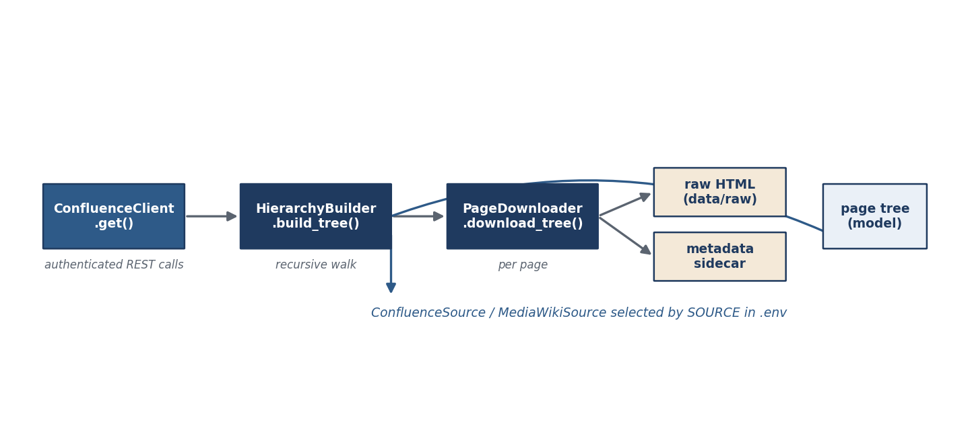
Figure 2 — Ingestion: connect → build tree → download each page → raw HTML + metadata.

8.1 client.py — class ConfluenceClient
__init__(self) -> None
In plain terms: sets up an authenticated connection to Confluence using settings from .env.
get(self, path, params=None) -> dict
In plain terms: calls a Confluence REST endpoint and returns the JSON result.
Parameters: path — API path; params — query parameters.
Returns: the parsed response.

8.2 hierarchy.py — class HierarchyBuilder
build_tree(self, parent_page_id) -> node
In plain terms: starts at a parent page and recursively discovers all child pages, returning the whole tree.
Parameters: parent_page_id — the root page to start from.
Returns: a tree of ConfluencePage nodes.

8.3 downloader.py — class PageDownloader
download_page(self, page) -> None
In plain terms: saves one page's raw HTML (and metadata) to the collection's raw folder.
download_tree(self, root) -> None
In plain terms: downloads every page in the tree.

8.4 models.py, page_fetcher.py, tree_utils.py
class ConfluencePage — a node in the page tree (id, title, level, children). class PageFetcher — fetches a single page's content on demand (get_page(page_id)). print_tree(root) — prints the hierarchy for a quick visual check during ingestion.

10. Processing Layer (app/processing)
Turns raw pages into clean, retrieval-ready chunks with rich metadata. Source-independent.
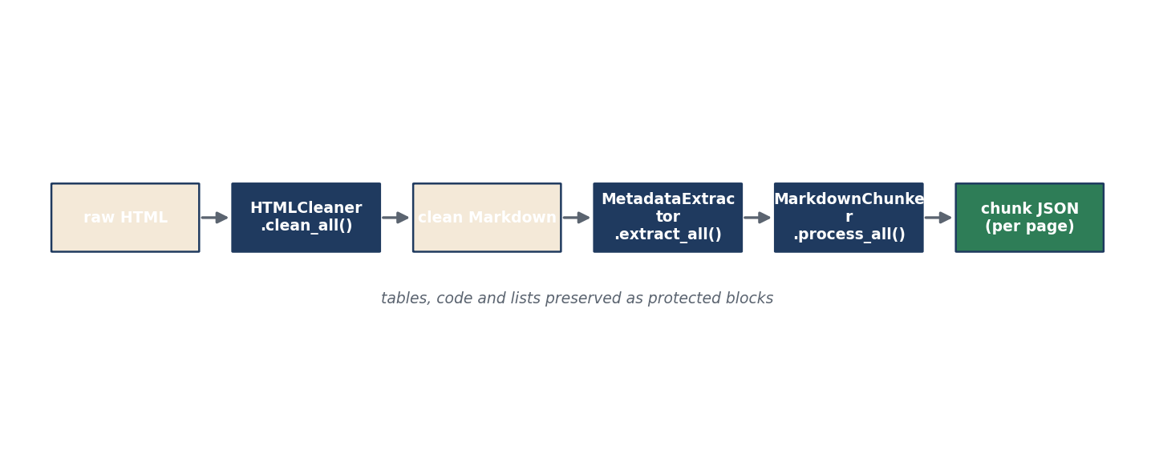
Figure 3 — Processing: raw HTML → clean Markdown → metadata → section-aware chunks.

9.1 html_cleaner.py
class ConfluenceMarkdownConverter — a custom HTML→Markdown converter with handlers convert_img, convert_table, convert_pre that preserve images, tables and code.

class HTMLCleaner
clean_html(self, html) -> str
In plain terms: converts one page's raw HTML into clean Markdown.
Parameters: html — the raw storage HTML.
Returns: clean Markdown text.
Notes: Internal helpers _cleanup_html and _post_process tidy the HTML before and the Markdown after conversion.
clean_file(self, path) -> str / clean_all(self) -> None
In plain terms: clean one file, or clean every downloaded page in the collection.

9.2 metadata_extractor.py — class MetadataExtractor
extract_file(self, path) -> dict
In plain terms: reads one cleaned page and pulls out its metadata — title, section, breadcrumb, owner, status, headings, source URL.
Parameters: path — the cleaned Markdown file.
Returns: a metadata dict for that page.
extract_all(self) -> None
In plain terms: extracts metadata for every page in the collection.
Notes: Rich internal helpers parse Confluence 'details' tables, Markdown tables, headings and API-reference fields, and build the page's source URL. These are grouped support functions for extract_file.

9.3 wiki_metadata.py — class WikiMetadataExtractor
extract_file(self, path) -> dict
In plain terms: the wiki version of metadata extraction — reads the sidecar the wiki adapter wrote, so no Confluence-specific calls are needed.
Notes: Subclass of MetadataExtractor; _load_sidecar reads the per-page metadata file saved during download.

9.4 chunker.py — class MarkdownChunker
The most involved component: it splits each page into section-aware chunks, keeping tables, lists and code blocks intact, with a small overlap between neighbours.
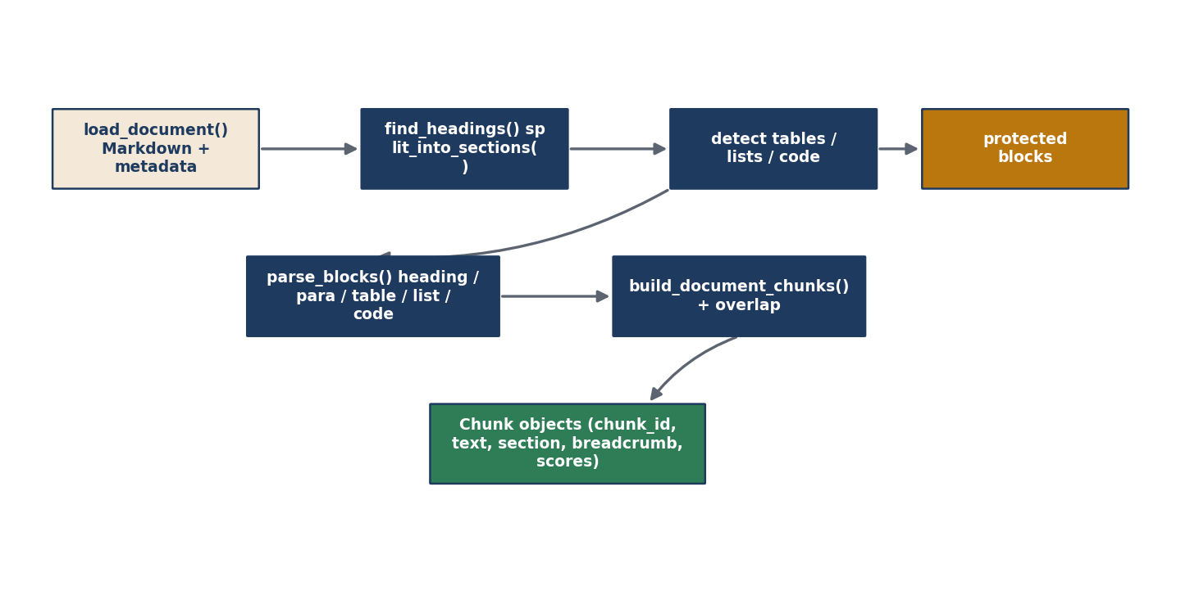
Figure 4 — Chunking: sections → protected blocks → typed blocks → chunk objects with overlap.

Main (public) functions
load_document(self, path) -> tuple
In plain terms: loads a cleaned page and its metadata, ready to chunk.
find_headings(self, text) -> list / split_into_sections(self, text) -> list
In plain terms: locate the page's headings and split it into sections on them.
detect_tables / detect_lists / detect_protected_blocks -> list
In plain terms: find tables, lists and code blocks that must never be split in the middle.
parse_blocks(self, ...) -> list
In plain terms: turn a section into typed blocks (heading, paragraph, table, list, code).
build_document_chunks(self, ...) -> list / create_chunk_objects(self, ...) -> list
In plain terms: assemble the final chunks (with overlap) and turn them into Chunk objects with all their metadata.
process_page(self, path) -> list / process_all(self) -> None / save_chunks(self, ...) -> None
In plain terms: chunk one page, chunk every page in the collection, and save the results as per-page chunk files.

Grouped internal helpers
A cluster of internal helpers handles the fiddly work of splitting over-sized content safely: _split_paragraph_block, _split_list_block, _split_table_block, _split_code_block, _split_oversized_block and _expand_large_blocks each split one kind of block so it fits the size limit without breaking structure; _create_overlap / _create_section_overlap add the small overlap between chunks; _finalize_chunk, _section_key, _is_protected_block, word_count, is_table_line and merge_small_sections are supporting utilities. Together they ensure a fact never falls between two chunks and structured content stays whole.

9.5 chunk_models.py — class Chunk
to_dict(self) -> dict
In plain terms: turns a chunk into a plain dictionary for saving to disk (id, text, title, section, breadcrumb, scores, source URL).

11. Embeddings Layer (app/embeddings)
Turns chunks into vectors and builds the searchable index — per collection.
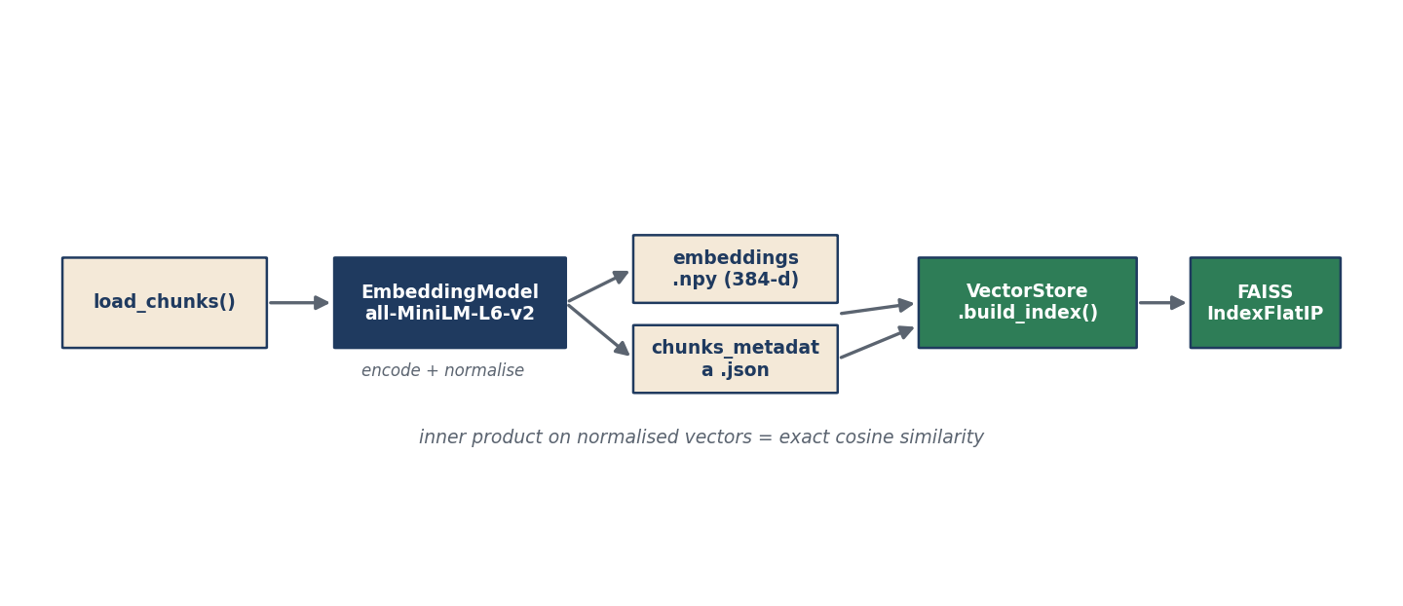
Figure 5 — Embedding & index: chunks → MiniLM vectors + metadata → FAISS index.

10.1 embedding_model.py — class EmbeddingModel
get_model() -> SentenceTransformer
In plain terms: loads the small local embedding model (all-MiniLM-L6-v2) once and reuses it.
Returns: the loaded model.
Notes: A singleton — loaded a single time to avoid repeated start-up cost. This is the model that turns text into 384-number vectors; it is NOT the LLM.

10.2 embedding_generator.py — class EmbeddingGenerator
__init__(self, chunk_dir='data/chunks', output_dir='data/vectorstore') -> None
In plain terms: sets where to read chunks from and where to write vectors — pointed at the active collection's folders by the pipeline.
Parameters: chunk_dir — the collection's chunk folder; output_dir — where embeddings + metadata are written.
Notes: The pipeline passes the collection's directories here explicitly, so a named collection is never embedded into 'default'.
load_chunks(self) -> list
In plain terms: reads all chunk files for the collection.
Returns: the list of chunks.
Notes: Raises FileNotFoundError if there are no chunks — the signal that an earlier stage produced nothing.
generate_embeddings(self, chunks) -> array
In plain terms: turns every chunk's text into a normalised vector.
Parameters: chunks — the loaded chunks.
Returns: an array of 384-d vectors.
save_outputs(self, ...) -> None
In plain terms: saves the vectors (embeddings.npy) and the aligned chunk metadata (chunks_metadata.json).
process_all(self) -> None
In plain terms: the whole embedding step: load chunks → embed → save.

10.3 vector_store.py — class VectorStore
__init__(self, vectorstore_dir='data/vectorstore') -> None
In plain terms: points at a collection's vector folder (embeddings, metadata, index).
build_index(self) -> None
In plain terms: builds the FAISS index from the saved vectors, so search is fast.
Notes: Uses inner product on normalised vectors, which equals exact cosine similarity — no approximation at this scale.
load_index(self) -> None
In plain terms: loads an existing index into memory for querying.
search(self, query_vector, k) -> list
In plain terms: finds the k most similar chunks to a query vector.
Parameters: query_vector — the embedded question; k — how many results.
Returns: the top-k chunks with similarity scores.

12. Retrieval Layer (app/retrieval)
Finds and orders the passages most likely to answer the question. Uses the embedding model + search + scoring — no LLM.
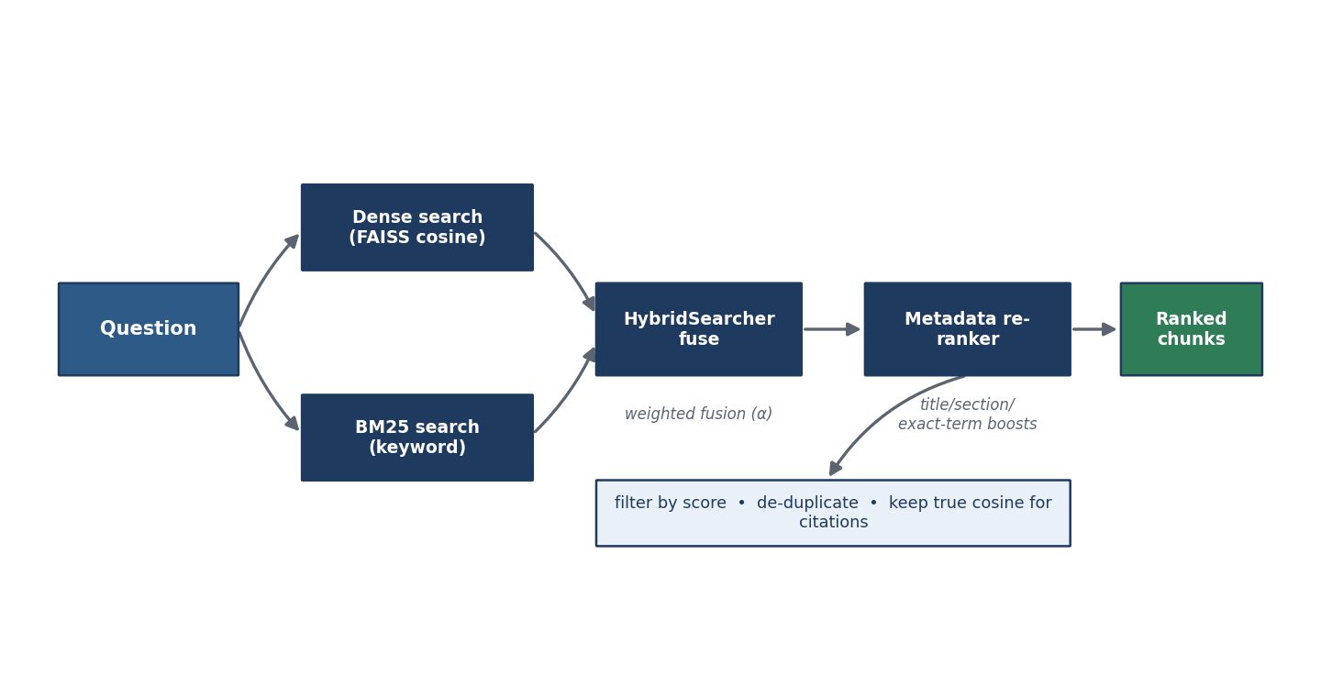
Figure 6 — Retrieval: dense + BM25 → hybrid fusion → metadata re-rank → filtered, ranked chunks.

11.1 bm25_index.py
tokenize(text) -> list
In plain terms: splits text into lowercase words for keyword matching.

class BM25Index
__init__(self, ...) -> None
In plain terms: builds a keyword index over the collection's chunks.
search(self, query, k) -> list
In plain terms: returns the chunks whose words best match the query — strong on exact terms like codes and names.
Parameters: query — the question text; k — how many results.
Returns: top-k chunks with BM25 scores.

11.2 hybrid.py
_minmax(scores) -> list
In plain terms: rescales a set of scores to 0–1 so two different scoring systems can be combined fairly.

class HybridSearcher
search(self, query, ...) -> list
In plain terms: runs both dense and BM25 search, normalises each, and combines them into one ranked list.
Parameters: query — the question; alpha — the weight on dense vs keyword (default balanced).
Returns: a fused, ranked list of chunks.
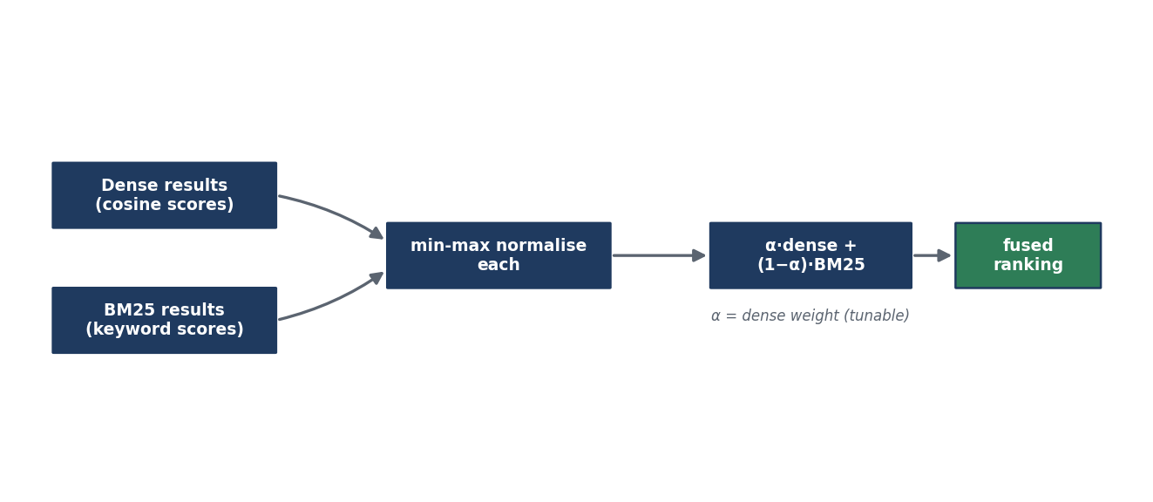
Figure 7 — Hybrid fusion: normalise each list, then weighted-combine into one ranking.

11.3 reranker.py
class ScoreBreakdown — records how much each signal contributed to a chunk's final score (its total() sums them). Powers the transparency you see in the app.

class RetrievalReranker
rerank(self, query, chunks) -> list
In plain terms: re-orders the shortlist by adding structural clues — a chunk whose title or section matches the query, or that contains the exact phrase, is boosted.
Parameters: query — the question; chunks — the candidate chunks.
Returns: the re-ordered chunks, each with a score breakdown.
score_chunk / exact_phrase_score / child_page_score / owner_score / match_score / keyword_overlap -> float
In plain terms: the individual signals — exact-phrase match, page/section match, keyword overlap, and metadata boosts — that add up to the re-rank score.

11.4 retriever.py — class Retriever
__init__(self, top_k=20, min_score=0.20, use_hybrid=None, hybrid_alpha=None, vectorstore_dir=None) -> None
In plain terms: sets up retrieval for a collection — how many candidates, the score floor, whether to use hybrid, and which collection's index to read.
Parameters: top_k — candidates to fetch; min_score — relevance floor; use_hybrid / hybrid_alpha — hybrid settings; vectorstore_dir — the collection's index folder.
retrieve(self, query) -> list
In plain terms: the main entry point: embed the question, get candidates (dense + optional BM25), re-rank, filter and de-duplicate.
Parameters: query — the question text.
Returns: the final ranked chunks.
retrieve_one(self, query) -> chunk
In plain terms: convenience: return just the single best chunk.

11.5 citation_builder.py — class CitationBuilder
build(self, chunks) -> list
In plain terms: turns ranked chunks into citation records — title, section, breadcrumb, link, snippet and scores — for display under the answer.
Parameters: chunks — the ranked chunks.
Returns: citation dicts.
format_inline(self, ...) -> str
In plain terms: formats a short inline citation label.

13. LLM Layer (app/llm)
The only layer that uses the large language model — and only to write the final answer from retrieved context.
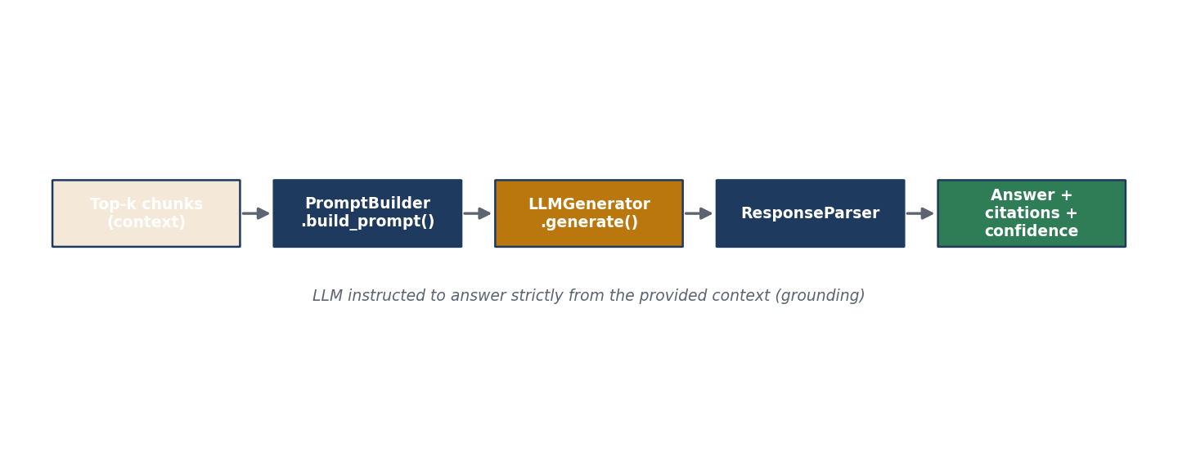
Figure 8 — Generation: top-k context → prompt → LLM → parsed answer + citations + confidence.

12.1 prompt_builder.py — class PromptBuilder
build_context(self, chunks) -> str
In plain terms: formats the retrieved chunks into a single context block for the model.
build_prompt(self, question, context) -> list
In plain terms: assembles the full instruction that tells the model to answer using ONLY the provided context.
Parameters: question — the user's question; context — the formatted chunks.
Returns: the message list for the LLM.

12.2 generator.py — class LLMGenerator
__init__(self, model=...) -> None
In plain terms: sets up the OpenAI client and which model to use.
generate(self, question, context) -> str
In plain terms: calls the LLM with the grounded prompt and returns the written answer.
Parameters: question — the question; context — the retrieved passages.
Returns: the answer text.
Notes: This is the single place an OpenAI key is required. Without it, the pipeline runs retrieval-only.

12.3 response_parser.py — class ResponseParser
build_response(self, ...) -> dict
In plain terms: packages everything the app shows — the answer, its citations, a confidence badge, and timing/retrieval metrics — into one structured result.
Returns: a response dict consumed by the app.

14. Pipeline Layer (app/pipeline)
Orchestrates a single question end to end — the object the app calls.

13.1 pipeline.py — class RAGPipeline
__init__(self, top_k=20, min_score=0.20, context_k=5, use_llm=True, model=..., use_hybrid=None, hybrid_alpha=None, vectorstore_dir=None) -> None
In plain terms: wires together retrieval and generation for a chosen collection, with all the knobs the sidebar exposes.
Parameters: top_k / min_score / use_hybrid / hybrid_alpha / vectorstore_dir — retrieval settings (per collection); context_k — how many chunks to feed the LLM; use_llm / model — generation settings.
retrieve(self, query) -> list
In plain terms: run retrieval only (no answer written) — used by the Evaluation page.
answer(self, query) -> dict
In plain terms: the full RAG flow: retrieve the best chunks, then (if an LLM key is present) generate a grounded, cited answer with a confidence score.
Parameters: query — the question.
Returns: a response dict (answer, citations, confidence, metrics).
_confidence(self, ...) -> str / generator (property)
In plain terms: derive a confidence label from the top similarity; lazily create the LLM generator only when needed.
Notes: Because the generator is lazy, retrieval and evaluation never require an API key.

15. Evaluation Layer (app/evaluation)
Proves retrieval quality per collection, with no LLM needed for scoring.
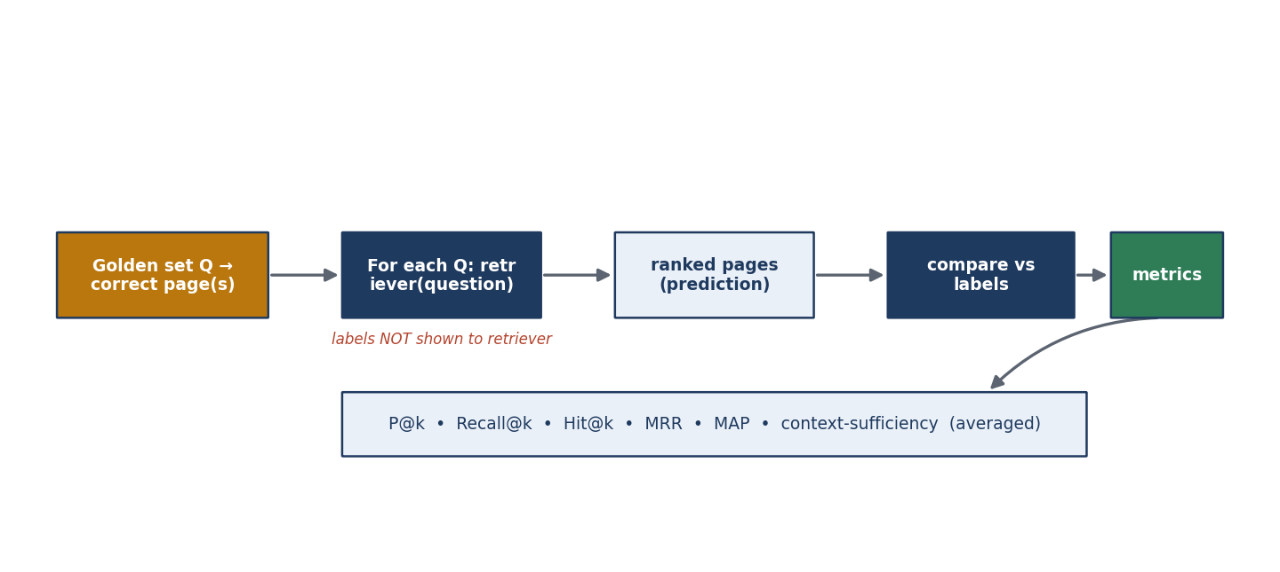
Figure 9 — Evaluation: labelled questions → retrieve → compare vs labels → averaged metrics.

14.1 metrics.py — the metric formulas
Each is a small, tested function. Full definitions with formulas are in Section 20.
precision_at_k / recall_at_k / hit_at_k / reciprocal_rank / average_precision / context_sufficiency -> float
In plain terms: the standard information-retrieval scores — each takes the retrieved pages and the known-correct pages and returns a number.
evaluate_single(...) -> dict / _dedup_keep_order(...) -> list
In plain terms: score one question across all metrics; and a helper that removes duplicate pages while keeping rank order.

14.2 evaluator.py — class RetrievalEvaluator
__init__(self, retriever, golden_path=...) -> None
In plain terms: sets up scoring for a collection — which retriever to test and which golden set to grade against.
Parameters: retriever — the retriever under test; golden_path — the collection's golden_qa.json.
run(self) -> dict
In plain terms: runs every golden question through the retriever and averages the metrics.
Returns: aggregate and per-question results.
Notes: The retriever receives only the question; the labels are used solely to grade — which is what makes the scores genuine.
ranked_page_ids / ranked_pages_and_texts / load_golden / print_report
In plain terms: supporting steps: get the retriever's ranked pages, load the golden questions, and print a readable report.

14.3 comparison.py — dense vs hybrid
run_comparison(dense_retriever, hybrid_retriever, hybrid_alpha=..., golden_path=..., save=True) -> dict
In plain terms: scores the same golden set with dense-only and with hybrid retrieval, so you can see the improvement hybrid brings.
Returns: both sets of metrics and their deltas.
print_comparison(...) -> None
In plain terms: prints the side-by-side comparison.

14.4 golden_bootstrap.py — creating a golden set
How a brand-new collection gets its own labelled questions (Section 9 of the design doc explains why this is needed).
auto_bootstrap(collection, per_page=2) -> list[dict]
In plain terms: drafts candidate questions from each page's title and sections — instant, no LLM.
Parameters: collection — which collection; per_page — questions per page.
Returns: candidate questions labelled with their source page.
llm_bootstrap(collection, model=None, per_page=2) -> list[dict]
In plain terms: asks the LLM to write grounded questions per page — sharper, needs a key.
Returns: candidate questions (LLM-authored).
approve_into_golden(collection, questions) -> int
In plain terms: merges approved candidates into the collection's golden set, skipping duplicates.
Returns: how many new questions were added.
save_candidates / load_candidates / candidates_path / load_pages / _keywords
In plain terms: supporting steps: stage candidates for review, read them back, and read a collection's pages/keywords.

16. Application (streamlit_app.py & main.py)
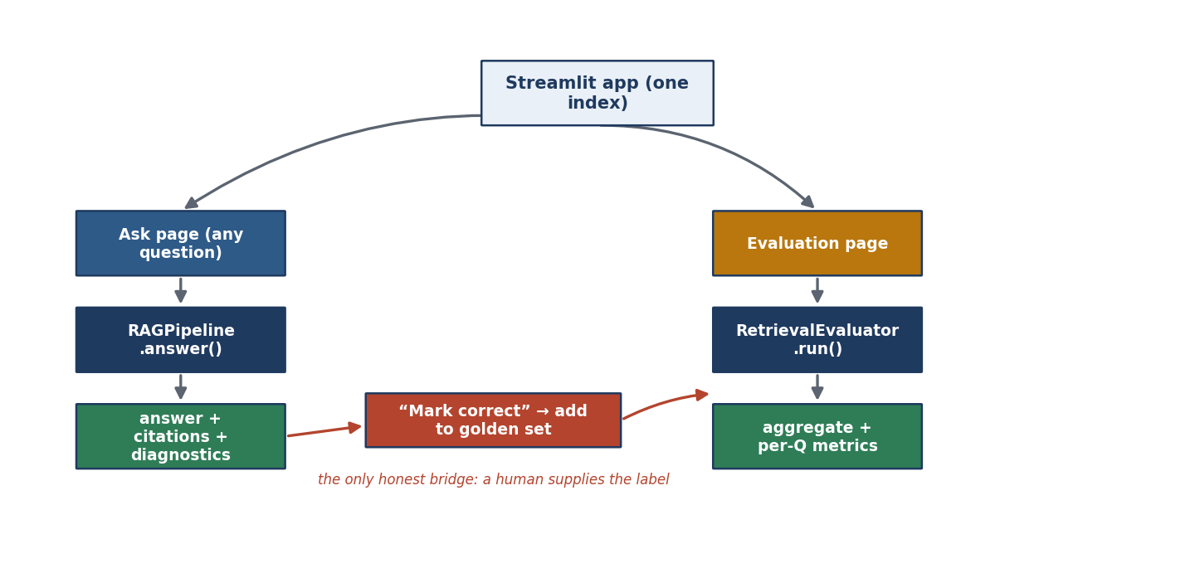
Figure 10 — Application: Ask and Evaluation over one index; ‘Mark correct' bridges to the golden set.

15.1 main.py — the ingestion CLI
The pipeline's command-line front door. It selects the active collection before loading configuration, so all paths point at the right folder.
stage_connect / stage_tree / stage_download / stage_clean / stage_metadata / stage_chunk / stage_embed / stage_index (state) -> None
In plain terms: the eight ordered stages of ingestion; each reuses the real modules. stage_embed and stage_index are pointed explicitly at the active collection's folders.
run(steps, collection) -> None
In plain terms: runs the chosen stages in order for a collection, with clear logging and error wrapping.
main() -> None
In plain terms: parses the command line — including --collection, --add-collection, --list-collections, --steps, and the wiki/Confluence options — and dispatches.
Notes: --collection is pre-parsed before config import so the path constants resolve to the right collection.

15.2 streamlit_app.py — the interactive app
set_active_collection(name) -> None
In plain terms: points all of the app's paths at the collection chosen in the sidebar, for the current run.
load_metadata(meta_path_str) -> list / load_pipeline(..., vectorstore_dir) -> RAGPipeline
In plain terms: load a collection's chunk metadata, and build (and cache) the pipeline for the chosen collection and settings.
Notes: Both are cache-keyed on the collection, so switching collections reloads the right data.
load_golden_questions() -> list / load_ask_history() -> list / log_ask(question, resp) -> None
In plain terms: read the active collection's golden questions, read/append the ask history.
add_to_golden(question, page_id, keywords=None) -> bool
In plain terms: the ‘Mark correct' action — labels an asked question with its correct page and adds it to the golden set (skipping duplicates).
Parameters: question — the asked question; page_id — the page the user marked correct; keywords — optional answer keywords.
Returns: True if added, False if already present.

The five tabs
- Ask — live question → grounded answer, citations, retrieval diagnostics; each citation has a ‘Mark correct' button.
- Evaluation — golden-set counter, run metrics, dense-vs-hybrid comparison, and the golden-set builder (auto/LLM + approval).
- Corpus — a view of the indexed chunks for transparency.
- Architecture — an in-app explanation of the system.
- Add source — the wizard: Register, then ‘Ingest & prepare' (live-progress ingest + automatic golden set).
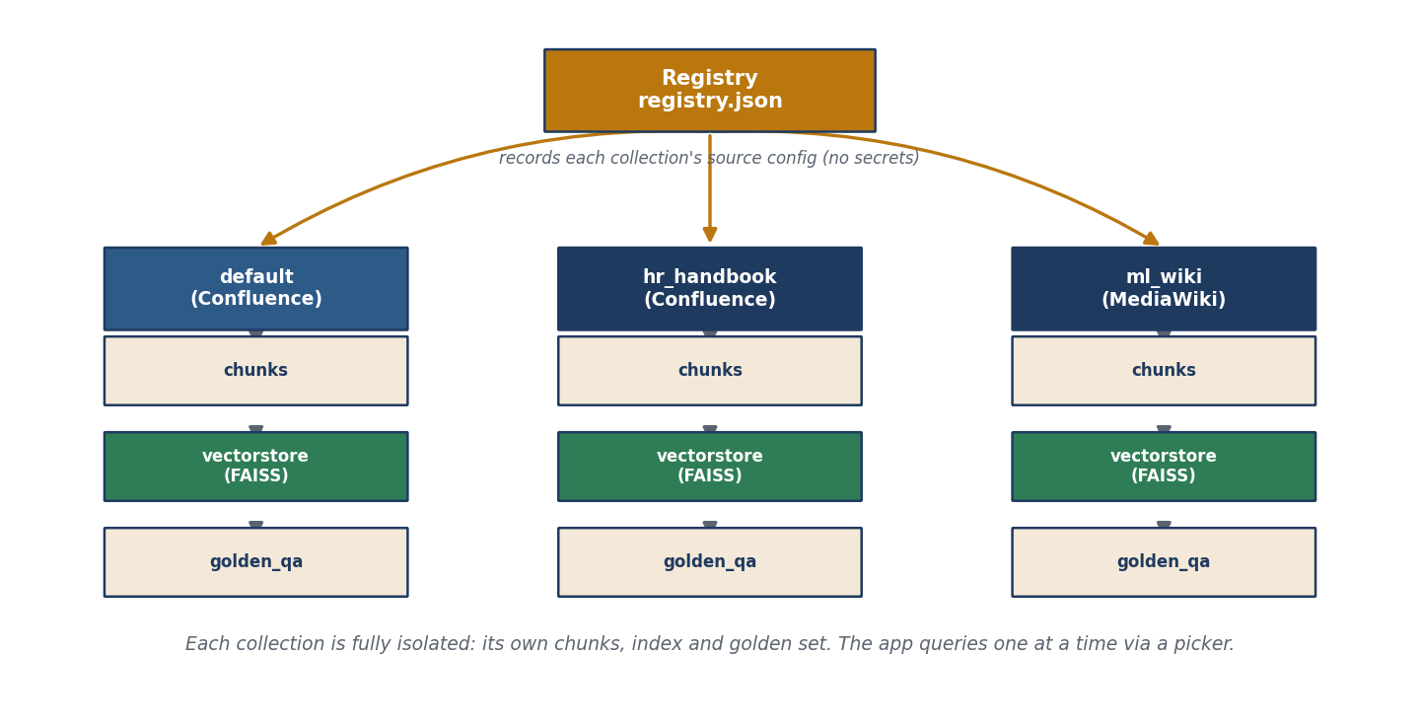
Figure 11 — Collections: each source is isolated with its own chunks, index and golden set; the registry records their config.
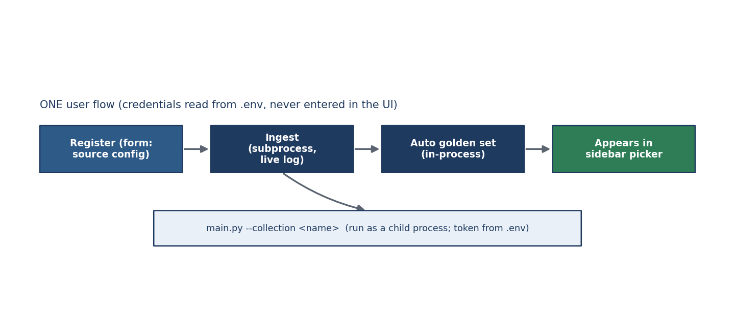
Figure 12 — The Add-source wizard: register → ingest (live) → auto golden set → appears in the picker.

17. Scripts

16.1 Application scripts (full)
Script | What it does
scripts/run_evaluation.py | Run the golden-set evaluation for a collection and print/save metrics.
scripts/run_comparison.py | Run the dense-vs-hybrid comparison.
scripts/bootstrap_golden.py | Create a starter golden set (--method auto|llm, --approve).
scripts/generate_synthetic_corpus.py | Build the synthetic benchmark corpus (unique-ID pages).
scripts/build_benchmark.py | Assemble the benchmark's golden questions.
scripts/run_benchmark.py | Run the benchmark and report dense-vs-hybrid gains.
scripts/generate_embeddings.py / build_vector_store.py | Stand-alone embed / index steps (the pipeline normally does these).
scripts/validate_chunks.py | Sanity-check the chunk files.

16.2 Legacy dev scripts (one-line note)
The following are older single-purpose development helpers, kept for reference and not part of the application flow: test_chunker.py, test_cleaner.py, test_connection.py, test_downloader.py, test_embedding_model.py, test_generator.py, test_hierarchy.py, test_metadata_extractor.py, test_page_fetch.py, test_retriever.py, debug_retrieval.py. Automated testing lives in tests/ (below).

16.3 tests/
The automated suite: test_collections.py, test_golden_bootstrap.py, test_sources.py, test_metrics.py, test_hybrid.py, test_comparison.py, test_citation_builder.py, test_config.py, test_synthetic.py, with shared fixtures in conftest.py. Run with pytest -q.

18. Data & Storage Layout
Each collection is fully isolated. 'default' uses the original data/ folders; every other collection lives under data/collections/<name>/ with the same structure.
Folder (per collection) | Contents
raw/ | Downloaded raw HTML (+ metadata sidecars). Regenerable.
cleaned/ | Clean Markdown per page.
chunks/ | Section-aware chunks, one file per page.
metadata/ | Extracted per-page metadata.
vectorstore/ | embeddings.npy, chunks_metadata.json, faiss.index.
evaluation/ | golden_qa.json, and (runtime) results / ask history / candidates.
Registry: data/collections/registry.json lists every collection and its source config. What is committed to git: the text (chunks, cleaned, metadata, golden sets, registry). What is regenerated: the binaries (embeddings.npy, faiss.index) — rebuilt with python main.py --steps embed index.

19. Configuration & Environment Reference
All settings come from environment variables (typically a .env file). Secrets never leave .env.
Variable | Meaning
SOURCE | 'confluence' or 'mediawiki' (the default source).
CONFLUENCE_BASE_URL / EMAIL / API_TOKEN | Confluence site, account, and token.
CONFLUENCE_PARENT_PAGE_ID | The page whose tree is ingested.
WIKI_API_URL | The wiki's action API (e.g. https://en.wikipedia.org/w/api.php).
WIKI_CATEGORY / WIKI_TITLES | Category to pull, or exact page titles (single/multi page).
WIKI_PAGE_LIMIT | Maximum pages to pull.
OPENAI_API_KEY / model | LLM key and model for answer generation.
COLLECTION | (set by main.py) the active collection for a run.
Notes: For a new Confluence with a different token, store it under a new env-var name and reference that name in the collection (token_env). Tokens are never entered in the UI or stored in the registry.

20. Metrics Defined
All metrics are computed per question, then averaged. 'Relevant' = a page that truly answers the question; 'retrieved' = the pages the system returned, in rank order.
Metric | Definition (plain) | Formula / rule | Reads as
Precision@k | Of the top-k returned, the fraction correct. | (correct in top-k) ÷ k | Are the top results on-target?
Recall@k | Of all correct pages, the fraction in top-k. | (correct in top-k) ÷ (all correct) | Did we find it at all?
Hit@k | 1 if any correct page is in top-k, else 0. | 1 if hit else 0 | Did the right page show up?
MRR | Mean of 1 ÷ rank of the first correct page. | avg(1/rank) | How high does it sit?
MAP | Mean average precision across correct pages. | avg of per-rank precision | Overall ranking quality.
Context-sufficiency | Fraction of expected answer facts present in retrieved text. | (keywords found) ÷ (keywords) | Can a faithful answer be written?
Interpretation note. When a question has a single correct page, Precision@3 is capped at 0.33 and Precision@5 at 0.20 — a property of single-answer questions, not a weakness. Hit@1 and MRR are the headline retrieval numbers.

21. End-to-End Worked Example
Question: “How do I apply for annual leave?” against the hr_handbook collection.
- 1. Pick collection. The sidebar sets hr_handbook active; the app loads that collection's index and golden set.
- 2. Embed. The question becomes a 384-d vector (embedding model — no LLM).
- 3. Retrieve. Dense search finds semantically close chunks; BM25 catches exact words like ‘leave' and ‘apply'.
- 4. Fuse & re-rank. The two lists are combined; the Leave Policy chunk is boosted by its title/section match and rises to the top.
- 5. Generate. The top chunks are given to the LLM, which writes the answer using only them (grounding).
- 6. Cite. The answer shows the Leave Policy page, section, link and scores, with a confidence badge.
If this question is in the golden set, the Evaluation page confirms the Leave Policy page ranked #1 (Hit@1 = 1, reciprocal rank = 1) — measured without the LLM.

22. Module & Function Index
A quick map from responsibility to module. Every function in these modules is documented in the sections above.
Layer | Modules
Core | config, collections, logger, exceptions, http, constants, ingest_runner
Sources | base, __init__ (factory), confluence, mediawiki
Ingestion | client, hierarchy, downloader, models, page_fetcher, tree_utils
Processing | html_cleaner, metadata_extractor, wiki_metadata, chunker, chunk_models
Embeddings | embedding_model, embedding_generator, vector_store
Retrieval | bm25_index, hybrid, reranker, retriever, citation_builder
LLM | prompt_builder, generator, response_parser
Pipeline | pipeline (RAGPipeline)
Evaluation | metrics, evaluator, comparison, golden_bootstrap
Application | main.py, streamlit_app.py
This document reflects the implemented codebase as uploaded. Every stage is independently runnable via python main.py --steps …, and the whole system is demonstrated through the Streamlit app.

