TECHNICAL DOCUMENTATION
Confluence / Wiki RAG Knowledge Assistant
End-to-End Process, Components, Concepts & Metrics
How every stage works, why each choice was made, with process-flow diagrams throughout

Field | Detail
Document type | Technical Reference & Process Walkthrough
Companion to | Solution Design & Delivery Plan v1.0
Prepared by | Sankha Suvra Ghosal
Version / Status | 1.0
Date | 13 August 2026

Contents
1. How to Read This Document
2. Key Concepts & Terminology (plain-English)
3. System Overview & Master Flow
4. Configuration & Core Utilities
5. Stage 1 — Ingestion
6. Stage 2 — Processing (clean, metadata, chunk)
7. Stage 3 — Embedding & Vector Index
8. Stage 4 — Retrieval & Ranking (dense + BM25 + hybrid + re-rank)
9. Stage 5 — Answer Generation
10. Stage 6 — Evaluation & Metrics (defined)
11. Stage 7 — Streamlit Application
12. Worked Example (a question end-to-end)
13. Module Map (quick reference)

1. How to Read This Document
This document explains, end to end, how the Confluence/Wiki RAG knowledge assistant works: what each part of the code does, why it was chosen, the concepts and jargon behind it, and the metrics used to prove it works. It is written to be understood by both technical and non-technical readers.
Structure. Section 2 defines the concepts and vocabulary in plain English. Section 3 gives the big picture with a master flow diagram. Sections 4–11 walk each stage in order — each with a short ‘what it does', a ‘why' rationale, the key code components, and its own process-flow diagram. Section 10 defines every evaluation metric explicitly. Section 12 traces a single question through the whole system, and Section 13 is a one-page module map.
A note on the core idea. RAG (Retrieval-Augmented Generation) means the system answers by first retrieving the most relevant passages from your own documents, then asking a language model to generate an answer using only those passages. It does not answer from the model's general memory. This is what makes answers accurate to your content and verifiable through citations.

2. Key Concepts & Terminology
These terms appear throughout. Each is defined in plain English first, with the technical meaning second.
Term | Plain-English meaning | In this system
RAG | Answer by looking things up in your documents, then writing an answer from what was found — not from memory. | The whole pipeline: retrieve relevant chunks, then generate a grounded answer.
Chunk | A small, self-contained passage of a page (a section or block). | The unit that is embedded, retrieved and cited. Pages are split into chunks.
Embedding | A list of numbers that captures the meaning of text, so similar meanings have similar numbers. | Each chunk becomes a 384-number vector via a small local model.
Vector | The list of numbers itself (a point in a high-dimensional space). | 384-dimensional; similar chunks sit close together.
Cosine similarity | A score (0–1) for how close two vectors point — higher = more similar in meaning. | Used to rank chunks against the question.
Vector index (FAISS) | A structure that finds the closest vectors to a query very fast. | Facebook AI Similarity Search; holds all chunk vectors.
BM25 | A classic keyword-matching score — strong at exact words (codes, names, IDs). | The sparse half of hybrid retrieval.
Hybrid retrieval | Combine meaning-based (embedding) and word-based (BM25) search. | Fused so exact terms and concepts are both handled.
Re-ranking | Re-ordering the shortlist using extra clues (title, section, exact match). | The metadata re-ranker lifts the truly relevant chunk to the top.
Grounding | Forcing the model to answer only from the supplied passages. | The main defence against made-up answers (hallucination).
Citation | A pointer to the exact passage an answer came from. | Every answer shows page, section, link and a relevance score.
Golden set | A labelled test set: questions paired with their correct page. | Used to score retrieval quality objectively.
One sentence to remember: meaning becomes numbers (embeddings), numbers are searched fast (FAISS), keyword search is added for exact terms (BM25), the best passages are re-ranked and shown as citations, and a language model writes the answer using only those passages.

3. System Overview & Master Flow
The system has three modes of operation. Indexing runs offline to build a searchable knowledge base. Query runs online for each question. Evaluation runs offline to measure retrieval quality. All three share the same index and retriever.
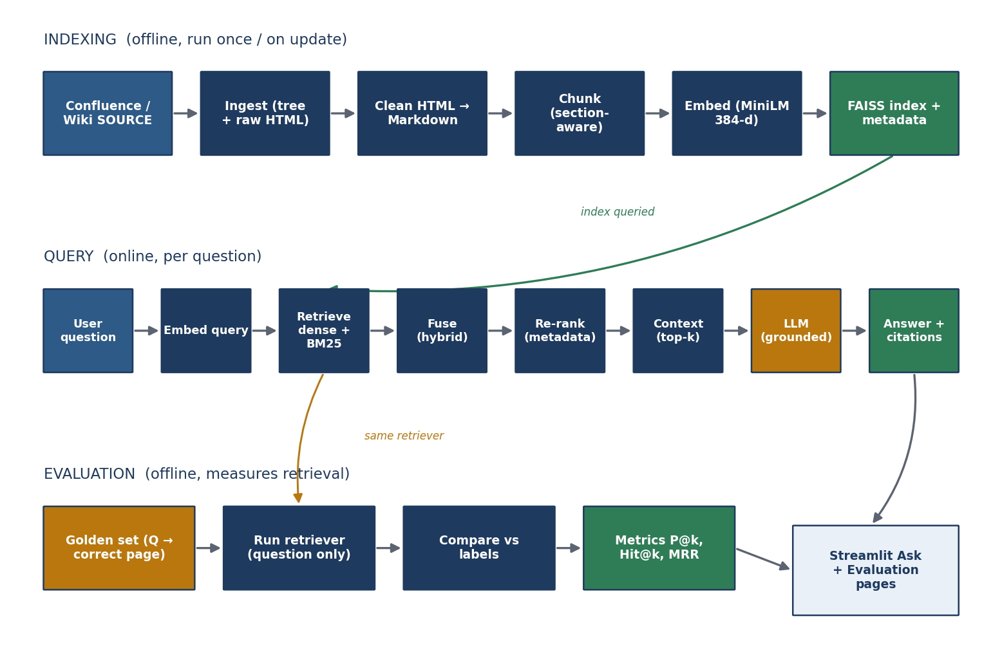
Figure 1 — Master flow: indexing (top), query (middle), and evaluation (bottom) share one index and one retriever.
- Indexing (offline): source → ingest → clean → chunk → embed → FAISS index. Run once, and again only when pages change.
- Query (online): question → embed → retrieve (dense + BM25) → fuse → re-rank → build context → LLM → answer + citations.
- Evaluation (offline): the golden set's questions are run through the same retriever and scored against their known-correct pages.
Why this shape. Each stage's output is the next stage's input, so there are no redundant parts; and because everything after ingestion is source-independent, the same pipeline serves Confluence or a wiki unchanged.

4. Configuration & Core Utilities
Before the stages, a small core layer keeps the system configurable, observable and robust.
Component | What it does | Why
config.py (Settings) | Loads all settings from the environment into one validated object; keeps backward-compatible constants. | One source of truth; validates only at point-of-use so the app still runs without every key.
exceptions.py | Typed errors per layer (ConfigError, IngestionError, RetrievalError, GenerationError…). | Failures are explicit and catchable, not silent.
logger.py | Central structured logging (loguru, with a fallback). | Every stage's progress and failures are traceable.
http.py (HttpClient) | A requests session with retries, back-off and timeouts. | Network calls to Confluence/Wiki survive transient errors.
constants.py | Shared constants (e.g. stop-words for keyword handling). | Consistent behaviour across retrieval and BM25.

5. Stage 1 — Ingestion
What it does. Connects to the source, walks the page hierarchy from a root page, downloads each page's raw HTML, and records a normalised metadata sidecar. A source factory selects Confluence or MediaWiki from configuration.
Why. Using the API (not scraping) gives reliable, structured content plus metadata and the parent/child tree — the tree becomes breadcrumbs that make later citations precise. Reducing every source to ‘raw HTML + metadata' is what makes the rest of the pipeline source-independent.
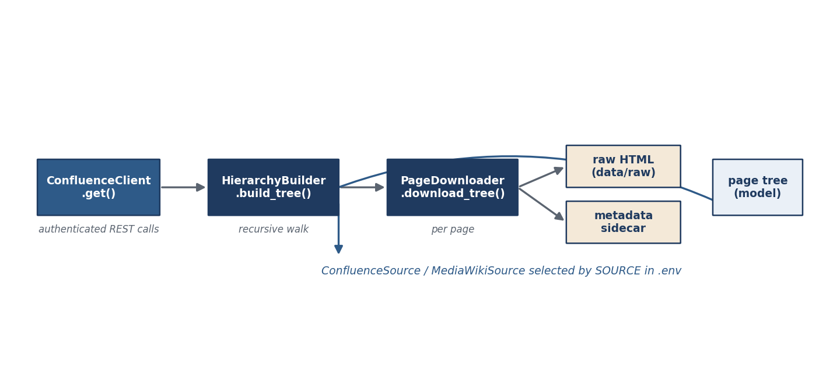
Figure 2 — Ingestion: connect → build page tree → download each page → raw HTML + metadata sidecar.

Key components
Code | Function | Role
ConfluenceClient | .get() | Authenticated REST calls to Confluence.
HierarchyBuilder | .build_tree() | Recursively walks parent → child pages into a tree.
PageDownloader | .download_tree() / .download_page() | Saves each page's raw HTML (and sidecar).
sources/ (KnowledgeSource) | get_source() | Interface + factory: ConfluenceSource or MediaWikiSource by SOURCE.
ConfluencePage (model) | — | The tree node: id, title, level, children.

6. Stage 2 — Processing (clean, metadata, chunk)
What it does. Converts storage HTML into clean Markdown, extracts per-page metadata, and splits each page into section-aware chunks with rich metadata.
Why. Models have context limits, so a whole page cannot be one unit; and retrieving a small section rather than a whole page is exactly what makes a citation precise. Splitting on headings keeps semantic units intact.
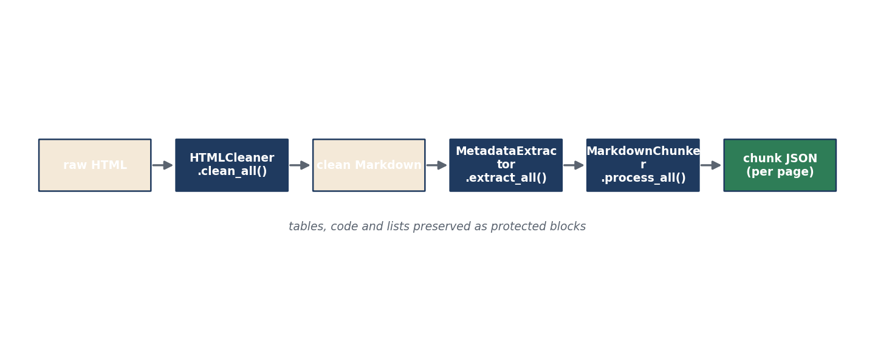
Figure 3 — Processing: raw HTML → clean Markdown → metadata → section-aware chunks.

6.1 Cleaning — HTMLCleaner
Converts Confluence storage HTML to Markdown (clean_html, clean_all), with a custom converter that preserves images, tables and code blocks, then post-processes the Markdown. Why: Markdown is compact, model-friendly, and keeps structure (tables/code/lists) that matters for retrieval.

6.2 Metadata — MetadataExtractor
Extracts title, section, breadcrumb, owner, status, source URL and headings (extract_file, extract_all). A generic variant reads a source-written sidecar so non-Confluence sources work without Confluence-specific calls. Why: these signals feed re-ranking and citations later, so they are captured once, up front.

6.3 Chunking — MarkdownChunker
The most involved component. It finds headings and splits into sections, detects and protects tables, lists and code blocks (so they are never split mid-structure), parses the page into typed blocks, and builds chunk objects with a small overlap between neighbours.
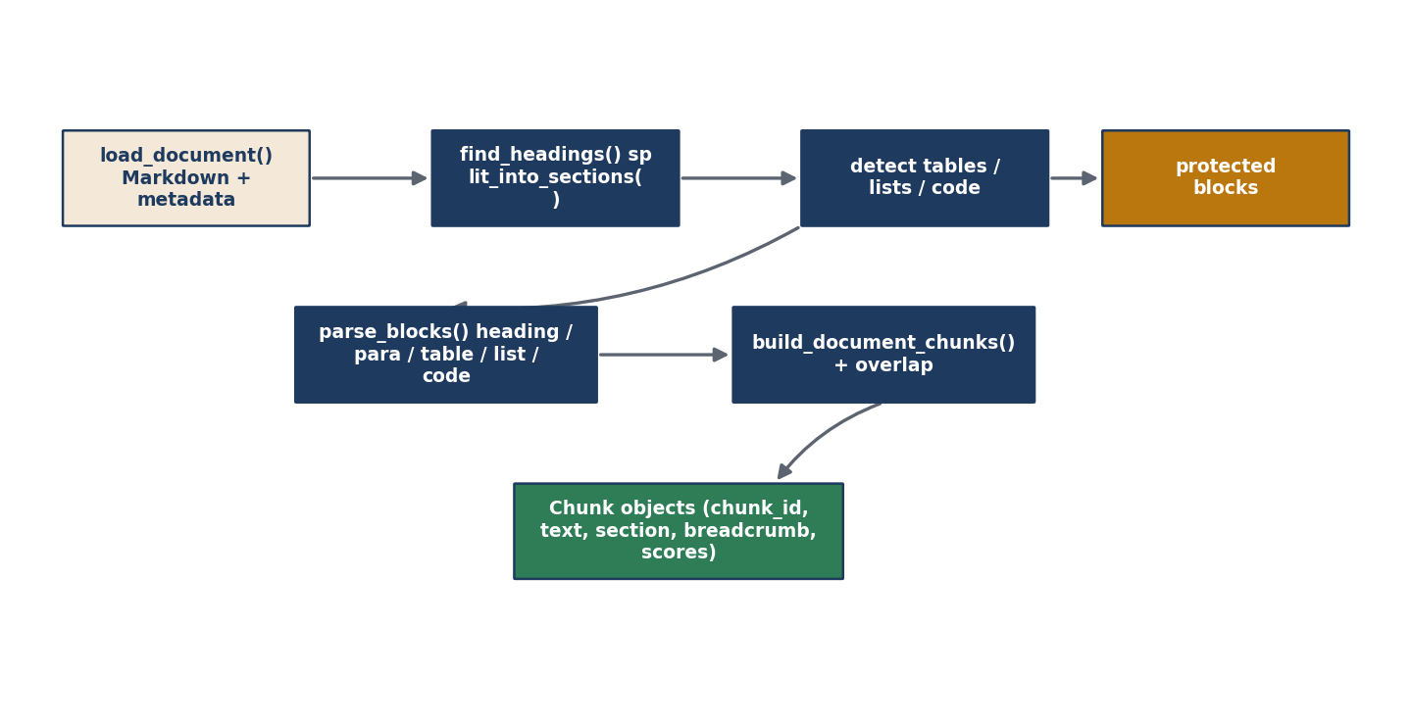
Figure 4 — Chunking detail: sections → protected blocks → typed blocks → chunk objects with overlap.
Function | Role
find_headings / split_into_sections | Break the page on its heading structure.
detect_tables / detect_lists / detect_protected_blocks | Identify structures that must stay intact.
parse_blocks | Turn the page into typed blocks (heading, paragraph, table, list, code).
build_document_chunks / _create_overlap | Assemble chunks and add overlap so context isn't lost at boundaries.
_split_* helpers | Split oversized paragraphs/lists/tables/code safely.
create_chunk_objects / save_chunks | Produce and persist the per-page chunk JSON.
Why overlap. A fact that straddles two chunks could be lost; a small overlap ensures the answer-bearing sentence appears whole in at least one chunk.

7. Stage 3 — Embedding & Vector Index
What it does. Encodes each chunk into a normalised 384-dimensional vector with a small local model, saves the vectors and an aligned metadata file, and builds a FAISS index.
Why. Embeddings match meaning, so ‘how do I undo a deploy' finds a chunk about ‘rollback'. The model is small and local — no per-query cost, and document content never leaves the environment. Normalising vectors and using an inner-product index gives exact cosine similarity with no approximation, which suits a high-value corpus of this size.
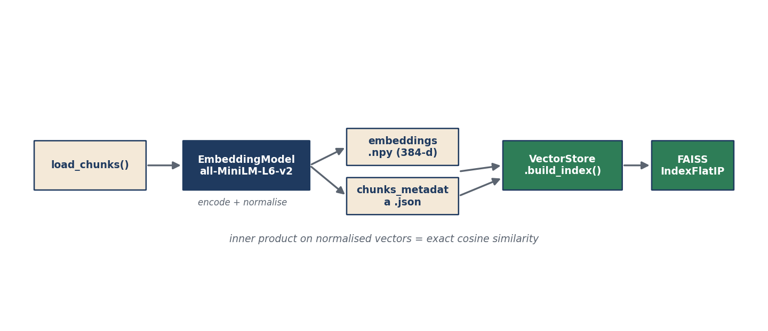
Figure 5 — Embedding & index: chunks → MiniLM vectors + metadata → FAISS index.
Code | Function | Role
EmbeddingModel | get_model() | Loads all-MiniLM-L6-v2 once (singleton).
EmbeddingGenerator | load_chunks / generate_embeddings / save_outputs / process_all | Encodes chunks, writes embeddings.npy and chunks_metadata.json.
VectorStore | build_index / load_index / search | Builds/loads the FAISS index; searches by query vector.

8. Stage 4 — Retrieval & Ranking
What it does. For a question, it generates candidate chunks two ways — dense (embedding) search and BM25 (keyword) search — fuses them (hybrid), then applies the metadata re-ranker, filters by score and de-duplicates.
Why. Embeddings can miss exact tokens like error codes and API names; BM25 catches them. Fusing both recovers cases either alone would miss. The re-ranker then adds cheap, high-precision structural signals on top — without any retraining.
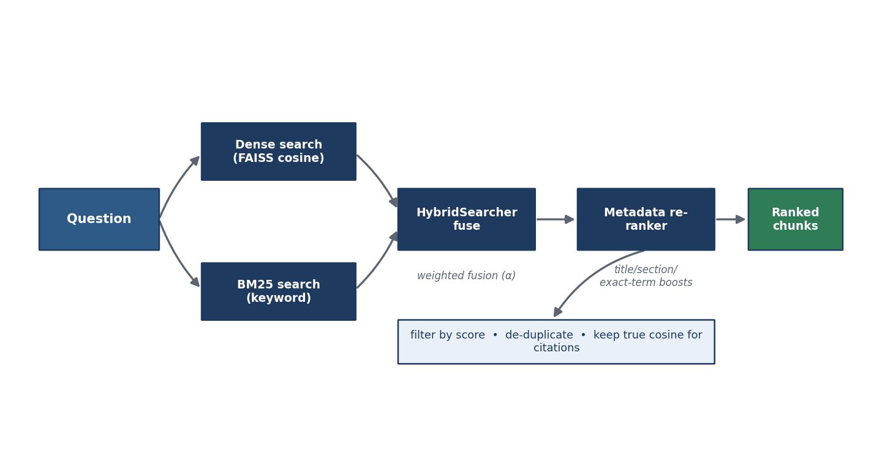
Figure 6 — Retrieval: dense + BM25 → hybrid fusion → metadata re-rank → filtered, ranked chunks.

8.1 Hybrid fusion (how dense and keyword scores combine)
Dense and BM25 scores are on different scales, so each candidate list is min-max normalised, then combined as α·dense + (1−α)·BM25. α is the dense weight (default 0.5), tunable in the app. The true cosine score is preserved separately so citations and confidence stay meaningful.
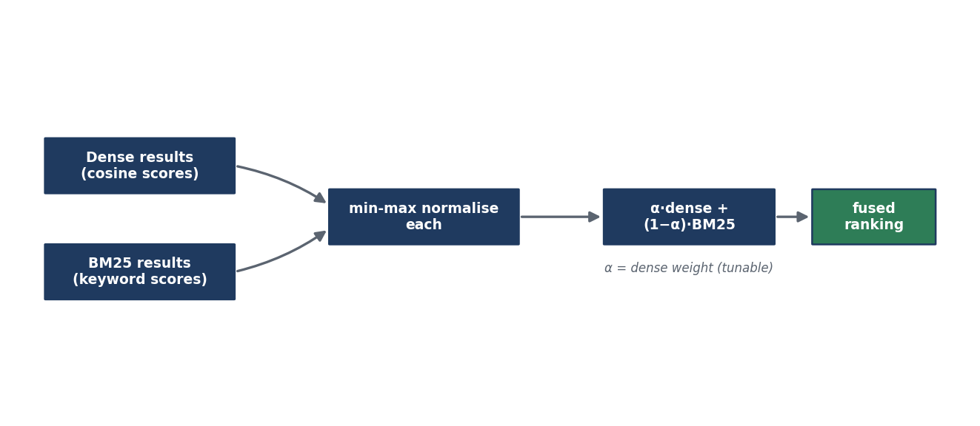
Figure 7 — Hybrid fusion: normalise each list, then weighted-combine into one ranking.
Code | Function | Role
VectorStore | search() | Dense (semantic) candidates by cosine.
BM25Index | search() | Sparse (keyword) candidates.
HybridSearcher | search() | Fuses the two lists into one ranked set.
RetrievalReranker | rerank() | Boosts title/section/heading/keyword/exact-phrase matches.
Retriever | retrieve() | Orchestrates candidates → rerank → filter → de-dup.
CitationBuilder | build() | Turns ranked chunks into citation records with scores and links.

9. Stage 5 — Answer Generation
What it does. Assembles the top-k chunks into a bounded context, builds a prompt instructing the model to answer strictly from that context, calls the LLM, and returns the answer with citations and a confidence badge. If no LLM key is set, it degrades to retrieval-only.
Why. Grounding (answer only from provided context) is the primary defence against hallucination; citations make every claim verifiable; and confidence (from the top similarity) flags weak-evidence answers.
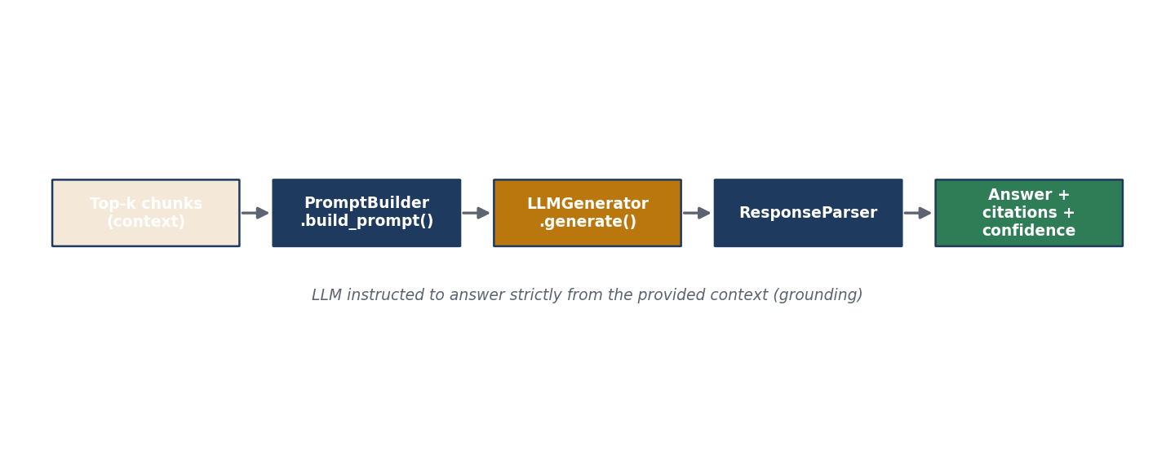
Figure 8 — Generation: top-k context → prompt → LLM → parsed answer + citations + confidence.
Code | Function | Role
PromptBuilder | build_context / build_prompt | Formats the retrieved chunks and the grounding instruction.
LLMGenerator | generate() | Calls the LLM (OpenAI) with the grounded prompt.
ResponseParser | build_response() | Structures answer, citations, confidence and metrics.
RAGPipeline | answer() / retrieve() / _confidence() | End-to-end query orchestrator (retrieval-only fallback).

10. Stage 6 — Evaluation & Metrics
What it does. Runs the golden set's questions through the same retriever and scores the ranked results against each question's known-correct page(s). The retriever is given only the question — never the labels — so the scores are genuine.
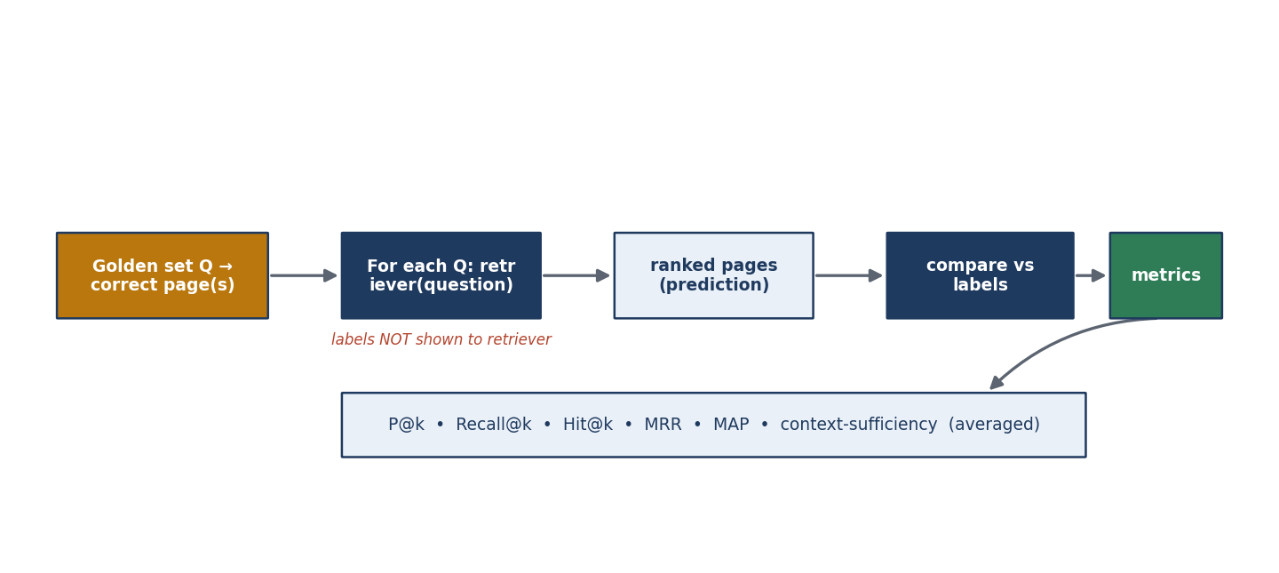
Figure 9 — Evaluation: labelled questions → retrieve → compare vs labels → averaged metrics.
Methodology (why it's fair). This is standard supervised information-retrieval evaluation: predict on the input, then grade the prediction against a hidden label. Because the retriever never sees the answer key, a high score reflects real quality, not leakage.

10.1 Metrics, defined explicitly
All metrics are computed per question and then averaged. ‘Relevant' means a page the question is truly answered by; ‘retrieved' means the pages the system returned, in rank order.
Metric | Definition (plain) | Formula / rule | Reads as
Precision@k | Of the top-k pages returned, the fraction that are correct. | (correct in top-k) ÷ k | Are the top results on-target?
Recall@k | Of all correct pages, the fraction that appear in the top-k. | (correct in top-k) ÷ (all correct) | Did we find it at all?
Hit@k | 1 if any correct page is in the top-k, else 0. | 1 if hit else 0 | Did the right page show up?
MRR | Mean of 1 ÷ (rank of the first correct page). | avg(1/rank) | How high does the right page sit?
MAP | Mean average precision across correct pages. | avg over ranks of precision | Overall ranking quality.
Context-sufficiency | Fraction of expected answer facts present in the retrieved text. | (keywords found) ÷ (keywords) | Is enough to answer actually retrieved?
Cosine similarity | Closeness of question and chunk vectors (0–1). | dot(a,b) for unit vectors | How semantically related?
Interpretation note (important for presenting). When a question has a single correct page, Precision@3 is capped at 0.33 and Precision@5 at 0.20 — a property of single-answer questions, not a weakness. Hit@1 and MRR are the headline retrieval numbers.

Code
Code | Function | Role
metrics.py | precision_at_k, recall_at_k, hit_at_k, reciprocal_rank, average_precision, context_sufficiency | The metric formulas (unit-tested).
RetrievalEvaluator | run(), ranked_pages_and_texts, print_report | Runs the golden set, aggregates, saves results.
comparison.py | run_comparison / print_comparison | Dense-vs-hybrid comparison on a benchmark.

11. Stage 7 — Streamlit Application
What it does. Provides two clearly separated surfaces over one index: an Ask page (live questions → answer, citations, retrieval diagnostics) and an Evaluation page (run the golden set → aggregate and per-question metrics). A ‘Mark correct' action lets a user label an asked question and add it to the golden set.
Why two surfaces. Ask is unlabelled inference; Evaluation is labelled measurement. Keeping them separate is itself a correctness statement — an ad-hoc question has no known-correct page, so it cannot be scored until a human labels it via ‘Mark correct'.
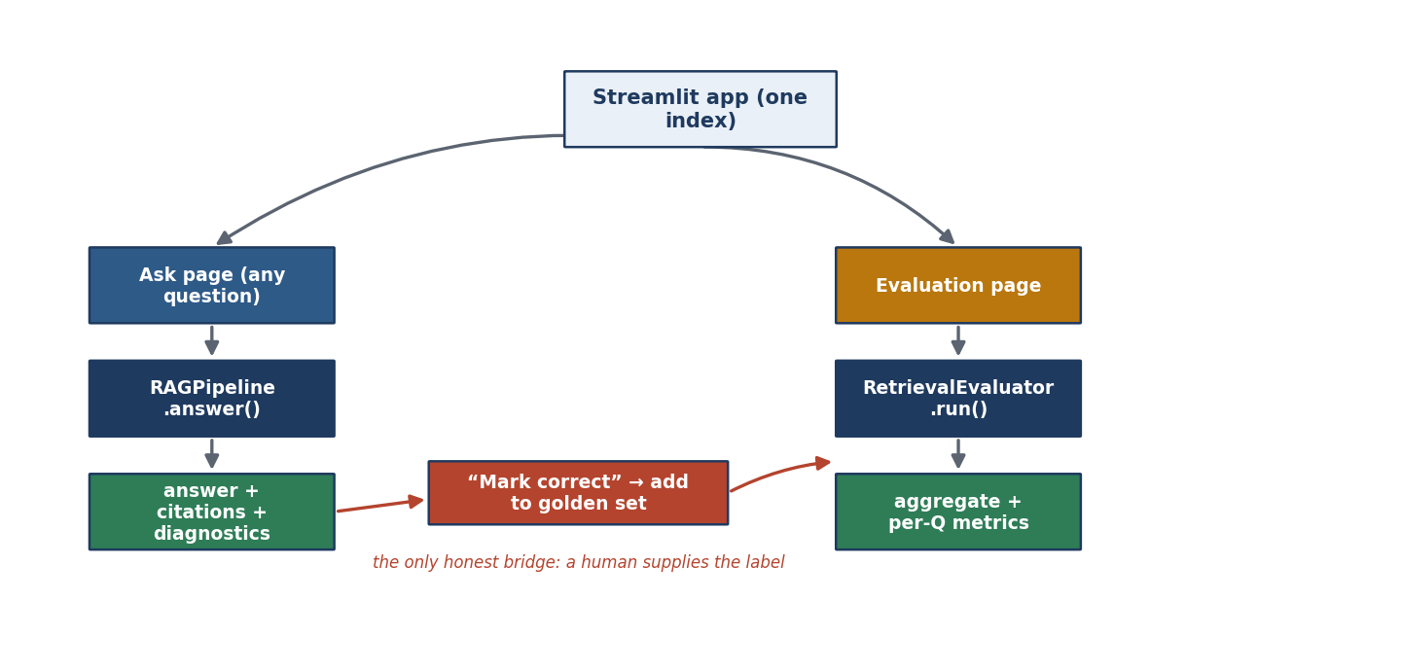
Figure 10 — Application: Ask and Evaluation paths over one index; ‘Mark correct' is the human-labelling bridge.

12. Worked Example — A Question End-to-End
Question: “What is the API rate limit?”
- 1. Embed. The question becomes a 384-d vector.
- 2. Retrieve. Dense search returns chunks near that vector; BM25 returns chunks containing ‘rate', ‘limit', ‘API'. The exact-term match helps BM25 surface the right chunk.
- 3. Fuse. Both lists are normalised and combined; the REST API Reference chunk rises because it appears in both.
- 4. Re-rank. Its section title (‘Rate limits') and exact-term overlap earn boosts, lifting it to rank 1.
- 5. Generate. The top chunks form the context; the LLM answers strictly from them: ‘100 requests per minute per token'.
- 6. Cite. The answer shows the REST API Reference page, section, link, cosine and BM25 scores, and a confidence badge.
If this question were in the golden set, evaluation would confirm the correct page was ranked #1 (Hit@1 = 1, reciprocal rank = 1).

13. Module Map (Quick Reference)
Layer | Modules | Responsibility
Core | config, logger, exceptions, http, constants | Settings, logging, errors, resilient HTTP.
Sources | sources/ (base, confluence, mediawiki) | Turn any source into raw HTML + metadata.
Ingestion | client, hierarchy, downloader, page_fetcher, models | Fetch pages and reconstruct the tree.
Processing | html_cleaner, metadata_extractor, chunker, chunk_models | Clean → metadata → section-aware chunks.
Embeddings | embedding_model, embedding_generator, vector_store | Vectors + FAISS index.
Retrieval | retriever, bm25_index, hybrid, reranker, citation_builder | Dense + BM25 + fuse + re-rank + cite.
LLM | generator, prompt_builder, response_parser | Grounded answer generation.
Pipeline | pipeline (RAGPipeline) | End-to-end query orchestration.
Evaluation | metrics, evaluator, comparison | Score retrieval; dense-vs-hybrid.
App | streamlit_app, main | Interface; ingestion CLI.
This document reflects the implemented codebase. Each stage above is independently runnable via python main.py --steps …, and the whole system is demonstrated through the Streamlit app.

