PHEKONG

Frontend Media Scan & Usage Plan
Local-only product image selection pack | 9 August 2026

Table of contents

1. Decision summary
Three JPEG frames were selected from paired JPEG/CR2 captures. Orientation, colour, crop, and presentation panels were adjusted without repainting product labels. An AI concept was rejected because small label text changed.

2. Homepage / collection landing
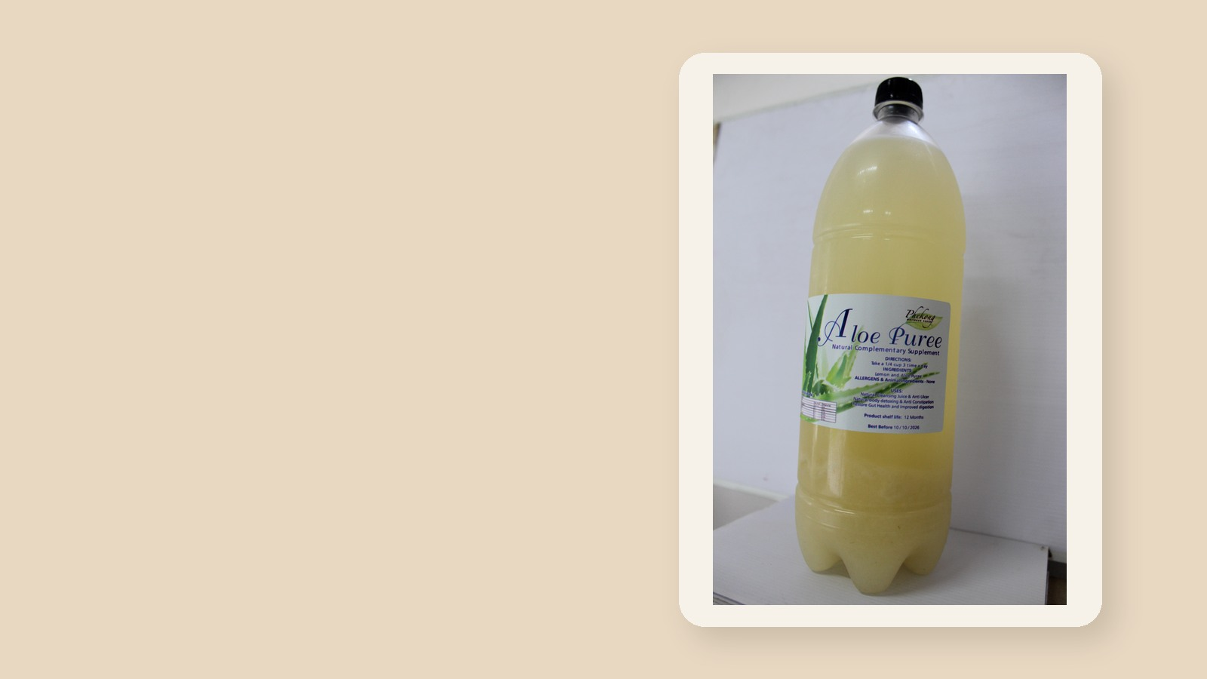
Source: IMG_0077.JPG | Edited asset: home-collection-hero-aloe-puree.jpg
Use the 16:9 composition as a campaign hero, keeping marketing copy in the left negative space.

3. Product-detail gallery
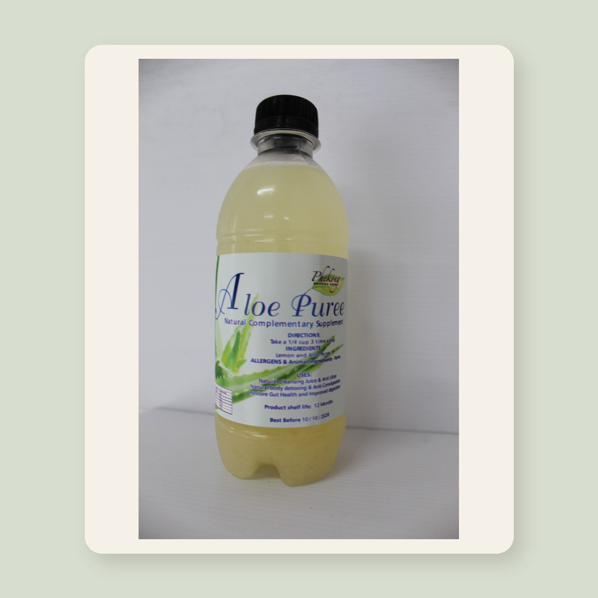
Source: IMG_0081.JPG | Edited asset: product-detail-aloe-puree.jpg
Use the square composition as the main gallery image with contain behavior and a zoomable original.

4. Catalogue card / editorial tile
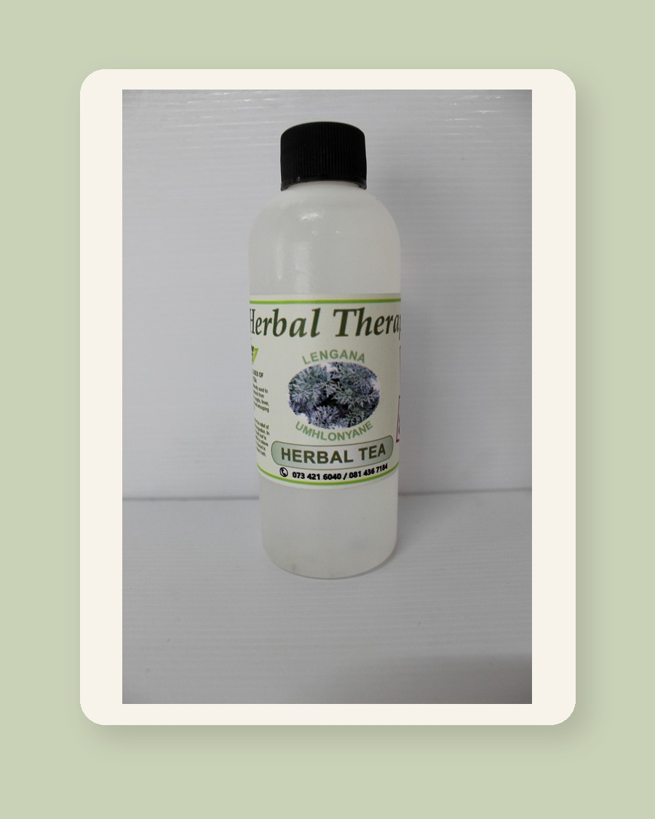
Source: IMG_0068.JPG | Edited asset: catalogue-card-herbal-therapy.jpg
Use the 4:5 crop for product grids and editorial discovery modules, especially on mobile.

5. Production gate
Before frontend promotion, verify catalogue mapping, product claims, image ownership/consent, final alt text, and responsive AVIF/WebP exports. This branch intentionally changes no application code.

6. Three-pass quality review
- Selection: distinct utility and readable product identity.
- Usability: desktop/mobile aspect ratios and copy-safe placement.
- Risk: rejected AI label distortion; production remains approval-gated.

