**Face Detection in a Video**

***A project report submitted in the fulfillment of the requirement for the award of the degree of Master of Computer Applications (MCA)***

**Submitted by**

Sankrita Patel

Roll No: 22223078

MCA- VI Semester

(Session: 2024-2025)

**Submitted to**

**Dr. Priyanka Tripathi**

**Head**

Department of Computer Applications

National Institute of Technology Raipur

**Dr. Naeem Ahmad**

**Supervisor**

Department of Computer Applications

National Institute of Technology Raipur



**Department of Computer Applications**

**National Institute of Technology, Raipur**

**DECLARATION**

I, **Sankrita Patel, 22223078**, hereby declare that the work done in the project entitled **Face detection in a Video** is done on my own.

I confirm that:

* The work contained in this report is original and has been done by me under the guidance of **Dr. Naeem Ahmad, Assistant Professor** Department of Computer Applications, National Institute of Technology Raipur.
* The work has not been submitted to any other institute for any other degree or diploma;
* I have followed the guidelines provided by the institute in preparing the project report;
* I have conformed to ethical norms and guidelines while writing the project report.
* Whenever I have used materials such as data, models, figures, and text from other sources, I have given them due credit by citing them in the report and providing their details in the references.

Place: Raipur Student name and signature

Date: Roll No: 22223078

MCA-VI Semester

**Certificate from Organization**



**CERTIFICATE FROM THE SUPERVISOR**

This is to certify that the project entitled **Face detection in a video** has been carried out by **Sankrita Patel, 22223078**, MCA 6th Semester, under my guidance.

The matter embodied in this project has not been submitted for the award of any other degree or diploma to the best of my knowledge.

Place: Raipur

Date:

__________________________

(Supervisor signature and seal)



**BONAFIDE CERTIFICATE BY THE HEAD OF THE DEPARTMENT**

This is to certify that Mr. **Sankrita Patel** a student of the Department of Computer Applications, National Institute of Technology, Raipur, Roll No. **22223078,** has carried out the project training at **National Informatics Center, Raipur** as partial fulfillment of the requirement for the award of the degree of Master of Computer Applications.

He/She has worked in the project entitled **Face Detection in a Video.** Their performance and conduct have been found to be good.

This certificate issued by the undersigned does not cover my responsibility regarding the statements made and work carried out by the concerned student. The current dissertation is hereby being forwarded for evaluation for the purpose for which it has been submitted.

Place: Raipur

Date:

__________________________

(Head signature and seal)



**CERTIFICATE OF APPROVAL**

The forgoing project entitled **Face Detection in a Video** is hereby approved as a creditable work for the partial fulfillment of the requirement for the award of the degree of Master of Computer Applications and has been presented in a satisfactory manner.

This certificate issued by the undersigned does not cover my responsibility regarding the statements made and work carried out by the concerned students. The current dissertation is hereby being forwarded for evaluation for the purpose for which it has been submitted.

Place: Raipur

Date:

____________________________

(Name and Signature Internal Examiner)

____________________________

(Name and Signature External Examiner)

1. **Table of Content**
2. **List of Tables**
3. **List of Figures**

**Acknowledgement**

I would like to express my sincere gratitude to everyone who supported and guided me throughout the development of the **Face Detection in a Video** project.

I am especially thankful to **Dr. Naeem Ahmad** for his valuable mentorship, insightful feedback, and constant encouragement at every stage of this project. His technical expertise and guidance played a crucial role in shaping the final outcome.

I am grateful to the **National Informatics Centre (NIC), Raipur**, for providing me the opportunity to undertake this project as part of my internship. The experience and exposure gained during this period have been immensely enriching and instrumental in the successful completion of this work.

I also extend my appreciation to the faculty and staff of the **National Institute of Technology, Raipur** for providing the necessary infrastructure and a conducive environment for learning and development.

My heartfelt thanks go to my friends and classmates for their continuous support, helpful suggestions, and collaboration during the course of this project. I would also like to acknowledge the developers and contributors of open-source technologies such as **OpenCV**, **TensorFlow**, **Django**, and **React**, which formed the foundation of this application.

Finally, I am deeply grateful to my family for their unwavering support, patience, and motivation, which helped me stay focused and committed throughout this journey.

***Face Detection in a Video***

***Abstract:***

The **Face Detection in a Video** project is a comprehensive facial analysis system that integrates multiple facial technologies into a unified web-based platform. This system leverages computer vision and deep learning techniques to provide real-time **face detection**, **face recognition**, **face similarity comparison**, and **facial emotion detection**. The backend is built using **Django REST Framework**, offering robust APIs for processing video frames and images, while the frontend is developed using **React.js**, delivering a responsive and user-friendly interface.

The application supports both webcam-based live video input and uploaded video files for analysis. Using pre-trained deep learning models and OpenCV, the system identifies faces in real-time, compares facial features for recognition and similarity scoring, and classifies emotions such as happy, sad, angry, surprised, and neutral.

Face detection in a Video can be applied to various domains such as surveillance, user authentication, human-computer interaction, and emotional analysis. The modular architecture ensures scalability and future integration of advanced facial features. The project demonstrates the powerful intersection of artificial intelligence and web technologies in creating intelligent, real-time facial analysis systems.

***Keywords****— Face Detection, Face Recognition, Face Similarity, Emotion Detection, Computer Vision, Deep Learning, OpenCV, Django REST Framework, React.js, Real-Time Analysis, Human-Computer Interaction, Artificial Intelligence.*

# Introduction

## Introduction to the Problem

In recent years, face-based technologies have emerged as vital tools across domains such as security, user authentication, emotion analytics, and surveillance. Traditional methods of authentication or surveillance rely on manual monitoring or physical identity proofs, which are susceptible to errors and inefficiencies. Face recognition and emotion detection offer a contactless, real-time solution to these challenges.

## Motivation

The increasing need for touchless and intelligent user interfaces—particularly in post-pandemic environments—has driven the demand for face-based technologies. This project aims to design a system capable of detecting faces, recognizing individuals, analysing facial expressions, and comparing facial similarity using cutting-edge computer vision and deep learning tools. The goal is to improve user authentication, security systems, and emotion-aware computing.

# Project Overview

## Problem Definition

The key challenge is to build a system that can:

* Detect human faces from both images and video.
* Recognize faces by comparing them with a known dataset.
* Analyse facial emotions in real-time.
* Measure similarity between two faces.

These tasks must be performed efficiently with minimal latency.

## Contribution

* Developed a full-stack application using Django REST API (backend) and React.js (frontend).
* Integrated face detection, recognition, similarity analysis, and emotion classification.
* Supported both webcam input and uploaded videos/images.
* Created modular, reusable APIs for integration into other systems.

## Outcomes

* Accurate real-time face detection and emotion recognition system.
* RESTful API endpoints for facial tasks.
* A responsive React-based UI with webcam and file upload interfaces.
* Achieved high face recognition accuracy using deep learning models.

# System Model

## Software

* Backend: Django, Django REST Framework
* Frontend: React.js
* Libraries: OpenCV, TensorFlow/Keras, Dlib, face-recognition
* Database: SQLite

## Design

The system follows an MVC-like pattern with a decoupled frontend and backend. Each module (face detection, recognition, emotion classification) is isolated for scalability and maintainability.

## Architecture

* Client (React.js): Captures or uploads media, sends API requests.
* Backend (Django REST): Processes media using CV and ML models.
* Model Layer: Handles face and emotion analysis.
* Database: Stores user data and recognition logs.

## Hardware

* Development machine with:
  + CPU: AMD Ryzen 7
  + RAM: 16 GB
  + GPU (for training or real-time inference): NVIDIA GEFORCE RTX
* Webcam (for live face detection)

## Libraries

* opencv-python
* face-recognition
* dlib
* mediapipe
* tensorflow / keras
* numpy, pandas
* django, djangorestframework

## Platform

* Cross-platform: Windows
* Web-based access via modern browsers

1. Methodology

## Algorithm

* Face Detection: MTCNN / Haar Cascades / OpenCV DNN
* Face Recognition: FaceNet embeddings + cosine similarity
* Emotion Detection: CNN-based model trained on FER-2013 dataset
* Face Similarity: Euclidean or cosine distance between face embeddings

## Proposed Method

* Use MTCNN/OpenCV for accurate multi-face detection.
* Extract face embeddings using a pre-trained FaceNet model.
* Compare embeddings to recognize identities or compute similarity.
* Emotion detection via CNN classifying expressions (happy, sad, angry, etc.)

# Implementation

## Flow Chart

### Login and Sign – Up Page Flow Chart

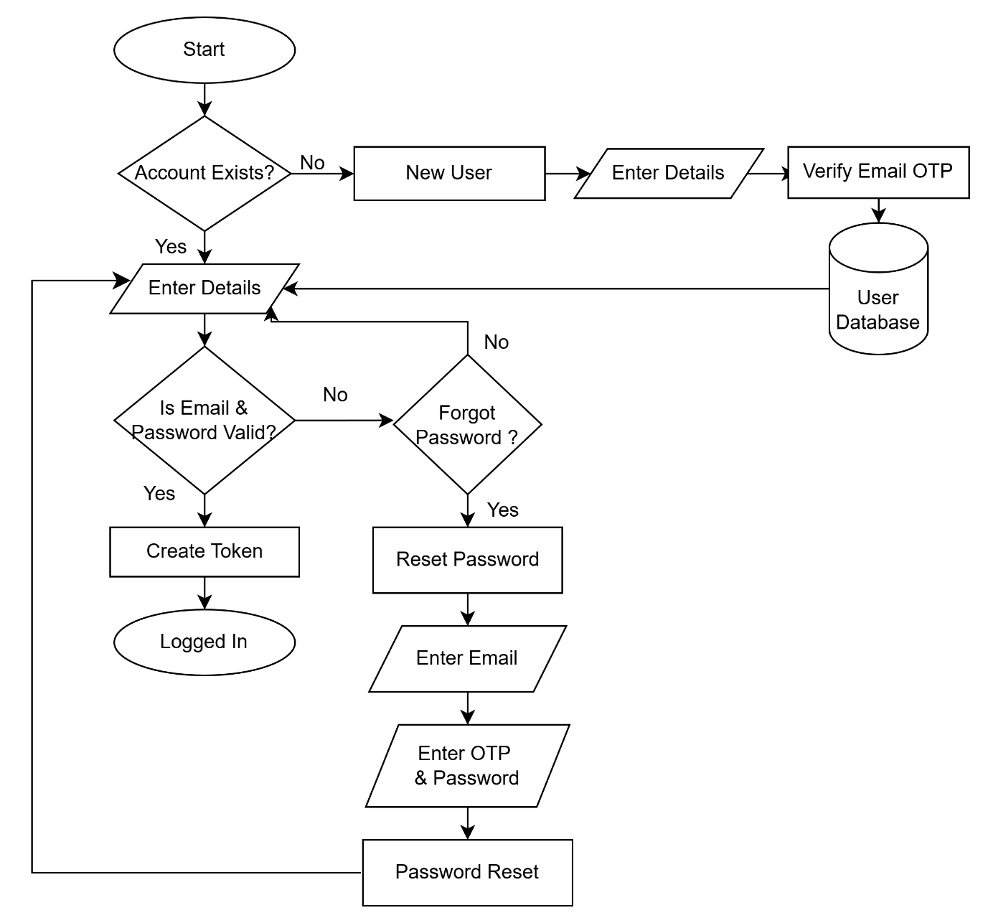

## E-R Diagram

## Code

## Simulation

# Results and Discussion

## Outcomes

## Experimental Results

### Face Detection

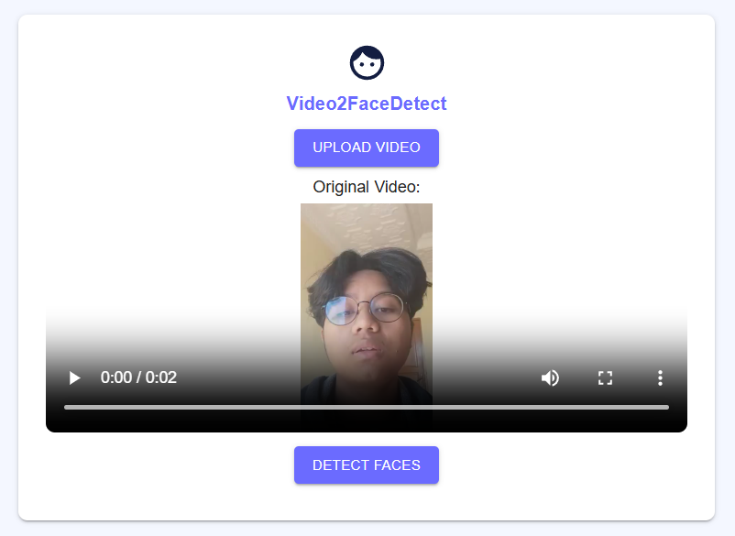

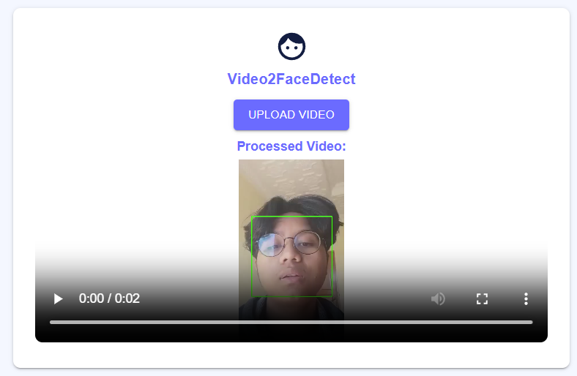

### Emotion Detection

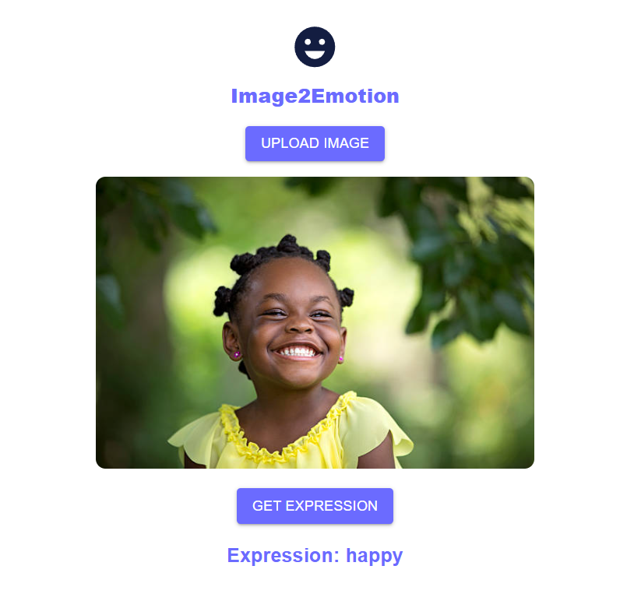

# Conclusion

This project demonstrates an end-to-end face technology platform integrating multiple facial analysis features. The modularity of the architecture allows independent improvements to each component. Future enhancements can include multi-face tracking, age/gender estimation, and deployment on edge devices.

# Bibliography / References

* FaceNet: “FaceNet: A Unified Embedding for Face Recognition and Clustering”, Schroff et al., 2015
* OpenCV Documentation - https://docs.opencv.org
* Dlib Library - <http://dlib.net>
* TensorFlow Documentation - <https://www.tensorflow.org>
* FER2013 Dataset - https://www.kaggle.com/datasets/msambare/fer2013