### Industrial Internship Report on

**” Automatic Door Opening System**

**Prepared by**

## Sanku Guruprakash

|  |
| --- |
| **Executive Summary** |
| This report provides details of the Industrial Internship provided by Upskill Campus and The IoT Academy in collaboration with Industrial Partner UniConverge Technologies Pvt Ltd (UCT).  **Abstract:**  Automatic doors use sensors to open and close the door, so the door opens and closes only when it recognizes a person. The problem is that the door opens and closes when a person who has no intention of opening the door passes by the automatic door. In this study, we propose an automatic door with loose security by using recorded words and poses. By developing an automatic door control system that only allows people who know the specific words and poses to pass through, we can maintain a certain level of security and avoid unnecessary opening and closing motions.  This internship gave me a very good opportunity to get exposure to Industrial problems and design/implement solutions for them. It was an overall great experience to have this internship. |

**TABLE OF CONTENTS**

1. Preface 3
2. Introduction 5
   1. About UniConverge Technologies Pvt Ltd 5
   2. About upskill Campus 9
   3. Objective 11
   4. Reference 11
3. Problem Statement 12
4. Existing and Proposed solution 14
5. Proposed Design/ Model 14

5.3 Interfaces (if applicable) ................................................... Error! Bookmark not defined.5

1. Performance Test 15
   1. Test Procedure 16
   2. Performance Outcome 16
2. My learnings 17
3. Conclusion 18

##### Preface

Summary of the whole 6 weeks’ work.

###### Week-1:

Studied about Internship Project providing company “UniConverge Technologies Pvt Ltd” ,which domains does it work, what kind of products/solutions does it work.

###### Week-2:

Do necessary study and Start working/designing the solution corresponding to your project.

* + Embedded system & IoT
  + Python
  + Core Java
  + Data Science & Machine Learning
  + Digital Marketing
  + 5G
  + Drones
  + Industry4.0
  + Electrical Vehicles
  + Cyber security

**Week-3:Week-4:Week-5:Week-6** Project Implementation Opportunity given by USC/UCT

 



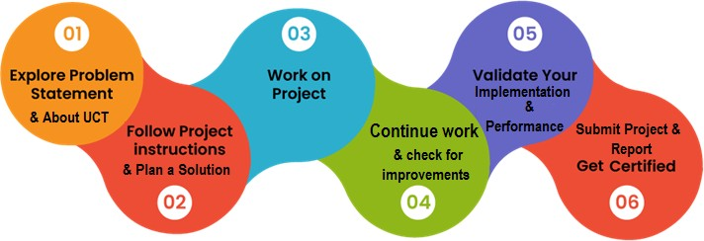

Thank to all Upskills Team, who have helped me directly or indirectly.

##### Introduction

###### About UniConverge Technologies Pvt Ltd

A company established in 2013 and working in Digital Transformation domain and providing Industrial solutions with prime focus on sustainability and RoI.

For developing its products and solutions it is leveraging various **Cutting Edge Technologies e.g. Internet of Things (IoT), Cyber Security, Cloud computing (AWS, Azure), Machine Learning, Communication Technologies (4G/5G/Lora WAN), Java Full Stack, Python, Front end** etc.

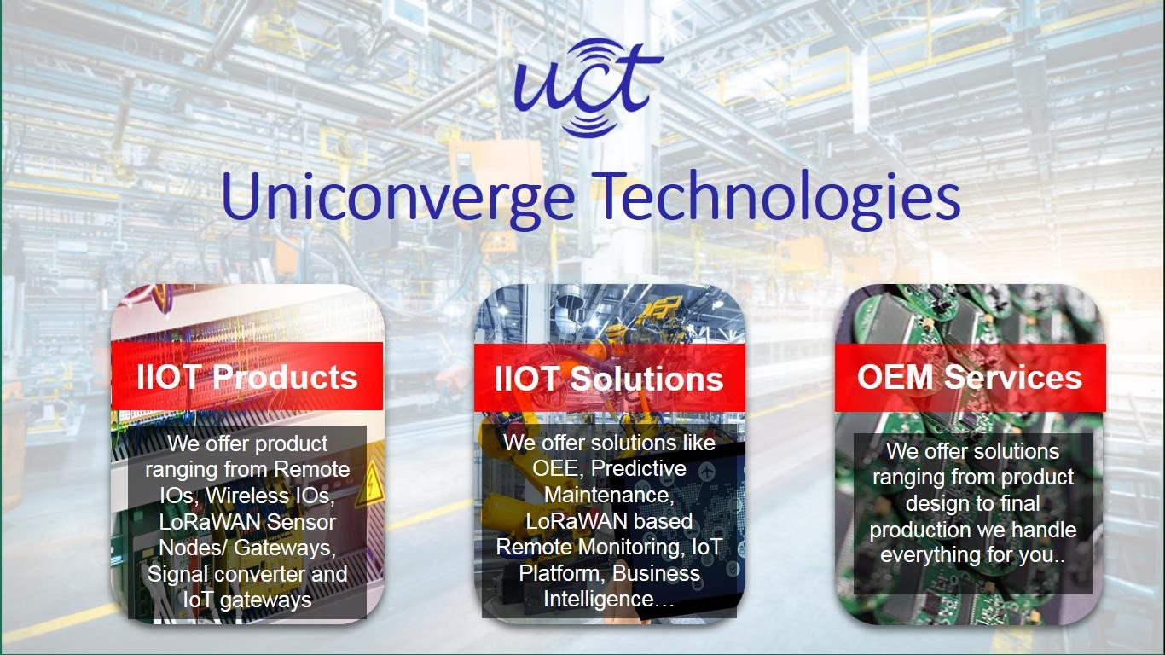

* + 1. **UCT IoT Platform ( )**

**UCT Insight** is an IOT platform designed for quick deployment of IOT applications on the same time

providing valuable “insight” for your process/business. It has been built in Java for backend and ReactJS for Front end. It has support for MySQL and various NoSql Databases.

* It enables device connectivity via industry standard IoT protocols - MQTT, CoAP, HTTP, Modbus TCP, OPC UA
* It supports both cloud and on-premises deployments.

It has features to

* Build Your own dashboard
* Analytics and Reporting
* Alert and Notification
* Integration with third party application(Power BI, SAP, ERP)
* Rule Engine

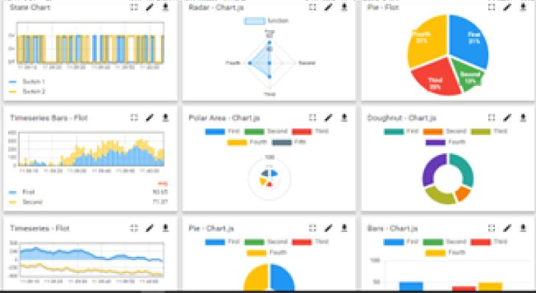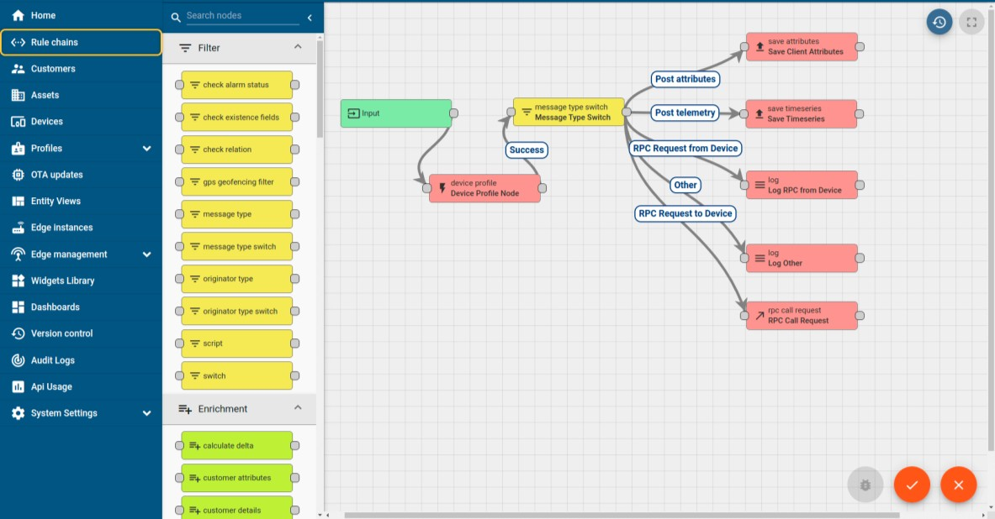

### Smart Factory Platform ( )

Factory watch is a platform for smart factory needs. It provides Users/ Factory

* with a scalable solution for their Production and asset monitoring
* OEE and predictive maintenance solution scaling up to digital twin for your assets.
* to unleased the true potential of the data that their machines are generating and helps to identify the KPIs and also improve them.
* A modular architecture that allows users to choose the service that they what to start and then can scale to more complex solutions as per their demands.

Its unique SaaS model helps users to save time, cost and money.

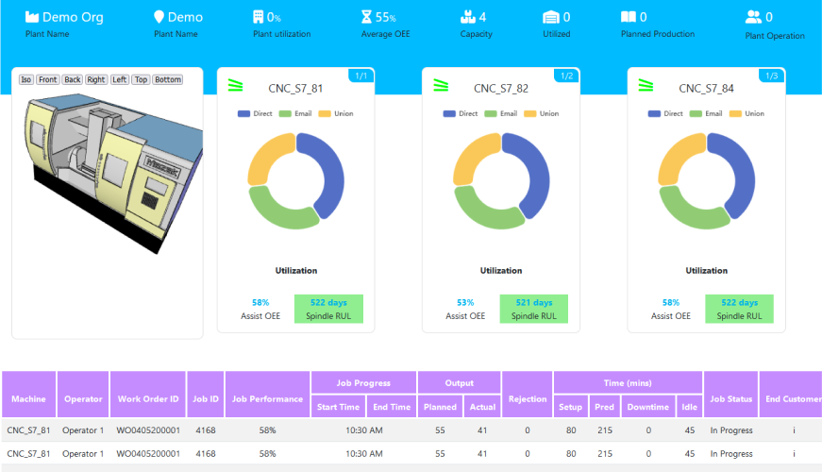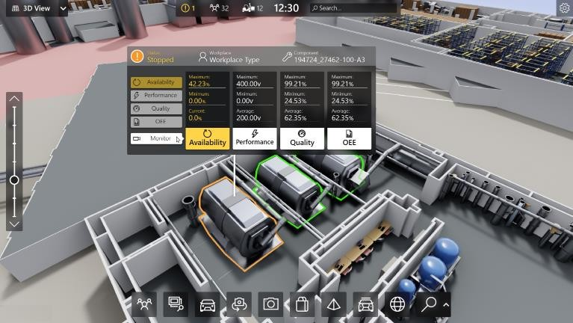

#### What is LoRaWAN? - Yeastar Workplace Helpbased Solution

UCT is one of the early adopters of LoRAWAN teschnology and providing solution in Agritech, Smart cities, Industrial Monitoring, Smart Street Light, Smart Water/ Gas/ Electricity metering solutions etc.

#### Predictive Maintenance

UCT is providing Industrial Machine health monitoring and Predictive maintenance solution leveraging Embedded system, Industrial IoT and Machine Learning Technologies by finding Remaining useful life time of various Machines used in production process.

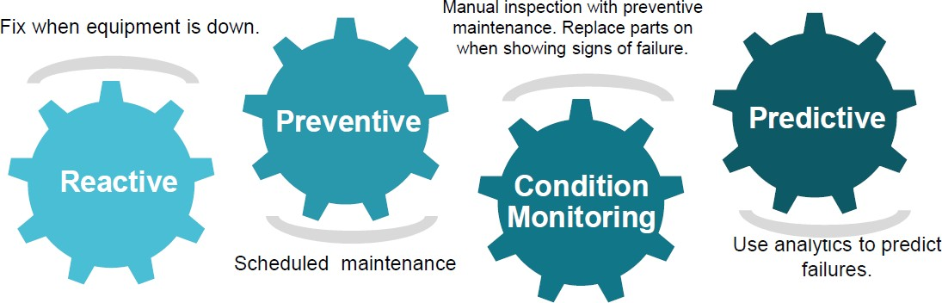

###### About upskill Campus (USC)

upskill Campus along with The IoT Academy and in association with Uniconverge technologies has facilitated the smooth execution of the complete internship process.

USC is a career development platform that delivers **personalized executive coaching** in a more affordable, scalable and measurable way.



Seeing need of upskilling in self paced manner along-with additional support services e.g. Internship, projects, interaction with Industry experts, Career

growth Services

upSkill Campus aiming to upskill 1 million learners in next 5 year

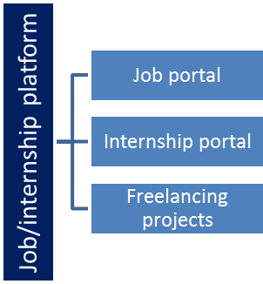<https://www.upskillcampus.com/>

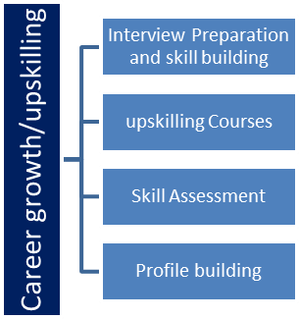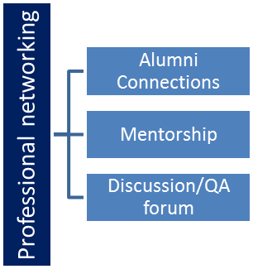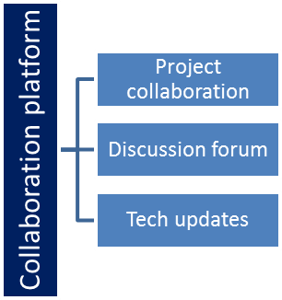

 



###### The IoT Academy

The IoT academy is EdTech Division of UCT that is running long executive certification programs in collaboration with EICT Academy, IITK, IITR and IITG in multiple domains.

###### Objectives of this Internship program

The objective for this internship program was to

☛ get practical experience of working in the industry.

☛ to solve real world problems.

☛ to have improved job prospects.

☛ to have Improved understanding of our field and its applications.

☛ to have Personal growth like better communication and problem solving.

###### Reference

1. Xuanang Feng, Yuina Yazawa, and Y. Zuo. 2017. Control of Automatic Door by Using Kinect Sensor. Bulletin of Networking, Computing, Systems, and

Software. 6, 1. 17-21.

1. Takuma Nakamura, Yuichi Mori, and Ikuko Yairi. 2020. Improvement of accuracy of posture estimation of soccer shot motion from video. In Proceedings of the 34th Annual Conference of the Japanese Society for

Artificial Intelligence.

1. Heejin Cho, Bing Liu, and Krishnan Gowri. 2010. Energy saving impact of ASHRAE 90.1 vestibule requirements: Modeling of air infiltration through door

openings. Pacific Northwest National Lab. (PNNL).

**Problem Statement**

**Introduction:**

An automatic door opening system is a modern technological solution designed to enhance convenience, accessibility, and efficiency in various environments, such as commercial buildings, healthcare facilities, residential spaces, and public spaces. This system employs sensors, motors, and control mechanisms to facilitate the seamless and hands-free operation of doors, eliminating the need for manual effort to open or close them.

The main objectives of an automatic door opening system are to provide ease of access, improve energy efficiency, enhance security, and create a more inclusive environment for individuals with disabilities or mobility challenges. This technology finds applications in a wide range of settings, from retail stores and airports to hospitals and hotels.

Key components of an automatic door opening system typically include:

**Sensors**: Various types of sensors, such as motion sensors, infrared sensors, and touchless sensors, detect the presence of individuals approaching the door. These sensors trigger the door opening mechanism when someone is within a specified range.

**Actuators:** Motors or pneumatic systems are used as actuators to physically move the door panels. These actuators respond to the signals from the sensors and initiate the door's opening or closing motion.

**Control System:** A central control unit or microcontroller manages the communication between sensors and actuators. It processes the sensor inputs and sends commands to the actuators to ensure smooth and coordinated door operation.

**Power Supply:** The system requires a reliable power source to operate the sensors, actuators, and control unit. Backup power solutions may be integrated to ensure continued functionality during power outages.

**Safety Features:** Automatic door opening systems incorporate safety mechanisms, such as obstacle detection sensors and safety sensors, to prevent accidents and ensure that the door stops or reverses its motion if an obstruction is detected.

**User Interface:** Some systems include user-friendly interfaces, such as push-button switches or touchless panels, allowing individuals to manually initiate door opening when necessary.

##### Benefits of an automatic door opening system:

**Convenience:** Users can enter or exit a building without the need to physically push or pull doors, making it particularly useful for those carrying items or pushing strollers.

**Accessibility:** Automatic doors are more inclusive, enabling easy access for people with disabilities or limited mobility.

**Energy Efficiency:** Automatic doors can help regulate indoor temperatures by minimizing the time doors are open, thus improving energy efficiency.

**Hygiene and Health:** In environments where hygiene is crucial, touchless sensors reduce the need for individuals to touch door handles, promoting cleanliness.

**Security:** These systems can be integrated with security features, such as access control systems, to manage and monitor entry into restricted areas.

**Aesthetics:** Automatic doors often have a modern and sleek appearance, enhancing the aesthetic appeal of a space.

# Existing and Proposed solution

Traditional manual doors are the most common type of door system found in various buildings. They require physical effort from users to open and close the doors. This solution has been widely used for many years and is familiar to most people. However, it has several limitations:

**Manual Operation:** Users need to physically push or pull the door to open and close it, which can be cumbersome, especially when carrying items or for individuals with mobility challenges.

**Limited Accessibility:** Manual doors can be difficult for people with disabilities or those using mobility aids to operate, leading to issues of inclusivity and accessibility.

**Energy Inefficiency:** Doors may be inadvertently left open, leading to temperature fluctuations and increased energy consumption for heating or cooling.

**Hygiene Concerns:** Manual doors require users to touch door handles, which can be a source of potential germ transmission, especially in high-traffic areas.

* 1. **Code submission (GitHublink):** Type your text

0-

* 1. **Report submission (Github link) :**

1. **Proposed Design/ Model**

An automatic door opening system presents an advanced solution that addresses the limitations of traditional manual doors. This proposed system offers numerous benefits:

**Convenience:** Users can enter or exit a building without the need for physical effort. Sensors detect approaching individuals and open the door automatically.

**Accessibility:** Automatic doors are highly accessible, catering to people with disabilities, seniors, and anyone with mobility challenges.

**Energy Efficiency:** Automatic doors help regulate indoor temperatures by minimizing the time doors are open, leading to reduced energy consumption and cost savings.

**Hygiene and Health:** Touchless sensors or touchless switches reduce the need for users to physically touch the door, promoting hygiene and reducing the risk of germ transmission.

**Safety:** Automatic doors often include safety features like sensors that detect obstacles, preventing the door from closing on a person or object.

**Security:** These systems can be integrated with access control systems, enhancing security by controlling who can enter the building and when.

**Aesthetics:** Automatic doors can have a modern and sleek appearance, enhancing the overall aesthetic of the building's entrance.

**Customization:** The speed of door opening and closing can be adjusted based on the environment and foot traffic, ensuring optimal performance.

**Remote Control:** Some advanced systems can be controlled remotely, allowing authorized personnel to manage door operations from a central location.

**Backup Power:** Many automatic door systems have backup power sources to ensure continued operation during power outages.

 



1. **Performance Test**

###### 3.1 Test Procedure

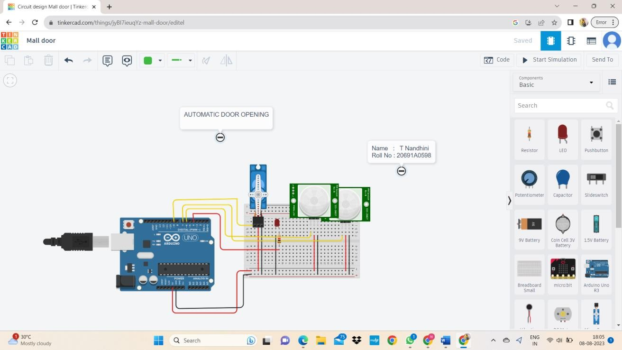

**4.2 Performance Outcome**

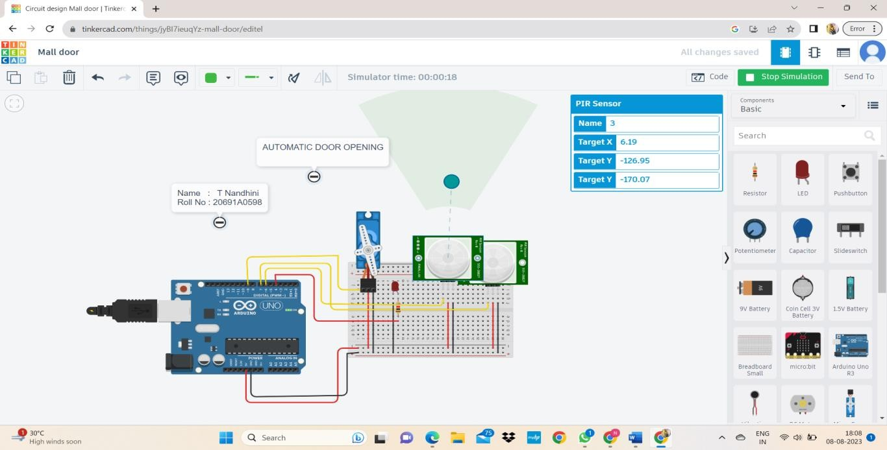

**4 My learnings**

The Work Experiences I Encountered During The Internship Allowed Me To Develop Iot Embedded System. I Think I Still Require To Work On My IoT Real Time project. But, The Overall Experience Was Positive, And Everything I Learned Would Be Useful In My Future Career In This Field.

# Conclusion:

The automatic door opening system has become an integral part of modern infrastructure, finding applications in commercial buildings, healthcare facilities, hospitality venues, public spaces, and beyond. As technology continues to evolve, we can anticipate further advancements and refinements in automatic door systems, leading to even smarter and more sophisticated solutions that redefine the way we interact with our surroundings. Overall, the automatic door opening system represents a fusion of convenience, technology, and practicality that has a lasting positive impact on the way we experience physical spaces.