**Naan Mudhalvan Project**

**Air Quality Analysis in Tamil Nadu**

**Phase 4**

**TEAM MEMBERS:**

Hematharshini E – 2021115041

Email - [hemae2512@gmail.com](mailto:hemae2512@gmail.com)

2. Sabitha S – 2021115087

Email - [sabitha.suresh15@gmail.com](mailto:sabitha.suresh15@gmail.com)

3. Sandhya Shankar – 2021115090

Email - [sandhya.shankar.2002@gmail.com](mailto:sandhya.shankar.2002@gmail.com)

4. Sanmitha V.S – 2021115092

Email - [sanmithasadhishkumar@gmail.com](mailto:sanmithasadhishkumar@gmail.com)

5. Akash P – 2021115314

Email - [akashpanneer2004@gmail.com](mailto:akashpanneer2004@gmail.com)

**Phase objective:**

In this phase of our air quality analysis project, we continue to explore and visualize the air quality data. The dataset is loaded from the file "modified_transportation_data.csv," and we focus on understanding the average levels of SO2, NO2, and RSPM/PM10 across monitoring stations and city/town/village/area. Additionally, we create visualizations, time-series plots, and correlation matrices to gain insights into air quality trends and relationships.

**Data Loading and Preparation:**

import pandas as pd

import matplotlib.pyplot as plt

import seaborn as sns

data = pd.read_csv("/content/modified_transportation_data.csv")

**Average Pollution Levels by Monitoring Stations:**

We calculated and visualized the average SO2, NO2, and RSPM/PM10 levels across different monitoring stations. The bar plots provide a clear overview of pollution levels by station.

**Average SO2 Levels:**

# Create a bar plot to visualize average SO2 levels by monitoring station

sns.barplot(x=average_levels.index, y=average_levels['SO2'])

plt.xlabel('Monitoring Station')

plt.ylabel('Average SO2 Level')

plt.title('Average SO2 Levels by Monitoring Station')

plt.xticks(rotation=90)

plt.show()

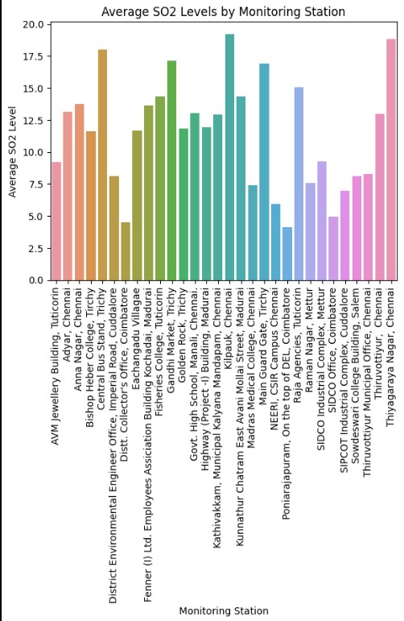

**Average NO2 Levels:**

# Create a bar plot to visualize average NO2 levels by monitoring station

sns.barplot(x=average_levels.index, y=average_levels['NO2'])

plt.xlabel('Monitoring Station')

plt.ylabel('Average NO2 Level')

plt.title('Average NO2 Levels by Monitoring Station')

plt.xticks(rotation=90)

plt.show()

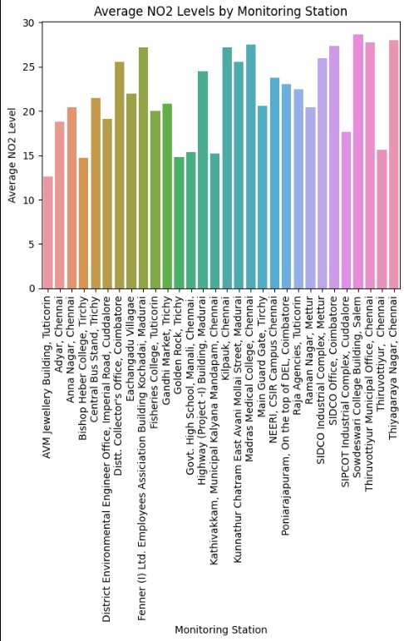

**Average RSPM/PM10 Levels:**

# Create a bar plot to visualize average RSPM/PM10 levels by monitoring station

sns.barplot(x=average_levels.index, y=average_levels['RSPM/PM10'])

plt.xlabel('Monitoring Station')

plt.ylabel('Average RSPM/PM10 Level')

plt.title('Average RSPM/PM10 Levels by Monitoring Station')

plt.xticks(rotation=90)

plt.show()

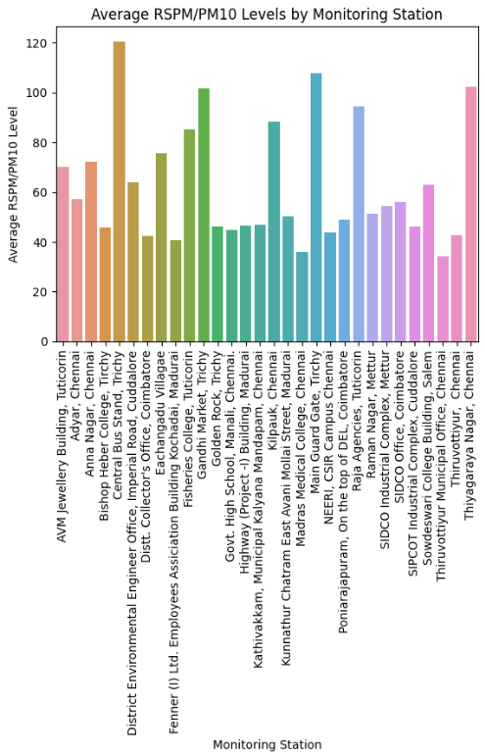

**Average Pollution Levels by City/Town/Village/Area:**

We calculated and visualized the average SO2, NO2, and RSPM/PM10 levels by city/town/village/area, providing insights into air quality on a larger scale.

**Average SO2 Levels:**

# Create a bar plot to visualize average SO2 levels by city/town/village/area

sns.barplot(x=average_city_levels.index, y=average_city_levels['SO2'])

plt.xlabel('City/Town/Village/Area')

plt.ylabel('Average SO2 Level')

plt.title('Average SO2 Levels by City/Town/Village/Area')

plt.xticks(rotation=90)

plt.show()

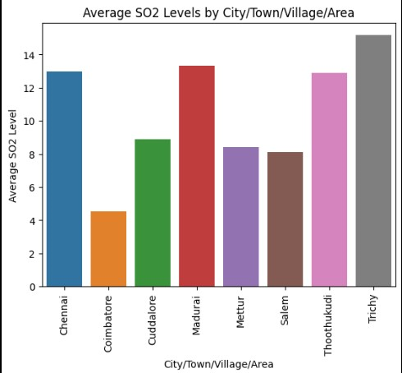

**Time-Series Plots:**

We created time-series plots to visualize the changes in pollutants levels over time.

**SO2:**

# Time-series plot for SO2 levels

sns.lineplot(x="Sampling Date", y="SO2", data=data)

plt.xlabel('Sampling Date')

plt.ylabel('SO2 Level')

plt.title('SO2 Level Over Time')

plt.xticks(rotation=45)

plt.show()

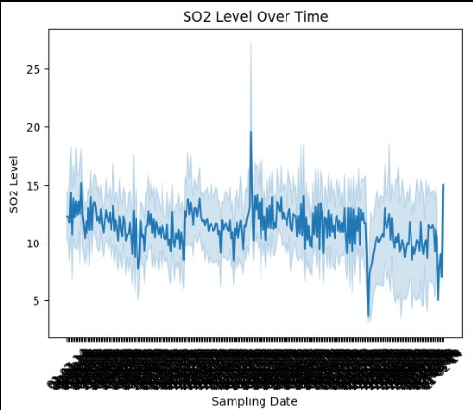

**NO2:**

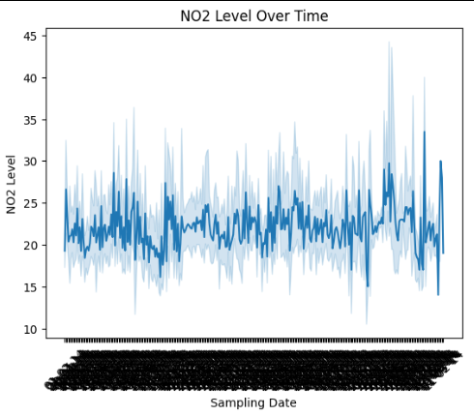

**Heatmaps:**

We generated heatmaps to observe variations in pollutants levels by monitoring station over time.

**SO2:**

# Heatmap for SO2 levels by monitoring station

sns.heatmap(data.pivot_table(values='SO2', index='Location of Monitoring Station', columns='Sampling Date'), cmap='YlGnBu')

plt.xlabel('Sampling Date')

plt.ylabel('Monitoring Station')

plt.title('SO2 Levels by Monitoring Station Over Time')

plt.xticks(rotation=45)

plt.show()

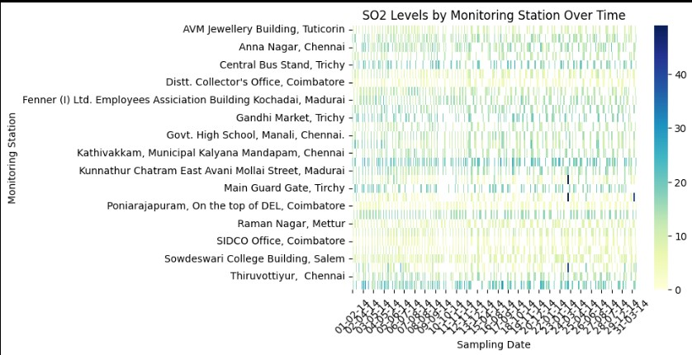

**NO2:**

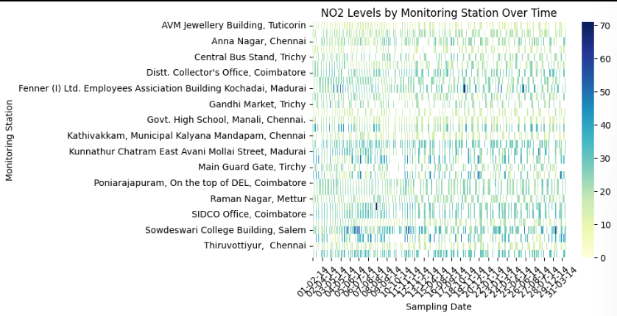

**Areas with Highest Pollution Levels:**

We sorted and identified areas with the highest average SO2, NO2, and RSPM/PM10 levels.

**SO2:**

# Sort by average SO2 levels

sorted_city_so2 = average_city_levels.sort_values(by='SO2', ascending=False)

print("Areas with highest average SO2 levels:")

print(sorted_city_so2.head(10))

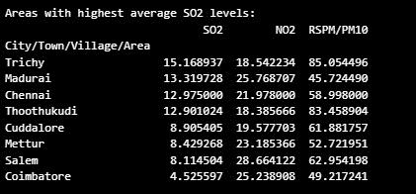

**NO2:**

# Sort by average NO2 levels

sorted_city_no2 = average_city_levels.sort_values(by='NO2', ascending=False)

print("Areas with highest average NO2 levels:")

print(sorted_city_no2.head(10))

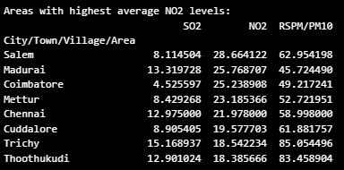

**Correlation Analysis:**

We calculated the correlation between pollutants and visualized the results using a heatmap.

**SO2:**

# Create similar analyses for NO2 and RSPM/PM10.

correlation_matrix = data[['SO2', 'NO2', 'RSPM/PM10']].corr()

sns.heatmap(correlation_matrix, annot=True, cmap='coolwarm', vmin=-1, vmax=1)

plt.title('Correlation Between Pollutants')

plt.show()

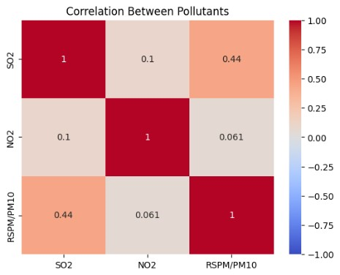

**NO2:**

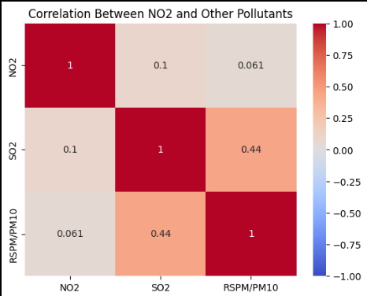

**Conclusion:**

In this phase of the air quality analysis project, we have conducted extensive data analysis, visualization, and correlation studies. These insights into pollution levels across monitoring stations, city/town/village/areas, and their correlations provide a solid foundation for understanding air quality trends and patterns. Future work may involve predictive modeling and more advanced analytics to address air quality challenges comprehensively.