*Madhav Ecommerce Insights & Analytics*

*INTRODUCTION*

1. Dataset Overview:

This project aims to analyze a dataset containing information about customer orders, including order ID, date, customer details, product categories, payment methods, and order amounts. The dataset, sourced from kaggle, provides a valuable opportunity to gain insights into customer behavior, sales trends, and product performance.

1. Reason for Selection:

This dataset was selected due to its potential to reveal various business insights. By analyzing this data, we can:

* Understand Customer Behavior: Identify customer preferences, purchasing patterns, and regional trends.
* Optimize Inventory Management: Analyze product popularity and sales trends to optimize inventory levels.
* Improve Marketing Strategies: Identify target customer segments and tailor marketing campaigns accordingly.
* Enhance Sales Performance: Analyze sales trends and identify opportunities for growth and improvement.

1. Expected Insights:

Based on the initial analysis of the dataset, we anticipate the following insights:

* Seasonal Trends: Identifying seasonal fluctuations in sales and adjusting marketing strategies accordingly.
* Product Performance: Determining the most popular product categories and identifying underperforming products.
* Customer Segmentation: Segmenting customers based on their purchasing behavior and preferences.
* Payment Method Analysis: Understanding the preferred payment methods of customers.
* Geographical Analysis: Identifying regions with the highest sales and customer base.

By uncovering these insights, we can make data-driven decisions to improve business operations and customer satisfaction.

*DATASET EXPLORATION*

1. Detailed Description of Columns

|  |  |  |
| --- | --- | --- |
| **Column Name** | **Data Type** | **Description** |
| Order ID | String | Unique identifier for each order |
| Order Date | Datetime | Date when the order was placed |
| Customer Name | String | Name of the customer |
| State | String | State of the customer's residence |
| City | String | City of the customer's residence |
| Amount | Numeric | Total amount of the order |
| Profit | Numeric | Profit made on the order |
| Quantity | Numeric | Quantity of items in the order |
| Category | String | Main category of the product |
| Sub-Category | String | Specific subcategory of the product |
| Payment Mode | String | Payment method used for the order |

1. Initial Visualizations:

* Bar Chart of Profit by Sub-Category:

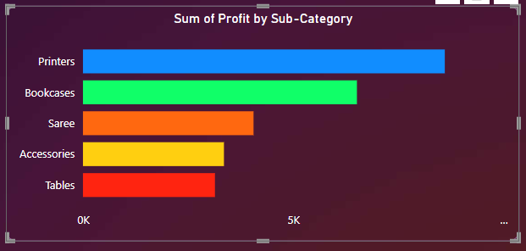

* Distribution of Order Amounts:

A histogram can be used to visualize the distribution of order amounts. This will help identify outliers and the overall range of order values.

* Profit By State:

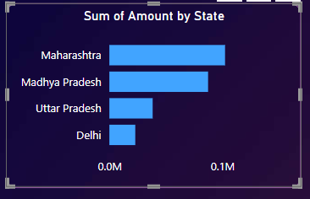

* Time Series Plot of Sales:

A line plot can be used to visualize the trend of sales over time. This can help identify seasonal patterns or trends.

* Profit by Month:

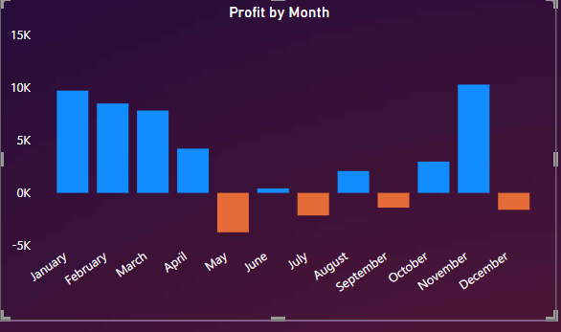

* Bar Chart of Orders by Category:

A bar chart can visualize the distribution of orders across different product categories.

1. Initial Observations:

The distribution of order amounts may be skewed, with a few high-value orders.There might be seasonal patterns in sales, especially if the data spans multiple years.Certain product categories might be more popular than others.By further exploring the data and conducting more in-depth analysis, we can uncover more valuable insights.

*DATA SCIENCE PROCESS*

Client Identification

Client: A leading e-commerce retailer

1. Entrepreneurs and managers running online retail stores who need insights into sales performance, customer behavior, and inventory management to enhance their business operations.
2. Marketing Teams: Professionals responsible for executing marketing strategies who can utilize the dashboard to track campaign effectiveness, customer engagement, and return on investment (ROI) from various marketing channels.
3. Data Analysts: Individuals tasked with analyzing sales data and generating reports for stakeholders, benefiting from the dashboard's ability to present complex data in a user-friendly format.
4. Investors and Stakeholders: Those interested in the financial performance of eCommerce businesses who require clear visualizations of sales trends and customer metrics to make informed investment decisions.

Objective Definition

The objectives of the Madhav eCommerce retail dashboard are clear and specific:

1. Performance Monitoring: To provide real-time insights into key performance indicators (KPIs) such as total sales, average order value, and customer acquisition costs, enabling businesses to monitor their performance effectively.
2. Customer Insights: To analyze customer behavior and preferences by tracking metrics like repeat purchases, customer demographics, and engagement levels, helping businesses tailor their offerings.
3. Inventory Management: To assist in managing stock levels by providing data on product performance and sales trends, allowing for better inventory planning and reducing stockouts or overstock situations.
4. Marketing Effectiveness: To evaluate the success of marketing campaigns by tracking metrics such as conversion rates and return on ad spend (ROAS), helping teams optimize their marketing strategies.
5. Data-Driven Decision Making: To facilitate informed decision-making by presenting complex data visually, enabling stakeholders to quickly understand trends and make strategic adjustments to their operations.

*DATA VISUALIZATION AND ANALYSIS*

Data Visualization:

* Time Series Analysis: Plot sales over time to identify trends and seasonality.
* Product Analysis: Analyze the distribution of sales across different product categories and subcategories.
* Customer Segmentation: Segment customers based on purchase frequency, total spending, and preferred payment methods.
* Geographical Analysis: Visualize sales by region to identify high-performing areas.

Predictive Modeling:

* Sales Forecasting: Develop models to predict future sales based on historical data.
* Customer Segmentation: Use clustering techniques to identify customer segments with similar behavior.
* Product Recommendation: Implement recommendation systems to suggest products to customers based on their purchase history and preferences.

Prescriptive Analytics:

* Inventory Optimization: Optimize inventory levels to minimize stockouts and excess inventory.
* Pricing Strategy: Analyze pricing strategies to maximize revenue and profit margins.
* Customer Retention: Identify strategies to retain loyal customers and reduce customer churn.

By addressing these objectives, the e-commerce retailer can make data-driven decisions to improve its overall performance and customer satisfaction.

1. What is the distribution of orders across different product categories in the given dataset?

A bar chart where the x-axis represents the categories, and the y-axis represents the number of orders for each category. The bars are colored 'skyblue'.

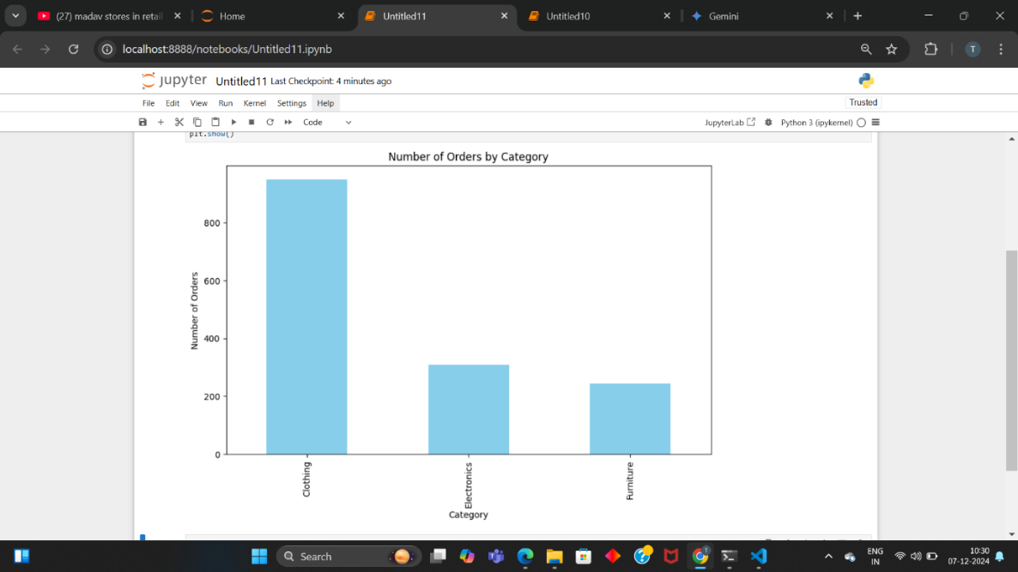

1. What percentage of total profit does each product category contribute?

 A pie chart that displays the distribution of profits across different categories, with each slice representing the percentage of total profit contributed by each category.

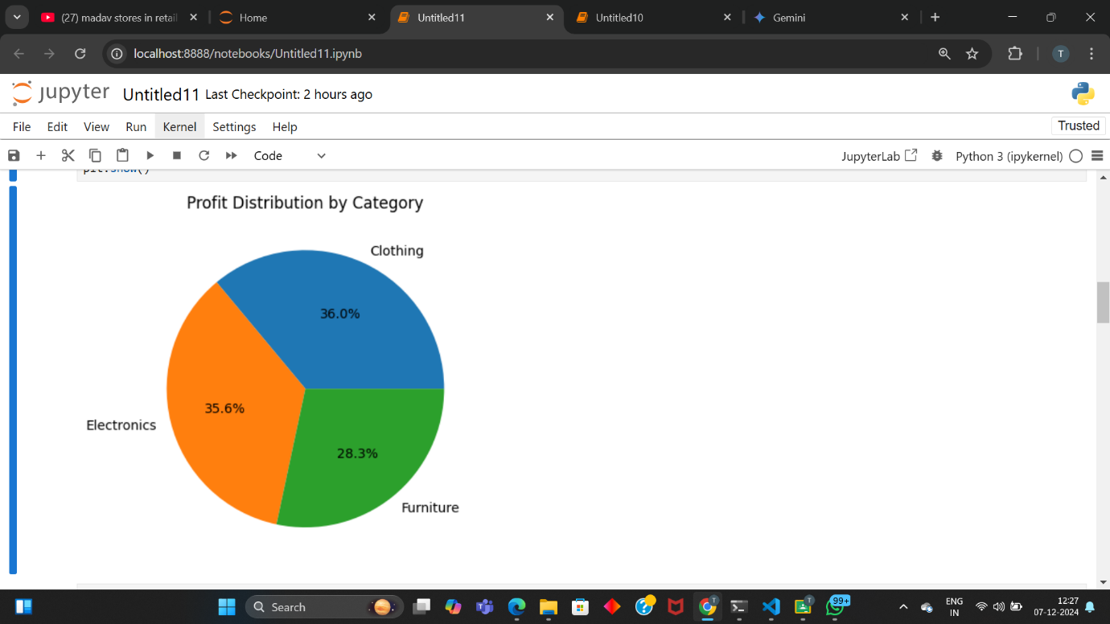

1. How do order counts vary across different categories and payment methods within the dataset?

A stacked bar chart that visualizes the number of orders for each category, broken down by payment method. Each bar represents a category, and the different colors within each bar indicate the various payment methods used.

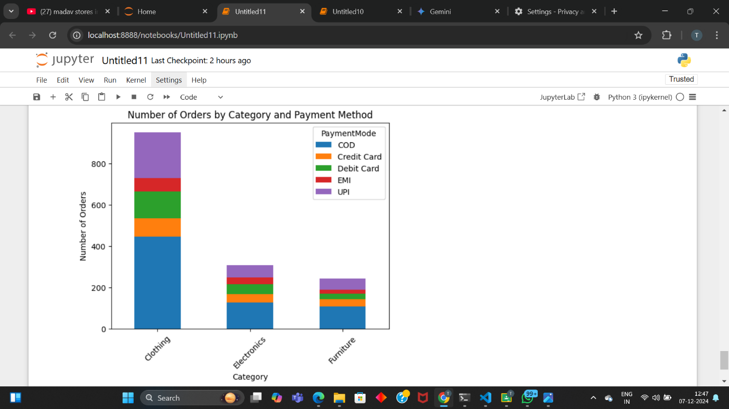

1. What is the distribution of customers across different regions?

OR

Which regions have the highest number of customers in the dataset?

A scatter plot where each region is represented along the x-axis, and the size of each point reflects the number of customers in that region. The larger the point, the more customers are in that region. The y-axis is a dummy variable set to a constant value for visualization purposes, allowing the focus to be on the varying sizes of the points.

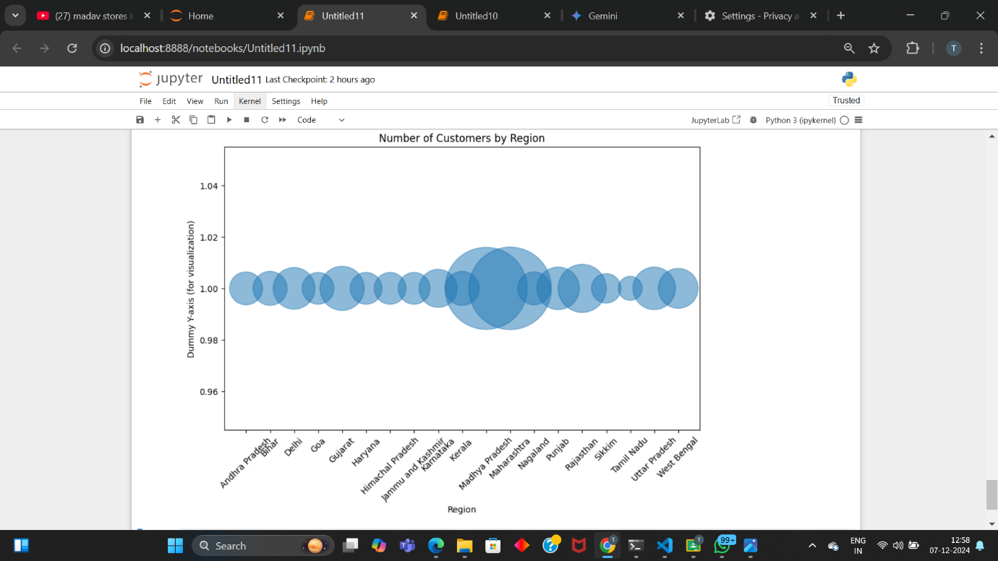

1. What is the overall trend of sales across different months in the dataset?

A line plot that illustrates the trend of total sales over the months, with each point representing the sum of sales for a specific month. The x-axis shows the months of the year, while the y-axis indicates the total sales amount.

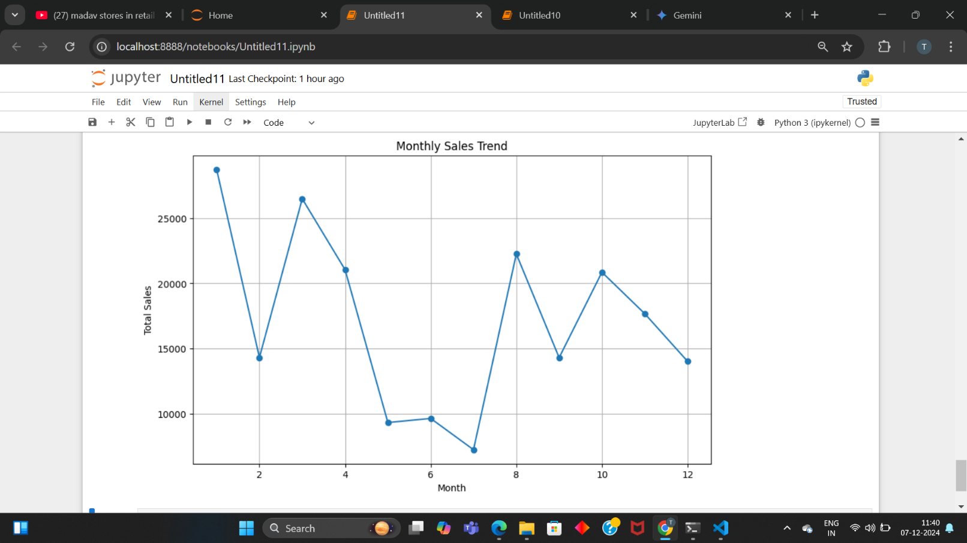

1. **How does the distribution of order quantities differ among various categories?**

A visual summary of how order quantities are distributed for each product category. By looking at the box plots, we can easily compare things like the typical order size, the range of order quantities, and whether there are any unusual or extreme order quantities for each category. This helps us understand the order behavior for different product types.

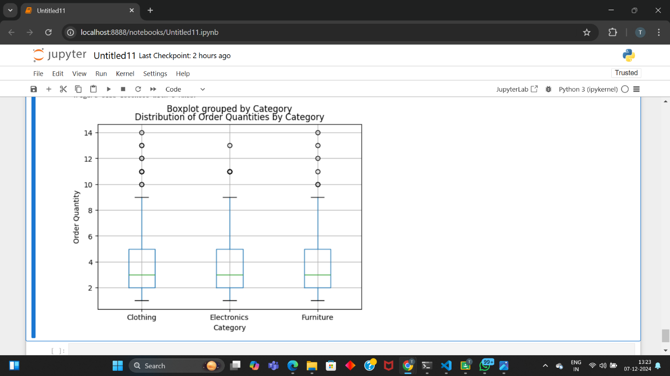

1. **What proportion of total order quantities comes from each category?**

 A pie chart that visualizes the distribution of order quantities across different categories, with each slice representing the percentage of total quantities contributed by each category

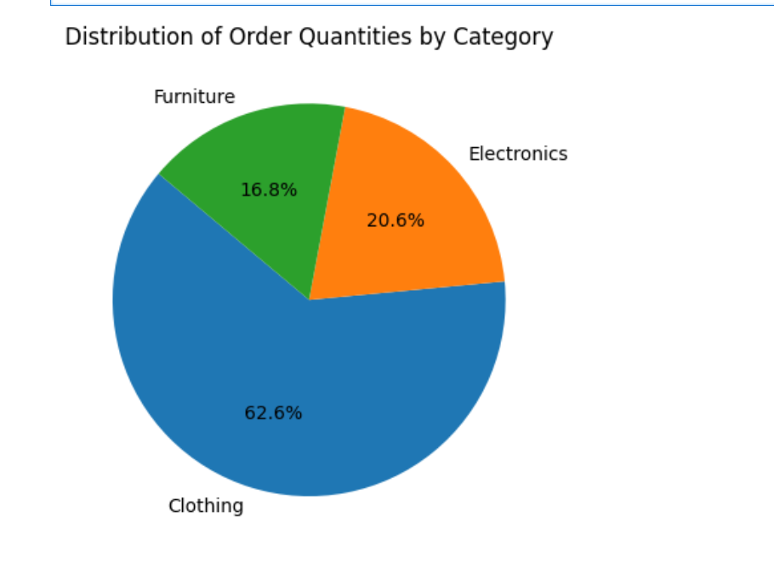

*CONCLUSION*

This project has provided valuable insights into the e-commerce industry by analyzing a comprehensive dataset. Through the data science process, we were able to explore the data, identify trends, and make informed recommendations.

Key Insights:

* Seasonal Trends: We identified seasonal patterns in sales, allowing for targeted marketing campaigns and inventory adjustments.
* Product Performance: We analyzed the performance of different product categories and subcategories to optimize inventory and marketing efforts.
* Customer Segmentation: We segmented customers based on their purchasing behavior, enabling personalized marketing strategies.
* Payment Method Preferences: We identified the most popular payment methods, helping to optimize payment processing and reduce transaction costs.
* Geographical Analysis: We analyzed sales by region to identify high-performing areas and potential expansion opportunities.

Learning Experience:

This project has enhanced my skills in data cleaning, exploratory data analysis, data visualization, and predictive modeling. I learned to leverage Python libraries like Pandas, NumPy, and Matplotlib to effectively manipulate and visualize data. Additionally, I gained experience in applying machine learning techniques to forecast sales and recommend products.

Future Work:

To further enhance the analysis, future work could involve:

* Incorporating External Factors: Considering external factors like economic indicators, competitor activities, and industry trends.
* Advanced Modeling Techniques: Exploring advanced machine learning algorithms for more accurate predictions and insights.
* Real-time Analytics: Implementing real-time analytics to monitor sales and customer behavior in real-time.
* A/B Testing: Conducting A/B tests to evaluate the effectiveness of different marketing strategies and product recommendations.

By continuously refining our analysis and incorporating new techniques, we can unlock even greater potential from the data and drive business growth.