Infosys Springboard Virtual Internship 7.0

Milestone - 4 Completion Report
_________________________________________________________________________________________________________

Batch :01
Team-C
Start Date :29/06/2026
Internship Duration : 2 months

Team Members:
1. Suryakanth Upadhyay
2. Sanmitha
3. Sabari Vasan

Internship duration – 8 weeks

1.Project Title
Supply Chain Visibility System with Optimization Analytics Group1

2.Project Objective
The primary objective of this project is to analyze supply chain operations using the provided dataset to improve visibility across procurement, inventory management, transportation, and delivery processes. The project focuses on identifying operational bottlenecks, evaluating supplier performance, reducing delivery delays, optimizing inventory levels, and improving overall supply chain efficiency through data-driven decision-making.
Additionally, the project aims to identify key performance indicators (KPIs) that influence operational performance and customer satisfaction. By analyzing logistics data and creating interactive dashboards, the project enables organizations to monitor business performance effectively and make informed strategic decisions.
This project also aims to demonstrate how data analytics and business intelligence tools can transform raw supply chain data into meaningful business insights. By analyzing various operational parameters such as supplier performance, transportation efficiency, inventory turnover, and delivery time, organizations can identify areas that require improvement and implement strategies to optimize overall supply chain performance.

3. Project Description

The Supply Chain Visibility & Optimization project was developed to analyze and improve various aspects of supply chain operations using data analytics and business intelligence techniques. The project focuses on monitoring procurement, inventory management, transportation, warehouse performance, supplier efficiency, customer demand, and delivery operations through interactive Power BI dashboards.
The project began with understanding the business problem and collecting the supply chain dataset provided for the internship. The dataset contained information related to product categories, supplier countries, customer countries, transportation modes, transportation costs, delivery days, inventory turnover, fill rate, stockout orders, and several operational metrics.
Python was used for data preprocessing, where missing values were handled, duplicate records were checked, data types were validated, and unnecessary inconsistencies were removed. After obtaining a clean dataset, it was imported into Microsoft Power BI for visualization and dashboard development.
Five interactive dashboards were created to provide insights into different areas of the supply chain:
- Supply Chain Overview
- Logistic & Inventory Analysis
- Customer & Supplier Analysis
- Delivery & Transportation Analysis
- Warehouse & Inventory Performance
The project demonstrates how business intelligence tools can transform raw operational data into meaningful insights that help organizations improve efficiency, reduce costs, and enhance customer satisfaction.

3.1 Overview
The Supply Chain Visibility & Optimization project focuses on analyzing supply chain data to understand operational performance and generate meaningful business insights using data visualization. The project provides an overview of different supply chain activities, including transportation, inventory management, supplier performance, customer orders, warehouse operations, and delivery processes. By bringing these aspects together, the project helps provide better visibility into the overall supply chain.
The project uses a structured data analytics workflow that includes problem understanding, data collection, data understanding, data connection, data preprocessing, data modeling, and data visualization. The collected dataset is examined and cleaned to ensure that the information used for analysis is accurate and reliable. Relevant supply chain metrics and Key Performance Indicators (KPIs) are then analyzed to identify trends, performance variations, and potential operational bottlenecks.
Microsoft Power BI is used to develop interactive dashboards that present the analyzed information through charts, graphs, KPI cards, filters, and other visual elements. These dashboards make complex supply chain data easier to understand and allow users to compare transportation performance, monitor inventory levels, evaluate supplier efficiency, and analyze delivery performance. Interactive filters also enable users to explore the data from different perspectives.
Overall, the project demonstrates how data analytics and visualization can support better supply chain management. The insights obtained from the analysis can help organizations improve operational efficiency, reduce unnecessary costs, monitor performance, and make informed business decisions. The project also provides a foundation for future enhancements such as predictive analytics, demand forecasting, and real-time supply chain monitoring.

3.2 Project Approach
Step 1: Understood the project requirements and business objectives.
Step 2: Collected and studied the supply chain dataset.
Step 3: Cleaned and preprocessed the data using Python by handling missing values and removing inconsistencies.
Step 4: Imported the cleaned dataset into Microsoft Power BI.
Step 5: Created relationships, verified data types, and prepared measures for analysis.
Step 6: Designed interactive dashboards using KPI cards, charts, tables, and filters.
Step 7: Analyzed the dashboards to identify trends, supplier performance, transportation efficiency, inventory status, and delivery performance.
Step 8: Prepared the final report, presentation, and project documentation.

3.3 Technology Used
A combination of data analytics, business intelligence, and collaboration tools was used throughout the project to collect, prepare, analyze, visualize, and manage the supply chain data.
- Microsoft Power BI Desktop: Used for importing data, creating the data model, developing interactive dashboards, and presenting supply chain KPIs and visualizations.
- Power Query: Used for data cleaning and transformation activities such as removing duplicates, handling missing values, changing data types, and preparing the dataset for analysis.
- DAX (Data Analysis Expressions): Used for creating calculated measures and KPIs required for analyzing supply chain performance.
- Microsoft Excel / CSV: Used for storing, inspecting, and verifying the supply chain dataset before importing it into Power BI.
- Kaggle: Used as the source for obtaining the supply chain dataset used for analysis and visualization.
- GitHub: Used for maintaining the project repository, storing project-related files, tracking changes, and managing different versions of the project.
- GitLab: Used for project collaboration, repository management, version control, and sharing project resources among team members.
- Microsoft Teams: Used for communication, project discussions, mentor interactions, meetings, and coordination during the internship.

3.4 Insights from the Dashboard
The dashboards provide valuable insights into different aspects of supply chain operations. They help analyze transportation patterns, supplier and customer performance, inventory turnover, storage costs, order delays, and delivery performance. By presenting these metrics visually, it becomes easier to identify trends, compare different operational areas, and understand factors affecting overall supply chain efficiency.
The dashboard also helps identify frequently used transportation modes and monitor delayed orders, allowing organizations to evaluate logistics performance and take appropriate corrective actions. Inventory-related visualizations provide information about stock movement and storage, which can support better inventory planning. Overall, these insights help organizations improve resource utilization, identify operational bottlenecks, and make more informed decisions based on the available data.

3.5 Real-World Impact for Media and Public Communication
The project demonstrates how Business Intelligence and data visualization can be applied to real-world supply chain management. Interactive dashboards convert complex operational information into simple and understandable visual reports, making it easier for managers, stakeholders, and other users to understand supply chain performance and communicate important findings.
The visual reports can support faster decision-making by providing a centralized view of important supply chain metrics. They can also improve coordination between different departments by making relevant information easier to access and share. Better visibility into inventory, transportation, suppliers, and deliveries can contribute to improved logistics planning and customer satisfaction. Thus, the project highlights the practical value of Business Intelligence in communicating data-driven insights and supporting efficient supply chain operations.

4. Timeline Overview

Week | Activities Planned | Activities Completed
Week 1 | Project understanding, dataset collection | Understood problem statement and collected dataset
Week 2 | Data cleaning | Removed missing values, checked duplicates
Week 3 | Data preprocessing | Feature selection and transformation completed
Week 4 | Data visualization | Developed initial Power BI dashboards
Week 5 | Dashboard enhancement | Added KPIs and interactive visuals
Week 6 | Dashboard testing | Validated insights and corrected visuals
Week 7 | Analyze dashboard results and generate insights | Analyzed delivery, transportation, inventory, supplier, customer, and operational performance
Week 8 | Finalize project and documentation | Completed dashboard analysis, documented findings, and prepared the final report

5a. Key Milestones

Milestone | Description | Date Achieved
Project Kickoff | Understood the problem statement, formed the team, collected the dataset, and finalized the project objective. | Week 1
Prototype/First Draft | Completed data preprocessing and developed the initial version of the Power BI dashboard. | Week 4
Mid-Term Review | Reviewed dashboard visuals, refined KPIs, improved layout, and incorporated mentor feedback. | Week 6
Final Submission
Presentation

5b. Project execution details

Workflow Diagram

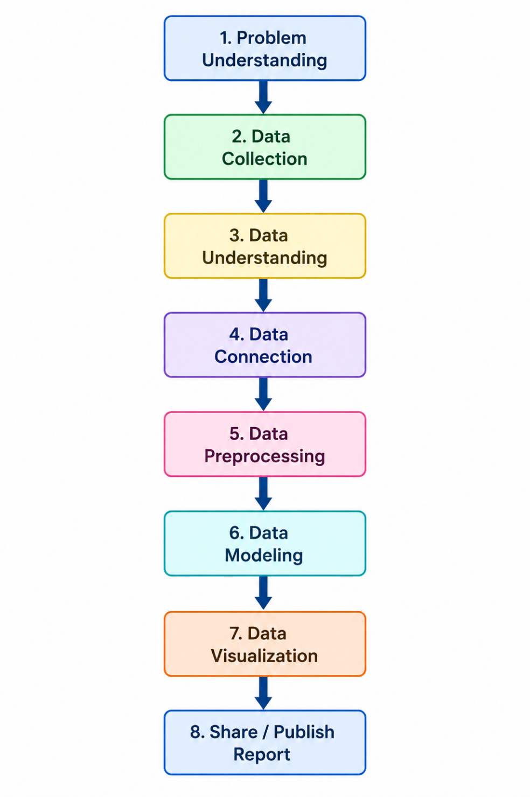

1.Problem Understanding
Problem understanding is the first phase of the project and serves as the foundation for the entire analytical process. Before performing any analysis, it is necessary to understand the business problem, organizational goals, and expected outcomes.
The major questions addressed in this project include:
- Which transportation mode performs the best?
- Which suppliers contribute to delivery delays?
- Are inventory levels maintained efficiently?
- How effectively are customer orders fulfilled?
- Which KPIs influence overall supply chain performance?
- How can operational efficiency be improved using data analytics?
A proper understanding of these business requirements ensures that every subsequent step contributes toward achieving the project objectives.

2.Data Collection
Data collection is the process of gathering relevant data required for analysis. The success of any data analytics project depends on the quality, completeness, and accuracy of the collected data. In this project, the supply chain dataset was provided in CSV format and contains information related to procurement, suppliers, inventory, transportation, and customer deliveries.
The dataset includes various attributes such as product category, supplier country, customer country, transportation mode, transport cost, delivery days, lead time, inventory turnover, fill rate, stockout indicator, and supplier performance. These attributes provide a comprehensive view of the organization's supply chain operations and serve as the foundation for further analysis.
During the data collection stage, the dataset was verified to ensure that all required information was available for the project objectives. The collected data was then stored in a structured format, making it easier to import into Python for preprocessing and later connect to Power BI for visualization. A well-organized and complete dataset ensures accurate analysis, reliable insights, and effective decision-making throughout the project.

3.Data Understanding
After collecting the dataset, the next step is to understand its overall structure and characteristics. This stage helps identify the nature of the available data before any processing begins.
The dataset is examined to determine:
- Number of rows and columns
- Data types of each attribute
- Numerical and categorical variables
- Missing values
- Duplicate records
- Statistical summaries
- Data distributions
Exploratory Data Analysis (EDA) is also performed to understand relationships among different variables and identify patterns within the data. Various statistical measures such as mean, median, standard deviation, minimum, and maximum values are calculated.
Understanding the dataset helps identify inconsistencies, detect anomalies, and determine which variables are most useful for achieving the project objectives.
4.Data Connection
Data connection refers to importing the collected dataset into analytical tools for further processing and visualization.
In this project, the CSV dataset is imported using the Pandas library in Python. After importing the dataset, several validation checks are performed to ensure that all records have been loaded correctly without any errors.
The following activities are carried out:
- Import the CSV file.
- Load data into a Pandas DataFrame.
- Verify dataset dimensions.
- Check column names.
- Validate data types.
- Generate summary statistics.
- Ensure successful loading of records.
Once the dataset is validated, it can also be connected to Power BI for dashboard development. Establishing a reliable data connection ensures consistency throughout the analysis and enables seamless integration between Python and Power BI for visualization and reporting.
5.Data Preprocessing
Data preprocessing is one of the most important stages in the data analytics workflow because real-world datasets often contain missing values, duplicate records, inconsistencies, and formatting issues.
To improve data quality, the following preprocessing steps were performed:
- Checked for missing values.
- Removed duplicate records.
- Standardized column names.
- Verified numerical and categorical data types.
- Identified outliers using descriptive statistics.
- Corrected inconsistent values.
- Selected relevant features for analysis.
- Organized data into a structured format.
- Validated data consistency.
- Prepared the final clean dataset for visualization.
A properly cleaned dataset reduces analytical errors, improves model accuracy, and ensures reliable business insights. Data preprocessing significantly enhances the quality and credibility of the overall analysis.

6.Data Modeling
After preprocessing, the cleaned dataset is used for data modeling and KPI analysis. Data modeling involves transforming raw operational data into meaningful business metrics that help evaluate organizational performance.
Several Key Performance Indicators (KPIs) are calculated during this stage, including:
- Average Delivery Time
- Transportation Cost
- Fill Rate
- Inventory Turnover
- Lead Time Variability
- Supplier Performance
- Stockout Rate
- Order Fulfillment Efficiency
These KPIs help organizations monitor operational performance, identify inefficiencies, compare suppliers, evaluate logistics operations, and improve business decision-making.
Data modeling converts raw transactional data into actionable business information that supports strategic planning and continuous improvement.

7.Data Visualization
After completing data modeling and KPI analysis, the next stage is to present the analyzed data through meaningful visualizations. In this project, Microsoft Power BI is used to create interactive dashboards that provide a clear overview of supply chain performance. Different charts, graphs, KPI cards, filters, and slicers are used to represent important operational metrics in an easy-to-understand format.
The dashboard visualizations are used to analyze transportation performance, supplier efficiency, inventory levels, delivery time, transportation costs, and order fulfillment. Interactive filters allow users to explore the data based on different categories and identify trends or areas that require attention. These visualizations make complex supply chain data easier to interpret and help users compare different operational factors.
The main objective of data visualization is to convert the results of the analysis into actionable insights. The Power BI dashboard helps identify operational bottlenecks, monitor important KPIs, and support data-driven decision-making. Effective visualization also improves communication of analytical findings to managers and other stakeholders.

8.Publish Report
The final stage of the workflow is to share and publish the completed dashboard and project report. After completing the data analysis and visualization, the results are organized into a structured report containing the project objectives, data analysis process, preprocessing activities, KPI analysis, dashboard visualizations, insights, and recommendations.
The Power BI dashboard and final report can be shared with project stakeholders and team members for review and discussion. Publishing the results makes the analyzed information accessible to users and allows them to understand the overall supply chain performance. The report also provides a documented summary of the complete analytical process followed during the project.
Sharing the final results ensures that the insights obtained from the analysis can be used for better planning, performance monitoring, and decision-making. This completes the data analytics workflow by transforming the collected supply chain data into useful information that can support operational improvement.

6. Screenshots

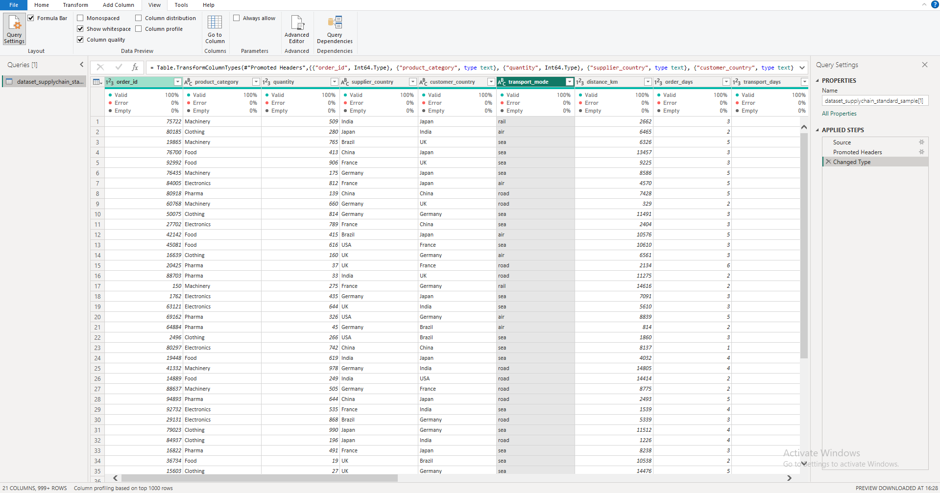

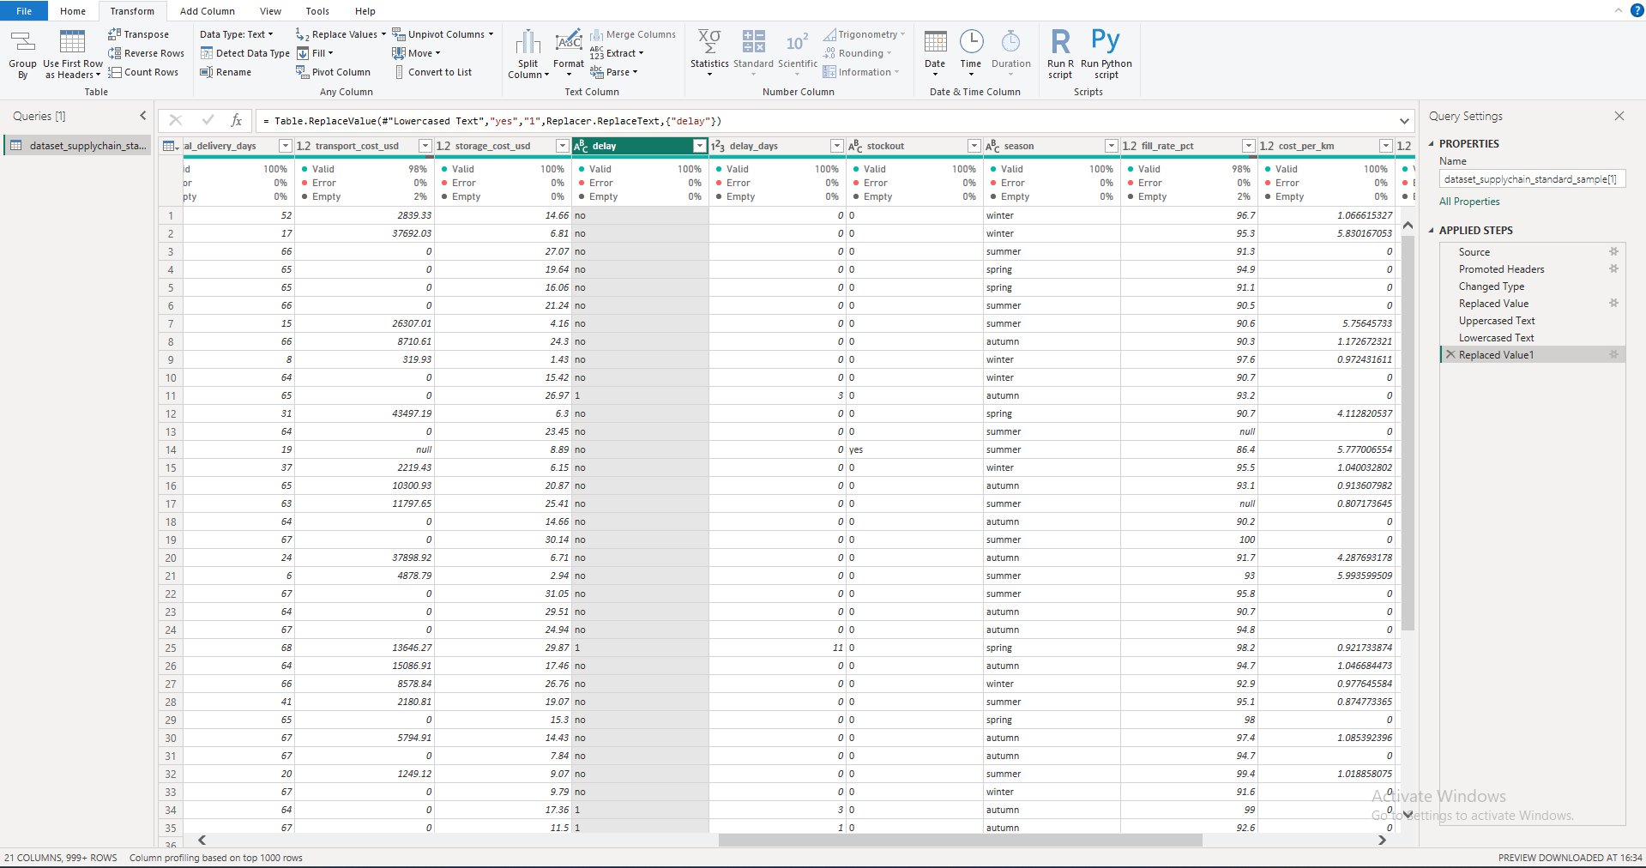

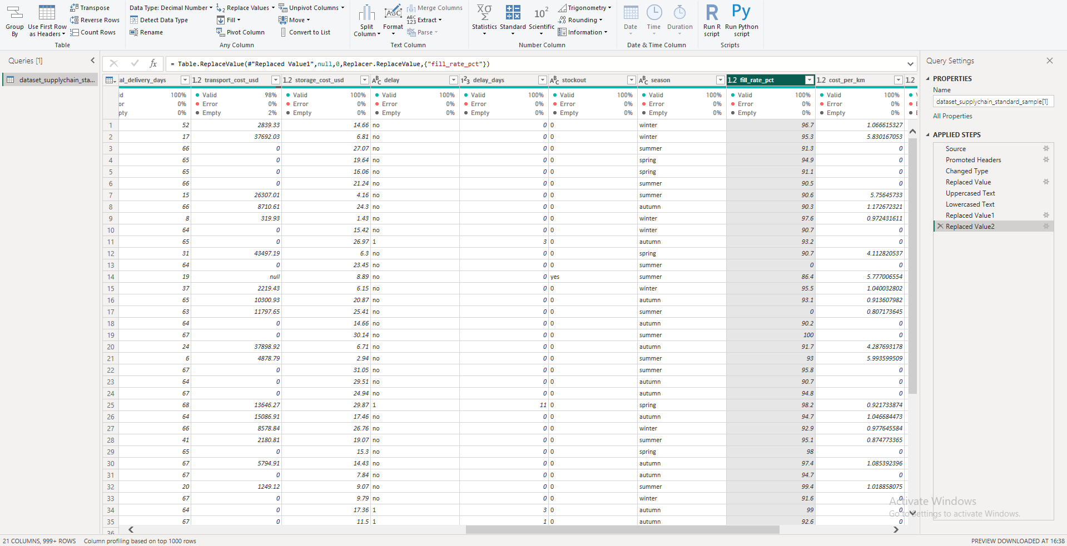

6.1 DASHBOARD 1 – SUPPLY CHAIN OVERVIEW

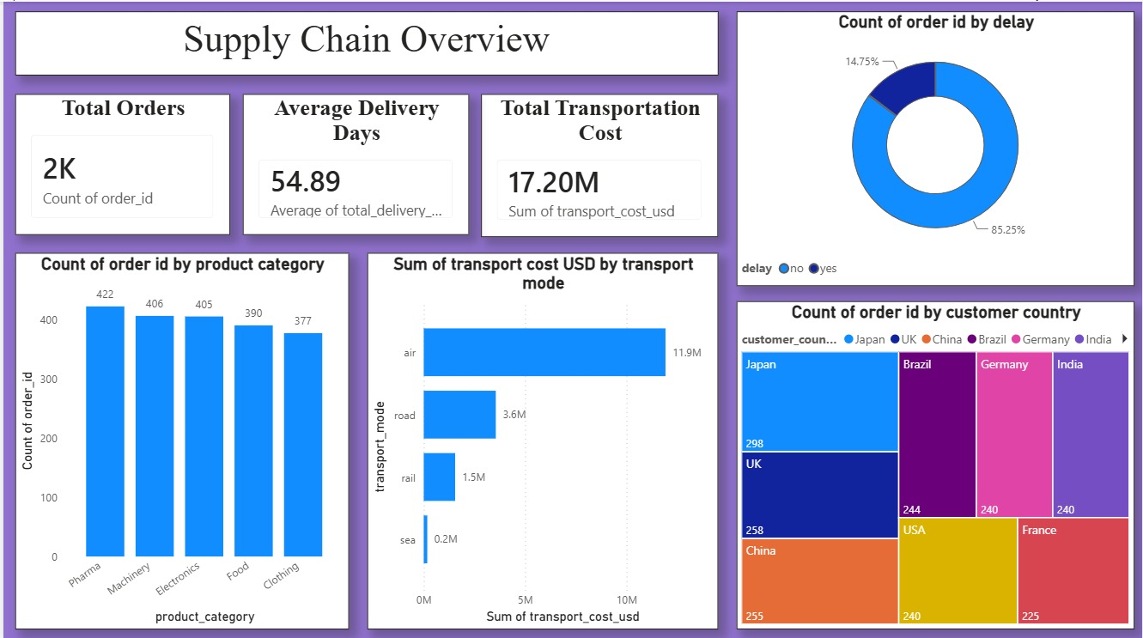

6.2 DASHBOARD 2- LOGISTIC AND INVENTORY ANALYSIS

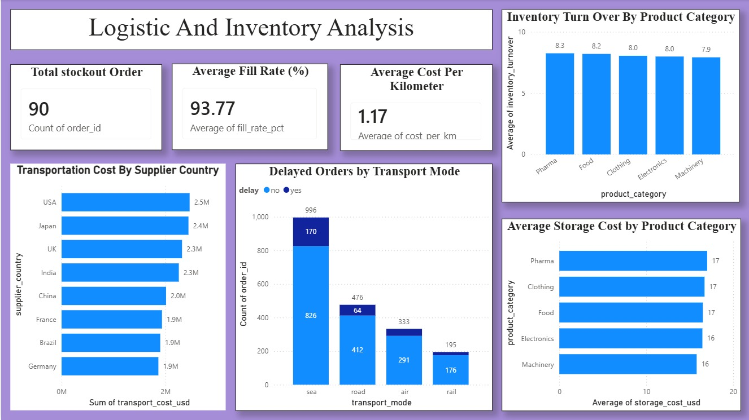
6.3 DASHBOARD 3- CUSTOMER & SUPPLIER ANALYSIS

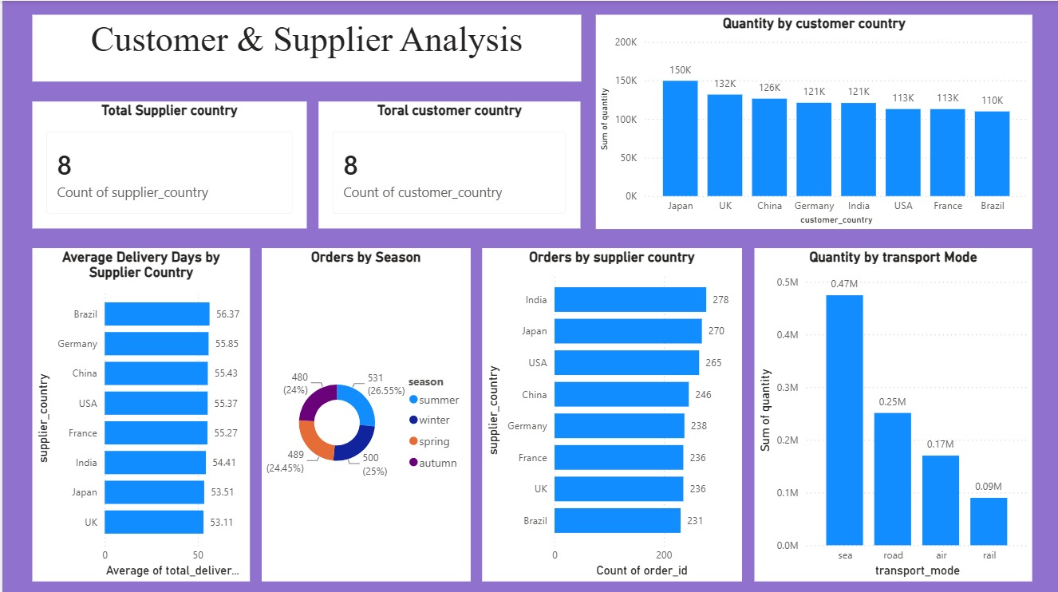

6.4 - DASHBOARD 4 – DELIVERY AND TRANSPORTATION ANALYSIS

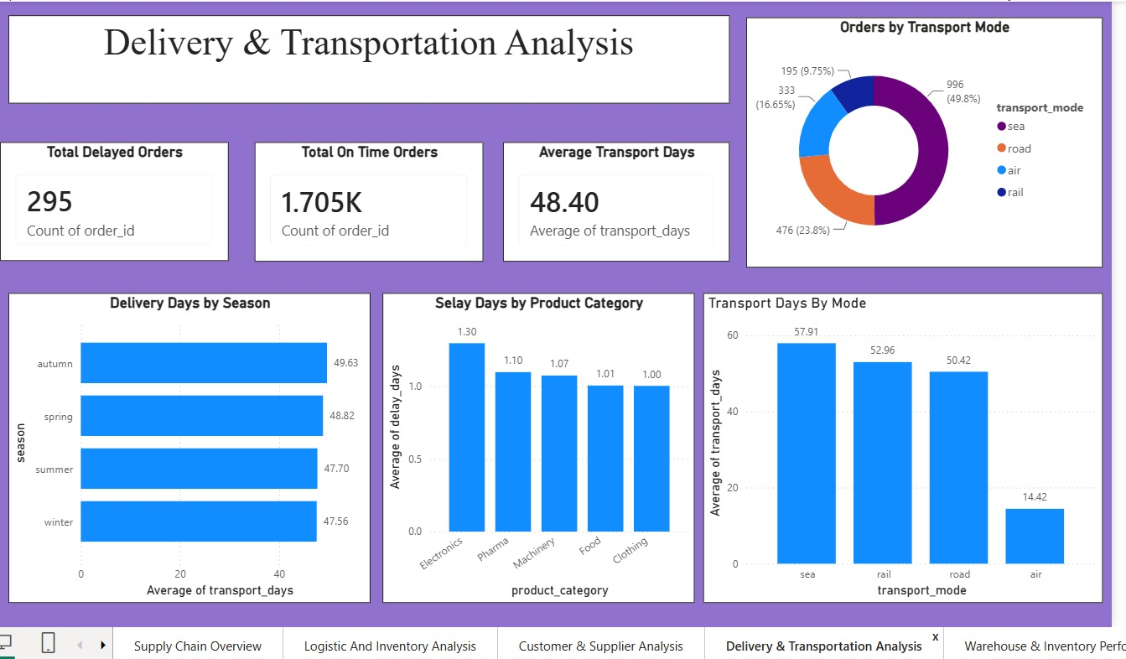
6.5 -DASHBOARD 5 – OPERATIONAL PERFORMANCE DASHBOARD

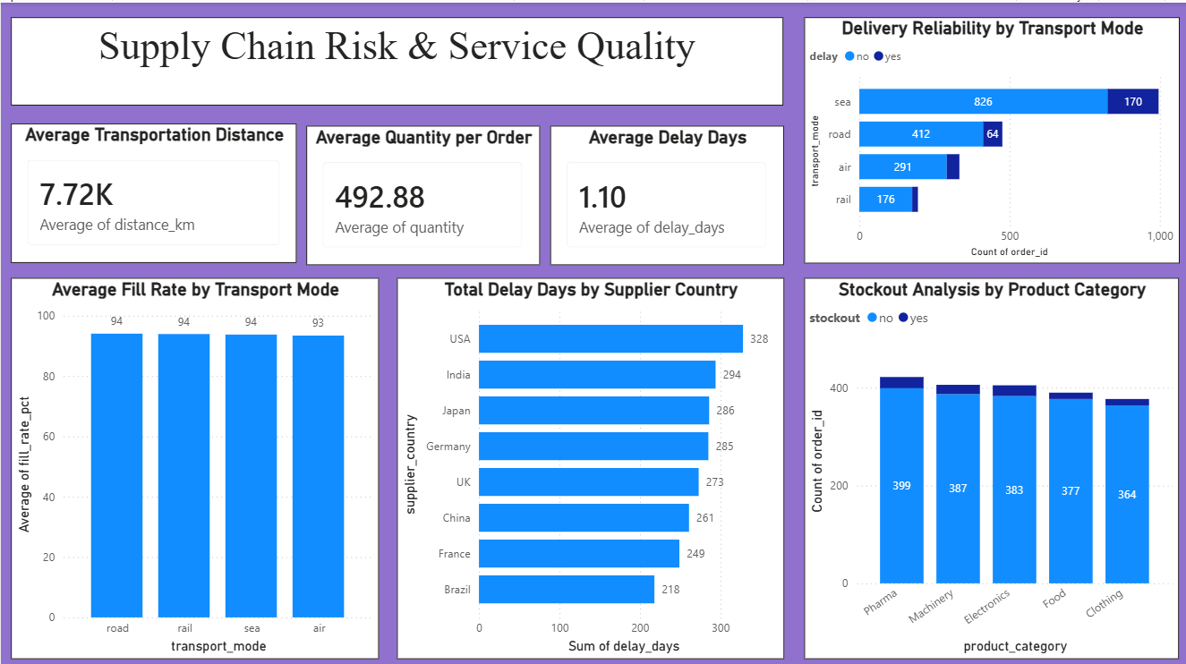
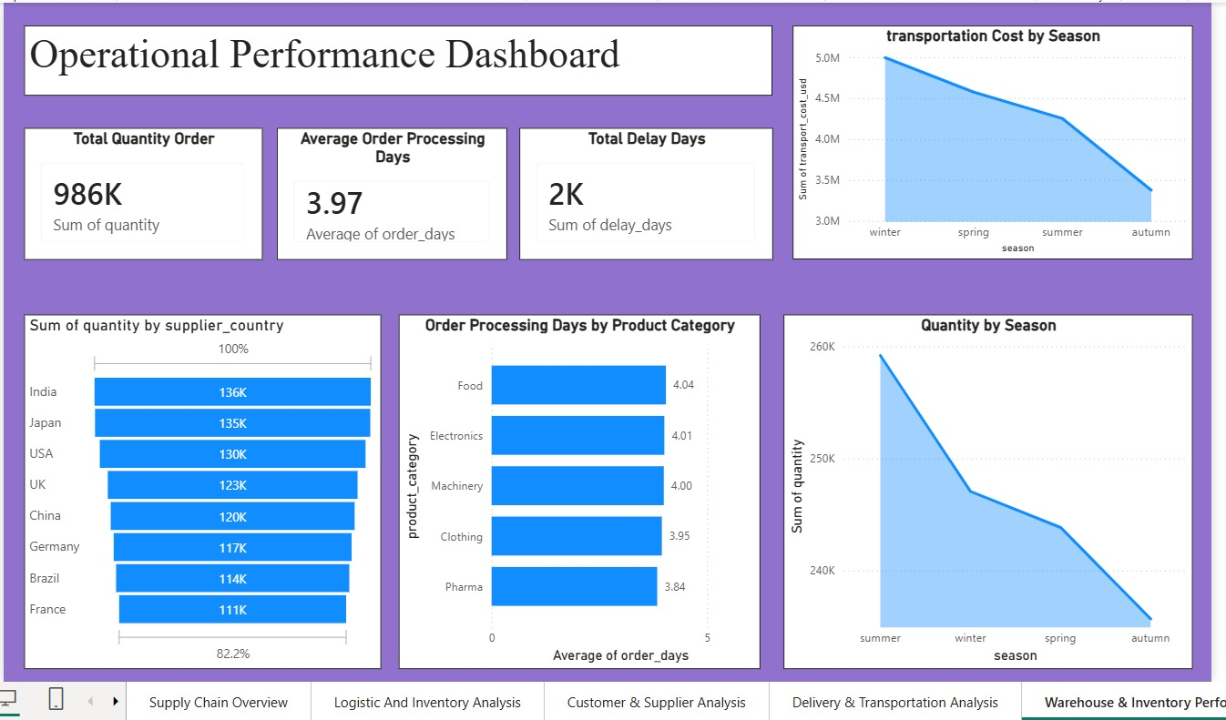

6.6-DASHBOARD 6 – SUPPLY CHAIN RISK & SERVICE QUALITY

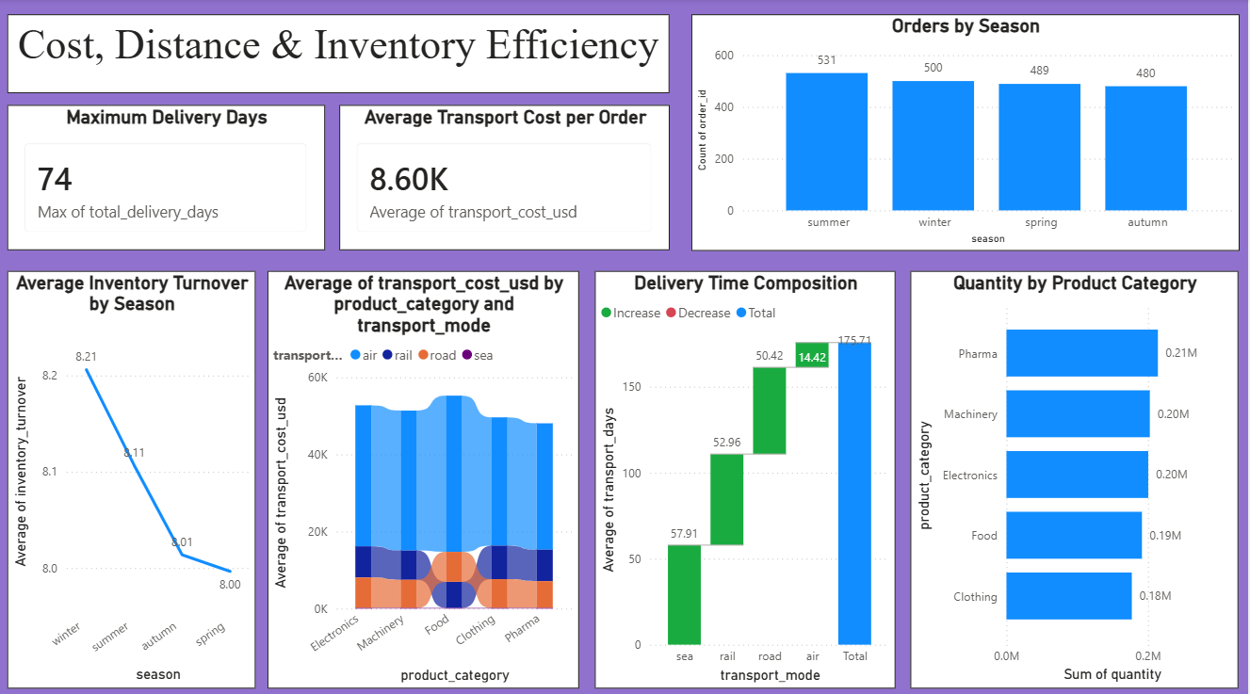
6.7-DASHBOARD 7 – COST DISTANCE & INVENTORY EFFICIENCY

Page 1: Supply Chain Overview

Visual Explanations
1. Total Orders (Card)
- Displays the total number of customer orders in the dataset.
- This KPI provides a quick overview of business activity.
2. Average Delivery Days (Card)
- Shows the average number of days required to deliver an order.
- It helps evaluate delivery efficiency and customer service performance.
3. Total Transportation Cost (Card)
- Displays the total transportation cost incurred for all shipments.
- Useful for monitoring logistics expenditure.
4. Delay Status (Donut Chart)
- Compares delayed orders and on-time deliveries.
- Helps identify the percentage of delayed shipments.
5. Orders by Product Category (Column Chart)
- Compares the number of orders across different product categories.
- Identifies the most demanded products.
6. Transportation Cost by Transport Mode (Bar Chart)
- Displays transportation cost for Air, Road, Rail, and Sea transport.
- Helps determine which transport mode contributes the highest logistics cost.
7. Customer Distribution (Treemap)
- Shows the number of customer orders received from different countries.
- Larger blocks indicate countries contributing more customer orders.

Page 2: Logistic and Inventory Analysis
Visual Explanations
1. Total Stockout Orders (Card)
- Displays the number of stockout orders.
- Indicates situations where products were unavailable to fulfill customer demand.
2. Average Fill Rate (%) (Card)
- Shows the average percentage of customer demand fulfilled successfully.
- Higher fill rate indicates efficient inventory management.
3. Average Cost Per Kilometer (Card)
- Displays the average transportation cost per kilometer.
- Helps measure transportation efficiency.
4. Transportation Cost by Supplier Country (Bar Chart)
- Compares transportation costs for suppliers from different countries.
- Helps identify suppliers with higher logistics expenses.
5. Delayed Orders by Transport Mode (Stacked Column Chart)
- Shows delayed and non-delayed orders for each transport mode.
- Helps identify transport modes experiencing more delays.
6. Inventory Turnover by Product Category (Column Chart)
- Compares inventory turnover among product categories.
- Higher turnover indicates faster inventory movement.
7. Average Storage Cost by Product Category (Bar Chart)
- Displays average storage cost for each product category.
- Helps identify products requiring higher warehouse storage costs.

Page 3: Customer & Supplier Analysis
Visual Explanations
1. Total Supplier Countries (Card)
- Displays the total number of supplier countries.
- Indicates supplier network coverage.
2. Total Customer Countries (Card)
- Displays the number of customer countries.
- Represents the geographical reach of customers.
3. Quantity by Customer Country (Column Chart)
- Compares product quantity ordered by customers from different countries.
- Helps identify major customer markets.
4. Average Delivery Days by Supplier Country (Bar Chart)
- Shows average delivery time for suppliers from different countries.
- Helps evaluate supplier efficiency.
5. Orders by Season (Donut Chart)
- Displays order distribution across Summer, Winter, Spring, and Autumn.
- Helps analyze seasonal demand.
6. Orders by Supplier Country (Bar Chart)
- Compares the number of orders received from suppliers in different countries.
- Identifies suppliers with higher order volumes.
7. Quantity by Transport Mode (Column Chart)
- Displays product quantity transported through different transportation modes.
- Helps understand transport mode utilization.

Page 4: Delivery & Transportation Analysis
Visual Explanations
1. Total Delayed Orders (Card)
- Displays the total number of delayed orders.
- Helps monitor delivery performance.
2. Total On-Time Orders (Card)
- Displays the number of successfully delivered orders.
- Indicates delivery reliability.
3. Average Transport Days (Card)
- Shows the average number of transport days.
- Helps evaluate logistics efficiency.
4. Orders by Transport Mode (Donut Chart)
- Displays the distribution of orders across Air, Road, Rail, and Sea transport.
- Helps understand transport mode preference.
5. Delivery Days by Season (Bar Chart)
- Compares average delivery days across different seasons.
- Helps analyze seasonal delivery performance.
6. Delay Days by Product Category (Column Chart)
- Displays average delay days for each product category.
- Helps identify products affected by longer delays.
7. Transport Days by Mode (Column Chart)
- Compares average transport days among transportation modes.
- Helps identify the fastest and slowest transport options.

Page 5: Warehouse & Inventory Performance
Visual Explanations
1. Total Quantity Order (Card)
- Displays the total quantity of products ordered.
- Indicates overall demand volume.
2. Average Order Processing Days (Card)
- Shows the average time required to process customer orders.
- Helps evaluate operational efficiency.
3. Total Delay Days (Card)
- Displays the total delay days recorded across all orders.
- Indicates the overall delay impact.
4. Transportation Cost by Season (Area Chart)
- Shows transportation cost variation across different seasons.
- Helps identify seasonal logistics expenses.
5. Quantity by Supplier Country (Funnel Chart)
- Displays the quantity supplied by each supplier country.
- Helps compare supplier contributions.
6. Order Processing Days by Product Category (Bar Chart)
- Compares average processing days across product categories.
- Helps identify products requiring more processing time.
7. Quantity by Season (Area Chart)
- Displays product quantity ordered during different seasons.
- Helps understand seasonal demand patterns.

Page 6 – Supply Chain Risk & Service Quality
1. Average Transportation Distance
This KPI shows the average distance travelled per order, which is 7.72K km. It helps measure the transportation scale of the supply chain and understand the typical distance involved in delivering products.
2. Average Quantity per Order
This KPI shows an average order quantity of 492.88 units. It indicates the approximate volume handled in each order and helps understand the overall order size.
3. Average Delay Days
The average delay is 1.10 days. This provides an indication of delivery reliability and helps identify whether delays are a significant operational issue.
4. Delivery Reliability by Transport Mode
This stacked bar chart compares on-time and delayed orders across transport modes. Sea has the highest number of orders and also the highest number of delayed orders, while air and rail have fewer orders. This helps identify which transportation modes require greater attention for improving delivery reliability.
5. Average Fill Rate by Transport Mode
This chart compares the average fill rate percentage for different transport modes. The values are around 93–94%, showing that most customer demand is being fulfilled successfully across all transportation modes.
6. Total Delay Days by Supplier Country
This chart shows the total delay days contributed by each supplier country. The USA has the highest total delay days (328), followed by India and Japan. This helps identify supplier locations where delivery delays may need closer monitoring.
7. Stockout Analysis by Product Category
This stacked column chart compares stockout and non-stockout orders across product categories. Pharma has the highest number of orders, while Clothing has the lowest. The chart helps identify product categories where stock availability should be monitored to reduce stockout situations.

Page 7 – Cost, Distance & Inventory Efficiency
1. Maximum Delivery Days
This KPI shows the maximum delivery time as 74 days. It highlights the longest delivery duration observed in the dataset and helps identify potential extreme delivery cases.
2. Average Transport Cost per Order
The average transportation cost per order is 8.60K USD. This KPI helps evaluate the typical transportation expenditure associated with fulfilling an order.

3. Orders by Season
This column chart compares the number of orders across seasons. Summer has the highest number of orders (531), followed by winter, spring and autumn. It helps identify seasonal variations in demand.
4. Average Inventory Turnover by Season
This line chart shows inventory turnover across seasons. Winter has the highest turnover (8.21), while spring has the lowest (8.00). Higher turnover indicates that inventory is being utilized or replenished more frequently.
5. Average Transport Cost by Product Category and Transport Mode
This visual compares transportation costs across product categories and transport modes. It helps identify how transportation expenses vary depending on both the type of product and the transportation method, supporting better cost-management decisions.
6. Delivery Time Composition
The waterfall chart shows how the average transportation time is composed across different transport modes. Sea contributes 57.91 days, rail 52.96 days, road 50.42 days, and air 14.42 days, resulting in a total of approximately 175.71 days. This helps understand the contribution of each mode to the overall transportation time.
7. Quantity by Product Category
This bar chart compares the total quantity across product categories. Pharma has the highest quantity at approximately 0.21M, while Clothing has the lowest at approximately 0.18M. This helps identify which product categories contribute the greatest volume.

7. Challenges Faced
During the internship, one of the initial challenges was understanding the supply chain dataset and identifying the most relevant KPIs for the project. The dataset contained different types of information related to orders, products, customers, suppliers, transportation, delivery and inventory. Understanding the purpose of each field and determining which metrics were useful for business analysis required careful study of the dataset.
Another challenge was data preprocessing and validation. The data had to be checked for missing values, inconsistent records and unsuitable data formats before creating the dashboards. Proper preprocessing was important because inaccurate or incomplete data could lead to misleading visualizations and incorrect business insights. The data was therefore reviewed and validated before being used for analysis.
Selecting appropriate Power BI visualizations was another challenge faced during the project. Different types of charts were experimented with depending on the type of information being presented. KPI cards were used for important summary values, while bar charts, column charts, line charts, stacked charts and other visuals were used to compare categories and identify trends. The main focus was to make every visualization meaningful and easy to interpret.
Another difficulty was avoiding repetition across multiple dashboard pages. Since several pages were created for different areas of supply chain analysis, it was important to ensure that each page provided different and useful information. Visuals were selected based on specific analytical objectives such as delivery performance, transportation, inventory, supplier performance, customer analysis and operational efficiency.
Dashboard layout and formatting also required considerable attention. The placement of charts, KPI cards, tables and headings had to be planned carefully so that the dashboards were clear and visually balanced. A consistent background, font style, formatting and overall theme were maintained across the pages to give the complete dashboard a professional appearance.

8. Learnings & Skills Acquired
8.1 Technical Skills
- Learned data preprocessing using Python.
- Developed interactive dashboards using Microsoft Power BI.
- Gained experience in creating KPI cards, charts, tables, and data visualizations.
- Improved knowledge of data analysis and dashboard design.

8.2 Analytical and Problem-Solving Skills
- Improved ability to analyze large datasets.
- Learned to identify trends, patterns, and business insights.
- Developed problem-solving skills by interpreting data and suggesting improvements.

8.3 Future Enhancements
- Integrate real-time supply chain data.
- Add predictive analytics using Machine Learning.
- Develop automated alerts for delays and stock shortages.
- Publish dashboards online for remote monitoring and collaboration.

8.4 Soft Skills and Team Collaboration
- Improved communication and presentation skills.
- Enhanced teamwork through collaborative project development.
- Learned effective time management and task planning.
- Gained confidence in preparing professional reports and presentations.

8.5 Domain Knowledge and Application
This project improved my understanding of supply chain management concepts such as inventory control, transportation management, warehouse operations, supplier evaluation, customer demand analysis, and logistics optimization. It also demonstrated how data analytics and business intelligence can be applied to solve real-world business problems and support strategic decision-making.

9. Testimonials from Team
The internship provided a valuable opportunity to work collaboratively as a team on a real-world supply chain analytics project. Regular team discussions and interactions helped us exchange ideas, understand different perspectives, and solve challenges together. Working on the project improved our communication, coordination, and problem-solving abilities.
The development of the dashboards also helped us gain practical experience in data analysis, data visualization, Power BI, and business intelligence. Each team member contributed to the overall project by participating in discussions, analysis, dashboard development, documentation, and presentation activities.
Overall, the internship was a valuable learning experience that helped us connect our academic knowledge with practical applications. It also taught us the importance of teamwork, responsibility, communication, and continuous learning while working towards a common project goal.

Suryakant Upadhyay :
The internship provided an opportunity to gain practical knowledge of supply chain analytics and data visualization. Working collaboratively with the team helped in understanding different perspectives, solving project challenges, and improving decision-making skills. The experience also strengthened technical abilities in data handling and visualization while providing valuable exposure to real-world industry

Sanmitha :
The internship was a valuable learning experience that provided practical exposure to data analysis and supply chain management. Working with the team helped in developing better communication, collaboration, and problem-solving skills. The experience of analyzing real-world data and contributing to the project improved both technical knowledge and confidence in handling business intelligence tasks.

Sabari Vasan N :
The internship provided valuable hands-on experience in supply chain analytics and business intelligence. Working on data preprocessing, analysis, and Power BI dashboard development helped in strengthening analytical and technical skills. Collaborating with team members also improved communication, coordination, and problem-solving abilities while working toward a common project goal.

10. Conclusion
This project demonstrates how data analytics and business intelligence techniques can significantly improve supply chain visibility and operational efficiency. By understanding business requirements, collecting and preprocessing data, analyzing key performance indicators, and developing interactive Power BI dashboards, organizations can gain valuable insights into procurement, inventory, transportation, and delivery operations.
The project highlights the importance of data-driven decision-making in reducing operational costs, minimizing delivery delays, improving supplier performance, and enhancing customer satisfaction. The dashboards developed during this project provide decision-makers with an effective tool for monitoring supply chain performance and identifying opportunities for continuous improvement.
In the future, this project can be further enhanced by integrating machine learning models for demand forecasting, delivery delay prediction, route optimization, and predictive inventory management. Such advanced analytical techniques can help organizations build smarter, more resilient, and highly efficient supply chain systems.

11. Acknowledgement
We would like to express our sincere gratitude to the Infosys Springboard Team for organizing this highly enriching virtual internship program and for providing a structured, industry-aligned learning platform. The well-designed modules, milestone-based framework, and practical orientation of the internship enabled us to gain meaningful exposure to real-world business intelligence applications.
We extend our heartfelt appreciation to our mentor, Ms. Nityasree, for her consistent guidance, valuable feedback, and continuous encouragement throughout the project lifecycle. Her insights and structured direction played a significant role in shaping the analytical depth and professional quality of this project. We would also like to acknowledge our team members for their strong collaboration, accountability, and shared commitment toward achieving project objectives. The coordinated distribution of responsibilities, open communication, and collective problem-solving approach significantly contributed to the successful execution of this project. In addition, we extend our appreciation to the creators and maintainers of Microsoft Power BI documentation and community resources, which served as essential references during dashboard development and KPI implementation. We are also grateful to Kaggle for providing access to publicly available datasets that facilitated practical, hands-on analytical experience. The structured learning resources and practical exposure provided through this internship have significantly strengthened our analytical thinking, technical proficiency, and business interpretation skills. This experience has enhanced our ability to approach data with a strategic mindset, collaborate effectively within a team environment, and execute projects with professional discipline. Overall, this internship has been a meaningful milestone in our academic and professional journey, reinforcing the value of data-driven decision-making and structured analytical execution in modern business environments.

