**Introduction**

Purpose

This document defines a software learning platform for youths under 15-25 years of age with graphical user interface in the scope of learning programming, cloud computing, web design, web development, Business Analytics and lots more.

Scope

This document is the *Graphical Interface Design Document* for AfricaHacks. The purpose of this document is to present the design approach for the graphical interface of the web application designed for AfricaHacks.

The primary intended audience of this document are youths who are interested in learning Software designs and software engineering. The document intents to provide AfricaHacks the demonstration project a unified view of the technical details of the web application to be followed during the development of the application. The document may need to be updated later to incorporate possible changes during development. The graphical user interface of the AfricaHacks Web application that will have the form of a lightweight web application, where all functionalities are grouped visually and logically into units, according to the types of entities they are associated with.

The design foresees the development of the web application using the following HTML templates, CSS3 with CSS reset, use of web standards and Content Management system like WORDPRESS, WIX or SQUARESPACE.

Home

This section educate the user of the website about the milestones that has been achieved by the organisation, and also introduce users to the number of certification courses available on the AfricaHacks.

**Colour used:** Orange, Green, Dark Background, white.

**Font used:** Roboto and Poppins

**Design Justification**: While sketching this interface, Personas experience was kept in mind. And before creating the interface personas were duly consulted in order keep the persona experience as top priority.

Since our targeted audience is between 15-25 years of age, I decided to use a dark theme as background and white with opacity reduced to 70% in order to have a nice contrast and interesting layout for anyone visiting for the first time and returning visitors and to engage the user to explore more features of the application

The design was kept simple by constraining to only two fonts and specific font weights

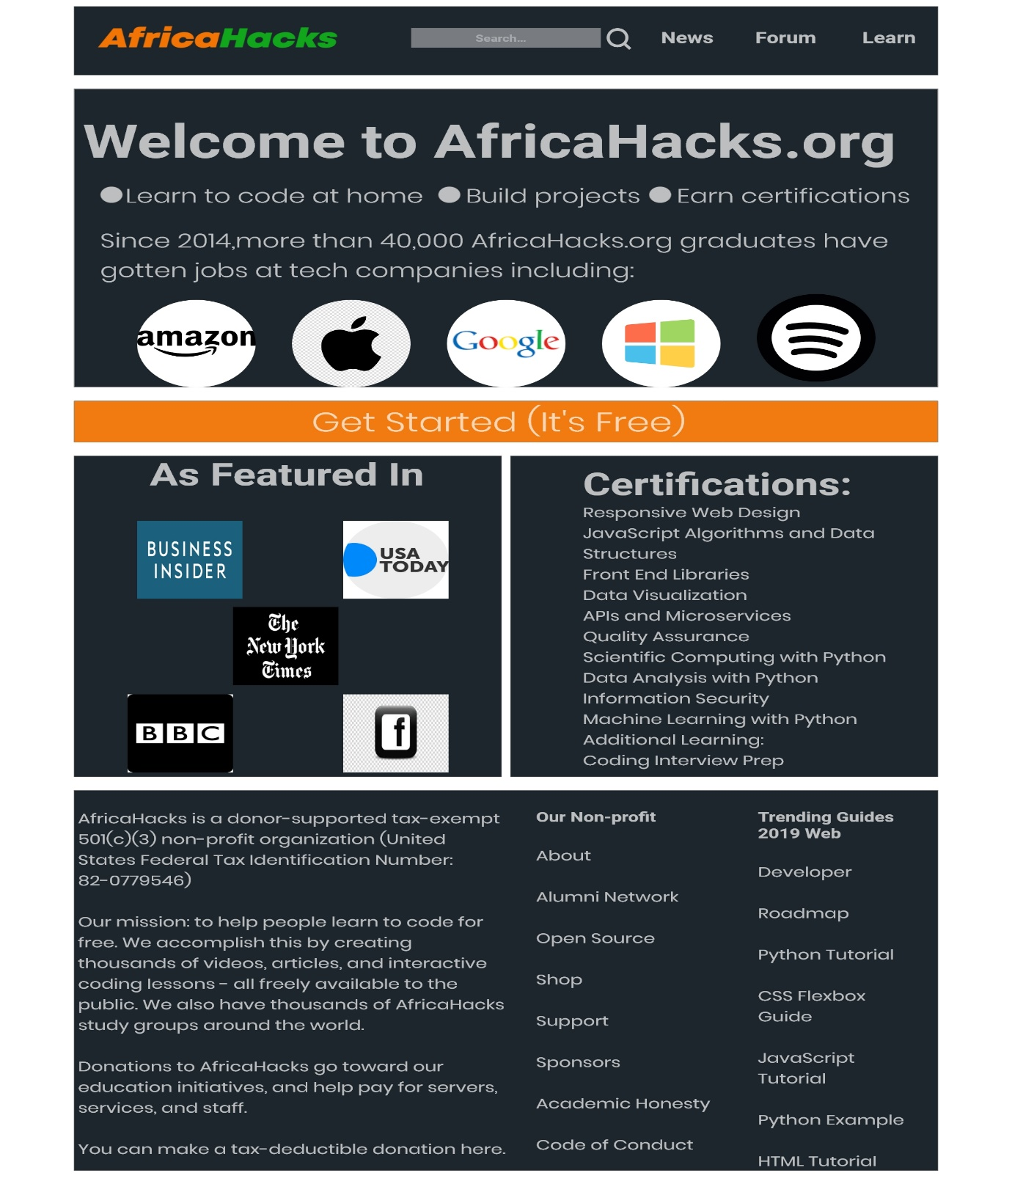

Learn

This section is where the user can actually pick up a course to learn and see the number of hours required to complete a particular course. The page was designed such that any user of the website can deduce the uniqueness of the brand colour and a line spacing of 2pixel was used between each of the page in order to distinguish sections and also to enable readability. The page has three sections which are the navigation section, Main Section and Footer Section.

The page comprises of different layout and valuable contents once a course is being clicked and it is scalable and interactivity for personas.

**Design Justification:** Before coming up with the interface, the following was put into consideration:

1. Is it helpful?
2. Is it easy to use?
3. Does it create a sense of familiarity after the first use?

**Font used:** Roboto and poppins

**Colour**: Orange, Green and White with opacity reduced to 70%.

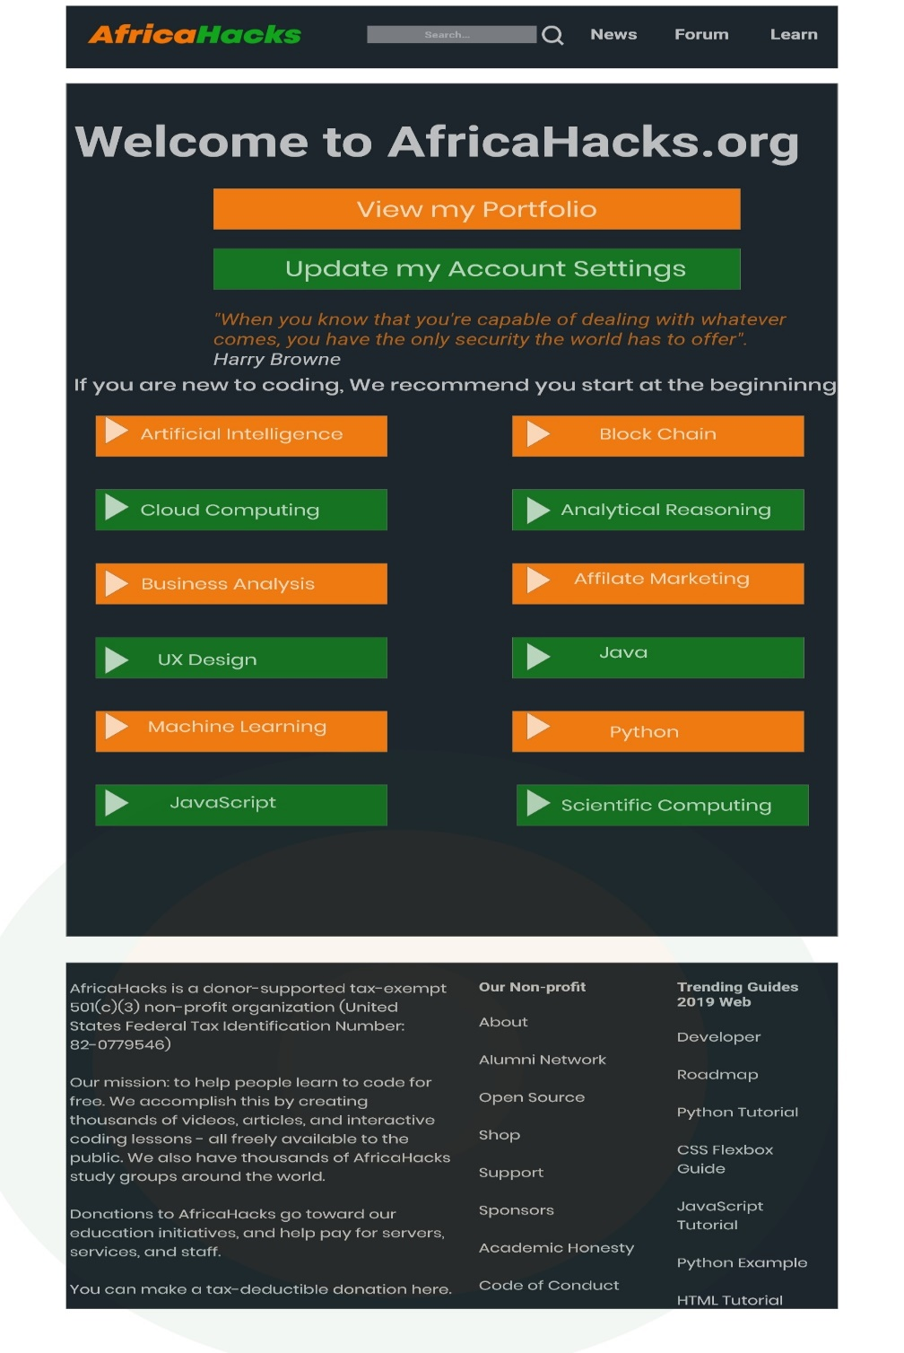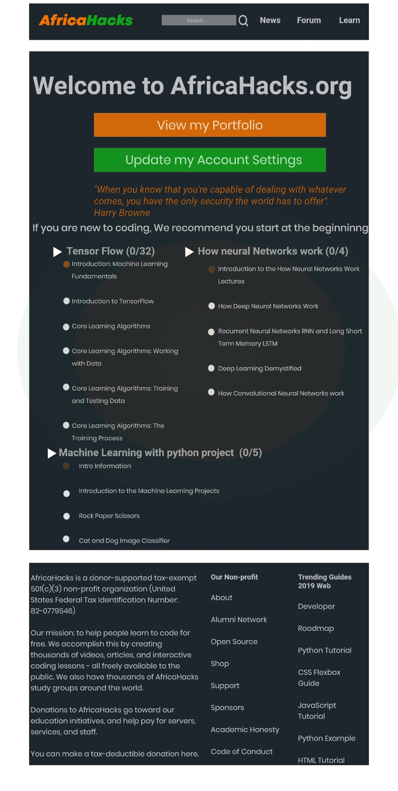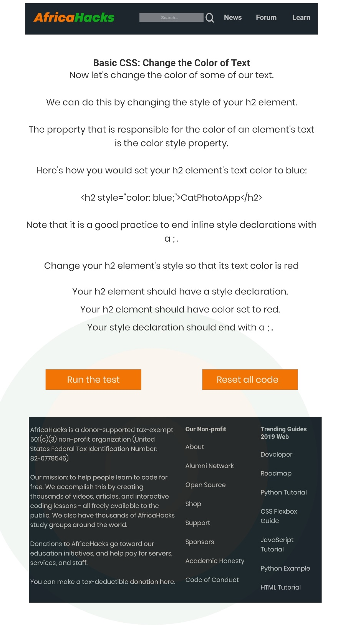

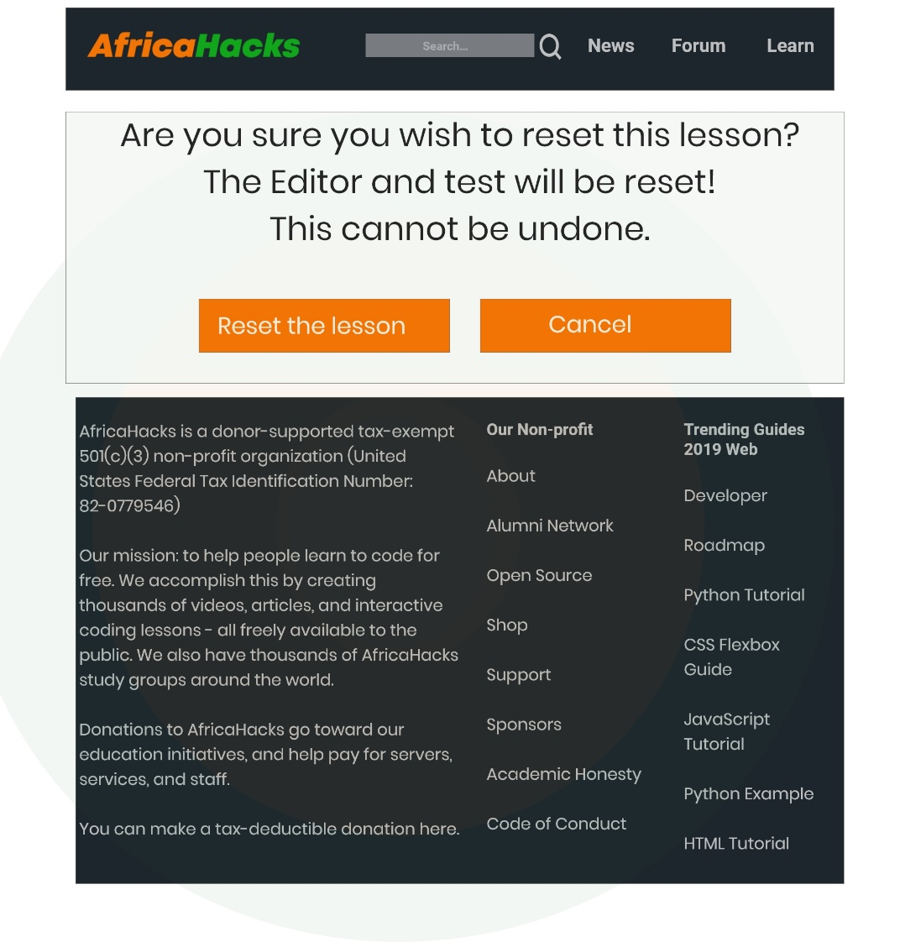

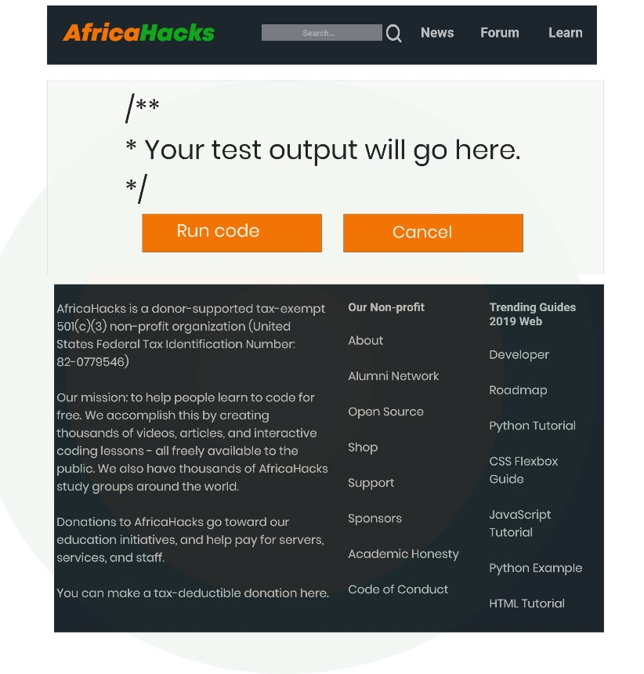

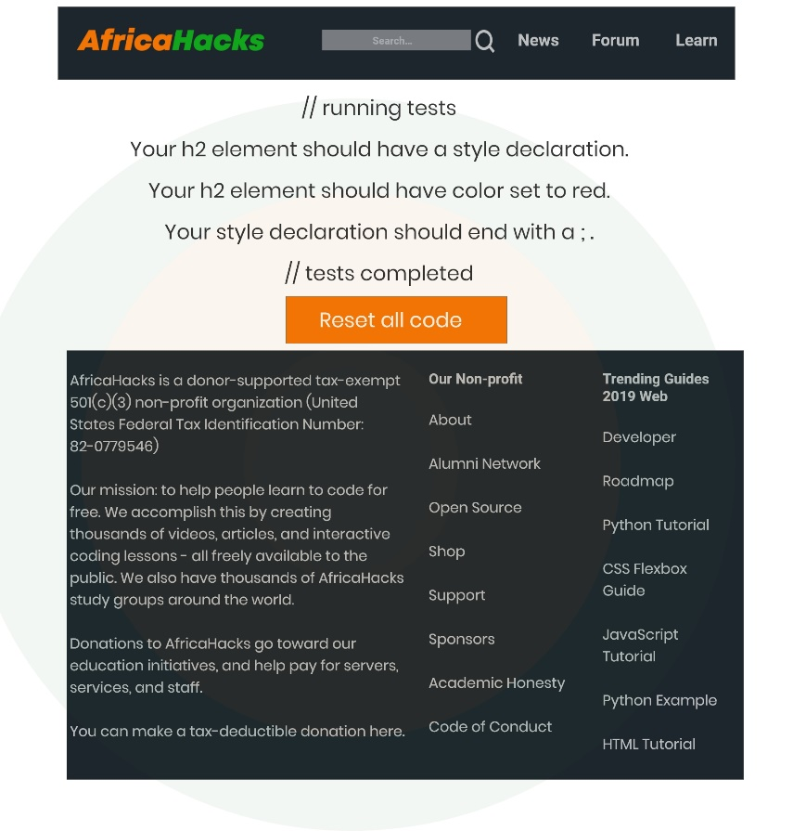

FORUM

This page is the most interactive part of the web application where users from all over the world come together to share knowledge about a subject matter and communicate thought and ideas. For any user to use the forum, such persona must have sign up with AfricaHacks and must login to contribute to forum post and the likes. The part with varieties of colour indicate the number of users online at that particular.

**Design Justification**: Before coming up with the forum interface the following conditions were put in consideration and personas were considered before making the final decision about the designed interface.

1. What objects go on the page?
2. What can we do to them?”

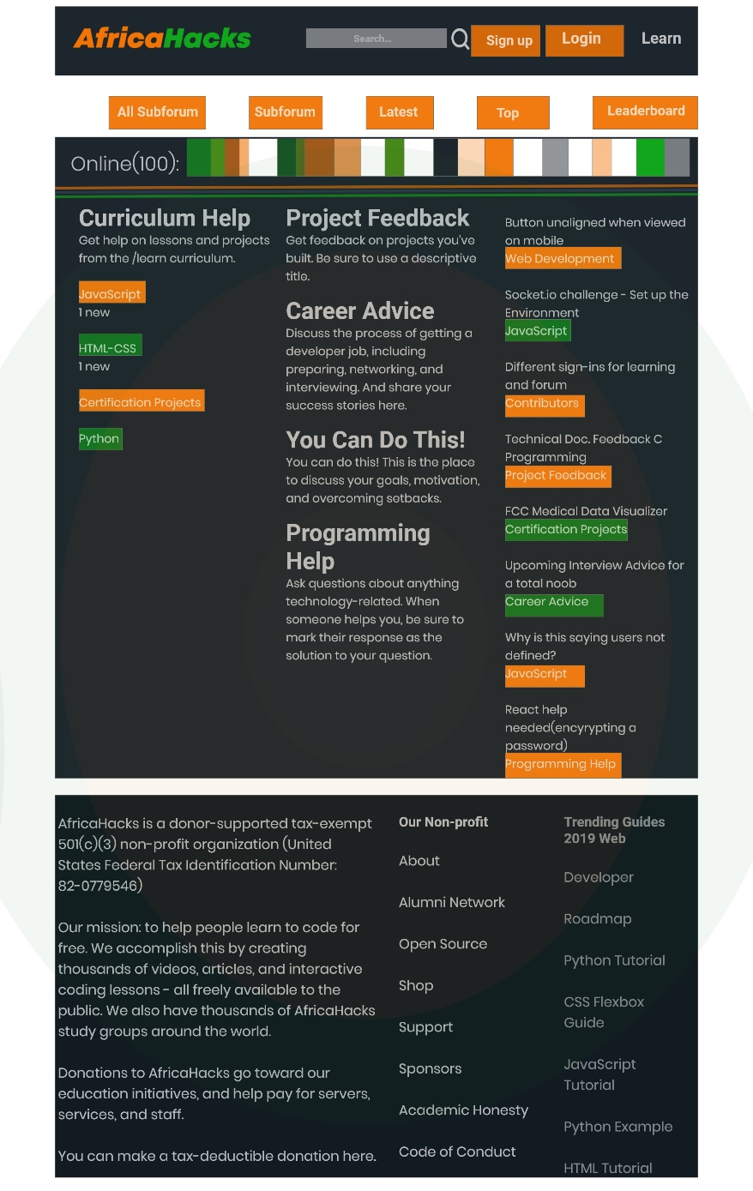

Sign Up & Login Section

This section is to enable personas to create an account in order to become a member of the form.

**Design Justifications:** Having known that a great product experience starts with a good understanding of your users. I considered a simple interface for sign up, login and success page, in order not bore users with something seem less irrelevant to them due to age range and consideration about who they are, motivations, fears, mentality and behaviour.

**Colour used:** white, orange and black

**Font used:** Poppins

