**SMART PARKING**

**Problem definition:**

The objective of this project is to design, develop, and deploy an innovative Parking management system that leverages Internet of Things (IoT) technology. The system will optimize parking space utilization, improve user experience, and reduce traffic congestion in urban areas. An IoT-based parking system is a centralized management that enables drivers to search for and reserve a parking spot remotely through their smartphones. It offers a convenient arrangement for drivers to park their cars when they are looking to avoid potential traffic congestion.

**Detailed Explanation:**

**Parking Monitoring:**

* ImplementIoT sensors in each parking space or at entrance/exit points of parking slots. These sensors detect the presence or absence of vehicles and send this data to a central server or cloud platform.

**Occupancy Monitoring:**

* Real-time data on parking space occupancy is collected and this information can be used to optimize parking space allocation and pricing strategies.

**Parking Guidance:**

* Develop a system to guide a drivers to the nearest available parking spaces using navigation and mapping services. This reduces the time and fuel wasted in searching for parking.

**User Interface:**

* A user-friendly mobile app provides real-time parking availability information to drivers. Users can view the nearest available parking spaces.

**Reservation and Payment:**

* Users can reserve parking spaces through the app and make payments electronically. This reduces the need for physical payment.

**Notifications and Alerts:**

* The system can send notifications and alerts to users, such as reminders for a parking reservations or notifications about parking availability**.**

**Design thinking:**

**Project objectives:**

* To develop a centralized management system based on IOT concepts that allows the drivers to use their smart phone to search for and reserve parking spot.

**IoT sensors:**

* Various type of IoT sensors used for detect the occupancy status of the parking spaces. The most commonly used sensors are Ultra Sonic sensors and Infra-Red sensors.
* These sensors collect the information about the parking spaces and transmit the data to a central server or a cloud platform via wired or wireless connectivity.

**Real Time Display:**

* Users can see the real-time notification about parking slot availability and occupancy availability through LCD display.

**Integration approach:**

* ThinkSpeak is a popular Internet of Things (IoT) platform that allows users to easily build and control IoT projects through a user-friendly mobile app. It provides a simple way to connect various hardware devices, sensors, and microcontrollers to the internet and control them remotely.

**Innovation:**

After thorough research and analysis, we arrived at an innovative solution to solve the above problem as detailed in phase 1 of our project. We implement an smart parking system with help of Arduino Uno that enables effective parking spot usage. We use IR sensors to detect parking space occupancy.

**Components:**

**1. Arduino**

The Arduino Uno is an open source microcontroller board based on the Microchip ATmega8p microprocessor. The board includes digital and analogue I/O pins that can be used to connect to expansion board and other circuits.

**2. Servo motor**

A Servo motor is a linear or rotatory actuator that permits exact control of angular and linear position, velocity and acceleration.

**3. IR Sensors**

An Infrared (IR) sensor is a type of sensor that detects and measure infrared radiation in the surroundings. It will detect the parking availability in the parking slot.

**Workflow:**

* The Arduino UNO microcontroller is utilized. The infrared sensors are attached to the Arduino's digital pins.
* When a car approaches the entry gate, the entry IR sensor sends a signal to Arduino, which instructs it to turn on the motor. When a car is recognized, the motor acts as a checkpoint or gate, allowing or prohibiting certain actions.
* There are already a certain amount of parking spots accessible. When the car pulls into the parking space, both IR sensors pick it up. If the car is first detected by the IR sensor-1 (located outside the check post), it is entering the parking area, and the total number of parking spaces will be decreased by one unit.
* The total number of parking spaces is increased by one unit if the IR sensor-2 (located within the check post) recognizes the car first. According to the vehicle detection, the motor constantly opens and closes the checkpoint.

**Flowchart:**

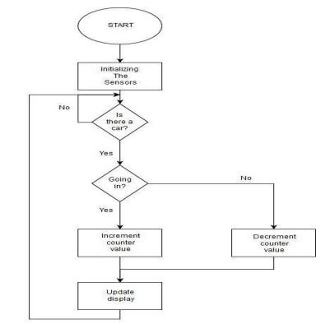

**Team Members:**

Sanmugavel R (2021504036)

Hariharan S (2021504007)

Madhavan T (2021504020)

Harish Keran E (2020504519)